

17th Arctic Climate Forum Consensus Statement

Summary of 2025/2026 Arctic winter-spring season and the 2026 Arctic summer Seasonal Climate Outlook

9 – 10 June 2026
Contents

Introduction to the Arctic Climate Forum Consensus Statement 3
Highlights for decision making 4
Understanding the Consensus Statement 5
Temperature 6
Summary for winter-spring 2025/2026 6
Verification of winter-spring 2025/2026 forecast 9
Outlook for summer 2026 10
Precipitation 11
Summary for winter-spring 2025/2026 11
Verification of winter-spring 2025/2026 forecast 12
Outlook for summer 2026 13
Polar Ocean 15
Summary for winter-spring 2025/2026 15
Sea-Ice 16
Summary for winter-spring 2025/2026 16
Sea-ice Outlook verification for winter 2026 ice extent and freeze-up dates: 18
Outlook for summer 2026 sea-ice break-up 20
Outlook for September 2026 Minimum sea-ice extent 22
2026 Summer Ice Conditions in Key Shipping Areas 23
Bioclimatic indexes (experimental product) 23
Summary for winter-spring 2025/2026 23
Verification of winter 2025/2026 forecast 26
Outlook for summer 2026 (experimental) 26
Observed extreme events during autumn 2025 – spring 2026 28
Possible impacts for summer 2026 31
Data sources and useful links: 33
Background and Contributing institutions 34
Acronyms 34

Introduction to the Arctic Climate Forum Consensus Statement

Arctic temperatures continue to rise at rates greater than the global average. Both the annual and seasonal air temperatures since early 2000s in the Arctic (northward of 50°N within the ArcRCC-N domain) have been among the highest in the time series of observations for 1900-2025/2026 period (figure 1) though significant interannual variations occur for all Arctic Essential Climate Variables (ECV), including the surface atmospheric, sea-ice and polar ocean ECVs.
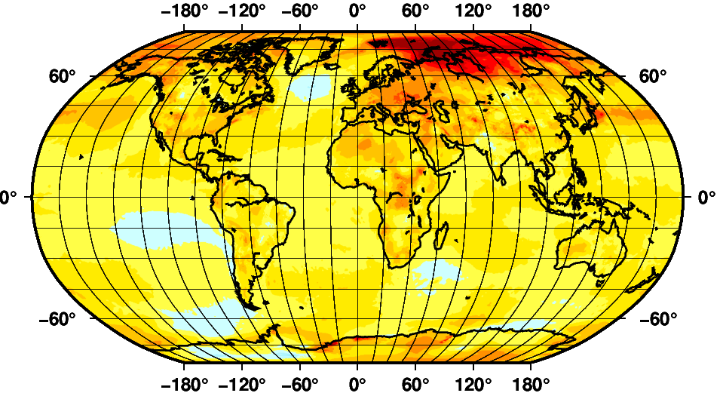 | 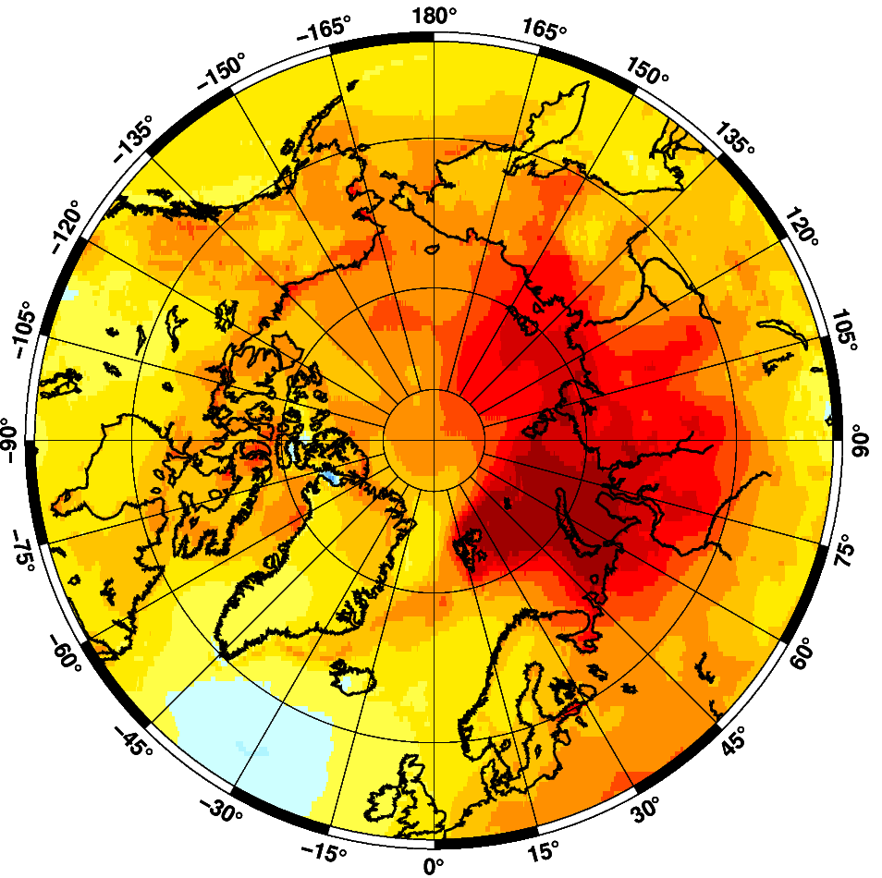
Figure 1: Global (with cutout for Arctic region) annual surface temperature trend (degrees/year) for 1996-2025 period. Graphics produced by the AARI. Data source: ERA5 monthly averaged surface air temperature at 2m level.

The role of the ArcRCC-Network is to foster collaborative regional climate services amongst Arctic (hydro)meteorological and ice services, as to meet climate adaptation and decision-making needs among societal actors across the Arctic. Arctic Climate Forums (ACFs) were established in 2018 and are convened by the Arctic Regional Climate Centre Network (ArcRCC-N) under the auspices of the World Meteorological Organization (WMO).
A main product of the ACFs is the Consensus Statements, which synthesize observations, historical trends, forecasts, and in doing so, include regional expertise. These statements include a review of the major climate features of the previous season and outlooks for the upcoming season for temperature, precipitation, sea-ice and several other experimental forecasts.
The elements of the Consensus Statements are presented and discussed at the Arctic Climate Forum (ACF) sessions, with both providers and users of climate information in the Arctic being held twice a year in May/June and October/November. The Consensus Statements are issued around the beginning of the summer melt and sea-ice break-up (May/June) and around the beginning of the winter sea-ice freeze-up (October/November).
This Consensus Statement is an outcome of the 17th session of the ACF held online 9-10 June 2026 coordinated by the Nordic Node of the ArcRCC-Network and hosted by the Norwegian Meteorological Institute (Met Norway).

Highlights for decision making

Temperature: For the whole land Arctic extremely warm conditions were observed in October and November 2025 (1st and 4th on record) with variative prominent negative/positive anomalies during all months of the past season, including positive in Central and Eastern Canada (1st - 3rd on record) and negative in Alaska and Western Canada (69th on record) in November - December, positive over Chukchi and Bering (3rd on record) with negative over Western (66th on record) and Eastern Nordic (63rd) in January – February and positive over Eastern Nordic (1st and 4th on record), Eastern Siberia (5th on record) and Chukchi and Bering (2nd on record) with strong negative anomalies over Alaska and Western Canada (76th on record) and Central and Eastern Canada (twice 68th on record) in March – April. For the June-July-August 2026 period, there is a probability of 50% or more that temperatures will be above normal in most of the regions across the Arctic with the highest (60-80%) for Western and Eastern Nordic, Western Siberia. Below normal temperatures are expected for areas south of Greenland Sea, Alaska Bay with a probability of 40-60%.

Precipitation: During the past season wetter (snowy) conditions occurred in parts of Canadian, Alaska, Eastern Siberia and Western Nordic regions. Drier conditions occurred in Eastern Nordic, parts of Alaska and Western Siberia. Impacts of precipitation/temperature anomalies led to lower or close to normal river discharge for most of the rivers in particular during the November – January period with Yukon experiencing greater discharge than normal. For the June – August 2026 period over the largest part of the Arctic region, equal precipitation chances are expected. Above normal precipitation with low probability (40-50%) is forecasted for Central Arctic, Greenland, marine areas south of Alaska and land part of Western Siberia. Below near precipitation also with low probability (40-50%) is forecasted for coastal areas of Western Canada and southmost parts of Central Canada.

Sea-ice: Maximum Arctic (Northern Hemisphere) winter 2025/2026 sea-ice extent was close to ~14.6 million km² or the 4-7th lowest on record since 1979 and was reached near 13 March 2026, which is close to climatic norm and earlier than the previous year. Special features of ice conditions in the Arctic included similar as in 2024/2025 occurrence of residual and further up to the end of winter season the second-year ice in the parts of the Chukchi and East Siberian Sea, close to decadal normal ice conditions in the Greenland and in late winter greater than 48-years median in the western Bering Sea but much lower-than-normal ice conditions in the Barents and in particular extremely low in the Okhotsk Seas. Cryosat-2 measurements showed general sea-ice thickness growth (relative to 2011-2026) along Transarctic drift area with its negative anomalies to the end of winter season for Greenland, Svalbard waters and eastern Eurasian Arctic.

Ongoing Impacts of Climate Change: Increase risk of coastal flooding and thawing permafrost lead to coastal erosion and losses of community infrastructure. All marine mammals with habitat on sea ice may be more difficult to harvest. Increasing interannual and intraseasonal variability lowers predictability of weather extremes, hereby challenging planning and operational decisions among communities and stakeholders inhabiting and operating in the Arctic region.

Understanding the Consensus Statement
This consensus statement includes: a seasonal summary, forecast verification for temperature, precipitation, and sea-ice for the previous 2025/2026 Arctic winter-spring season (from October 2025 to April 2026) and an outlook for the upcoming 2026 Arctic summer season (from June to September 2026 period) for temperature, precipitation and sea-ice. Experimental products with outlooks for snow water equivalent and weather severity index are also included in this consensus statement. Figure 2 shows the regions, which are defined by the ArcRCC-N members on the basis of accepted regional practices to capture the different geographic features and environmental factors influencing temperature, precipitation and other Arctic ECVs. Figure 3 shows the established shipping routes and regions used for the sea-ice products.

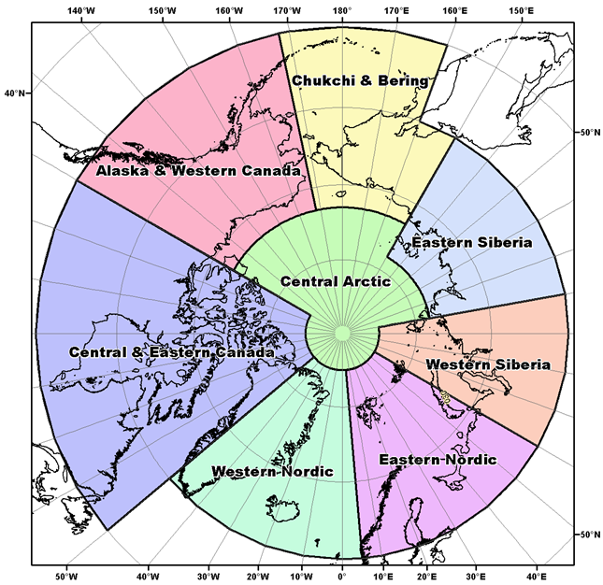 | 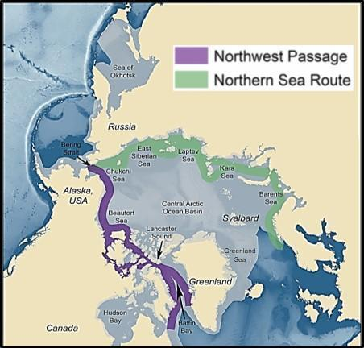
Figure 2: ArcRCC-N regions accepted for seasonal summaries and outlooks | Figure 3: Sea-ice Regions. Map Source: Courtesy of the U.S. National Academy of Sciences

Seasonal summaries for temperature, precipitation, sea-ice and other Arctic ECVs are based on a synthesis of routine observations at polar stations and marine mobile platforms, sea-ice analysis from the national ice services, satellite estimates of sea-ice extent and thickness, WMO GCW SeaIceWatch and SnowWatch data, and a set of modern reanalysis products including Copernicus climate change service (ERA5, MEMS, GloFAS-ERA5) and NCEP-NCAR reanalysis. Anomalies of the parameters are given in the majority of cases for the 3rd WMO reference period 1991-2020, which allows to efficiently underline the most recent interannual variability.
The seasonal forecasts for temperature and precipitation are based on thirteen WMO Global Producing Centers of Long-Range Forecasts (GPCs-LRF) models and consolidated by the WMO Lead Centre for Long Range Forecast Multi-Model Ensemble (LC-LRFMME). In terms of models’ skill (i.e., the ability of the climate model to simulate the observed seasonal climate), a multi-model ensemble (MME) approach essentially overlays all of the individual model performances. This provides a forecast with higher confidence in the regions where different model outputs/results are consistent, versus a low confidence forecast in the regions where the models don’t agree. The MME approach is a methodology well-recognized by the WMO to be providing the most reliable objective forecasts.
Sea-ice and snow water equivalent outlooks are based primarily on the Canadian Seasonal to Interannual Prediction System (CanSIPSv3, 40 ensemble members, 20 each from GEM5.2-NEMO and CanCM5.1p1bc) with additional use of sea-ice forecasts from the Coupled Unified Forecast System (NOAA UFS; 5 ensemble members) and INM-CM5 climate model (INM RAS/Hydrometcenter of Russia, 30 ensemble members). MME for sea-ice is not yet available; the outlook is a subjective ‘ensemble’ of probabilistic/deterministic model forecasts. Therefore, for sea-ice the forecast confidence is a subjective assessment of hindcast model skill, ensemble spread and forecast agreement between models. When sea ice extent is at its minimum in September of each year, forecasts are available for the following peripheral seas where there is variability in the ice edge: Barents Sea, Beaufort Sea, Canadian Arctic Archipelago, Chukchi Sea, Eastern Siberian Sea, Greenland Sea, Kara Sea, and Laptev Sea. In addition to these regions, forecasts for sea ice break-up are also available for Baffin Bay, Bering Sea, East Siberian Sea, Kara Sea, Laptev Sea, Chukchi Sea, Barents Sea, Greenland Sea, Hudson Bay, and Labrador Sea.

Temperature

Summary for winter-spring 2025/2026
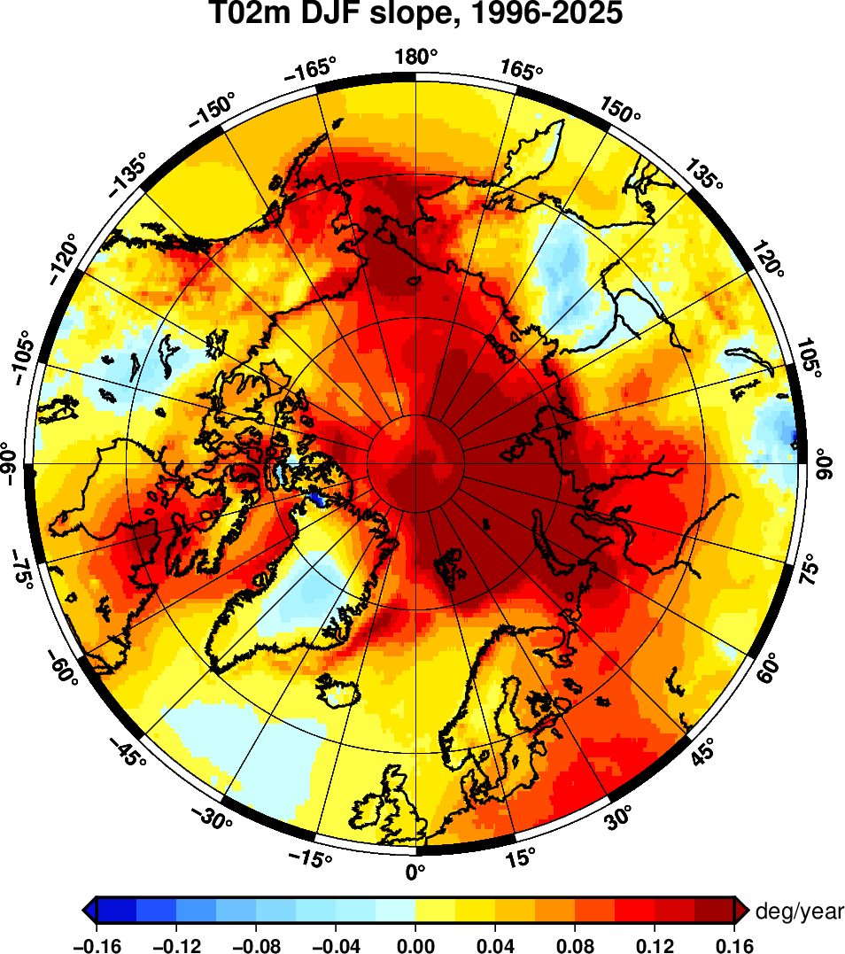
Figure 4a – Winter (December - January) surface air temperature 2m linear trend (degrees/year) for 1996 – 2025. Data source: CCCS ERA5, graphics produced by the AARI.
Decadal analysis of the annual trends for the past 30 years shows that extreme positive values (more than 0.14 degree / year) is persistent for the northern part of the Eastern Nordic, Western Siberia, Arctic Basin and most of Chukchi and Bering regions while overall negative trends are persistent for southern part of West Nordic, Central Greenland, Eastern Siberia and parts of Central Canada. Negative anomalies (to 1991-2020 period) in general occurred in the mid 20th century.
The start of winter 2025/2026 (October-November-December) surface air temperature (Figure 4b, Table 1) showed prominent positive anomalies in Eastern Nordic (4th on record), Alaska and Western Canada (October - 4th on record), Chukchi and Bering (1st on record) and in particular Central and Eastern Canada (1st and 3rd on record), with simultaneously recorded negative anomalies in Alaska and Western Canada (69th on record - December). During mid-winter (January-February 2026) strong positive anomalies (Figure 4b, Table 1) were observed only over Chukchi and Bering (3rd on record) with significant negative anomalies observed over Western (66th on record) and in particular over Eastern Nordic (twice 63rd on record). Further by the end of winter in March – April 2026 strong positive anomalies (Figure 4b, Table 1) were observed over Eastern Nordic (1st and 4th on record), Eastern Siberia (5th on record) and Chukchi and Bering (2nd on record) with strong negative anomalies over Alaska and Western Canada (76th on record) and Central and Eastern Canada (twice 68th on record).
Due to a lack of surface marine observations, conclusions drawn from reanalysis for the central Arctic include warmer conditions in October, December, March and April, and colder conditions in November, January and February (Figure 4c).
For the whole land Arctic extremely warm conditions were observed in October and November 2025 (1st and 4th on record) with variative negative and positive anomalies in other months of the past season (Table 1).

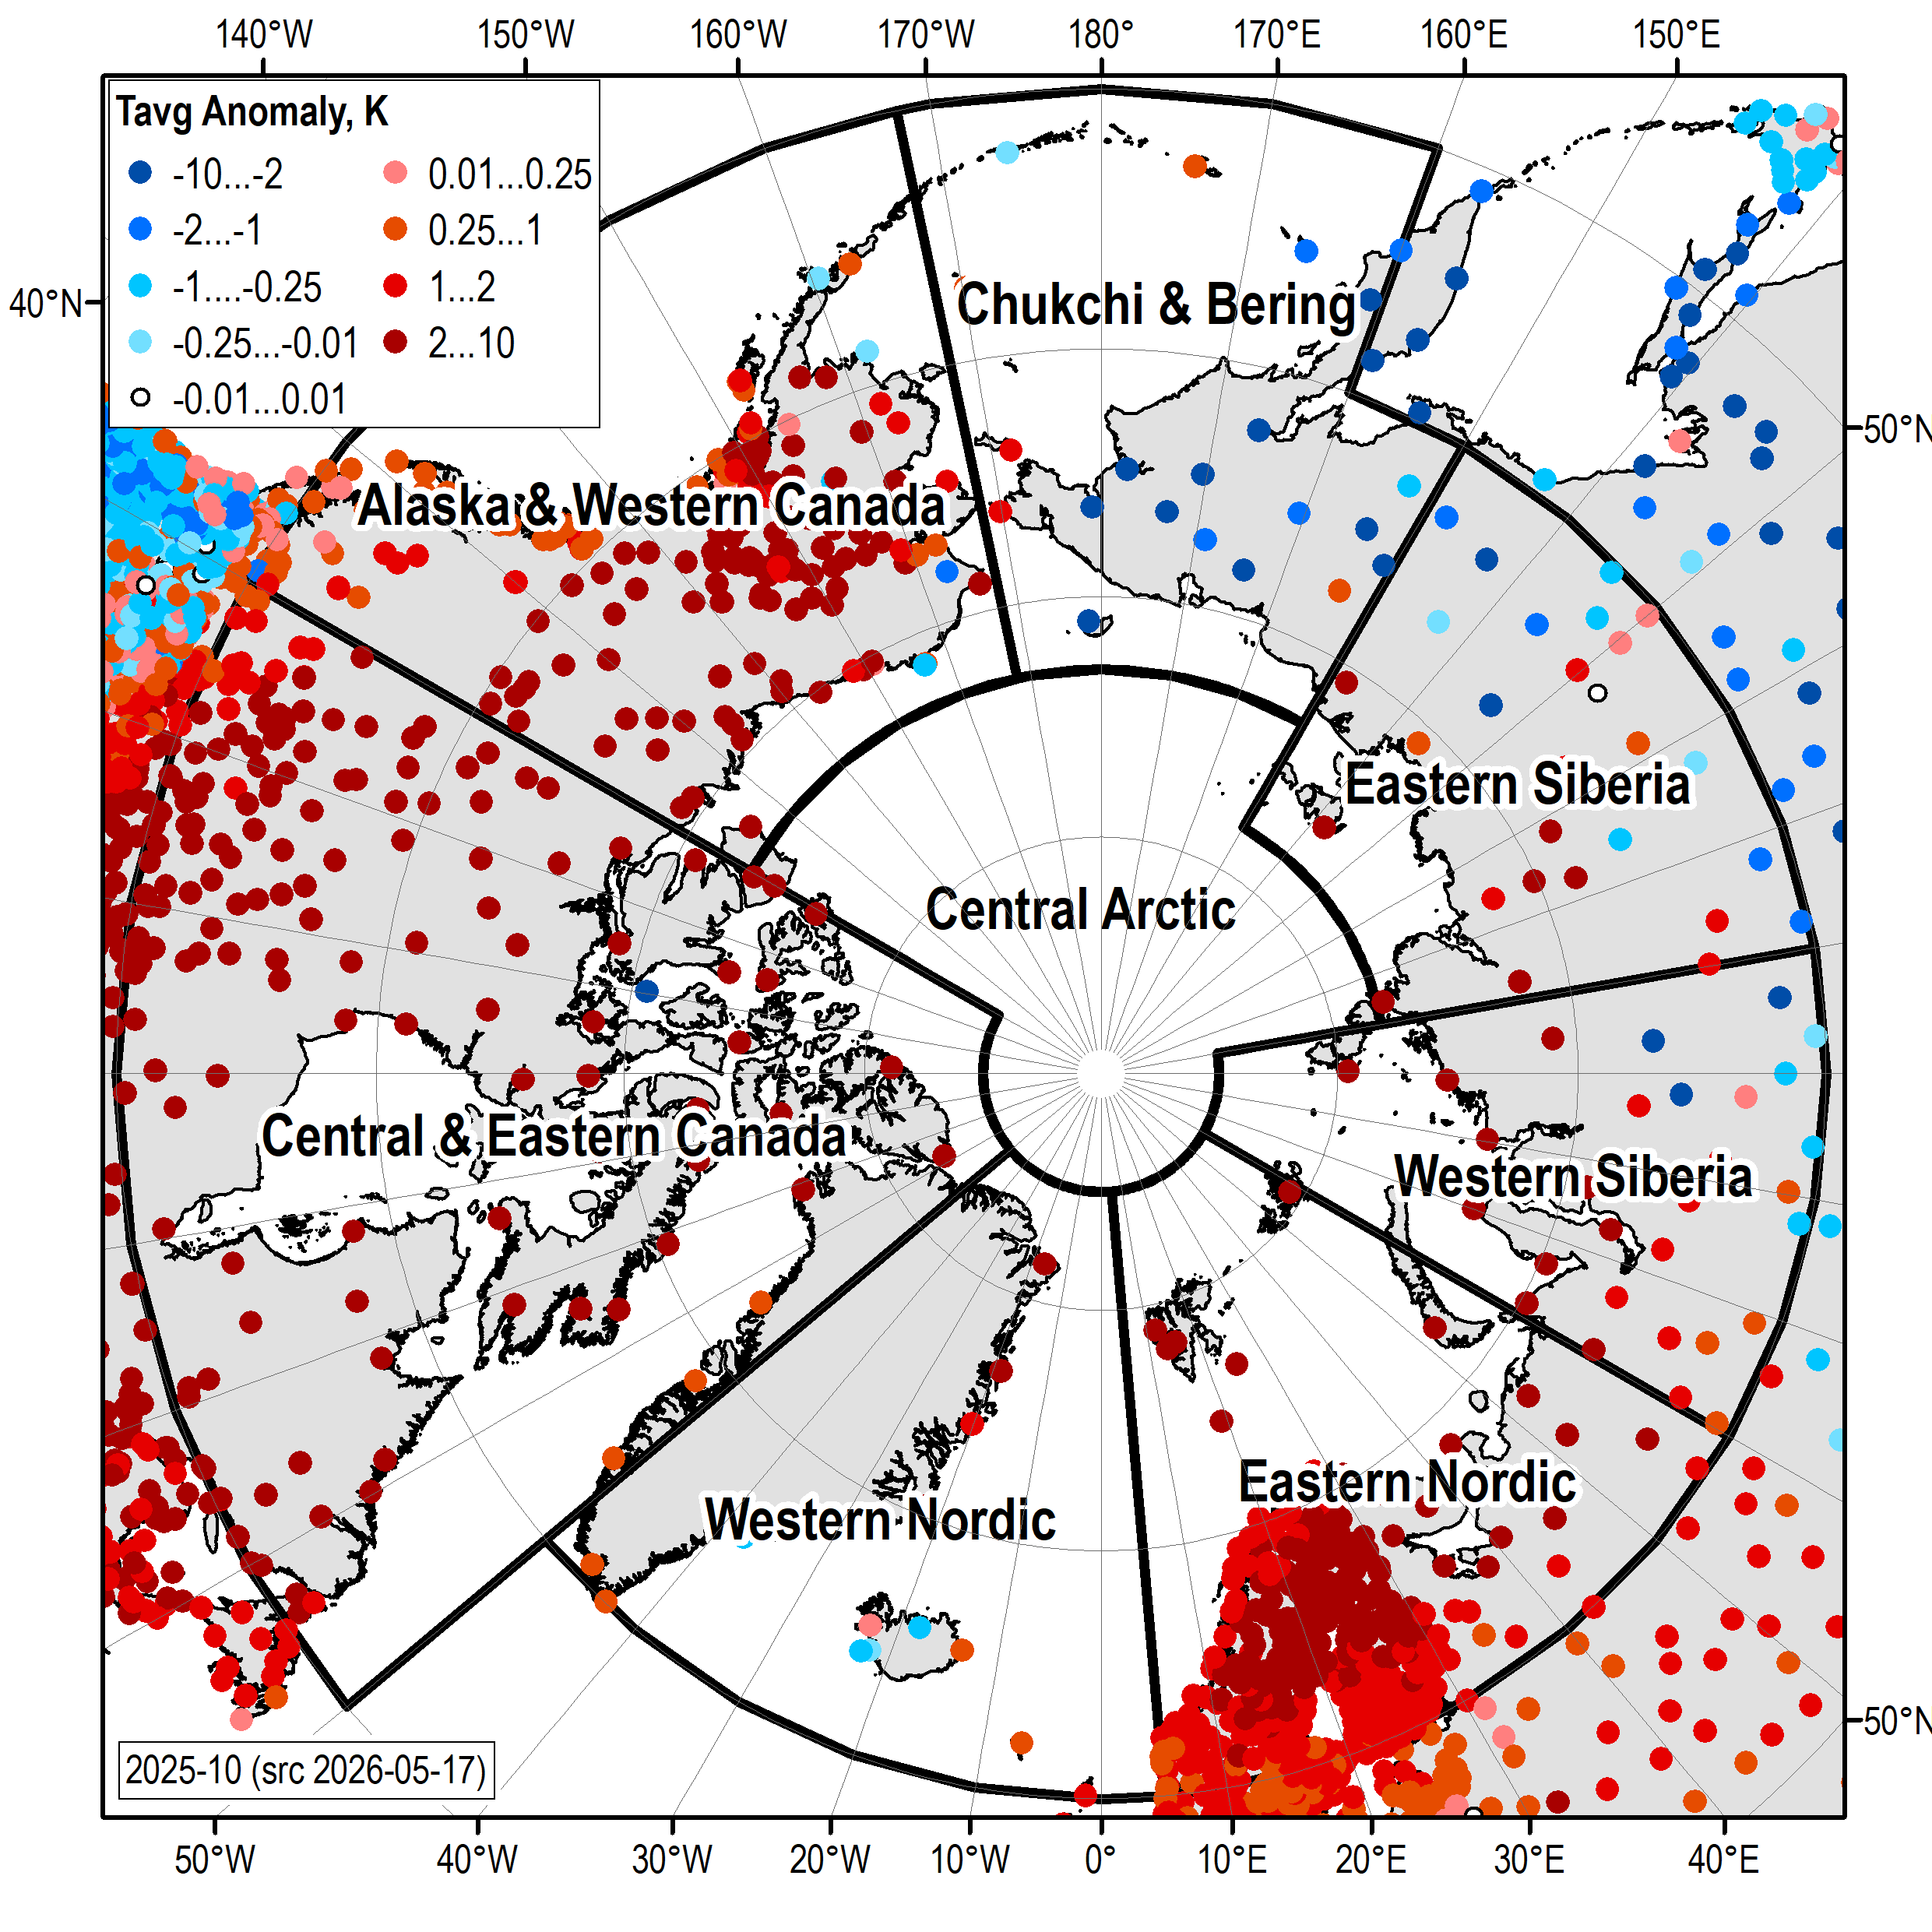 | 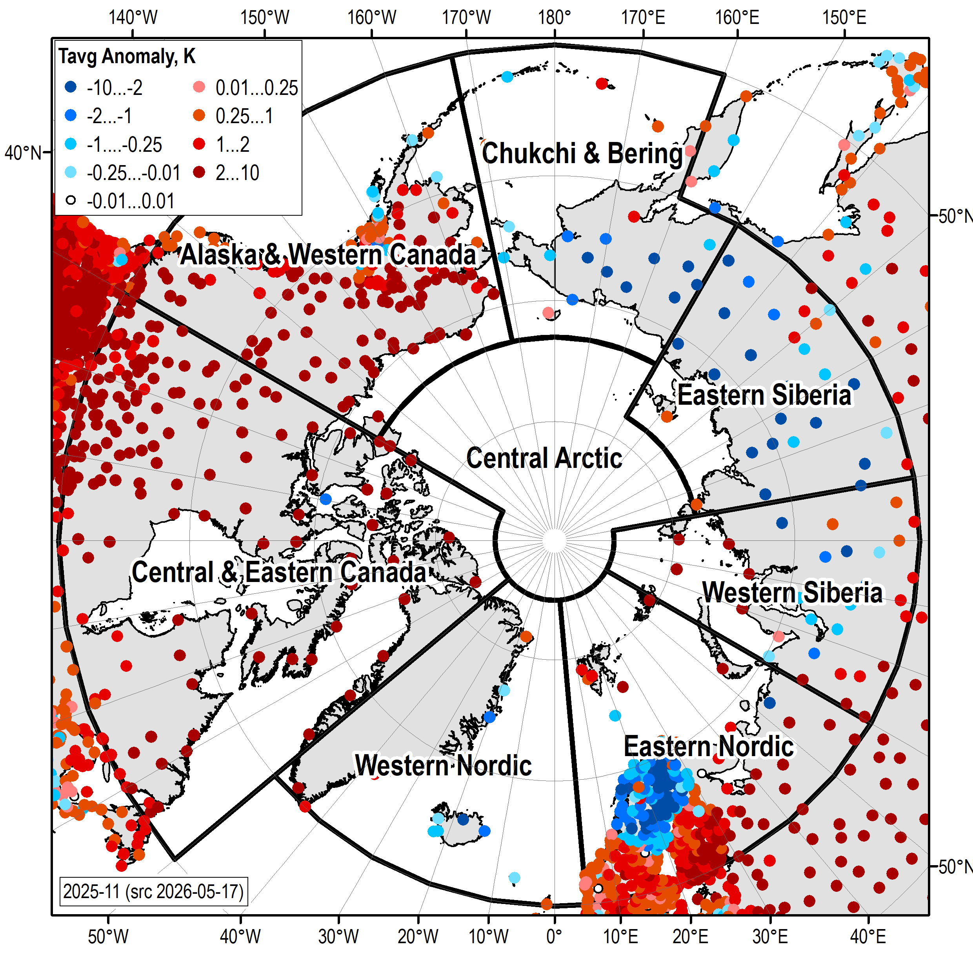 | 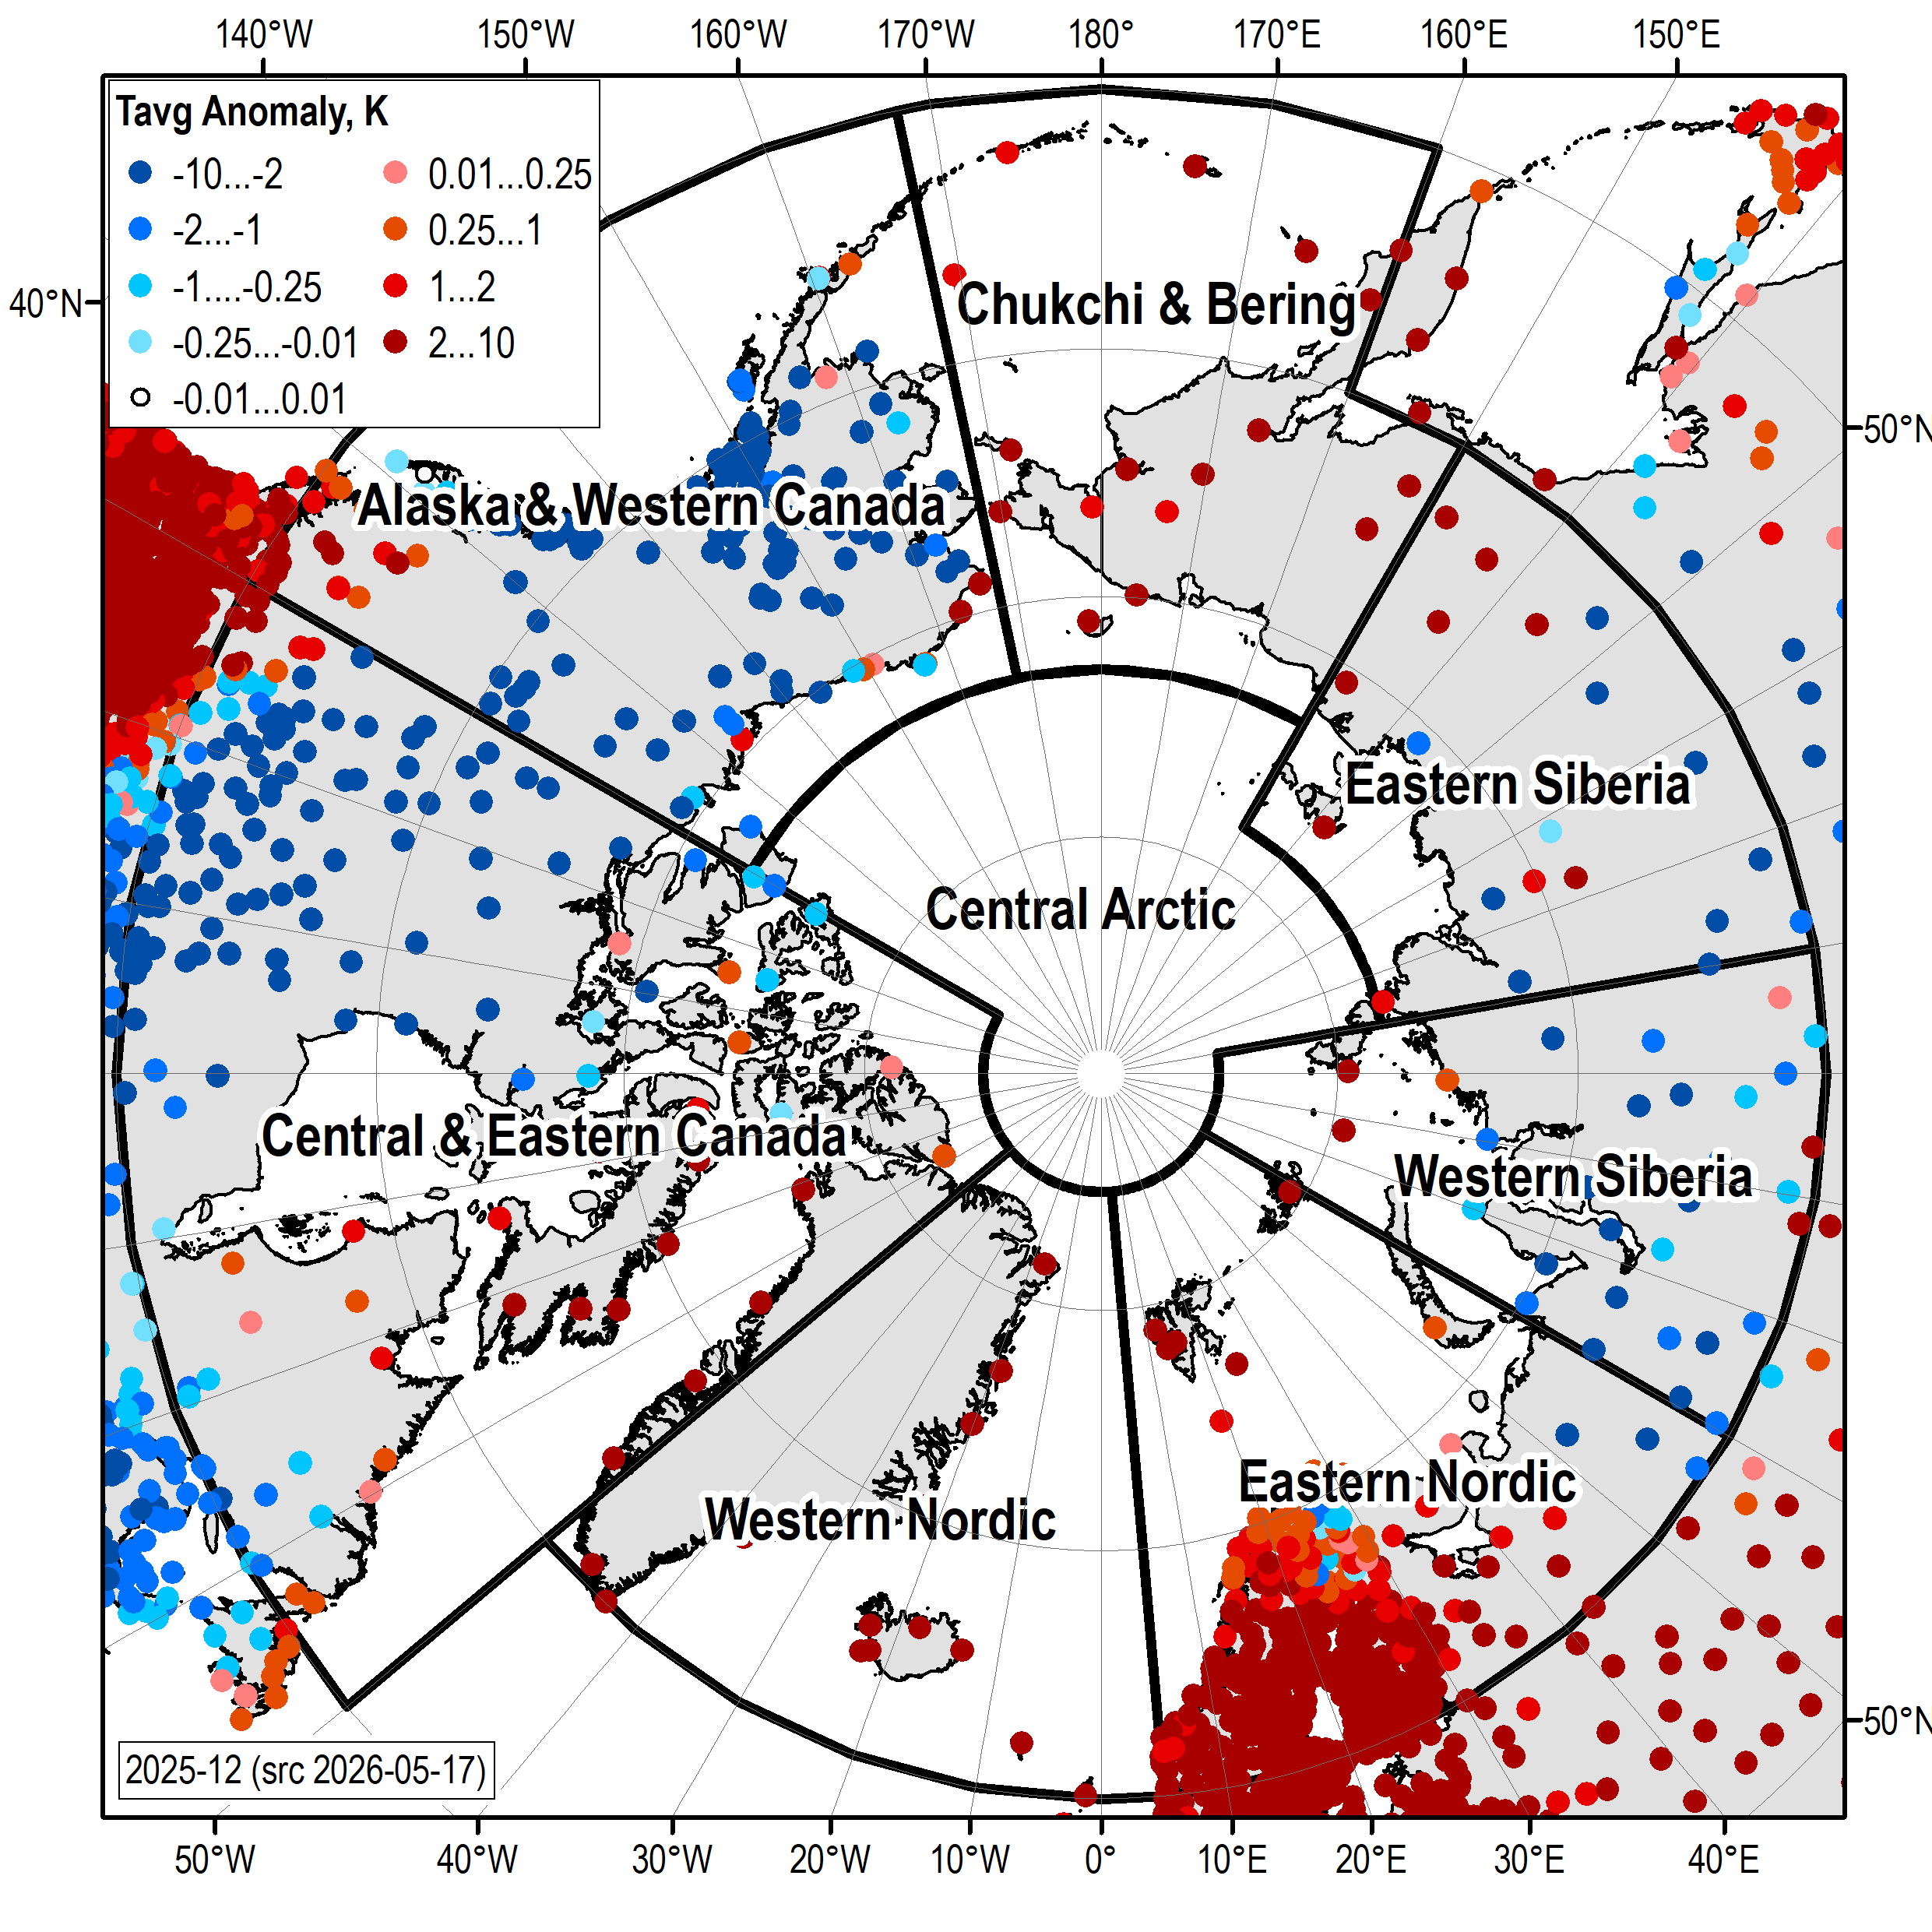
October 2025 | November 2025 | December 2025
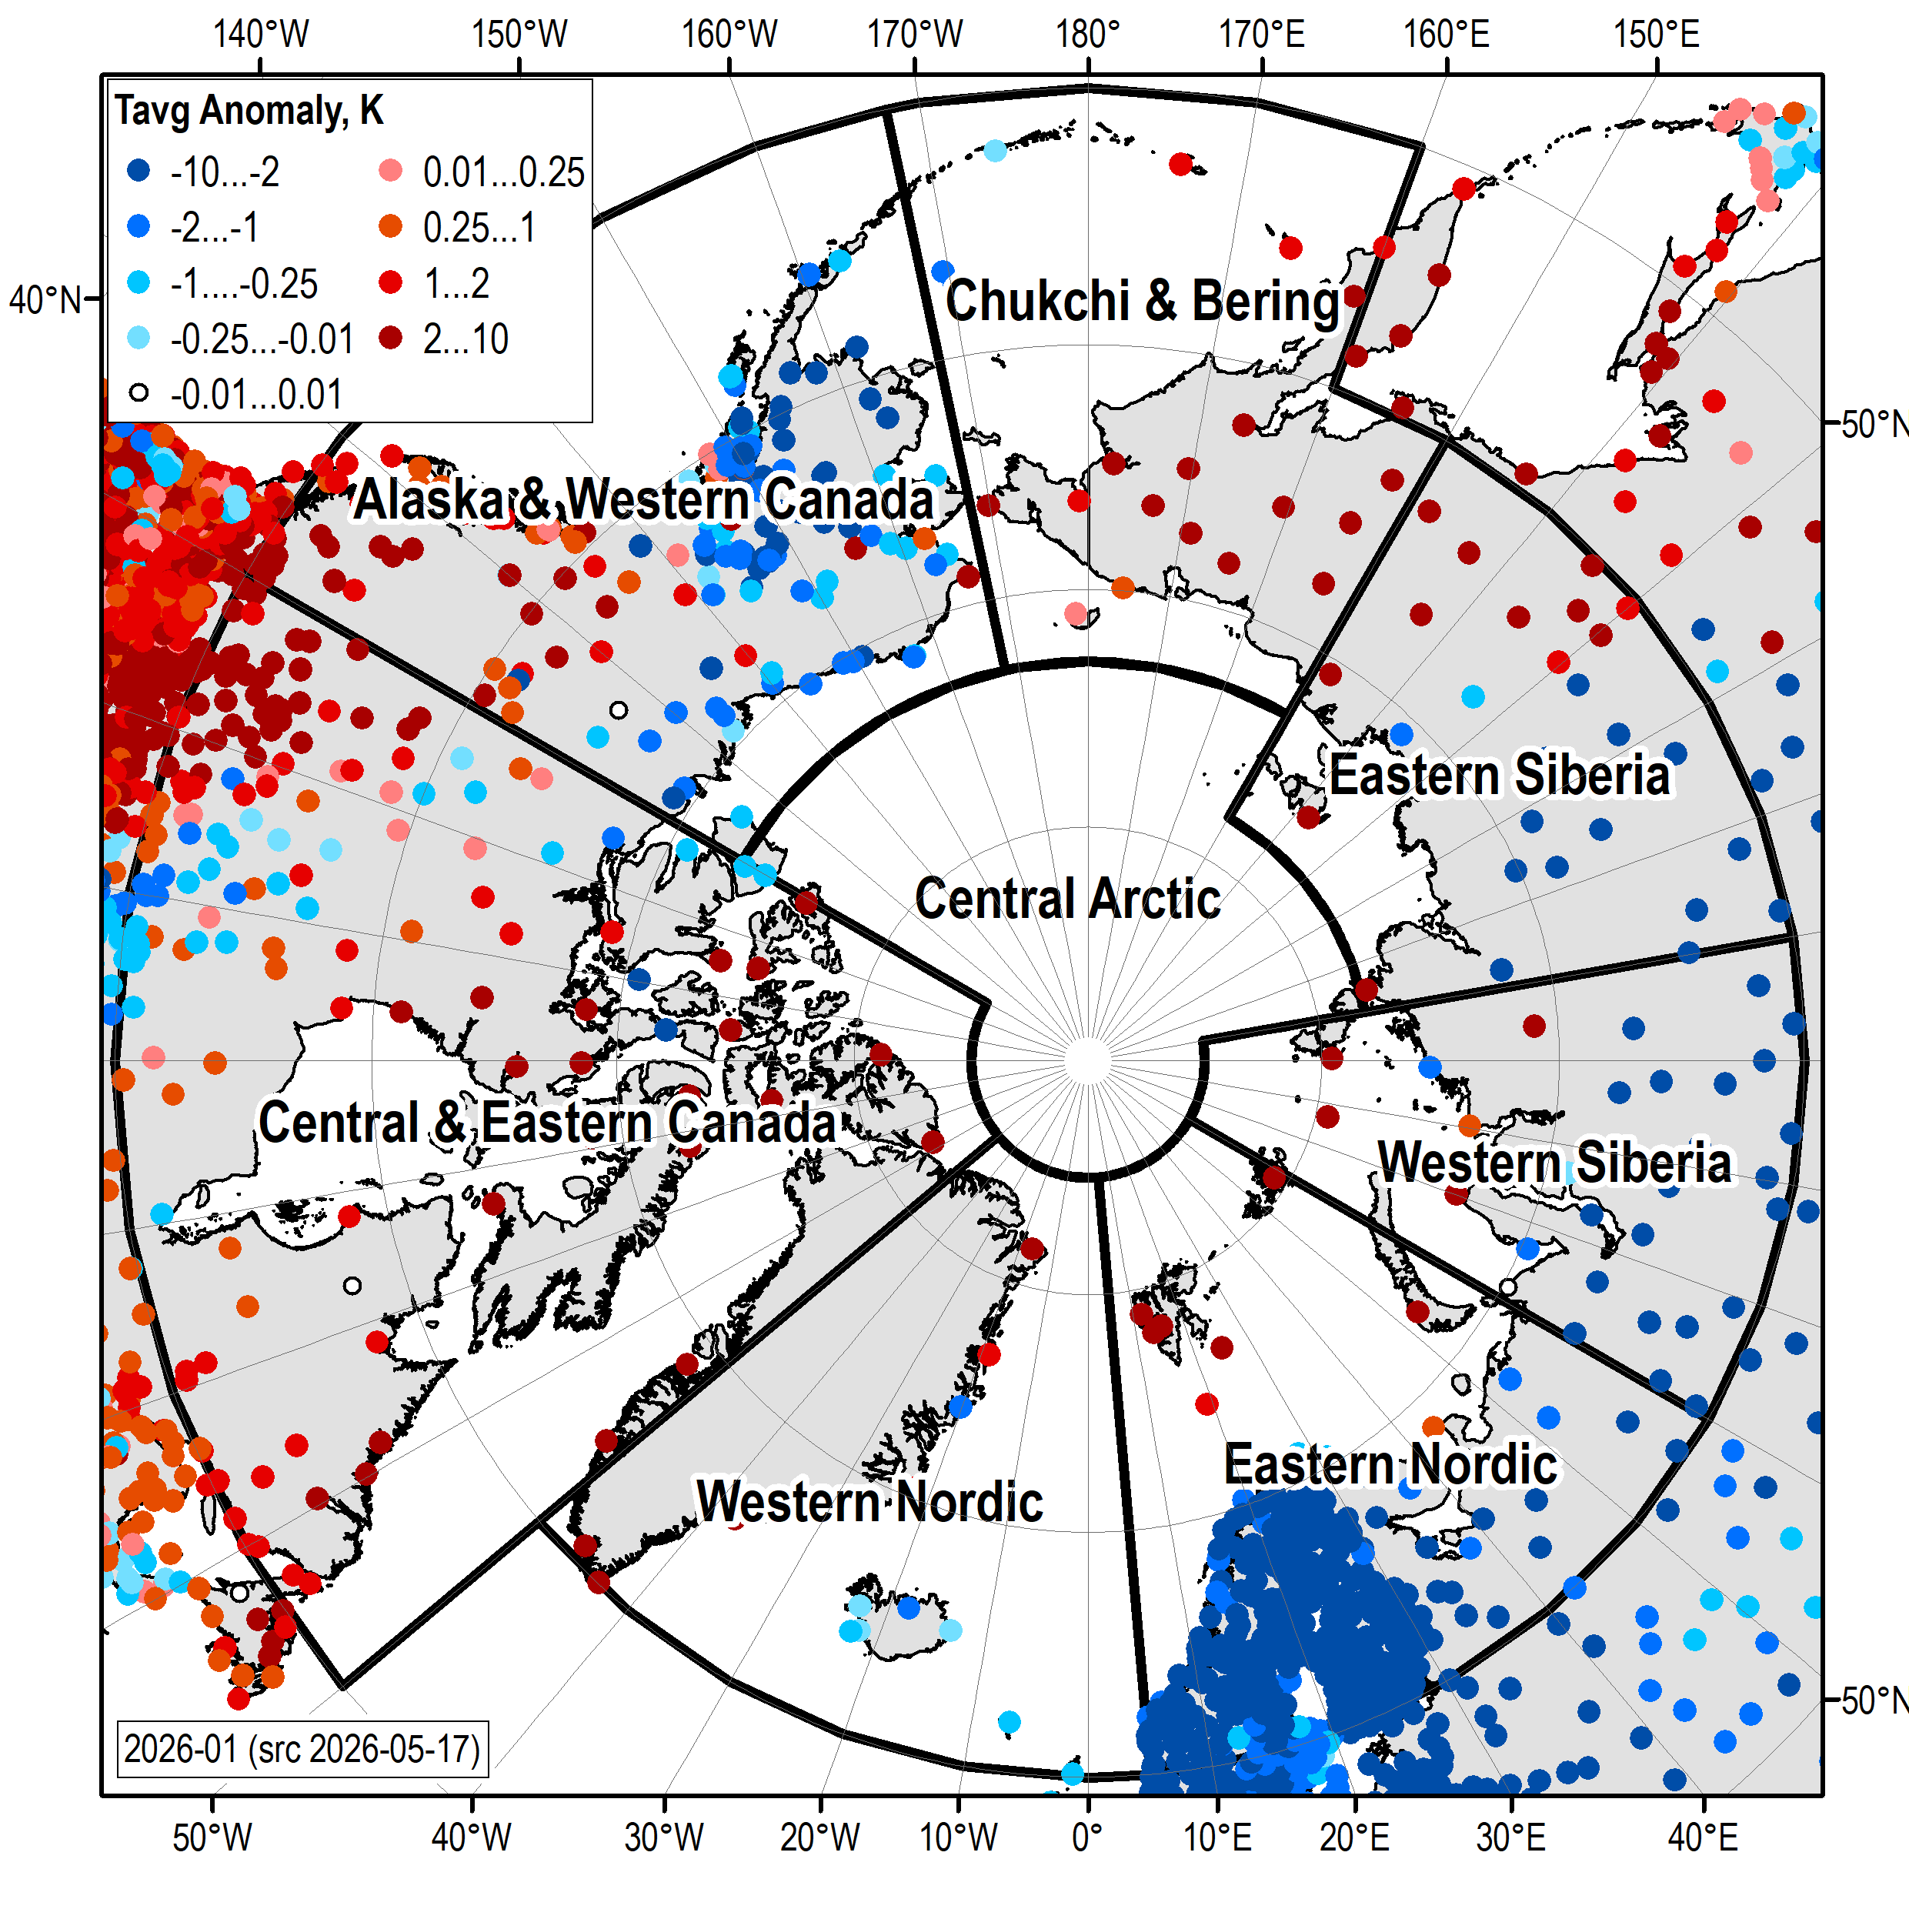 | 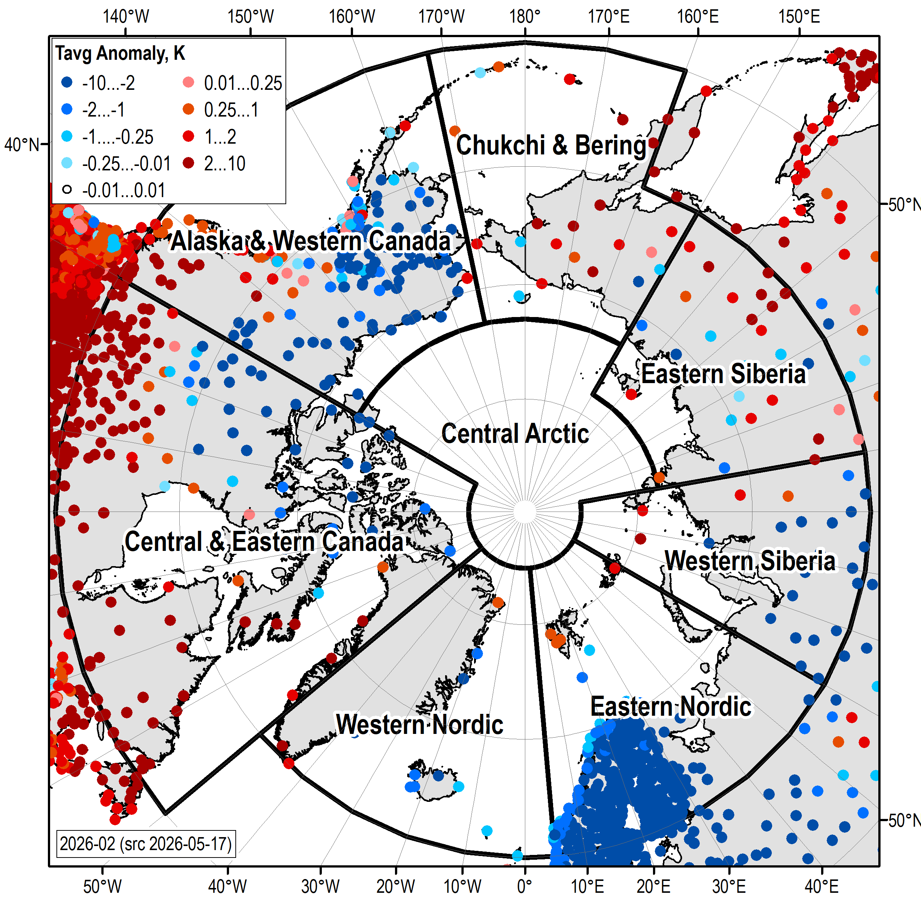 | 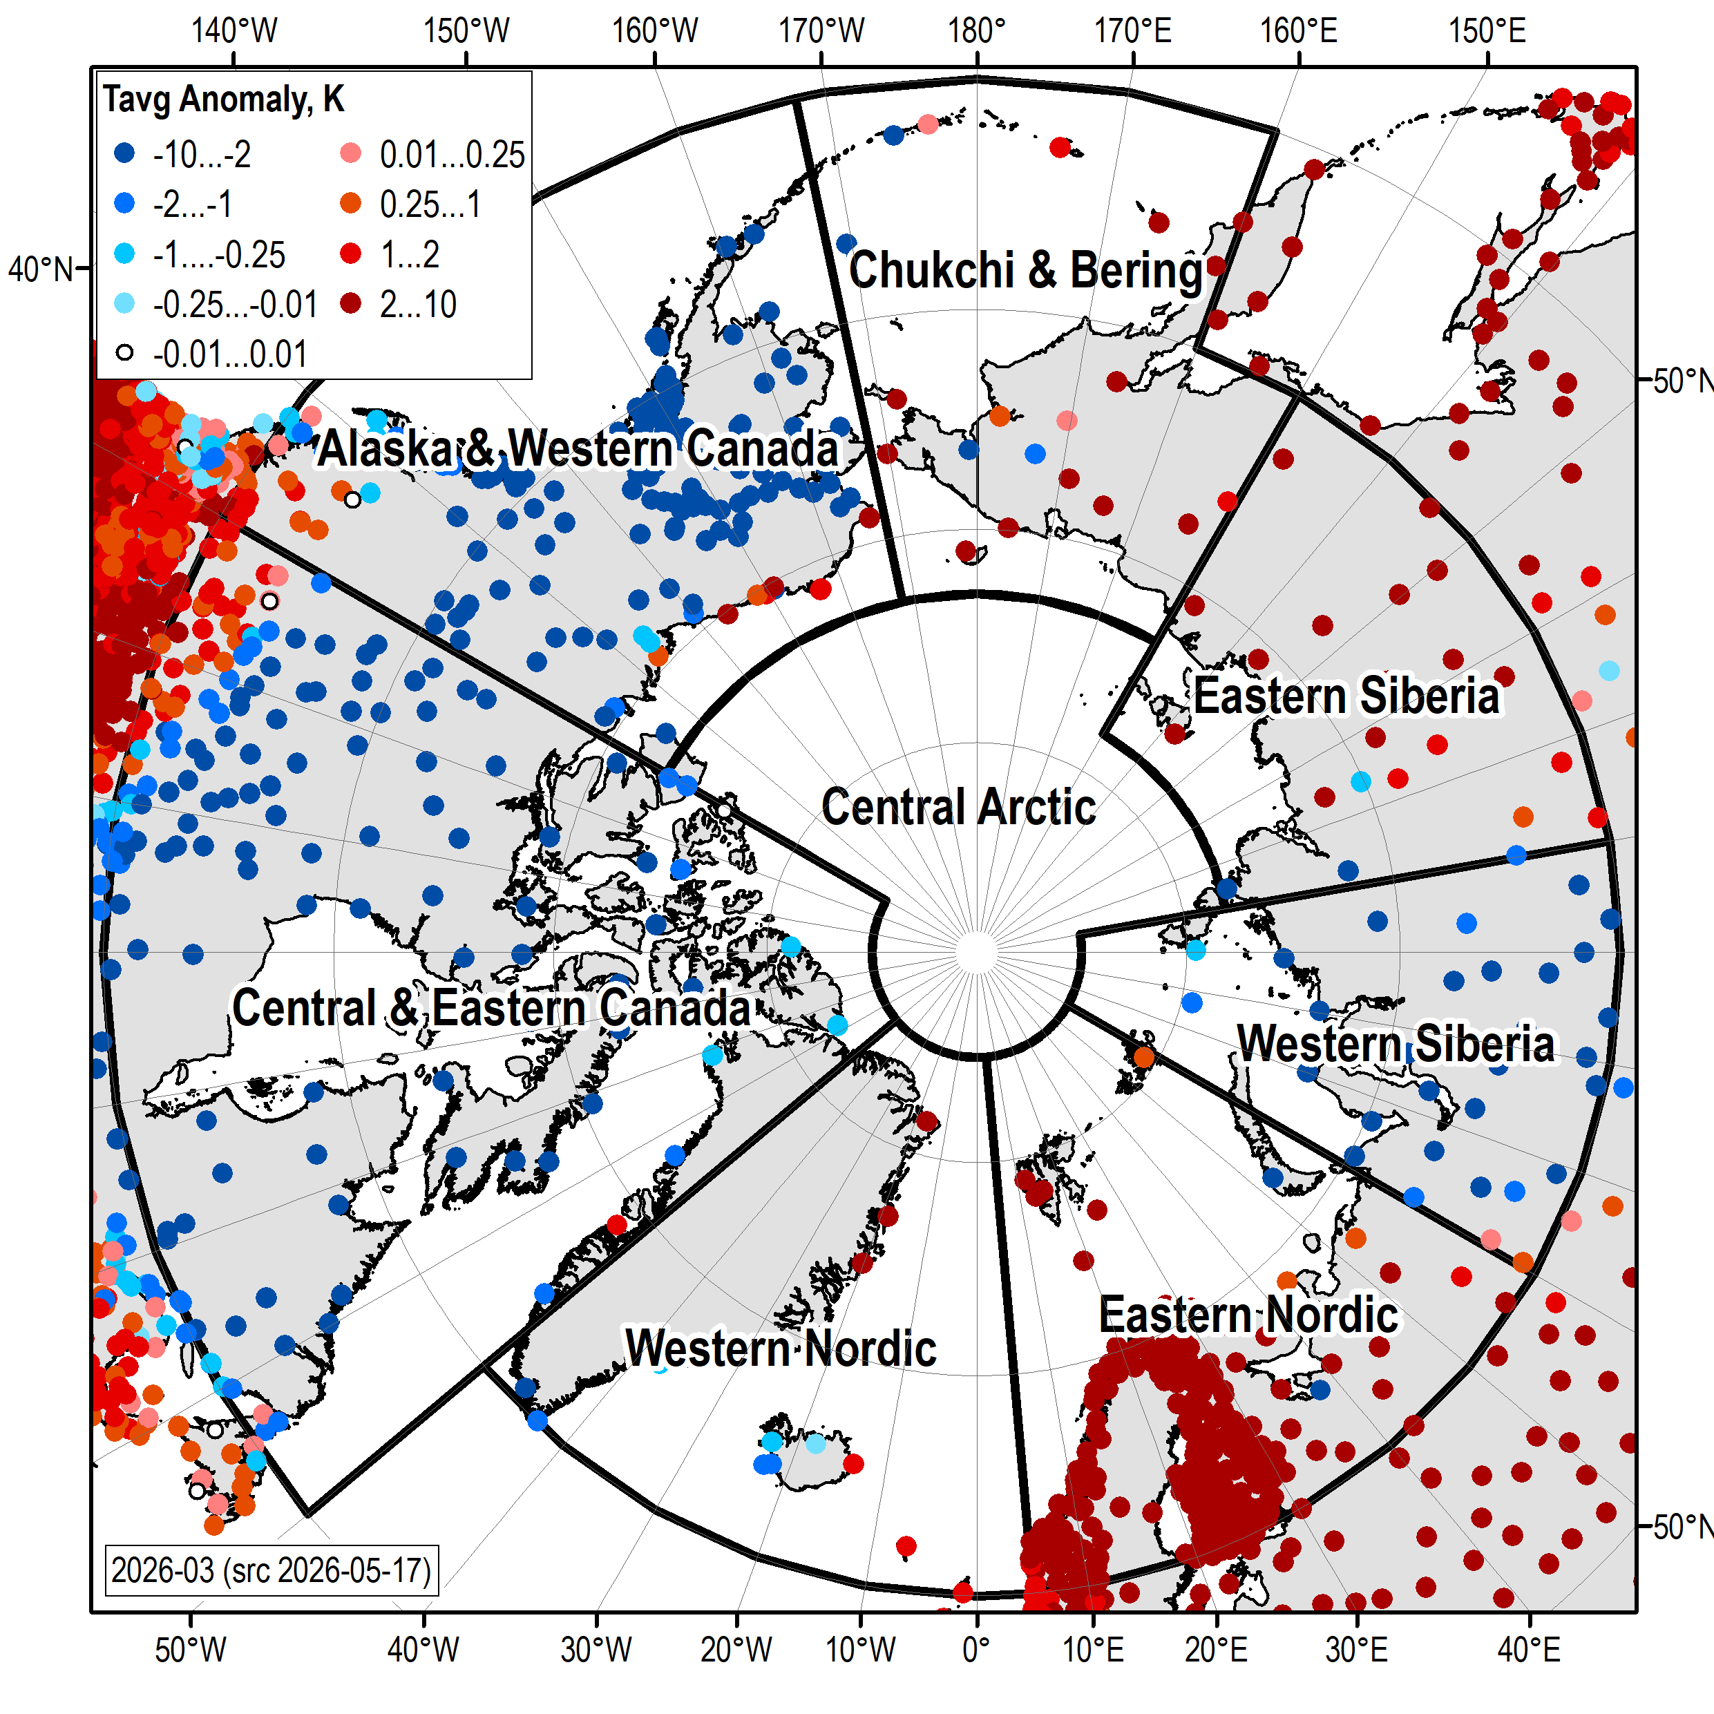
January 2026 | February 2026 | March 2026
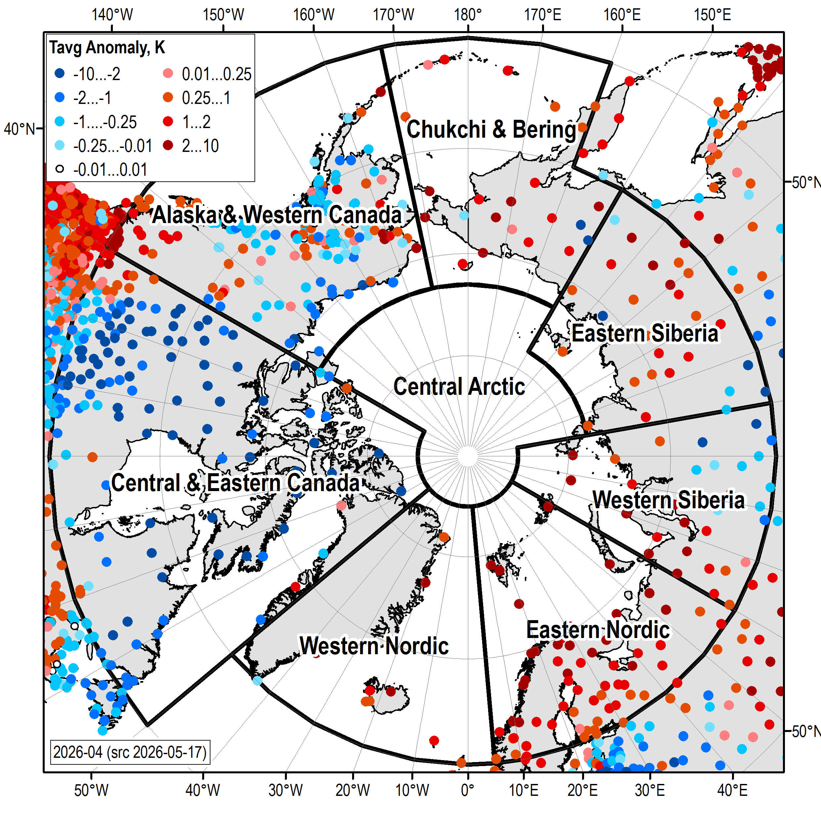 | 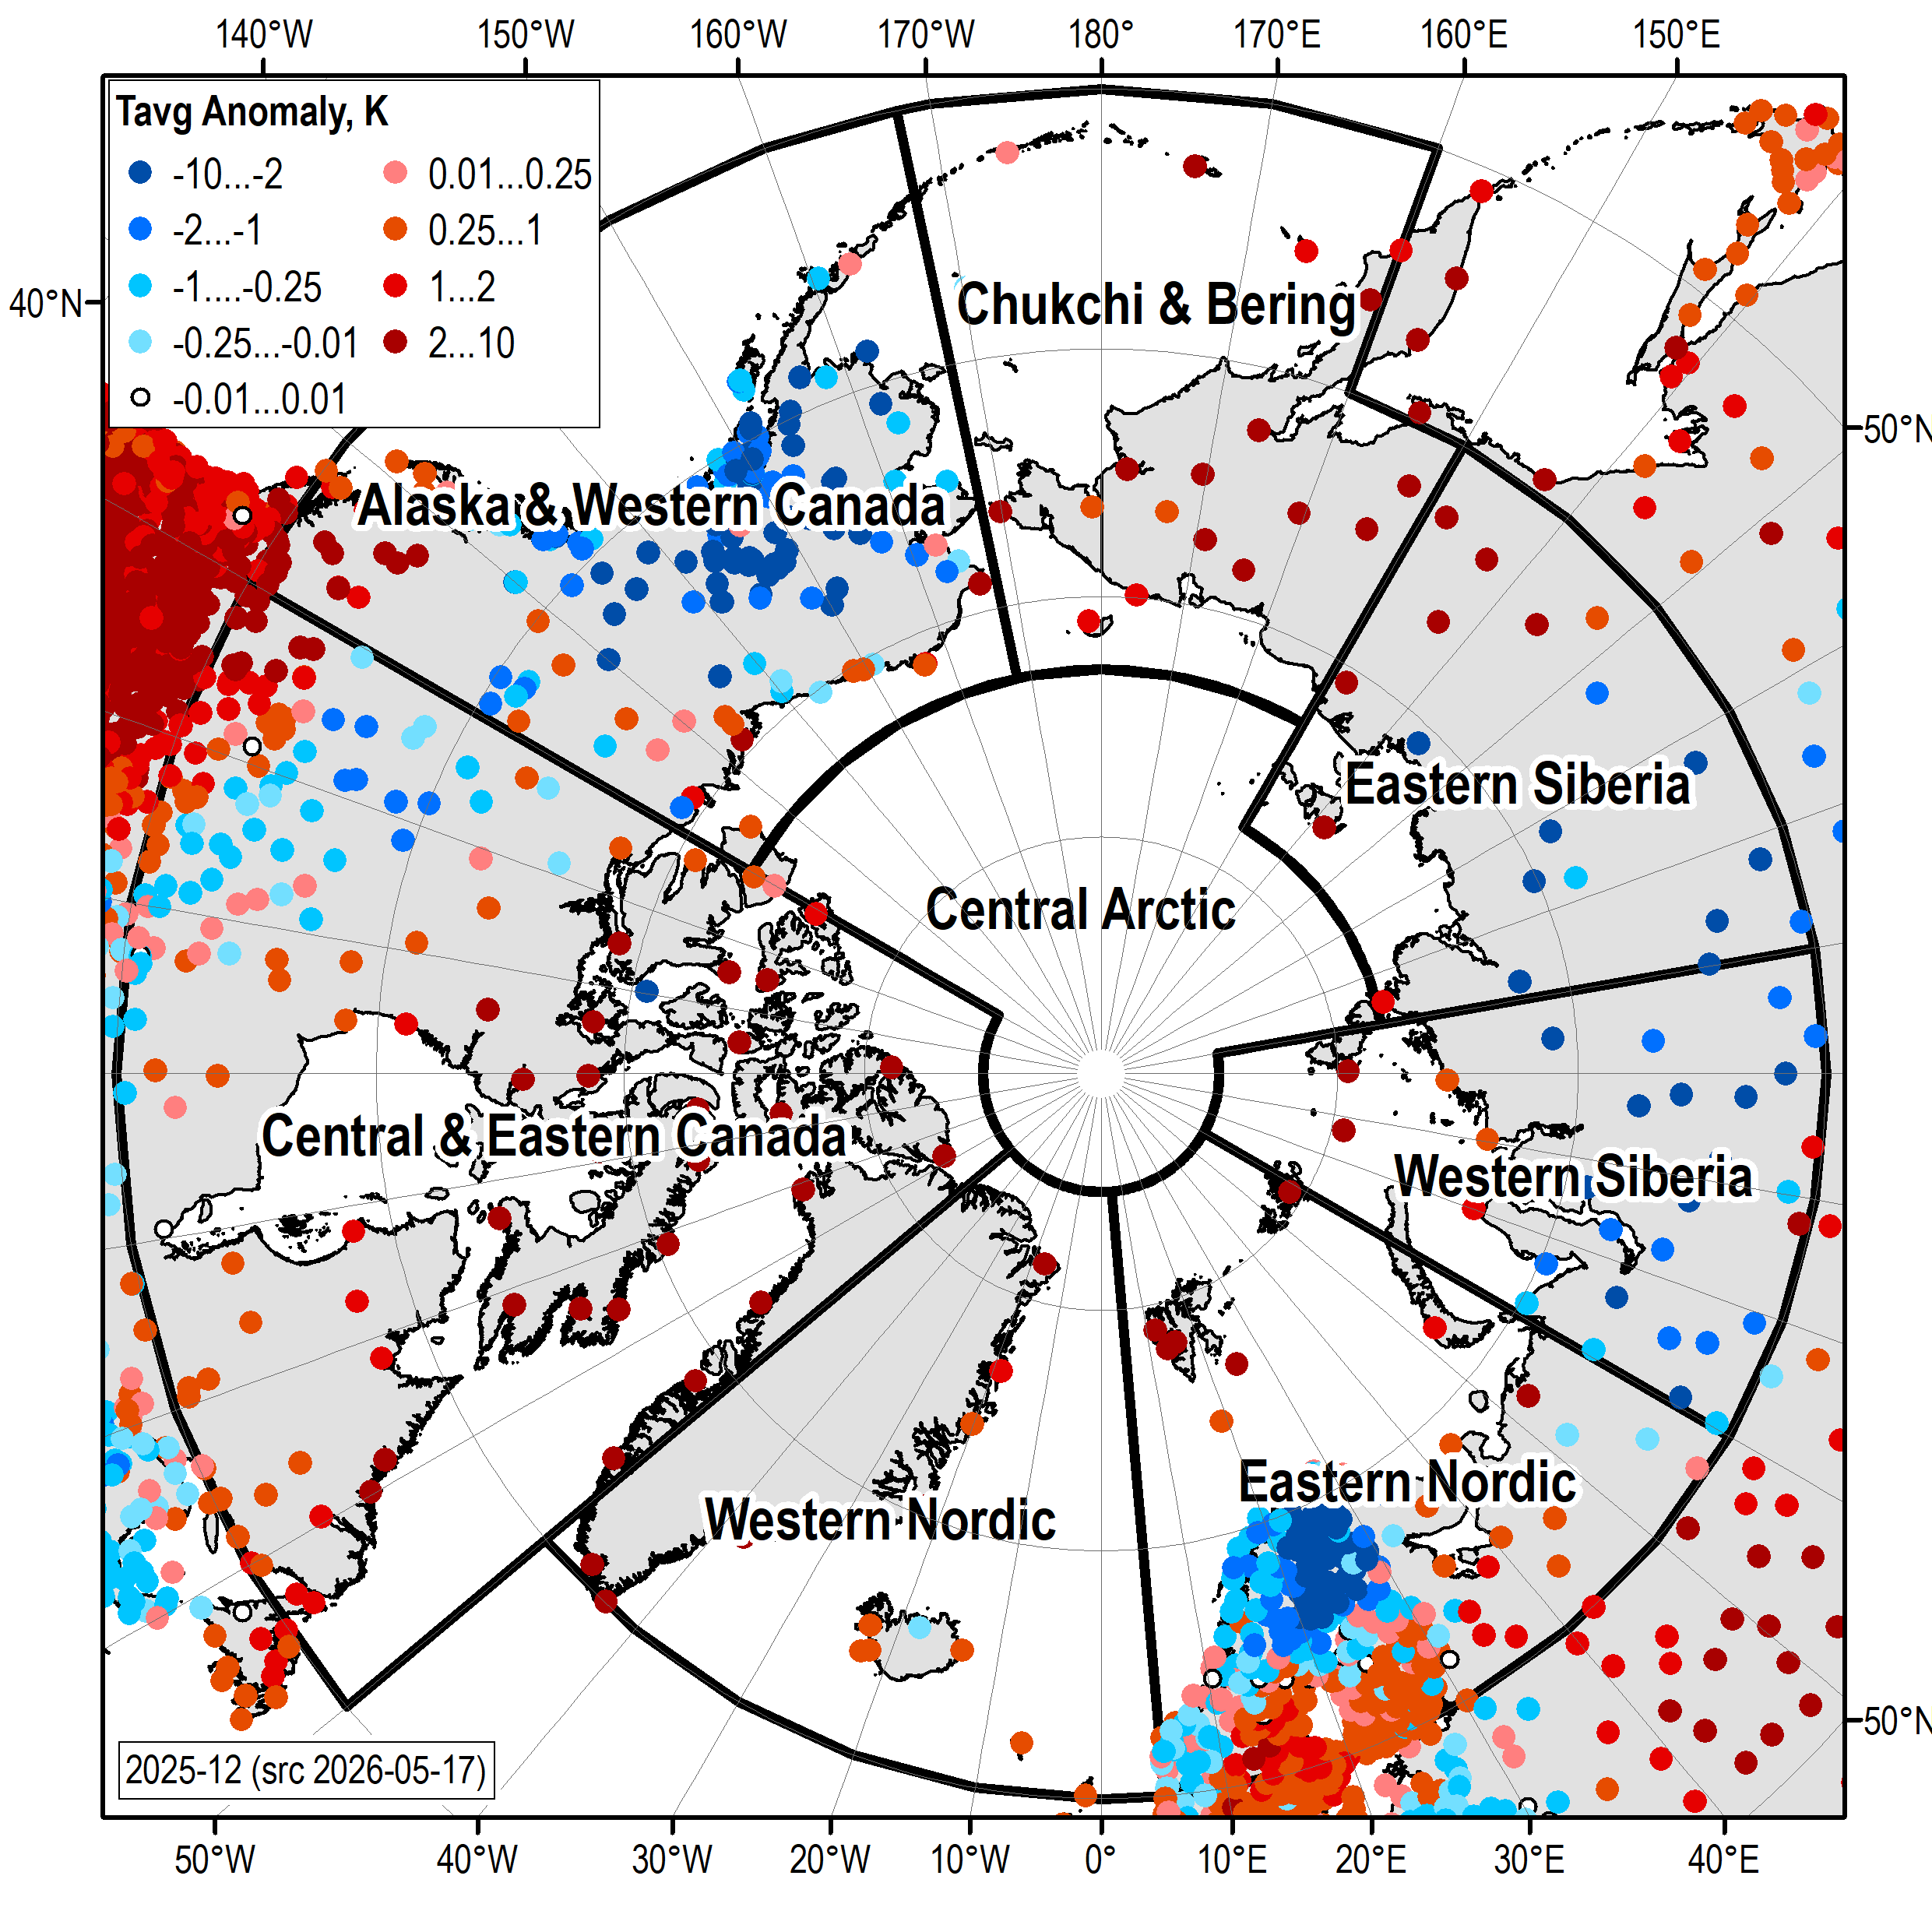 | 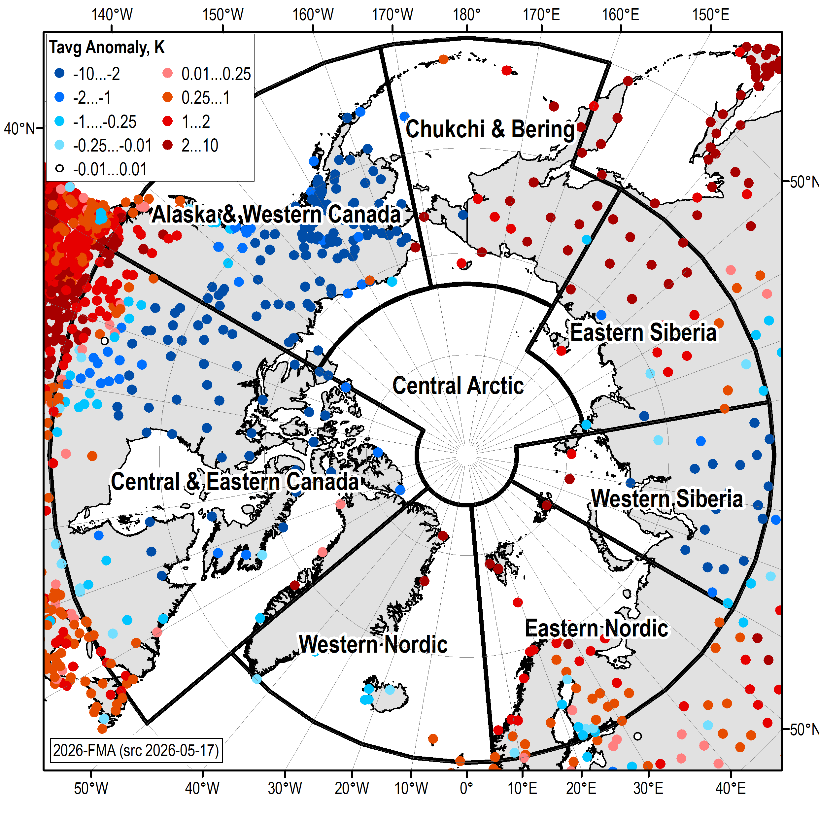
April 2026 | NDJ 2025/2026 | FMA 2026

Figure 4b: Surface air temperature (2m, °C) monthly and seasonal anomalies relative to 1991-2020 period for October 2025 – April 2026. Data source: WMO GTS, graphics produced by AARI.

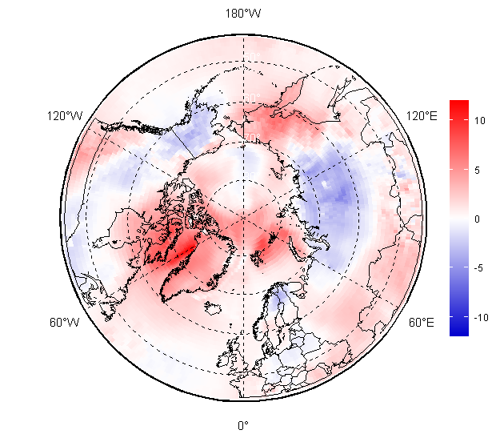 | 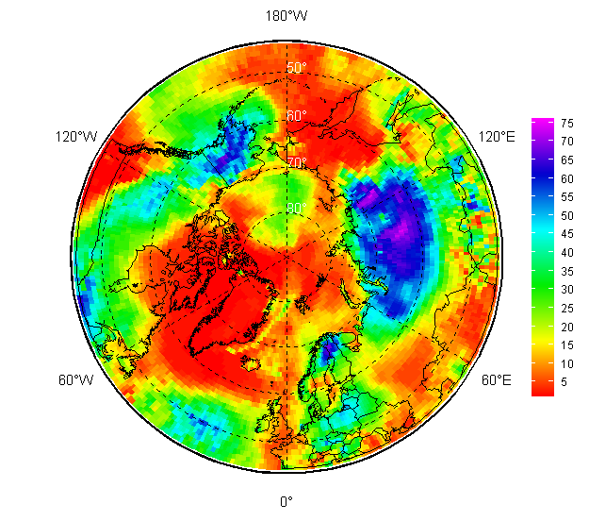
November 2025 – January 2026 (NDF)
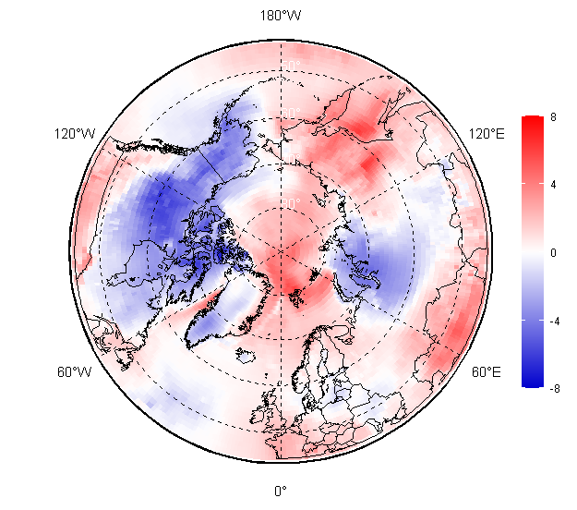 | 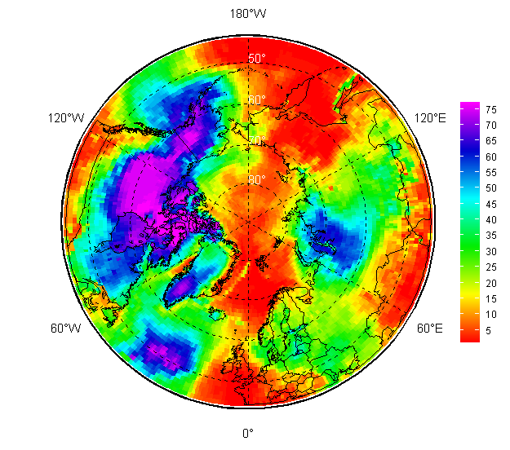
February – April 2026
Figure 4c: Winter – spring 2025/2026 SAT anomalies, left (ref. 1991-2020), and ranks, right (ref. 1950-2025/2026). Maps produced by the AARI. Data source: CCCS ERA5

Table 1 – Surface air temperature anomalies (reference period 1991-2020) and consecutive ranks in brackets (reference period 1950-2025/2026) for October 2025 – April 2026 by the ArcRCC-N regions based on observations at polar stations
Arctic region / period | Western  Nordic | Eastern  Nordic | Western  Siberia | Eastern  Siberia | Chukchi & Bering | Alaska &  Western  Canada | Central &  Eastern  Canada | Arctic
Oct | +0.58(17) | +2.28(04) | +1.69(16) | +0.81(19) | -1.14(38) | +2.68(04) | +3.18(01) | +2.53(01)
Nov | -0.47(43) | +0.52(27) | +0.97(25) | -1.87(44) | -0.29(23) | +2.61(17) | +3.31(03) | +1.75(04)
Dec | +2.24(08) | +2.78(08) | -1.33(46) | +1.58(21) | +8.97(01) | -4.37(69) | -2.86(56) | +0.17(16)
Jan | +0.29(26) | -4.31(63) | -2.53(48) | -0.76(34) | +6.29(03) | -0.01(41) | +1.80(15) | -1.22(40)
Feb | -2.66(66) | -4.05(63) | -2.97(56) | +0.91(22) | +3.95(09) | -1.42(47) | +0.95(24) | -1.59(40)
Mar | +0.81(20) | +5.08(01) | -4.04(58) | +4.00(05) | +5.00(02) | -5.34(76) | -4.13(68) | -1.05(39)
Apr | +1.42(13) | +1.43(04) | +0.72(23) | +0.49(20) | +2.69(06) | -0.08(32) | -2.66(68) | -1.43(42)
Nov-Jan | +0.67(18) | -0.31(29) | -0.92(43) | -0.19(30) | +5.00(03) | -0.56(44) | +0.60(17) | +0.24(17)
Feb-Apr | -0.55(41) | -1.87(54) | -1.42(33) | +1.93(08) | +3.97(03) | -2.57(69) | -1.96(58) | -2.15(56)

Verification of winter-spring 2025/2026 forecast
The FMA 2026 temperature forecast was verified by objective comparison between the forecast (Figure 5, left) and ERA5 reanalysis (Figure 5, right), region by region with results summarized in Table 2. The verification score represents the percentage of correct forecasts. It compares the forecasted and observed categories (above normal, near normal, or below normal temperature or precipitation) without considering the forecast probabilities associated with each category. In other words, only the most likely category is evaluated. This deterministic metric indicates the percentage of correct forecasts over the selected region.

Against ERA5 reanalysis (Figure 5, right): above normal temperatures were mostly accurately forecasted for the Western and Eastern Nordic (60% and 78%), Eastern Siberia (55%) and Chukchi and Bering (60%). Forecasts were not correct in the Alaska and Western Canada (0%), Central and Eastern Canada (7%) and Western Siberia (16%) regions. Considering all Arctic regions (60-90deg) the objective score is 55%. Similar results, although with some differences, are found when evaluating the MME against alternative reanalysis datasets, such as CFSR (Table 2). Across most Arctic regions, differences in skill estimates between the two reanalysis datasets are generally below 10%. The main exception occurs over the Siberian regions, where considerably larger differences are evident, suggesting increased uncertainty associated with the underlying reanalysis datasets.
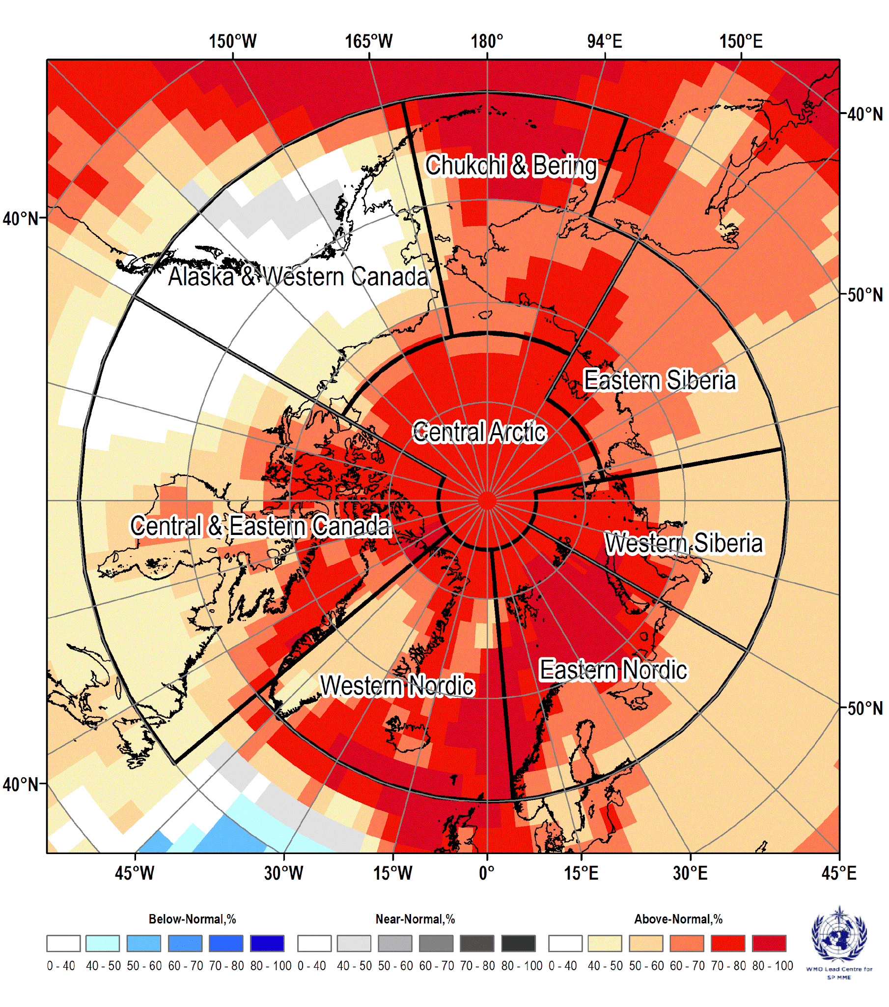 | 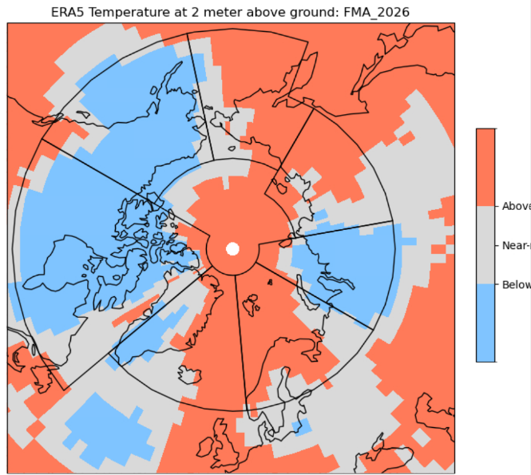
Figure 5: (left) Multi-model ensemble (MME) probability forecast (published on 2026-01-15) for surface air temperature at 2m (left) for February - April 2026. Three categories: below normal (blue), near normal (grey), above normal (red); no agreement amongst the models is shown in white. Source: www.wmolc.org. (Right): ERA5 reanalysis for air temperature for February - April 2026.

Table 2 – Objective comparison of the surface air temperature anomaly for FMA2026 of the MME probabilistic forecast, ERA5 and CFSR reanalysis. Percent correct (PC) skill score (%).
Region PC (against ERA5),% PC (against CFSR), %
Alaska & Western Canada 0 1
Central & Eastern Canada 7 17
Western Nordic 60 65
Eastern Nordic 78 86
Western Siberia 16 36
Eastern Siberia 55 95
Chukchi & Bering 60 51
Arctic 60-90 55 63

Outlook for summer 2026
For the June-July-August 2026 period, there is a probability of 50% or more that temperatures will be above normal in most of the regions across the Arctic (Figure 6, bottom right map: red areas; Table 2). The highest probabilities for an above-normal summer (60-80% or more) are in Western and Eastern Nordic, Western Siberia (Figure 6: dark red areas; Table 3). Below normal temperatures are expected for areas south of Greenland Sea, Alaska Bay with probability 40-60% (Figure 6, bottom right map: light blue areas; Table 2).

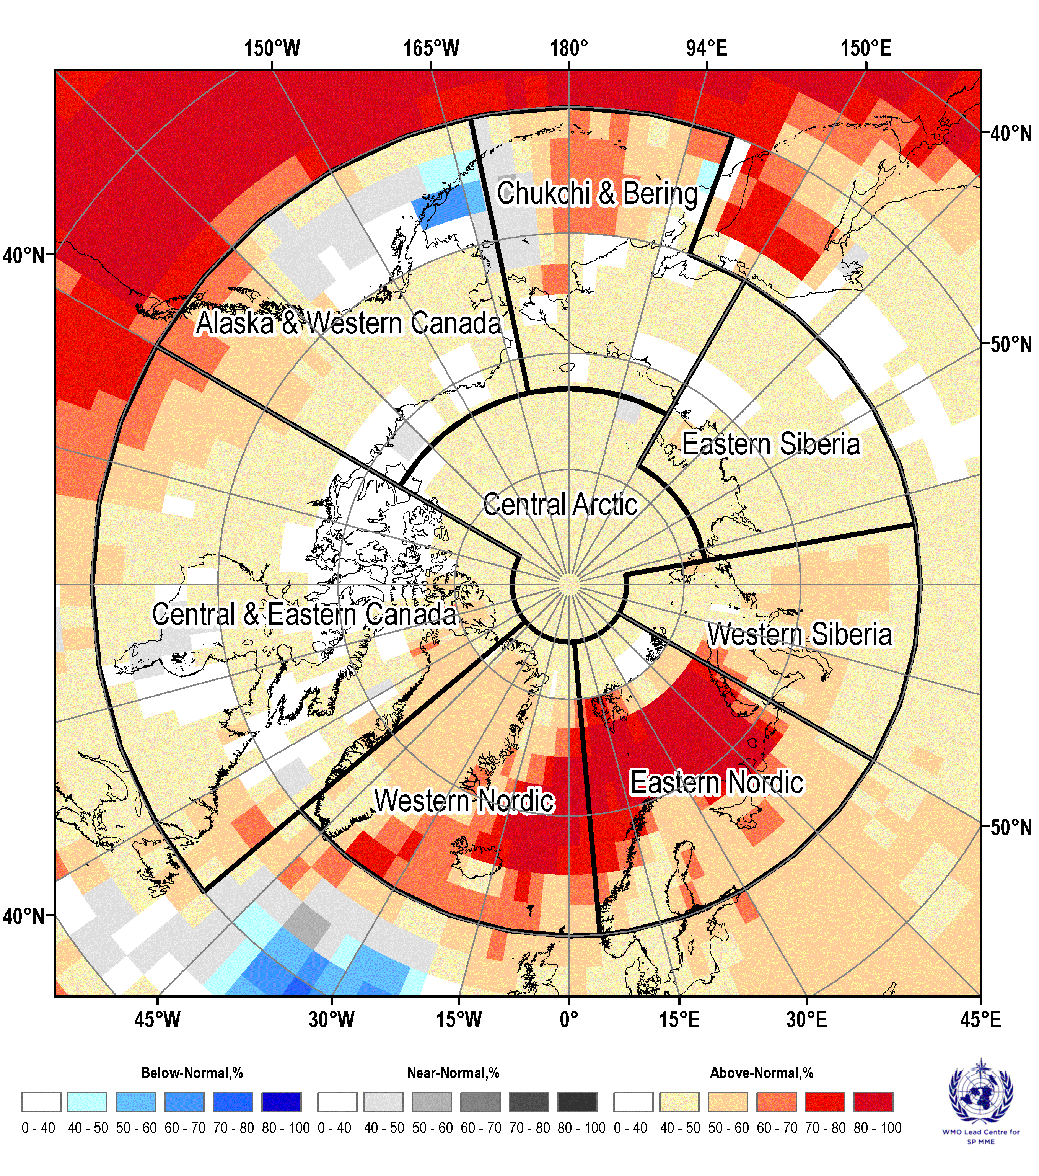 | 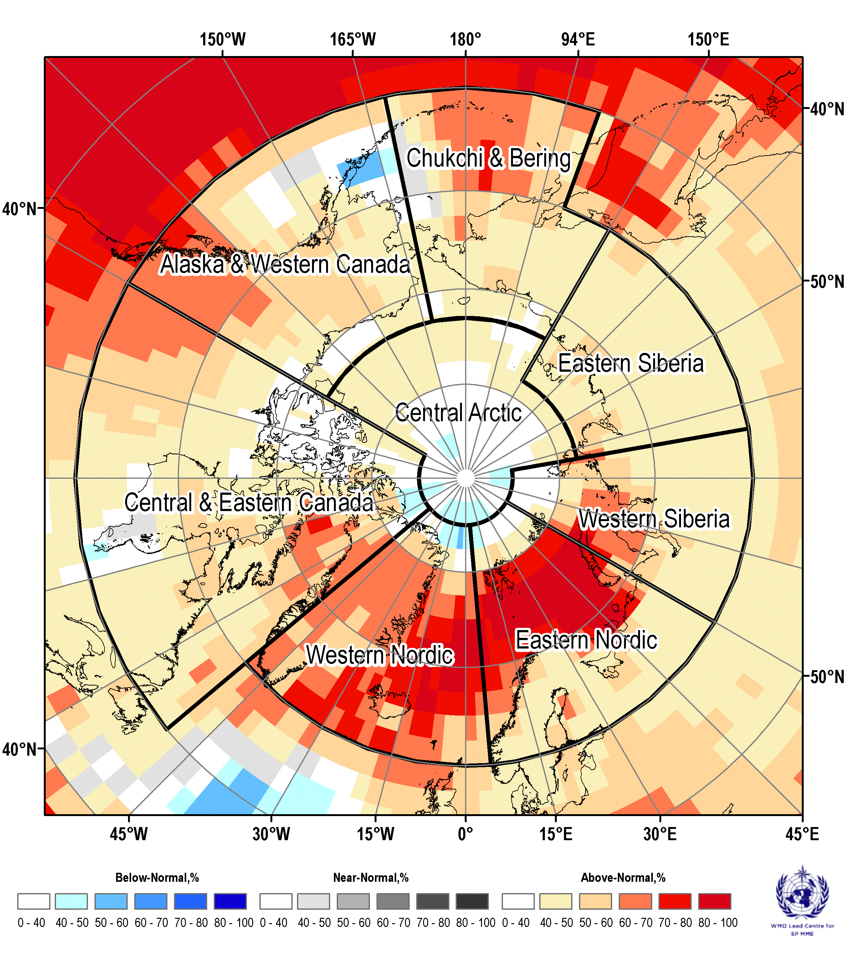
June 2026 | July 2026
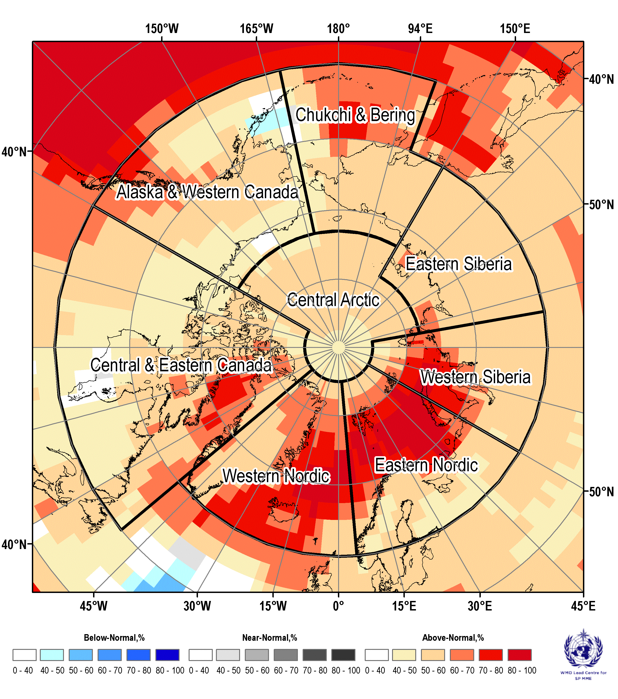 | 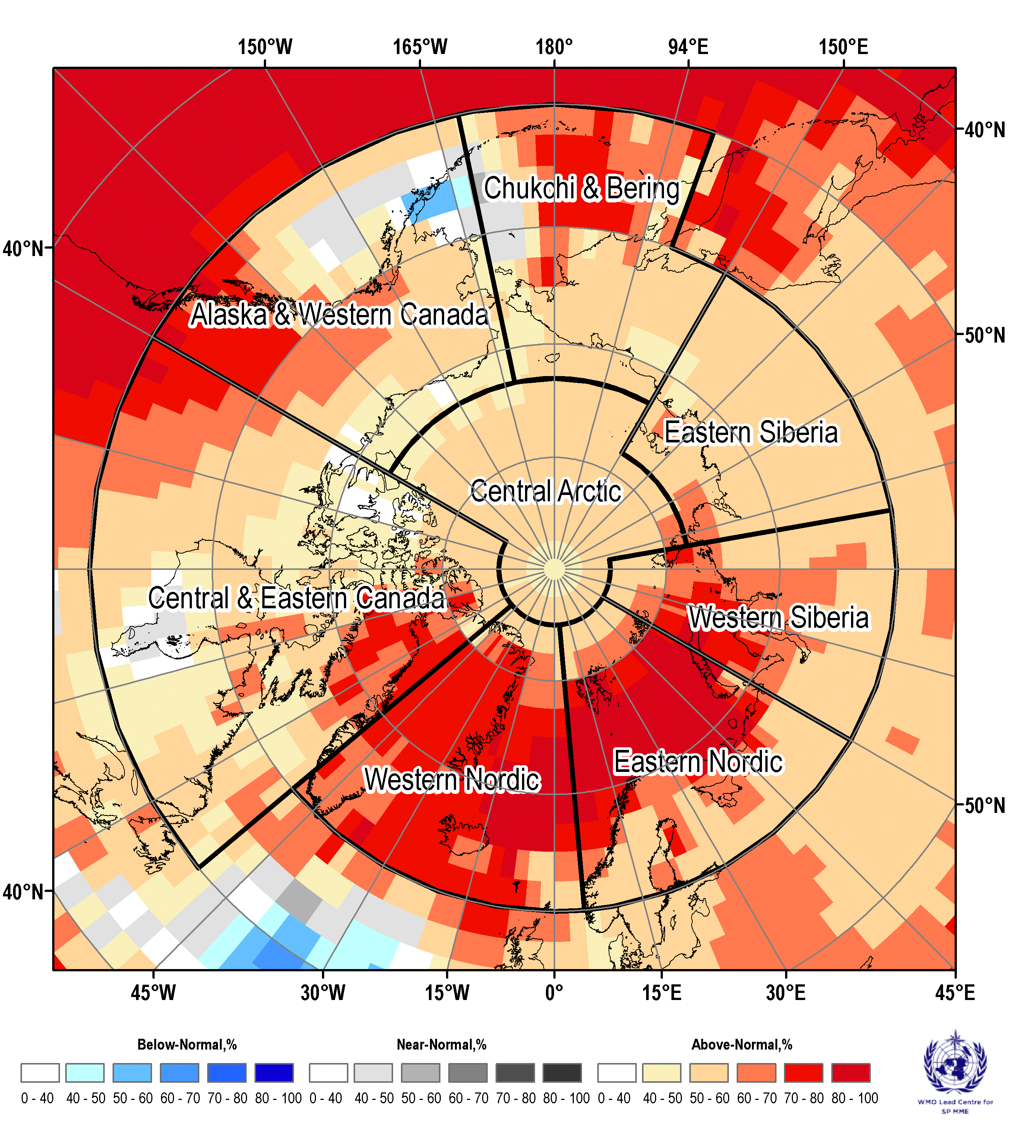
August 2026 | JJA 2026
Figure 6: Multi model ensemble 2-meter temperature probability forecast for June, July, August 2026. Redder color indicates higher probability for above normal temperature, bluer color indicates higher probability for below normal temperature, grayer color indicates higher probability for near-normal temperature. White color indicates no agreement amongst the models. Source: www.wmolc.org.

Table 3 – June, July, August 2026 outlook: Arctic regional forecasts for surface air temperature
Arctic Region | MME Temperature  Forecast Agreement | MME Temperature  Forecast
Alaska and Western Canada | Low (western and marine part), moderate to high (eastern part) | Above normal with exception of below normal for Gulf of Alaska and normal for southern marine parts and part adjacent to Bering Strait
Central and Eastern Canada | Moderate to low (continental part), high (eastern marine part) | Above normal for most of area, normal in parts of Hudson Bay and Labrador Sea
Western Nordic | High | Above normal
Eastern Nordic | Moderate (Fennoscandia and south-eastern part) to high elsewhere | Above normal
Western Siberia | High (Arctic Basin, Kara Sea and central part) to moderate in the southern part | Above normal
Eastern Siberia | Moderate | Above normal
Bering and Chukchi | Moderate (in Chukchi Sea and continental part), high in eastern Bering Sea, low to no agreement in Bering Strait | Above normal with exception of normal for Bering Strait and adjacent area of Bering Sea
Central Arctic | Low | Above normal
*: See non-technical regional summaries for greater detail

Precipitation

Summary for winter-spring 2025/2026
In general, during the whole season wetter (snowy) conditions occurred in parts of Canadian, Alaska, Eastern Siberia and Western Nordic regions (Figure 7). Drier conditions occurred in Eastern Nordic, parts of Alaska and Western Siberia.
Impacts of wetter/drier and colder/warmer weather conditions were reflected in the winter/spring 2025/2026 Arctic rivers discharge (Figure 7) though the frozen ground restricts direct effects - lesser drainage than normal was persistent for most of the rivers in particular during the November – January period with Yukon experienced greater discharge than normal. Close to normal river discharge was estimated for Lena and further eastward Siberian rivers.

NDJ 2025/2026 | FMA 2026
Surface precipitation
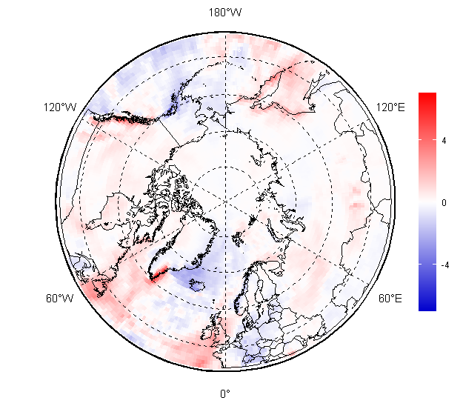 | 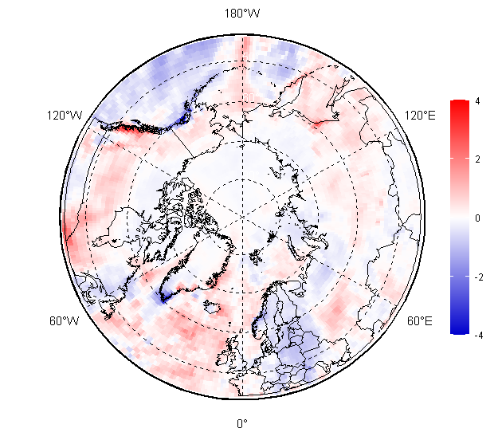
River discharge
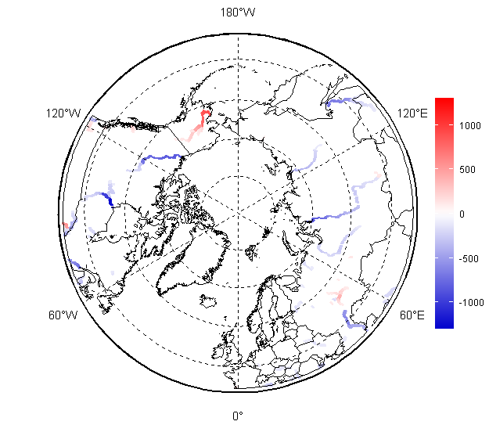 | 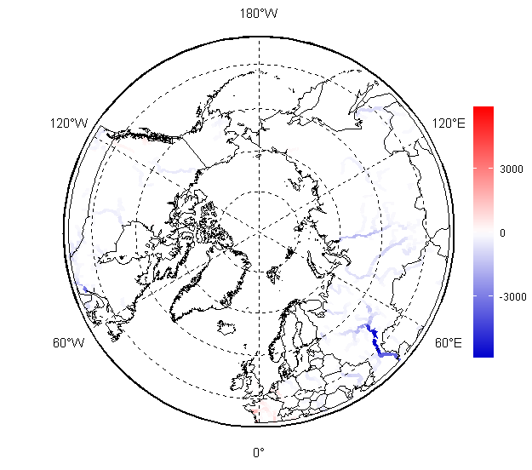
Figure 7 – November-January 2025/2026 and February – April 2026 surface precipitation (top) and river discharge (bottom) anomalies (ref. 1991-2020). Maps produced by the AARI. Data source: CCCS ERA5 and RA5-GloFAS.

Verification of winter-spring 2025/2026 forecast
The February – April 2026 precipitation forecast was verified by objective comparison between the forecast (Figure 8, left) and ERA5 reanalysis (Figure 8, right), region by region and summarized in Table 3.

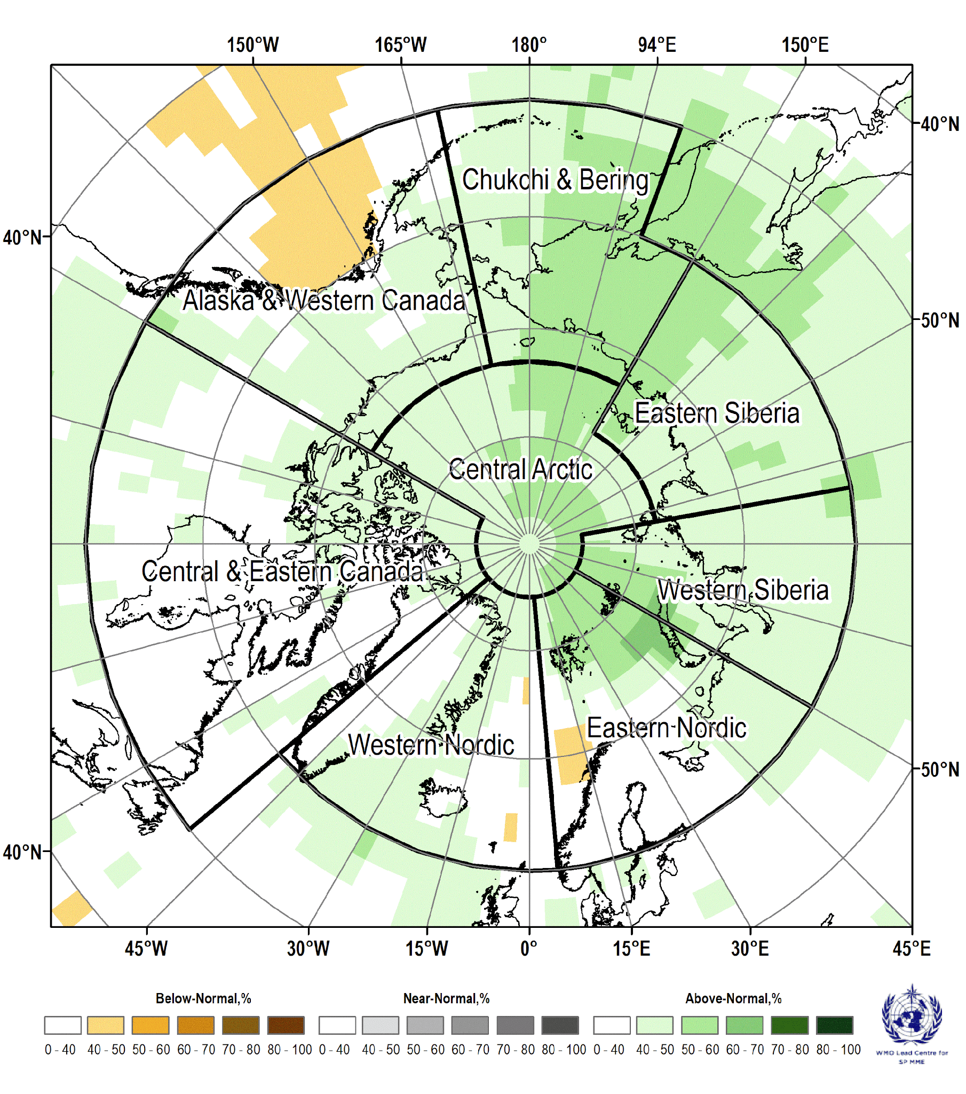 | 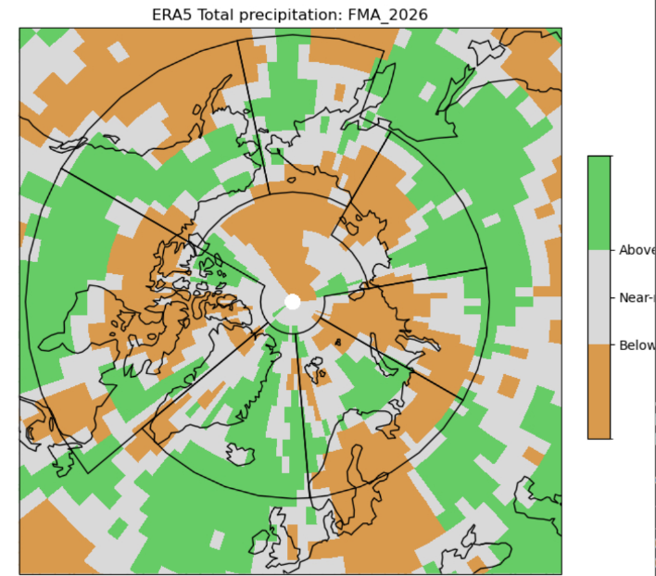
Figure 8: (left) Multi-model ensemble (MME) probability forecast (published on 2026-01-15) for surface precipitation for February - April 2026 (left). Three categories: below normal (orange), near normal (grey), above normal (green); no agreement amongst the models is shown in white. Source: www.wmolc.org. (Right): ERA5 reanalysis for precipitation for February - April 2026.

Table 3 – Objective comparison of the surface precipitation anomaly FMA MME probabilistic forecast and ERA5 reanalysis, %.
Region PC (against ERA5),% PC (against CFSR), %
Alaska & Western Canada 39 28
Central & Eastern Canada 13 14
Western Nordic 30 24
Eastern Nordic 14 7
Western Siberia 3 8
Eastern Siberia 29 62
Chukchi & Bering 19 12
Arctic 60-90 16 20

Overall, in the regions where MME forecast was decisive (where white color, indicating near-normal conditions, was absent), the forecast was not performant during the February – April 2026. (Figure 8). The forecast was at best for above normal precipitation for Alaska and Western Canada and Eastern Siberia regions though the scores remained low (39% and 29% respectively). Overall score for the Arctic was 16%.

Outlook for summer 2026
For the June – August 2026 period (figure 9 bottom right panel) over the largest part of the Arctic region, equal precipitation chances are expected which means that there is no intermodal agreement on the precipitation forecast (Figure 9: white areas; Table 3). Above normal precipitation (wetter conditions) with probability 40-50% (light green areas) is expected for Central Arctic, Greenland, marine areas south of Alaska and land part of Western Siberia. Below near precipitation with probability 40-50% (light orange areas) is expected for coastal areas of Western Canada and southmost parts of Central Canada.

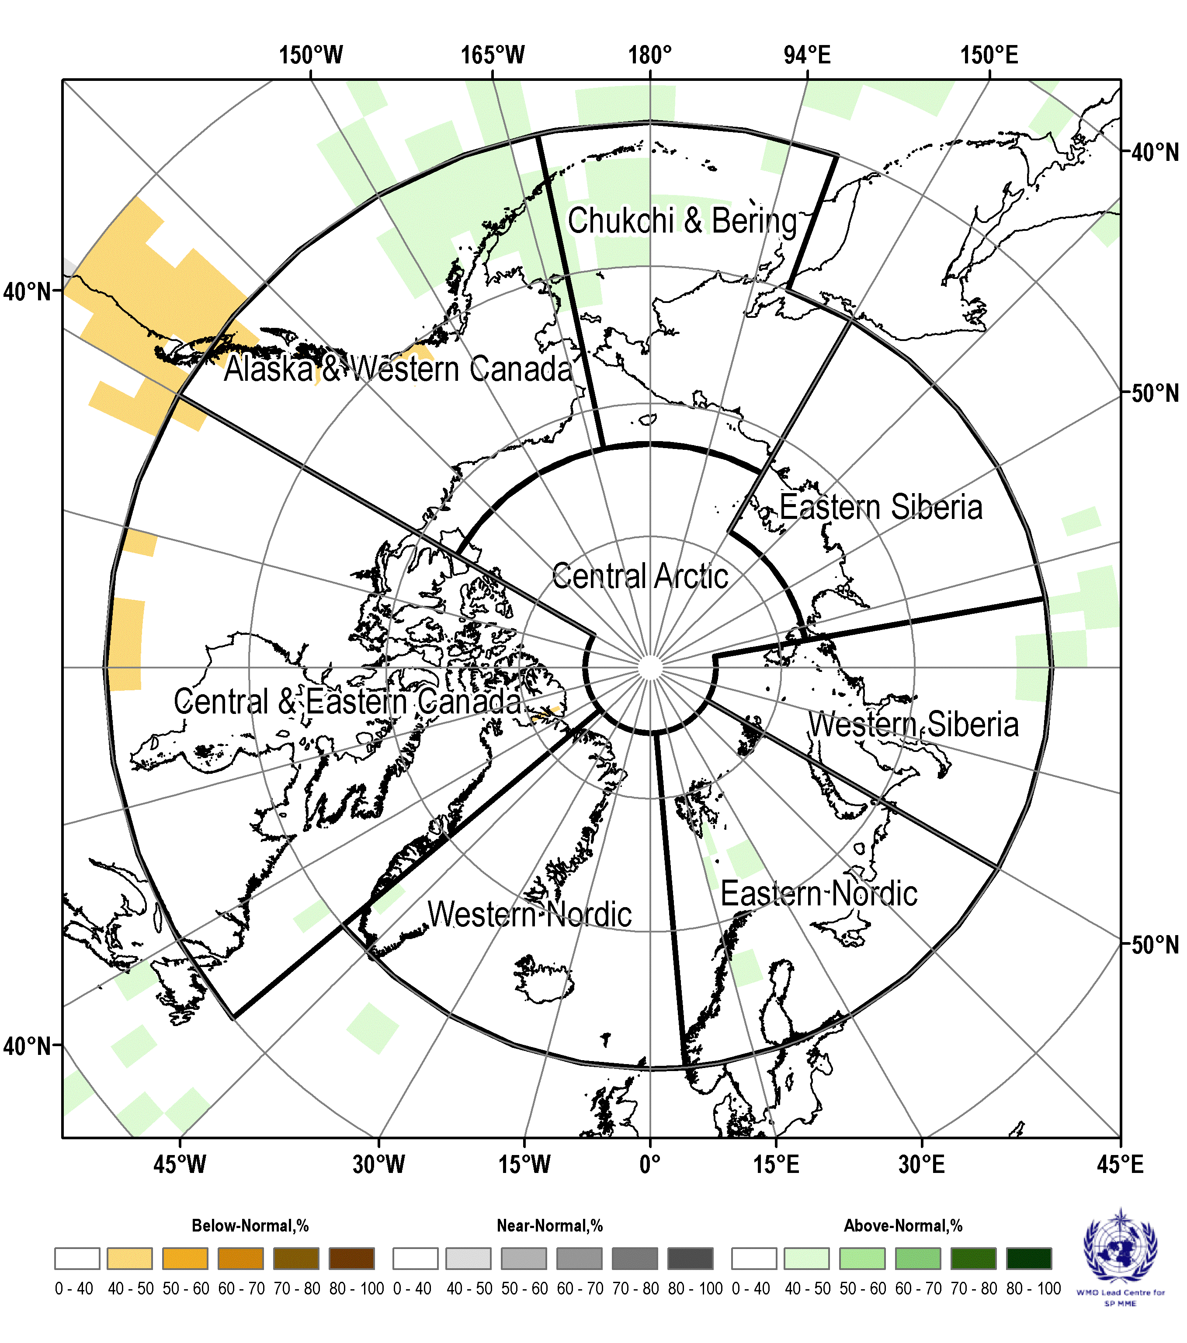 | 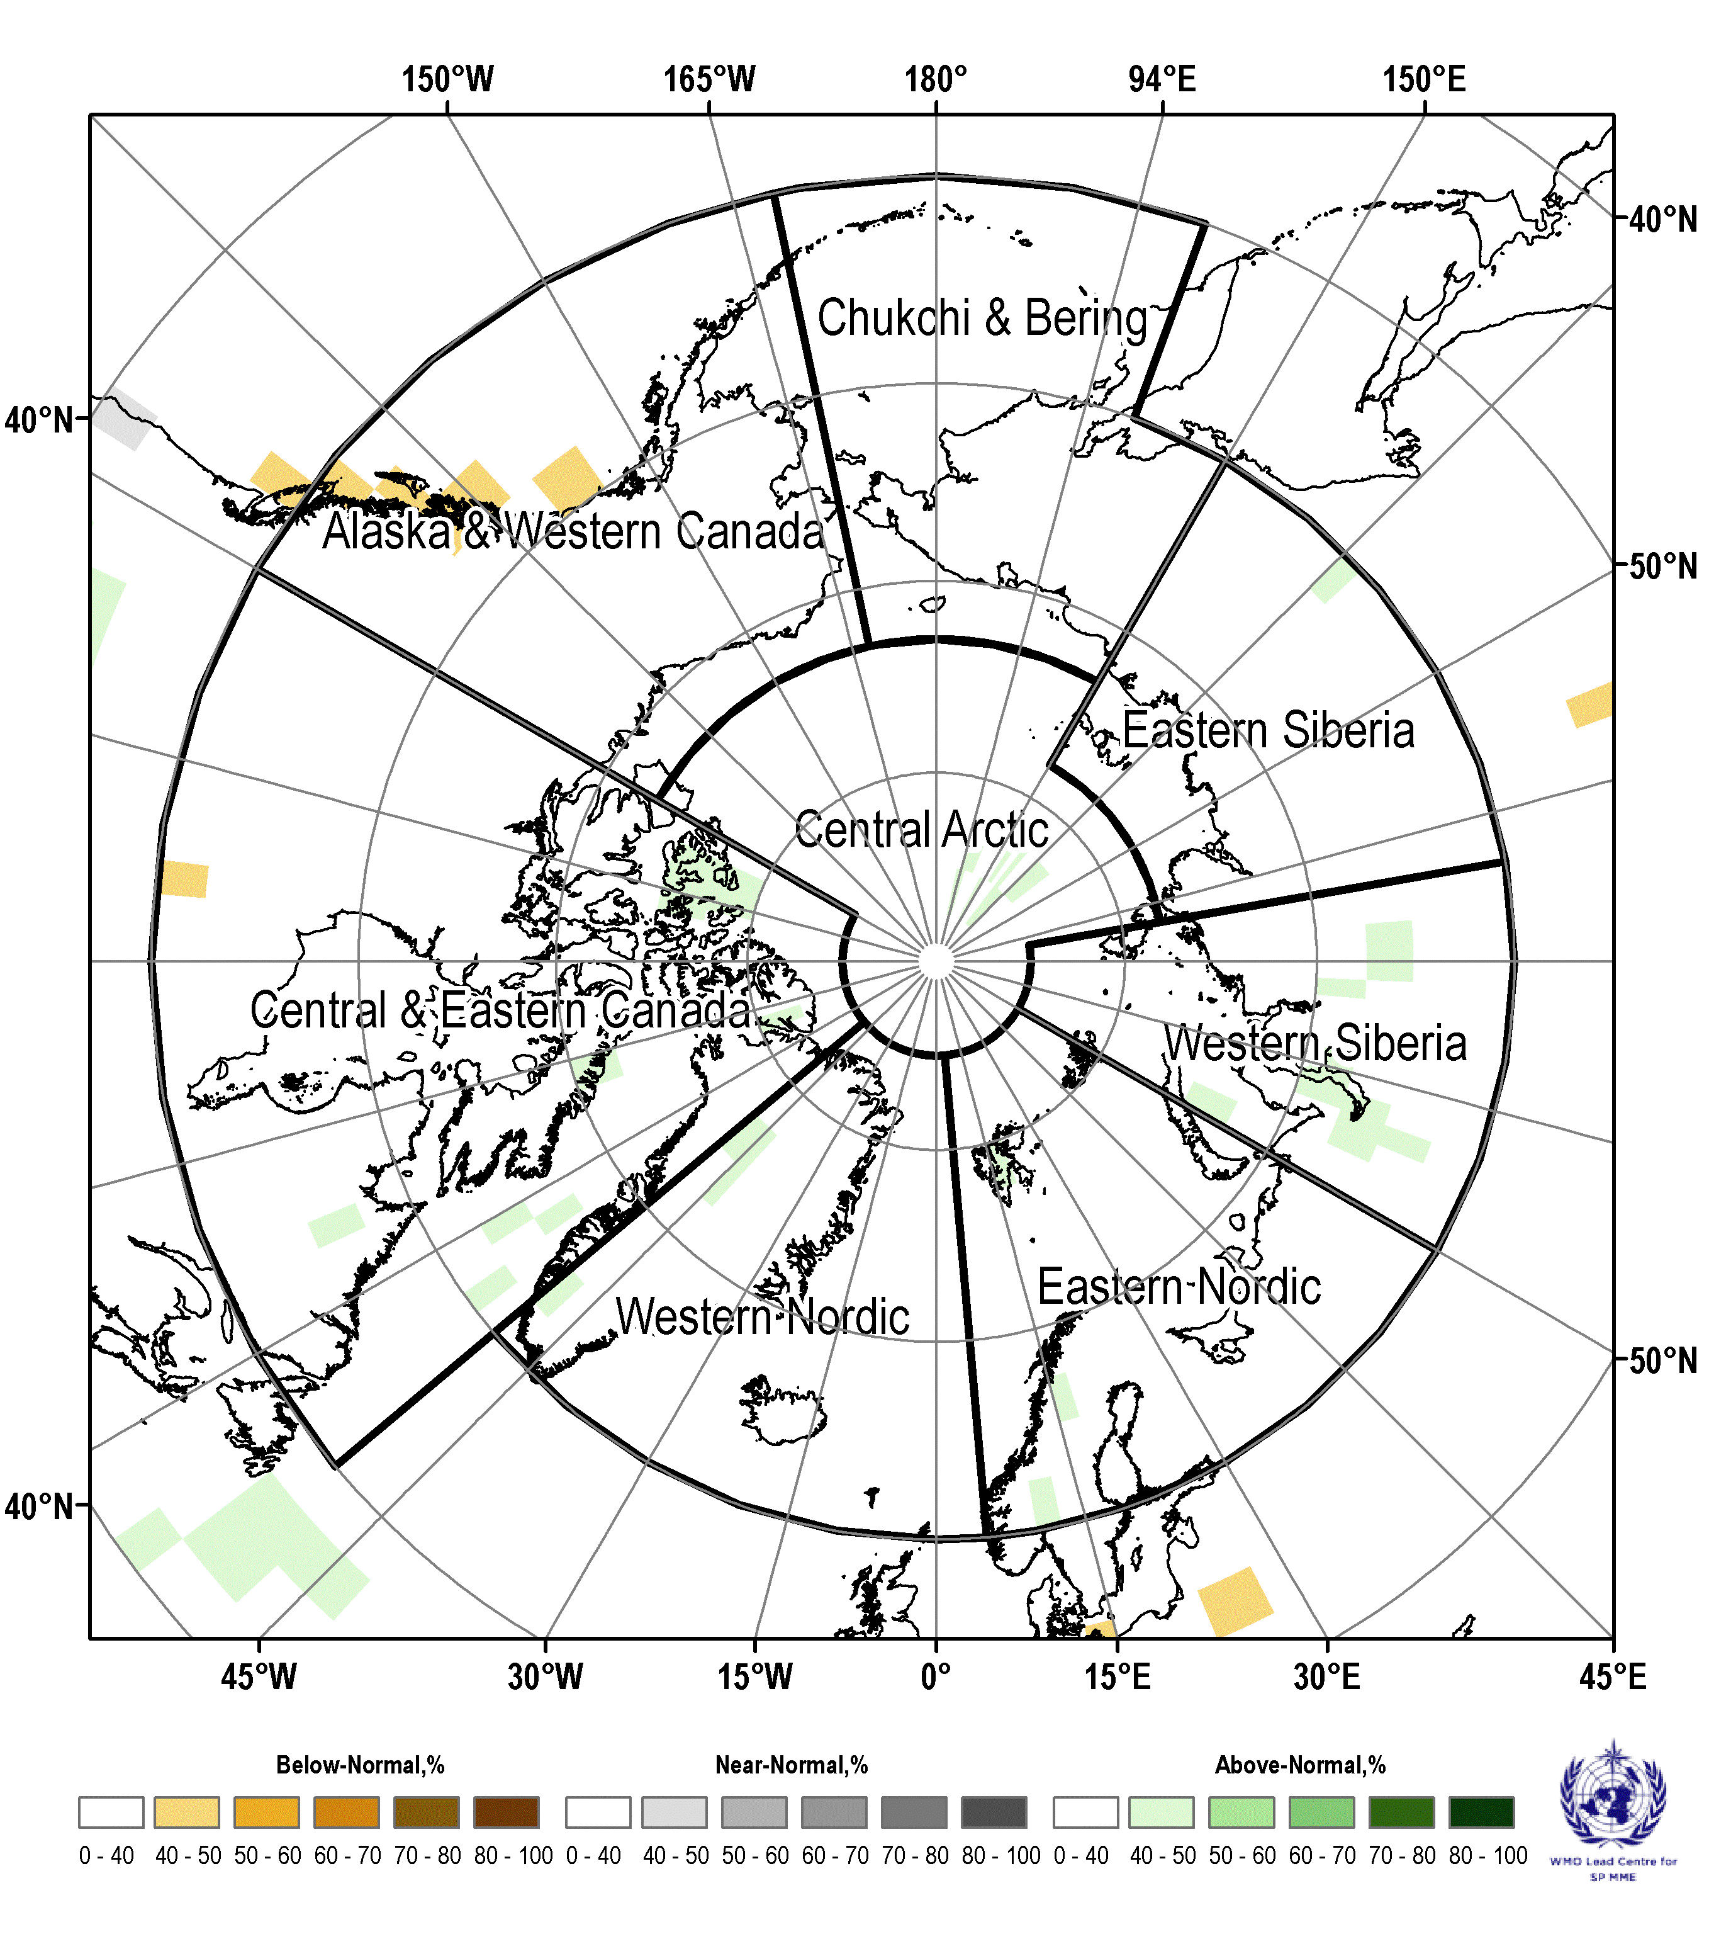
June 2026 | July 2026
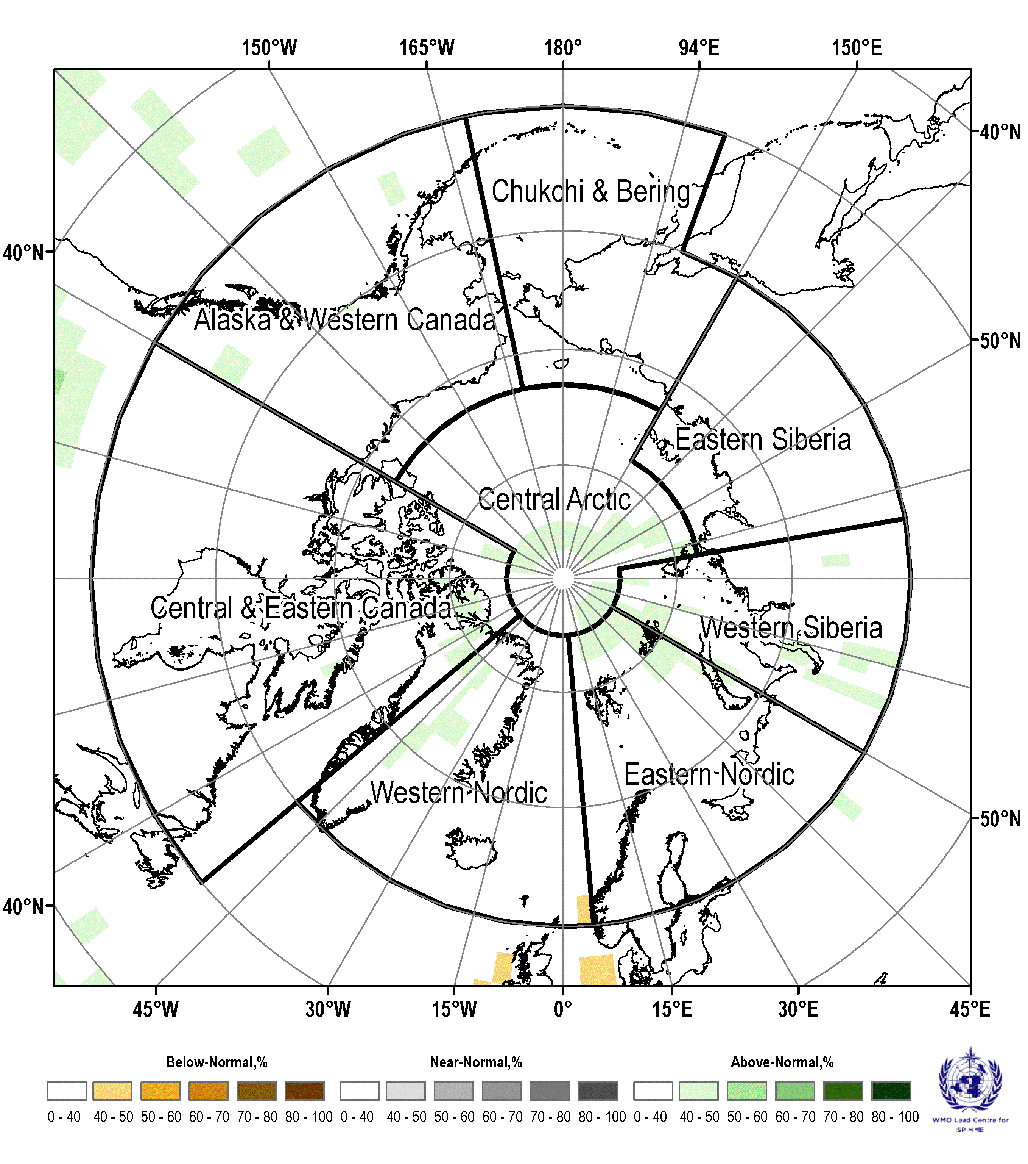 | 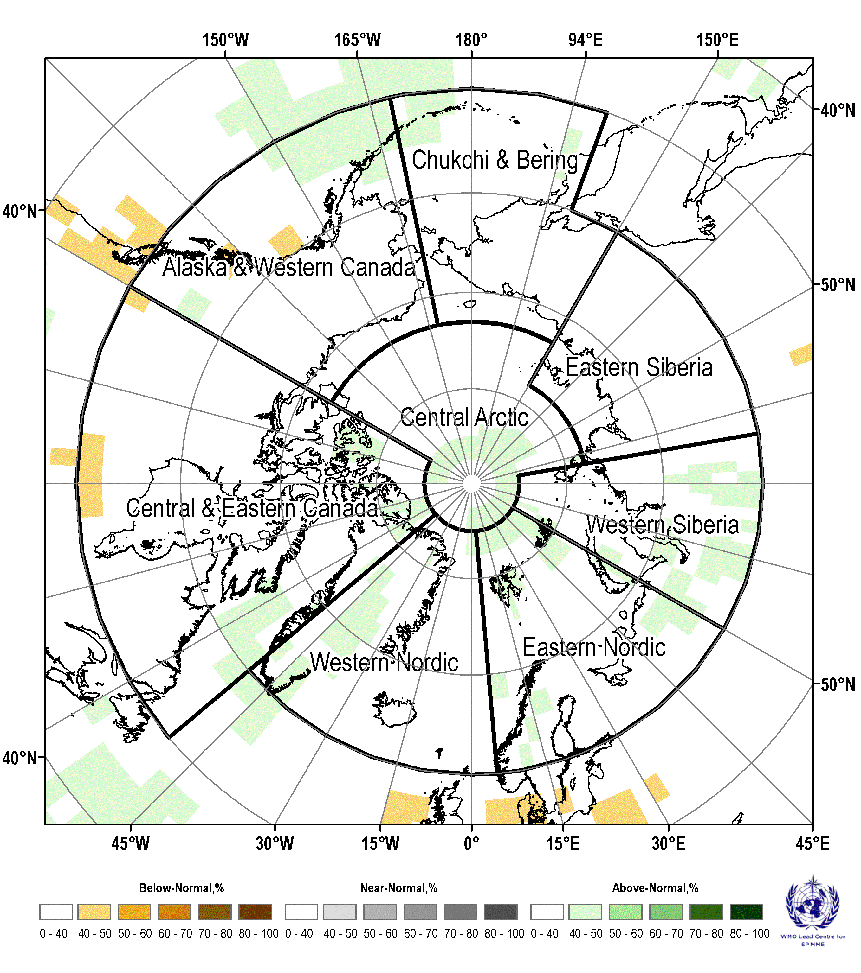
August 2026 | JJA 2026
Figure 9: Multi model ensemble probability forecast for surface precipitation for June, July, August 2026. Greener color indicates higher probability for above normal precipitation (wetter), brown color indicates higher probability for below normal precipitation (drier), grayer color indicates higher probability for near-normal precipitation, white color indicates no agreement amongst the models. Source: www.wmolc.org.

Table 4 – June, July, August 2026 outlook: forecasted Arctic precipitation by region
Region (see Fig.2) | MME Precipitation Forecast Agreement* | MME Precipitation Forecast
Alaska and Western Canada | Low | Above normal near Alaska Peninsula, below normal in south-western coastal areas, no model agreement for other areas
Central and Eastern Canada | Low | Above normal for Labrador Sea and parts of Canadian Archipelago, below normal in southern part, no model agreement for other parts
Western Nordic | Low | Mostly no model agreement, above normal over Greenland
Eastern Nordic | Low to moderate | Mostly no model agreement, above normal in the FJL and south-eastern areas
Western Siberia | Low | Above normal in the southern part, no model agreement in northern part
Eastern Siberia | Low | No model agreement
Chukchi and Bering | Low | Mostly no model agreement, above normal in south-western part
Central Arctic | Low | Above normal in North Pole region, no model agreement elsewhere
*: See non-technical regional summaries for greater detail

Polar Ocean

Summary for winter-spring 2025/2026
During the first part of the winter 2025/2026 higher 15 m upper ocean layer Heat Content (HC) was noticed in the eastern Bering, Barents, and in particular Hudson Bay and southern Greenland waters (Figure 10 top). Lower HC was noticed for western Bering, Chukchi Sea, southern part of the Sea of Okhotsk with somewhat neutral over other parts of the Arctic. Later in winter the HC was mostly neutral to 1993-2020 average for most of the Arctic with the lower HC for the western Bering Sea and higher for eastern Bering, Barents and Sea of Okhotsk.
Numerical models show for the current winter season both positive pH 2m anomalies for the Arctic Basin, Laptev, Chukchi Seas (Figure 10 bottom) and negative pH anomalies (acidification) for the Barents, parts of the Kara, East Siberian, Greenland Seas to the 1993-2020 period, which is in general similar to 2022-2024, the latter may point to acidification processes in the Barents, Greenland Seas though that need verification with ground-truth data.

15 m upper ocean layer Heat Content
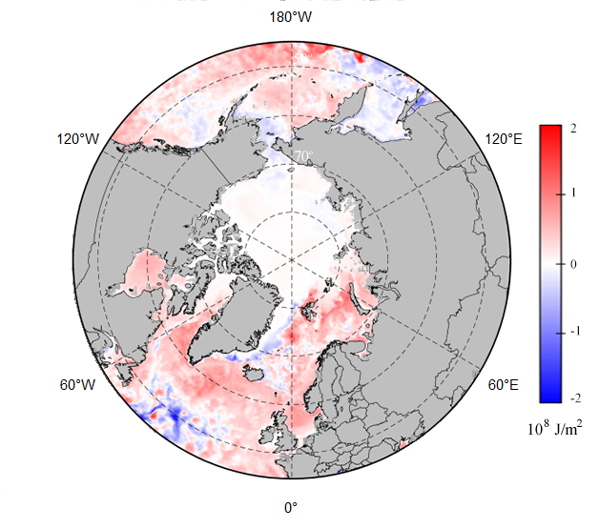 | 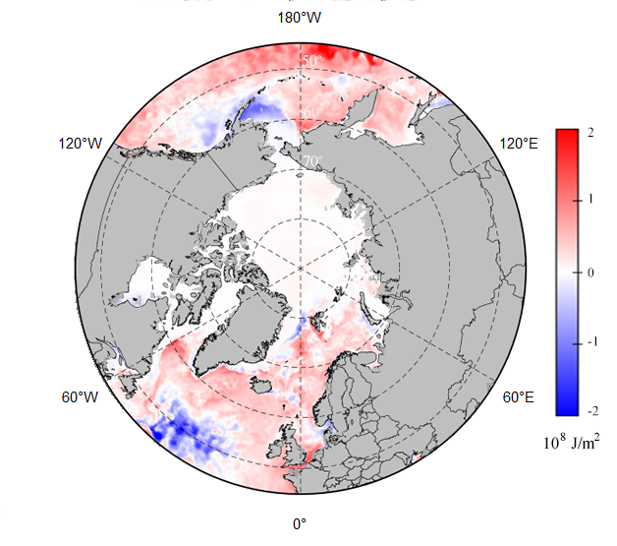
pH 2 meter layer
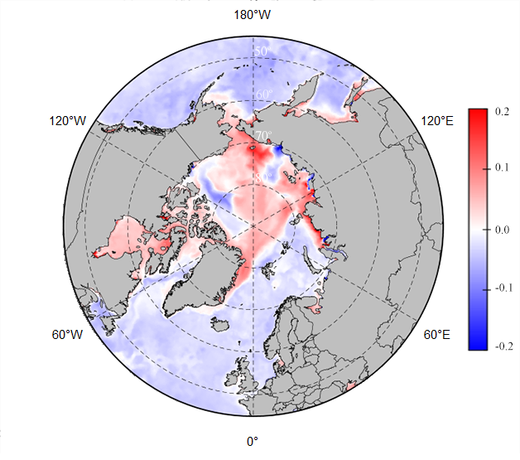 | 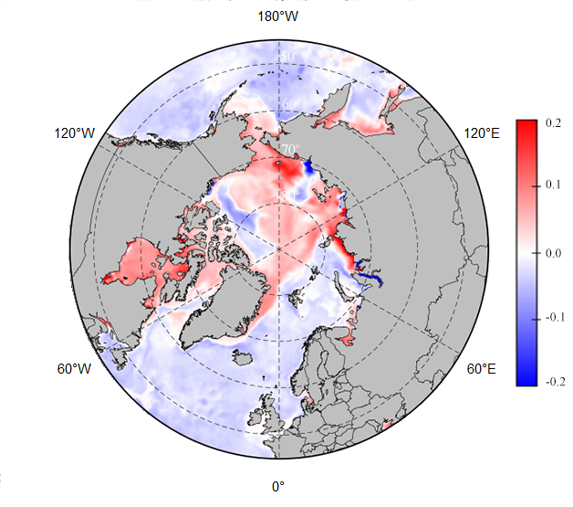
NDJ 2025/2026 | FMA 2026
Figure 10: November-January 2025/2026 (left) and February – April 2025 (right) upper 15 m ocean layer heat content (top) and pH 2m ocean layer (bottom) anomaly (ref. 1993-2020 period). Maps produced by the AARI. Data source: CCCS MEMS.

Sea-Ice

Summary for winter-spring 2025/2026
Prevailing positive ocean heat content (HC) anomaly during September – December 2025 for the Barents, Kara, Hudson Bay, Sea of Okhotsk slowed freezing processes in these regions. Oppositely, zero or negative HC anomalies in Laptev, ESS, Chukchi, Beaufort provided background for closer to normal freeze-up. Further in winter during FMA 2026 occurrence of general positive SAT anomalies over Barents Sea, Central Arctic, Baffin Bay, eastern Bering and Sea of Okhotsk slowed the ice growth, with negative SAT anomalies stimulating ice growth in the Kara Sea, Canadian Archipelago, western Bering Sea.

Maximum Arctic (Northern Hemisphere) winter 2025/2026 sea-ice extent was close to ~14.6 mln km² or 4-7th in row from 1979 and was reached near 13 March 2026 (Figure 11), which is close to climatic norm and earlier than previous year. Opposite to 2024-2025 the Bering Sea had ice extent though the Sea of Okhotsk had again extremely diminished ice cover.

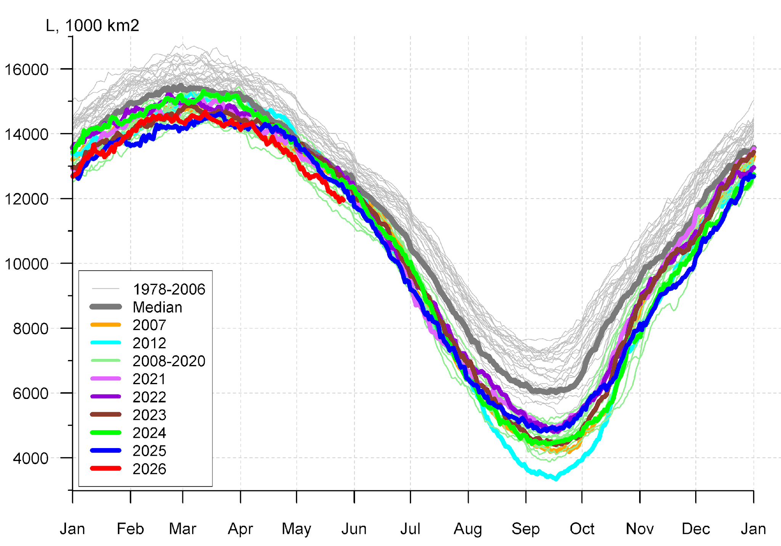  Arctic (Northern hemisphere) | 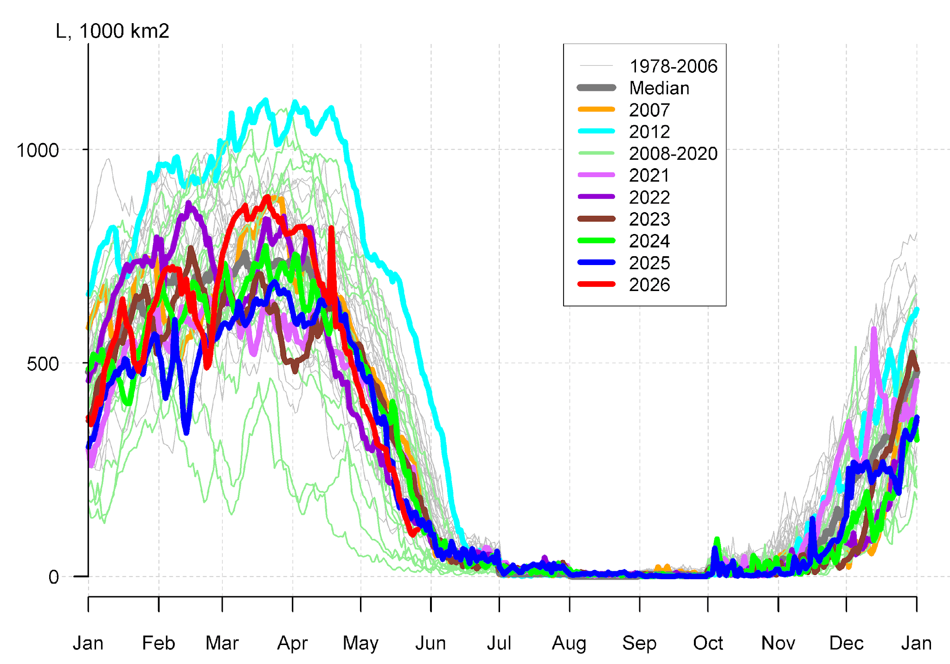
 | Bering Sea
 | 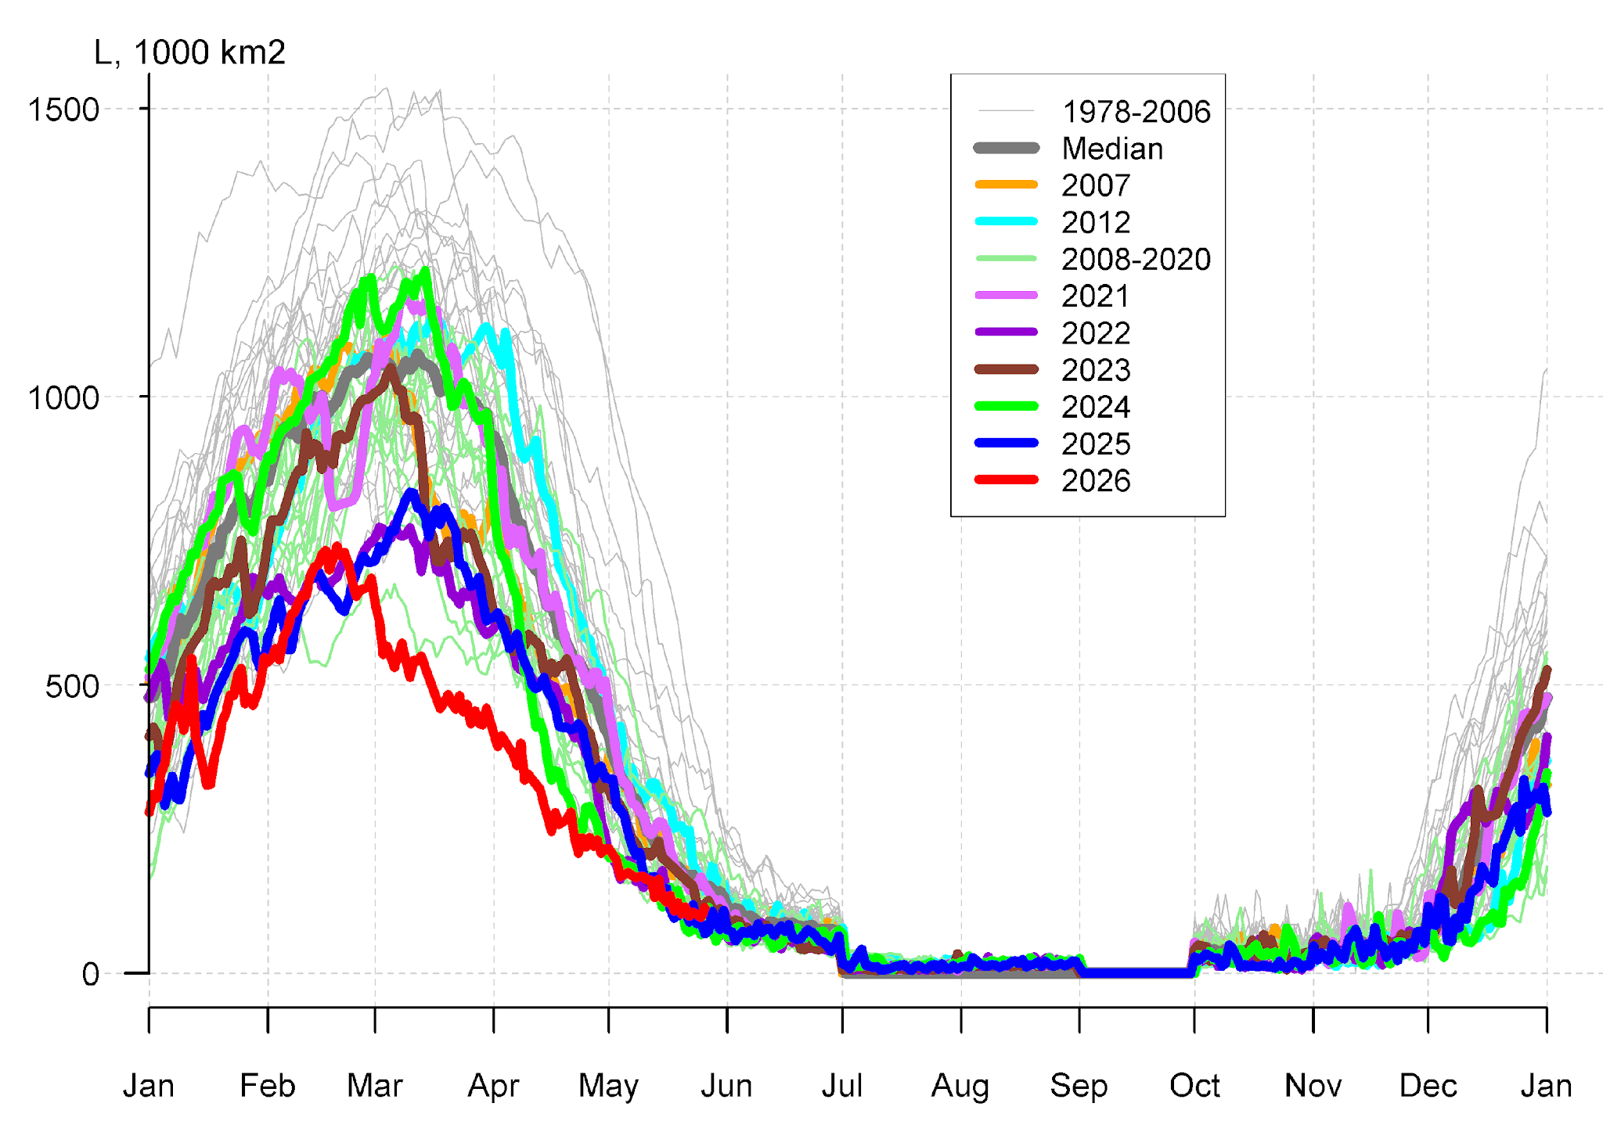
 | Sea of Okhotsk
Figure 11: Arctic (Northern Hemisphere), Bering and Sea of Okhotsk daily sea-ice extent for October 1978 - May 2026. Graphics produced by the AARI. Data source: NSIDC.

Special features of ice conditions in the Arctic during autumn – winter 2025/2026 included:
- similar as in 2024/2025 occurrence of residual and further up to the end of winter season the second-year ice in the parts of the Chukchi and East Siberian Sea (Figure 12) and close to normal autumn ice growth within eastern lanes of the NSR,
- close to decadal normal ice conditions in the Greenland and in late winter greater than 48-years median in the western Bering Sea but much lower-than-normal ice conditions in the Barents and in particular extremely low in the Okhotsk Seas (Figure 11).
- Cryosat-2 SIT measurements for past season show general SIT growth (relative to 2011-2026) along Transarctic drift area and in parts of Eurasian and Canadian Arctic (Figure 12) with negative SIT anomalies to the end of season for Greenland waters, Chukchi, ESS and Svalbard waters with sea ice volume estimates close to extreme 2025 values.

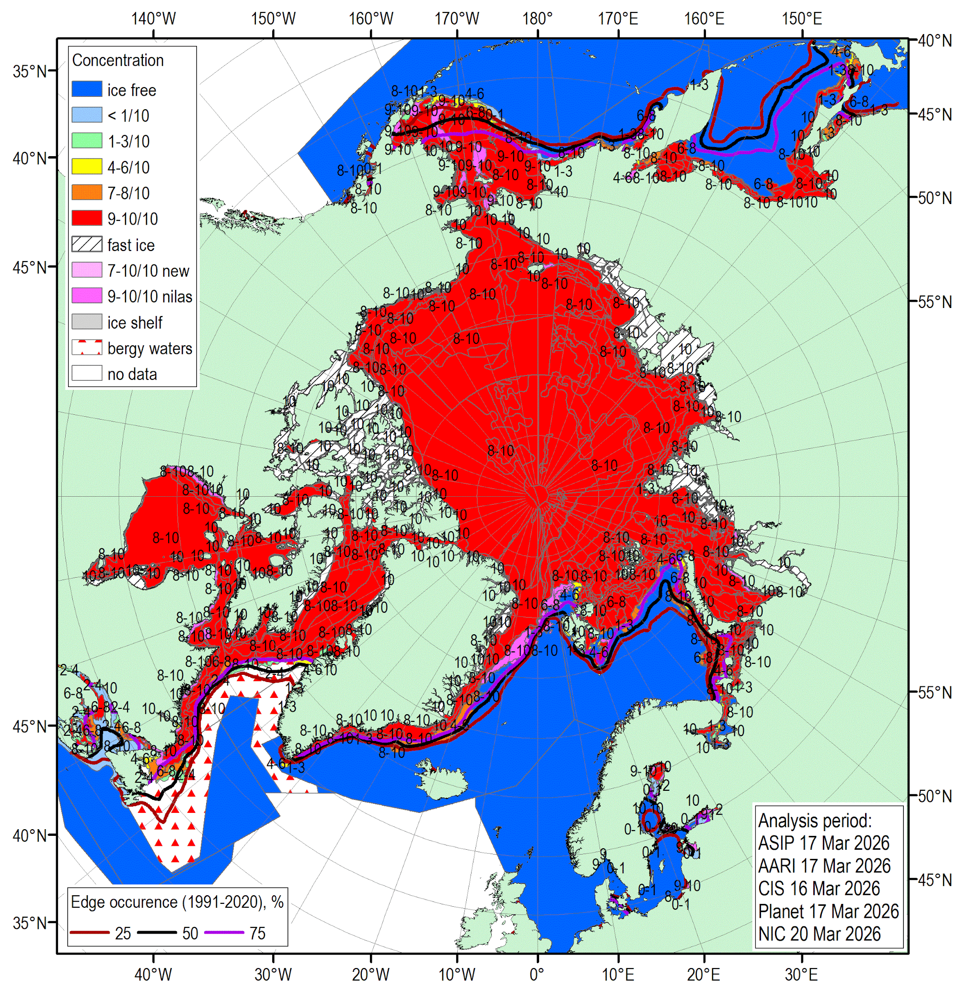 | 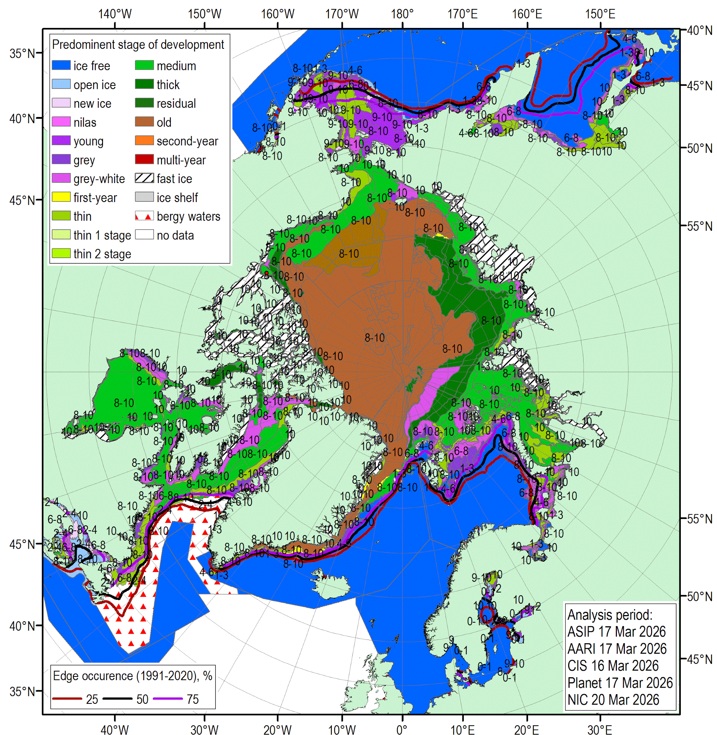
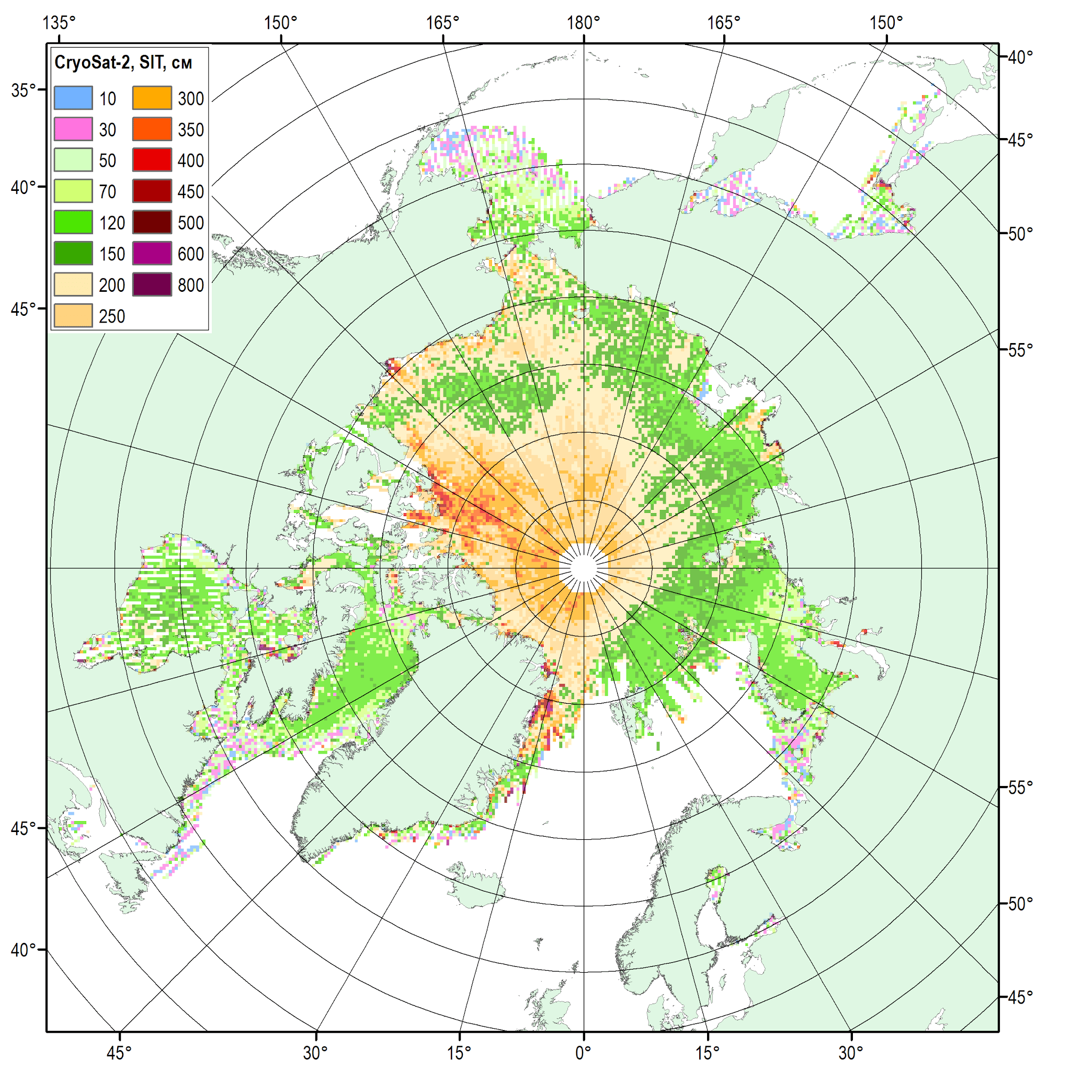 | 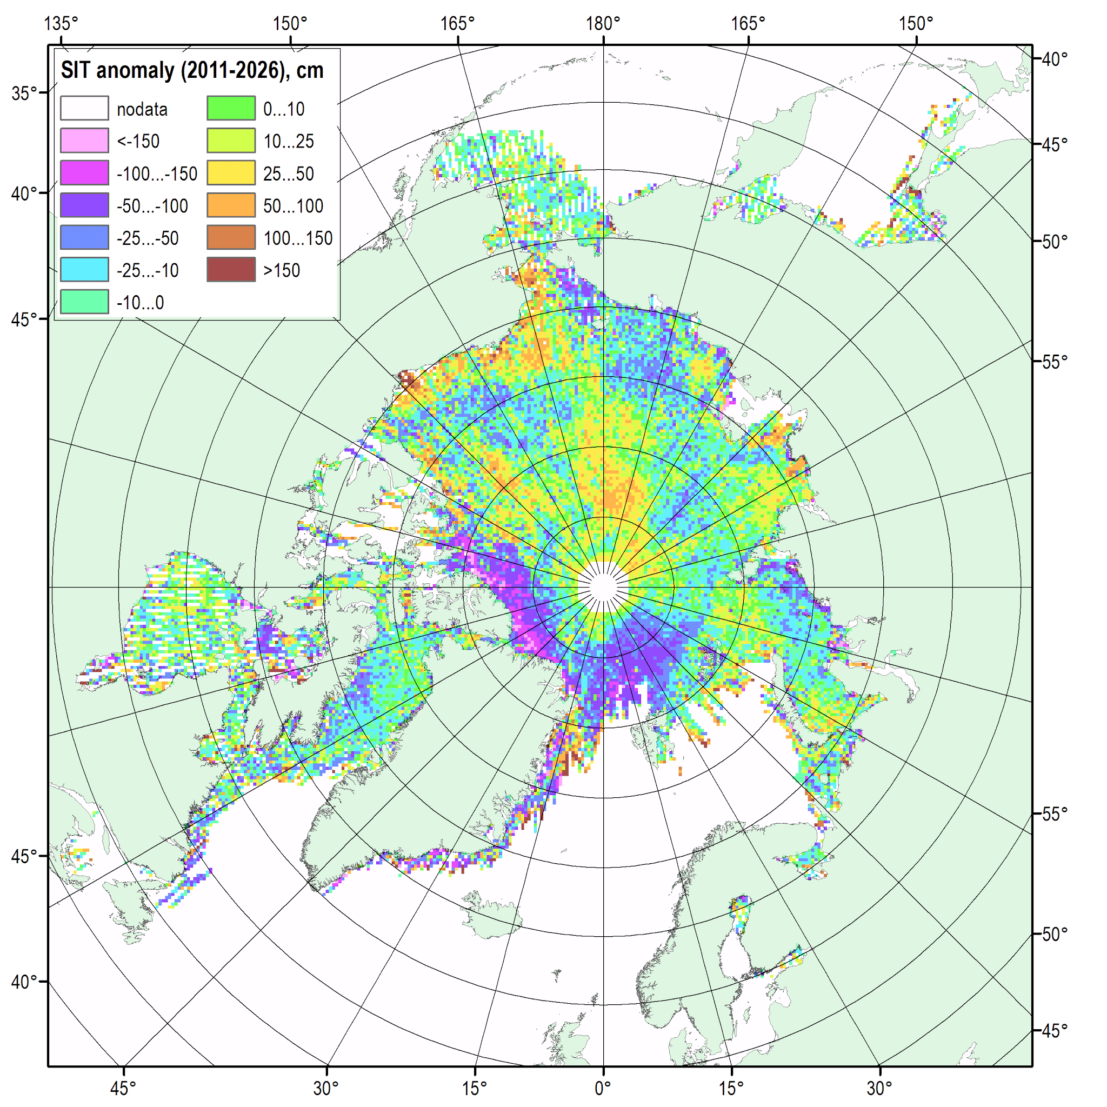
Figure 12: Blended Arctic sea-ice chart (AARI, ASIP, CIS, NIC, Planet) for 16-20 March 2026 and sea-ice edge occurrences for 16-20 March for 1991-2020 reference period (top), left top: total concentration, right top: predominant stage of development.; CryoSAT-2 sea-ice thickness (AWI v2p6) (bottom), bottom left: mean for March 2026, bottom right: anomaly for 2011-2026 reference period (bottom). Graphics produced by the AARI

Sea-ice Outlook verification for winter 2026 ice extent and freeze-up dates:
The forecast for March 2026 sea-ice extent was primarily based on output from Canadian Seasonal to Inter-annual Prediction System (CanSIPSv3) with additional use of sea ice forecasts from the Coupled Unified Forecast System (NOAA UFS) and INM-CM5 climate model (INM RAS/Hydrometcenter of Russia).
Below normal ice extent was correctly forecasted for the Sea of Okhotsk, northern Greenland, Labrador seas and Baffin Bay (Figure 13, table 5). Similarly, a correct forecast of near normal extent was predicted for the southern Greenland Sea. The model did not forecast the above normal ice extent for the Bering Sea and near normal for the Barents Sea.
Forecast accuracy for the winter 2025/2026 freeze-up dates (also based on output from CanSIPS v3) was generally less good across the Arctic regions. The model correctly forecasted late freeze-up dates (Figure 14, table 6) in the Baffin Bay, western Hudson Bay, Canadian Archipelago, north-eastern Kara, northern Barents and northern Greenland seas, normal or near in eastern Hudson Bay, north-eastern Barents, Laptev seas, and early in southern Bering, Chukchi, northern East Siberia and southern Greenland seas. Model missed later that normal freeze-up for Labrador, coastal part of Beaufort, Sea of Okhotsk seas, and early for coastal part of East Siberia, south-western Kara and southern Barents seas.
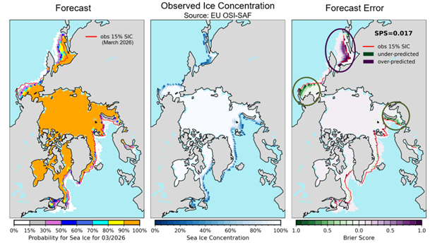
Figure 13: Verification of CanSIPSv3 probabilistic forecast for March 2026: Probability of ice concentration exceeding 15%

Table 5 – March 2026 actual sea-ice extent versus vs ArcRCC-N outlook
Regions | Forecast Confidence | Forecast Extent Anomaly from 2017-2025 | Observed Ice Extent  NOAA/NSIDC CDR* (2017-2025 average) | Sea-Ice Forecast Accuracy
Bering Sea | Low to moderate | Below normal | Above normal | Miss
Sea of Okhotsk | Moderate | Below normal | Below normal | ~Hit
Barents Sea | Moderate | Below normal | Near normal | Miss
Greenland Sea | Moderate | Near normal (S); Below Normal (N) | Below normal | ~Hit
Baffin Bay / Labrador Sea | Low to Moderate | Near normal(N);Below normal (S) | Below normal | ~ Hit
Northern Baltic Sea | Low | Below normal | Data not available | n/a

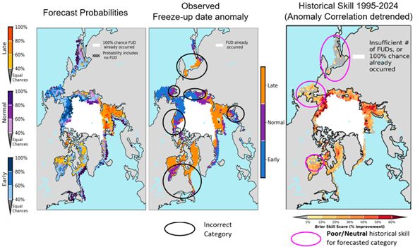Figure 14: Verification of CanSIPSv3 probabilistic forecast for Winter 25/26 Freeze-up

Table 6 -Verification of ArcRCC sea-ice freeze-up outlook for 2025/2026
Regions | CanSIPS Sea-Ice Forecast Confidence | CanSIPSv3 Sea-Ice Forecast | Observed Freeze-up | CanSIPSv3 Sea-Ice Forecast Accuracy
Baffin Bay | High | Late | Late | Hit
Labrador Sea | Low | Normal | Late | Miss
Hudson Bay | Moderate | Normal (E); Late (W) | Normal (E); Late (W) | Hit
CAA | Moderate | Mainly Late | Mainly Late | Hit
Beaufort Sea | High | Early | Early; Late (Coast / E) | Hit (N); Miss (Coast / E)
Bering Sea | Low | Early | Early (S); Near Normal (NE) | ~ Hit
Sea of Okhotsk | Low | Normal | Late | Miss
Chukchi Sea | Moderate to High | Early | Early | Hit
East Siberian Sea | High | Early; Late (coast) | Early | Hit; Miss (coast)
Laptev Sea | High | Normal | Near Normal | ~ Hit
Kara Sea | High | Late | Late; Early (SW) | Hit; Miss (SW)
Barents Sea | Moderate | Late | Late (N); Early (S) | Hit (N); Miss (S)
Greenland Sea | Moderate to High | Late (N); Early (S) | Late (N); Early (S) | ~ Hit

Outlook for summer 2026 sea-ice break-up
Sea-ice break-up is defined as the first day in a 10-day interval where ice concentration falls below 50% in a region. The outlook for summer break-up shown in Figure 15 displays the sea-ice freeze-up anomaly in days (deterministic forecast) and the probabilistic forecast from CanSIPSv3 based on the 15 years climatological period from 2011-2025. The qualitative 3-category (high, moderate, low) confidence of the forecast is based on the historical model skill. A summary of the forecast for the summer 2026 sea-ice break-up for the different Arctic regions is shown in Table 5.
Earlier than normal break-up dates (yellow-red areas, Figure 15; Table 7) are forecasted for northern Greenland, Baffin Bay and Labrador Sea, Canadian Archipelago, southern Beaufort Sea, northern Chukchi, East Siberian, Laptev, Kara and Barents seas. A near normal (light blue and light-yellow areas, Figure 15, Table 7) is forecasted for the southern part of Hudson Bay. Late break-up (blue areas, Figure 15, Table 7) is forecasted for NE Beaufort Sea and coastal part of the Chukchi sea.
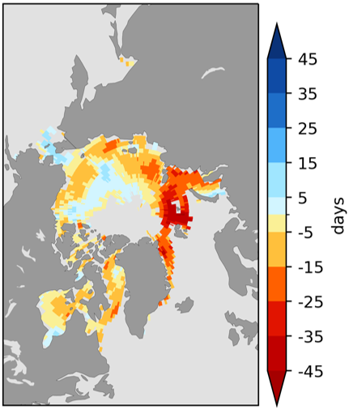 | 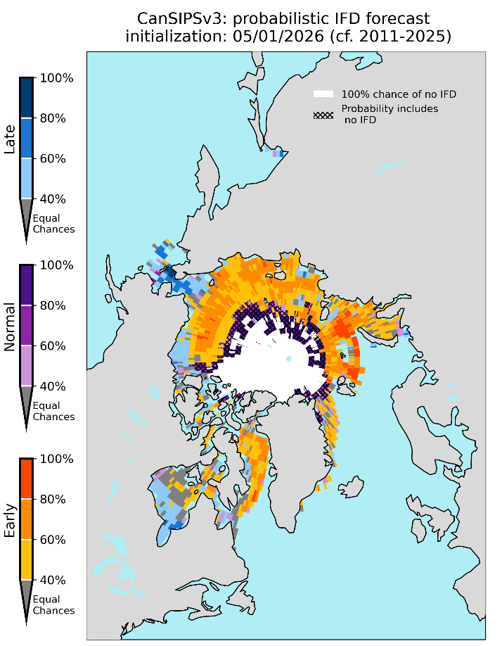
Figure 15: Left - deterministic break-up forecast for summer 2026 from CanSIPSv3: break-up date anomaly from 2011-2025 average, right - CanSIPS v3 Probability for summer 2026 for Early, Near-Normal or Late Break-up (forecast from May 1). Note: White area represents 100% chance that retreat does not occur (concentration never <50%). Hatching indicates where near-normal category is most likely, and includes the case that retreat does not occur (concentration never <50%).
Table 7 - Summer 2026 outlook: regional forecasts for sea-ice break-up date anomalies
Regions | CanSIPSv3 Sea- Ice Forecast Confidence | CanSIPSv3 Sea-ice break-up forecast
Greenland Sea (N) | Low | Early
Baffin Bay/  Labrador Sea | Moderate | Early
Hudson Bay | Low | Near-normal; Early (NE);
CAA | Low | Early
Beaufort Sea | Moderate | Early; Late (NE)
Chukchi Sea | Moderate | Early; Late (coast)
East Siberian Sea | Low | Early
Bering | Already occurred
Laptev Sea | Low | Early
Kara Sea | High | Early
Barents Sea | High | Early

Outlook for September 2026 Minimum sea-ice extent
Minimum sea-ice extent is reached each year for the Northern Hemisphere polar seas during the month of September with sub-polar seas becoming ice free between June to early August. Table 8 categorizes the sea-ice extent forecast confidence and relative extent (i.e., near normal, below normal, above normal) with respect to a 2016-2024 climatology for the Arctic region. The probabilistic forecast for September 2026 minimum sea-ice extent from CanSIPS v3.0 is shown in Figure 16; forecast confidence is subjective and based on historical model skill. A below normal September ice extent is forecasted for all regions (Table 8) with moderate confidence (low confidence for CAA) with exception of below to near normal sea-ice extent for the Greenland Sea.
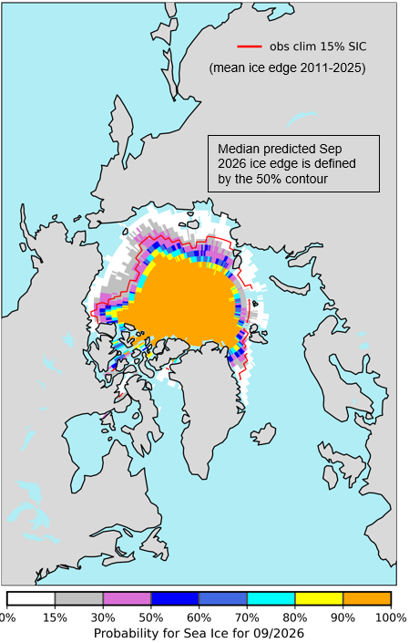
Figure 16: CanSIPSv3.0 September 2026 Sea-ice extent (probability of sea-ice total concentration exceeding 15%).
Table 8 - September 2026 outlook: sea-ice extent anomalies by regions
Regions | Sea-ice Forecast Confidence | Sea-ice Forecast Extent
Greenland Sea | Moderate | Below normal, near normal (E)
Barents Sea | Moderate | Below normal
Kara Sea | Moderate | Below normal
Laptev Sea | Moderate | Below normal
East Siberian Sea | Moderate | Below normal
Chukchi Sea | Moderate | Below normal
Beaufort Sea | Moderate | Below normal
Canadian Arctic Archipelago | Low | Below normal

2026 Summer Ice Conditions in Key Shipping Areas

Northern Sea Route

Current conditions as of June 3rd – earlier than normal open water area or open ice within the south-western coastal part of Kara Sea, the Great Siberian Polynya, in the eastern coastal part of the East Siberian Sea and north-east part of the Chukchi Sea. Close to normal well-developed areas of fast ice within the NSR. Close to normal ice conditions in the south-western part of Chukchi Sea. Model forecast for earlier than normal break-up over most of the Northern Sea Route. Outlook – easier than normal summer shipping season. Continuing risk of old ice occurrence within the eastern part of the East Siberian – western part of Chukchi Sea.

Northwest Passage

Current conditions as of May 19th – normal ice cover for this time of year and some anomalies in break-up, more multi-year ice than normal in southwestern Beaufort Sea and in MacClure Strait but less multi-year ice in the islands and polar pack. Model forecast for early clearing along the coast of the Beaufort, but possibly late in the eastern sections. Outlook – southern route could clear with a chance of lingering ice in the eastern Beaufort. Increased risk of multi-year ice at the west end of the northern route.

Hudson Bay and Hudson Strait

Current conditions as of May 19th - early clearing in Hudson Bay and Hudson Strait compared to 30-year normal, melt less advanced than at this time last year. Model forecast for near-normal break-up, earlier than normal in the northeastern section of Hudson Bay. Outlook – normal shipping season, an early start is possible.

Baffin Bay

Current conditions as of May 19th – lower extent compared to 30-year normal, lower ice cover compared to last year, slightly more than normal old ice in Nares Strait than the 30-year normal but comparable to the last 2 years; the ice arch is still in place. Model forecast for an early clearing. Outlook – normal shipping season.

Bioclimatic indexes (experimental product)
Estimates of the weather comfort or bioclimatic indexes are commonly done for the mid-latitude, sub-polar and polar regions using the Bodman’s weather severity index S (developed specifically for the Arctic cold season, based on a derivative of surface wind speed and air temperature and scaled from slightly severe to extremely severe), or the effective temperature ET (year-round, based on a derivative of surface air temperature and relative humidity and scaled from comfort to extreme discomfort).

Summary for winter-spring 2025/2026
Extremely severe conditions were observed in the OND period over the Greenland, Fram Strait, Central Arctic, Beaufort Sea, over the seas of the Northern Sea Route from eastern Kara Sea to Chukchi Sea (Figure 17a). Within the Canadian Arctic Archipelago, extremely severe conditions prevailed in the southwestern part, while the northeastern sector belonged to a relatively milder uncomfortable zone (Figure 17a).
These conditions were predominantly close to the 1991–2020 climatological norm (Figure 17b, white areas on the anomalies map). More severe than usual conditions (Figure 17b, red color) were observed over Laptev Sea, adjacent land areas to the south, the Sea of Okhotsk, and parts of Alaska. Milder conditions (Figure 17b, blue color) were recorded over southern Greenland, the Fram Strait, the Beaufort and Labrador Seas, the Canadian Arctic Archipelago, the Bering Strait, as well as parts of the Central Arctic, the Barents, Kara, and Laptev Seas, and regions of Scandinavia and Eastern Europe.

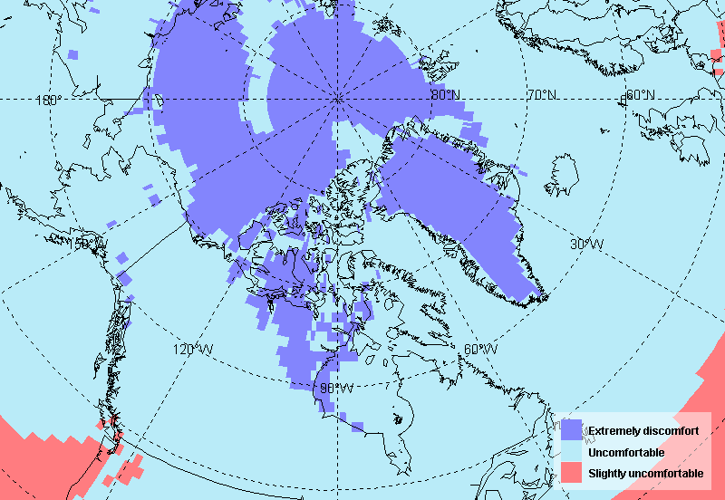 | 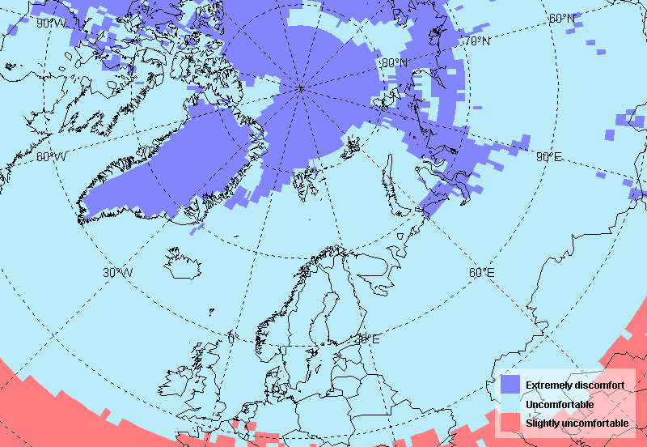 | 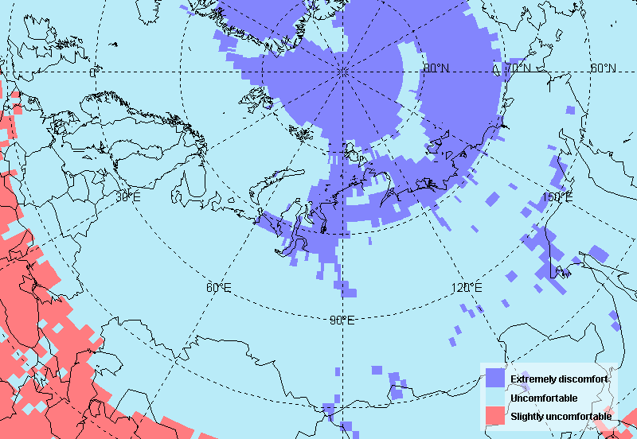
October-December 2025
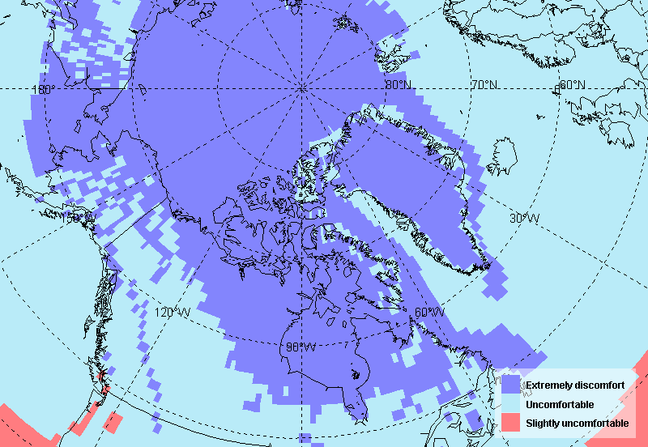 | 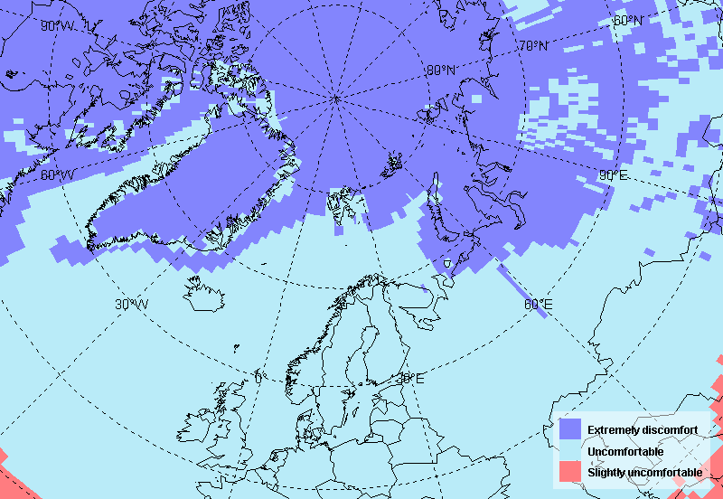 | 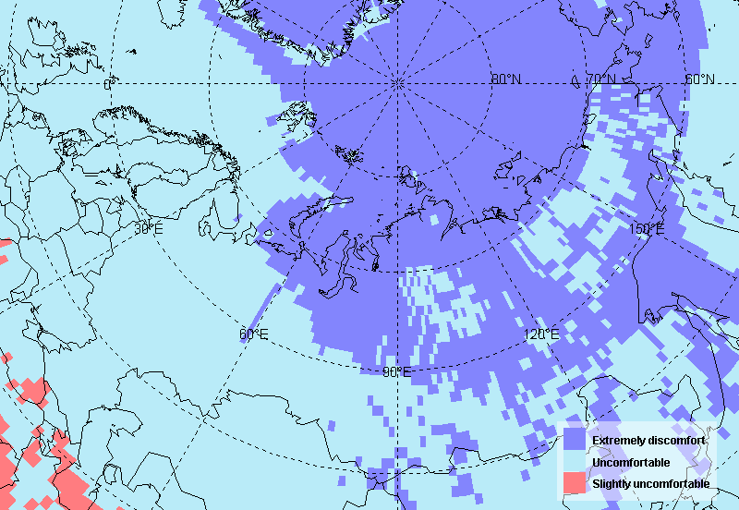
December 2025 – February 2026
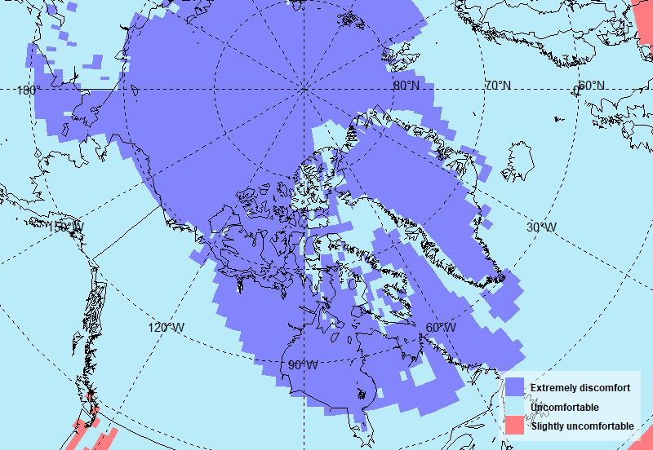 | 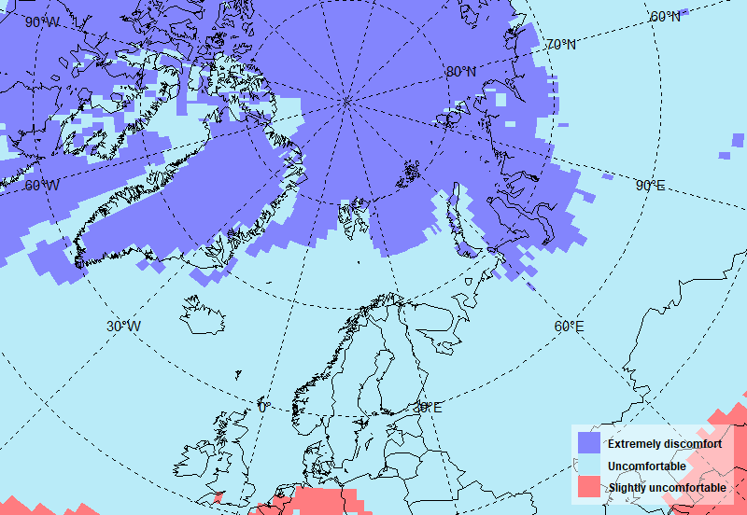 | 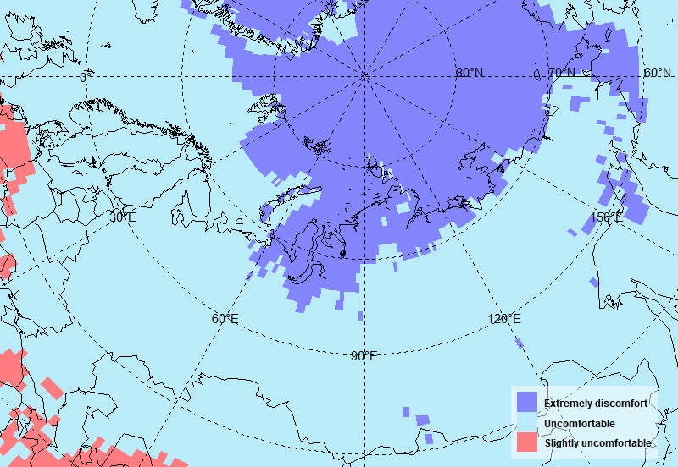
February - April 2026
Figure 17a: Bodman’s index (S) of weather severity for October 2025 – April 2026. Maps produced by the AARI. Data source: CCCS ERA5.

In winter (DJF), extremely severe conditions expanded relative to the autumn, covering the Canadian Arctic Archipelago and adjacent land areas to the south, Hudson Bay, only western part of Baffin Bay and southern part of Labrador Sea (in contrast to winter 2024-2025), and Fram Strait (Figure 17a). In Eurasian part extremely severe conditions extended over the northern and eastern Barents Sea, Kara Sea, patchy distribution across the land areas of Siberia and the Far East, Bering Strait and Bering Sea and parts of the Sea of Okhotsk (Figure 17a).
Distinctly milder conditions (Figure 17b, blue color) prevailed around Greenland, while over Greenland it remained close to normal. Milder conditions were also observed over the Norwegian, Barents, Kara, and Laptev Seas, as well as in the western part of the Bering Sea. More severe conditions (Figure 17b, red color) occurred over the East Siberian Sea and across land areas of both Eurasia and North America, with the exception of eastern Canada. The most pronounced severe conditions were recorded over Alaska and northern Canada.

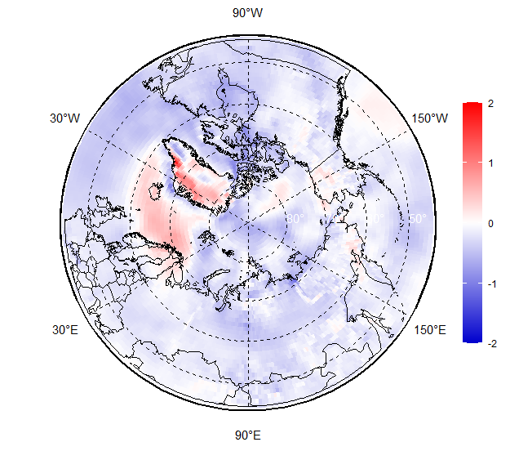 | 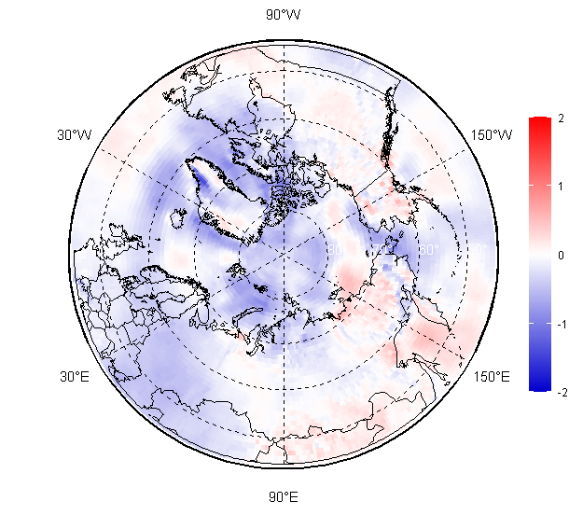 | OND 2025
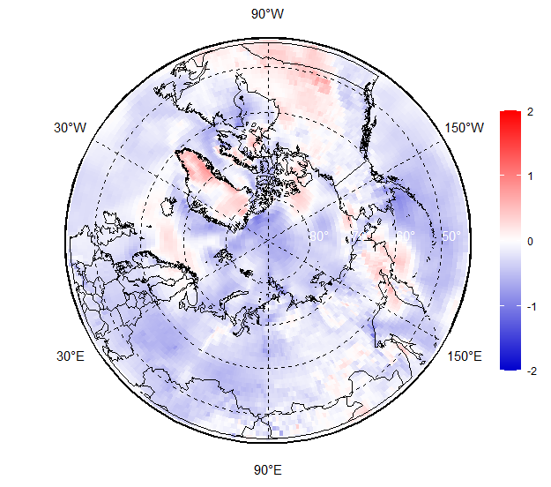 | 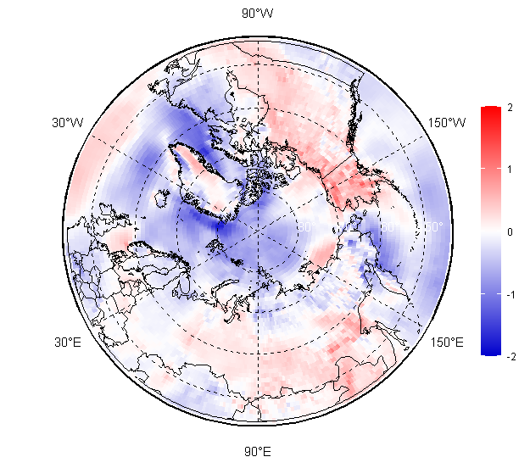 | DJF 2025/2026
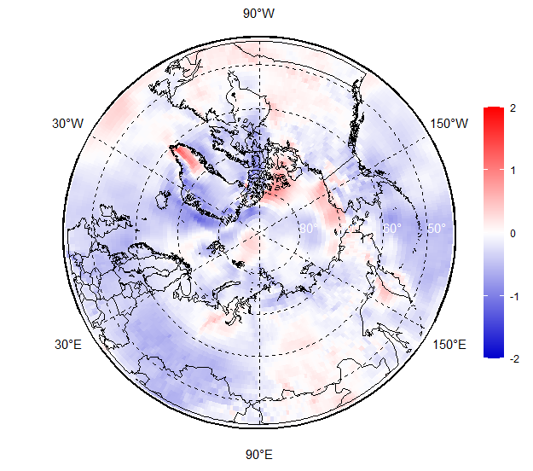 | 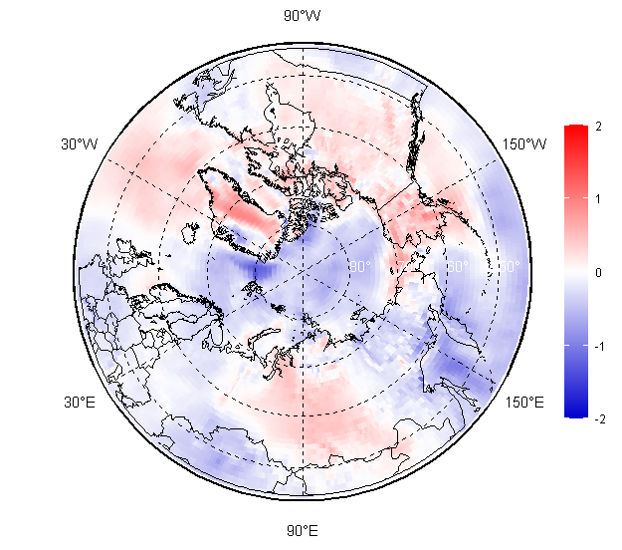 | FMA 2026
2025 | 2026
Figure 17b: Bodman’s index (S) of weather severity anomalies relative to 1991-2020 for corresponding seasons in 2024-2025 and 2025/2026. Maps produced by the AARI. Data source: CCCS ERA5.

During the FMA 2026 period, extremely severe conditions expanded over the Labrador Sea, while over the Sea of Okhotsk and most land areas of Eastern Siberia they were replaced by less severe uncomfortable conditions (Figure 19a). Exceptions included the Taymyr Peninsula and northern regions of Canada, where extremely severe conditions persisted (Figure 17a).
As seen on anomalies map, milder conditions (Figure 17b, blue color) prevailed over the Central Arctic, Fram Strait, Greenland Sea, Barents Sea, Sea of Okhotsk, and Bering Sea, whereas conditions over the marginal seas remained predominantly close to normal. In contrast, more severe conditions (Figure 17b, red color) dominated over the Chukchi Sea, Bering Strait, Gulf of Alaska, and the Beaufort and Labrador Seas. Over land areas, conditions were generally either more severe than normal (Figure 19b, red color) or close to the climatological norm. Slightly milder conditions were observed in Eastern Siberia, particularly within the Lena and Kolyma river basins, as well as over the Kamchatka Peninsula

Verification of winter 2025/2026 forecast

For the Alaska and Canada region, the forecast identified extremely severe conditions quite accurately, except from a huge underestimation over Greenland where there were extremely severe conditions according to ERA5 rather than severe conditions in forecast (Figure 18). A relatively small forecast overestimation was observed along the western coast of Greenland, while over the Labrador Sea the forecast was in good agreement with the ERA5 data. For the Eurasian region, the forecast was also generally accurate, except for some underestimation of weather severity over land areas near Yakutsk (figure 18).

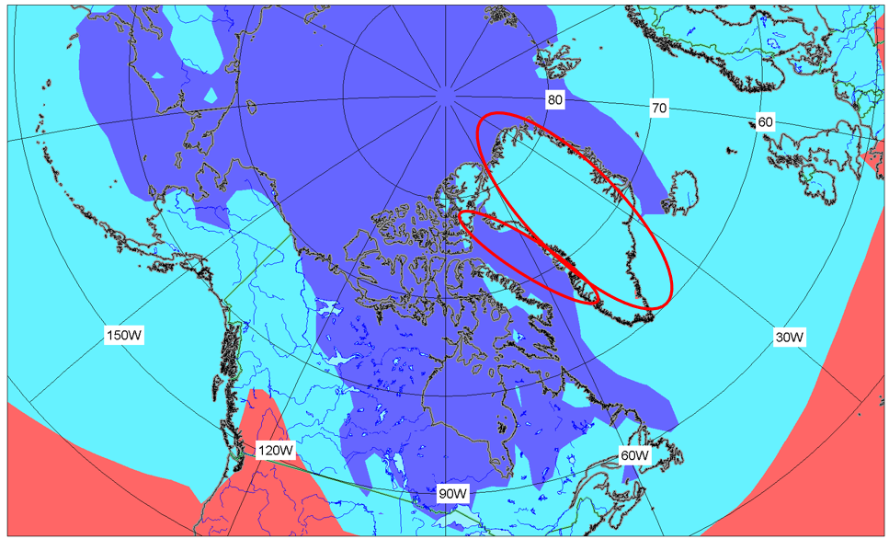 | 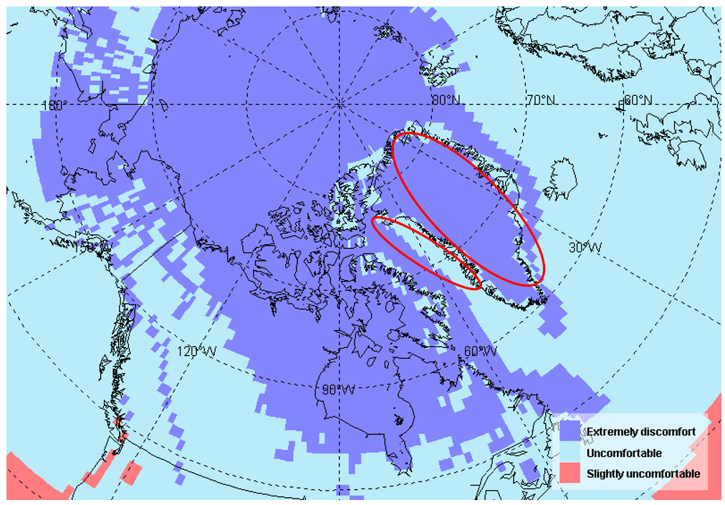
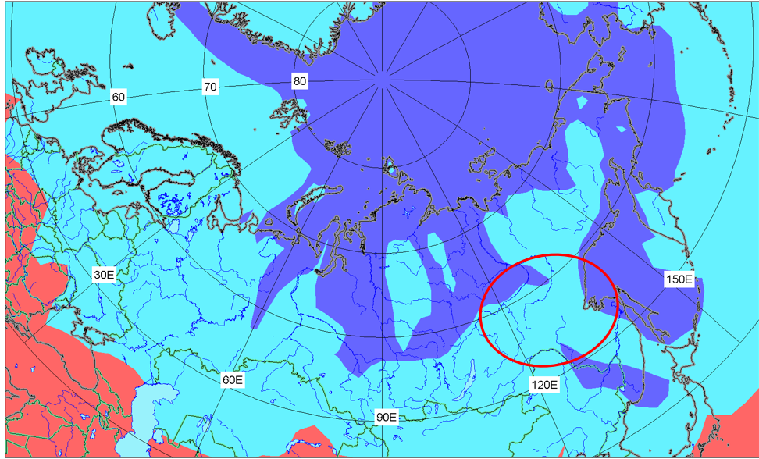 | 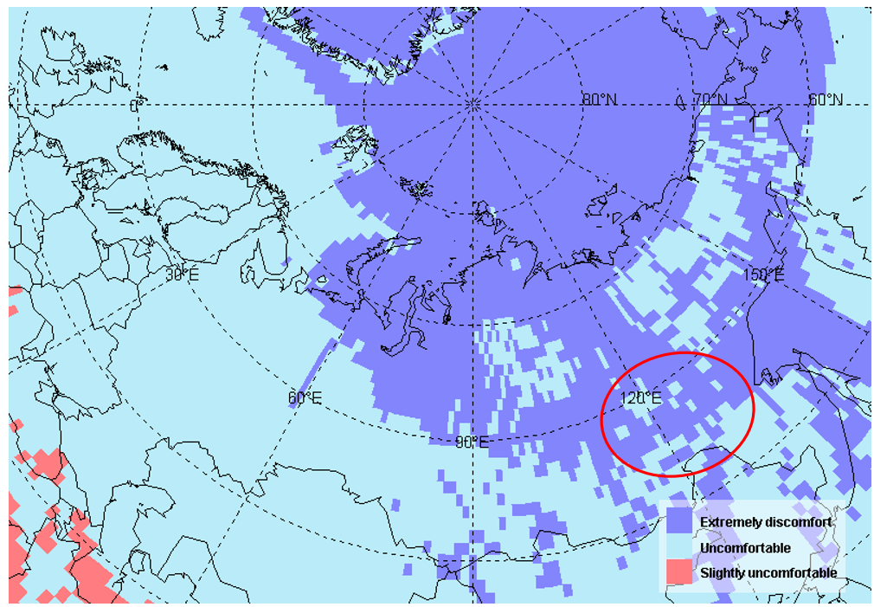
Forecast | ERA5 data
Figure 18: Bodman’s index (S) of weather severity forecast (left) and ERA5 reanalysis estimate (right) for December 2025 – February 2026. Maps produced by the AARI and Hydrometcenter Russia. Data source: Hydrometcenter Russia and CCCS ERA5.

Outlook for summer 2026 (experimental)
Outlook for summer 2026 is based on Universal thermal climate index (UTCI), which is a measure of how human beings experience “thermal comfort”, or what the weather “feels like”, outdoors (Figure 19a). To calculate the UTCI index values for the summer season of 2026, operational forecasts of the INM-CM6 model were used (spatial resolution 1.25° х 1°, number of ensemble members – 30, hindcasts for period 1991-2020.
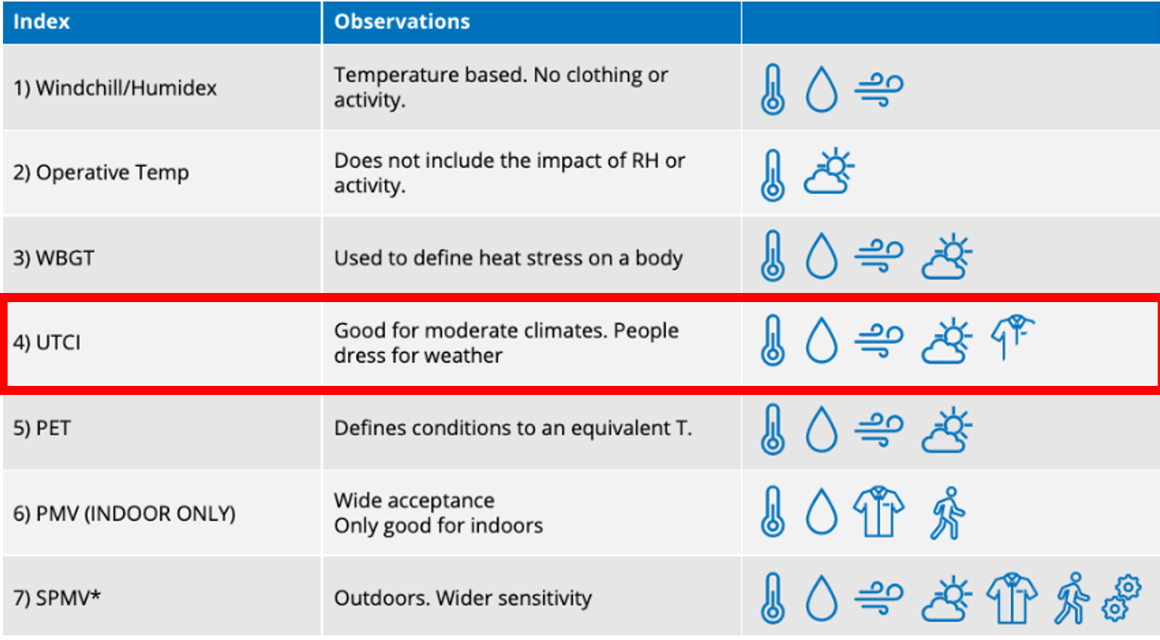 | 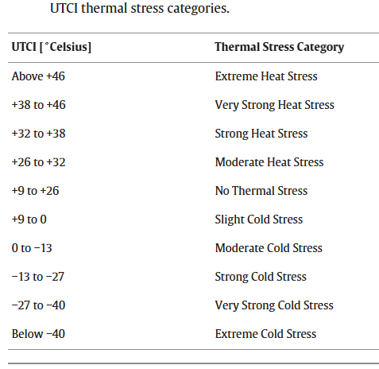
Different Approaches for Evaluating Thermal Comfort | Universal thermal climate index (UTCI)
Figure 19a: Definition of the Universal thermal climate index (UTCI).

Alaska, Canada and Western Nordic | Eurasia
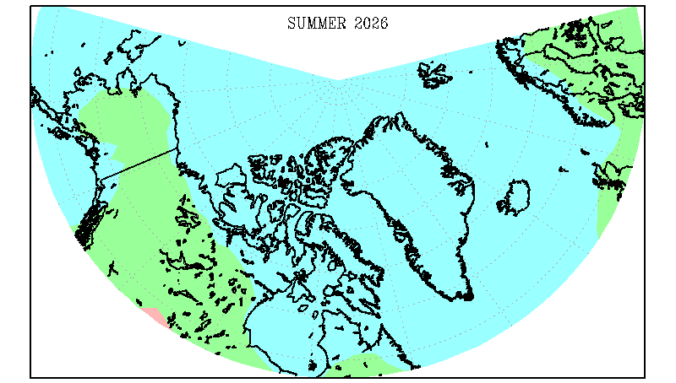 | 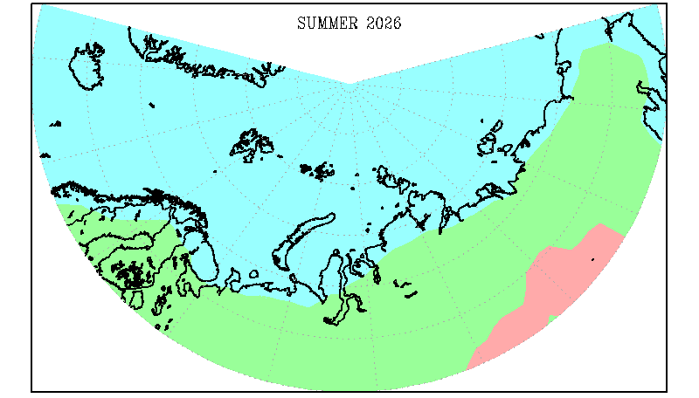
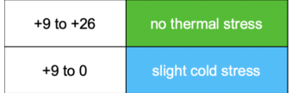

Figure 19b: UTCI index outlook for June, July, August 2026. Maps and data source: Institute of Numerical Mathematics Russian Academy of Science.

In the summer of 2026, slight cold stress conditions are expected throughout Greenland, in coastal areas of Alaska, in the north of the provinces of Nunavut, Quebec and the Northwest Territories (Figure 19b,c). No thermal stress conditions are predicted for central Alaska, Yukon, most of the Northwest Territories, and the southern half of the province of Nunavut.
Slight cold stress conditions are predicted for Iceland, Spitsbergen, in the coastal part of Norway, in the north of Sweden, Finland and the Kola Peninsula (Figure 19b,c). In Siberia Slight cold stresses are predicted along the entire coast of the northern seas. At the same time there will be no thermal stress conditions in the large area of ​​northern Europe and northern Eurasia.
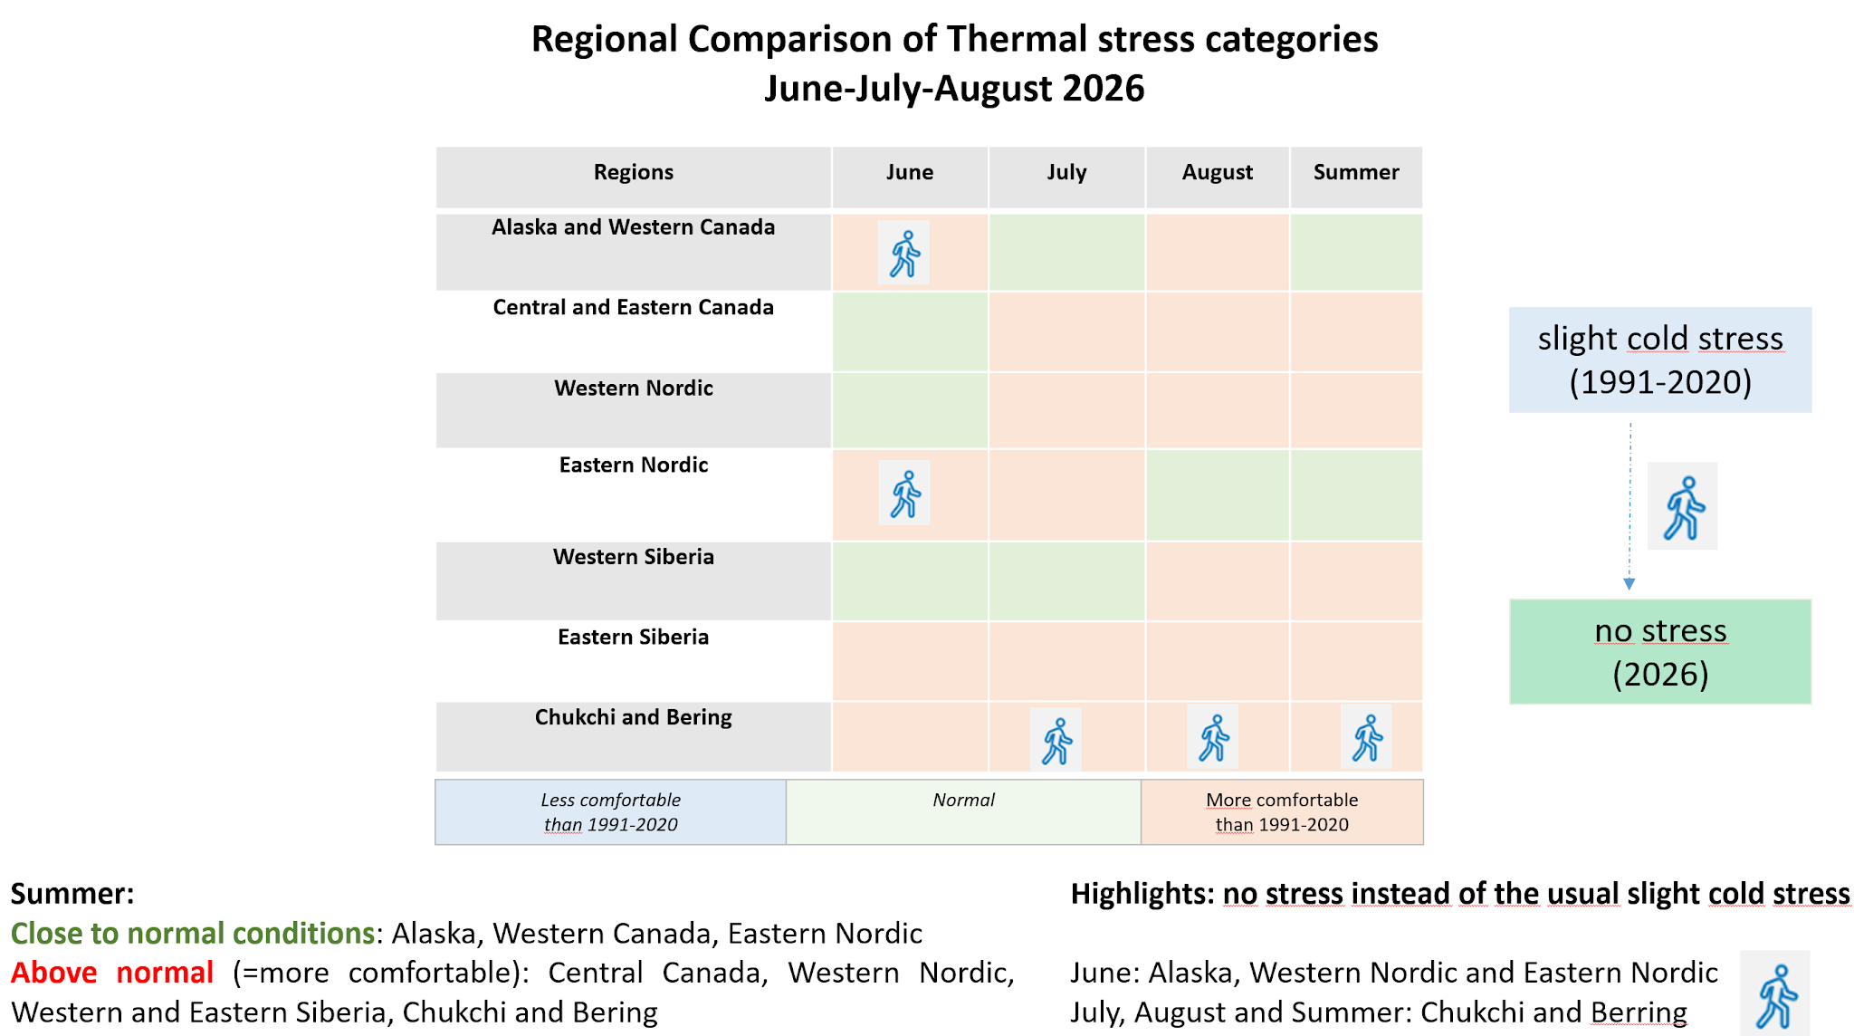

Figure 19c: UTCI index infographics for June, July, August 2026 by ArcRCC-N regions. Maps and data source: Institute of Numerical Mathematics Russian Academy of Science.

Observed extreme events during autumn 2025 – spring 2026

Category | Location | Rarity | Impacts associated with event
Alaska and Western Canada
Snowfall | Southeastern Alaska | Record snowfall in parts of Southeastern Alaska in December. Snowiest December on record for Juneau, Alaska. | Widespread roof collapses due to snow load. Several boats in Juneau Harbor sank due to snow load.
Cold Temperatures | Alaska/Yukon | Significant cold weather across all of Alaska and western Canada from early December through mid-January. Coldest mid-minter period in decades for some locations. | Financial hardship to heat homes due to prolonged, intense cold and the high price of fuel. Frozen pipes in many Alaska communities.
Cold Temperatures | Western Canada | Significant cold weather across all of western Canada with the largest negative anomalies across the Yukon Territory | Financial hardship to heat homes due to prolonged, intense cold and the high price of fuel.
Central and Eastern Canada
Cold Temperatures | ISR | Many locations in ISR experienced prolonged periods of very cold temperatures below -30°C. Inuvik experienced 19 days with a minimum temperature below -30°C in Feb 2026 (normal is 11.6), and 5 days with temps below -40°C (normal is 1.4 days). | Extreme cold in Jan, high propane use. Delayed propane deliveries to Inuvik due to blizzard conditions, prompted residents to conserve propane and reduce appliance use. Extreme cold in Feb forced contractors to suspend services, prompting Tuktoyaktuk to ask residents to conserve water
Cold Temperatures | Nunavik | Some regions of Nunavik recorded wind chill values equal to or below 40 between January 18 to 28, 2026.
Warm Temperatures | Nunavut | Nunavut saw unusual warmth in early January, with Pangnirtung reaching 10°C above normal. Many stations had their 1st or 2nd warmest January on record. | Warm, rain, strong winds and tides exposed beaches – allowed for clam digging (typically only possible in summer and fall). Freeze-thaw cycles and high winds made travel and hunting difficult. Thin ice led to cancellation of winter games and community events for second consecutive year
Warm Temperatures | Nunatsiavut | Warmth in Nunatsiavut during typically coldest time of the year. Nain, Makkovik, and Hopedale ranked in the top 5th warmest on record for February.
Blizzards/Wind | Nunavut | Series of blizzards and strong winds throughout the winter across the region  On February 27, Grise Fiord saw 130 km/h winds (5th strongest wind gust recorded since 2007). | Many days of near-zero visibility, whiteout conditions, power outages, services disruptions, school and business closures and a fatality.
 | ISR | Blizzards and high winds closed main highway to ISR for many days | Municipal service disruptions and prolonged road closures led to many requests to conserve water, food, and fuel
Sea Ice | All regions | - Late freeze-up in all areas. Thinner ice due to delayed start to winter and warm temperatures. | Late start to on ice travel between communities and subsistence activities. Prolonged shipping season. Canadian Coast Guard opened reactivated after seasonal stand down for the first time ever due to low ice and increased on water use in Pangnirtung
Western Nordic
Temperature | Iceland  December | 3rd warmest December on record  New national maximum temperature record set for December, 19.8 °C in Seyðisfjörður in the Eastfjords on 24th of December.
Temperature | Greenland  January | January exceptionally warm in Greenland. Warmest January on record along the western coast of Greenland.  Monthly mean temperature in Nuuk 7.8 degrees warmer than normal
Precipitation | Iceland  January | Unusually dry January, especially in western Iceland. 2nd driest January on record in Reykjavík and Stykkishólmur. Dry conditions continued well into February | Because of the dry weather and lack of snow, there was significant airborne dust pollution in the Capital Region.  Vegetation and soil had become very dry, and wildfires broke out in several locations within the city limits.
Eastern Nordic
- | - | - | -
Western Siberia
Cold weather and slow melting of snow (high snow cover in spring | Yamalo-Nenets Autonomous Okrug | - | Agrometeorological monitoring stations regularly reported difficulties grazing domestic reindeer. The reasons for this include very low temperatures, frequent snowstorms (every 3-4 days per season on average), and ice crusts on the snow cover.  Due to deep soil freezing in winter, during the sudden warm spell in April and May, subsidence occurred (there were casualties).
Eastern Siberia
Cold weather | Krasnoyarsk Territory (eastern and northern parts), Sakha-Yakutia | Absolute DJF minimum -50.7˚C - January, south of Krasnoyarsk Territory, -50,3˚C - February, south of Taymyr | Power, water, and heating outages; excessive fuel consumption; emergency situation mode
Complex phenomena (cold weather, heavy snowfall, strong winds) | Krasnoyarsk Territory | - | -
Chukchi and Bering
Strong winds | Chukotka Autonomous Okrug | - | Strong winds in December and February (gusts up to 43 m/s). No official information on impact.
Cold waves in February | North and northeast of Sakha-Yakutia | - | Fires, frostbite, class cancellations, power outages

Possible impacts for summer 2026
Economy sector/  Livelihood conditions | Outlook | Impacts associated
Alaska and Western Canada
All | Wildfires | Health impacts due to wildfire smoke.
Transportation, Housing | Flooding | Cold winter conditions increase the chance of significant ice jam flooding in Arctic regions in June.
Central and Eastern Canada
Subsistence fishing and hunting, inter-community travel | Earlier than normal ice break-up, above normal temperatures – quickly changing ice conditions | Unsafe, abnormal conditions for subsistence fishing and hunting. Traditional ice routes become unreliable
Marine Traffic  Sea Lift, Resupply  Marine Domain Awareness | Low agreement in sea ice outlooks for the Arctic Archipelago.  Earlier than normal break up in eastern regions.  Above normal temperatures through most major shipping routes. | Potential increase in icebreaking requests and SAR activations  Increasing marine traffic, world shipping corridors adjustments  Increasing demand for patrol and enforcement  Expanding timelines for on-water activities
Tourism | Earlier than normal ice break-up, above normal temperatures | Increasing tourism in the north, particularly adventure travelers through the NWP
Other | Low probability for near normal temperatures in the northwest (ISR)  Above normal temperatures | Indirect impacts such as smoke transport  Increasing operational costs for infrastructure adaptation and hazard mitigation
Search and Rescue (SAR) cases are increasing year over year
Weather is one of the top 5 causes for SAR activations in the Canadian Arctic
Western Siberia
Mining industry  Social life  Livestock farming | Above norm surface air temperature and precipitation on the east | Due to unstable soil after a cold winter, taking into account positive temperature and precipitation anomalies in the summer, a high probability of active cryogenic and thermokarst processes and, as a consequence, soil collapse is predicted for the summer of 2026.  In the east of the Yamalo-Nenets Okrug, warm conditions can cause heat waves, warm and humid weather causes muggy weather with a lot of insects, which is unfavorable
Eastern Siberia
Forestry | Above normal temperature | An increased risk of wildfires is expected due to above-normal temperatures forecast for northern Eastern Siberia.
Ecosystems | Minimum ice extent in the seas | Threat to the ice-dependent species and reindeers
Physical risks/coastal communities | Minimum ice extent in the seas | Coastline destruction due to erosion/potential damage to the coastline infrastructure
Physical risks/coastal infrastructure | Above normal temperature | Coastline destruction due to thermal abrasion and thermokarst/potential damage to the coastal infrastructure
Hydrology | Above normal temperature | Intensification of surge flooding
Chukchi and Bering
Ecosystems | Minimum ice extent in the seas | Threat to the ice-dependent species
Physical risks/coastal communities | Minimum ice extent in the seas | Coastline destruction due to erosion/potential damage to the coastline infrastructure
Physical risks/coastal infrastructure | Above normal temperature | Coastline destruction due to thermal abrasion and thermokarst/potential damage to the coastal infrastructure

Data sources and useful links:

Arctic and Antarctic Research Institute
- Seasonal bulletins of the state of Arctic (in Russian)
- Seasonal NSR outlooks (in Russian)
- ArcRCC-N NE node monthly and seasonal graphs for the Arctic ECVs
- ArcRCC-N NE node Arctic Ocean blended ice charts
Copernicus Climate Change Service
- ERA5 monthly averaged data on pressure and single levels (ERA5)
- Marine environment monitoring service (CMEMS)
- GloFAS operational global river discharge reanalysis (ERA5-GloFAS)
Danish Meteorological Institute
- Polar Portal
- Ocean and sea ice services
Finnish Meteorological Institute
Environment Canada and Climate Change
- Seasonal forecasts
- Canadian Ice Service latest ice conditions and forecasts
ESA CryoSAT-2 sea-ice thickness estimates (AWI)
Icelandic Meteorological Office
National Snow and Ice Data Center (NSIDC)
- NSIDC Near-Real-Time DMSP SSMIS Daily Polar Gridded Sea-ice Concentrations
NOAA/National Weather Service Alaska Forecast Office
- NWS Alaska Sea Ice Program
Norwegian Meteorological Institute
Swedish Meteorological and Hydrological Institute
US National Ice Center
WMO Arctic Regional Climate Centre - Network (ArcRCC-N)
WMO Global Cryosphere Watch (GCW)
- GCW SnowWatch
- Rutgers Univercity Global Snow Lab
WMO Lead Center for Long-Range Forecast Multi-Model Ensemble
- Seasonal forecast

Background and Contributing institutions
The Arctic seasonal climate summary and outlooks were prepared for ACF-17 in partnership between the Canadian, Danish, Finnish, Icelandic, Norwegian, Russian, Swedish and United States meteorological agencies, sea-ice services and with contributions from the WMO GCW.
The ArcRCC-Network, a collaborative arrangement with formal participation by all the eight Arctic Council member countries, is from June 2024 in operational phase as a WMO RCC-Network by the WMO Executive Council in 2024. For more information, please visit https://arctic-rcc.org/.

Acronyms

AARI Arctic and Antarctic Research Institute
ArcRCC-Network Arctic Regional Climate Centre Network (https://www.arctic-rcc.org)
ACF Arctic Climate Forum
AMAP Arctic Monitoring and Assessment Programme
CAA Canadian Arctic Archipelago
CanSIPSv2 Canadian Seasonal to Inter-annual Prediction System
CAP Common Alerting Protocol
CCCS Copernicus climate change service
CFSR U.S. NSF Climate Forecast System Reanalysis
CIS Canadian Ice Service
CMEMS CCCS Marine environment monitoring service
DMI Danish Meteorological Institute
ECCC Environment and Climate Change Canada
ECMWF European Centre for Medium-Range Weather Forecasts
ESA European Space Agency
FMI Finnish Meteorological Institute
GCW Global Cryosphere Watch
GPCs-LRF WMO Global Producing Centres Long-Range Forecasts
GloFAS-ERA5 CCCS operational global river discharge reanalysis
GloSea5 Met Office Global Seasonal forecasting system version 5
H50, H500 Geopotential heights 50hPa, 500hPa
HYCOM-CICE HYbrid Coordinate Ocean Model, Coupled with sea-ice
IICWG International Ice Charting Working Group
IMO Icelandic Meteorological Office
IOC Intergovernmental Oceanographic Commission
LC-LRFMME WMO Lead Centre for Long Range Forecast Multi-Model Ensemble
MSLP Mean sea level pressure
NAO North Atlantic Oscillation
NIC National Ice Center (United States)
NCAR National Center for Atmospheric Research
NCAR CFSR National Center for Atmospheric Research Climate Forecast System Reanalysis
NMI Norwegian Meteorological Institute
NOAA/NWS/NCEP/CPC National Oceanic and Atmospheric Administration/National Weather Service/National Centers for Environmental Prediction/Climate Prediction Center (United States)
NSIDC National Snow and Ice Data Center (United States)
MME Multi-model ensemble
NSR Northern Sea Route
NWP Northwest Passage
PIOMAS Pan-Arctic Ice Ocean Modeling and Assimilation System
RCC WMO Regional Climate Centre
RCOF Regional Climate Outlook Forum
SAT Surface air temperature
SST Sea surface temperature
SMHI Swedish Meteorological and Hydrological Institute
SWE Snow Water Equivalent
WMO World Meteorological Organization

Surface sea waters in the Arctic have a pH of about 8.1, with a range of about 7.5 to 8.4. The term ocean acidification refers to an increase in acidity (i.e., a decrease in pH). AMAP, 2019. Arctic Ocean Acidification Assessment 2018: Summary for Policy-Makers. Arctic Monitoring and Assessment Programme (AMAP), Oslo, Norway. 16 p.
Bodman’s weather severity index S is defined using following formula S = (1 – 0.04T) (1 + 0.272 V), where V is wind speed (in m/ s) at 10 m above ground level, T is air temperature (in °C)
Effective temperature ET is defined as ET = T – 0,4(T – 10) (1 – f / 100), where T is air temperature (in °C) and f is relative humidity (%).

