Arctic Climate Forum Consensus Statement

2021 Arctic Summer Seasonal Climate Outlook
(along with a summary of 2020-2021 Arctic Winter Season)

CONTEXT
Arctic temperatures continue to warm at more than twice the global average. Annual surface air temperatures over the last 5 years (2016–2020) in the Arctic (60°–85°N) have been the highest in the time series of observations for 1936-2020¹. During the autumn 2020 freezing period, the drastically reduced after the summer melt ice cover (the 2nd minimum since 1979 reached on 12 September 2020) and the accumulated ocean heat content led close to the lowest on record the Arctic ice extent and ice volume². However, futher negative winter SAT anomalies stimulated the general ice growth with the winter 2021 maximum ice extent reaching 7th - 10^{th3} in row for the whole NH and median for the last 40 years for a number of areas within the the Arctic Ocean. That was accompanied by both milder and harsher weather anomalies to the newest 3rd WMO period 1991-2020 across the Arctic during winter 2020/2021. To support Arctic decision makers in this changing climate with increasing innerseasonal and interannual variability, the recently established Arctic Climate Forum (ACF) convened by the Arctic Regional Climate Centre Network (ArcRCC-Network) under the auspices of the World Meteorological Organization (WMO) provides consensus climate outlook statements in May prior to summer thawing and sea-ice break-up, and in October before the winter freezing and the return of sea-ice. The role of the ArcRCC-Network is to foster collaborative regional climate services amongst Arctic meteorological and ice services to synthesize observations, historical trends, forecast models and fill gaps with regional expertise to produce consensus climate statements. These statements include a review of the major climate features of the previous season, and outlooks for the upcoming season for air and sea surface temperature, precipitation, snow water equivalent and sea-ice. The elements of the consensus statements are presented and discussed at the Arctic Climate Forum (ACF) sessions with both providers and users of climate information in the Arctic twice a year in May and October, the latter typically held online. This consensus statement is an outcome of the 7th session of the ACF held online on 26-27 May 2021 and coordinated by the Nordic Node of ArcRCC-Network hosted by Iceland.

HIGHLIGHTS
Warmer than normal surface air temperatures over the Nordic regions and Arctic Oceans contributed to mostly below normal ice conditions during the 2020-2021 winter all across the Arctic, although some interannual variability was observed. A meridian type of circulation with several ‘cold waves’ in Nordic, Western Siberian and Alaska regions stimulated ice growth in coastal parts of Eurasian Arctic Seas and Beaufort Sea.

Forecasted warmer than normal temperatures contributed to early to near normal spring break-up and below to near normal sea ice extent for the summer of 2021.

Temperature: The average surface air temperatures for February, March, and April ranked much lower than normal in Siberia and Alaska, to higher than normal for Greenland, Svalbard, and the Arctic Seas. Above normal temperatures and sea-surface temperatures are expected over the majority of the Arctic regions in June, July, and August 2021.

Precipitation: February, March, and April were drier than normal over parts of Western and Eastern Siberian regions, while Alaska, Bering and Chukchi, Central Canada, and Svalbard were wetter than normal. Wetter than normal conditions are expected to continue over several Arctic regions: Chukchi and Bering, Alaska, Eastern Canada and Canadian Archipelago. Historically, we do not have a high confidence in the precipitation forecast over the Arctic in June, July, and August 2021.

Sea-ice: The northern hemisphere March 2021 sea-ice extent maximum was the 10th lowest since 1979, driven by significant absences of ice in the Bering Sea, Barents Sea and the East Coast of Canada. For summer 2021, lower to near normal ice cover is the predominant forecast for the Arctic, while early to near normal break-up of sea ice is expected for most regions.

Understanding the Consensus Statement

This consensus statement includes: a seasonal summary and forecast verification for temperature, precipitation, and sea-ice for the previous 2020/2021 Arctic winter season (February, March, and April 2021); an outlook for the upcoming 2021 Arctic summer season (June, July, and August 2021). Experimental products with outlooks for snow water equivalent and sea-surface temperature are also included in this consensus statement. Figure 1 shows the regions that capture the different geographic features and environmental factors influencing temperature/precipitation. Figure 2 shows the established shipping routes and regions used for the sea-ice products.

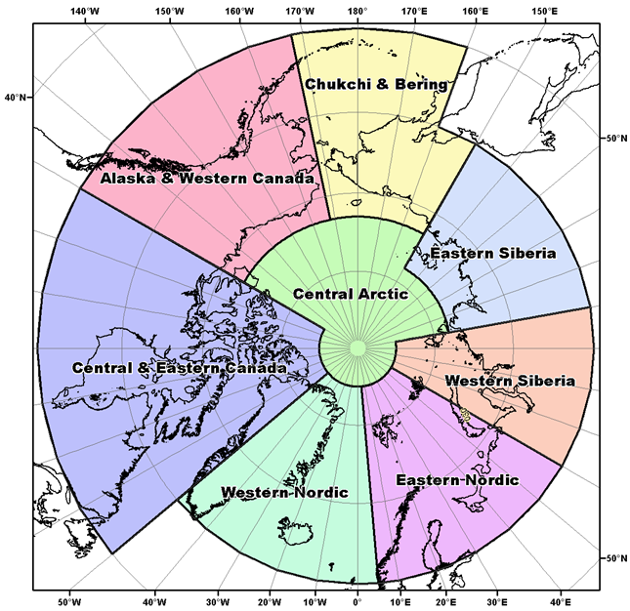 | 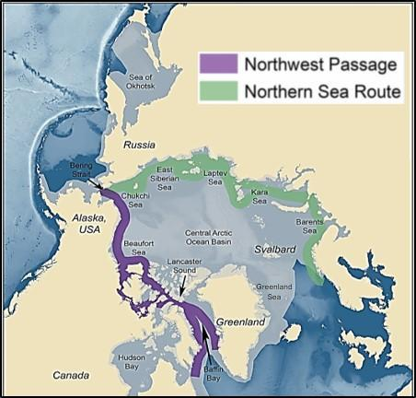
Figure 1: Regions used for the seasonal summary and outlook of temperature and precipitation | Figure 2: Sea-Ice Regions. Map Source: Courtesy of the U.S. National Academy of Sciences

The temperature and precipitation forecasts are based on eleven WMO Global Producing Centers of Long-Range Forecasts (GPCs-LRF) models and consolidated by the WMO Lead Centre for Long Range Forecast Multi-Model Ensemble (LC-LRFMME). In terms of models’ skill (i.e. the ability of the climate model to simulate the observed seasonal climate), a multi-model ensemble (MME) approach essentially overlays all of the individual model performances. This provides a forecast with higher confidence in the regions where different model outputs/results are consistent, versus a low confidence forecast in the regions where the models don’t agree. The MME approach is a methodology well-recognized to be providing the most reliable objective forecasts.

The majority of the sea-ice extent and experimental freeze-up forecasts are based on the Canadian Seasonal to Inter-annual Prediction System (CanSIPSv2), an MME of two climate models. The Baltic Sea forecasts are developed using outputs from the ECMWF Long-Range Forecasts, UK MetOffice, and NOAA CFSv2. A larger multi-model ensemble that will include forecasts from the following WMO GPC-LRFs is under development: ECCC/MSC (CanSIPSv2), NOAA (CFSv2), Meteo-France (System 5), UK MetOffice (GloSea5) and ECMWF (SEAS5). When sea ice extent is at its minimum in September of each year, forecasts are available for the following peripheral seas where there is variability in the ice edge: Barents Sea, Beaufort Sea, Canadian Arctic Archipelago, Chukchi Sea, Eastern Siberian Sea, Greenland Sea, Kara Sea, and Laptev Sea. In addition to these regions, forecasts for sea ice break-up are also available for Baffin Bay, Bering Sea, East Siberian Sea, Kara Sea, Laptev Sea, Chukchi Sea, Barents Sea, Greenland Sea, Hudson Bay, and Labrador Sea. Summer outlooks for key shipping areas are provided by the Arctic and Antarctic Research Institute, Alaska Sea Ice Program, and Canadian and Finnish ice services, and are based on statistical model guidance and forecast expertise.

TEMPERATURE
Summary for February, March, and April 2021:

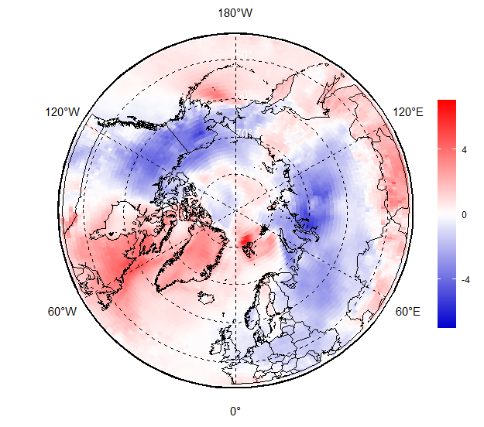
Figure 3: February, March, and April (FMA) 2021 surface air temperature (SAT) anomaly based on the 1991-2020 reference period. SAT red indicates warner than normal temperatures, and blue indicates cooler than normal temperatures. Map produced by the Arctic and Antarctic Research Institute http://www.aari.ru. Data source: ERA5.
During February, March and April (FMA) 2021 negative MSLP anomalies were observed in the southern parts of Siberian regions, over Hudson Bay, parts of the Central Arctic Ocean, but not in Alaska, Western Canada and Western and Eastern Nordic (ERA5, not shown here). The very intence polar vortex led to increased anticyclonic activity with several ‘cold waves’ in Nordic, Western Siberian and Alaska regions and less precipitation. Average surface air temperatures in the Arctic were above normal over parts of the Sea of Okhotsk, Bering Sea, Eastern Canada, Greenland and Svalbard (red areas in Figure 3), while very strong negative anomalies were observed over eastern parts of Nordic region, Siberia and Alaska (blue areas in Figure 3). In general positive linear trends for winter temperatures continued for all Arctic seas, while for the land regions greater interannual variability was observed. Assessment of the bioclimatic weather severity using Bodman’s index (linear combination of SAT and wind speed, not shown here) indicates that milder than the last 30 years weather in January 2021 observed in Canada and Alaska switched to a more severe in Feb 2021. Similar situation was observed for February – March for Central and Eastern Siberia while Nordic region experienced milder weather in Jan 2021 and more severe in Apr 2021
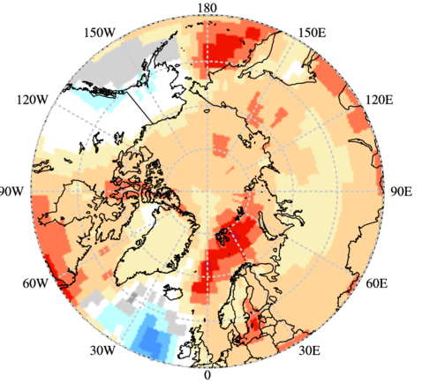 | 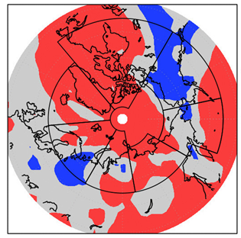
 | 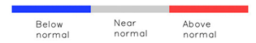
Figure 4: Left) Multi-model ensemble (MME) probability forecast for surface air temperatures: February, March, and April 2021. Three categories: below normal (blue), near normal (grey), above normal (red); no agreement amongst the models is shown in white. Source: www.wmolc.org. Right): NCAR (National Center for Atmospheric Research) Climate forecast System Reanalysis (CFSR) for air temperature for February, March, and April 2021.

The FMA 2021 temperature forecast was verified by subjective comparison between the forecast (Figure 4, left) and re-analysis (Figure 4, right), region by region. A re-analysis is produced using dynamical and statistical techniques to fill gaps when meteorological
observations are not available.

Above normal temperatures were accurately forecast in Central and Eastern Canada, Western Nordic, Eastern Siberia and Central Arctic regions for the FMA 2021 season (Figure 4, Table 1). Note that for the Western part of Central Canada, the models were indecisive, but they verify well for the rest of the region. The forecast accuracies were moderate over Alaska and Western Canada and Eastern Nordic regions. In Alaska and Western Canada, observations were mostly below normal, while the forecast temperatures were mostly equal and below normal, but also here the models were indecisive in parts of the region. In the Eastern Nordic region, the forecast temperatures were above normal for the full region, while the observations showed above normal temperatures only in the north. Otherwise, the temperatures were below and near normal.

The temperatures in Western Siberia, and Chukchi and Bering regions, were not accurately forecast. All forecasts indicated above normal temperatures, while in Western Siberia, observations showed above normal temperatures in smaller parts in the north and south, and otherwise near normal temperatures. In Chukchi and Bering, near normal temperatures were observed in most of the region. As a general conclusion, the multi-model ensemble forecast was accurate for approximately half of the Arctic territory.

Table 1. February, March, and April 2021: Regional Comparison of Observed and Forecasted Arctic Temperature
Regions  (see Figure 1) | MME Temperature Forecast Agreement | MME Temperature Forecast | NCAR CFSR Reanalysis (observed) | MME Temperature Forecast Accuracy
Alaska and Western Canada | Low | Mostly equal and below normal in the south and south west | Mostly below normal | Moderate
Central and Eastern Canada | Low to moderate | Above in central and east | Above in central and East, below and near normal in the West | High
Western Nordic | Moderate | Above normal | Mostly above normal | High
Eastern Nordic | Moderate | Above normal | Above normal in northern central Scandinavia, below in the East | Moderate
Western Siberia | Low to moderate | Above normal | Above in the South and North, near normal in the center and South West | Low
Eastern Siberia | Moderate | Above normal | Mostly above normal | High
Chukchi and Bering | Moderate to high | Above normal | Near normal in the continental parts | Low
Central Arctic | Moderate | Above normal | Mostly above normal | High

Outlook for summer 2021:
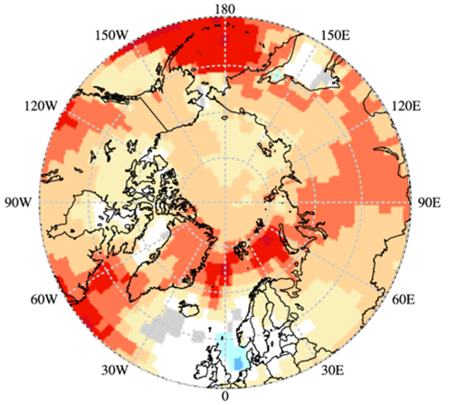
Figure 5: Multi model ensemble probability forecast for temperature for June, July, and August 2021. Red indicates warmer conditions, blue colder conditions and white, no agreement amongst the models. Source: www.wmolc.org.
Surface air temperatures during summer (JJA: June, July, and August) are forecast to be above normal in almost all regions across the Arctic (orange and red areas in Figure 5). The confidence of the forecast is low to moderate for most of the land areas of the Arctic region (light red areas in Figure 5, Table 2). The forecast confidence is high for Greenland, Western Siberia and southern parts of the Chukchi and Bering regions (dark red areas in Figure 5, Table 2). There are equal chances for an above, below or near normal summer temperature over Iceland and western part of the Eastern Nordic region, meaning that the multi-model ensemble of climate models is not decisive over these regions (white areas in Figure 5).

Table 2. Summer (JJA) 2021 Outlook: Regional Forecasts for Arctic Temperatures
Region  (see Figure 1) | MME Temperature Forecast Agreement* | MME Temperature Forecast
Alaska and Western Canada | Moderate | Above normal
Central and Eastern Canada | Low to moderate | Above normal
Western Nordic | Low to moderate | Mostly above normal, below normal in the north
Eastern Nordic | Low to moderate | Above normal
Western Siberia | Moderate | Above normal
Eastern Siberia | Moderate | Above normal
Chukchi and Bering | Moderate | Above normal
Central Arctic | Low to moderate | Above normal
*: See non-technical regional summaries for greater detail

PRECIPITATION
Summary for February, March, and April 2021:

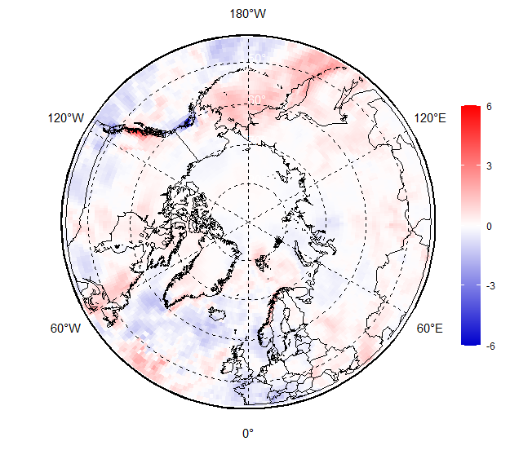 | 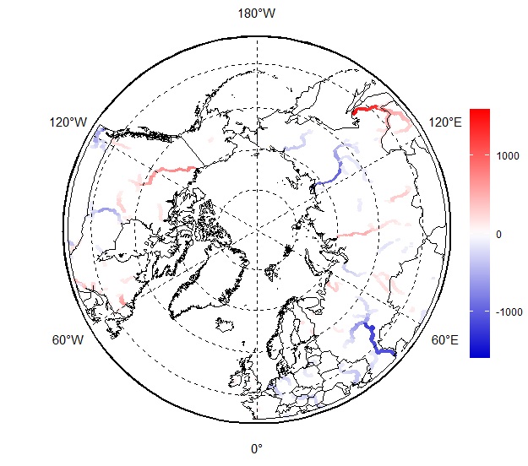
Figure 6. February, March, and April (FMA) 2021 precipitation (left) based on the 1991-2020 reference period and river discharge (right) anomalies based on the 2000-2019 reference period. Red indicates wetter (left) or greater river flow (right) than normal conditions, while blue indicates drier (left) or lesser river flow (right) than normal conditions. Map produced by the Arctic and Antarctic Research Institute http://www.aari.ru. Data source: ERA5 and GloFAS-ERA5.

During February, March, and April (FMA) 2021, wetter than normal conditions were observed in the Alaska, Bering and Chukchi, Central Canada and Svalbard regions (red areas in Figure 6, left), while Western and Eastern Siberia regions experienced drier than normal conditions (blue areas and Figure 6, left). Siberian shelf seas, Sea of Okhotsk, and the Nordic region experienced both wetter and drier conditions.

Impacts of wetter/drier regions were reflected in the winter/spring 2020-2021 Arctic rivers discharge: lesser drainage than normal is seen for Ob’ and Lena rivers, and further eastward (blue areas in Figure 6, right) during FMA 2021, while Mackenzie, Yukon and Enisey experienced greater discharge than normal (red areas in Figure 6, right). This is similar to previous winter/spring 2019-2020 (not shown).
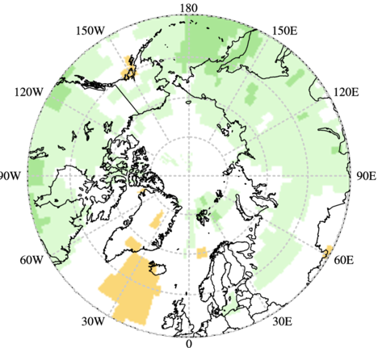 | 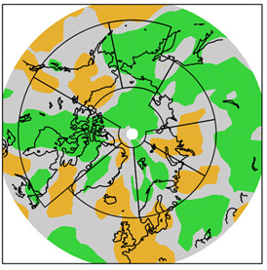
 | 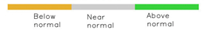
Figure 7: Left) Multi-model ensemble (MME) probability forecast for precipitation: February, March, and April 2021. Three categories: below normal (brown), near normal (grey), above normal (green); no agreement amongst the models is shown in white. Source: www.wmolc.org. Right): NCAR CFSR for precipitation for February, March, and April 2021.

Table 3. February, March, and April 2021: Regional Comparison of Observed and Forecasted Arctic Precipitation
Regions  (see Figure 1) | MME Precipitation Forecast Agreement | MME Precipitation Forecast | NCAR CFSR Reanalysis (observed) | MME Precipitation Forecast Accuracy
Alaska and Western Canada | Low | Above normal | Mostly below and near normal. | Low
Central and Eastern Canada | Low | Above normal | Above over the continental central parts,and over the Archipelago | Moderate
Western Nordic | Low | Mostly equal chances | Below over Iceland, near normal | N/A
Eastern Nordic | Low | Mostly equal chances | Near normal and below normal over the continental parts | N/A
Western Siberia | Low | Above normal | Below normal in the North, near normal in the South | Low
Eastern Siberia | Low | Above normal | Above in the South East, near normal in the North and West | Moderate
Chukchi and Bering | Low to moderate | Above normal | Above normal mostly | High
Central Arctic | Low | Mostly equal chances | Above normal mostly | N/A

The FMA 2021 precipitation forecast was verified by subjective comparison between the forecast (Figure 7, left) and re-analysis (Figure 7, right), region by region. As for temperature, precipitation re-analysis is produced using statistical techniques to fill gaps when meteorological observations are not available.

Overall, the accuracy of the FMA 2021 precipitation forecast was low (Figure 7, Table 3). In the regions where the models were decisive, the forecast subjective score is 40%. The best scores were over Chukchi and Bering, Eastern Canada and Western Siberia regions. However, there was little model agreement in the Eastern Nordic, Western Nordic, Eastern Siberia, Alaska and Western Canada, and Central Arctic regions (predominance of white areas in these regions). As a general conclusion, the multimodel ensemble forecast for precipitation was not accurate for FMA 2021.

Outlook for summer 2021:
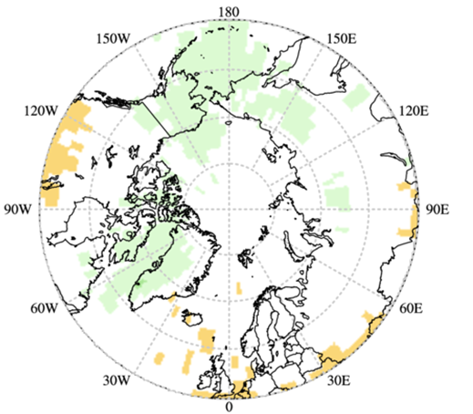
Figure 8: Multi model ensemble probability forecast for precipitation for June, July, and August 2021. Green indicates wetter conditions, orange drier conditions and white, no agreement amongst the models. Source: www.wmolc.org.
Precipitation during summer 2021 (JJA: June, July, and August) is expected to be above normal over most of the Alaskan and western Canadian Arctic, the Canadian Archipelago, Greenland, and Chukchi and Bering regions (light green areas in Figure 8, Table 4).

Iceland is expecting below normal precipitation (light orange areas in Figure 8, Table 4).

Equal chances of precipitation are expected over the remainder of the Arctic region (white areas in Figure 8, Table 4).

Table 4. Summer (JJA) 2021 Outlook: Forecasted Arctic Precipitation by Region
Region  (see Figure 1) | MME Precipitation Forecast Agreement* | MME Precipitation Forecast
Alaska and Western Canada | Low | Above normal in west
Central and Eastern Canada | Low | Above normal in the east, below normal in the south-west
Western Nordic | Low | Above normal over Greenland
Eastern Nordic | Low | No agreement
Western Siberia | Low | No agreement
Eastern Siberia | Low | Above normal in the east
Chukchi and Bering | Low | Above normal
Central Arctic | Low | No agreement
*: See non-technical regional summaries for greater detail

SNOW WATER EQUIVALENT
(experimental product)

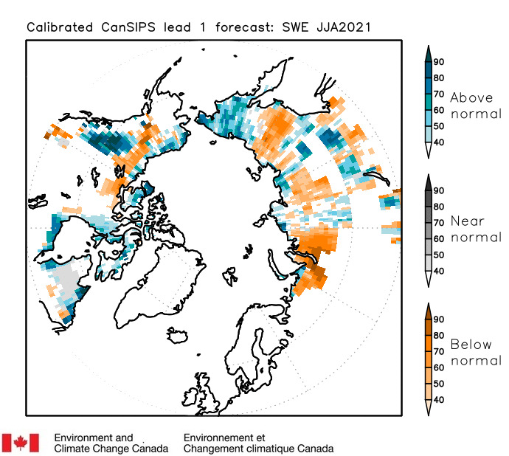
Outlook for summer 2021:
Snow water equivalent (SWE) calibrated probabilistic seasonal forecast is performed with the Canadian Seasonal to Interannual Prediction System (CanSIPS) (Figure 10, Table 5).
Figure 10: Canadian Seasonal to Interannual Prediction system probability forecast for snow water equivalent for June, July, and August 2021.

Above normal SWE is forecast over the Alaska and Western Canada region, the Canadian Archipelago, northern and southwestern parts of the western Siberian region, and Chukchi and Bering region (blue areas in Figure 10, Table 5). The forecast confidence is mostly low to moderate for these areas, but is somewhat higher in southern parts of Alaska and Western Canada, and Chukchi and Bering regions. This is in agreement with the precipitation forecast with above normal precipitation for the Chukchi and Bering region (Figure 8), indicating rather a solid-type precipitation for this area in summer 2021.

Below normal SWE is forecast in the central and eastern part in the Alaskan and western Canada region, eastern Siberia, southeastern parts of western Siberia (brown areas in Figure 10, Table 5). The forecast confidence is moderate to high in southern parts of eastern Siberia, but otherwise low to moderate.

Table 5. Summer (JJA) 2021 Outlook: Forecasted Arctic Snow Water Equivalent by Region
Region  (see Figure 1) | MME Precipitation Forecast Agreement* | MME Precipitation Forecast
Alaska and Western Canada | Low to moderate | Above normal in the north and south, below normal in central and eastern part
Central and Eastern Canada | Low | Above normal
Western Nordic | Low | No agreement
Eastern Nordic | Low | No agreement
Western Siberia | Low to moderate | Above normal in north and northwest, below normal otherwise
Eastern Siberia | Moderate | Below normal
Chukchi and Bering | Moderate to high | Above normal
Central Arctic | Low | No agreement
*: See non-technical regional summaries for greater detail

SEA-SURFACE TEMPERATURE
(experimental product)

Outlook for summer 2021:
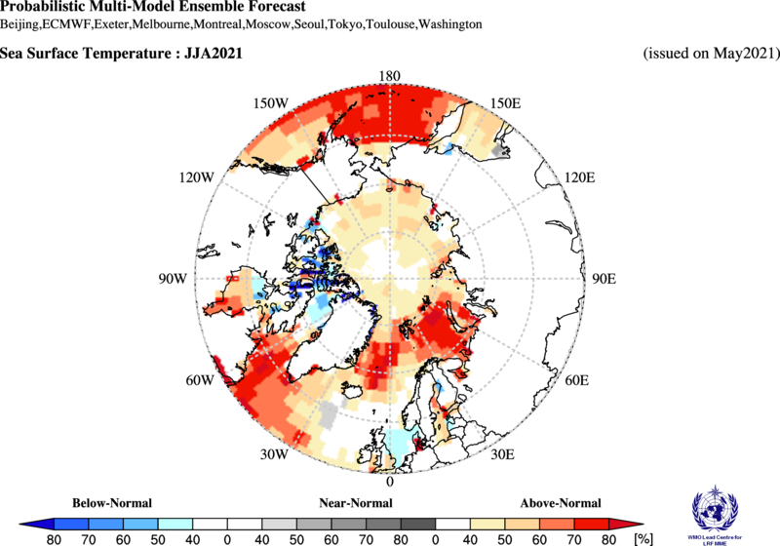
Figure 11: Multi model ensemble probability forecast for sea-surface temperature for June, July, and August 2021. Red indicates warmer conditions, blue colder conditions and white, no agreement amongst the models. Source: www.wmolc.org.
Over the largest portion of the Arctic seas, the multi-model ensemble approach is forecasting above normal SST’s (Figure 11, Table 6). Above normal SST’s are forecast for the Sea of Okhotsk, Bering Sea, Greenland Sea and Barents Sea with a rather high confidence. East Siberian, Chukchi, Kara, Laptev Sea and Beaufort Sea have low chances for above normal SST’s.

Canadian Archipelago, northern parts of Hudson Bay and Baffin Bay are the only locations with below normal SST expectation, however, the confidence level is low.

Region  (see Figure 2) | MME Temperature Forecast Agreement* | MME Temperature Forecast
Baffin Bay | Low | Below normal
Barents Sea | High | Above normal
Beaufort Sea | Low | Above normal
Bering Sea | High | Above normal
Canadian Archipelago | Low | Below normal
Chukchi Sea | Low | Above normal
East Siberian Sea | Low | Above normal
Greenland Sea | High | Above normal
Hudson Bay | Low | Below normal
Kara Sea | Low | Above normal
Laptev Sea | Low | Above normal
Sea of Okhotsk | High | Above normal
*: See non-technical regional summaries for greater detail

SEA-ICE AND ARCTIC OCEAN
Prevailing positive ocean heat content (HC) anomaly (to 2000-2019) in upper 20 m layer during October - November 2020 for most of the Eurasian seas significantly slowed freezing processes in these regions. Oppositely, zero or slightly negative HC anomalies during these months in Beaufort Sea, parts of Canadian Arctic provided background for close to normal freeze-up. Further in winter dominance of significant negative SAT anomalies stimulated ice growth in the coastal parts of Eurasian Arctic Seas and Beaufort Sea, with the opposite situation in Greenland, Svalbard waters (not shown here). Observed in March 2021, maximum sea ice extent was somewhat similar to that in March 2020 (Figure 12). Eurasian shelf seas including the Nothern Sea Route (NSR) were covered by medium and thick first year ice (FYI), instead of thick first-tear ice mostly, without any inclusions of old ice (which is strongly opposite for old times, e.g. 2006). Close to normal sea ice conditions were observed in the Sea of Okhotsk. Quite mild ice conditions were observed in the Baltic Sea till January, however further negative SAT anomalies in the region stimulated freezing processes and led to ice extent below and near normal till April this year. Similar mild conditions were observed in general for the Barents Sea till mid January and ice conditions were normal to slightly above normal in February and March. The Svalbard area experienced very mild conditions till March with further close to normal ice extent.

The ~15.1 million km² maximum winter ice extent was reached 11 March 2021, being 7th - 10th lowest in row (due to low difference rankvaries following the source of assesment – AARI or NSIDC), compared to ~15,4 in 2020, 16th lowest in row reached 4 March in 2020. That means the 2021 maximum somewhat slightly if any correlates with summer 2020 conditions which ranked as the 2nd lowest sea ice extent . During the freezing period, the lowest on record Arctic ice extent was observed in October-mid November in the Eurasian Arctic, due to drastically reduced ice cover, accumulated heat content and positive SAT anomalies.

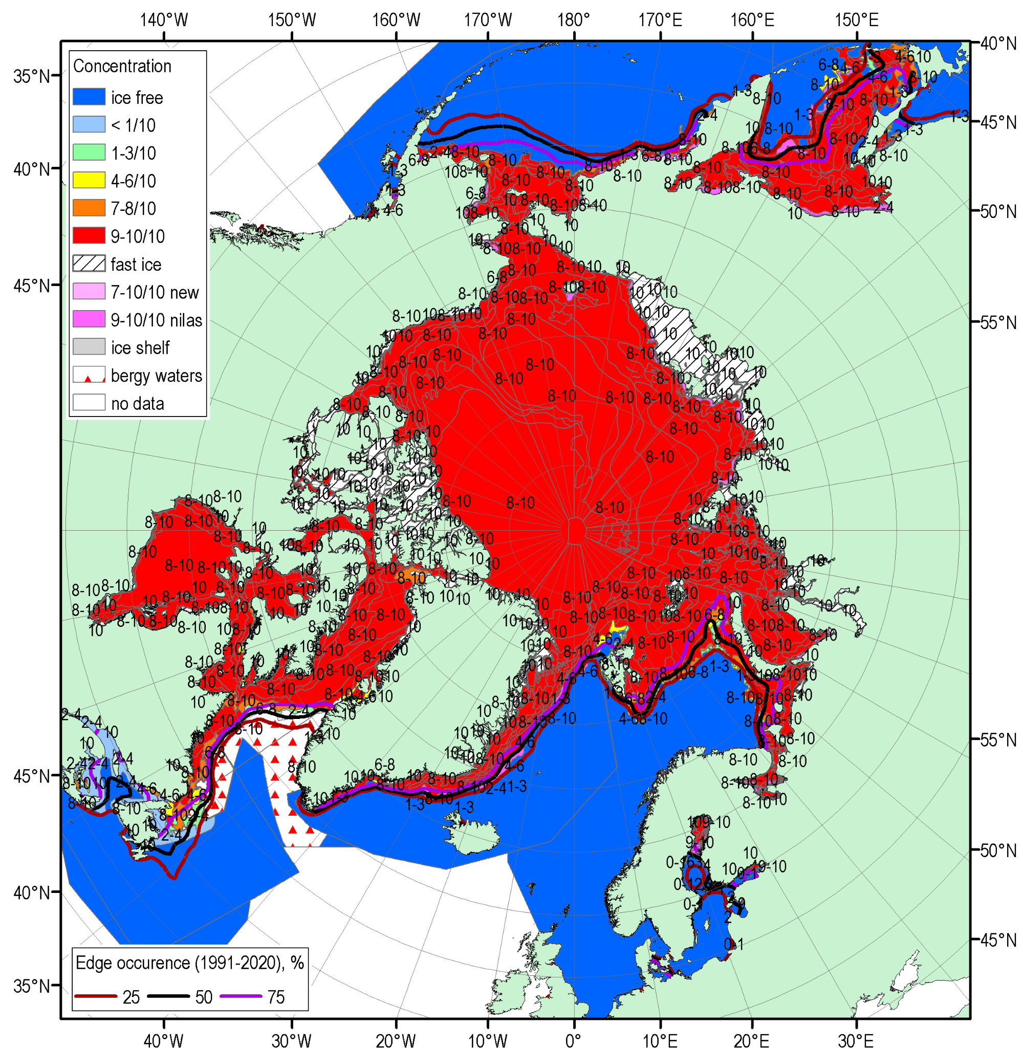 | 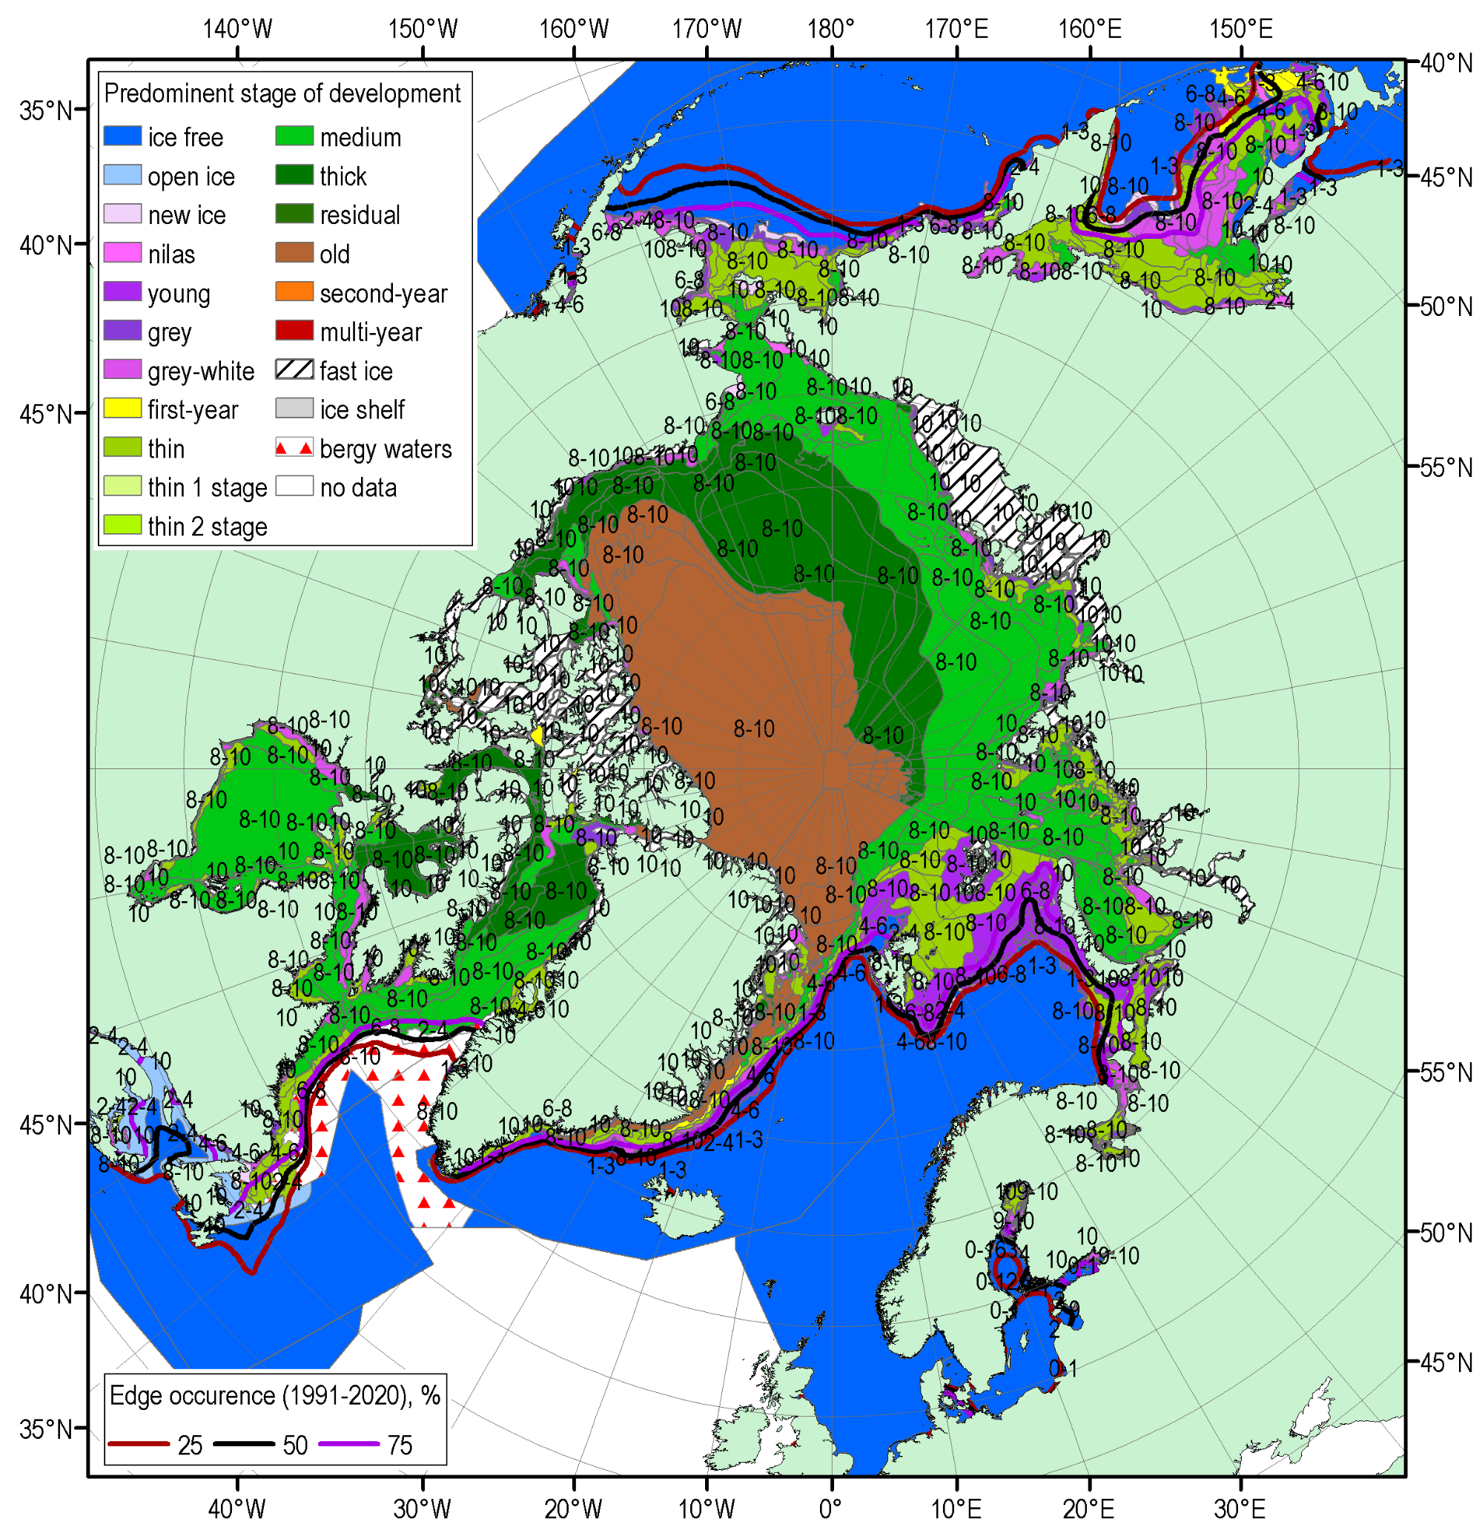

Figure 12: Blended Arctic ice chart (AARI, CIS, NIC) and ice edge occurences for 15-18 March with reference period 1991-2020. Left: total concentration, right: predominant stage of development.

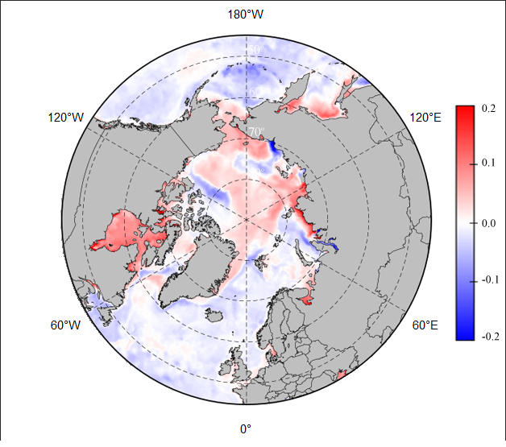
Figure 13 shows the Copernicus CCCS MEMS ocean pH anomalies for February, March, and April (FMA) 2021, where both positive (red areas in Figure 13: Arctic Basin, Laptev Sea, North-Eastern part of Kara Sea, Hudson Bay), and negativ (blue areas in Figure 13: Kara, Greenland Sea) pH anomalies are shown, relative to the 1993-2020 period. The latter may point to acidification processes, though this needs further verification with e.g. AMAP data.

Figure 13: pH 2m depth anomalies in February, March, and April 2021 relative to 1993-2020. Map produced by the Arctic and Antarctic Research Institute http://www.aari.ru. Data source: Copernicus MEMS..

The forecast for March 2021 sea ice extent (Figure 14) was based on output from CanSIPSv2, an MME of two climate models, and verified well (right column,Table 7). Forecast accuracy was high for the Northern Baltic Sea, Gulf of St. Lawrence and Labrador Sea, with moderate accuracy for the Greenland Sea and Barents Sea. The Bering Sea was a source of low forecast accuracy despite strong model confidence as below normal ice extent was observed despite a forecast for near normal conditions. Ice extents in the Bering Sea reached their 8th lowest coverage according to the NSIDC Sea Ice Index v3, while on the East Coast of Canada (encompassing the Gulf of St. Lawrence and Labrador Coast) ice cover was the 2nd lowest according to Canadian Ice Service records.

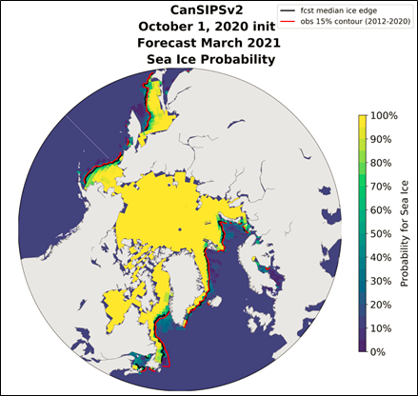
Figure 14: March 2021 probability of sea ice at concentrations greater than 15% from CanSIPSv2 (ECCC). Forecast median ice extent (black) and observed mean ice extent 2012-2020 (red).

Table 7. Winter 2020-2021: Regional Comparison of Observed and Forecasted Maximum Sea-Ice Extent
Regions  (see Figure 2) | CanSIPS Sea-Ice Forecast Confidence | CanSIPS Sea-Ice Forecast | Observed Ice Extent | CanSIPS Sea-Ice Forecast Accuracy
Barents Sea | moderate | near normal | slightly below normal | moderate
Bering Sea | high | near normal | below normal | low
Greenland Sea | moderate | near normal | below normal | moderate
Northern Baltic Sea | moderate | below normal | below normal | high
Gulf of St. Lawrence | moderate | below normal | below normal | high
Labrador Sea | low | below normal | below normal | high

Outlook for Spring Break-up 2021:
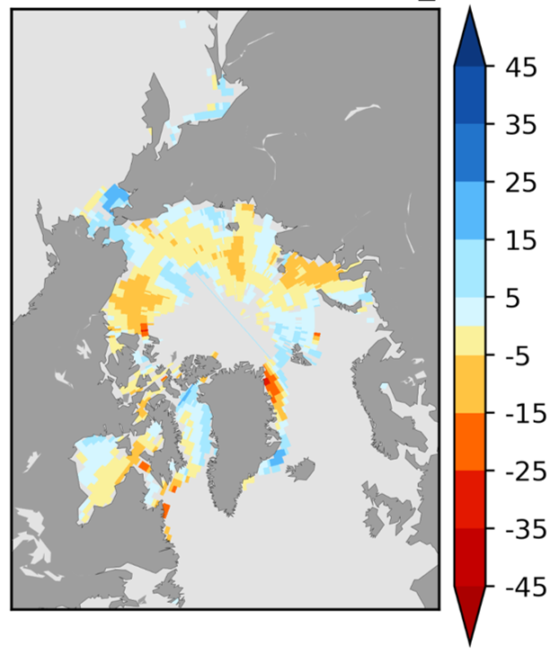
Sea ice break-up is defined as the first day in a 10-day interval where ice concentration falls below 50% in a region. The outlook for spring break-up shown in Figure 15 displays the sea ice break-up anomaly from CanSIPSv2 based on the nine-year climatological period from 2012-2020. The qualitative 3-category (high, moderate, low) confidence in the forecast is based on the historical model skill. Only regions where the model has historical skill are included in the outlook (Figure 16). A summary of the forecast for the 2021 spring break-up for the different Arctic regions are shown in Table 8.
later
than
normal
earlier
than
normal
Break-up Date Anomaly
Climatology period 2012-2020

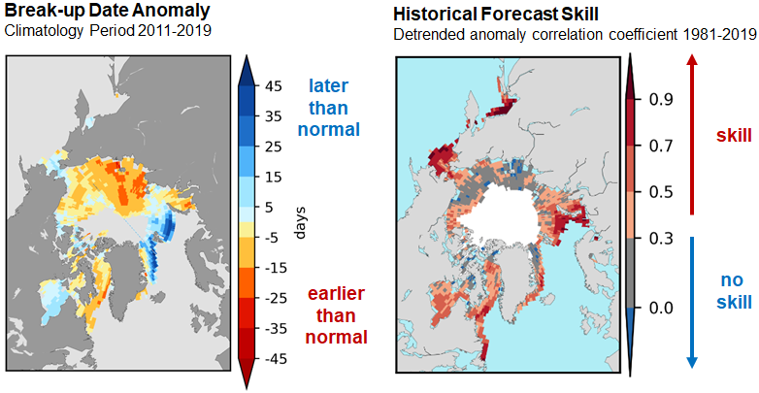
Historical Forecast Skill
Detrended anomaly correlation coefficient 1981-2019

Figure 15: Forecast for the 2021 spring break-up expressed as an anomaly (difference from normal), where break-up is defined as the date when the ice
concentration drops below 50%.
Figure 16: Historical forecast skill defined as the detrended anomaly correlation coefficient based on the 1981-2019 period.

Table 8: Spring 2021 Regional Outlook for Arctic Sea Ice Break-up

Regions  (see Figure 2) | CanSIPSv2 Sea-Ice Forecast Confidence | CanSIPSv2 Sea-Ice Break-up Forecast
Baffin Bay | High | Near normal - northern section  Early – southern section
Barents Sea | High | Near normal
Beaufort Sea | High | Near normal in the west, Early in the east
Bering Sea | High | Near normal to Late
Chukchi Sea | Moderate | Early
East Siberian | Low | Early
Greenland Sea | High | Early
Hudson Bay | High | Near normal
Kara Sea | High | Early
Labrador Sea | High | Early
Laptev Sea | Low | Early

Outlook for September 2021 Minimum Sea Ice Extent
Minimum sea ice extent is achieved each year during the month of September in the northern hemisphere. Table 9 categorizes the sea ice extent forecast confidence and relative extent (i.e. near normal, below normal, above normal) with respect to a 2012-2020 climatology by Arctic region. Figure 17 displays the probabilities of ice presence for concentrations greater than 15% and the forecasted mean ice extent from CanSIPSv2 (black), with the observed median ice extent for the 2012-2020 period in red. The sea ice extent is expected to be near normal for the Beaufort Sea, Chukchi Sea and Greenland Sea; and below normal for the Barents Sea, Canadian Arctic Archipelago, Kara Sea, Laptev Sea and Eastern Siberian Sea.

Table 9: Summer 2021 Regional Outlook for Minimum Sea-Ice Extent
Regions  (see Figure 2) | CanSIPSv2 Sea-Ice Extent Forecast Confidence | CanSIPSv2 Sea-Ice extentForecast
Barents Sea | High | Below normal
Beaufort Sea | High | Near normal
Canadian Arctic Archipelago | Moderate | Below normal
Chukchi Sea | High | Near normal
Eastern Siberian Sea | Moderate | Below normal
Greenland Sea | High | Near normal
Kara Sea | High | Below normal
Laptev Sea | High | Below normal

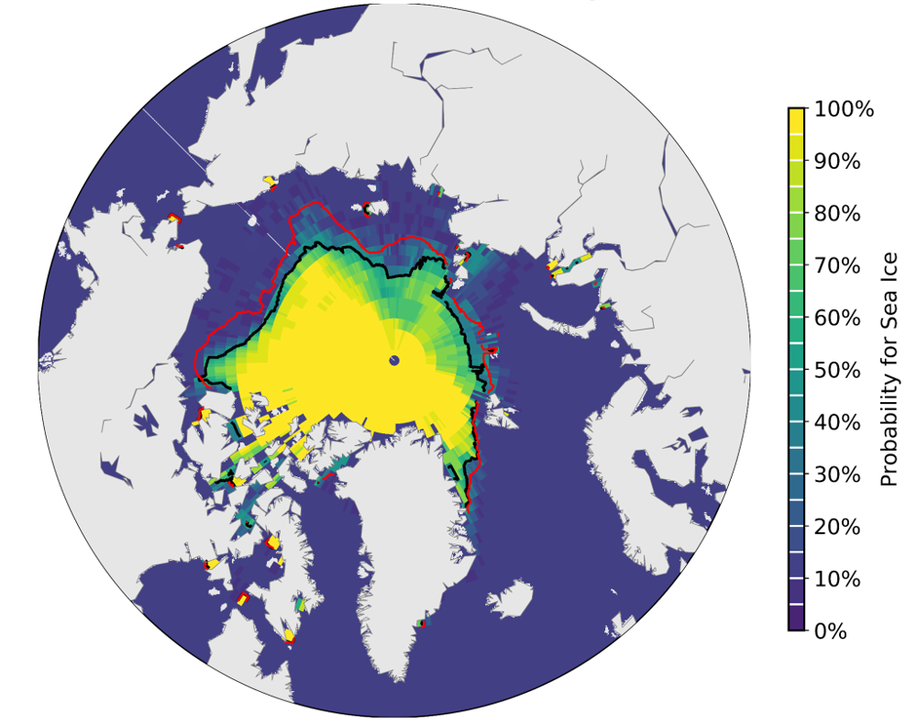

Figure 17: September 2021 probability of sea ice at concentrations greater than 15% from CanSIPSv2 (ECCC). Forecast median ice extent from CanSIPSv2 (black) and observed mean ice edge 2012-2020 (red).

Outlook for Key shipping regions

Bering Sea:
Bering Sea ice extent at the March maximum was the 8th lowest since 1979, but has seen a slow decline during the month of April despite the passage of storms through the area. Some earlier than normal break-up is possible in the eastern Bering Sea due to thinner ice than usual in this sector. The sea is expected to be ice free by the end of June.

Beaufort Sea:
The break-up of sea ice in the western Beaufort is expected to be later than normal due to the presence of multi-year ice.

Recent observations show evidence of this early break-up as the pack ice in the Amundsen Gulf has begun to flush from the basin and observed lower than normal concentrations of sea ice are present in the southeastern Beaufort region. Break-up of sea ice is expected to be earlier than normal for the eastern Beaufort Sea this summer.

Northwest Passage (NWP):
Break-up of sea ice is expected to be earlier than normal throughout the NWP this summer, and areas of consolidated ice will become mobile earlier than normal in the season as has been the case in recent years. Fast ice breakup already ahead of climatological normal in Barrow Strait.

Enhanced mobility of sea ice in the Canadian Arctic Archipelago could maintain elevated old ice concentrations in the NWP, but initial concentrations remain near normal in important sectors such as Larsen Sound and Victoria Strait.

Hudson Bay/Hudson Strait:
Faster than normal sea ice break-up is underway in Hudson Strait and Ungava Bay. Areas of open water are expanding in the northern portion of the strait this spring where thinner ice types predominate.

Near normal break-up is forecasted for the western portion of Hudson Bay and earlier than normal in the eastern section. Signals of this early breakup in the eastern section are emerging as sea ice concentration is anomalously low for spring.

Baffin Bay and Labrador:
Earlier than normal sea ice break-up is forecasted for Baffin Bay this summer in the southern section, due to current lower than normal ice extents in the region and forecasted warmer than normal temperatures in this region. Near normal ice breakup has taken place in the northern section and in Greenland waters.

Record low sea ice observed along the Labrador Coast this past winter, and this pattern extends northward with anomalously low extent along the marginal ice zone in Baffin Bay and Davis Strait. Nares Strait ice bridge warrants monitoring as breakup has been much earlier than normal in recent years. Frobisher Bay ice concentration elevated and may present shipping issues later in season.

Svalbard:
September minimum sea ice extent is forecast below normal, with a high forecast confidence. Thus we do not foresee significant impacts for the shipping activities for the 2021 summer around Svalbard.

East Greenland:
Median sea ice edge was close to 1980-2010 average during winter. Retreat of sea ice up the coast of East Greenland is likely to be late during summer 2021.

Northern Sea Route (NSR):

Current observations show below normal ice conditions, including stages of development. Projected above normal air temperature and ocean heat content is leading to earlier than normal sea ice deterioration.

Landfast ice will break-up earlier than normal by +5 to +15 days.

Light ice conditions are expected with areas of ice massifs lower than normal. Incursions of old ice are not expected, however the greater mobility of the sea ice cover may lead to unexpected ice occurrence and ice compacting.

Overall, ice navigation is not expected to be problematic this summer.

Background and Contributors
This Arctic seasonal climate outlook was prepared for ACF-7. Contents and graphics were prepared in partnership with the Russian, United States, Canadian, Norwegian, Danish, Finnish, Swedish, and Icelandic meteorological agencies and contributions of the former JCOMM Expert Team on Sea-ice, former CCl/CBS Inter-Programme Expert Team on Regional Climate Activities, the GCW, the IICWG, and with input from AMAP.

The ArcRCC-Network, a collaborative arrangement with formal participation by all the eight Arctic Council member countries, is in demonstration phase to seek designation as a WMO RCC-Network, and its products and services are in development and are experimental. For more information, please visit https://arctic-rcc.org/acf-spring-2021

Acronyms:
AARI: Arctic and Antarctic Research Institute
ArcRCC-Network: Arctic Regional Climate Centre Network https://www.arctic-rcc.org/
ACF: Arctic Climate Forum
AMAP: Arctic Monitoring and Assessment Programme
CAA: Canadian Arctic Archipelago
CanSIPSv2: Canadian Seasonal to Inter-annual Prediction System
CCl: WMO Commission for Clilmatology/
CBS: WMO Comission for Basic Systems
CIS: Canadian Ice Service
ECCC: Environment and Climate Change Canada
ECMWF: European Centre for Medium-Range Weather Forecasts
ESS: Eastern Siberian Seas
GCW: Global Cryosphere Watch
GPCs-LRF: WMO Global Producing Centres Long-Range Forecasts
GloSea5: Met Office Global Seasonal forecasting system version 5
HYCOM-CICE: HYbrid Coordinate Ocean Model, Coupled with sea-ICE
IICWG: International Ice Charting Working Group
IOC: Intergovernmental Oceanographic Commission
JCOMM: Joint WMO/IOC Technical Commission on Oceanography and Marine Meteorology
LC-LRFMME: WMO Lead Centre for Long Range Forecast Multi-Model Ensemble
NIC: National Ice Center (United States)
NCAR: National Center for Atmospheric Research
NCAR CFSR: National Center for Atmospheric Research Climate Forecast System Reanalysis
NOAA/NWS/NCEP/CPC: National Oceanic and Atmospheric Administration/National Weather Service/National Centers for Environmental Prediction/Climate Prediction Center (United States of America)
NSIDC: National Snow and Ice Data Center (United States)
MME: Multi-model ensemble
NSR: Northern Sea Route
NWP: Northwest Passage
PIOMAS: Pan-Arctic Ice Ocean Modeling and Assimilation System
RCC: WMO Regional Climate Centre
RCOF: Regional Climate Outlook Forum
WMO: World Meteorological Organization

