Information for Visitors

Meeting Venue
Arctic Regional Climate Centre-Network (ArcRCC-N) meeting will take place 25-27 February 2019, in the Minor Hall, 1st floor, of the Arctic and Antarctic Research Institute (AARI), 38 Bering str., St. Petersburg, Russian Federation (see http://www.aari.ru).
Federal State Budgetary Institution "Arctic and Antarctic Research Institute" (AARI), the oldest polar research institute in Russia (est. 20 March 1920), belongs to Russian Federal Service for Hydrometeorology and Environmental Monitoring (Roshydromet, http://meteorf.ru) and conducts comprehensive research in the Arctic and Antarctic as well as provides operational hydrometeorological services for a variety of customers in Polar Regions.
The building is located in the western part of the city on the Vasilievsky Island, about 300 meters from the underground station “Primorskaya” and at distance of 0.6 km from the recommended ***MFK Gornyi Hotel and at a distance of 1.6 km from the second recommended ****Park Inn by Radisson Pribaltiyskaya Hotel, see attached maps.

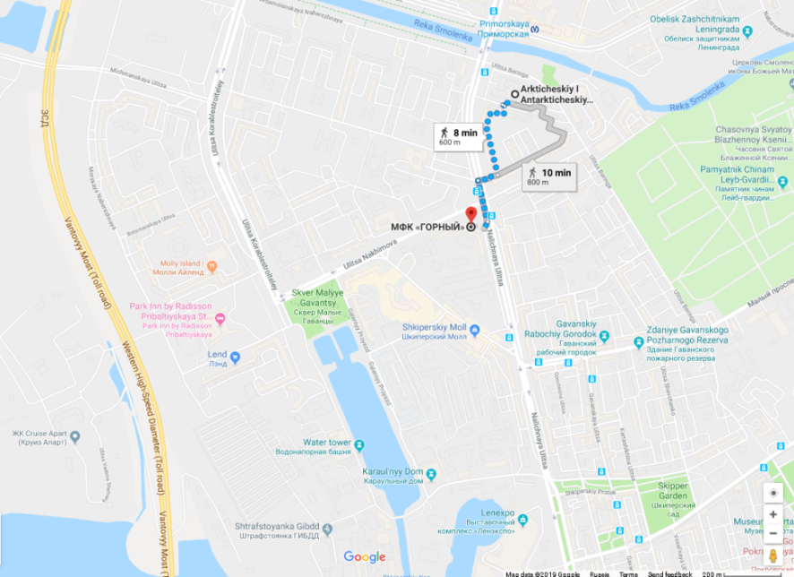

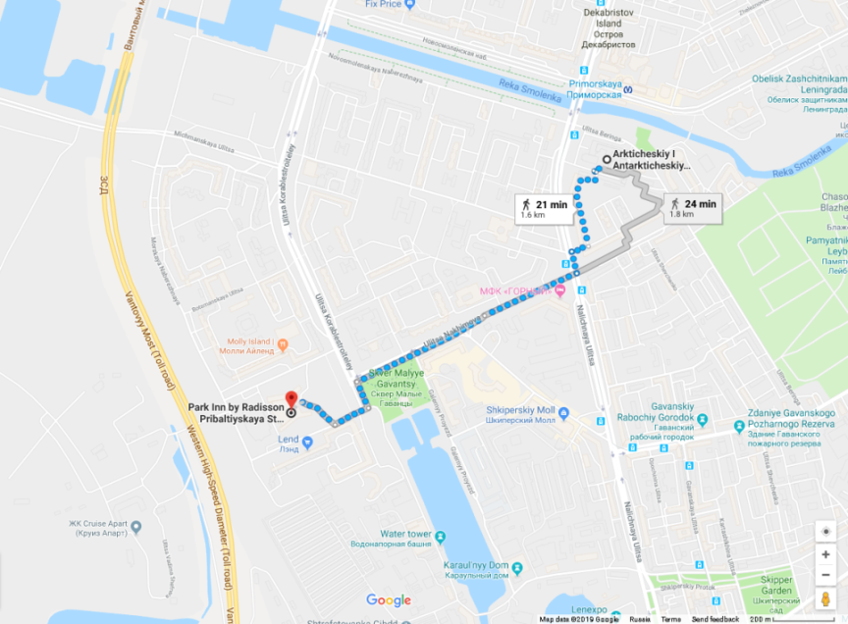

Hotels
Prices for 4 nights stay at **** MFK Gornyi, the first recommended option, start from 249 USD (24-28.02.2019) – see https://mfk-gornyi.ru/en/ or e.g. booking.com.

Prices for 4 nights stay at **** Park Inn by Radisson Pribaltiyskaya Hotel, the second recommended option, start from 211 USD (24-28.02.2019) – see https://www.parkinn.com/hotelpribaltiyskaya-stpetersburg or e.g booking.com.
Both hotels are in walkable distance from the meeting place and provide airport shuttle service.
There are plenty of other very good options to stay in the center of St.Petersburg, however, due to traffic jams in the morning, the reliable recommended transportation from the hotels in the central poart of the city to the institute will be St.Petersburg metro and not the ground transport.

Reception and no host dinner
Reception on Monday evening, 25 February will be held inside AARI.
«Austeria» restaurant proposed for no-host diner on Tuesday evening, 26 February, is located in a authentic building of mid 18th century inside the Peter and Paul Fortress, in the center of St.Petesrsburg.

Airport
St.Petersburg Pulkovo (LED) international airport is located to the south the city and is about 25 km to the AARI. See https://pulkovoairport.ru/en/ for additional information on the Pulkovo airport facilities. The newly built western highway is very close to both recommended hotels and the institute so we highly recommend to use the hotel shuttle or take a taxi from the airport to the recommended hotels (should be app. 25-30 USD/1500-2000 RUB), about 20-30 minutes, contact taxi desk at the arrival section.
Public transportation is also an option, will include bus, metro, bus or tram and take about 80 – 90 minutes, cost 2-3 USD/125 RUB.

Transportation
Ground local transport (http://www.visit-petersburg.ru/en/) includes buses, trams and trolleybuses. Petersburg ticket costs 40 rubles. Ground transport is working 6.00 - 0.00-0.30. The route is usually painted on board the vehicle - on the plate number. In general, citizens travel mainly on route taxis. On the commercial routes operate minibuses and large buses with index «K», «T» or «E» in the composition of numbers. They run frequently and in all corners of the city, fares are close to 40 rubles.
Petersburg metro (http://www.visit-petersburg.ru/en/transport/198703/) - the deepest in the world: as the city stands on a swamp, tunnels were digged in the thick Cambrian clay to a depth of 110 m. The halls of old stations designed luxurious: marble and granite columns and bas-reliefs, mosaics and sculptures. There are several stations where the road separated from the platform with automatic sliding. To orient in your own in the subway is very easy: for each station, there are many signs and circuit lines. One travel costs 45 rubles. Metro - the most reliable transportation Petersburg, there are no traffic jams and accidents are extremely rare. However, during peak hours there is a serious jam at the entrance to the station and in the cars. Subway trains run with the interval of 2 to 3 minutes, but from 8:00 a.m. to 10:00 a.m. and from 5:00 p.m. to 7:00 p.m. on the weekday, the coaches may be overcrowded. Long-distance transportation is available from one of the 5 Railway Stations, with Finland railway station serving also routes to Helsinki (3 hours) and Moscow railway station to Moscow (4-8 hours) and southern Russia.

Electricity
The electric power system of the city is: AC current, 220V voltage, current frequency 50Hz, plug-and-socket connection with two circular joints.

Money
The Russian currency is the Russian ruble (RUB) and kopecks. In January 2019:
1 USD = 65.93 RUB
1 EUR = 75.19 RUB
In addition to the hotels, an ATM machine is located on the ground floor of the AARI.
All major credit cards are accepted in most the places. Most restaurant, taxi and similar bills already incorporate some form of service charge, so additional tipping is not obligatory. Nevertheless, tips are always welcome, 10% of the bill is suggested.

Internet facilities
Wi-Fi connection is available in the meeting room inside AARI.
Wi-Fi and 2G-4G mobile connections should be available in the hotels, metro and through the city.

History and tourist guides
Saint Petersburg (Russian Sankt Peterburg), second largest city and largest seaport in Russia, located in the northwestern part of the country, at the head of the Gulf of Finland (an arm of the Baltic Sea). The capital of Russia for two centuries (1712-1918), Saint Petersburg is one of the most beautiful cities in Europe, noted for its lavish palaces and grand cathedrals, including the Winter Palace (Hermitage), the Russian Museum, St.Issak and Kazan Cathedrals etc. It is also a major rail junction and an industrial, cultural, and scientific center. The city is located on both banks of the Neva River and on a number of river islands….. See www.visit-petersburg.ru/en/

Climate and geography
St. Petersburg is the northernmost major city of the world. It is located at 59° 57' Latitude North, 30° 19' Longitude East (Pulkovo meridian). The climate is humid, close to maritime, with a moderately warm summer and a rather long moderately cold winter. The average winter temperature is -8°C, the average summer temperature is +17.8°C. The temperature may significantly vary in winter from +5°C to -30°C. Precipitation reaches 550-600 mm per year.
The Neva River is the city's main waterway. The name of the river derives from the ancient name of Lake Ladoga, the Neva where it begins. The Neva is 74 kilometers long, flowing 32 kilometers within the city boundaries. The average width of the Neva within the city is 600 meters, depth - up to 24 meters. In the delta, the Neva splits into three main branches: the Bolshaya Neva, the Malaya Neva and the Bolshaya Nevka.
The city is located on 44 islands formed by the Neva River and 90 more rivers and canals. The abundance of islands has led to the construction of a multitude of bridges. Of these, nowadays there are 308 within the city proper, and 5-34 if suburbs are included. 22 of the bridges are drawbridges. The total length of all the bridges is about 16 kilometers. The longest bridge across the Neva is the Alexander Nevsky Bridge (909 meters with runways), the widest bridge is the Siniy Bridge on the Moika River (99.5 meters).
The highest elevation equals 42 meters above the sea level (Poklonnaya Gora). Floods occur frequently in the city Most often they happen in autumn due to strong westerly winds. In the history of the city the Neva has risen above ordinary level more than 300 times. A water-meter was built near the Mining Institute in 1877. A flood is registered if the water rises 180 cm above the normal level. The biggest flood was on November 7 1824 when the water rose 4.1 metres above the ordinary level.

Weather and 5 days forecast
Expected weather conditions are -10…0, cloudy, snow.
For actual weather and 3-5 days forecasts see http://www.meteo.nw.ru/ (NW branch of Roshydromet) or Hydrometcenter Moscow (https://meteoinfo.ru/en/pogoda-eng/russia/leningrad-region/sankt-peterburg).

Local contacts
Ms Elena Berezina  Department of international cooperation  Tel. +7 (812) 337-3155 (office)  +7 (921) 345-1916 (mobile)  E-mail: berezina@aari.ru | Dr Vasily Smolyanitsky  Head of laboratory for sea ice climate manuals  WMO/IOC JCOMM chair  Tel. +7(812) 337-3149 (office/mobile)  +7(951)654-4196 (mobile)  Skype: vasily.smolyanitsky  E-mail: vms@aari.aq

