Summary statement:

Temperature: The June to August 2018 average surface air temperature anomalies were above average for most of the Arctic domain, with the exception of parts of the Canadian Arctic and central Greenland, where anomalies were negative.

Precipitation: Precipitation between June and August 2018 was slightly below average over the Arctic region.

Sea ice: The Northern Hemisphere summer 2018 minimum sea ice extent was the 6th on record since 1979. High spatial variability in sea ice conditions between the Canadian and Eurasian Arctic was observed during the entire 2018 summer period.

Terrestrial Arctic Snow: Snow accumulation during the 2017/18 winter (up to June 2018) was above average across both the North American and Eurasian Arctic.

Temperature

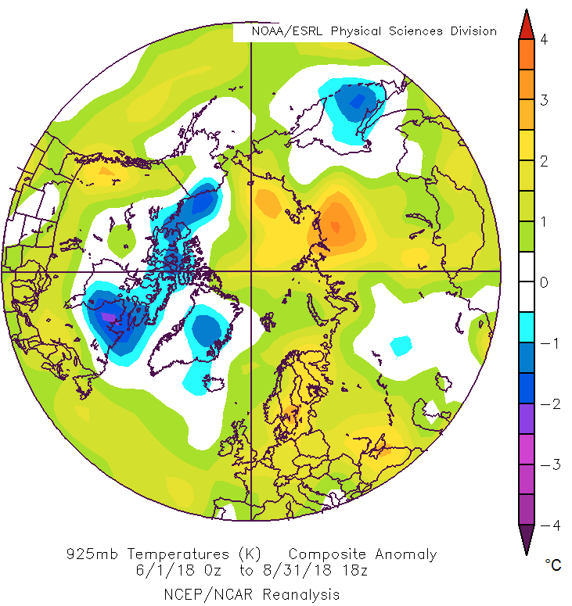
Figure 1: June, July, August 2018 925 mb temperature anomaly based on the 1981-2010 reference period from NCEP/NCAR Reanalysis. The 925 mb temperature anomaly is representative of surface conditions.
Last season: The June, July, and August (JJA) 2018 average surface air temperature in the Arctic domain north of 65°N ranged between the highest (eastern Siberia) to the 17th highest (Canadian Arctic) warmest summer since 1949. The JJA 925 mb temperature anomalies (Figure X) were average or above average for most of the Arctic domain, with the exception of parts of the Canadian Arctic and central Greenland, where anomalies were negative.

Data from NCEP/NCAR reanalysis was also used to rank the 2-m surface temperatures since 1949. Between May and September 2018, most of Scandinavia, northern Siberia, the Arctic Ocean, the Chukchi and Beaufort Seas, as well as the North Pole experienced their warmest year since 1949, while parts of the eastern Canadian Arctic and southern Greenland experienced their coldest temperatures since 1949.

Precipitation

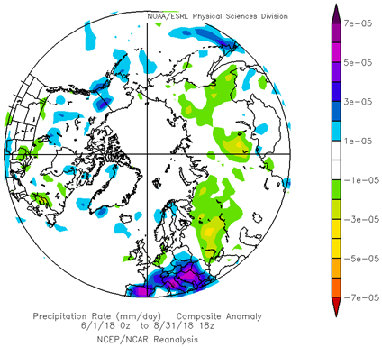
Figure 1: June, July, August 2018 precipitation anomaly based on the 1981-2010 reference period from NCEP/NCAR Reanalysis.
Last season: For the JJA 2018 time period, lower than average precipitation was observed over the Siberia (yellow and green areas), while close to normal and slightly above average values were observed in Atlantic, the Northern European and Canadian Arctic regions (blue areas) (Figure X). Taken as a whole however, the Arctic region experienced lower than average precipitation for that same time period. Data from NCEP/NCAR reanalysis was also used to rank precipitation since 1949. The Chukchi Sea region and northwestern Siberia saw their driest summer since 1949.

Sea Ice

Last season: The summer 2018 minimum sea ice extent was reached on September 16, 2018, making 2018 the 6th minimum sea ice extent since 1979 (Figure X). Estimates of the sea ice volume, based on numerical reanalysis (HYCOM-CICE, PIOMAS), show similar 6th minimum in row from 1979 and higher ice thicknesses in comparison to 2017. A precursor of higher sea ice thicknesses in the Central Arctic could be higher precipitation during pre-melt season (April).

High spatial variability in sea ice conditions between the Canadian and Eurasian Arctic was observed during the entire 2018 summer period. Sea ice extent for the Canadian Arctic was higher than the last decade’s median extend, with the Northwest Passage remaining blocked for ice free navigation. Simultaneously, parts of the Eurasian Arctic (southeastern Barents, Kara, and Eastern Siberian Seas) showed close to the 1998-2017 median ice coverage until the middle of July, with further extreme low sea ice extent in the most parts of this region until the end of September.

Until the end of October 2018, persistent strong westerly winds (North Atlantic Oscillation index – NAO >0) continued to generate a positive surface air temperature anomaly over the Eastern and Central Arctic (with the exception of the Canadian archipelago and the Hudson Bay regions); slowing the sea ice formation process in those areas.

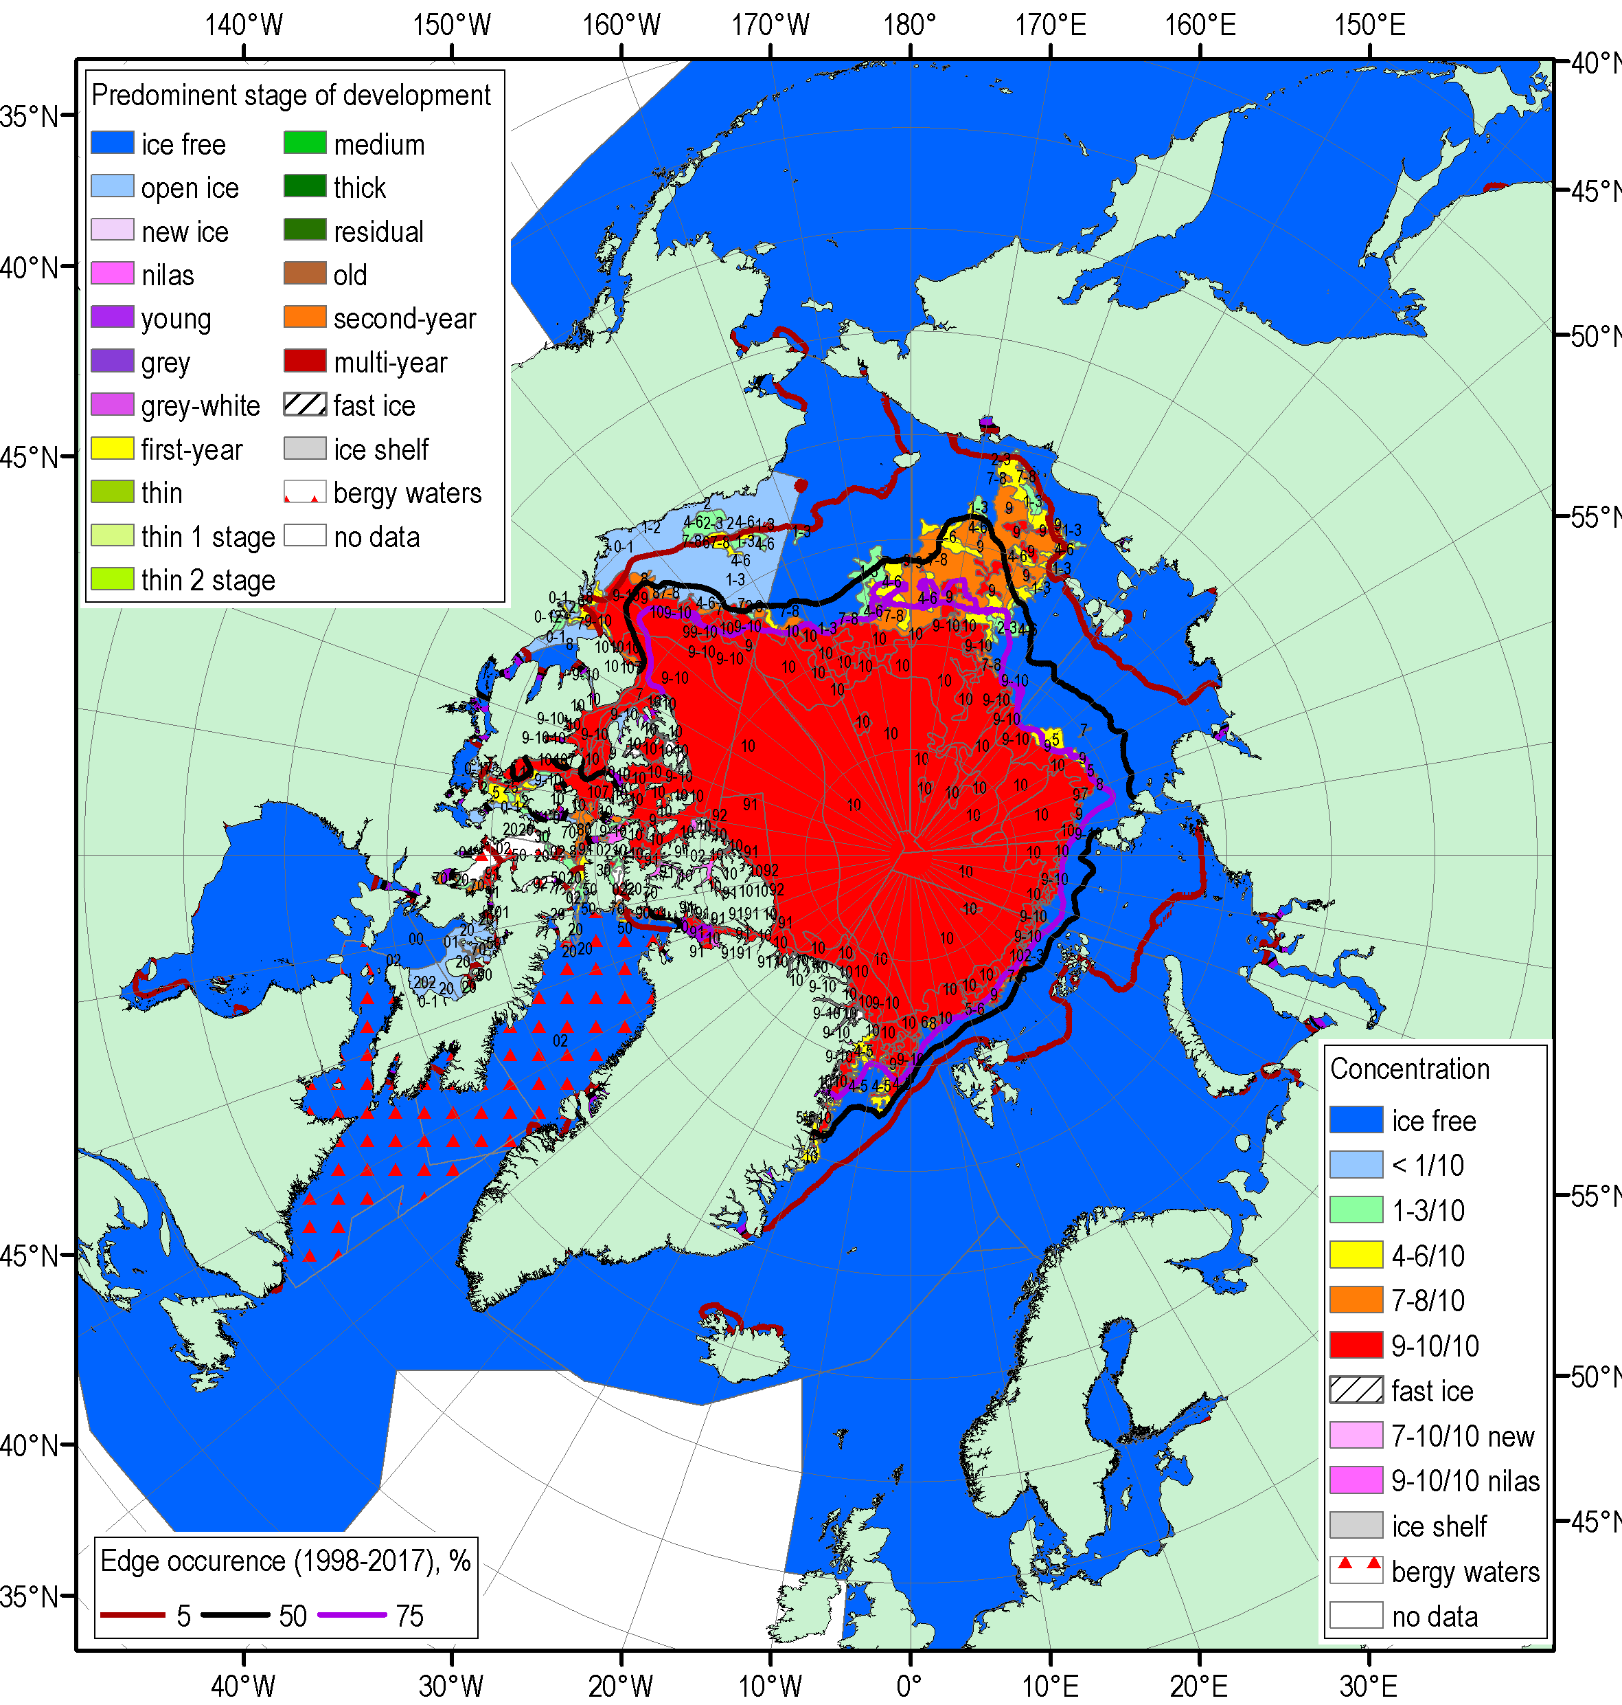
Figure 5: Blended Arctic ice chart (AARI, CIS, NIC) for 17-20 September 2018 and ice edge occurrences for 16–20 September for 1998–2017.

Terrestrial Arctic Snow

Pre-summer 2018 period: Snow accumulation during the 2017/18 winter (till June 2018) was above average across both the North American and Eurasian Arctic, consistent with an early start to the snow season in the fall (therefore a longer accumulation period) and above-average winter snowfall.
Snow cover extent for Eurasia was above average during April, slightly above average for May, and below average by June (relative to the 1981-2010 average). This month-to-month change is consistent with unusually high early spring accumulation combined with rapid late spring snow loss. Despite relatively high spring snow accumulation and snow cover extent over the Arctic during the previous two spring seasons, long-term trends remain negative.

Data from the Snow Watch/WMO GCW was used to summarize terrestrial Arctic snow conditions.

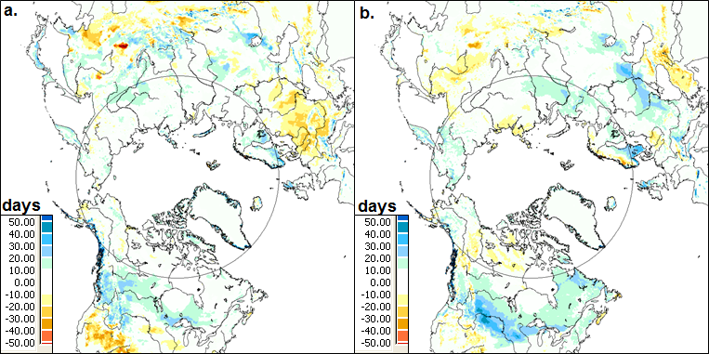
Figure X: Snow cover duration (SCD in days) departures (difference from 1998-2010 mean) for the 2017-2018 snow year: (a) fall; and (b) spring. The grey circle marks the latitude 60° N. Source: NOAA IMS data record. [2018 Arctic Report Card, L. Mudryk, R. Brown, C. Derksen, K. Luojus, and S. Helfrich].

