Arctic Regional Climate Centre Consensus Statement

2020 Arctic Winter Seasonal Summary and 2020 Arctic Summer Seasonal Outlook

CONTEXT
Arctic temperatures continue to warm at more than twice the global mean. Annual surface air temperatures over the last 4 years (2014-2018) in the Arctic have been the highest on record since 1900. The extent of winter sea-ice is at record low levels, and the volume of Arctic sea-ice present in the month of September has declined by more than 50% compared to the mean value for 1979-2018¹. To support Arctic decision makers in this changing climate, the new Arctic Regional Climate Centre (ArcRCC) Network now provides climate consensus statements in May prior to summer thawing and sea-ice break-up, and in October before the winter freezing and the return of sea-ice. The role of the ArcRCC is to collaborate amongst Arctic meteorological and ice services to synthesize observations, historical trends, forecast models and fill gaps with regional expertise to produce these climate consensus statements. These consensus statements provide a review of the major climate trends of the previous season, and outlooks for the upcoming season for temperature, precipitation and sea-ice. They are released at Arctic Climate Forums (ACFs) with Arctic users in May, and through a virtual on-line ACF in October.

HIGHLIGHTS

The strong positive surface air temperature anomaly (warmer than normal) over Eurasia and the Arctic Ocean contributed to below to near normal ice conditions observed in winter 2020 (February, March, and April: FMA) across the entire Arctic region. The range of confidences in the forecast for above normal temperatures and wetter-than-average conditions across the different Arctic regions between June and August 2020 are contributing to the spatial variability in spring break-up and minimum sea ice extent forecast for the summer of 2020.

Temperature: The winter 2020 average surface air temperatures ranged from lower than normal in the western hemisphere to higher than normal in the eastern hemisphere, with Siberia experiencing one of its warmest FMA on record. Above normal temperatures are expected to continue across the majority of the Arctic regions between June and August 2020.

Precipitation: Wetter than average conditions during winter 2020 were observed across the majority of the Arctic region. Only a few isolated areas, including the northeastern coast of Greenland, northern Canada, and a small swath over southern Alaska, experienced drier than average conditions. Wetter than normal conditions are expected to continue across Alaska, and portions of the Chukchi, Eastern Siberia, and northern Canadian regions.

Sea-ice: The Northern Hemisphere March 2020 maximum sea-ice extent was the 11th lowest since 1979. Earlier than normal spring break-up is expected for the majority of the regions across the Arctic, with the exception the Barents Sea, Greenland Sea, and the eastern half of Hudson Bay, where a later than normal spring break-up is expected. For the 2020 minimum sea ice extent, below normal conditions are forecast for the Beaufort Sea, Canadian Arctic Archipelago, Chukchi Sea, East Siberian Sea, Kara Sea and Laptev Sea, while above normal conditions are forecast for the Barents and Greenland Seas.

Understanding the Consensus Statement
This consensus statement includes a seasonal summary and forecast verification for temperature, precipitation, and sea-ice for previous 2020 Arctic winter season (February, March, and April 2020). This statement also includes an outlook for the upcoming 2020 Arctic summer season (June, July, and August 2020). Figure 1 shows the regions that capture the different geographic features and environmental factors influencing temperature/precipitation. Figure 2 shows the established shipping routes and regions used for the sea-ice products.
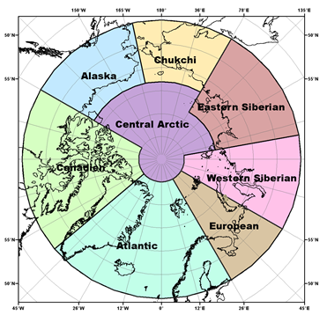
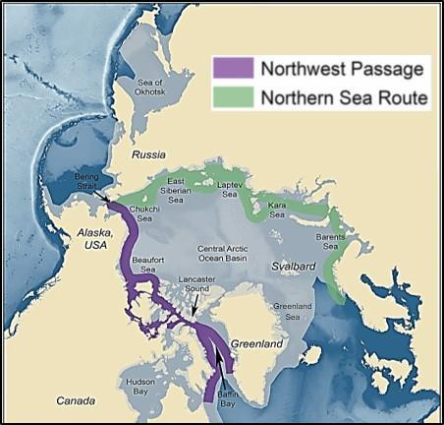
Figure 1: Regions used for the seasonal summary and outlook of temperature and precipitation
Figure 2: Sea-Ice Regions. Map Source: Courtesy of the U.S. National Academy of Sciences.

The temperature and precipitation forecasts are based on eight WMO Global Producing Centers Long-Range Forecasts (GPC-LRFs) models. In terms of models’ skill (i.e. the ability of the climate model to simulate seasonal climate), a multi-model ensemble (MME) approach essentially overlays all of the separate model performances. This provides a forecast with higher confidence in the regions where separate models agree (regions where models have the same result), versus a low confidence forecast in the regions where the models don’t agree. The multi-model ensemble approach is a methodology reputed as providing the most reliable objective forecasts.

The sea ice extent and experimental freeze-up forecasts are based on the Canadian Seasonal to Inter-annual Prediction System (CanSIPSv2), an MME of two climate models. A larger multi-model ensemble that will include forecasts from the following WMO GPC-LRFs is under development: ECCC/MSC (CanSIPSv2), NOAA (CFSv2), Meteo-France (System 5), UK MetOffice (GloSea5) and ECMWF (SEAS5). When sea ice extent is at its minimum in September of each year, forecasts are available for the following peripheral seas where there is variability in the ice edge: Barents Sea, Beaufort Sea, Canadian Arctic Archipelago, Chukchi Sea, Eastern Siberian Sea, Greenland Sea, Kara Sea, and Laptev Sea. In addition to these regions, forecasts for sea ice break-up are also available for Baffin Bay, Bering Sea, East Siberian Sea, Kara Sea, Laptev Sea, Chukchi Sea, Barents Sea, Greenland Sea, Hudson Bay, and Labrador Sea. Summer outlooks for key shipping areas are provided by the Canadian and Finnish ice services, and are based on statistical model guidance and forecast expertise.
TEMPERATURE
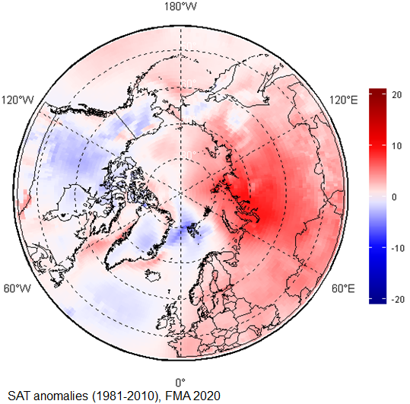
Summary for Winter 2020:
The February, March, and April (FMA) 2020 average surface air temperatures in the Arctic north of 65°N ranged from higher than normal in the eastern hemisphere, to lower than normal in the western hemisphere (Figure 3). Scandinavia and the majority of the Eastern and Western Scandinavia regions experienced warmer than normal conditions (red areas in Figure 3), while the majority of Canada, Alaska, Greenland, and the North Atlantic Ocean experienced near normal (white areas in Figure 3) or slightly below normal (light blue areas in Figure 3) conditions. Using data from NCEP/NCAR reanalysis to rank the average surface air temperature, the boundary between Eastern and Western Siberia saw their fifth warmest FMA period, on average, since the start of the record in 1949 (not shown).
Figure 3: February, March, and April (FMA) 2020 surface air temperature anomaly based on the 1981-2010 reference period. Red indicates warner than normal termperatures, and blue indicates cooler than normal temperatures. Map produced by the Hydrometcenter of Russia https://meteoinfo.ru/ Data source: ERA-5.

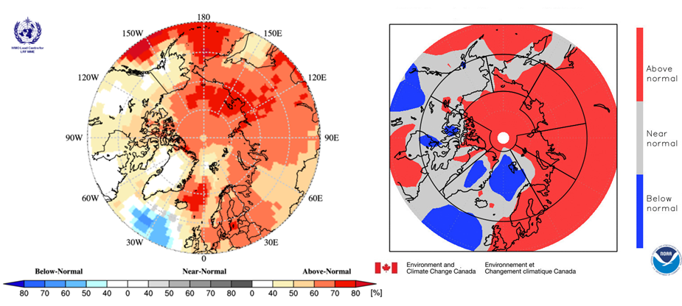
Figure 4: Left) Multi-model ensemble (MME) probability forecast for Surface Air Temperatures:February, March, and April 2020. Three categories:below normal (blue), near normal (grey), above normal (red); no agreement amongst the models is shown in white. Source: www.wmolc.org. Right): NCAR (National Center for Atmospheric Research) Climate forecast System Reanalysis (CFSR) for air temperature for February, March, and April 2020.

The FMA 2020 temperature forecast was verified by subjective comparison between the forecast (Figure 4, left) and re-analysis (Figure 4, right), region by region. A re-analysis is produced using dynamical and statistical techniques to fill gaps when meteorological observation are not available.

Above-normal surface air temperatures over the European, Eastern Siberia, Western Siberia, and Central Arctic regions were accurately forecast for the JFMA 2020 season (Figure 4, Table 1). Over the Atlantic region, the forecast accuracies were variable but near-normal temperatures over Iceland and parts of Greenland were accurately forecast. The observed near-normal temperatures over Alaska and the majority of Canada (grey areas on Figure 4, right) were not accurately forecast. Similarly, the observed below-normal temperatures over the Norwegian Sea and parts of Greenland (blue areas on Figure 4, right) were not accurately forecast. As a general conclusion, the multi-model ensemble forecast was accurate for approximately 50-60% of the Arctic territory.

Table 1. Winter 2020: Regional Comparison of Observed and Forecasted Arctic Temperature
Regions  (see Figure 1) | MME Temperature Forecast Agreement | MME Temperature Forecast | NCAR CFSR Reanalysis (observed) | MME Temperature Forecast Accuracy
Alaska | Low | Above normal | Near normal | Low
Chukchi | High | Above normal | Above to near normal | Moderate
Eastern Siberia | High | Above normal | Above normal | High
Western Siberia | High | Above normal | Above normal | High
European | Moderate | Above normal | Above normal | High
Atlantic | Moderate | Mostly near normal | Above normal (Scandinavia only) | Moderate
Canada | Low | Above normal | Near to below normal | Low
Central Arctic | High | Above normal | Above normal | High

Outlook for Summer 2020:
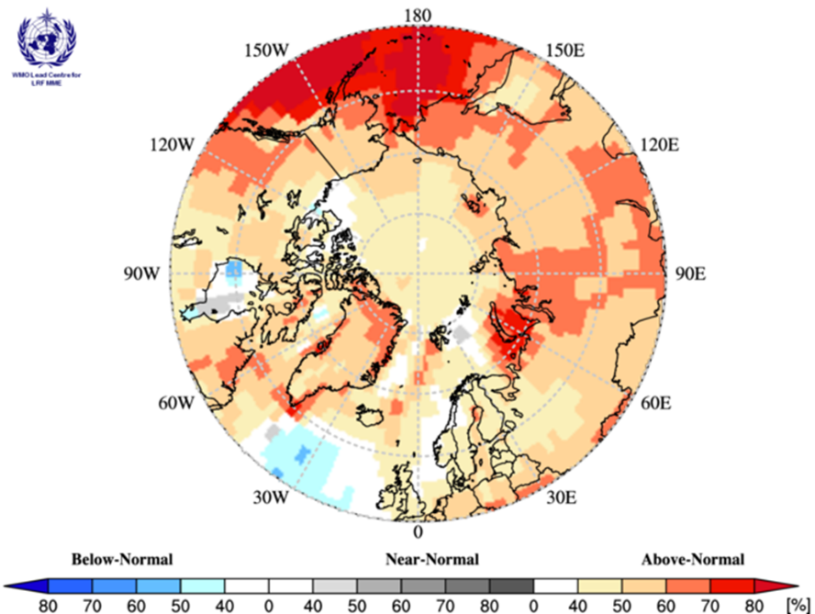
Surface air temperatures during summer 2020 (JJA: June, July, and August 2020) are forecast to be above normal across the majority of the Arctic regions (orange and red areas in Figure 5). The confidence of the forecast is low to moderate over the majority of the continental Arctic (land areas) (yellow and orange areas in Figure 5, Table 2), while forecast confidences are high for the maritime parts of the Atlantic region, the Bering Sea, and a portion of the Barents and Kara Seas (dark red areas in Figure 5, Table 2). The multi-model ensemble did not agree over a few maritime areas across the Arctic (white areas in Figure 5).
Figure 5: Multi model ensemble probability forecast for surface temperature for June, July, and August 2020. Three categories: below normal (blue), near normal (grey), above normal (red) and no agreement amongst the models (white). Source: www.wmolc.org.

Table 2. Summer (JJA) 2020 Outlook: Regional Forecasts for Arctic Temperatures
Region  (see Figure 1) | MME Temperature Forecast Agreement* | MME Temperature Forecast
Alaska | Moderate | Above normal
Chukchi | High | Above normal
Eastern Siberia | Moderate | Above normal
Western Siberia | Moderate | Above normal
European | Moderate | Above normal
Atlantic | Moderate | Above normal
Canada | Low to moderate | Above normal (below for Hudson Bay)
Central Arctic | Low to moderate | Above normal
*: See non-technical regional summaries for greater detail

PRECIPITATION
Summary for Winter 2020:
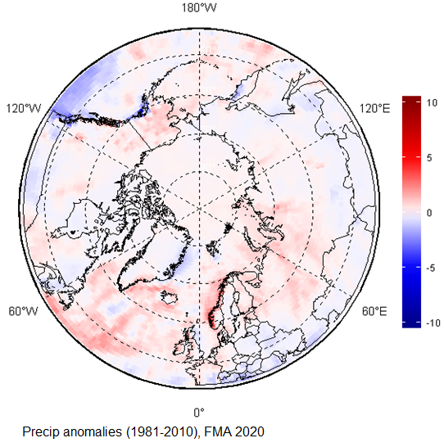
Wetter than average conditions were observed during the winter 2020 (February, March, and April: FMA) across the majority of Arctic region (red areas in Figure 6). Only a few isolated areas, including the northeastern coast of Greenland, northern Canada, and a small swath over southern Alaska, experienced drier than average conditions (blue areas in Figure 6).

The FMA 2020 precipitation forecast was verified by subjective comparison between the forecast (Figure 7, left) and re-analysis (Figure 7, right), region by region. As for temperature, precipitation re-analysis is produced using statistical techniques to fill gaps when meteorological observation are not available.
Figure 6. February, March, and April (FMA) 2020 precipitation based on the 1981-2010 reference period. Red indicates wetter than normal conditions, and blue indicates drier than normal conditions. Map produced by the Hydrometcenter of Russia https://meteoinfo.ru/ Data source: ERA-5.

Above-normal precipitation over the majority of the Arctic were accurately forecast for the FMA 2020 season (Figure 7, Table 3). The only exception was the Chukchi area, where observed near-normal precipitation were inaccurately forecast. There was no agreement amongst the models over the Eastern Canada and Central Arctic region (predominance of white areas over those regions). As a general conclusion, the multi-model ensemble forecast was accurate for approximately 70% of the Arctic territory.

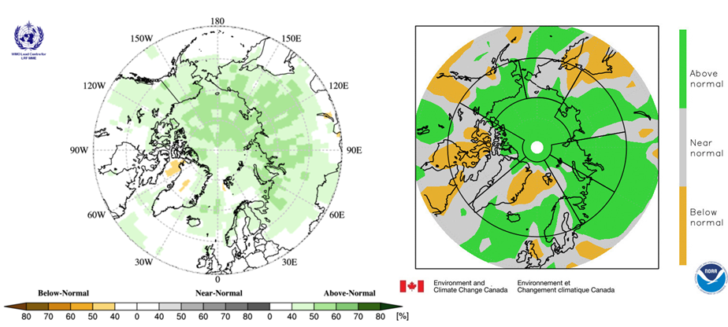
Figure 7: Left) Multi-model ensemble (MME) probability forecast for precipitation: February, March, and April 2020. Three categories:below normal (brown), near normal (grey), above normal (green); no agreement amongst the models is shown in white. Source: www.wmolc.org. Right): NCAR (National Center for Atmospheric Research) Climate forecast System Reanalysis (CFSR) for precipitation for February, March, and April 2020.

Table 3. February, March, April 2020: Regional Comparison of Observed and Forecasted Arctic Precipitation
Regions  (see Figure 1) | MME Precipitation Forecast Agreement | MME Precipitation Forecast | NCAR CFSR Reanalysis (observed) | MME Precipitation Forecast Accuracy
Alaska | Moderate | Above normal | Above normal | High
Chukchi | Moderate | Above normal | Near normal | Low
Eastern Siberia | Moderate | Above normal | Above normal | High
Western Siberia | Moderate | Above normal | Above normal | High
European | Moderate | Above normal | Above normal | High
Atlantic | Moderate | Above normal (continental regions only) | Above normal (continental regions only) | High
Canada | No agreement | No forecast | Near normal in the south and west, below in the center | N/A
Central Arctic | No agreement | No forecast | N/A | N/A

Outlook for Summer 2020:
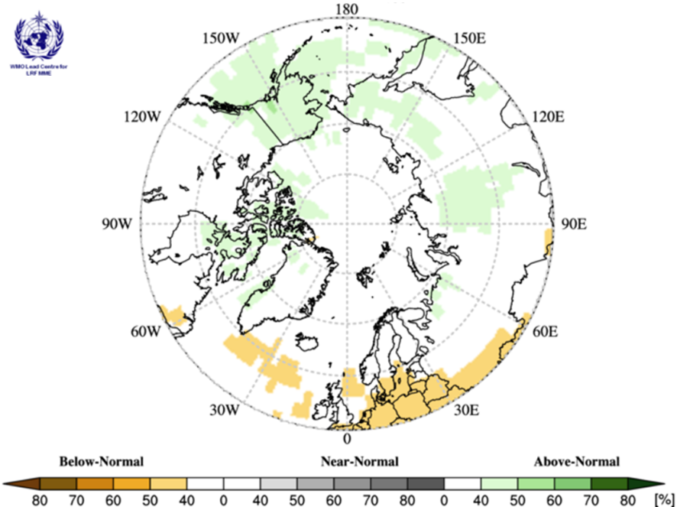
Precipitation during summer 2020 (JJA: June, July, and August 2020) is forecast to be above normal over Alaska, and portions and the Chukchi, Eastern Siberia, and northern Canadian region; the confidence of the forecast is low (light green areas in Figure 8). A low confidence for below normal conditions is forecasted for a portion of Northern Atlantic (light orange areas in Figure 8). The multi-model ensemble did not agree over the remainder of the Arctic region (white areas in Figure 8).
Figure 8: Multi model ensemble probability forecast for precipitation for JJA 2020. Green indicates wetter conditions, orange drier conditions and white, no agreement amongst the models. Source: www.wmolc.org.

Table 4. Winter (NDJ) 2019-2020 Outlook: Forecasted Arctic Precipitation by Region
Region  (see Figure 1) | MME Precipitation Forecast Agreement* | MME Precipitation Forecast
Alaska | Low | Above normal
Chukchi | Low | Above normal
Eastern Siberia | Low | Above normal
Western Siberia | No agreement | No forecast
European | No agreement | No forecast
Atlantic | Low | Below normal
Canada | Low | Above normal
Central Arctic | Low | Above normal (near Canada only)
*: See non-technical regional summaries for greater detail

SEA-ICE
Summary for Winter 2019-2020:
Maximum sea-ice extent, volume and thickness is normally reached each year in the Arctic during the month of March (Figure 9). The 5.81 mln km² maximum sea-ice extent reached on March 5, 2020 is the 11th lowest maximum sea-ice extent since 1979, but the highest since 2013.

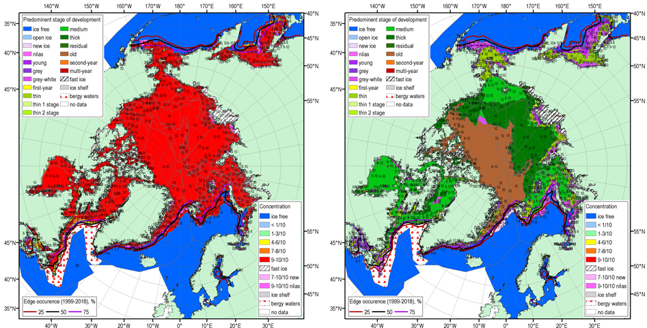
Figure 9: Blended Arctic ice chart (AARI, CIS, NIC) for 16-19 March 2020 and ice edge occurences for 16-20 March for 1999-2018. Left: total concentration, right: predominant stage of development

The forecast for March 2020 sea ice extent (Figure 10) was based on output from CanSIPSv2, an MME of two climate models and verified reasonably well for the Greenland Sea, the Gulf of St. Lawrence, and the Labrador Sea. One region, the Gulf of St. Lawrence had a high forecast accuracy (Table 5). Above normal air temperatures in Davis Strait and over the northern Labrador Coast suppressed ice growth during the past winter, leading to significantly lower ice export from these regions southward along the Labrador Coast and into the northwestern section of the Gulf of St. Lawrence. A near normal temperature regime was observed over the Gulf of St. Lawrence but the lack of sea ice contributions from northern regions led to a lower than normal ice extent for the Gulf. Pronounced warm air temperature and low surface level pressure anomalies over the Barents and Greenland Seas for winter 2019/20 restricted sea ice development, as ice expansion was slowed by the lack of deep, sustained cold and the presence of regular destructive wind events. Relatively normal surface pressure and air temperature patterns over the Bering Sea and the Sea of Okhotsk supported near normal ice coverages.

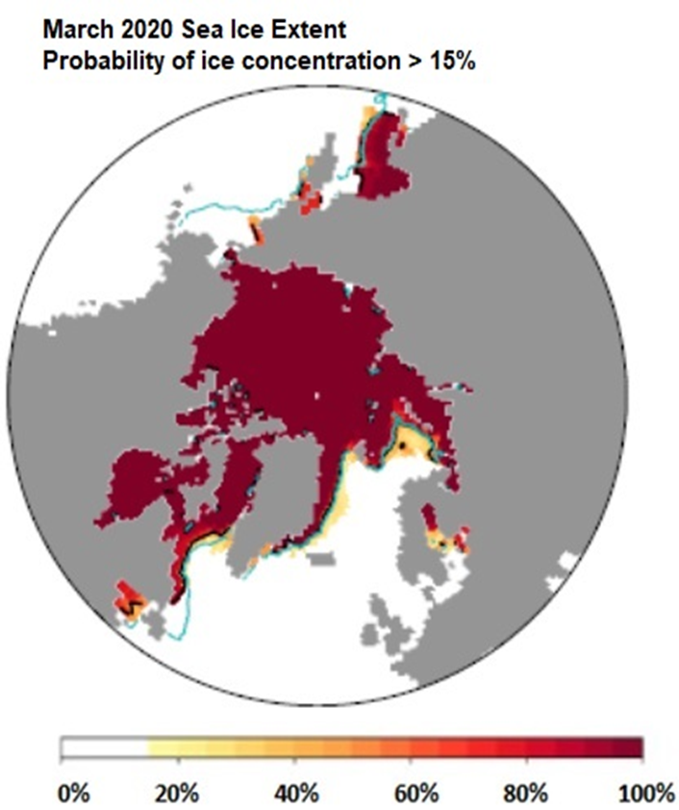
Figure 10: March 2020 probability of sea ice at concentrations greater than 15% from CanSIPS (ECCC). Forecast mean ice extent (black) and observed mean ice extent 2009-2017 (green).

Table 5. Winter 2019-2020: Regional Comparison of Observed and Forecasted Maximum Sea-Ice Extent
Regions  (see Figure 2) | CanSIPS Sea-Ice Forecast Confidence | CanSIPS Sea-Ice Forecast | Observed Ice Extent | CanSIPS Sea-Ice Forecast Accuracy
Bering Sea | Low | Below normal | Normal | Low
Sea of Okhotsk | Low | Below to near normal | Below to near normal | High
Barents Sea | Low | Near normal | Below normal | Low
Greenland Sea | High | Near normal | Below to near normal | Moderate
Gulf of St. Lawrence | Low | Below normal | Below to near normal | High
Labrador Sea | Moderate | Below normal | Below to near normal | Moderate

Outlook for Spring Break-up 2020:
Sea ice break-up is defined as the first day in a 10-day interval where ice concentration falls below 50% in a region. The outlook for spring break-up shown in Figure 11 displays the sea ice break-up anomaly from CanSIPSv2 based on the nine-year climatological period from 2011-2019. The qualitative 3-category (high, moderate, low) confidence in the forecast is based on the historical model skill. Only regions where the model has historical skill are included in the outlook (Figure 12). A summary of the forecast for the 2020 spring break-up for the different Arctic regions is shown in Table 6.

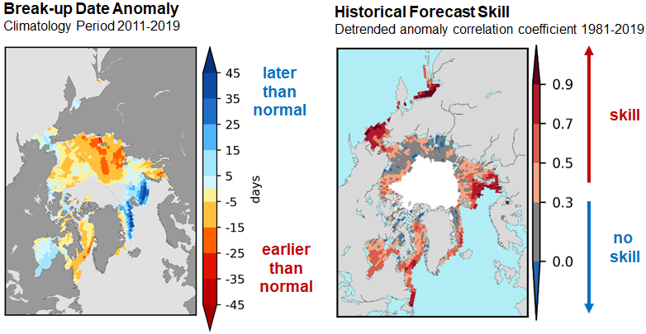
Figure 11: Forecast for the 2020 spring break-up expressed as an anomaly (difference from normal), where break-up is defined as the date when the ice
concentration drops below 50%.
Figure 12: Historical forecast skill defined as the detrended anomaly correlation coefficient based on the 1981-2019 period.

Table 6: Spring 2020 Regional Outlook for Arctic Sea Ice Break-up
Regions  (see Figure 2) | CanSIPSv2 Sea-Ice Forecast Confidence | CanSIPSv2 Sea-Ice Break-up Forecast
Baffin Bay | High | Early
Barents Sea | High | Late in northern section
Beaufort Sea | High | Early
Bering Sea | Moderate | Near normal to late
Chukchi Sea | High | Early
East Siberian | Low | Early southern section, near normal northern section
Greenland Sea | High | Late
Hudson Bay | Moderate | Late eastern half, near normal western half
Kara Sea | Moderate | Early in the west, near normal in the east
Labrador Sea | High | Early
Laptev Sea | Low | Early

Outlook for September 2020 Minimum Sea Ice Extent
Minimum sea ice extent is achieved each year during the month of September in the northern hemisphere. Table 7 categorizes the sea ice extent forecast confidence and relative extent (i.e. near normal, below normal, above normal) with respect to a 2011-2019 climatology by Arctic region. Figure 13 displays the probabilities of ice presence for concentrations greater than 15% and the forecasted mean ice extent from CanSIPSv2 (black), with the observed median ice extent for the 2011-2019 period in red. The sea ice extent is expected to be below normal for the Beaufort Sea, Canadian Arctic Archipelago, Chukchi Sea, East Siberian Sea, Kara Sea and Laptev Sea, and above normal for the Barents and Greenland Seas.

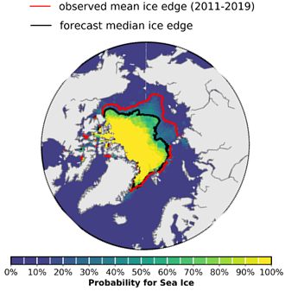  September 2020 sea ice probability of ice concentration > 15% | Regions (see Figure 2) CanSIPSv2 Sea-Ice Extent Forecast Confidence CanSIPSv2 Sea-Ice extentForecast  Barents Sea Low Above normal (northern section)  Beaufort Sea Moderate Below normal  Canadian Arctic Archipelago Moderate Below normal  Chukchi Sea High Below normal  Eastern Siberian Sea Moderate Below normal  Greenland Sea High Above normal  Kara Sea High Below normal  Laptev Sea High Below normal
Figure 13: September 2020 probability of sea ice at concentrations greater than 15% from CanSIPSv2 (ECCC). Forecast median ice extent from CanSIPSv2 (black) and observed mean ice edge 2011-2019 (red).
Table 7: Summer 2020 Regional Outlook for Minimum Sea-Ice Extent

Outlook for Key shipping regions

Northern Sea Route (NSR): Ice conditions are not expected to be problematic for the whole of the NSR during the spring and summer seasons in 2020. Currently observed below normal ice conditions, and projected above normal air temperatures and earlier than normal sea ice deterioration form the basis for this assessment. Light ice conditions will prevail throughout the sector and areas of landfast ice will break-up earlier than normal. Significant incursions of old ice are not expected along the route this summer season.

Northwest Passage: Break-up of sea ice is expected to be earlier than normal throughout the Northwest Passage this summer, and areas of consolidated ice will become mobile earlier in the season than normal. Ice conditions will be light in the southern route of the Northwest Passage in August 2020, with lessening ice conditions following in northern route by early September 2020. Anomalous concentrations of old ice are a potential hazard for the northern route and the western portion of the passage, as higher than normal amounts of old sea ice are present in these areas. Enhanced mobility of sea ice in the Canadian Arctic Archipelago could maintain elevated old ice concentrations in the aforementioned sectors throughout the summer 2020 period.

Baffin Bay: Early than normal sea ice break-up is forecasted for Baffin Bay this summer, due to current lower than normal ice extents in the region and predicted warmer than normal temperatures in the area of interest. Old ice concentrations in the bay are in line with climatological normal, and no specific hazards are anticipated. The presence of an ice bridge in Nares Strait well into this spring has cut off the inflow of old ice from the Arctic Ocean into northern Baffin Bay, thereby maintaining a limited influx of old ice into the region.

Hudson Bay/Hudson Strait: Faster than normal sea ice break-up is underway in Hudson Strait with significant areas of open water expanding in the northern portion of the strait this spring. Projections for ice break-up in Hudson Bay are more delayed than for the Hudson Strait, with near normal break-up expected for the western portion of the bay, and later than normal break-up in the eastern section. Ice thicknesses throughout Hudson Bay are notably thicker this spring than those observed in spring 2019, as predominantly thick first-year ice covers the western and central portions of the bay while in 2019, medium first-year ice comprised a significant fraction of the ice cover. This thicker ice coverage along with forecasted colder than normal surface air temperatures over Hudson Bay could lead to a more challenging navigation season, particularly in the eastern half of Hudson Bay.

Background and Contributors
This Arctic seasonal climate outlook was prepared for ACF-5. Contents and graphics were prepared in partnership with the Russian, United States, Canadian, Norwegian, Danish, Finnish, Swedish, and Icelandic meteorological agencies and contributions of the Expert Team on Sea-ice, an expert team of the Joint WMO/IOC Technical Commission on Oceanography and Marine Meteorology, CCl/CBS Joint Expert Team on Regional Climate Centres, the Global Cryosphere Watch, the International Ice Charting Working Group, and with input from the Arctic Monitoring and Assessment Programme (AMAP).

The ArcRCC is in demonstration phase to seek designation as a WMO RCC-Network, and products are in development and are experimental. For more information, please visit www.arctic-rcc.org.

Acronyms:
AARI: Arctic and Antarctic Research Institute
ArcRCC: Arctic Regional Climate Centre https://www.arctic-rcc.org/
ACF: Arctic Climate Forum
CAA: Canadian Arctic Archipelago
CanSIPS: Canadian Seasonal to Interannual Prediction System
CCl/CBS: Commission for Clilmatology/Comission for Basic Systems
CIS: Canadian Ice Service
ECCC: Environment and Climate Change Canada
ECMWF: European Centre for Medium-Range Weather Forecasts
ESS: Eastern Siberian Seas
GCW: Global Cryosphere Watch
GPC-LRF: Global Producing Centres Long-Range Forecasts
HYCOM-CICE: HYbrid Coordinate Ocean Model, Coupled with sea-ICE https://www7320.nrlssc.navy.mil/GLBhycomcice1-12/arctic.html
IICWG: International Ice Charting Working Group
IOC: Intergovernmental Oceanographic Commission
NIC: National Ice Center (United States)
NCAR: National Center for Atmospheric Research
NOAA/NWS/NCEP/CPC: National Oceanic and Atmospheric Administration/National Weather Service/National Centers for Environmental Prediction/Climate Prediction Center
NSIDC: National Snow and Ice Data Center (United States)
MME: Multi-model ensemble
NSR: Northern Sea Route
NWP: Northwest Passage
PIOMAS: Pan-Arctic Ice Ocean Modeling and Assimilation System
http://psc.apl.uw.edu/research/projects/arctic-sea-ice-volume-anomaly/
RCC: Regional Climate Centre
RCOF: Regional Climate Outlook Forum
WMO: World Meteorological Organization

