Arctic Climate Forum Consensus Statement

2020-2021 Arctic Winter Seasonal Climate Outlook
(along with a summary of 2020 Arctic Summer Season)

CONTEXT
Arctic temperatures continue to warm at more than twice the global mean. Annual surface air temperatures over the last 5 years (2016–2020) in the Arctic (60°–85°N) have been the highest in the time series of observations for 1936-2020¹. Though the extent of winter sea-ice approached the median of the last 40 years, both the extent and the volume of Arctic sea-ice present in September 2020 were the second lowest since 1979 (with 2012 holding minimum records)². To support Arctic decision makers in this changing climate, the recently established Arctic Climate Forum (ACF) convened by the Arctic Regional Climate Centre Network (ArcRCC-Network) under the auspices of the World Meteorological Organization (WMO) provides consensus climate outlook statements in May prior to summer thawing and sea-ice break-up, and in October before the winter freezing and the return of sea-ice. The role of the ArcRCC-Network is to foster collaborative regional climate services amongst Arctic meteorological and ice services to synthesize observations, historical trends, forecast models and fill gaps with regional expertise to produce consensus climate statements. These statements include a review of the major climate features of the previous season, and outlooks for the upcoming season for temperature, precipitation and sea-ice. The elements of the consensus statements are presented and discussed at the Arctic Climate Forum (ACF) sessions with both providers and users of climate information in the Arctic twice a year in May and October, the later typically held online. This consensus statement is an outcome of the 6th session of the ACF held online on 28-29 October 2020 and coordinated by the North American Node of ArcRCC-Network hosted by the United States of America.

HIGHLIGHTS
The combination of an Arctic meridional atmospheric circulation (north-south) and high ocean surface heating this summer (JJA: June, July, August 2020) was the main driver of this past season’s temperature, precipitation and sea ice anomalies. Above normal temperatures forecast for all Arctic regions this winter (November 2020 to December 2021) will continue to have implications for sea-ice over that time period.

Temperature: The summer 2020 average surface air temperatures were above normal for most of the Arctic domain, with Eastern Siberia observing record-breaking temperatures. Above normal temperatures are expected to continue across the majority of the Arctic this winter.

Precipitation: Wetter than average conditions during JJA 2020 were observed across the majority of the Arctic, except for Eastern and Western Siberia (drier than average). Wetter than normal conditions are expected across the majority of the Arctic region this winter.

Sea-ice: The Northern Hemisphere September 2020 minimum sea-ice extent was the 2nd lowest since 1979, with the Eurasian seas and the Northern Sea Route completely ice free while sea-ice conditions in the Beaufort Sea and the Canadian Archipelago were close to normal. Later than normal fall freeze-up is expected for Baffin Bay, East Siberia, and the Kara, Labrador, and Laptev Seas; near normal to early freeze-up is expected for all other regions. Below to near normal 2021 maximum sea ice extent are forecast for majority of the Arctic.
Understanding the Consensus Statement
This consensus statement includes: a seasonal summary and forecast verification for temperature, precipitation, and sea-ice for previous 2020 Arctic summer season (June, July, and August 2020); an outlook for the upcoming 2020-2021 Arctic winter season (November 2020, December 2020, and January 2021). Figure 1 shows the regions that capture the different geographic features and environmental factors influencing temperature/precipitation. Figure 2 shows the established shipping routes and regions used for the sea-ice products.

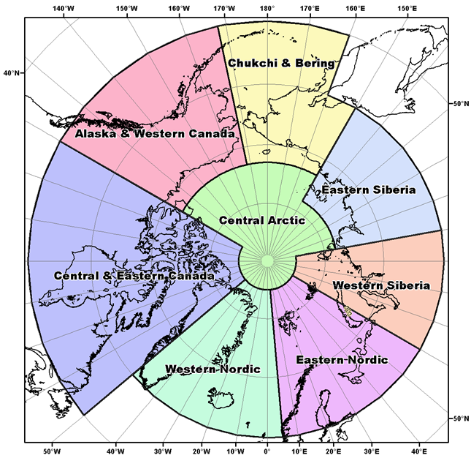 | 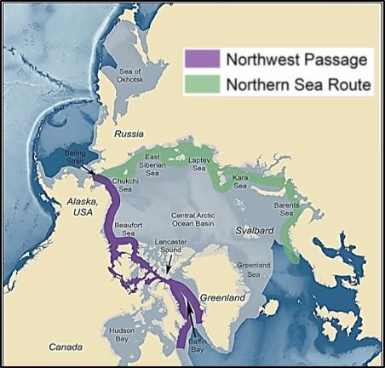
Figure 1: Regions used for the seasonal summary and outlook of temperature and precipitation | Figure 2: Sea-Ice Regions. Map Source: Courtesy of the U.S. National Academy of Sciences

The temperature and precipitation forecasts are based on eight WMO Global Producing Centers of Long-Range Forecasts (GPCs-LRF) models and consolidated by the WMO Lead Centre for Long Range Forecast Multi-Model Ensemble (LC-LRFMME). In terms of models’ skill (i.e. the ability of the climate model to simulate the observed seasonal climate), a multi-model ensemble (MME) approach essentially overlays all of the individual model performances. This provides a forecast with higher confidence in the regions where different model outputs/results are consistent, versus a low confidence forecast in the regions where the models don’t agree. The MME approach is a methodology well-recognized to be providing the most reliable objective forecasts.

The majority of the sea-ice extent and experimental freeze-up forecasts are based on the Canadian Seasonal to Inter-annual Prediction System (CanSIPSv2), an MME of two climate models. The Baltic Sea forecasts are developed using outputs from the ECMWF Long-Range Forecasts, UK MetOffice, and NOAA CFSv2. A larger multi-model ensemble that will include forecasts from the following WMO GPC-LRFs is under development: ECCC/MSC (CanSIPSv2), NOAA (CFSv2), Meteo-France (System 5), UK MetOffice (GloSea5) and ECMWF (SEAS5). When sea-ice extent is at its maximum in March of each year, forecasts are available for the following peripheral seas where there is variability in the sea-ice edge: Barents Sea, Bering Sea, Greenland Sea, Northern Baltic Sea, Gulf of St. Lawrence, Labrador Sea, and Sea of Ohkotsk. In addition to these regions, forecasts for sea-ice freeze-up are also available for Hudson Bay, East Siberian Sea, Kara Sea, Laptev Sea, Chukchi Sea and the Beaufort Sea. Winter outlooks for key shipping areas are provided by the Arctic and Antarctic Research Institute, American, Canadian, Norwegian and Finnish ice services, and are based on statistical model guidance and forecast expertise.

TEMPERATURE
Summary for June, July, and August 2020:
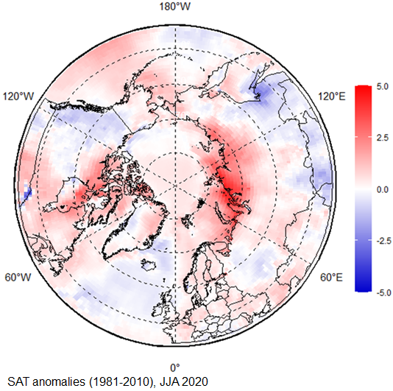
The June, July, and August (JJA) 2020 average surface air temperatures in the Arctic north of 65°N was above normal over most of the region, including Western and Eastern Siberia, the Chukchi and Bering region, and the central part of the Canadian Arctic (red areas in Figure 3). A persistent high atmospheric pressure over the Central Arctic and Eastern Siberia regions through the summer, combined with low atmospheric pressure over the Alaska and Western Canada region (ERA5, not shown here), led to several heat waves in Eastern Siberia in June and July 2020 and record high temperatures in Eastern Siberia (+38 °C at Verkhoyansk on 20 June). In turn, this atmospheric pattern resulted in slightly below normal surface air temperatures over Western Canada and a portion of the Norwegian Sea (light blue areas in Figure 3).
Figure 3: June, July, and August (JJA) 2020 surface air temperature (SAT) anomaly based on the 1981-2010 reference period. Red indicates warner than normal termperatures, and blue indicates cooler than normal temperatures. Map produced by the Arctic and Antarctic Research Institute http://www.aari.ru. Data source: ERA5.

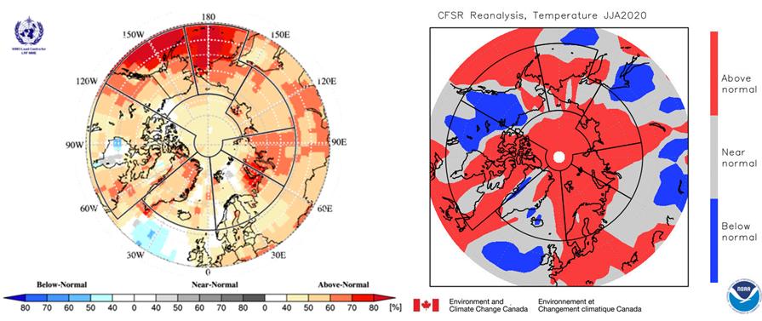
Figure 4: Left) Multi-model ensemble (MME) probability forecast for surface air temperatures: June, July, and August 2020. Three categories: below normal (blue), near normal (grey), above normal (red); no agreement amongst the models is shown in white. Source: www.wmolc.org. Right): NCAR (National Center for Atmospheric Research) Climate forecast System Reanalysis (CFSR) for air temperature for June, July, and August 2020.

The JJA 2020 temperature forecast was verified by subjective comparison between the forecast (Figure 4, left) and re-analysis (Figure 4, right), region by region. A re-analysis is produced using dynamical and statistical techniques to fill gaps when meteorological observation are not available.

Above-normal surface air temperatures over the Eastern Nordic and Eastern Siberia regions were accurately forecast for the JJA 2020 season (Figure 4, Table 1). The forecast accuracies were moderate over the Western Siberia and Chukchi and Bering regions, but the observed above-normal temperatures over the northern part of Western Siberia were accurately forecast. On the other hand, the observed below to near-normal temperatures over Alaska, Canada, and the Western Nordic regions (grey areas on Figure 4, right) were not accurately forecast. As a general conclusion, the multi-model ensemble forecast was accurate for approximately 60% of the Arctic territory.

Table 1. June, July, August 2020: Regional Comparison of Observed and Forecasted Arctic Temperature
Regions  (see Figure 1) | MME Temperature Forecast Agreement | MME Temperature Forecast | NCAR CFSR Reanalysis (observed) | MME Temperature Forecast Accuracy
Alaska and Western Canada | Moderate | Above normal | Below to above normal | Low
Central and Eastern Canada | Low to moderate | Above normal | Below to above normal | Low
Western Nordic | Moderate | Above normal | Near normal | Low
Eastern Nordic | Moderate | Above normal | Above normal | High
Western Siberia | Moderate | Above normal | Above normal in the northern region | Moderate
Eastern Siberia | Moderate | Above normal | Above normal | High
Chukchi and Bering | High | Above normal | Near normal in the west and central | Moderate
Central Arctic | Low to moderate | Above normal | Above normal | High

Outlook for winter 2020-2021:
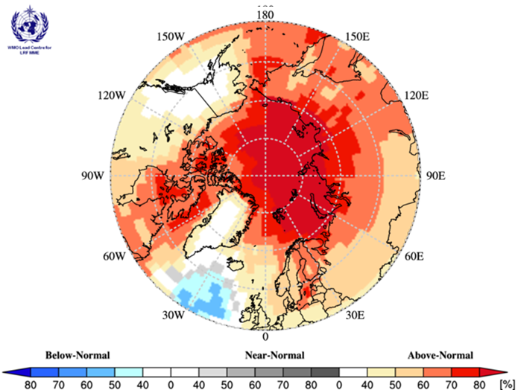
Surface air temperatures during winter 2020 (NDJ: November 2020, December 2020, and January 2021) are forecast to be above normal across the majority of the Arctic regions (yellow, orange and red areas in Figure 5). The confidence of the forecast is low to moderate over Alaska, Canada, Eastern Siberia, and the Chukchi and Bering regions (yellow and orange areas in Figure 5, Table 2), and high over the Eastern Nordic, Western Siberia, and Central Arctic regions (dark red areas in Figure 5, Table 2). The multi-model ensemble did not agree over central Alaska and most of Greenland (white areas in Figure 5).
Figure 5: Multi model ensemble probability forecast for surface temperature for November 2020, December 2020, and January 2021. Three categories: below normal (blue), near normal (grey), above normal (red) and no agreement amongst the models (white). Source: www.wmolc.org.

Table 2. Winter (NDJ) 2020-2021 Outlook: Regional Forecasts for Arctic Temperatures
Region  (see Figure 1) | MME Temperature Forecast Agreement* | MME Temperature Forecast
Alaska and Western Canada | Low | Above normal
Central and Eastern Canada | Moderate | Above normal
Western Nordic | Low | Above normal
Eastern Nordic | High | Above normal
Western Siberia | High | Above normal
Eastern Siberia | Moderate | Above normal
Chukchi and Bering | Moderate | Above normal
Central Arctic | High | Above normal
*: See non-technical regional summaries for greater detail

PRECIPITATION
Summary for June, July, and August 2020:

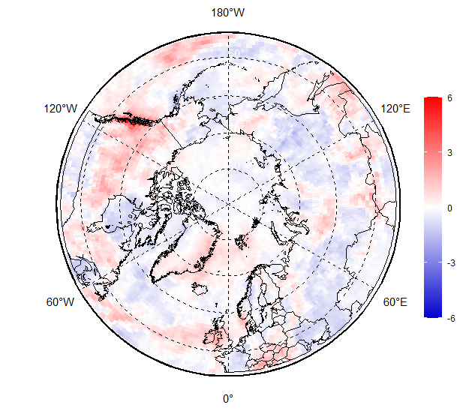 | 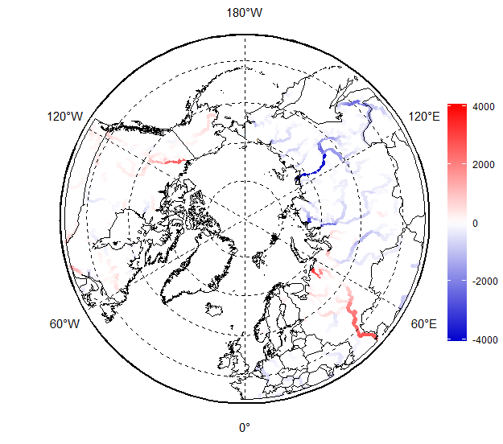
Figure 6. June, July, and August (JJA) 2020 precipitation anomaly based on the 1981-2010 reference period (left), and July 2020 river discharge anomalies based on 2000-2019 reference period (right). Red indicates wetter (left) or greater river flow (right) than normal conditions, while blue indicates drier (left) or lesser river flow (right) than normal conditions. Map produced by the Arctic and Antarctic Research Institute http://www.aari.ru. Data source: ERA5.

Wetter than average conditions were observed during June, July, and August 2020 (JJA) 2020 over the Western Nordic, and Alaska and Western Canada regions (red areas in Figure 6, left). On the other hand, the majority of the Eastern and Western Siberia regions, along with the Hudson Bay area, experienced drier than average conditions (blue areas in Figure 6, left). The impacts of wetter/drier regions were reflected in the JJA 2020 Arctic rivers discharge: lesser drainage than normal is seen in Ob’, Enisey and Lena rivers, and further eastward (blue areas in Figure 6, right), while the Mackenzie and Yukon rivers experinced greater discharge than normal over that same time period (red areas in Figure 6, right). The snow extent in May-September 2020 was lower than normal, with extreme negative anomalies (no snow) observed in most of Siberia and Alaska (Rutgers Glob SnowLab-https://climate.rutgers.edu/snowcover/). Positive anomalies (more snow) were observed in May in parts of Scandinavia, Eastern Canada, and in September in Northrn Canada (not shown here).

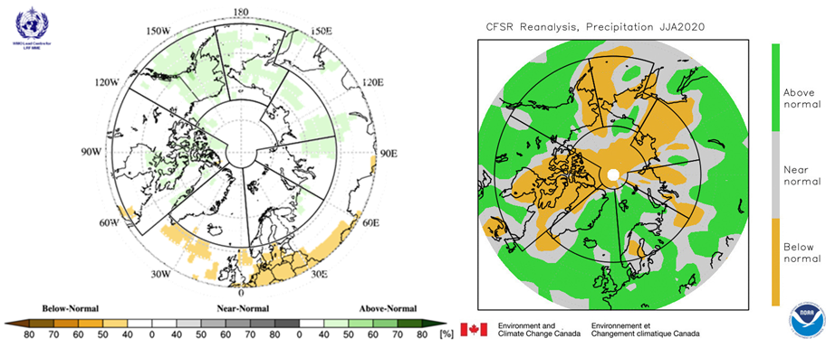
Figure 7: Left) Multi-model ensemble (MME) probability forecast for precipitation: June, July, and August 2020. Three categories: below normal (brown), near normal (grey), above normal (green); no agreement amongst the models is shown in white. Source: www.wmolc.org. Right): NCAR CFSR for precipitation for June, July, and August 2020.

Table 3. June, July, August 2020: Regional Comparison of Observed and Forecasted Arctic Precipitation
Regions  (see Figure 1) | MME Precipitation Forecast Agreement | MME Precipitation Forecast | NCAR CFSR Reanalysis (observed) | MME Precipitation Forecast Accuracy
Alaska and Western Canada | Low | Above normal (Alaska only) | Above to below normal | Low
Central and Eastern Canada | Low | Above normal | Above to below normal | N/A
Western Nordic | No agreement | No forecast | Above normal | N/A
Eastern Nordic | No agreement | No forecast | Above normal | N/A
Western Siberia | Low | Above normal (eastern part only | Below to near normal | Low
Eastern Siberia | Low | Above normal | Below to near normal | Low
Chukchi and Bering | Low | Above normal | Below to near normal | Low
Central Arctic | Low | Above normal (near Canada only) | Mostly below normal | Low

The JJA 2020 precipitation forecast was verified by subjective comparison between the forecast (Figure 7, left) and re-analysis (Figure 7, right), region by region. As for temperature, precipitation re-analysis is produced using statistical techniques to fill gaps when meteorological observation are not available.

Overall, the accuracy of the JJA 2020 precipitation forecast was low. Indeed, the observed below to near-normal precipitation over the majority of the Arctic were not accurately forecast for the JJA 2020 season (Figure 7, Table 3). In addition, there was no agreement amongst the models over the Western Nordic, Eastern Nordic, and the majority of the Western Siberia regions (predominance of white areas over those regions). As a general conclusion, the multi-model ensemble forecast was not accurate for JJA 2020.

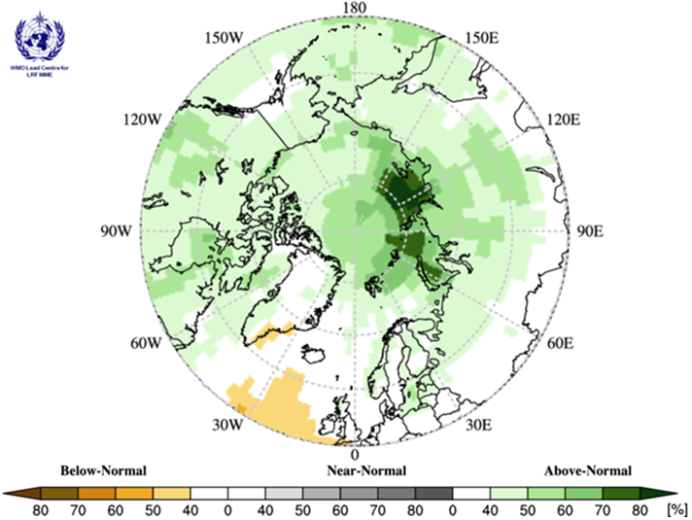
Outlook for winter 2020-2021:
Precipitation during winter 2020-2021 (NDJ: November 2020, December 2020, and January 2021) is forecast to be above normal over the majority of the Arctic region. Forecast confidence is primarily low (light green areas in Figure 8, Table 4), with the exception of the northern parts of the Western and Eastern Siberia regions, and parts of the Central Arctic region, where forecast confidence is moderate (dark green areas in Figure 8, Table 4). The multi-model ensemble did not agree over the majority of the Western Nordic region (white areas in Figure 8).

Figure 8: Multi model ensemble probability forecast for precipitation for November 2020, December 2020, and January 2021. Green indicates wetter conditions, orange drier conditions and white, no agreement amongst the models. Source: www.wmolc.org.

Table 4. Winter (NDJ) 2020-2021 Outlook: Forecasted Arctic Precipitation by Region
Region  (see Figure 1) | MME Precipitation Forecast Agreement* | MME Precipitation Forecast
Alaska and Western Canada | Low | Above normal
Central and Eastern Canada | Low | Above normal
Western Nordic | No agreement | No forecast
Eastern Nordic | Low | Above normal
Western Siberia | Moderate | Above normal
Eastern Siberia | Moderate | Above normal
Chukchi and Bering | Low | Above normal
Central Arctic | Moderate | Above normal
*: See non-technical regional summaries for greater detail

SEA-ICE and ARCTIC OCEAN
Sea surface temperature (SST) anomalies and the heat content (HC) of the upper layer of the polar ocean influences the melting and growth of sea-ice. High positive SST anomalies and prevailing positive polar ocean upper layer (20 m) HC during June-August 2020 (MERCATOR Ocean reanalysis, not shown here) simulated the melting of sea-ice in parts of the Kara and Laptev Sea. On the other hand, near normal to below normal SST and HC anomalies over that same time period slowed the melting of sea-ice in the Beaufort and Chukchi Seas (Figure 9).

The 3.9 mln km² minimum sea-ice extent reached on September 12, 2020 is the second lowest minimum sea-ice extent since 1979, with the minimum summer sea-ice extent observed in 2012 (3.35 mln km²). Estimates of the sea-ice volume based on numerical reanalysis (HYCOM-CICE, PIOMAS) show that the 2020 sea-ice volume is the second lowest, with 2012 and 2016 tied for lowest. The 2020 sea-ice is not considerably lower than that of 2019, suggesting higher summer sea-ice thickness in 2020 compared to 2019. However, extreme reduction of the Arctic sea-ice cover this summer significantly differs in shape with that of 2019. While the Eurasian shelf seas and the Northern Sea Route were completely ice free, sea-ice conditions in the Beaufort Sea and the Canadian Archipelago were close to normal, with the Northwest Passage closed.

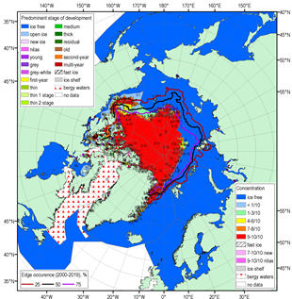 | 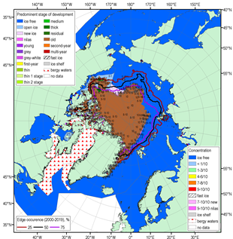

Figure 9: Blended Arctic sea-ice chart (AARI, CIS, NIC) for 14-17 September 2020 and sea-ice edge occurences for 14-17 September for 2000-2019. Left: total concentration, right: predominant stage of development

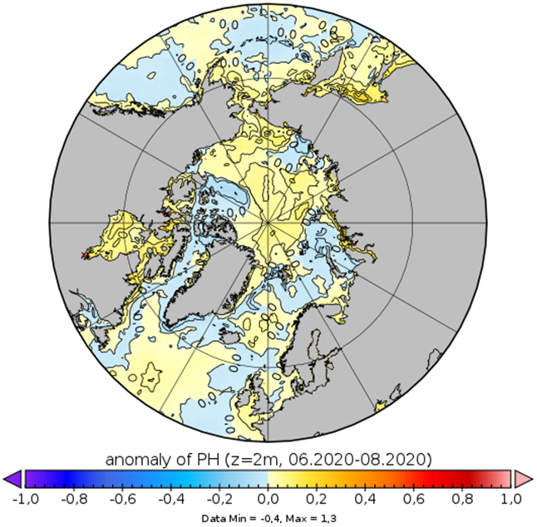
Figure 10 shows the MERCATOR Ocean pH anomalies for summer 2020, where areas of both positive (yellow areas: Arctic Basin, Norwegian Sea, and Chukchi Sea) and negative pH (blue areas: Barents, Kara Sea, and Canadian Arctic) anomalies can be identified. Such pH anomalies indicate possible effects of the different alkalization and acidification processes to Arctic marine wildlife.

Higher than normal sea surface temperatures and surface layer heat content were observed in the Eurasian Arctic, Bering Seas, and parts of the Baffin Sea and Hudson Bay during summer 2020. On the other hand, the Beaufort Sea and a portion of the Greenland and Barents Seas experienced their lowers surface heating in 20 years. The absence of sea-ice, combined with high surface heating, resulted in stormier than normal conditions over most of the Arctic shelf seas and adjacent parts of the Arctic Basin (not shown here).
Figure 10: pH 2m depth anomalies in June, July, and August 2020 relative to 2000-2019. Map produced by the Arctic and Antarctic Research Institute http://www.aari.ru. Data source: Copernicus Marine Service.

The forecast for September 2020 sea-ice extent (Figure 11) was based on output from CanSIPSv2 and an MME of two climate models. Forecast accuracy was high for all regions with the only exceptions being two instances of low accuracy noted in the Barents and Greenland Seas (Table 5). The summer seasonal forecast of above normal sea-ice extent in the two aforementioned areas were the only instances of forecasted higher than normal sea-ice coverage, whereas all regions in the Arctic summer forecast witnessed below normal conditions. Above normal air temperatures across most of the Arctic supported significant sea-ice losses in all basins, as below normal sea-ice extents at the September 2020 minimum were observed in every forecast region. Additionally, notable warm sea surface temperature anomalies were observed in the Eurasian Basin and northern Baffin Bay that contributed to the severely diminished sea-ice extents in these sectors. Observed lower than normal old sea-ice concentrations in the southern Beaufort Sea and the Canadian Arctic Archipelago also led to lower extents in these regions as old ice tends to be thicker and thus less prone to complete melt than first-year ice types.
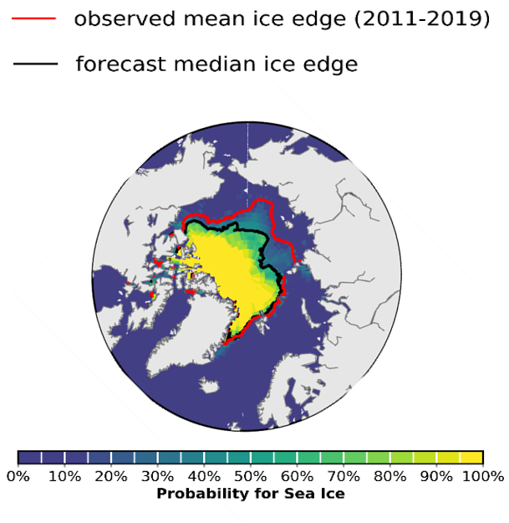
Figure 11: September 2020 probability of sea-ice at concentrations greater than 15% from CanSIPSv2 (ECCC). Forecast median ice extent (black) and observed mean sea-ice extent 2011-2019 (red).

Table 5. Summer 2020: Regional Comparison of Observed and Forecasted Minimum Sea-Ice Extent
Regions  (see Figure 2) | CanSIPS Sea-Ice Forecast Confidence | CanSIPS Sea-Ice Forecast | Observed Ice Extent | CanSIPS Sea-Ice Forecast Accuracy
Barents Sea | Low | Above normal (northern section) | Below normal | Low
Beaufort Sea | Moderate | Below normal | Below-Near normal | High
Canadian Arctic Archipelago | Moderate | Below normal | Below normal | High
Chukchi Sea | High | Below normal | Below normal | High
Eastern Siberian Sea | Moderate | Below normal | Below normal | High
Greenland Sea | High | Above normal | Below normal | Low
Kara Sea | High | Below normal | Below normal | High
Laptev Sea | High | Below normal | Below normal | High

Outlook for Fall Freeze-up 2020:
Sea-ice freeze-up is defined as the date where ice concentration exceeds 50% in a region. The outlook for fall freeze-up shown in Figure 12 displays the sea-ice freeze-up anomaly from CanSIPSv2 based on the nine-year climatological period from 2011-2019. The qualitative 3-category (high, moderate, low) confidence in the forecast is based on the historical model skill. Only regions where the model has historical skill are included in the outlook (Figure 13). A summary of the forecast for the 2020 fall freeze-up for the different Arctic regions is shown in Table 6.

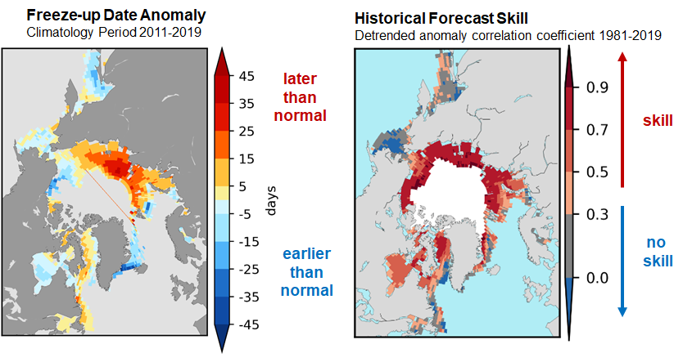
Figure 13: Historical forecast skill defined as the detrended anomaly correlation coefficient based on the 1981-2019 period.

Figure 12: Forecast for the 2021 winter freezek-up expressed as an anomaly (difference from normal), where freeze-up is defined as the date when the ice
concentration exceeds 50%.

Table 6: Winter 2020-2021 Regional Outlook for Arctic Sea Ice Freeze-up
Regions  (see Figure 2) | CanSIPSv2 Sea-Ice Forecast Confidence | CanSIPSv2 Sea-Ice Freeze-up Forecast
Baffin Bay | Moderate | Late
Barents Sea | High | Near normal
Beaufort Sea | High | Near normal to early
Bering Sea | Low | Near normal to early
Chukchi Sea | Moderate | Near normal
East Siberian | High | Late
Greenland Sea | High | Near normal to early
Hudson Bay | Moderate | Near normal to early
Kara Sea | High | Late
Labrador Sea | Moderate | Late
Laptev Sea | High | Late
Sea of Okhotsk | Low | Near normal

Outlook for March 2021 Maximum Sea Ice Extent
Maximum sea-ice extent is normally achieved each year during the month of March in the northern hemisphere. Table 7 categorizes the sea-ice extent forecast confidence and relative extent (i.e. near normal, below normal, above normal) by Arctic region with respect to an average sea ice extent based on 2009-2017 conditions. Figure 14 displays the probabilities of sea-ice presence for concentrations greater than 15% and the forecasted mean ice extent from CanSIPSv2 (black), with the observed median sea-ice extent for the 2012-2020 period in red. The sea-ice extent is expected to be below normal for the Northern Baltic Sea, the Gulf of St. Lawrence, and the Labrador Sea, and near normal for the Barents Sea, the Bering Sea, the Greenland Sea, and the Sea of Okhotsk.

March 2021 sea-ice probability of ice concentration > 15%
Regions  (see Figure 2) | CanSIPSv2 Sea-Ice Extent Forecast Confidence | CanSIPSv2 Sea-Ice extentForecast
Barents Sea | moderate | Near normal
Bering Sea | High | Near normal
Greenland Sea | Moderate | Near normal
Northern Baltic Sea | Moderate | Below normal
Gulf of St. Lawrence | Moderate | Below normal
Labrador Sea | Low | Below normal
Sea of Okhotsk  Table 7: Winter 202-2021 Regional Outlook for Maximum Sea-Ice Extent | High | Near normal

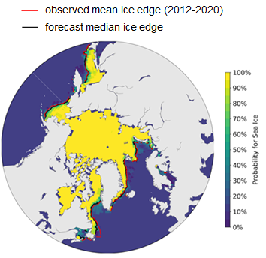

Figure 14: March 2021 probability of sea-ice at concentrations greater than 15% from CanSIPSv2 (ECCC). Forecast median ice extent from CanSIPSv2 (black) and observed mean ice edge 2012-2020 (red).

Outlook for Key shipping regions

Gulf of St. Lawrence: Below normal sea-ice conditions are expected this winter based on current sea surface temperatures, forecasted surface air temperatures and numerical model guidance. Forecasted lighter ice conditions should mitigate any significant difficulties encountered in the Gulf and in individual ports. The expected winter air temperature regime may delay freeze-up significantly and reduced ice thickening may lead to rapid and early spring break-up.

The Baltic Sea: The sea-ice season in the Baltic Sea regime is expected to become mild according to the seasonal sea ice forecast. Navigation will be affected by ice mainly in the Bay of Bothnia and in the eastern Gulf of Finland. A mild winter with its fluctuating weather typically causes ice deformation and brash ice barriers to form at the ice edge, both of which are difficult for shipping.

Svalbard and Barents Sea: The sea-ice freeze-up time and March 2021 extent around Svalbard and in the northern part of the Barents Sea is expected to be close to normal for the upcoming winter season, based on the forecast model. However, since the model does not show if the sea-ice extent is composed of older ice advected into the area or new ice grown in situ, the impact for users is difficult to ascertain.

Northern Sea Route
Present and forecasted higher sea surface and air temperatures will support later by several weeks than average freeze-up in the NSR Seas and subsequently very light sea-ice conditions till end of November. The expected winter air temperature regime will continue to support lower than normal for the last decade stages of ice development with predominance of medium first year ice in the Kara Sea and later appearance of thick first year ice in the Laptev and Eastern Siberian Seas. That should mitigate any significant difficulties to ice navigation in the area. Expected greater snow height may delay start of melting processes.

Sea of Okhotsk
Due to current lower ocean temperatures slightly earlier than average freeze-up is expected for most of sea area though it will be further compensated by the expected above normal air temperatures. Close to average for the last decade ice conditions are expected by the summit of ice season in March 2021.

Background and Contributors
This Arctic seasonal climate outlook was prepared for ACF-6. Contents and graphics were prepared in partnership with the Russian, United States, Canadian, Norwegian, Danish, Finnish, Swedish, and Icelandic meteorological agencies and contributions of the former JCOMM Expert Team on Sea-ice, former CCl/CBS Inter-Programme Expert Team on Regional Climate Activities, the GCW, the IICWG, and with input from AMAP.

The ArcRCC-Network, a collaborative arrangement with formal participation by all the eight Arctic Council member countries, is in demonstration phase to seek designation as a WMO RCC-Network, and its products and services are in development and are experimental. For more information, please visit https://arctic-rcc.org/acf-fall-2020

Acronyms:
AARI: Arctic and Antarctic Research Institute
ArcRCC-Network: Arctic Regional Climate Centre Network https://www.arctic-rcc.org/
ACF: Arctic Climate Forum
AMAP: Arctic Monitoring and Assessment Programme
CAA: Canadian Arctic Archipelago
CanSIPSv2: Canadian Seasonal to Inter-annual Prediction System
CCl: WMO Commission for Clilmatology/
CBS: WMO Comission for Basic Systems
CIS: Canadian Ice Service
ECCC: Environment and Climate Change Canada
ECMWF: European Centre for Medium-Range Weather Forecasts
ESS: Eastern Siberian Seas
GCW: Global Cryosphere Watch
GPCs-LRF: WMO Global Producing Centres Long-Range Forecasts
GloSea5: Met Office Global Seasonal forecasting system version 5
HYCOM-CICE: HYbrid Coordinate Ocean Model, Coupled with sea-ICE
IICWG: International Ice Charting Working Group
IOC: Intergovernmental Oceanographic Commission
JCOMM: Joint WMO/IOC Technical Commission on Oceanography and Marine Meteorology
LC-LRFMME: WMO Lead Centre for Long Range Forecast Multi-Model Ensemble
NIC: National Ice Center (United States)
NCAR: National Center for Atmospheric Research
NCAR CFSR: National Center for Atmospheric Research Climate Forecast System Reanalysis
NOAA/NWS/NCEP/CPC: National Oceanic and Atmospheric Administration/National Weather Service/National Centers for Environmental Prediction/Climate Prediction Center (United States of America)
NSIDC: National Snow and Ice Data Center (United States)
MME: Multi-model ensemble
NSR: Northern Sea Route
NWP: Northwest Passage
PIOMAS: Pan-Arctic Ice Ocean Modeling and Assimilation System
RCC: WMO Regional Climate Centre
RCOF: Regional Climate Outlook Forum
WMO: World Meteorological Organization

