Reference tables for International and Russian national symbology according to [1] WMO Sea-Ice Nomenclature, Supplement № 4, WMO/OMM/ВМО -No.259, 1989, [2] Manual on ice air reconnaissance (Rukovodstvo po proizvodstvu ledovoi aviatsionnoi razvedki), GIMIZ, 1974 and [3] Ice Chart Colour Standard, WMO/Td-No.1215, 2004

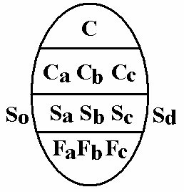  International egg-symbol  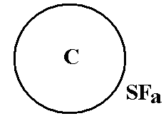  Drifting ice, Russian symbol  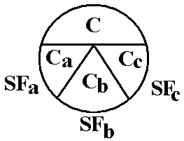  Drifting ice, Russian symbol  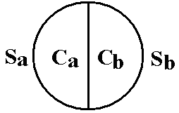  Fast ice, Russian symbol | Table 1. Total concentration of ice (C)  Concentration Symbol  Ice free  Less than one tenth 0  1/10 1  2/10 2  3/10 3  4/10 4  5/10 5  6/10 6  7/10 7  8/10 8  9/10 9  More than 9/10 less than 10/10 9+  10/10 10  Undetermined or unknown x ? ?  Concentration (C)  C – Total concentration of ice in the area, reported in tenths (see symbols in table 1).  Note: Ranges of concentration may be reported.  C_{a} C_{b} C_{c} – Partial concentrations of thickest (C_{a}), second thickest (C_{b}) and third thickest (C_{c}) ice, in tenths.  Note: Less than 1/10 is not reported. 10/10 of one stage of development is reported by C, S_{a} and F_{a} or C S_{a} F_{p} F_{s}  Note: acc. to Russian national symbology fast ice is indicated by hatching  Stage of development (S)  S_{a} S_{b} S_{c} – Stage of development of thickest (S_{a}), second thickest (S_{b}) and third thickest S_{c}) ice, of which the concentrations are reported by C_{a}, C_{b}, C_{c} respectively (see symbols in table 2).  Notes:  (1) If more than one class of stage of development remains after selection of S_{a} and S_{b}, S_{c} should indicate the class having the greatest concentration of the remaining classes (see also Note (2))  (2) Reporting of S_{a}, S_{b} and S_{c} should generally be restricted to a maximum of three significant classes. In exceptional cases, further classes can be reported as follows:  S_{o} – stage of development of ice thicker than Sa but having a concentration of less than 1/10;  S_{d} – stage of development of any other remaining class.  (3) No concentration are reported for S_{o} and S_{d}.  (4) acc. to Russian national symbology depiction of stages of development (SF_{a} SF_{b} SF_{c}) is combined with depiction of forms of ice  Form of ice (F)  (a) First variant-  F_{a} F_{b} F_{c} – Form of ice (floe size) corresponding to S_{a}, S_{b} and S_{c} respectively (see symbols in table 3.3).  Notes: (1) Absence of information on any one of these forms of ice should be reported with an “x” at the corresponding position.  (2) When icebergs are present in sufficient numbers to have concentration figure, this situation can be reported with F_{a} = 9, the appropriate symbol for S_{a} and the corresponding partial concentration C_{a}.  (3) In situation when only two stages of development are present, a dash (-) should be added in place of F_{c} to separate these situations from those when F_{p} and F_{s} are being reported.  (b) Second variant  F_{p} F_{s} – Predominant (F_{p}) and secondary (F_{s}) floe size, reported independently from S_{a}, S_{b} and S_{c} respectively (see symbols in table 3.3).  Note: If only the predominant floe size (form of ice) is reported, only the symbol for F_{p} shall be reported.  (c) Russian national symbology  Acc. to Russian national symbology depiction of stages of development (SF_{a} SF_{b} SF_{c}) is combined with depiction of forms of ice

Table 2. Stage of development and thickness (S_{a} S_{b} S_{c} S_{o} S_{d})
№ WMO  Nomen. | Stage of development | Ice thickness  interval | Symbol |  | Sample coding |  | Color code
 |  |  | [1] | [2] | Drifting ice | Fast ice | [3]
1 | 2 | 3 | 4 | 5 | 6 | 7 | 8
4.2.8 | Ice free | - | 0
2.1 | New ice | - | 1
2.2 | Nilas | < 10 cm | 2
2.2.1 | Dark nilas | 0-5 cm | 2 |  | 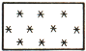
2.2.2 | Light nilas | 5-10 cm | 2 |  | 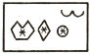 | 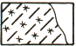
2.2.3 | Ice rind | 0-5 cm | 2 |  | 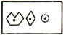 | 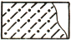
2.4 | Young ice | 10-30 cm | 3
2.4.1 | Grey ice | 10-15 cm | 4 |  | 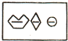 | 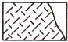
2.4.2 | Grey-white ice | 15-30 cm | 5 |  | 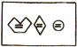 | 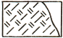
2.5 | First-year ice (FY) | 30-200 cm | 6
2.5.1 | FY thin ice (white ice) | 30-70 cm | 7 |  | 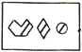 | 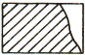
2.5.1.1 | FY thin ice (white ice) first stage | 30-50 cm | 8
2.5.1.2 | FY thin ice (white ice) second stage | 50-70 cм | 9
2.5.2 | FY medium ice | 70-120 cм | 1• |  | 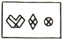 | 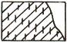
2.5.3 | FY thick ice | > 120 cм | 4• |  | 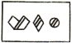 | 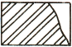
2.6 | Old ice (MY) |  | 7• |  | 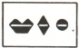 | 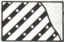
2.6.1 | FY residual ice | 50—180 cm | 6• |  | 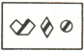 | 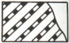
2.6.2 | Second-year ice | 180-280 cm | 8• |  | 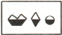 | 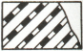
2.6.3 | Multi-year ice | > 300 cm | 9• |  | 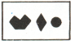 | 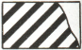
10.4 | Drifting ice of land origin |  | ▲• |  |  |  | ▲▲
 | Ice of undefined stage of development |  | x |  |  |  | ? ?
 | Indicator of ice thickness intervals (cm) beginning from the oldest | 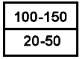
Table 3. - Form of ice (F_{a} F_{b} F_{c} F_{p} F_{s})  № WMO Nomen. Form of ice Floe size Symbol  1 2 3 4  4.3.1 Pancake ice - 0  4.3.3.1 Small ice cake; brash ice < 2 m 1  4.3.3 Ice cake 2-20 m 2  4.3.2.5 Small floe 20-100 m 3  4.3.2.4 Medium floe 100-500 m 4  4.3.2.3 Big floe 500 m-2 km 5  4.3.2.2 Vast floe 2-10 km 6  4.3.2.1 Giant floe > 10 km 7  3.1 Fast ice - 8 See table 2  10.4.2 Icebergs, bergy bits, growlers or floebergs - 9 See table 4  Undetermined or unknown - x | Table 4. – Calved ice of land origin (icebergs)  №. WMO Nomen. Iceberg form Symbol  1 2 3  10.4.2.1 Glacier berg  10.4.2.2 Tabular berg  Dome-shaped berg  Inclined berg  Destructing berg  10.4.4 Bergy bit  10.4.5 Growler  Icebergs concentration  10.4.3 Ice island

Table 5. Sea ice surface characteristics and openings in ice  № WMO Nomen. Characteristic Symbol  1 2 3  8.2.3.1 Hummocks concentration (points)  8.2.2. Ridge  8.6 Snow on ice concentration (points) and predominant direction of zastrugi (arrow)  9.0 Stages of melting (points)  6.4 Rafted ice and raftness concentration (points)  4.4.8.1.1 Jammed brash barrier  7.1.1 Crack (ice stage of development covering the crack, number within area/width)  7.1.2-7.1.5 Fracture (ice stage of development covering the crack, number within area/width)  7.3 Lead (ice stage of development covering the crack, number within area/width)  5. Ice drift  5.1 Diverging  5.2 Compacting (points)  5.3 Shearing | Table 6. Terms related to surface shipping  № WMO Nomen. Characteristic Symbol  1 2 3  Recommended place for the ship  12.1 Ship beset by ice  Recommended route for the ship  Route of ship drift

