|  |  |  |
| --- | --- | --- |
| **WORLD METEOROLOGICAL ORGANIZATION**  **\_\_\_\_\_\_\_\_\_\_\_\_\_** |  | **INTERGOVERNMENTAL OCEANOGRAPHIC COMMISSION (OF UNESCO) \_\_\_\_\_\_\_\_\_\_\_** |

**ICE CHART COLOUR CODE STANDARD**

Version 1.0

WMO/TD-No. 1215

Originally Published 2004

Version 1 May 2014

**JCOMM Technical Report No. 24**

N O T E

The designations employed and the presentation of material in this publication do not imply the expression of any opinion whatsoever on the part of the Secretariats of the Intergovernmental Oceanographic Commission (of UNESCO), and the World Meteorological Organization concerning the legal status of any country, territory, city or area, or of its authorities, or concerning the delimitation of its frontiers or boundaries.

**1. Preface**

While the WMO international standard for ice charts only dealt with black and white charts, in keeping with the paper facsimile technology of the time, colour has long been used to help differentiate the various ice conditions on a paper chart. In the last decade, progress in computer processing and communication, as well as increased demands of users prompted the necessity to develop a new WMO International Ice Colour Code Standard for ice charts.

In the Russian Federation, one of the first colour coding standards for en-route and operational ice charts was included into the “Manual on Air Reconnaissance conduct” published in 1953. However, practices of routine colour enhancement of paper ice charts in support of navigation through the Northern Sea Route may be traced back to the 1930s. Subsequent editions of the stated manual included recommendations for colour coding which were very close to the original summer (blue-green-brown scheme) and winter (purple-green-brown scheme) for navigation in the Arctic Seas. The last edition published in 1981 served as one of the starting points for developing new WMO International Ice Colour Code.

Similar to the practices in the Eurasian Arctic, ice service specialists in the Canadian Ice Service coloured paper charts manually as an aid to briefing icebreaker captains. There was no standard for these colour schemes but they were generally based on some version of green-yellow-red for light-medium-heavy ice conditions. As colour technology became more commonplace, the Canadian Ice Service adopted an internal standard based on the Ice Services Specialist practices and began producing colour charts routinely. Correspondingly, Canadian practice provided another of the bases for the present standard.

The same long practice of colour coding on a national level is characteristic of the Baltic Sea ice services, e.g. ice charts have been optionally coloured by German experts from the 1st part of the XX century which served as another prototype for a colour standard for seas with seasonal ice cover. Additionally, a specific case of colour coding has been examined by Danish ice experts for Greenland waters, to contribute to an international colour standard.

The first steps in colour code standardization were undertaken by the former CMM Group on Sea Ice as early as the 1950s. After a long break, the next phase was initiated by the International Ice Charting Working Group (IICWG), an ad-hoc group closely related to the JCOMM Expert Team on Sea Ice. The IICWG-II Meeting (October 2000) started with initial ideas and principles. IICWG-III (November 2001) drafted the basis for agreement on the standard with refinements based on comments from Ice Services who tested the proposal during the first half of 2002.

During 2003, IICWG and ETSI experts proceeded with editing and testing the standard, which in its final version includes two separate colour codes with options for use on ice charts:

1. one based on total concentration (CT) intended for use when the stage of development is relatively uniform but concentration is highly variable (e.g. arctic summer navigation);
2. one based on stage of development (SoD) intended for use when the concentration is relatively uniform (high) but the stage of development is variable (e.g. arctic winter navigation).

In 2010 and 2014 further changes were introduced by ETSI fourth and fifth sessions. That included additions to the colours based on CT for bergy waters and compact floating ice and for the colours based on SoD for the term ‘residual ice’ as a sub-category of ‘old ice’.

The CT and SoD Colour Code Standards are given below as tables 1 and 2 respectfully. For the convenience of users, definitions of basic symbols in WMO oval form are repeated in Table 3.

Section 2 provides notes for utilizing the Colour Code Standard.

Application of the Standard is exemplified in the sample ice charts from national ice services included in Annex I.

**2. Ice Chart Colour Code - Notes**

1. Two separate colour codes are mutually exclusive - only one or the other should be used on a single chart.
2. A legend depicting the colour code used should be included on every chart.
3. The optional colour indicating 9+-10 tenths of nilas or grey ice should only be used to indicate level ice, mainly on leads; it should not be used for ice broken into brash or ice cakes or for concentrations less than 9+ tenths.
4. Undefined ice is used when it is known that ice is in an area but its characteristics are not known - this is different from “No Information” which indicates that nothing at all is known about the area.
5. No specific colour is assigned to areas of “No Information”; such areas should be clearly indicated on ice charts - text annotation may be used where appropriate; an assigned colour within the code should not be used to indicate “No Information”.
6. Colour codes do not preclude use of black and white hatching patterns or egg codes; egg codes and/or black and white hatching may be used along with colours.
7. If properly documented, other symbols may be used in addition to the standard colours to depict special ice conditions under national practice.

The present document is an integral part and extension of the WMO Sea Ice Nomenclature, Supplement No. 4 (WMO - No. 259) currently in force.

**Table 1. Total Concentration Colour Code Standard**

|  |  |  |  |  |
| --- | --- | --- | --- | --- |
| Colour | | RGB  colour model | Total concentration (definition from WMO Nomenclature) | Number  from WMO Nomenclature |
| alternative | prime |
| |  | | --- | |  | | |  | | --- | |  | | 000-100-255 | Ice free | 4.2.8 |
|  | |  | | --- | |  | | 150-200-255 | Less than one tenth (open water) | 4.2.6 |
| |  | | --- | | ▲ ▲ ▲ | | |  | | --- | | ▲ ▲ ▲ | | 150-200-255 | Bergy water | 4.2.7 |
|  | |  | | --- | |  | | 140-255-160 | 1/10 - 3/10 (very open ice) | 4.2.5 |
|  | |  | | --- | |  | | 255-255-000 | 4/10 - 6/10 (open ice) | 4.2.4 |
|  | |  | | --- | |  | | 255-125-007 | 7/10 - 8/10 (close ice) | 4.2.3 |
|  | |  | | --- | |  | | 255-000-000 | 9/10 - 10/10 (very close ice) | 4.2.2 |
|  | |  | | --- | |  | | 145-000-000 | 10/10 (compact floating ice) | 4.2.1 |
|  | |  | | --- | |  | | 150-150-150 | Fast ice | 1.1.1 |
|  | |  | | --- | |  | | 210-210-210 | Ice shelf | 10.3 |
|  | |  | | --- | | ? ? ? | | 255-255-255 | Undefined ice | - |
|  | | | | |
| **Optional** | |  | | --- | |  | | 255-175-255 | 7/10-10/10  new ice | 2.1 |
|  | |  | | --- | |  | | 255-100-255 | 9/10-10/10 nilas, grey ice (mainly on leads) | 2.2, 2.4 |
| **Areas of No Information are annotated accordingly** | | | | |

**Table 2. Stage of Development Colour Code Standard**

|  |  |  |  |  |
| --- | --- | --- | --- | --- |
| Colour | | RGB  colour model | Stage of development  (SoD) | Number from WMO Sea Ice Nomenclature |
| alternative | prime |
| |  | | --- | |  | | |  | | --- | |  | | 000-100-255 | Ice free | 4.2.8 |
|  | |  | | --- | |  | | 150-200-255 | <1/10 ice of unspecified SoD (open water) | 4.2.6 |
|  | |  | | --- | |  | | 240-210-250 | New ice | 2.1 |
|  | |  | | --- | |  | | 255-175-255 | Dark nilas | 2.2.1 |
|  | |  | | --- | |  | | 255-100-255 | Light nilas | 2.2.2 |
|  | |  | | --- | |  | | 170-040-240 | Young ice | 2.4 |
|  | |  | | --- | |  | | 135-060-215 | Grey ice | 2.4.1 |
|  | |  | | --- | |  | | 220-080-235 | Grey-white ice | 2.4.2 |
|  | |  | | --- | |  | | 255-255-000 | First-year ice (FY) | 2.5 |
|  | |  | | --- | |  | | 155-210-000 | FY thin ice (white ice) | 2.5.1 |
|  | |  | | --- | |  | | 215-250-130 | FY thin ice (white ice) first stage | 2.5.1.1 |
|  | |  | | --- | |  | | 175-250-000 | FY thin ice (white ice) second stage | 2.5.1.2 |
|  | |  | | --- | |  | | 000-200-020 | FY medium ice | 2.5.2 |
|  | |  | | --- | |  | | 000-120-000 | FY thick ice | 2.5.3 |
|  | |  | | --- | |  | | 180-100-050 | Old ice | 2.6 |
|  | |  | | --- | |  | | 000-120-000 | Residual ice | 2.6.1 |
|  | |  | | --- | |  | | 255-120-010 | Second-year ice | 2.6.2 |
|  | |  | | --- | |  | | 200-000-000 | Multi-year ice | 2.6.3 |
|  | |  | | --- | |  | | 150-150-150 | Fast ice of unspecified SoD | 2.6 |
|  | |  | | --- | |  | | 210-210-210 | Ice shelf | 10.3 |
|  | |  | | --- | | ? ? ? | | 255-255-255 | Ice of undefined SoD | - |
|  | |  | | --- | | ▲ ▲ ▲ | | 255-255-255 | Drifting ice of land origin (icebergs) | 10.4.2 |
| **Areas of No Information are annotated accordingly** | | | | |

**Table 3. Definitions of Basic Symbols in Oval Form** (according to WMO Sea Ice Nomenclature, Suppl. No 4, WMO-No.259)

|  |  |  |  |  |  |  |  |  |  |  |  |  |  |  |  |  |  |  |  |  |  |  |  |  |  |  |  |  |  |  |  |
| --- | --- | --- | --- | --- | --- | --- | --- | --- | --- | --- | --- | --- | --- | --- | --- | --- | --- | --- | --- | --- | --- | --- | --- | --- | --- | --- | --- | --- | --- | --- | --- |
| egg_code  Table 3.1  Total concentration of ice (C)   |  |  | | --- | --- | | *Concentration* | *Symbol* | | Ice free |  | | Less than one tenth | 0 | | 1/10 | 1 | | 2/10 | 2 | | 3/10 | 3 | | 4/10 | 4 | | 5/10 | 5 | | 6/10 | 6 | | 7/10 | 7 | | 8/10 | 8 | | 9/10 | 9 | | More than 9/10 less than 10/10 | 9+ | | 10/10 | 10 | | Undetermined or unknown | x | | **Concentration (C)**  C – Total concentration of ice in the area, reported in tenths (see symbols in table 3.1).  Note: Ranges of concentration may be reported.  Ca Cb Cc – Partial concentrations of thickest (Ca), second thickest (Cb) and third thickest (Cc) ice, in tenths.  Note: Less than 1/10 is not reported. 10/10 of one stage of development is reported by C, Sa and Fa or C Sa Fp Fs  **Stage of development (S)**  Sa Sb Sc – Stage of development of thickest (Sa), second thickest (Sb) and third thickest Sc) ice, of which the concentrations are reported by Ca, Cb, Cc respectively (see symbols in table 3.2).  Notes:  (1) If more than one class of stage of development remains after selection of Sa and Sb, Sc should indicate the class having the greatest concentration of the remaining classes (see also Note (2))  (2) Reporting of Sa, Sb and Sc should generally be restricted to a maximum of three significant classes. In exceptional cases, further classes can be reported as follows:  So – stage of development of ice thicker than Sa but having a concentration of less than 1/10;  Sd – stage of development of any other remaining class.  (3) No concentration are reported for So and Sd.  **Form of ice (F)**  **(a) First variant**  Fa Fb Fc – Form of ice (floe size) corresponding to Sa, Sb and Sc respectively (see symbols in table 3.3).  Notes: (1) Absence of information on any one of these forms of ice should be reported with an “x” at the corresponding position.  (2) When icebergs are present in sufficient numbers to have concentration figure, this situation can be reported with Fa = 9, the appropriate symbol for Sa and the corresponding partial concentration Ca.  (3) In situation when only two stages of development are present, a dash (-) should be added in place of Fc to separate these situations from those when Fp and Fs are being reported.  **(b) Second variant**  Fp Fs – Predominant (Fp) and secondary (Fs) floe size, reported independently from Sa, Sb and Sc respectively (see symbols in table 3.3).  Note: If only the predominant floe size (form of ice) is reported, only the symbol for Fp shall be reported. |

|  |  |  |  |  |  |  |  |  |  |  |  |  |  |  |  |  |  |  |  |  |  |  |  |  |  |  |  |  |  |  |  |  |  |  |  |  |  |  |  |  |  |  |  |  |  |  |  |  |  |  |  |  |  |  |  |  |  |  |  |  |  |  |  |  |  |  |  |  |  |  |  |  |  |  |  |  |  |  |  |  |  |  |  |  |  |  |  |  |  |  |  |  |  |  |  |  |  |  |  |  |  |  |  |  |  |  |  |  |  |  |  |  |  |
| --- | --- | --- | --- | --- | --- | --- | --- | --- | --- | --- | --- | --- | --- | --- | --- | --- | --- | --- | --- | --- | --- | --- | --- | --- | --- | --- | --- | --- | --- | --- | --- | --- | --- | --- | --- | --- | --- | --- | --- | --- | --- | --- | --- | --- | --- | --- | --- | --- | --- | --- | --- | --- | --- | --- | --- | --- | --- | --- | --- | --- | --- | --- | --- | --- | --- | --- | --- | --- | --- | --- | --- | --- | --- | --- | --- | --- | --- | --- | --- | --- | --- | --- | --- | --- | --- | --- | --- | --- | --- | --- | --- | --- | --- | --- | --- | --- | --- | --- | --- | --- | --- | --- | --- | --- | --- | --- | --- | --- | --- | --- | --- | --- | --- |
| Table 3.2  Stage of development and thickness (Sa Sb Sc So Sd)   |  |  |  |  | | --- | --- | --- | --- | | *Number from WMO Sea Ice Nomenclature* | *Element* | *Thickness* | *Symbol* | |  | No stage of development | - | 0 | | 2.1 | New ice | - | 1 | | 2.2 | Nilas; ice rind | < 10 cm | 2 | | 2.4 | Young ice | 10-30 cm | 3 | | 2.4.1 | Gray ice | 10-15 cm | 4 | | 2.4.2 | Gray-white ice | 15-30 cm | 5 | | 2.5 | First-year ice | 30-200 cm | 6 | | 2.5.1 | Thin first-year ice | 30-70 cm | 7 | | 2.5.1.1 | Thin first-year ice, first stage | 30-50 cm | 8 | | 2.5.1.2 | Thin first-year ice, second stage | 50-70 cm | 9 | | 2.5.2 | Medium first-year ice | 70-120 cm | 1• | | 2.5.3 | Thick first-year ice | > 120 cm | 4• | | 2.6 | Old ice |  | 7• | | 2.6.1 | Residual ice |  | 6• | | 2.6.2 | Second-year ice |  | 8• | | 2.6.3 | Multi-year ice |  | 9• | | 10.4 | Ice of land origin |  | ▲• | |  | Undetermined or unknown |  | x | | Table 3.3  Form of ice (Fa Fb Fc Fp Fs)   |  |  |  | | --- | --- | --- | | *Element* | *Floe size* | *Symbol* | | Pancake ice | - | 0 | | Small ice cake; brash ice | < 2 m | 1 | | Ice cake | 2-20 m | 2 | | Small floe | 20-100 m | 3 | | Medium floe | 100-500 m | 4 | | Big floe | 500 m-2 km | 5 | | Vast floe | 2-10 km | 6 | | Giant floe | > 10 km | 7 | | Fast ice | - | 8 | | Icebergs, growlers or floebergs | - | 9 | | Undetermined or unknown | - | x | |

**Annex I**

**Sample ice charts**

**from national ice services**

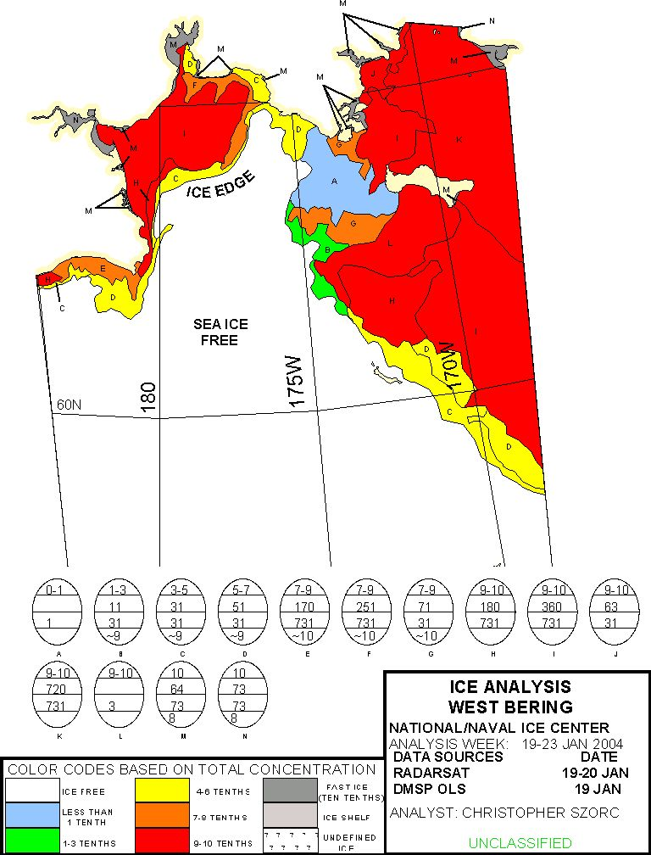

Fig. 1. Bering Sea western part ice chart for 19-23 January 2003 produced by USA National Ice Center. Ice chart is based on Total concentration Colour Standard.

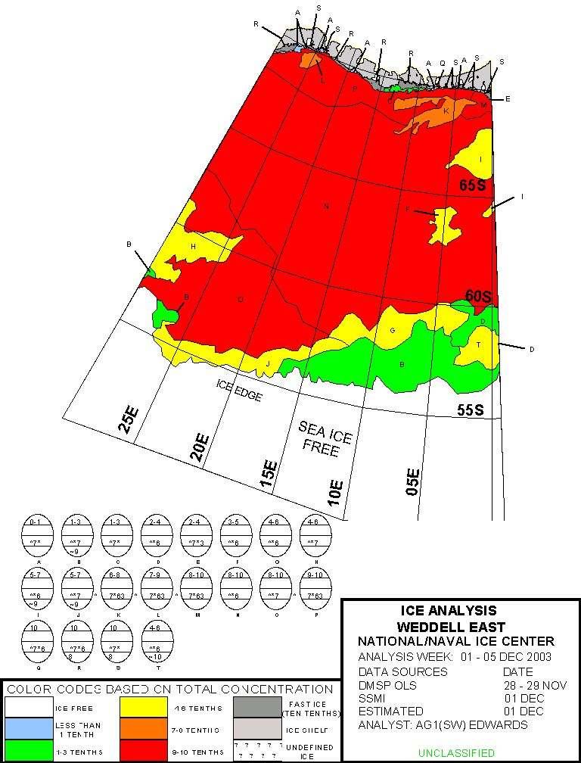

Fig. 2. Weddell Sea eastern part ice chart for 01-05 December 2003 produced by USA National Ice Center. Ice chart is based on Total concentration Colour Standard.

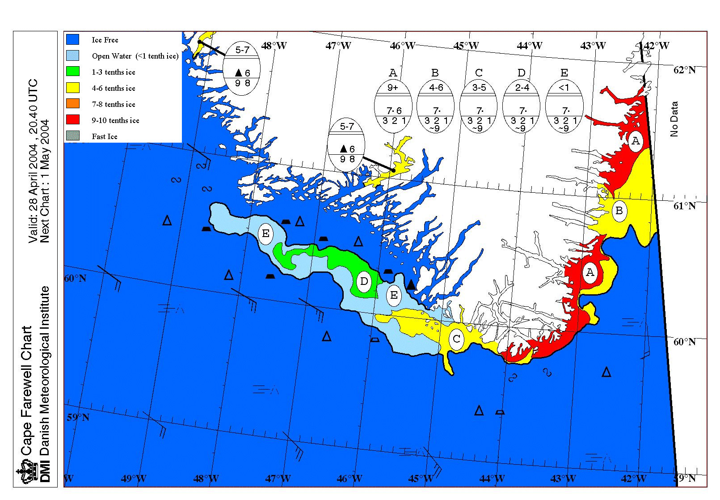

Fig. 3. Cape Farewell ice chart for 28 April 2004 produced by Danish Meteorological Institute. Ice chart is based on Total concentration Colour Standard.

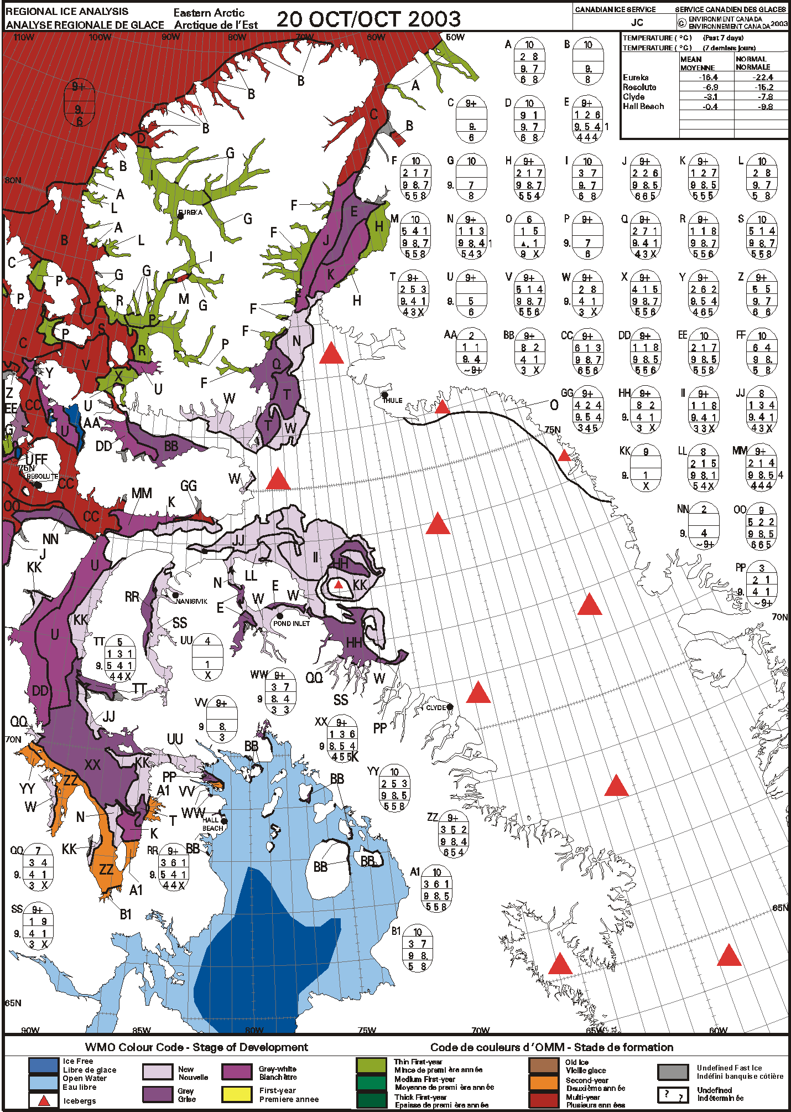

Fig. 4. Eastern Arctic ice chart for 20 October 2003 produced by Canadian Ice Service. Ice chart is based on Stage of Development Colour Standard.

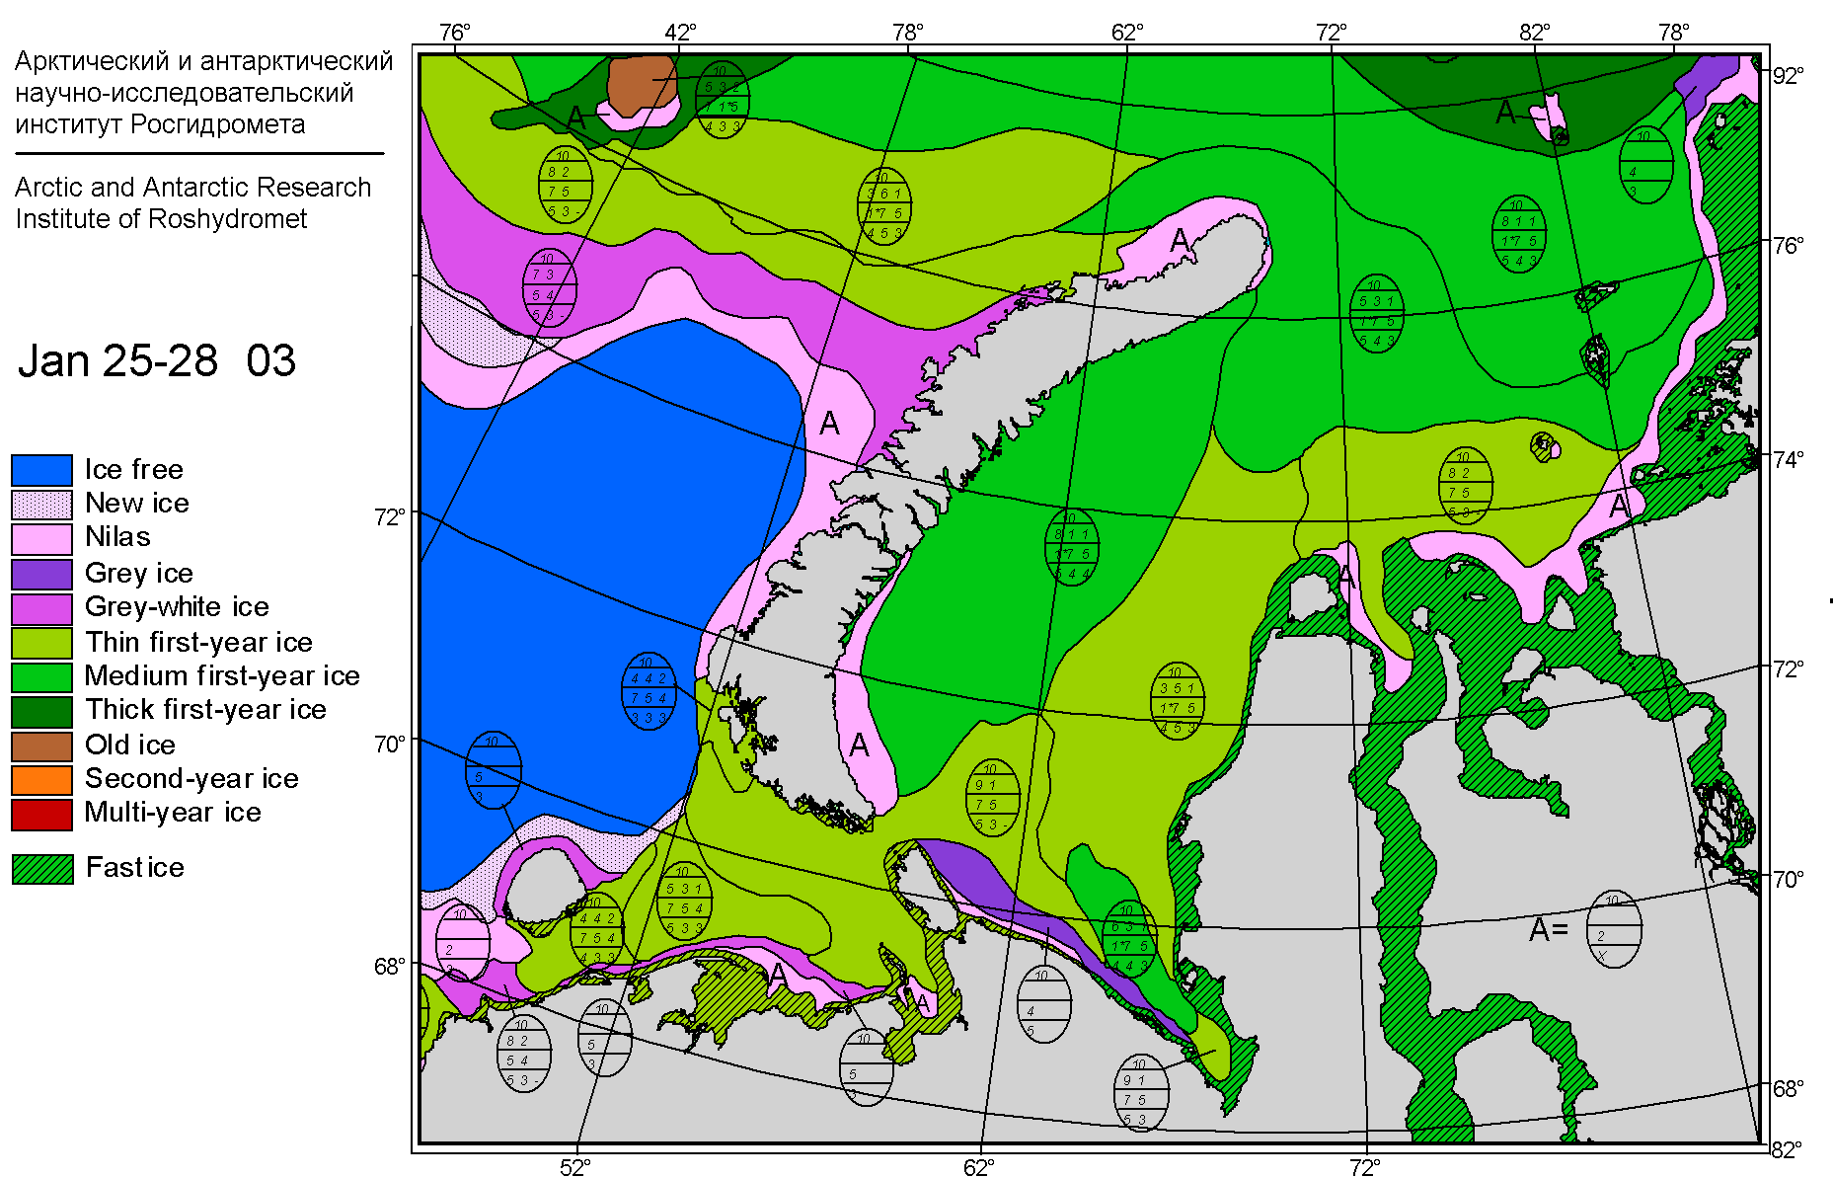

Fig. 5. Barents Sea ice conditions chart for 25-28 January 2003 produced by Arctic and Antarctic Research Institute, Russian Federation. Ice chart is based on Stage of Development Colour Standard with optional hatching of fast ice.