INTERNATIONAL HYDROGRAPHIC ORGANIZATION

**JCOMM**



**S-411 Ice Information Product Specification**

**Edition 1.1.0, June 2014**

**JCOMM Technical Report No. 81**

Published by the

International Hydrographic Bureau

4, Quai Antoine 1er

B.P. 445 - MC 98011 MONACO Cedex

Principauté de Monaco

Telefax: (377) 93 10 81 40

E-mail: [info@ihb.mc](mailto:info@ihb.mc)

Web: [www.iho.int](http://www.iho.int)

|  |  |  |  |
| --- | --- | --- | --- |
| Version Number | Date | Author | Purpose |
| 1.0.0 | 28.02.2014 | Alexander Benke |  |
| 1.1.0 | 15.06.213 | Jürgen Holfort | Clarifications in the based on ETSI Meeting 2014 and new color for 10/10. |
|  |  |  |  |
|  |  |  |  |
|  |  |  |  |
|  |  |  |  |
|  |  |  |  |

Contents

1 Overview 1

1.1 Introduction 1

1.2 References 1

1.3 Terms, definitions and abbreviations 1

1.3.1 Use of Language 1

1.3.2 Terms and Definitions 1

1.3.3 Abbreviation 1

1.4 General Data Product Description 1

1.5 Data product specification metadata 2

1.5.1 Product Specification Maintenance 2

2 Specification Scopes 3

2.1 General Scope 3

3 Data Product Identification 3

4 Data Content and Structure 4

4.1 Introduction 4

4.2 Application Schema 4

4.3 Feature Catalogue 5

4.3.1 Introduction 5

4.3.2 Application Schema Elements, Named Types 5

4.3.3 Feature Types Summary 19

4.4 Dataset Types 21

4.4.1 Introduction 21

4.5 Geometry 21

5 Coordinate Reference Systems (CRS) 22

6 Data Quality 22

7 Data Capture and Classification 22

8 Data Product format (encoding) 23

8.1 Introduction 23

8.2 Encoding Rules 23

8.2.1 Longitude / Latitude 23

8.2.2 Elements and attributes 23

8.3 Encoding Examples 23

8.3.1 Polygon Feature 23

8.3.2 LineString Feature 23

8.3.3 Point Feature 24

9 Data Product Delivery 25

9.1 Introduction 25

9.2 Exchange Set 25

9.2.1 Exchange Set Naming 26

9.3 Dataset 26

9.3.1 Dataset Naming 26

9.4 Support Files 26

9.4.1 Support File Naming 26

9.5 Exchange Catalogue 26

9.5.1 Exchange Catalogue Naming 26

10 Metadata 27

10.1 Introduction 27

10.1.1 ISO 19139 Metadata 27

10.2 Language 31

11 Maintenance 32

11.1 Maintenance and Update Frequency 32

12 Portrayal 33

12.1 Rules 33

12.2 Symbols 34

12.2.1 Polygon Features 34

12.2.2 Line Features 37

12.2.3 Point Features 38

12.2.4 Draw order 39

13 Additional Information 40

Annex A – Data Classification and Encoding Guide 41

Annex B – Data Product format (encoding) 41

Annex D – Feature Catalogue 41

Annex F – Portrayal Catalogue (SE, XSLT + SVG) 41

Annex G – Encoding Example for all ice features 41

Annex I – Exchange Catalogue Example 41

Page intentionally left blank

# Overview

This document has been produced by the BSH as part of JCOMM/ETSI in response to a requirement to produce an ice data product that can be used within Electronic Chart Display and Information Systems.

## Introduction

The Ice Information product specification is based on the IHO S-100 framework specification, Geography Markup Language (GML) Encoding Standard and the ISO 19100 series of standards. It is a vector product specification that is primarily intended for encoding the extent and nature of Sea Ice for navigational purpose.

## References

S-100 IHO Universal Hydrographic Data Model

GML OpenGIS® Geography Markup Language (GML) Encoding Standard (Version 3.2.1)

## Terms, definitions and abbreviations

### Use of Language

* “Must” indicates a mandatory requirement.
* “Should” indicates an optional requirement, that is the recommended process to be followed, but is not mandatory.
* “May” means “allowed to” or “could possibly”, and is not mandatory.

### Terms and Definitions

### Abbreviation

CRS Coordinate Reference System

ECDIS Electronic Chart Display Information System

EPSG European Petroleum Survey Group

ENC Electronic Navigational Chart

IHO International Hydrographic Organization

IMO International Maritime Organization

ISO International Organization for Standardization

GML Geography Markup Language

ETSI Expert Team on Sea Ice

## General Data Product Description

**Title: Ice Information**

**Abstract: Ice information for ship navigation**

**Content: Ice features as vector data**

**Spatial Extent:**

**Description:**

**East Bounding Longitude:** -180

**West Bounding Longitude:** 180

**North Bounding Latitude:** 90

**South Bounding Latitude:** *-*90

**Purpose: Navigation in ice covered regions**

## Data product specification metadata

**Title: Ice Information Product Specification**

**S-100 Version:** **1.0.0**

**S-411 Version: 1.0.0**

**Date: 28.02.2013**

**Language: English**

**Contact: Jürgen Holfort (ice@bsh.de)**

**Identifier: JCOMM S-411**

**Maintenance: Changes to this product specification are coordinated by ETSI.**

### Product Specification Maintenance

#### Introduction

Changes to JCOMM S-411 will be released by the IHO as a new edition, revision, or clarification.

#### New Edition

New Editions of S-10n introduce significant changes. New Editions enable new concepts, such as the ability to support new functions or applications, or the introduction of new constructs or data types. New Editions are likely to have a significant impact on either existing users or future users of S-10n.

#### Revisions

Revisions are defined as substantive semantic changes to S-10n. Typically, revisions will change S-10n to correct factual errors; introduce necessary changes that have become evident as a result of practical experience or changing circumstances. A revision must not be classified as a clarification. Revisions could have an impact on either existing users or future users of S-10n. All cumulative clarifications must be included with the release of approved corrections revisions. Changes in a revision are minor and ensure backward compatibility with the previous versions within the same Edition. Newer revisions, for example, introduce new features and attributes. Within the same Edition, a dataset of one version could always be processed with a later version of the feature and portrayal catalogues. In most cases a new feature or portrayal catalogue will result in a revision of S-10n.

#### Clarification

Clarifications are non-substantive changes to S-10n. Typically, clarifications: remove ambiguity; correct grammatical and spelling errors; amend or update cross references; insert improved graphics in spelling, punctuation and grammar. A clarification must not cause any substantive semantic change to S-10n. Changes in a clarification are minor and ensure backward compatibility with the previous versions within the same Edition. Within the same Edition, a dataset of one clarification version could always be processed with a later version of the feature and portrayal catalogues, and a portrayal catalogue can always rely on earlier versions of the feature catalogues. Changes in a clarification are minor and ensure backward compatibility with the previous versions

#### Version Numbers

The associated version control numbering to identify changes (n) to S-10n must be as follows:

New Editions denoted as **n**.0.0

Revisions denoted as n.**n**.0

Clarifications denoted as n.n.**n**

# Specification Scopes

## General Scope

**Scope Identification:** JCOMM S-411 dataset

**Hierarchical Lelvel:** MD_ScopeCode -005

**Hierarchical Level Name:** dataset

**Extent:**  EX_GeographicExtent -Global coverage of maritime areas.

EX_TemporalExtent -Not defined for this product specification.

EX_VerticalExtent-Not defined for this product specification.

# Data Product Identification

**Title:** Ice Information

**Abstract:** Ice Information for navigation in ice covered regions

**Topic Category:** transportation, climatologyMeteorologyAtmosphere

**Geographic Description:** Ice covered regions

**Spatial Resolution: ---**

**Purpose:** Navigation in ice covered regions

**Language:** English (optional additional)

**Classification:** Unclassified

**Spatial Representation Type:** vector

**Point of Contact:** Producing Agency

**Use Limitation: ---**

# Data Content and Structure

## Introduction

The application schema of ice information product contains 28 feature types with their attributes, enumerations etc. It is based on the ice objects catalogue (Version 5.1) and can also be found in the ICE domain of the IHO Registry. Because of this it is not possible to describe full schema in suitable form in this specification. The full schema can be found as XML Schema File in Annex B – Data Product format (encoding).

## Application Schema

Picture below shows very simplified structure of ice data structure

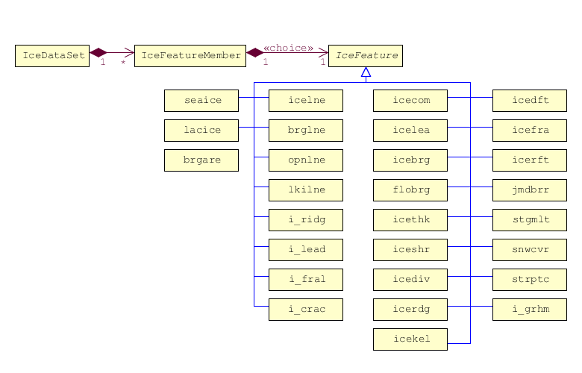

Figure 1: Ice Data Product – Structure

General GML (XML) representation:

<?xml version=*"1.0"* encoding=*"UTF-8"*?>

<ice:IceDataSet xmlns:ice=*"http://www.iho.int/ice"*

xmlns:gml=[*http://www.opengis.net/gml/3.2*](http://www.opengis.net/gml/3.2)>

<ice:IceFeatureMember>

<ice:seaice>

<ice:iceact> … </ice:iceact>

.

.

<gml:Polygon srsName=*".."*>… </gml:Polygon>

</ice:seaice>

</ice:IceMember>

<ice:IceMember>

<ice:i_ridg>

<ice:icerdv> … </ice:icerdv>

.

.

<gml:LineString srsName=*".."*>… </gml:LineString>

</ice:i_ridg>

</ice:IceMember>

<ice:IceMember>

<ice:icebrg>

<ice:icebsz> … </ice:icebsz>

.

.

<gml:Point srsName=*".."*>… </gml:Point>

</ice:icebrg>

</ice:IceFeatureMember>

## Feature Catalogue

### Introduction

The feature Catalogue for Ice Information contains only geographic features. The ice features which can be used in ECDIS are fully presented in the ICE domain of the IHO Registry.

### Application Schema Elements, Named Types

#### Ice Application Schema Types Overview

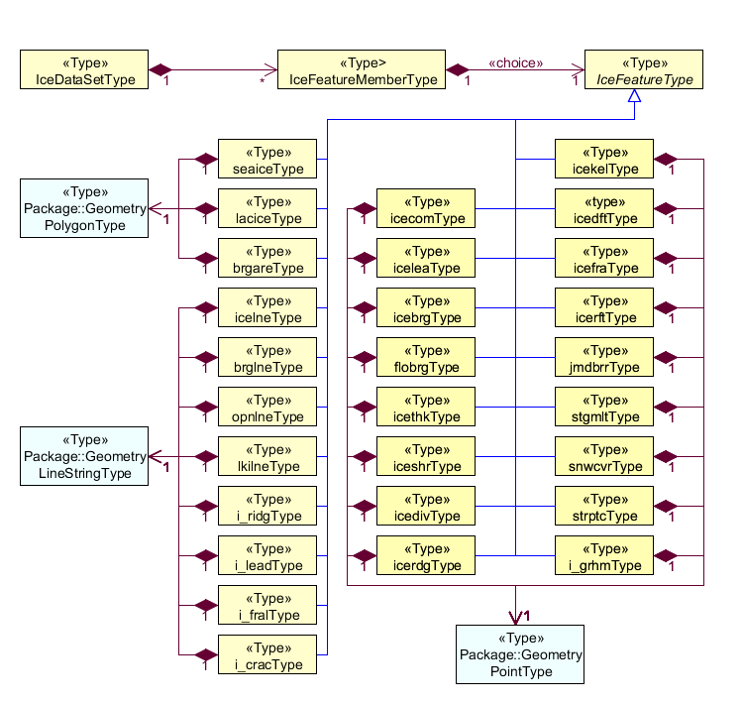

Figure 2: Ice App Schema Types

|  |  |  |  |  |
| --- | --- | --- | --- | --- |
| **Role Name** | **Name** | **Description** | **Mult.** | **Data Type** |
| Class | IceDataSet | Set of ice data | - | IceDataSetType |
| Association | IceFeatureMember | Contains ice feature members | 1..* | IceFeatureMemberType |

|  |  |  |  |  |
| --- | --- | --- | --- | --- |
| **Role Name** | **Name** | **Description** | **Mult.** | **Data Type** |
| Class | IceFeatureMember | A member of Ice Features in a Dataset | - | IceFeatureMember Type |
| Association | IceFeature | Abstract ice feature | 1..1 (choice) | IceFeatureType |
| Association | IceDataSet | Set of ice data | *..1 | IceDataSetType |

|  |  |  |  |  |
| --- | --- | --- | --- | --- |
| **Role Name** | **Name** | **Description** | **Mult.** | **Data Type** |
| Class | IceFeature | Abstract ice feature class | - | IceFeatureType |
| Association | IceFeatureMember | Contains one of ice feature | 1..1  (choice) | IceFeatureMemberType |
| Association | seaice | One of choice options: Sea Ice | 1..1 | seaiceType |
| Association | lacice | One of choice options: Lake Ice | 1..1 | laciceType |
| Association | brgare | One of choice options: Iceberg Area | 1..1 | brgareType |
| Association | icelne | One of choice options: Ice Edge | 1..1 | icelneType |
| Association | brglne | One of choice options: Iceberg Limit | 1..1 | brglneType |
| Association | opnlne | One of choice options: Limit of Open Water | 1..1 | opnlneType |
| Association | lkilne | One of choice options: Limit of All Known Ice | 1..1 | lkilneType |
| Association | i_ridg | One of choice options: Line of Ice Ridge | 1..1 | i_ridgType |
| Association | i_lead | One of choice options: Line of Ice Lead | 1..1 | i_leadType |
| Association | i_fral | One of choice options: Line of Ice Fracture | 1..1 | i_fralType |
| Association | i_crac | One of choice options: Line of Ice Crack | 1..1 | i_cracType |
| Association | icecom | One of choice options: Ice Compacting | 1..1 | icecomType |
| Association | icelea | One of choice options: Ice Lead | 1..1 | iceleaType |
| Association | icebrg | One of choice options: Iceberg | 1..1 | icebrgType |
| Association | flobrg | One of choice options: Floeberg | 1..1 | flobrgType |
| Association | icethk | One of choice options: Ice Thickness | 1..1 | icethkType |
| Association | iceshr | One of choice options: Ice Shear | 1..1 | iceshrType |
| Association | icediv | One of choice options: Ice Divergence | 1..1 | icedivType |
| Association | icerdg | One of choice options: Ice Ridge | 1..1 | icerdgType |
| Association | icekel | One of choice options: Ice Keel | 1..1 | icekelType |
| Association | icedft | One of choice options: Ice Drift | 1..1 | icedftType |
| Association | icefra | One of choice options: Ice Fracture | 1..1 | icefraType |
| Association | icerft | One of choice options: Ice Rafting | 1..1 | icerftType |
| Association | jmdbrr | One of choice options: Jammed Brash Barrier | 1..1 | jmdbrrType |
| Association | stgmlt | One of choice options: Stage of Melt | 1..1 | stgmltType |
| Association | snwcvr | One of choice options: Snow cover | 1..1 | snwcvrType |
| Association | strptc | One of choice options: Strips and Patches | 1..1 | strptcType |
| Association | i_grhm | One of choice options: Grounded Hummock | 1..1 | i_grhmType |

|  |  |  |  |  |
| --- | --- | --- | --- | --- |
| **Role Name** | **Name** | **Description** | **Mult.** | **Data Type** |
| Class | seaice | Sea Ice, one of IceFeatureMember | - | seaiceType |
| Association | IceFeatureMember | contains ice feature | 1..1 | IceFeatureMemberType |

|  |  |  |  |  |
| --- | --- | --- | --- | --- |
| **Role Name** | **Name** | **Description** | **Mult.** | **Data Type** |
| Class | lacice | Lake Ice, one of IceFeatureMember | - | laciceType |
| Association | IceFeatureMember | contains ice feature | 1..1 | IceFeatureMemberType |

|  |  |  |  |  |
| --- | --- | --- | --- | --- |
| **Role Name** | **Name** | **Description** | **Mult.** | **Data Type** |
| Class | brgare | Iceberg Area, one of IceFeatureMember | - | brgareType |
| Association | IceFeatureMember | contains ice feature | 1..1 | IceFeatureMemberType |

|  |  |  |  |  |
| --- | --- | --- | --- | --- |
| **Role Name** | **Name** | **Description** | **Mult.** | **Data Type** |
| Class | icelne | Ice Edge, one of IceFeatureMember | - | icelneType |
| Association | IceFeatureMember | contains ice feature | 1..1 | IceFeatureMemberType |

|  |  |  |  |  |
| --- | --- | --- | --- | --- |
| **Role Name** | **Name** | **Description** | **Mult.** | **Data Type** |
| Class | brglne | Iceberg Limit, one of IceFeatureMember | - | brglneType |
| Association | IceFeatureMember | contains ice feature | 1..1 | IceFeatureMemberType |

|  |  |  |  |  |
| --- | --- | --- | --- | --- |
| **Role Name** | **Name** | **Description** | **Mult.** | **Data Type** |
| Class | opnlne | Limint of Open Water, one of IceFeatureMember | - | opnlneType |
| Association | IceFeatureMember | contains ice feature | 1..1 | IceFeatureMemberType |

|  |  |  |  |  |
| --- | --- | --- | --- | --- |
| **Role Name** | **Name** | **Description** | **Mult.** | **Data Type** |
| Class | lkilne | Limint of All Known Ice, one of IceFeatureMember | - | lkilneType |
| Association | IceFeatureMember | contains ice feature | 1..1 | IceFeatureMemberType |

|  |  |  |  |  |
| --- | --- | --- | --- | --- |
| **Role Name** | **Name** | **Description** | **Mult.** | **Data Type** |
| Class | i_ridg | Line of Ice Ridge, one of IceFeatureMember | - | i_ridgType |
| Association | IceFeatureMember | contains ice feature | 1..1 | IceFeatureMemberType |

|  |  |  |  |  |
| --- | --- | --- | --- | --- |
| **Role Name** | **Name** | **Description** | **Mult.** | **Data Type** |
| Class | i_lead | Line of Ice Lead, one of IceFeatureMember | - | i_leadType |
| Association | IceFeatureMember | contains ice feature | 1..1 | IceFeatureMemberType |

|  |  |  |  |  |
| --- | --- | --- | --- | --- |
| **Role Name** | **Name** | **Description** | **Mult.** | **Data Type** |
| Class | i_fral | Line of Ice Fracture, one of IceFeatureMember | - | i_fralType |
| Association | IceFeatureMember | contains ice feature | 1..1 | IceFeatureMemberType |

|  |  |  |  |  |
| --- | --- | --- | --- | --- |
| **Role Name** | **Name** | **Description** | **Mult.** | **Data Type** |
| Class | i_crac | Line of Ice Crack, one of IceFeatureMember | - | i_cracType |
| Association | IceFeatureMember | contains ice feature | 1..1 | IceFeatureMemberType |

|  |  |  |  |  |
| --- | --- | --- | --- | --- |
| **Role Name** | **Name** | **Description** | **Mult.** | **Data Type** |
| Class | icecom | Ice Compacting, one of IceFeatureMember | - | icecomType |
| Association | IceFeatureMember | contains ice feature | 1..1 | IceFeatureMemberType |

|  |  |  |  |  |
| --- | --- | --- | --- | --- |
| **Role Name** | **Name** | **Description** | **Mult.** | **Data Type** |
| Class | icelea | Ice Lead, one of IceFeatureMember | - | iceleaType |
| Association | IceFeatureMember | contains ice feature | 1..1 | IceFeatureMemberType |

|  |  |  |  |  |
| --- | --- | --- | --- | --- |
| **Role Name** | **Name** | **Description** | **Mult.** | **Data Type** |
| Class | icebrg | Iceberg, one of IceFeatureMember | - | seaiceType |
| Association | IceFeatureMember | contains ice feature | 1..1 | IceFeatureMemberType |

|  |  |  |  |  |
| --- | --- | --- | --- | --- |
| **Role Name** | **Name** | **Description** | **Mult.** | **Data Type** |
| Class | flobrg | Floeberg, one of IceFeatureMember | - | seaiceType |
| Association | IceFeatureMember | contains ice feature | 1..1 | IceFeatureMemberType |

|  |  |  |  |  |
| --- | --- | --- | --- | --- |
| **Role Name** | **Name** | **Description** | **Mult.** | **Data Type** |
| Class | icethk | Ice Thickness, one of IceFeatureMember | - | icethkType |
| Association | IceFeatureMember | contains ice feature | 1..1 | IceFeatureMemberType |

|  |  |  |  |  |
| --- | --- | --- | --- | --- |
| **Role Name** | **Name** | **Description** | **Mult.** | **Data Type** |
| Class | iceshr | Ice Shear, one of IceFeatureMember | - | iceshrType |
| Association | IceFeatureMember | contains ice feature | 1..1 | IceFeatureMemberType |

|  |  |  |  |  |
| --- | --- | --- | --- | --- |
| **Role Name** | **Name** | **Description** | **Mult.** | **Data Type** |
| Class | icediv | Ice Divergence, one of IceFeatureMember | - | icedivType |
| Association | IceFeatureMember | contains ice feature | 1..1 | IceFeatureMemberType |

|  |  |  |  |  |
| --- | --- | --- | --- | --- |
| **Role Name** | **Name** | **Description** | **Mult.** | **Data Type** |
| Class | icerdg | Ice Ridge / Hummock, one of IceFeatureMember | - | icerdgType |
| Association | IceFeatureMember | contains ice feature | 1..1 | IceFeatureMemberType |

|  |  |  |  |  |
| --- | --- | --- | --- | --- |
| **Role Name** | **Name** | **Description** | **Mult.** | **Data Type** |
| Class | icekel | Ice Keel / Bummock, one of IceFeatureMember | - | icekelType |
| Association | IceFeatureMember | contains ice feature | 1..1 | IceFeatureMemberType |

|  |  |  |  |  |
| --- | --- | --- | --- | --- |
| **Role Name** | **Name** | **Description** | **Mult.** | **Data Type** |
| Class | icedft | Ice Drift, one of IceFeatureMember | - | icedftType |
| Association | IceFeatureMember | contains ice feature | 1..1 | IceFeatureMemberType |

|  |  |  |  |  |
| --- | --- | --- | --- | --- |
| **Role Name** | **Name** | **Description** | **Mult.** | **Data Type** |
| Class | icefra | Ice Fracture, one of IceFeatureMember | - | icefraType |
| Association | IceFeatureMember | contains ice feature | 1..1 | IceFeatureMemberType |

|  |  |  |  |  |
| --- | --- | --- | --- | --- |
| **Role Name** | **Name** | **Description** | **Mult.** | **Data Type** |
| Class | icerft | Ice Rafting, one of IceFeatureMember | - | icerftType |
| Association | IceFeatureMember | contains ice feature | 1..1 | IceFeatureMemberType |

|  |  |  |  |  |
| --- | --- | --- | --- | --- |
| **Role Name** | **Name** | **Description** | **Mult.** | **Data Type** |
| Class | jmdbrr | Jammed Brash Barrier, one of IceFeatureMember | - | jmdbrrType |
| Association | IceFeatureMember | contains ice feature | 1..1 | IceFeatureMemberType |

|  |  |  |  |  |
| --- | --- | --- | --- | --- |
| **Role Name** | **Name** | **Description** | **Mult.** | **Data Type** |
| Class | stgmlt | Stage of melt, one of IceFeatureMember | - | stgmltType |
| Association | IceFeatureMember | contains ice feature | 1..1 | IceFeatureMemberType |

|  |  |  |  |  |
| --- | --- | --- | --- | --- |
| **Role Name** | **Name** | **Description** | **Mult.** | **Data Type** |
| Class | snwcvr | Snow cover, one of IceFeatureMember | - | snwcvrType |
| Association | IceFeatureMember | contains ice feature | 1..1 | IceFeatureMemberType |

|  |  |  |  |  |
| --- | --- | --- | --- | --- |
| **Role Name** | **Name** | **Description** | **Mult.** | **Data Type** |
| Class | strptc | Strips and Patches, one of IceFeatureMember | - | strptcType |
| Association | IceFeatureMember | contains ice feature | 1..1 | IceFeatureMemberType |

|  |  |  |  |  |
| --- | --- | --- | --- | --- |
| **Role Name** | **Name** | **Description** | **Mult.** | **Data Type** |
| Class | i_grhm | Grounded Hummock, one of IceFeatureMember | - | i_grhmType |
| Association | IceFeatureMember | contains ice feature | 1..1 | IceFeatureMemberType |

#### IceDataSet / Types

##### IceDataSetType

*IceDataSetType* is a type of root Element of an ice information data set.

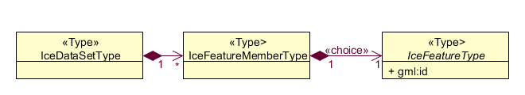

Ice Data Set contains an unlimited number of Ice Feature Members, each Ice Feature Member contains one Ice Feature (seaice, lacice, iceberg, etc.).

#### seaiceType (Sea Ice)

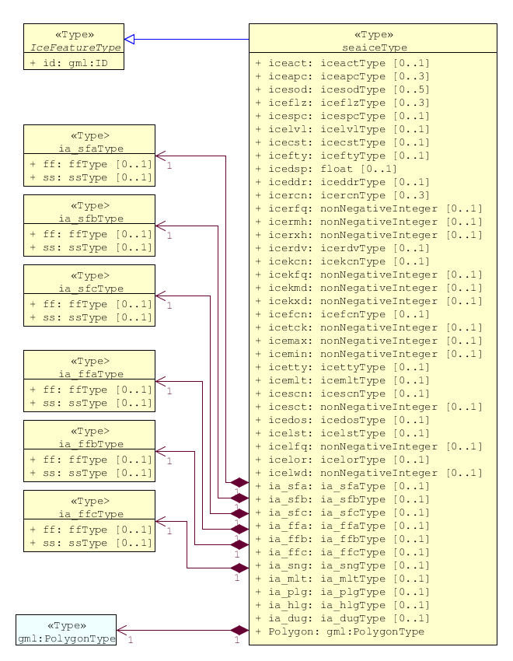

#### laciceType - Lake Ice

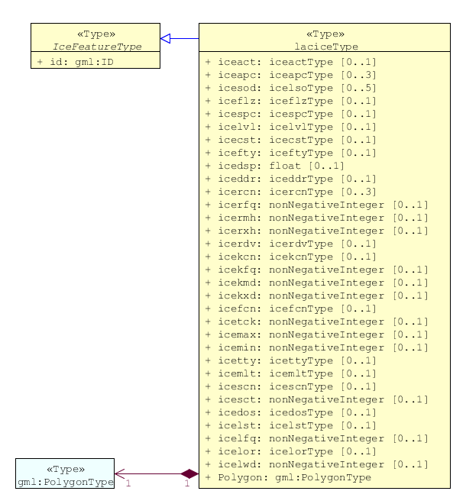

#### brgareType - Iceberg Area

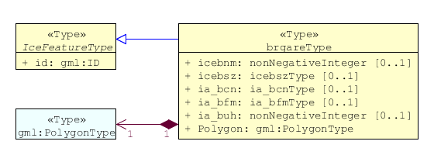

#### icelneType - Ice Edge

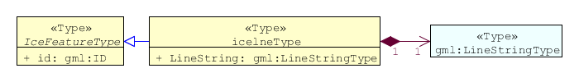

#### brglneType - Iceberg Limit

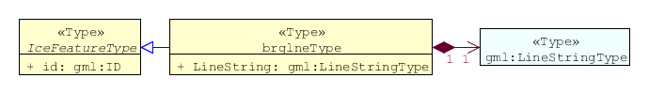

#### opnlneType - Limit of Open Water

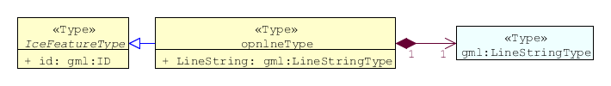

#### lkilneType - Limit of All Known Ice

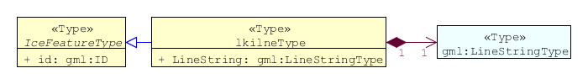

#### i_ridgType - Line of Ice Ridge

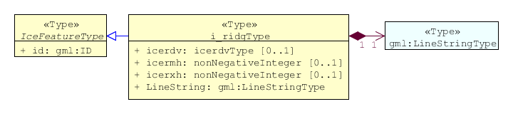

#### i_leadType - Line of Ice Lead

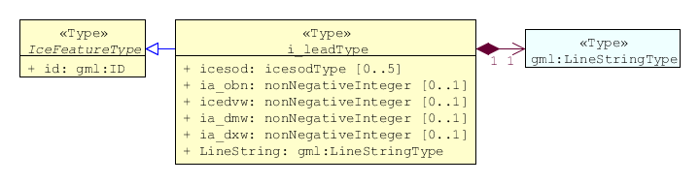

#### i_fralType - Line of Ice Fracture

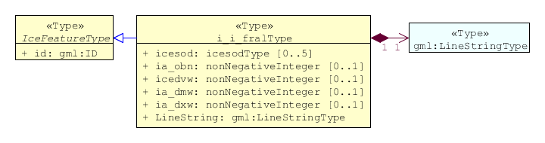

#### i_cracType - Line of Ice Crack

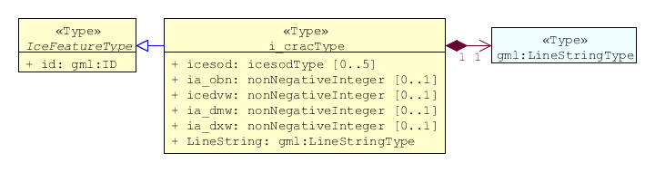

#### icecomType – Ice Compacting

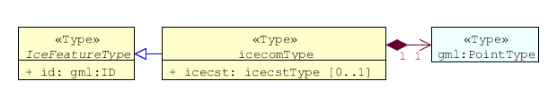

#### iceleaType – Ice Lead

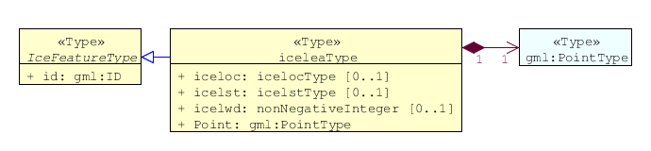

#### icebrgType – Iceberg

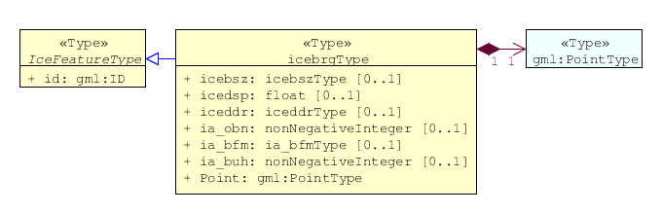

#### flobrgType – Floeberg

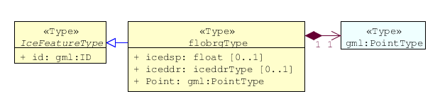

#### icethkType – Ice Thickness

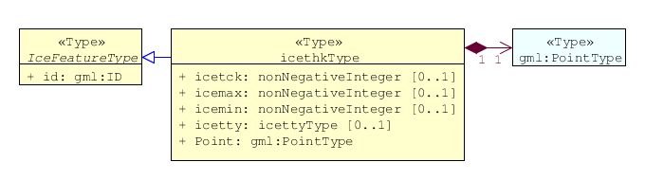

#### iceshrType – Ice Shear

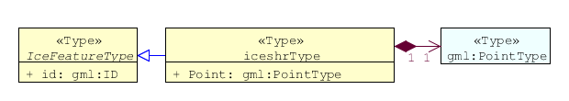

#### icedivType – Ice Divergence

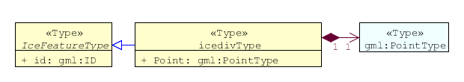

#### icerdgType – Ice Ridge/Hummock

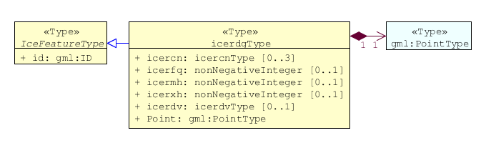

#### icekelType – Ice Keel/Bummock

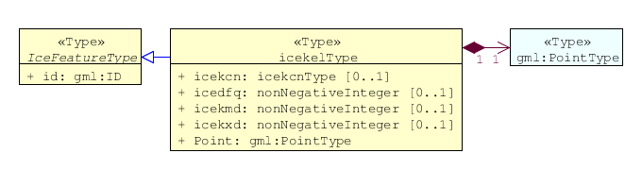

#### icedftType – Ice Drift

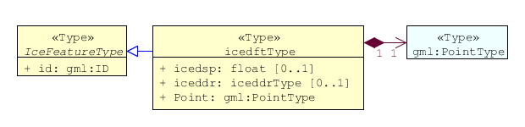

#### icefraType – Ice Fracture

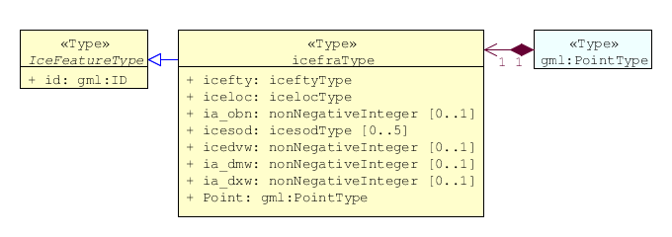

#### icerftType – Ice Rafting

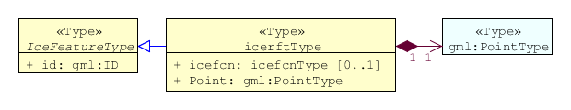

#### jmdbrrType – Jammed Brash Barrier

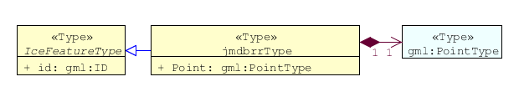

#### stgmltType – Stage of Melt

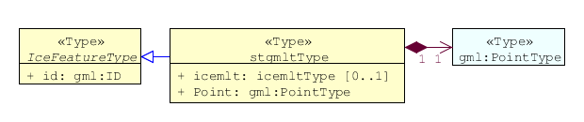

#### snwcvrType – Snow Cover

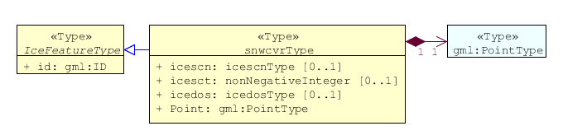

#### strptcType – Strips and Patches

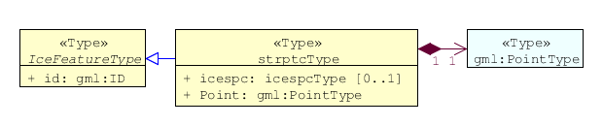

#### i_grhmType – Grounded Hummock

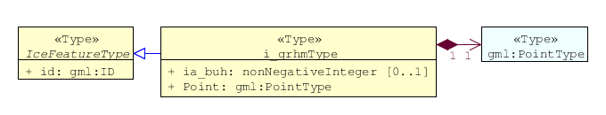

### Feature Types Summary

Table 1: Summary of Types

| **Register Dictionary** | **Index** | **Alpha code** | **Name** |
| --- | --- | --- | --- |
| **IceFCD** | Feature | SEAICE | Sea Ice |
| **IceFCD** | Feature | LACICE | Lake Ice |
| **IceFCD** | Feature | BRGARE | Iceberg Area |
| **IceFCD** | Feature | ICELNE | Ice Edge |
| **IceFCD** | Feature | BRGLNE | Iceberg Limit |
| **IceFCD** | Feature | OPNLNE | Limit of Open Water |
| **IceFCD** | Feature | LKILNE | Limit of All Known Ice |
| **IceFCD** | Feature | I_RIDG | Line of Ice Ridge |
| **IceFCD** | Feature | I_LEAD | Line of Ice Lead |
| **IceFCD** | Feature | I_FRAL | Line of Ice Fracture |
| **IceFCD** | Feature | I_CRAC | Line of Ice Crack |
| **IceFCD** | Feature | ICECOM | Ice Compacting |
| **IceFCD** | Feature | ICELEA | Ice Lead |
| **IceFCD** | Feature | ICEBRG | Iceberg |
| **IceFCD** | Feature | FLOBRG | Floeberg |
| **IceFCD** | Feature | ICETHK | Ice Thickness |
| **IceFCD** | Feature | ICESHR | Ice Shear |
| **IceFCD** | Feature | ICEDIV | Ice Divergence |
| **IceFCD** | Feature | ICERDG | Ice Ridge/Hummock |
| **IceFCD** | Feature | ICEKEL | Ice Keel/Bummock |
| **IceFCD** | Feature | ICEDFT | Ice Drift |
| **IceFCD** | Feature | ICEFRA | Ice Fracture |
| **IceFCD** | Feature | ICERFT | Ice Rafting |
| **IceFCD** | Feature | JMDBRR | Jammed Brash Barrier |
| **IceFCD** | Feature | STGMLT | Stage of Melt |
| **IceFCD** | Feature | SNWCVR | Snow Cover |
| **IceFCD** | Feature | STRPTC | Strips and Patches |
| **IceFCD** | Feature | I_GRHM | Grounded Hummock |
| **IceFCD** | Attribute | ICEACT | Total Concentration |
| **IceFCD** | Attribute | ICEAPC | Partial Concentration |
| **IceFCD** | Attribute | ICESOD | Ice Stage of Development |
| **IceFCD** | Attribute | ICELSO | Lake Ice Stage of Development |
| **IceFCD** | Attribute | ICEFLZ | Floe Sizes |
| **IceFCD** | Attribute | ICEMLT | Melt Stage |
| **IceFCD** | Attribute | ICESPC | Concentration of Strips and Patches |
| **IceFCD** | Attribute | ICEBNM | Number of Icebergs in Area |
| **IceFCD** | Attribute | ICELVL | Level Ice |
| **IceFCD** | Attribute | ICECST | Compacting Strength |
| **IceFCD** | Attribute | ICEFTY | Ice Fracture Type |
| **IceFCD** | Attribute | ICELST | Ice Lead Status |
| **IceFCD** | Attribute | ICELFQ | Frequency of Leads or Fractures |
| **IceFCD** | Attribute | ICELOR | Orientation of Leads or Fractures |
| **IceFCD** | Attribute | ICELWD | Ice Lead (or Fracture or Crack) Width |
| **IceFCD** | Attribute | ICELOC | Ice Location Information |
| **IceFCD** | Attribute | ICEBSZ | Iceberg Size |
| **IceFCD** | Attribute | ICEDDR | Ice Drift Direction |
| **IceFCD** | Attribute | ICEDSP | Ice Drift Speed |
| **IceFCD** | Attribute | ICETCK | Ice Average Thickness |
| **IceFCD** | Attribute | ICEMAX | Maximum Ice Thickness |
| **IceFCD** | Attribute | ICEMIN | Minimum Ice Thickness |
| **IceFCD** | Attribute | ICETTY | Ice Thickness Type |
| **IceFCD** | Attribute | ICESCT | Snow Depth |
| **IceFCD** | Attribute | ICESCN | Snow Cover Concentration |
| **IceFCD** | Attribute | ICEDOS | Direction Of Sastrugi |
| **IceFCD** | Attribute | ICERCN | Ice Ridge Concentration |
| **IceFCD** | Attribute | ICERDV | Ice Ridge Classification |
| **IceFCD** | Attribute | ICERMH | Ice Ridge Mean Height |
| **IceFCD** | Attribute | ICERFQ | Ice Ridge Frequency |
| **IceFCD** | Attribute | ICERXH | Ice Ridge Maximum Height |
| **IceFCD** | Attribute | ICEKCN | Ice Keel Concentration |
| **IceFCD** | Attribute | ICEKFQ | Ice Keel Frequency |
| **IceFCD** | Attribute | ICEKMD | Ice Keel Mean Depth |
| **IceFCD** | Attribute | ICEKXD | Ice Keel Maximum Depth |
| **IceFCD** | Attribute | ICEFCN | Ice Rafting Concentration |
| **IceFCD** | Attribute | IA_SFA | Ice Stage of Development and Floe Size for the 1st p.c. |
| **IceFCD** | Attribute | IA_SFB | Ice Stage of Development and Floe Size for the 2nd p.c. |
| **IceFCD** | Attribute | IA_SFC | Ice Stage of Development and Floe Size for the 3rd p.c. |
| **IceFCD** | Attribute | IA_FFA | Ice Breccia for the 1st partial concentration |
| **IceFCD** | Attribute | IA_FFB | Ice Breccia for the 2nd partial concentration |
| **IceFCD** | Attribute | IA_FFC | Ice Breccia for the 3rd partial concentration |
| **IceFCD** | Attribute | IA_SNG | Snow concentration |
| **IceFCD** | Attribute | IA_MLT | Stage of melting |
| **IceFCD** | Attribute | IA_PLG | Contamination |
| **IceFCD** | Attribute | IA_HLG | Hills concentration |
| **IceFCD** | Attribute | IA_DUG | Fractures concentration |
| **IceFCD** | Attribute | IA_BCN | Icebergs concentration |
| **IceFCD** | Attribute | IA_BFM | Prevailing iceberg form |
| **IceFCD** | Attribute | IA_BUH | Max. height of the above-water part (iceberg / grounded hummock) |
| **IceFCD** | Attribute | IA_OBN | Number of ice objects |
| **IceFCD** | Attribute | IA_DXW | Max. width of ice lead (or fracture or crack) |
| **IceFCD** | Attribute | IA_DMW | Min. width of ice lead (or fracture or crack) |
| **IceFCD** | Attribute | ICEBRS | Brash Ice |

## Dataset Types

### Introduction

At the moment is only one type of dataset supported. This is GML(XML) encoded ice feature collections.

## Geometry

Ice Information datasets use S-100 Level 3a geometry which supports 0-, 1-, and 2-dimensional objects (points, line strings, and polygons).

Figure 3: Geometric Primitives in Ice Information Product

There are three types of geometry: Point, Line String and Polygon. Multi-geometries will be not supported. The standard geometries of GML where redefined for S-411. The reason for this is to reduce file sizes. It is only possible to use “posList” with blanks separated coordinate values, like

<gml:posList>-73.991 40.736 -73.991 40.736</gml:posList>

For standard GML it would be also possible to use following (**DO NOT USE THIS**):

<gml:posList>

<pos>-73.991 40.736</pos>

<pos>-73.991 40.736</pos>

</gml:posList>

Which means much more chars in the file and growing of file size.

All multi-geometries must be splitted into single geometries. Encoding for geometry is GML:

Point encoding example:

<gml:Point

<gml:pos>147.291 -42.851</gml:pos>

</gml:Point>

Line String encoding example:

<gml:LineString>

<gml:posList>-73.991 40.736 -73.991 40.736</gml:posList>

</gml:LineString>

Polygon encoding example:

<gml:Polygon>

<gml:exterior>

<gml:LinearRing>

<gml:posList>

22.546 62.391 25.033 62.404 24.995 60.182 22.483 60.169 22.546 62.391

</gml:posList>

</gml:LinearRing>

</gml:exterior>

<gml:interior>

<gml:LinearRing>

<gml:posList>

23.227 61.811 23.467 61.306 24.023 61.621 24.035 61.621 23.227 61.811

</gml:posList>

</gml:LinearRing>

</gml:interior>

</gml:Polygon>

# Coordinate Reference Systems (CRS)

For exchange of ice data WGS84 (EPSG: 4326) must be used.

# Data Quality

As ice charts are done for different purposes (from weekly overview to tactical charts and further to model forecasts) data quality can differ. Differences can also be found between ice charts of the same region and same nominal date resulting from different issuing agencies or also from different forecasts models. Further information can be found in the WMO publication 574.

# Data Capture and Classification

The data will be captured normally from satellite data. The extraction and classification will be done by ice analysts. In some areas of the world (e.g. the Baltic Sea) in addition also some direct shore and ship based observations and textual ice reports from ice authorities will be used. Further information can be found in the WMO publication 574 in Appendix A.

# Data Product format (encoding)

## Introduction

This clause describes encoding rules for S-100 base ice datasets. For the encoding of ice datasets GML 3.2.1 was used.

## Encoding Rules

### Longitude / Latitude

* Longitude and latitude must be encoded in decimal degrees, e.g. : 12.567 56.765
* Number of decimals is not limited, but it should be as less as possible for minimizing of file size, normally 3 or even 2 digits are enough

### Elements and attributes

* Names of elements representing ice features or attributes (from IceFDC dictionary see Table 1: Summary of Types) must be encoded with lower case letters
* Names of elements representing features or attributes from other dictionaries must be encoded with upper case letters
* Character Set is UTF-8
* Elements or attributes may be empty, but it should be eliminated for minimizing of file size

## Encoding Examples

Below there are three examples of the encoding of various ice features using different geometric primitives, the encoding of other ice objects can be done in a similar way.

### Polygon Feature

<ice:IceFeatureMember>

<ice:brgare gml:id=*"brgare.1"*>

<ice:icebnm/>

<ice:icebsz/>

<ice:ia_bcn/>

<ice:ia_bfm/>

<ice:ia_buh/>

<gml:Polygon srsName=*"http://www.opengis.net/gml/srs/epsg.xml#4326"*>

<gml:exterior>

<gml:LinearRing>

<gml:posList>

22.546 62.391 25.033 62.404 24.995 60.182 22.483 60.169 22.546 62.391

</gml:posList>

</gml:LinearRing>

</gml:exterior>

<gml:interior>

<gml:LinearRing>

<gml:posList>

23.227 61.811 23.467 61.306 24.023 61.621 24.035 61.621 23.227 61.811

</gml:posList>

</gml:LinearRing>

</gml:interior>

</gml:Polygon>

</ice:brgare>

</ice:IceFeatureMember>

### LineString Feature

<ice:IceFeatureMember>

<ice:i_fral gml:id=*"i_fral.1"*>

<ice:icesod>*83*</ice:icesod>

<ice:ia_obn>*50*</ice:ia_obn>

<ice:icedvw>*30*</ice:icedvw>

<ice:ia_dmw>*25*</ice:ia_dmw>

<ice:ia_dxw>*35*</ice:ia_dxw>

<gml:LineString srsName=*"http://www.opengis.net/gml/srs/epsg.xml#4326"*>

<gml:posList>-73.991 40.736 -73.991 40.736</gml:posList>

</gml:LineString>

</ice:i_fral>

</ice:IceFeatureMember>

### Point Feature

<ice:IceFeatureMember>

<ice:icecom gml:id=*"icecom.1"*>

<ice:icecst/>

<gml:Point srsDimension=*"2"* srsName=*"http://www.opengis.net/gml/srs/epsg.xml#4326"*>

<gml:pos>147.291 -42.851</gml:pos>

</gml:Point>

</ice:icecom>

</ice:IceFeatureMember>

# Data Product Delivery

## Introduction

Ice Information Product will be delivered as Exchange Set, containing dataset itself, metadata, etc. It is also possible that several charts are available for an area. The decision, which one to use, is within the responsibility of the navigator on the vessel.

## Exchange Set

The exchange set for the Ice Information Product has following structure:

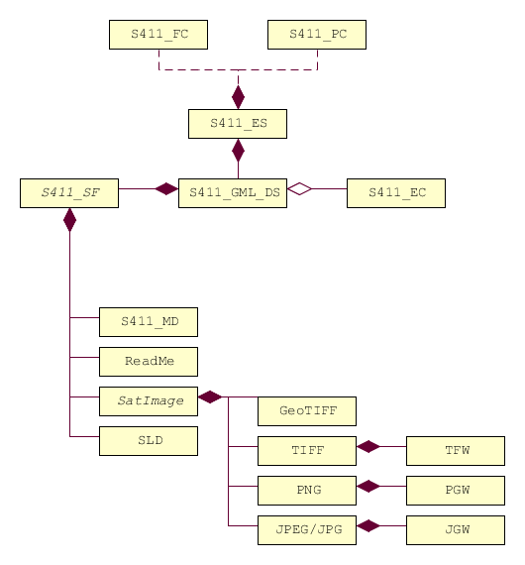

Figure 4: Exchange Set Structure

### Exchange Set Naming

Name of Exchange Set has following structure:

S411_ProducerCode_DatasetNameWithoutEnding

Example: S411_BSH_ek1-20130305-17

An exchange Set can be a simple data folder, but it is recommended to zip this folder for minimizing file size. In this case name of Exchange Set looks like:

S411_ProducerCode_DatasetNameWithoundEnding.zip

Example: S411_BSH_ek1-20130305-17.zip

or if .tar.gz compressing algorithm is in use:

S411_ProducerCode_DatasetNameWithoutEnding.tar.gz

Example: S411_BSH_ek1-20130305-17.tar.gz

## Dataset

### Dataset Naming

The data producer are free to choose file name for data set. The ending or postfix must be “*.gml”.

Example: **ek1-20130305-17.gml**

## Support Files

### Support File Naming

There are no restrictions for support file naming. But it is important to describe the files in the exchange catalogue file.

#### ISO Metadata File

The metadata for Dataset based on ISO 19139/19115, is also official S-100 Metadata with mandatory file identifier. ( See Chapter 10)

#### Portrayal, Symbology

The portrayal (display instructions) should be a part of system, installed on board. But as option display instructions could be a part of exchange set, that means the display instruction xml file and svg symbols can be delivered within the exchange set as support files.

#### SVG Graphics

#### Readme

## Exchange Catalogue

### Exchange Catalogue Naming

Name of Exchange Catalogue is

**CATALOG.ICE**

# Metadata

## Introduction

There are two kinds of metadata to prepare:

* ISO 19139 Metadata

This kind of metadata implementation can be read by broad range of software.

* S100 Metadata

The S100 metadata are for describing the structure of Exchange Catalogue

### ISO 19139 Metadata

For the description of ice data following metadata are necessary:

|  |  |  |
| --- | --- | --- |
| **Element Name** | **Description** | **Namespace** |
| **MD_Metadata** | root element | gmd |
| **fileIdentifier** | Id for dataset | gmd |
| **language** | Product language | gmd |
| **characterSet** | Used characterset | gmd |
| **contact** | Contact data | gmd |
| **dateStamp** | date of publishing | gmd |
| **identificationInfo** | Specific info about product | gmd |

<?xml version=*"1.0"* encoding=*"UTF-8"*?>

<gmd:MD_Metadata xmlns:gmd=*"http://www.isotc211.org/2005/gmd"*

xmlns:gco=*"http://www.isotc211.org/2005/gco"*

xmlns:gml=*"http://www.opengis.net/gml/3.2"*> <gmd:fileIdentifier> ... </gmd:fileIdentifier>

<gmd:language> ... </gmd:language>

<gmd:characterSet> ... </gmd:characterSet>

<gmd:contact> ... </gmd:contact>

<gmd:dateStamp> ... </gmd:dateStamp>

<gmd:identificationInfo> ... </gmd:identificationInfo>

</gmd:MD_Metadata>

#### fileIdentifier

|  |  |  |
| --- | --- | --- |
| **Element Name** | **Description** | **Namespace** |
| **fileIdentifier** | Id for dataset | gmd |
| **CharacterString** | String contained id value | gco |

<gmd:fileIdentifier>

<gco:CharacterString>bsh_ek1-20130114-08</gco:CharacterString>

</gmd:fileIdentifier>

#### language

|  |  |  |
| --- | --- | --- |
| **Element Name** | **Description** | **Namespace** |
| **language** | Language of dataset | gmd |
| **LanguageCode** | Code for language | gmd |

LanguageCode element contains two attributes:

* codeList: Link to the list containing the codes for languages
* codeListValue value from the list defining the used language

<gmd:language>

<gmd:LanguageCode codeList=*"http://www.isotc211.org/2005/resources/Codelist/ML_gmxCodelists.xml#LanguageCode"* codeListValue=*"eng"*>English</gmd:LanguageCode>

</gmd:language>

#### characterSet

|  |  |  |
| --- | --- | --- |
| **Element Name** | **Description** | **Namespace** |
| **characterSet** | characterSet of dataset | gmd |
| **MD_CharacterSetCode** | Code for characterSet | gmd |

MD_CharacterSetCode element contains two attributes:

* codeList: Link to the list containing the codes for character set
* codeListValue value from the list defining the used character set

<gmd:characterSet>

<gmd:MD_CharacterSetCode codeList=*"http://www.isotc211.org/2005/resources/Codelist/ML_gmxCodelists.xml#MD_CharacterSetCode"* codeListValue=*"utf8"*>UTF 8</gmd:MD_CharacterSetCode>

</gmd:characterSet>

#### contact

|  |  |  |
| --- | --- | --- |
| **Element Name** | **Description** | **Namespace** |
| **contact** | Contact for questions to dataset | gmd |
| **CI_ResponsibleParty** | ISO Element for contact data | gmd |
| **individualName** | Name of responsible person | gmd |
| **CharacterString** | individualName value (text) | gco |
| **organisationName** | Name of responsible organisation | gmd |
| **CharacterString** | organisationName value (text) | gco |
| **contactInfo** | Contact information | gmd |
| **CI_Contact** | ISO Element for contact information | gmd |
| **phone** | phone | gmd |
| **CI_Telephone** |  | gmd |
| **voice** |  | gmd |
| **CharacterString** | Voice telephone value (text) | gco |
| **facsimile** |  | gmd |
| **CharacterString** | Fax number value (text) | gco |
| **address** |  | gmd |
| **CI_Address** |  | gmd |
| **deliveryPoint** |  | gmd |
| **CharacterString** | Postal Address (street, house number) | gco |
| **city** |  | gmd |
| **CharacterString** | City name value (text) | gco |
| **administrativeArea** |  | gmd |
| **CharacterString** | Administrative Area name value (text) | gco |
| **postalCode** |  | gmd |
| **CharacterString** |  | gco |
| **electronicMailAddress** |  | gmd |
| **CharacterString** | Email value (text) | gco |
| **role** |  | gmd |
| **CI_RoleCode** |  | gmd |

CI_RoleCode element contains two attributes

* codeList: Link to the list containing the codes for roles
* codeListValue value from the list defining the used roles

<gmd:contact>

<gmd:CI_ResponsibleParty>

<gmd:individualName>

<gco:CharacterString>Jürgen Holfort</gco:CharacterString>

</gmd:individualName>

<gmd:organisationName>

<gco:CharacterString>FMHA Germany (BSH)</gco:CharacterString>

</gmd:organisationName>

<gmd:contactInfo>

<gmd:CI_Contact>

<gmd:phone>

<gmd:CI_Telephone>

<gmd:voice>

<gco:CharacterString>+49 (0) 381 4563-782</gco:CharacterString>

</gmd:voice>

<gmd:facsimile>

<gco:CharacterString>+49 (0) 381 4563-949</gco:CharacterString>

</gmd:facsimile>

</gmd:CI_Telephone>

</gmd:phone>

<gmd:address>

<gmd:CI_Address>

<gmd:deliveryPoint>

<gco:CharacterString>Neptunallee 5</gco:CharacterString>

</gmd:deliveryPoint>

<gmd:administrativeArea>

<gco:CharacterString>Rostock</gco:CharacterString>

</gmd:administrativeArea>

<gmd:postalCode>

<gco:CharacterString>18057</gco:CharacterString>

</gmd:postalCode>

<gmd:electronicMailAddress>

<gco:CharacterString>ice@bsh.de</gco:CharacterString>

</gmd:electronicMailAddress>

</gmd:CI_Address>

</gmd:address>

</gmd:CI_Contact>

</gmd:contactInfo>

<gmd:role>

<gmd:CI_RoleCode codeList=*"http://www.isotc211.org/2005/resources/Codelist/gmxCodelists.xml#CI_RoleCode"* codeListValue=*"originator"*>originator</gmd:CI_RoleCode>

</gmd:role>

</gmd:CI_ResponsibleParty>

</gmd:contact>

#### dateStamp

|  |  |  |
| --- | --- | --- |
| **Element Name** | **Description** | **Namespace** |
| **dataStamp** | Date Stamp | gmd |
| **Date** | Formatted String (yyyy-MM-dd) | gco |

The dateStamp should be used for the publication date (just day using gco:date or including the time using gco:datetime). The date and time where the ice chart is considered valid should be given in identificationinfo (see 10.1.1.6). Classic operational ice charts should have a time stamp within the temporal extent given in identificationinfo, a dateStamp preceding the temporal extent denotes a prognosis chart, a dateStamp that is more recent then the temporal extent denotes an historic reanalysis or a climatological chart.

<gmd:dateStamp>

<gco:Date>2013-02-25</gco:Date>

</gmd:dateStamp>

#### identificationInfo

|  |  |  |  |
| --- | --- | --- | --- |
| **Element Name** | **Description** | | **Namespace** |
| **identificationInfo** | |  | gmd |
| **MD_DataIdentification** | |  |  |
| **citation** | |  |  |
| **CI_Citation** | |  |  |
| **title** | |  |  |
| **CharacterString** | |  | gco |
| **date** | |  |  |
| **CI_Date** | |  |  |
| **date** | |  |  |
| **Date** | |  | gco |
| **dateType** | |  |  |
| **CI_DateTypeCode** | |  |  |
| **abstract** | |  |  |
| **CharacterString** | |  | gco |
| **language** | |  |  |
| **LanguageCode** | |  |  |
| **characterSet** | |  |  |
| **MD_CharacterSetCode** | |  |  |
| **topicCategory** | |  |  |
| **MD_TopicCategoryCode** | |  |  |
| **extent** | |  |  |
| **EX_Extent** | |  |  |
| **geographicElement** | |  |  |
| **EX_GeographicBoundingBox** | |  |  |
| **westBoundLongitude** | |  |  |
| **Decimal** | |  | gco |
| **eastBoundLongitude** | |  |  |
| **Decimal** | |  | gco |
| **southBoundLatitude** | |  |  |
| **Decimal** | |  | gco |
| **northBoundLatitude** | |  | gmd |
| **Decimal** | |  | gco |
| **temporalElement** | |  | gmd |
| **EX_TemporalExtent** | |  | gmd |
| **extent** | |  | gmd |
| **TimePeriod** | |  | gml |
| **beginPosition** | |  | gml |
| **endPosition** | |  | gml |

<gmd:identificationInfo>

<gmd:MD_DataIdentification>

<gmd:citation>

<gmd:CI_Citation>

<gmd:title>

<gco:CharacterString>IceArea25022013.shp</gco:CharacterString>

</gmd:title>

<gmd:date>

<gmd:CI_Date>

<gmd:date>

<gco:Date>2013-02-25</gco:Date>

</gmd:date>

<gmd:dateType>

<gmd:CI_DateTypeCode codeList=*"http://www.isotc211.org/2005/resources/Codelist/ML_gmxCodelists.xml#CI_DateTypeCode"* codeListValue=*"creation"*>creation</gmd:CI_DateTypeCode>

</gmd:dateType>

</gmd:CI_Date>

</gmd:date>

</gmd:CI_Citation>

</gmd:citation>

<gmd:abstract>

<gco:CharacterString>Ice Chart for Baltic sea</gco:CharacterString>

</gmd:abstract>

<gmd:language>

<gmd:LanguageCode codeList=*"http://www.isotc211.org/2005/resources/Codelist/ML_gmxCodelists.xml#LanguageCode"* codeListValue=*"eng"*>English</gmd:LanguageCode>

</gmd:language>

<gmd:characterSet>

<gmd:MD_CharacterSetCode codeList=*"http://www.isotc211.org/2005/resources/Codelist/ML_gmxCodelists.xml#MD_CharacterSetCode"* codeListValue=*"utf8"*>UTF 8</gmd:MD_CharacterSetCode>

</gmd:characterSet>

<gmd:topicCategory>

<gmd:MD_TopicCategoryCode>geoscientificInformation</gmd:MD_TopicCategoryCode>

</gmd:topicCategory>

<gmd:extent>

<gmd:EX_Extent>

<gmd:geographicElement>

<gmd:EX_GeographicBoundingBox>

<gmd:westBoundLongitude>

<gco:Decimal>8.963</gco:Decimal>

</gmd:westBoundLongitude>

<gmd:eastBoundLongitude>

<gco:Decimal>30.353</gco:Decimal>

</gmd:eastBoundLongitude>

<gmd:southBoundLatitude>

<gco:Decimal>53.613</gco:Decimal>

</gmd:southBoundLatitude>

<gmd:northBoundLatitude>

<gco:Decimal>65.0</gco:Decimal>

</gmd:northBoundLatitude>

</gmd:EX_GeographicBoundingBox>

</gmd:geographicElement>

<gmd:temporalElement>

<gmd:EX_TemporalExtent>

<gmd:extent>

<gml:TimePeriod gml:id=*"ek1-20130225-16"*>

<gml:beginPosition>2013-02-25</gml:beginPosition>

<gml:endPosition>2013-02-27</gml:endPosition>

</gml:TimePeriod>

</gmd:extent>

</gmd:EX_TemporalExtent>

</gmd:temporalElement>

</gmd:EX_Extent>

</gmd:extent>

</gmd:MD_DataIdentification>

</gmd:identificationInfo>

## Language

The language used in metadata must be English. Other languages are optional and only as addition to the English version.

# Maintenance

## Maintenance and Update Frequency

Ice information datasets should be maintained if a new dataset of region and provider is available. There is no updating mechanism necessary, because the datasets itself will not updated. The old one have to be replaced with new one.

# Portrayal

## Rules

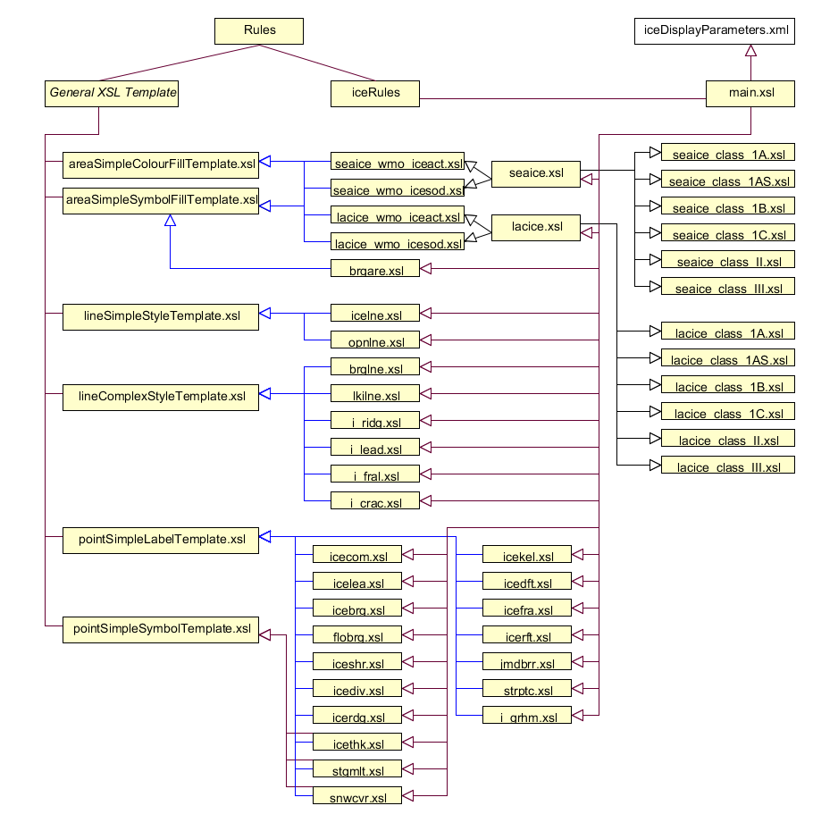

**main.xsl** includes all the rules for single feature types. It manages the selection of the right rule, depending on current feature type in dataset and parameters in iceDisplayParameters.xml.

**iceDisplayParameters.xml** contains parameters important for display of ice features:

* String iceclass
* Boolean encoverlay
* String Display Mode

Depending on the iceclass parameter the right seaice or lacice rule can be selected. The default is *_class_III.xsl

The encoverlay parameter helps to calculate the priority for display of single ice feature types. If encoverlay is true, the priority will be calculated, depending on priority of land area feature in ENC. The area objects of ice features should be displayed under the land area polygons, because they are usually drawn over the land.

## Symbols

### Polygon Features

#### IceNavigationalDisplayMode (Traffic Light Principle, depends on Ice Class)



#### IceScientificIceactDisplayMode

|  |  |  |  |
| --- | --- | --- | --- |
| **iceact** | **description** | **rgb** | **color** |
| 1 | Ice Free | 000 100 255 |  |
| 2 | Open Water (< 1/10 ice) | 150 200 255 |  |
| 3 | Bergy Water | 150 200 255 |  |
| 10 | 1/10 ice | 140 255 160 |  |
| 12 | 1/10 to 2/10 ice | 140 255 160 |  |
| 13 | 1/10 to 3/10 ice | 140 255 160 |  |
| 20 | 2/10 ice | 140 255 160 |  |
| 23 | 2/10 to 3/10 ice | 140 255 160 |  |
| 24 | 2/10 to 4/10 ice | 140 255 160 |  |
| 30 | 3/10 ice | 140 255 160 |  |
| 34 | 3/10 to 4/10 ice | 140 255 160 |  |
| 35 | 3/10 to 5/10 ice | 255 255 000 |  |
| 40 | 4/10 ice | 255 255 000 |  |
| 45 | 4/10 to 5/10 ice | 255 255 000 |  |
| 46 | 4/10 to 6/10 ice | 255 255 000 |  |
| 50 | 5/10 ice | 255 255 000 |  |
| 56 | 5/10 to 6/10 ice | 255 255 000 |  |
| 57 | 5/10 to 7/10 ice | 255 255 000 |  |
| 60 | 6/10 ice | 255 255 000 |  |
| 67 | 6/10 to 7/10 ice | 255 255 000 |  |
| 68 | 6/10 to 8/10 ice | 255 125 007 |  |
| 70 | 7/10 ice | 255 125 007 |  |
| 78 | 7/10 to 8/10 ice | 255 125 007 |  |
| 79 | 7/10 to 9/10 ice | 255 125 007 |  |
| 80 | 8/10 ice | 255 125 007 |  |
| 81 | 8/10 to 10/10 ice | 255 000 000 |  |
| 89 | 8/10 to 9/10 ice | 255 125 007 |  |
| 90 | 9/10 ice | 255 000 000 |  |
| 91 | 9/10 to 10/10 or 9+/10 ice | 255 000 000 |  |
| 92 | 10/10 ice | 145 000 000 |  |
| 99 | Undetermined/Unknown | SymbolFill |  |

#### IceScientificIcesodDisplayMode

|  |  |  |  |
| --- | --- | --- | --- |
| **icesod** | **desc** | **rgb** | **color** |
| 1 | Ice Free | 150 200 255 |  |
| 70 | Brash Ice | 150 200 255 |  |
| 80 | No stage of development | 150 200 255 |  |
| 81 | New Ice (<10 cm) | 240 210 250 |  |
| 82 | Nilas Ice Rind (<10 cm) | 255 100 255 |  |
| 83 | Young Ice (10 to <30 cm) | 170 040 240 |  |
| 84 | Grey Ice (10 to <15 cm) | 135 060 215 |  |
| 85 | Grey – White Ice (15 to <30 cm) | 220 080 235 |  |
| 86 | First Year Ice (30 to 200 cm) | 255 255 000 |  |
| 87 | Thin First Year Ice (30 to <70 cm) | 155 210 000 |  |
| 88 | Thin First Year Ice Stage 1 (30 to <50 cm) | 215 250 130 |  |
| 89 | Thin First Year Ice Stage 2 (50 to <70 cm) | 175 250 000 |  |
| 91 | Medium First Year Ice (70 to 120 cm) | 000 200 020 |  |
| 93 | Thick First Year Ice (>120 cm) | 000 120 000 |  |
| 94 | Residual Ice | 000 120 000 |  |
| 95 | Old Ice | 180 100 050 |  |
| 96 | Second Year Ice | 255 120 010 |  |
| 97 | Multi-Year Ice | 200 000 000 |  |
| 98 | Glacier Ice (Icebergs) | SymbolFill | |  | | --- | |  | |
| 99 | Undetermined/Unknown | SymbolFill |  |

### Line Features



### Point Features

|  |  |  |
| --- | --- | --- |
| **Feature Class** | **Acronym** | **Symbol** |
| Ice Compacting | icecom |  |
| Ice Lead | icelea |  |
| Floeberg | flobrg |  |
| Ice Shear | iceshr |  |
| Ice Divergence | icediv |  |
| Ice Ridge / Hummock | icerdg |  |
| Ice Keel / Bummock | icekel |  |
| Ice Fracture | icefra |  |
| Ice Rafting | icerft |  |
| Jammed Brash Barrier | jmdbrr |  |
| Stage of Melt | stgmlt |  |
| Snow Cover | snwcvr |  |
| Strips and Patches | strptc |  |
| Grounded Hummock | i_grhm |  |
| Iceberg | icebrg |  |
|  | icebrg 01 (Growler) |  |
|  | icebrg 02 (Bergy Bit) |  |
|  | icebrg 03 (Small Iceberg) |  |
|  | icebrg 04 (Medium Iceberg) |  |
|  | icebrg 05 (Large Iceberg) |  |
|  | icebrg 06 (Very large Iceberg) |  |
|  | icebrg 07 (Ice Island Fragment) |  |
|  | icebrg 08 (Ice Island) |  |
|  | icebrg 09 (Radar Target) |  |
|  | icebrg 99 (Unknown) |  |
| Ice Drift | icedft |  |
|  | icedft 01 (No Ice Motion) |  |
|  | icedft 02 (NE) |  |
|  | icedft 03 (E) |  |
|  | icedft 04 (SE) |  |
|  | icedft 05 (S) |  |
|  | icedft 06 (SW) |  |
|  | icedft 07 (W) |  |
|  | icedft 08 (NW) |  |
|  | icedft 09 (N) |  |
|  | icedft 10 (Variable) |  |
|  | icedft 99 (Unkonwn) |  |

### Draw order

The highest number will be drawn on the top.

|  |  |  |
| --- | --- | --- |
| **No.** | **Name** | **Acronym** |
| 1 | Sea Ice | seacie |
| 1 | Lake Ice | lacice |
| 2 | Iceberg Area | icebrg |
| 3 | Ice Edge | icelne |
| 4 | Iceberg Limit | brglne |
| 5 | Limit of Open Water | opnlne |
| 6 | Limit of All Known Ice | lkilne |
| 7 | Line of Ice Ridge | i_ridg |
| 8 | Line of Ice Lead | i_lead |
| 9 | Line of Ice Fracture | i_fral |
| 10 | Line of Ice Crack | i_crac |
| 11 | Ice Compacting | icecom |
| 12 | Ice Lead | icelea |
| 13 | Iceberg | icebrg |
| 14 | Floeberg | flobrg |
| 15 | Ice Thickness | icethk |
| 16 | Ice Shear | iceshr |
| 17 | Ice Divergence | icediv |
| 18 | Ice Ridge / Hummock | icerdg |
| 19 | Ice Keel / Bummock | icekel |
| 20 | Ice Drift | icedft |
| 21 | Ice Fracture | icefra |
| 22 | Ice Rafting | icerft |
| 23 | Jammed Brash Barrier | jmdbrr |
| 24 | Stage of Melt | stgmlt |
| 25 | Snow Cover | snwcvr |
| 26 | Strips and Patches | strptc |
| 27 | Grounded Hummock | i_grhm |

# Additional Information

# Annex A – Data Classification and Encoding Guide

The data classification is generally done by ice services, see the WMO publication “Sea-Ice Information Services in the World” (WMO-No.574). As a guide for encoding some python scripts are given in directory “software” to convert shapefiles (e.g. SIGRID-3) into S-411.

# Annex B – Data Product format (encoding)

In directory “Schemas”

# Annex D – Feature Catalogue

File S411FC.xml

# Annex F – Portrayal Catalogue (SE, XSLT + SVG)

In directory “Portrayal”

# Annex G – Encoding Example for all ice features

In directory “Test”

# Annex I – Exchange Catalogue Example

In directory “Example”; templates for Metadata and Exchange set are also found in directory “software”.