Information for Visitors

Meeting Venue
The Fourth Session of the JCOMM Expert Team on Sea Ice (ETSI) of the Joint WMO/IOC Technical Commission for Oceanography and Marine Meteorology (JCOMM), and the Twelfth Session of the Steering Group for the JCOMM project “Global Digital Sea Ice Data Bank” (GDSIDB) will take place in the Minor Hall, 1st floor, of the Arctic and Antarctic Research Institute (AARI), 38 Bering str., St. Petersburg, Russian Federation. The building (B) is located in the western part of the city on the Vasilievsky Island, about 300 meters from the underground station “Primorskaya” and at distance of 2 km from the recommended **** Pribaltiyskaya Hotel (A), see attached map for exact location. Other locations and distances on the map: C – TRANSAS, D – historical icebreaker “Krasin” (A-B – 1.8 km or 22 min, B-C – 1.8 km or 22 min, C-D – 2.0 km or 24 min).
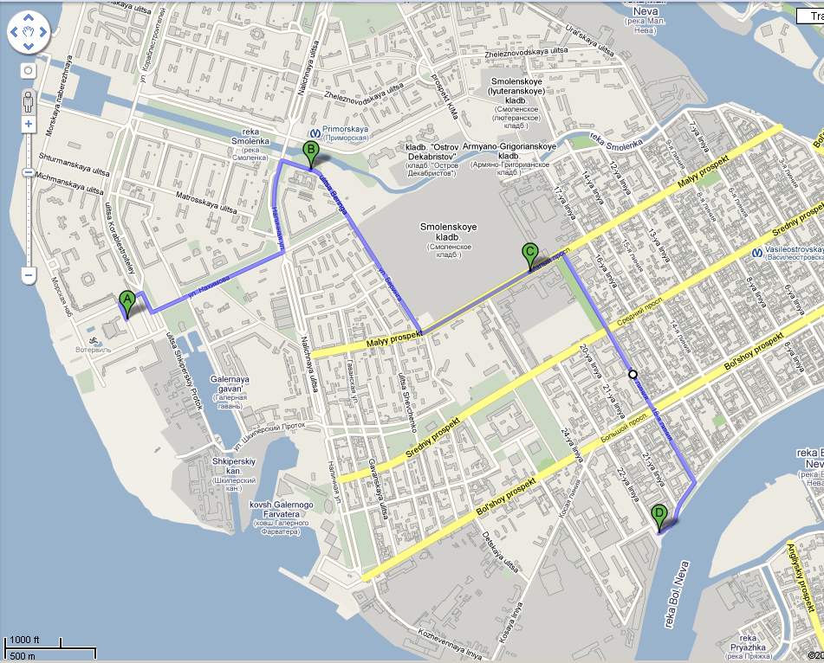

Hotel
A block reservation for participants in ETSI-IV-GDSIDB-XII has been made at the Park Inn Pribaltiyskaya Hotel (14 Korablestroiteley Street) via the DarAlex tourist company for the nominal arrival on February 27th and departure on March 7th. We are asking the participants to contact the local committee (in additional to Russian visa support) to confirm the reservations and period of stay and by arrival at the hotel to contact DarAlex representative at the lobby. The prices are close to 80EUR for a single room and 100 EUR for a double, breakfast included. The Hotel has good access to St.Petersburg transportation system, provides shuttle service to the city center and is 25 km from St. Petersburg Pulkovo II International Airport, 10 km from the nearest railway station and 2 km to the closest subway station, see more information at http://pribaltiyskaya.parkinn.com.ru/.

Airport
St.Petersburg Pulkovo-II (LED) international airport is located to the south the city and about 25 km to the AARI or Park Inn Pribaltiyskaya Hotel. See http://www.pulkovoairport.ru/eng/ for additional information on the Pulkovo-II airport facilities. We recommend to take a taxi from the airport to the hotel (about 50 EUR, 40 minutes, contact one the taxi desk at the arrival section), for public transportation (shuttle bus, underground, bus) see http://www.pribaltiyskayahotel.ru/go.html.

Transportation
Ground local transport (http://petersburgcity.com/city/transport/publictransport/g_transport/) includes buses, trams and trolleybuses. Petersburg ticket costs 19 rubles, you need to pay the conductor. Ground transport is working with up to 5.00-5.30 and 0.00-0.30. The route is usually painted on board the vehicle - on the plate number. In general, citizens travel mainly on route taxis. On the commercial routes operate minibuses and large buses with index «K», «T» or «E» in the composition of numbers. They run frequently and in all corners of the city, fares are asked to 26 rubles at the center and less in the suburbs. Large expresses admit and release the passengers only at bus stops for public transport, minibuses - almost anywhere. Mini bus is caught as taxi - a hand’s move.
Petersburg subway (http://petersburgcity.com/city/transport/publictransport/subway/) - the deepest in the world: as the city stands on a swamp, tunnels were digged in the thick Cambrian clay to a depth of 110 m. The halls of old stations designed luxurious: marble and granite columns and bas-reliefs, mosaics and sculptures. There are several stations where the road separated from the platform with automatic sliding. To orient in your own in the subway is very easy: for each station, there are many signs and circuit lines. One travel costs 22 rubles, but you can save by buying a ticket to 10-50 trips or for a fixed period of time. Metro - the most reliable transportation Petersburg, there are no traffic jams and accidents are extremely rare. However, during peak hours there is a serious jam at the entrance to the station and in the cars.
City subway stations are marked with the blue letter "M". They work from 5:45 a.m. until midnight. The last train leaves the end station at 12 midnight, so you might actually be able to catch it sometime between 12:00 and 12:30 at stations closer to the middle of the line. Subway trains run with the interval of 2 to 3 minutes, but from 8:00 a.m. to 10:00 a.m. and from 5:00 p.m. to 7:00 p.m. on the weekday, the coaches may be overcrowded.

Long-distance transportation is available from one of the 5 Railway Stations, with Finland railway station serving also routes to Helsinki (5 hours) and Moscow railway station to Moscow (4-8 hours) and southern Russia. See http://petersburgcity.com/city/transport/railwaycommunication/ .

Visas
Visitors to Russian Federation from most countries will require a visa to enter the country. They should also be in possession of national passports valid for at least 6 months from the first date of travel. Support for either business or tourist visa is provided by AARI, Ms Elena Berezina (see local contacts section). The applicant should provide a filled form (http://wdc.aari.ru/wmo/etsi-iv/Visa_data.doc) and scanned copy of his/her passport (e-mailed or faxed) to Ms Berezina for organizing a letter of invitation in advance of at least 3-4 weeks. For formal visa requirements and other information on entry conditions, see information on visa sections of Russian consulates.

Money
The Russian currency is the Russian ruble (RUB) and kopecks. In February 2010:
1 USD = 30.2 RUB
1 EUR = 42.1 RUB
In addition to the hotel, an ATM machine is located on the ground floor of the AARI.
All major credit cards are accepted in most the places. Most restaurant, taxi and similar bills already incorporate some form of service charge, so additional tipping is not obligatory. Nevertheless, tips are always welcome, 10% of the bill is suggested.

Internet facilities
In additional to the session, broadband free wireless connection is available in the hotel ground floor.

History and tourist guides
Saint Petersburg (Russian Sankt Peterburg), second largest city and largest seaport in Russia, located in the northwestern part of the country, at the head of the Gulf of Finland (an arm of the Baltic Sea). The capital of Russia for two centuries (1712-1918), Saint Petersburg is one of the most beautiful cities in Europe, noted for its lavish palaces and grand cathedrals, including the Winter Palace (Hermitage), the Russian Museum, St.Issak and Kazan Cathedrals etc. It is also a major rail junction and an industrial, cultural, and scientific center. The city is located on both banks of the Neva River and on a number of river islands. See http://petersburgcity.com/city - internet Guide to St.Petersburg and http://www.infoservices.com/stpete/index.html - city yellow pages.

Climate and geography
St. Petersburg is the northernmost major city of the world. It is located at 59° 57' Latitude North, 30° 19' Longitude East (Pulkovo meridian). The climate is humid, close to maritime, with a moderately warm summer and a rather long moderately cold winter. The average winter temperature is -8°C, the average summer temperature is +17.8°C. The temperature may significantly vary in winter from +5°C to -30°C. Precipitation reaches 550-600 mm per year.
The Neva River is the city's main waterway. The name of the river derives from the ancient name of Lake Ladoga, the Neva where it begins. The Neva is 74 kilometers long, flowing 32 kilometers within the city boundaries. The average width of the Neva within the city is 600 meters, depth - up to 24 meters. In the delta, the Neva splits into three main branches: the Bolshaya Neva, the Malaya Neva and the Bolshaya Nevka.
The city is located on 44 islands formed by the Neva River and 90 more rivers and canals. The abundance of islands has led to the construction of a multitude of bridges. Of these, nowadays there are 308 within the city proper, and 5-34 if suburbs are included. 22 of the bridges are drawbridges. The total length of all the bridges is about 16 kilometers. The longest bridge across the Neva is the Alexander Nevsky Bridge (909 meters with runways), the widest bridge is the Siniy Bridge on the Moika River (99.5 meters).
The highest elevation equals 42 meters above the sea level (Poklonnaya Gora). Floods occur frequently in the city Most often they happen in autumn due to strong westerly winds. In the history of the city the Neva has risen above ordinary level more than 300 times. A water-meter was built near the Mining Institute in 1877. A flood is registered if the water rises 180 cm above the normal level. The biggest flood was on November 7 1824 when the water rose 4.1 metres above the ordinary level.

Weather and 5 days forecast
It’s better use forecast, see - http://wmc.meteoinfo.ru/forecasts5000/russia/leningrad-region

Visa support and local contacts
Ms Elena Berezina  Department of international cooperation  Tel. +7 (812)352-0319 (office)  +7 (921) 345-1916 (mobile)  Fax. +7 (812) 3522883  E-mail: aaricoop@aari.ru | Dr Vasily Smolyanitsky  Head of laboratory for sea ice climate manuals  WMO/IOC JCOMM chair  Tel. +7 (812)352-2152 (office)  +7 (951)654-4196  Skype: vasily.smolyanitsky  Fax. +7 (812)352-2688  E-mail: vms@aari.aq

