WORLD METEOROLOGICAL ORGANIZATION  ________________________ | INTERGOVERNMENTAL OCEANOGRAPHIC  COMMISSION (OF UNESCO)  ________________________
JOINT WMO/IOC TECHNICAL COMMISSION FOR OCEANOGRAPHY AND MARINE METEOROLOGY (JCOMM)  EXPERT TEAM ON SEA ICE – FOURTH SESSION  STEERING GROUP FOR THE PROJECT GLOBAL DIGITAL SEA ICE DATA BANK (GDSIDB) – TWELTH SESSION  ST PETERSBURG, RUSSIAN FEDERATION  1 TO 5 MARCH 2010 | ETSI-IV GDSIDB-XI/Doc. 2.5.2  (19.02.2010)  __________  ITEM 2.5.2  Original: ENGLISH

Report of the Joint WMO/IHO/IMO group on Maritime Safety Services

(Submitted by Nick Ashton, ETMSS Vice-Chairperson)

Summary and Purpose of Document
This document provides a short summary report on the activities of the Joint IMO/IHO/WMO correspondence group on Arctic MSI services.

ACTION PROPOSED
The Expert Team on Sea Ice (ETSI) is invited to note and comment on the information provided as appropriate.
________________________

DISCUSSION

Introduction

1 At its tenth session (6-10 March 2006) the COMSAR Sub-Committee of IMO agreed to establish a Joint IMO/IHO/WMO Correspondence Group on MSI services and specifically the introduction of new services in the Arctic Region. This Correspondence Group has bee re-established by subsequent Sub Committee sessions and at its thirteenth session (19-23 January 2009), the Sub-Committee noted the report of the Joint IMO/IHO/WMO Correspondence Group (CG) on Arctic MSI Services and considered that it would be necessary to continue with the work of the CG until such time that the new NAVAREA/METAREA services were operational. The CG was chaired by Mr. Peter Doherty (IHO).

2 The JCOMM Expert Team on Maritime Safety Services has been active in this joint IMO/IHO/WMO Correspondence Group in ensuring that all relevant issues for the METAREA Issuing Services are properly addressed.

3 The Joint IMO/IHO/WMO Correspondence Group on Arctic MSI Services was tasked with giving consideration and providing comments and recommendations relating to:
1 monitoring the testing of Arctic NAVAREAs/METAREAs including status,
infrastructure, monitoring of messages and relationships with information providers (i.e., International Ice Patrol, METAREA Issuing Authorities, Search and Rescue Authorities, National Administrations and other NAVAREA Coordinators);
2 facilitate the coordination of transmissions on the NAVTEX frequencies
of 518 kHz, 490 kHz and 4209.5 kHz through the NAVTEX Coordinating Panel;
3 facilitate the coordination of transmissions of SafetyNET messages through the International SafetyNET Panel, including identification of prospective Service Providers;
4 determine NAVAREA/METAREA overlap zone limits in the use of rectangular
area addressing for SafetyNET;
5 develop Arctic NAVAREA/METAREA/NAVTEX coverage diagram including
service areas and times of transmissions;
6 monitor Inmarsat’s progress on updating the System Definition Manual;
and
7 monitor the status of training, assistance and support to achieve operational
capability of Arctic MSI services.

Progress to Date of the Correspondence Group

4 Canada’s NAVAREA XVII and XVIII facility will be operated by the Canadian Coast
Guard. Canada will begin its Initial Operational Capability (IOC) testing in January 2010 via
transmission of NAVAREA warnings through the POR and AOR-W satellites utilizing the
approved broadcast schedule timeframe listed below.
Canadian METAREA service preparations are continuing on an appropriate pace to reach testing status by May 2010. Specifications have been developed for upload services in order to establish a contract with an upload service provider, and the equipment required to monitor the METAREA messages has been identified. Monitoring of the three INMARSAT-C satellites (POR, AOR-W and AOR-E) will be routed to a central location for monitoring purposes.
Norway’s NAVAREA XIX facility will be operated by the Norwegian Coastal Administration
(NCA). Norway will began its IOC testing in January 2010 via transmission of NAVAREA
warnings through the AOR-E satellite utilizing the approved broadcast schedule.
Norway’s METAREA services will be provided by the Norwegian Meteorological Institute (met.no). Met.no is coordinated with the Norwegian Coastal Administration (NCA) in the planning towards operational capability in 2011. To date, there has been no testing of messages for METAREA XIX; however the checking of range for the HF NBDP signals is ongoing (Coast Guard and Telenor Maritime Radio). In addition, a contact is established with UK Met Office to help out with training and advice.

Both Canada and Norway have now been issued with SafetyNet Broadcast certificates by the International SafetyNet Panel.
The Russian Federation’s NAVAREA XX and XXI facility is located at the State Hydrographic Department Ministry of Transport of the Russian Federation. The Russian Federation was issued a Certificate of Authorization for SafetyNET services in 2000 and has been providing transmission of NAVAREA warnings through the IOR and POR satellites, utilizing the approved broadcast schedule.

5. The use of rectangular addressing for the Arctic NAVAREAs/METAREAs was
approved at COMSAR 13 and the CG has established overlap zones between the new Arctic NAVAREAs/METAREAs, in order to ensure that ships receive relevant information prior to arrival in a NAVAREA/METAREA. It was agreed that an overlap zone of approximately 300 miles would be used, as appropriate. The CG worked with the IHO WWNWS, the IMO SafetyNET Panel and Inmarsat to determine the necessary overlap zones for each of the Arctic NAVAREAs/METAREAs which have subsequently been agreed by all parties.

Linked to this, Inmarsat is preparing a Change Proposal (CP) for the Inmarsat-C System Definition Manual (SDM). This is a technical requirement’s document for the Mobile Earth Station manufacturers and will contain a revised EGC SafetyNET matrix showing boundaries of all NAVAREAs/METAREAs to be implemented in the firmware of Inmarsat-C and mini-C maritime terminals which support the EGC SafetyNET function. Updated firmware should be available in mid 2010 following relevant changes in the SDM and ships navigating in the Arctic with updated firmware will then be able to receive MSI addressed to these areas automatically.

Implementation of Arctic MSI areas

6. The aim of “Full Operational Status” being declared at COMSAR 15 in 2011 was declared by the CG (this session is provisionally scheduled for March 2011). The CG, supported by the IHO WWNWS, considers this event to be a significant milestone in the delivery of MSI worldwide, and is worthy of major IMO, IHO and WMO celebration. WMO Secretariat have been advised of this, with a view that it may be considered appropriate for the Secretary-General to attend such an event.

7. In addition to the assistance provided by the Joint IMO/IHO/WMO Correspondence Group on Arctic MSI services to the Arctic NAVAREA coordinators and METAREA Issuing Services in developing their operating plans for the implementation of the GMDSS in the Arctic areas, focal points for METAREAs I (UK Met Office), II (Météo-France) and IV (NOAA/NWS) also agreed to provide assistance. The forthcoming MSS Workshop scheduled for May 2010 (Melbourne, Australia) and the ETMSS-III in autumn 2010 will offer the opportunity for additional discussions and the finalising of implementation plans.
Attachments

Appendix 1 – Delimitation of Arctic NAVAREAs/METAREAs

Appendix 1

Delimitation of Arctic NAVAREAs/METAREAs

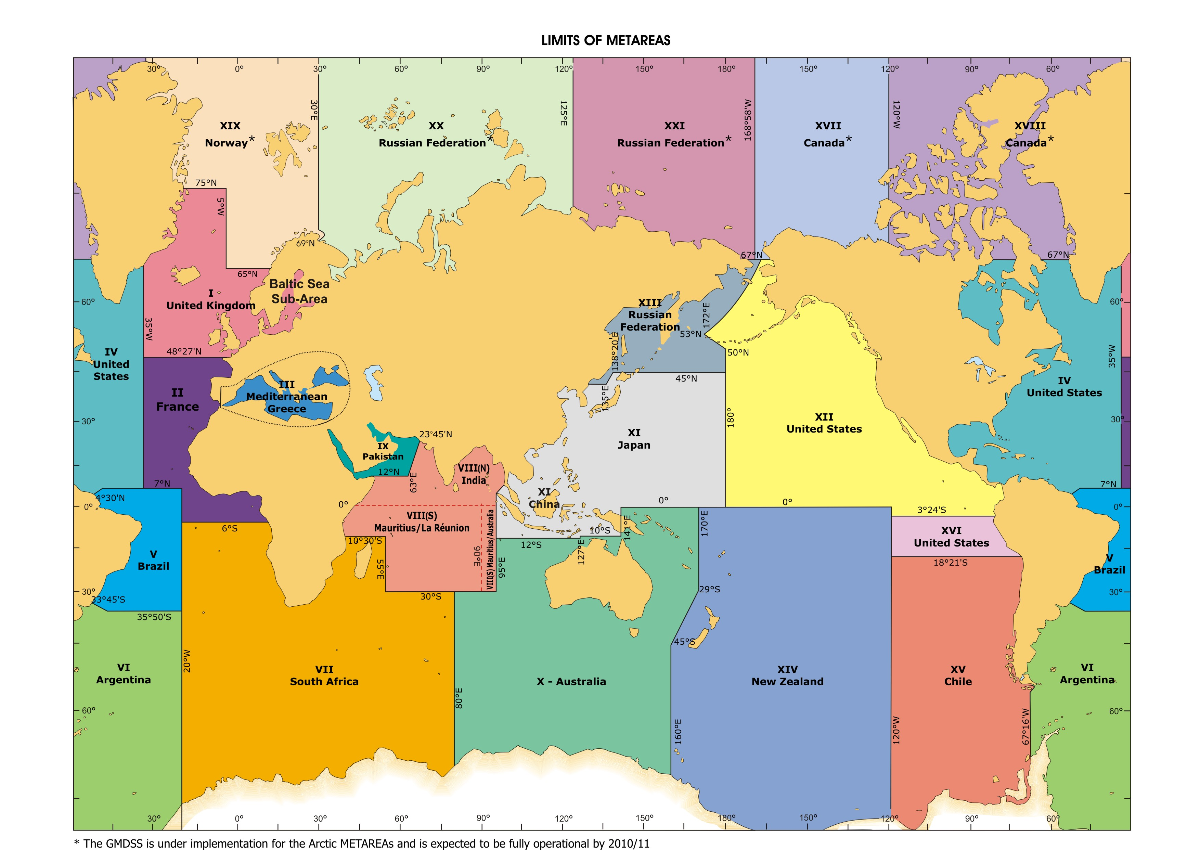
Figure 1 – METAREAs for coordinating and promulgating meteorological forecasts and warnings within the GMDSS. Note: The delimitation of such areas is not related to and shall not prejudice the delimitation of any boundaries between States. (Source: Joint IMO/IHO/WMO Manual on Maritime Safety Information, Edition 3, 2009).

The boundaries of each Arctic NAV/METAREA are fixed as followed (note that the limit of NAV/METAREA I shall be adjusted accordingly):

- METAREA XVII bound by :
67°00’. 00N 168°58’. 00W,
90°00’. 00N 168°58’. 00W,
90°00’. 00N 120°00’. 00W,
south to the Canadian Coastline along the 120°00’.00W meridian,

- METAREA XVIII bound by:
A position on the Canadian Coastline at the 120°00’.00W meridian to:
90°00’. 00N 120°00’. 00W,
90°00’. 00N 035°00’. 00W,
67°00’. 00N 035°00’. 00W;

- METAREA XIX bound by:
From a position on the Norwegian Coastline at 65°00’.00N to:
65°00’.00N 005°00’.00W,
75°00’.00N 005°00’.00W,
west to a position on the Greenland Coastline,
From the border between Norway and Russia (Inland) to:
69° 47’. 68N 030° 49’. 16E,
69° 58’. 48N 031° 06’. 24E,
70° 22’. 00N 031° 43’. 00E,
71° 00’. 00N 030° 00’. 00E,
From this co-ordinate (71° 00’.00N - 030°00’.00E) further north along the 030°00’.00E Meridian to:
90° 00’. 00N 030° 00’.00E,
90° 00’. 00N 035° 00’.00W,
south to the Greenland coastline along the 035° 00’.00W meridian.

- METAREA XX bound by:
From the border between Norway and Russia (Inland) to:
69° 47’. 68N 030° 49, 16E,
69° 58’. 48N 031° 06, 24E,
70° 22’. 00N 031° 43, 00E,
71° 00’. 00N 030° 00, 00E,
From this co-ordinate (71° 00’. 00N - 030°00’. 00E) further north along the 030° 00’.00E Meridian to:
90°00’. 00N 030°00’. 00E,
90°00’. 00N 125°00’. 00E,
then south to the Russian Federation Coastline along the 125°00’. 00E meridian;

- METAREA XXI bound by:
From a position on the Russian Federation Coastline at the 125°00’. 00E meridian to:
90°00’. 00N 125°00’. 00E,
90°00’. 00N 168°58’. 00W,
67°00’. 00N 168°58’. 00W,
west to a position on the Russian Federation Coastline along the 67°00’. 00N parallel;

