WORLD METEOROLOGICAL ORGANIZATION  ________________________ | INTERGOVERNMENTAL OCEANOGRAPHIC  COMMISSION (OF UNESCO)  ________________________
JOINT WMO/IOC TECHNICAL COMMISSION FOR  OCEANOGRAPHY AND MARINE METEOROLOGY (JCOMM)  EXPERT TEAM ON SEA ICE – FOURTH SESSION  STEERING GROUP FOR THE PROJECT GLOBAL DIGITAL SEA ICE DATA BANK (GDSIDB) – TWELTH SESSION  ST PETERSBURG, RUSSIAN FEDERATION  1 TO 5 MARCH 2010 | ETSI-IV GDSIDB-XI/Doc. 2.6.4(1)  (25.II.2010)  __________  ITEM 2.6.4  Original: ENGLISH

SEA ICE IN ENCs – PROGRESS IN RUSSIA

(Submitted by Evgeny Anashkin, AARI and Konstantin Ivanov, TRANSAS)

Summary and Purpose of Document
This document contains a status report on the progress that was made by the Russia Arctic and Antarctic Research Institute in cooperation with TRANSAS with respect to sea ice information in Electronic Navigation Charts.

ACTION PROPOSED
The Expert Team on Sea Ice (ETSI) is invited to:
- Note and comment on the information in this document;
- Provide advice on future directions and recommend mechanisms for harmonization and formalization of the draft specification for presentation schemas and file naming conventions.
(c) Discuss possibilities of presentation of the sea ice information and services as marine meteorological layer on ENC for demonstration during JCOMM-IV (2012).

______________________
APPENDICES
Appendix 1 - Ice information for ENC presentation schemes for Ice Objects
Appendix 2 - Ice information for ENC data file naming convention and structure

DISCUSSION
Introduction
1. The ETSI-III in March 2007 adopted the “Ice Objects Catalogue Version 4.0” as the sea ice extension of the IHO S-57 format for the ENCs and agreed on a formal mechanism for its maintenance and development with JCOMM ETSI recognized as the competent international technical group on sea ice and icebergs by the WMO, IOC and IHO Committee on Hydrographic Requirements and Information Systems (CHRIS), the WMO Secretariat as Register Owner and Manager, Register Users as anyone interested in sea ice or iceberg MIOs, the Control Body as the ETSI ENC Ice Objects Task Group (TG ENCIO), the Submitting Organization as WMO and proposers as ETSI Members from Canada, Germany, Russian Federation and USA. In May 2008 the TG ENCIO finalized inclusion of the “Ice Objects Catalogue Version 4.0” into the IHO Register, so that presently the S-57 sea ice extensions are freely available within the Open Geospatial Consortium (OGS) Geospatial Data Abstraction Library (GDAL). The JCOMM-III session noted this unique situation, with ETSI being a bridge between CHRIS and WMO, as being stimulating for JCOMM.

Development of ICE charts product
2. Starting from summer 2007, the Arctic and Antarctic Research Institute (AARI) has worked with Transas (a major multi-national Electronic Navigation Charts systems manufacturer), to implement mechanisms of displaying ice chart information on ENC systems. In the course of this activity, AARI and Transas have developed, implemented software support and tested a number of specifications for ice objects classes (polygon, linear and point) presentation schemes (colour, hatching) and sea ice information data file naming convention and structure in ENC.

3. The following task were resolved
(a) Ice charts in vector S-57 format product specification has been developed
(b) Extended S-57 ice object and attribute catalog has been prepared.
Details of the items (a) and (b) above are provided in document “Report -002P-2”
(c) Presentation rules and was developed.
The presentation rules are made in pseudo IHO S-52 Presentation library lookup tables. Example of the ice lookup table string is provided below
"SEAICE","ICEACT92ICEAPC?,?,?IA_SFA?/?,?/?,?/?IA_SFB?/?,?/?,?/?A_SFC?/?,?/?,?/?","SY(ICEBEL03);SY(ICENMB10)"
The difference from IHO presentation library lookup tables is that ice symbology always consists of composite symbols. One object can be symbolized up to ten simple symbols comprising one composite symbol.
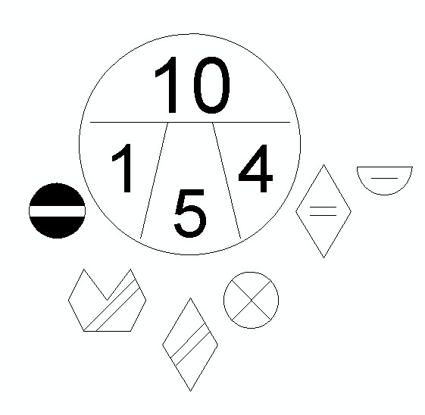
(d) Symbol library was prepared in a format that complies with IHO S-52 symbol library.
4. The described approach allows ECDIS software use existing algorithms that are used for ENC symbolization. Some modifications were required in ECDIS to follow the rules described in pseudo lookup table and implement new symbols.
5. Another challenge faced during the implementation of Ice charts in ECDIS is a need to provide ice charts transparency so important navigation information from ENC not to be obscured.
6. Configured transparency for ice charts allows user to combine and view ice charts from different sources: satellite images with forecast ice charts in S-57 format and also navigational information is presented under the ice chart overlay.
7. Additional attributes SYMINS and SYMINR are used to define color of ice coverage area according to the Russian or international symbology rules. The following example shows presentation of ice coverage area on top of ENC data.

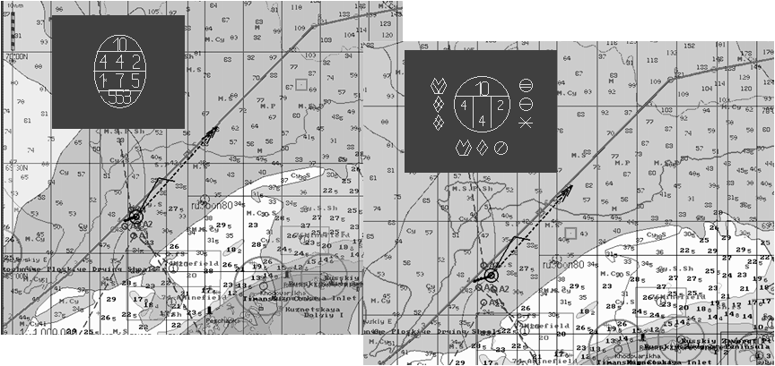
Issues identified at the current stage
8. When work on development of the AARI Ice product specification was started (2007), there was no information about standardized product specification for Ice Marine Information Overlays. The Ice Coverage MIO product specification was introduced by the Canadian Ice Service in late 2008. Therefore at the current stage there are some discrepancies between Russian and Canadian ice data implementation and provision of S-57 dataset.
File Naming.
9. The Canadian Ice service product specification proposes the following naming scheme.
MIO data set files follow the same basic approach that is used for ENC and AML (8 characters).
More specifically, they are named according to the following convention:
# characters
2 Producer Code (from IHO S-62 or OEF Producer Code Register2)
2 MIO category (M + MIO sub-category as a capital letter)*
1 Scale band (most will be non-scale = zero)
3 Unique MIO number (a producer organisation develops its own scheme)
10. The AARI naming scheme following the following convention
# characters
2 Producer Code (from IHO S-621 or OEF Producer Code Register2)
1 Scale band according to IHO ENC product specification
1 Geographical region
2 Date
1 consecutive number within the date
1 forecast duration (for forecast charts)
Chart header implementation differences
11. The Ice MIO Product Spec (CIS) proposes to use date and duration information in COMT (Comment) subfield of CATD field in the catalog files while this information is encoded in the AARI filename
12. CIS Product specification uses product specification identifier DSID/PRSP = {60} while AARI uses DSIS/PRSP= {100}
13. CIS uses profile ID subfield DSID/PROF equal to 1=EN that is similar to ENC product specification. AARI uses DSID/PROF=100 for current charts and DSID/PROF=101 for forecast charts.

______________________

