WORLD METEOROLOGICAL ORGANIZATION  ________________________ | INTERGOVERNMENTAL OCEANOGRAPHIC  COMMISSION (OF UNESCO)  ________________________
JOINT WMO/IOC TECHNICAL COMMISSION FOR  OCEANOGRAPHY AND MARINE METEOROLOGY (JCOMM)  EXPERT TEAM ON SEA ICE – FOURTH SESSION  STEERING GROUP FOR THE PROJECT GLOBAL DIGITAL SEA ICE DATA BANK (GDSIDB) – TWELTH SESSION  ST PETERSBURG, RUSSIAN FEDERATION  1 TO 5 MARCH 2010 | ETSI-IV GDSIDB-XI/Doc. 2.7.3(1)  (10.II.2010)  __________  ITEM 2.7.3  Original: ENGLISH

Assimilation of Ice Charts into Numerical Now and Forecasting Systems: Activities in Canada

(Marie-France Gauthier, Tom Carrieres - Canadian Ice Service
and Mark Buehner - Canadian Meteorological Centre)

This document contains a brief summary of activities in Canada related to the assimilation of ice charts into numerical now and forecasting systems.

ACTION PROPOSED
The Expert Team on Sea Ice (ETSI) is invited to:

- Take note of the activities in the following.
______________________

In collaboration with the Environment Canada Data Assimilation Section, CIS has been developing a sea ice data assimilation system for use in sea ice analysis and forecasting and numerical weather prediction. Using a 3D variational (3DVar) approach, a variety of ice observations can be assimilated with this system including: passive microwave data from the AMSR and SSMI instruments, gridded data from CIS image analysis and daily charts and CIS lake ice analysis data. One of the crucial elements in assimilating these observations is to define the error statistics associated with each observation and the trial field as well as developing a forward model that relates the analysis fields to the observations. Initial global estimates of these have been made but the system is quite flexible in that future refinements can easily be incorporated.

Several implementations are underway or nearing completion:

- An automated sea ice analysis at 5 km resolution for North America, see Error: Reference source not found. This system uses a persistence model and the output products available four times per day are gridded sea ice concentration and days since last observation. It is planned to implement this system in experimental mode at the Canadian Meteorological Centre (CMC) in the next few months. Subjective evaluation by CIS Operations of the model output as an ice edge product over a full year has indicated that it should meet operational accuracy requirements. Objective evaluations using CIS regional charts and the MODIS ice extent product both demonstrate that this system is more accurate than the current CMC sea ice analysis system.

- The 3DFGAT (First Guess at Appropriate Time - a 3DVar variant) system has been coupled to an ice-ocean model for the east coast of Canada as described by Caya et al. Results indicate that this system is generally superior to the current operational nudging technique. Both the operational and new techniques assimilate ice thickness distributions provided by egg code data extracted from CIS ice charts. The new system is able to assimilate passive microwave data, image analysis charts and daily ice charts while the operational system only ingests daily charts. The new system will be running at CIS in experimental mode this winter.The model extends from 40 to 66 N at a resolution of roughly 15 km.

- A very similar system to b) has been developed for a coupled atmosphere-ice-ocean model. This system will replace the semi-operational nudging system in the coming months. Both systems assimilate CIS image analysis charts but the new system also assimilates passive microwave data and daily ice charts. The ice-ocean model covers the Gulf of St Lawrence at a resolution of 5 km.

- A northern hemisphere (NH) sea ice analysis system that is almost identical to a) has been developed as a step towards a global system. The NH system is running in experimental mode at 15 km. It is planned to replace this system with a global system that will have a resolution of around 5 km. Once developed and thoroughly tested, this system will replace the current operational sea ice analysis running at CMC.

In addition to the implementations discussed above, several research projects are underway. These include: development of a radiative transfer model for passive microwave data (in collaboration with the Danish Meteorological Institute): development of techniques for assimilating AVHRR data ( in collaboration with MetNo); and development of techniques for assimilating active radar data. Other R&D currently underway or planned includes using displacement errors and spatially varying error statistics.

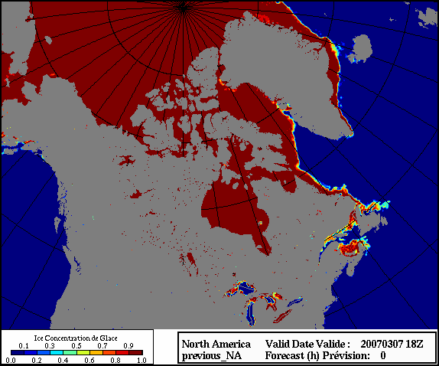Figure: 1 North American domain for the automated sea ice analysis system.

Analysis and forecasting of sea ice conditions with three-dimensional variational data assimilation and a coupled ice-ocean model by Alain Caya, Mark Buehner and Tom Carrieres. J. Atmos. Oceanic Technol., 27, 353–369.

