WORLD METEOROLOGICAL ORGANIZATION  ________________________ | INTERGOVERNMENTAL OCEANOGRAPHIC  COMMISSION (OF UNESCO)  ________________________
JOINT WMO/IOC TECHNICAL COMMISSION FOR  OCEANOGRAPHY AND MARINE METEOROLOGY (JCOMM)  EXPERT TEAM ON SEA ICE – FOURTH SESSION  STEERING GROUP FOR THE PROJECT GLOBAL DIGITAL SEA ICE DATA BANK (GDSIDB) – TWELTH SESSION  ST PETERSBURG, RUSSIAN FEDERATION  1 TO 5 MARCH 2010 | ETSI-IV GDSIDB-XI/Doc. 2.7.3(2)  (27.II.2010)  __________  ITEM 2.7.3  Original: ENGLISH

Assimilation of Ice Charts into Numerical Now and Forecasting Systems: Activities in the Arctic and Antarctic Research Institute, Russia

(Sergey Klyachkin – Arctic and Antarctic Research Institute, Russia)

This document contains a brief summary of activities in Russian Federation Arctic and Antarctic Research Institute related to the assimilation of ice charts into numerical now and forecasting systems

ACTION PROPOSED
The Expert Team on Sea Ice (ETSI) is invited to:

(a) Take note of the activities in the following.
______________________

Annex 1 – Sample numerical prognostic charts for the Barents and Kara Seas
Discussion

1. A noticeable progress has been achieved in the automating of preparation of initial ice data for numerical ice forecasting. Not more than 15-20 years ago this procedure was implemented manually with the help of transparence grid put on the hard copy of ice chart. Then, the special software which allowed drawing ice chart (both ice zone boundaries and ice cover characteristics in every zone) on the monitor in the interactive regime was elaborated. It is quite obvious that both procedures were very labor-capacious and took much time.

2. In present, due to geo-information system (GIS) technologies, the process of ice data preparation was significantly improved. An expert decoding the satellite image works directly within the GIS ArcView medium and develops the ice chart as a vector shape-file containing the information on the uniform ice zones and ice characteristics in every zone. These characteristics are recorded into the attribute table in strict accordance with the international standard SIGRID-3. The shape-file is put into the entrance of numerical forecasting technology, where specially developed ArcView application analyzes the coordinates of ice zones along with the coordinates of the grid cells and forms the ASCII matrix file containing the ice characteristics in every grid cell.

3. If necessary, this file is complemented with the data taken from other sources (as a rule – from previous forecast). The necessity of such complementation is caused by several reasons. Firstly, the satellite image put into basis of ice chart often does cover the entire calculation area (position of orbit, cloudiness, disturbances, etc.). In this case, the information for the zone invisible on the image is taken from the previous forecast and combined with the data taken from the image. As a result, one obtains the composite ice matrix which is directly used as the initial data for new forecast. Secondly, when decoding the satellite image, the expert often is not able to assess some important ice parameters (ice thickness, ice ridge concentration, stage of ice melting). More of it, in summer, the list of “indefinite” parameters is added with partial concentration of ice stages, because in summer only the total concentration is identified from the satellite image. All these parameters are taken from previous forecast (diagnosis).

4. The process of composite ice chart preparation is implemented automatically. All results of all forecasts are accumulated in the special archive, and the software selects the forecast which (1) has the least period of advance and (2) has the minimum temporal lag relative to the image.

5. Following AARI numeric short-term prognostic products utilize (entirely or partially) assimilation of different information from the AARI ice charts (regional and local):
- Diagnostic and forecast patterns (0..+6d) of ice drift, surface currents and sea level elevation in the Arctic Ocean based on AARI hydrodynamic model with viscous ice rheology, http://www.aari.ru/projects/ecimo/index.php?im=102&sub=4;
- Diagnostic and forecast patterns (0..+6d) of the evolution of ice cover in Barents and Kara Seas (total concentration, stages of ice development, hummocks concentration and level of compacting) based on AARI thermo hydrodynamic with elastic viscous-plastic ice rheology, http://www.aari.ru/projects/ecimo/index.php?im=102&sub=1;
- Diagnosis and forecast charts (00…+72h with 6-h interval) for winds, wave significant height and direction and ice accretion for open water areas in the Eurasian Arctic Seas based on AARI spectral parametric wave model, http://www.aari.ru/projects/ecimo/index.php?im=102&sub=2.

Annex 1 – Sample numerical prognostic charts for the Barents and Kara Seas

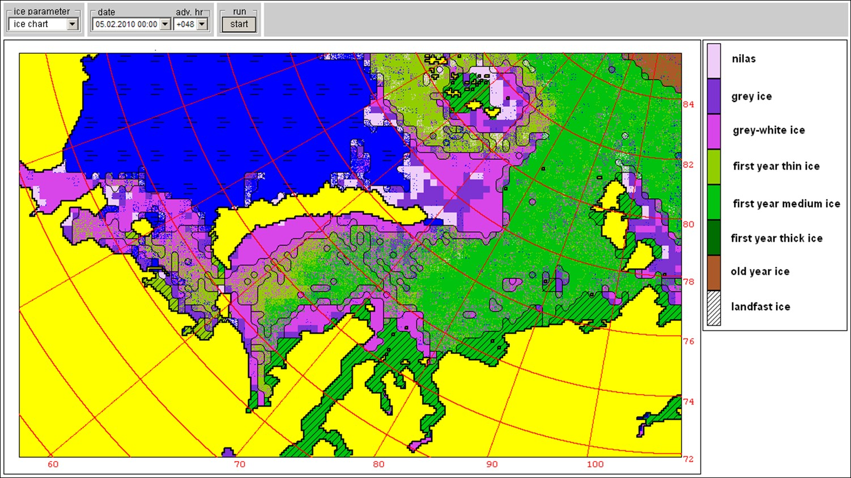 | 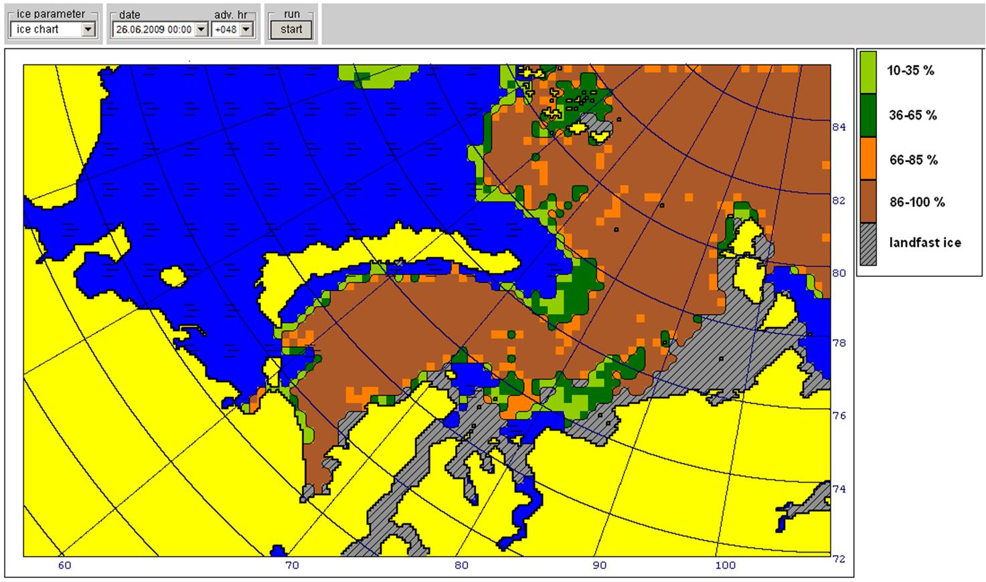
Stages of ice development, 2010-02-05 +048h | Sea ice total concentration, 2009-06-26 +048h
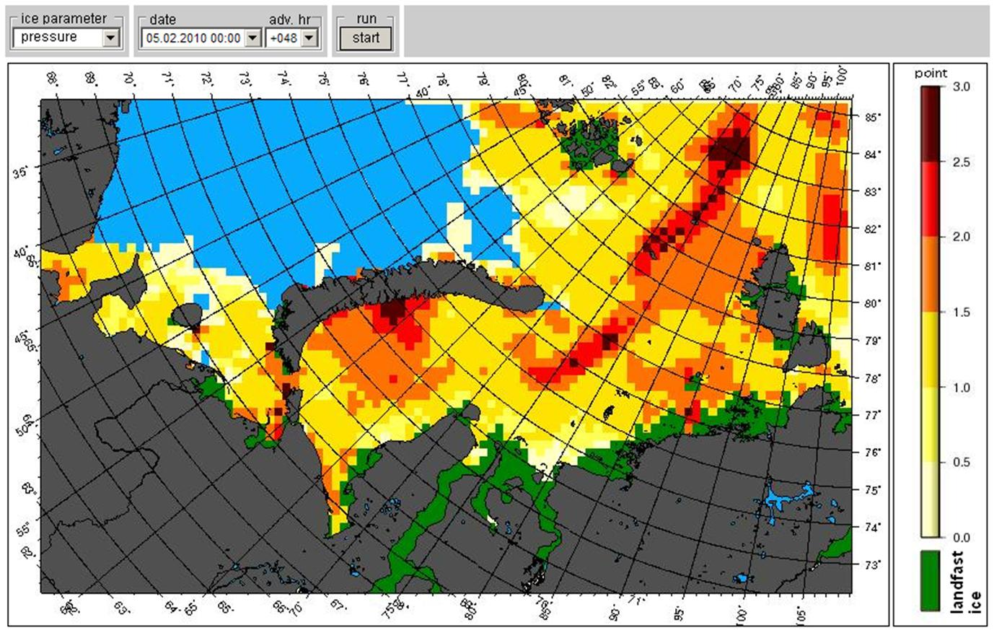 | 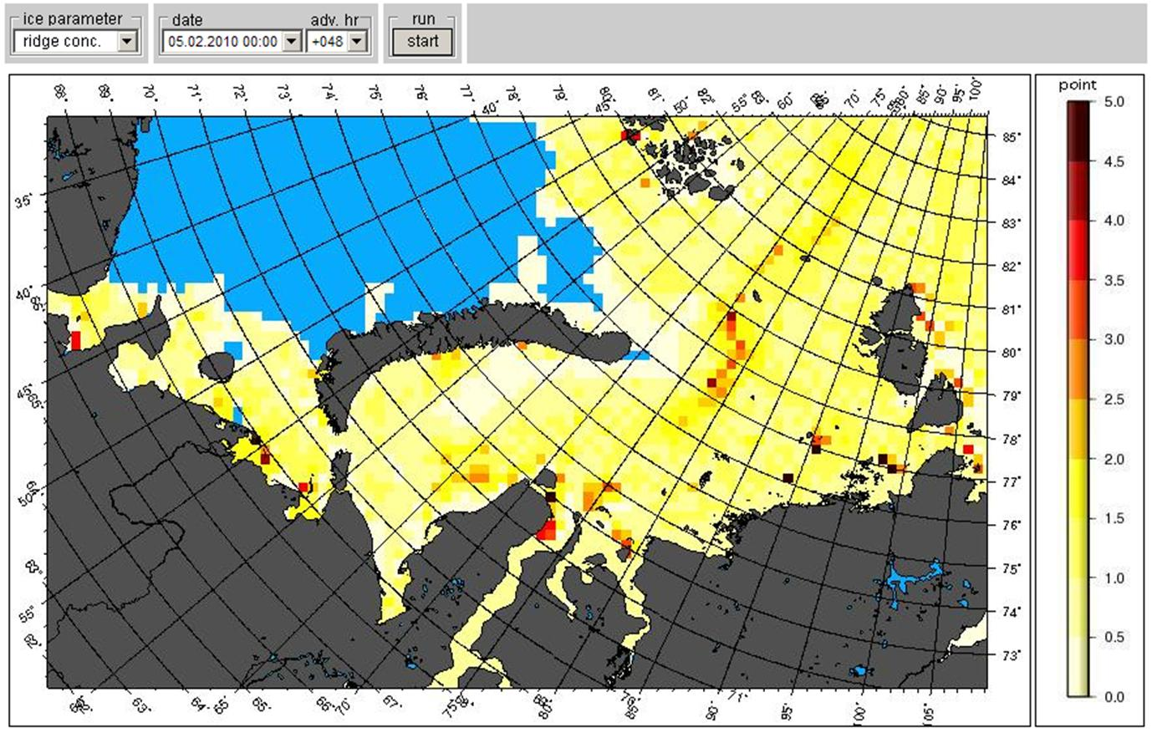
Level of compacting, 2010-02-05 +048h | Concentration of ridges, 2010-02-05 +048h

