2.10. Characteristic of the Bering Sea ice conditions
2.10.1. General aspects

The Bering Sea – is a sea in the northern Pacific Ocean, separated by Islands Aleut and Commander. The Bering Sea is joined with the Chukchi Sea and Arctic Ocean by Bering Straight. The sea washes coast of Russia and the USA (Fig. 2.10.1). Its area is 2,304 000 km². Average depth - 1600 m, maximum — 4773 m. Air temperature over the water basin is +7, +10 °C in summer and −1, −23 °C in winter. Salinity 33,0-34,7 pro mille.
Conditions of ice formation and ice melting in the Bering Sea significantly differ from other Siberian Arctic shelf seas. The sea is located in moderate latitudes. Such location defines softer climate conditions. Relatively warm Pacific waters come through southern sea border to its central part, so ice isn’t formed here. In most severe winters only half of the sea is covered with ice.
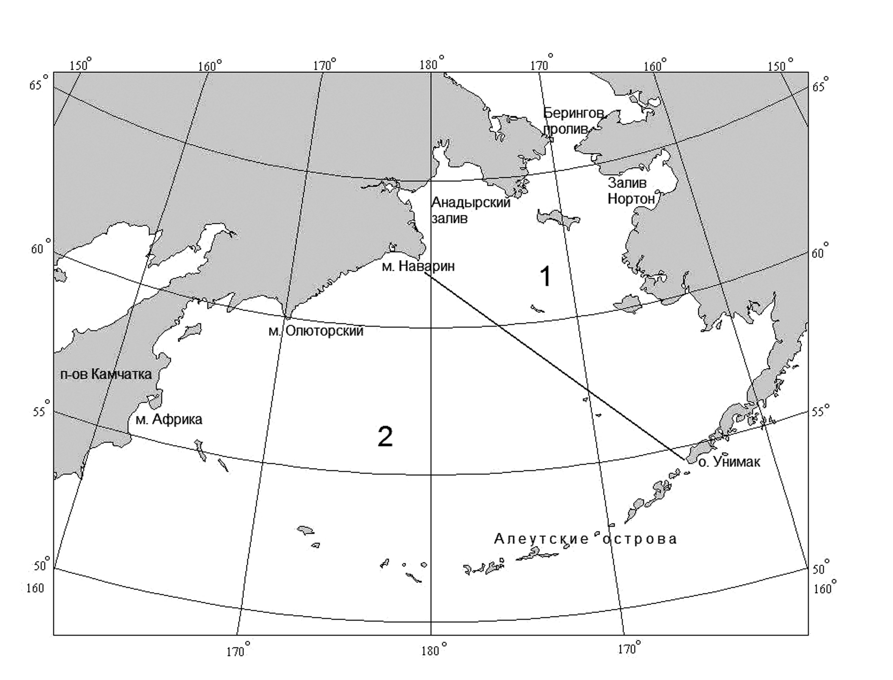
Fig. 2.10.1. The Bering Sea and its main islands and gulfs.

2.10.1. Ice formation

Ice formation is the result of interaction of factors, forming heat accumulation in the sea in the heating period and intensity of heat emission in the cooling period. The beginning of the sea cooling process coincides in time with the maximum heat accumulation in the surface
layer. New ice appears in ice-free areas.
Ice formation in the Bering Sea, as a rule, occurs in open water and starts in peaks of gulfs and bays in the northern sea region, where ice usually appears in the middle of October (Fig. 2.10.2). Main “wave” of ice formation comes from the Chukchi Sea through Bering Straight in second 10-day period of November (Fig. 2.10.3).
In December all places of ice formation join together in one ice massif. Boundary of ice propagation gets wedge-shaped. Its peak at first is directed to Gulf of Anadir, and then moves to Cape Navarin (Fig. 2.10.4). Velocity of stable ice formation increases till late December and decreases with approaching to deep water sea region with large depth of convection layer. Ice formation lasts on average till late April. Ice edge is stable in zone of isobath about 3000 m.
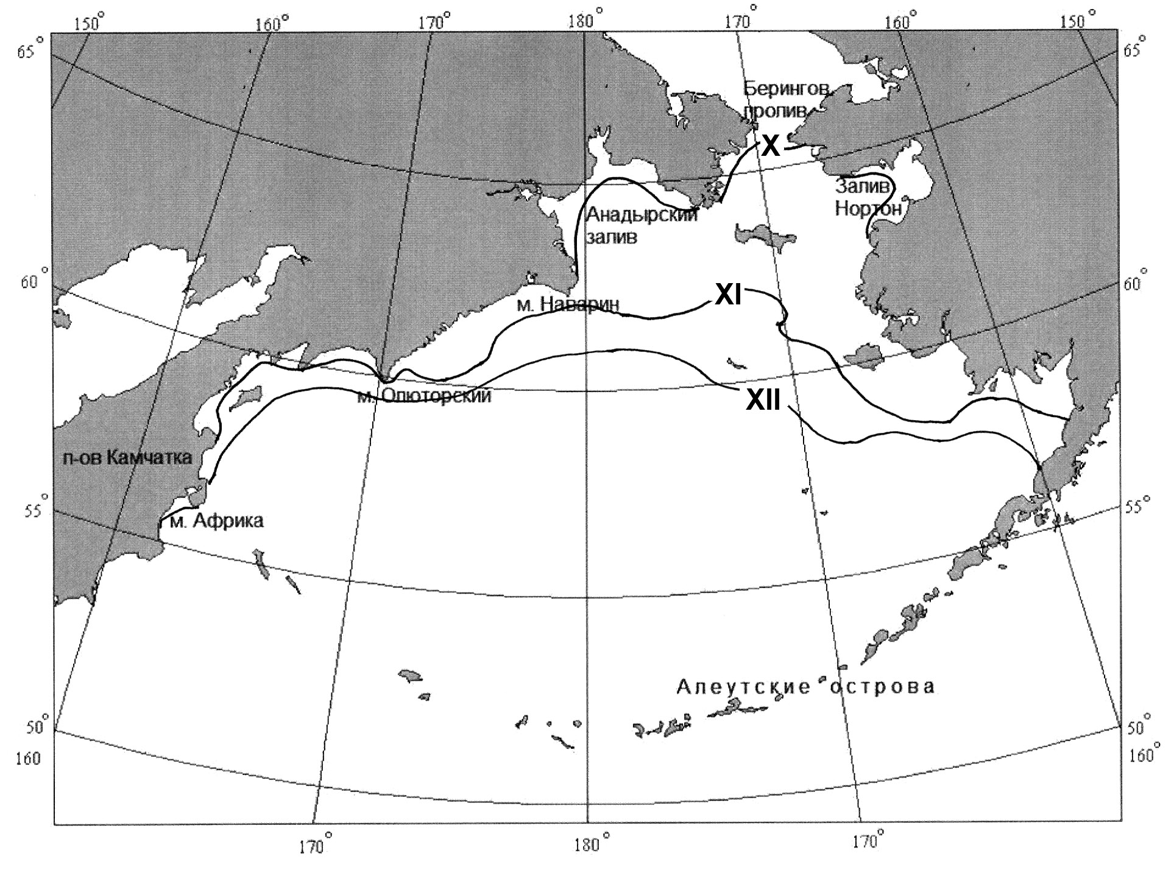
Fig. 10.2. Annual mean beginning of stable ice formation in October
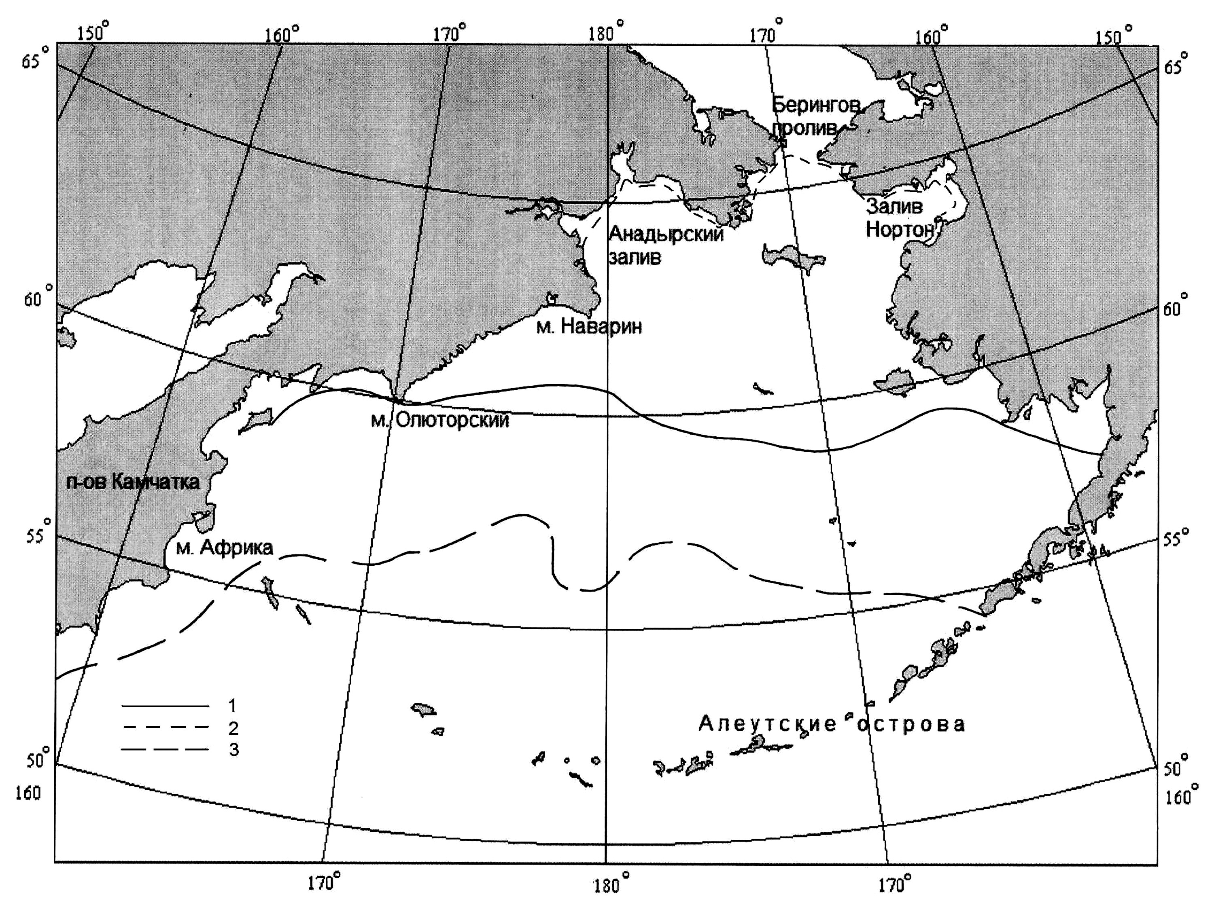
Fig. 10.3. Annual mean propagation of drift ice in November
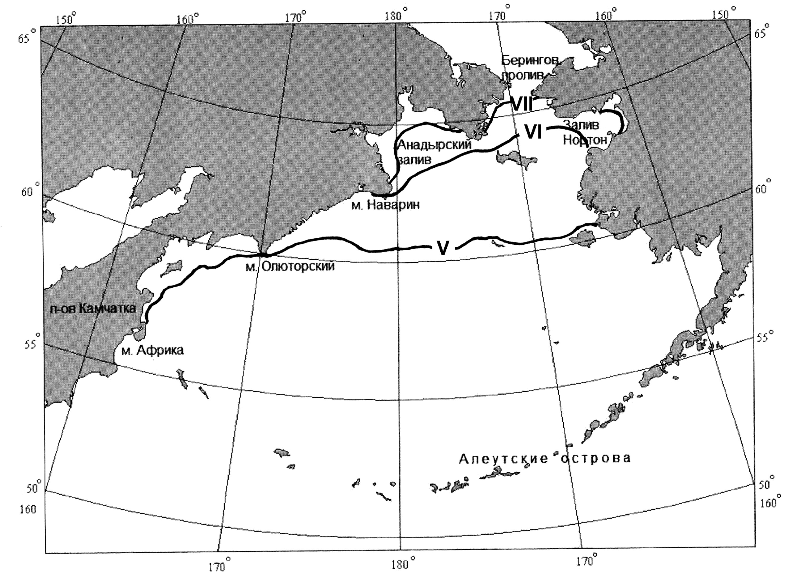
Fig. 10.4. Propagation of ice formation “wave” in December

Terms of stable ice formation depend on meteorological and ice-hydrologic conditions of spring-summer and autumn periods. These conditions have significant interannual changes. Therefore terms of stable ice formation can significantly differ from average ones. Terms variability of stable ice formation is expressed by amplitudes of terms of stable ice formation. Regime peculiarities of cooling water conditions of the Arctic Seas, which precede freezing, in significant measure are expressed by spatial distribution of amplitude values.
Early ice formation can start in the middle of September in cold autumn, and in warm - delay till early November. Thus, amplitude of stable ice formation terms in the Bering Sea on average is about month and a half.

2.10.2. Ice cover in winter period

Boundary of drift ice in the Bering Sea during ice growth can move in direction of open water. Ice propagation in sea occurs till the middle of April. Location of ice edge during freezing coincides with isochrones location of stable ice formation terms.
Velocity of ice propagation in sea rapidly increases from November to December – on 13% (Fig. 2.10.4), and then it slows down with moving to the central sea regions. The central sea regions have high heat storage. To the end of ice growth period, in April, ice cover in the Bering Sea approaches on average 37%.
However, the largest ice propagation in the Bering Sea during soft and severe conditions doesn’t occur simultaneously. Thus, in warm years ice maximum can be approached in February and can be only 20%. During moderate and severe winters ice cover reaches its maximum values 38 and 56% in April.

In Table 2.10.1 ice cover changes in the Bering Sea by months for different complicated types of ice conditions are presented. In moderate years ice cover is less than 40%, in severe years ice occupies more than a half of the sea water area. Difference in sea ice in warm and severe winters can reach 49%.

Table 2.10.1 – Ice changes in the Bering Sea during freeze-up period, %

Characteristic | Months
Characteristic | X | XI | XII | I | II | III | IV
Average | 1 | 5 | 18 | 27 | 33 | 35 | 38
Maximum | 4 | 8 | 28 | 38 | 45 | 52 | 56
Minimum | 0 | 1 | 7 | 15 | 20 | 18 | 16

Ice cover in the Bering Sea is highly dynamic. Typical feature of ice cover development for the entire sea is a sharp increase of a compact ice (10/10-th) frequency of occurrence in winter months (December-February) and decrease of concentration in April-May.
Increasing of thin first-year ice during winter period is typical for the Bering Sea. Young ice during winter decreases and in April is close to zero.
To early December frequency of occurrence of thin first-year ice is about 20%, then it slowly increases and in middle of February reaches its first maximum– 80-100%. Then frequency of occurrence of thin first-year ice decreases on 10-20% mostly till late March, that obviously depends on deep anticyclones coming over the Bering Sea. April is characterized by new increasing of frequency of occurrence of thin first-year ice to its maximum due to intensive melting of new and young ice.
Different ice forms are observed during entire cold year period in the northern region. Ice cake and small floes prevail during early ice formation, but large and medium ice floes appear in December. From January to the end of ice growth period ice mostly consists from large and medium floes. In zone of ice edge with width 30-90 miles broken ice prevails till second half of January. Ice cake and small floes are observed in zone of ice edge till the end of summer melting.
Zones with high ridging are stable in Bering Straight near Cape Navarin and in internal part of Gulf of Karagin in the first winter half. In water area ridging mostly approaches 1-2.
General increasing of ridging (2-3) is observed in March. In April reformation of ridging zones occurs due to change of general drift direction from western to northern. Ridging increases in northern regions, and in the south hummocks also disappear due to ice melting.
Several regions with stable ice compacting are observed in the sea. They are: internal part of Gulf of Karagin, western part of Anadir Straight, northern part of Bristol Straight and western part of Bering Straight.
Strong ice compacting in open sea occurs, when deep cyclones come to the south-western and southern Bering Sea.
Four zones with high snow cover are determined in the Bering Sea. In December snow areas (more than 2 marks) are formed in the western part of Gulf of Anadir, eastwards from Gulf of St. Lawrence to Bering Straight in internal parts of Gulf of Karagin and Norton-Saundo. Large amount of snow on ice is observed in Anadir liman and Gulf of Crest. Amount of snow on ice increases in late March. General decreasing of snow on ice is noticed in May due to intensive melting.

2.10.3. Ice cover melting and sea clearing from ice

Ice melting in the Bering Sea occurs from middle of April to June. Places of sea clearing are near ice edge zone, river mouth zones and also stable polynyas. Ice melting intensively occurs in near ice edge zone.
Open water, areas of open and very open ice (concentration 4-6-th and 1-3-th, respectively) appear due to start of melting and under influence of dynamic processes. Sea water area, covered with all types of ice concentration (ice cover), decreases due to ice melting.
In April and May melting intensity is rather small, and ice edge in central sea region moves northwards on one degree of latitude (in the centre of sea to latitude 60° N). During July ice melting intensively increases, and open water areas approach to Bering Straight and to Gulf of Norton-Sauno. Absolute disappearance of drift ice in the Bering Sea occurs in early June.

Drift ice absolutely disappears in the Bering Sea under favorable conditions in June.
In Table 2.10.2 ice cover changes in the Bering Sea are presented by months for different complicated types of ice conditions in summer.

Table 2.10.2 – Ice changes in the Bering Sea during melting period, %

Characteristic | Months
Characteristic | V | VI | VII | VIII | IX
Average | 20 | 5 | 0 | 0 | 0
Maximum | 35 | 16 | 4 | 1 | 1
Minimum | 6 | 0 | 0 | 0 | 0

Under average conditions ice cover of the Bering Sea approaches 20% in May, ice remains by this time in the northern sea region and absolutely melts away only in July. Ice can remain in the western half of Bering Straight from Ratmanov Island to Providence Bay till August and even September after winter with large ice cover and unfavorable ice conditions. In separate years ice can be observed in the Bering Sea during entire year under unfavorable development of ice processes in summer.

