2.11 Characteristics of ice conditions in the Sea of Okhotsk
2.11.1. General aspects

The Sea of Okhotsk – is a sea in the north-western Pacific Ocean, separated by Kamchatka peninsula, Kuril Islands and Island Hokkaido. The sea washes coasts of Japan and Russia (Fig. 2.11.1).
Sea area is 1,603 000 km². Average depth is 1780 m, maximum depth approaches 3521 m. Western sea region with small depth is located on continental shelf. Hollow of Derugin (in the south) and TINRO trough are located in the sea centre. Kurilskaya hollow with maximum depth is located in the eastern sea region.
Northern coast is strongly indented. Gulf of Shelikhov (the largest sea gulf) is located in the north-eastern Sea of Okhotsk. Coast line of Kamchatka peninsula practically doesn’t have any gulfs in the east. Gulf of Aniva and Terpeniya Bay are the largest in the south-west.
From October to May-June northern sea region is covered with ice. South-eastern region is practically ice-free.
Main harbors: on continent – Magadan, Ayan, Okhotsk (harbor point), De-Castri (harbor point); on Sakhalin Island – Korsakov, on Kuril Islands – North-Kurilsk.
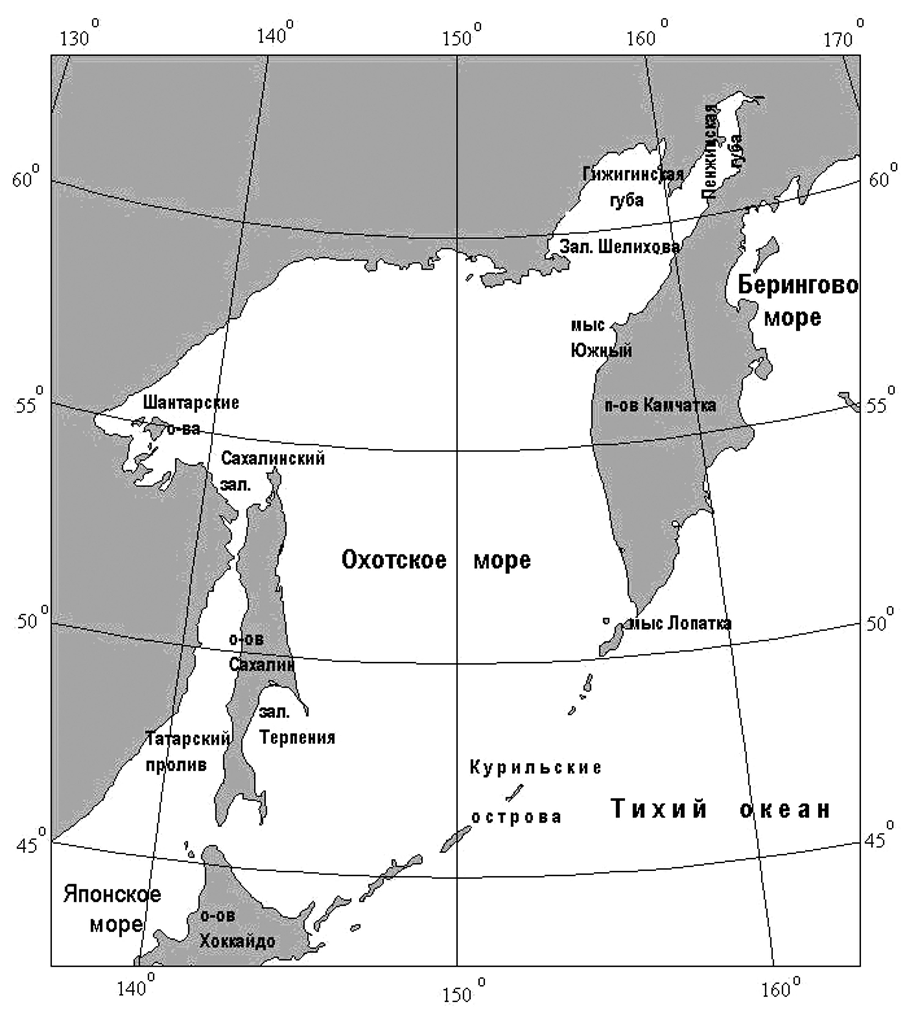
Fig. 2.11.1. The Sea of Okhotsk map

2.11.2. Ice formation

Stable ice formation normally starts in the north-western sea region in November, and in mouth parts, where water is desalinated, – in second half of October. Ice sequentially propagates southwards along western and eastern coast and then to the open sea region. In late November and in early December northern and north-western sea regions are cooling so strong, that intensive ice formation starts on large open sea areas (Fig. 2.11.2). In December and January stable ice formation in sea intensively propagates. Ice formation in sea is observed till the first half of March.
In December extensive motionless fast ice is formed in gulfs and bays.
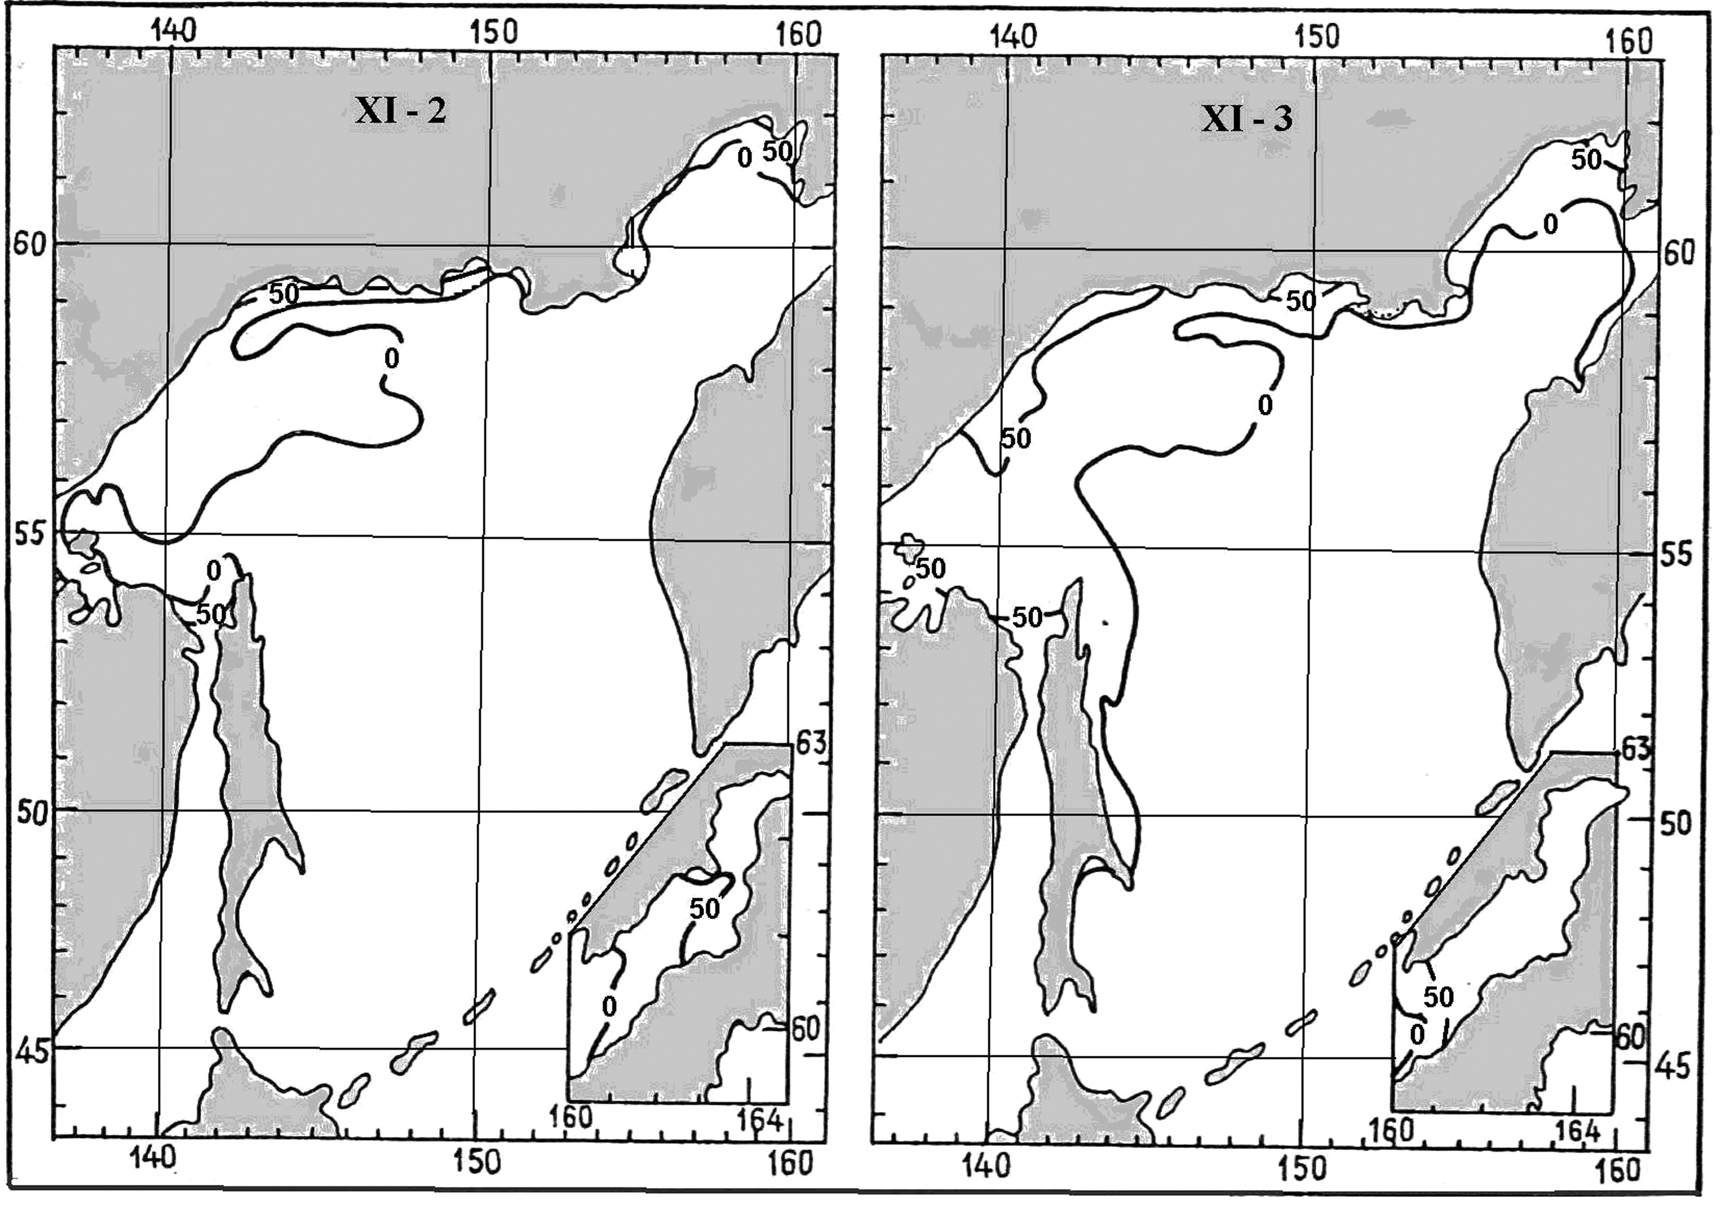
Fig. 2.11.2. Propagation of stable ice formation in the Sea of Okhotsk in November

2.11.3. Ice growth in winter and age composition of drift ice

Long-term winters with strong frosts lead to sea surface cooling, accompanied by intensive ice formation and ice growth mostly in all sea regions. During winter drift ice of different age is observed in most sea area. Propagation maximum of ice cover is observed in the first half of March. By this time sea is normally ice-free only in the south-western sea region (about 20% of sea area) (Fig. 2.11.3)

The Sea ice has only local origin. In general, the Sea of Okhotsk can be compared to the Arctic Seas by severity of ice conditions. Average duration of ice period in the north-western sea region is 250 days, in northern regions and near coast of Sakhalin Island - 190-200, and in the south – 110-120 days a year. Maximum duration of ice period in most severe winters can reach 290 days.

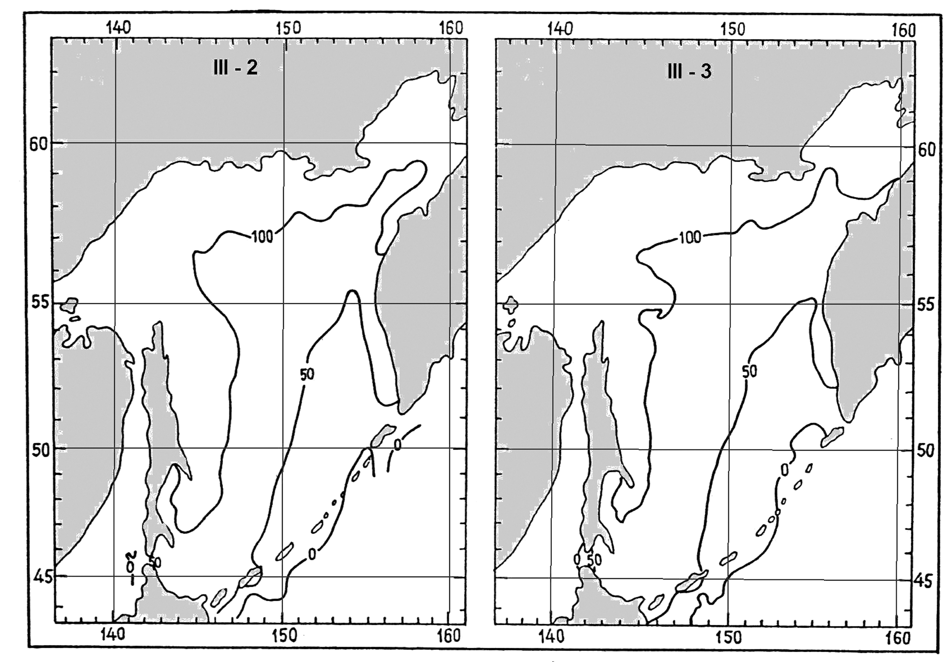
Fig. 2.11.3. Probability of ice observation (%) in the Sea of Okhotsk in period of its maximum propagation

Sea ice is about 80% (Table 2.11.1). In most severe winters ice cover occupies up to 97% of entire sea area. Only along ridge of Kuril Islands there is a narrow stripe of open water. In mild winters about 57% of sea area is covered with ice.

Table 2.11.1 – Average values of ice cover (%) in the Sea of Okhotsk in the middle of month

Characteristic | Month
Characteristic | December | January | February | March | April | May
Average | 20 | 54 | 74 | 82 | 67 | 27
Standard deviation | 6 | 13 | 12 | 9 | 12 | 10

Low temperatures of wind and air influence new ice compacting, freezing and rafting. Ice growth occurs rapidly, and forms of young ice appear – grey and grey-white.
In Amur liman and in peak of Penzhinskaya Bay new ice transforms into grey and grey-white in the middle of November. In December thin first-year ice is observed in these zones. Medium first-year ice is normally observed in the mid-February. It propagates to Hokkaido Island and blocks La Perouse Straight.
Ice thickness (if not accounting ridging) in coastal and shallow zones approaches 40-50 cm in January and December, in Gulf of Shelikhov and along Kamchatka coast - 30-40 cm, in open sea (average conditions of winter severity) - 40-70 cm. Maximum values of ice thickness (90-160 cm) are observed in severe winters in Gulf of Sakhalin and in zone north-eastwards from Elizabeth Cape (Northern Sakhalin).
Hummock height in open sea is less than 1 m. In separate gulfs with intensive ridging, in Gulf of Sakhalin, Yamskaya and Penzhinskaya Bays, it increases up to 1,5-3,0 m. Ice ridging in the Sea of Okhotsk is caused by stormy winds, tidal currents and horizontal ice motion forced by wind and currents. Stormy wind is caused by cyclones, coming to the Sea of Okhotsk from the south. As a result such type of ridging is mostly observed in the southern and
eastern sea regions. Ridging under effect of tidal currents is typical for Penzhinskaya Bay and ware areas, adjoining to Gulf of Sakhalin.
The strongest ice compacting occurs under total effect of wind, currents and tidal currents. Gulf of Sakhalin and Yamskaya Bay can be related to these regions. In Gulf of Sakhalin zone with high ridging up to 3 is formed in January. In listed regions, and also near northern coast of eastern Sakhalin grounded hummocks are formed on depth up to 20 m.
In March drift ice mostly propagates southwards and south-eastwards. At this time very compact ice (up to 10-th) is observed everywhere.
Drift ice in the Sea of Okhotsk is presented by all age types during its development in winter, including thick first-year ice (Fig. 2.11.4). In the end of growth period ice thickness reaches its maximum - 120-140 cm (Gulf of Sakhalin). Ice reaches thickness of thick first-year ice (30-70 cm) in 2,5-3 10-day periods (from the beginning of ice formation), and thickness of medium first-year ice (70-120 cm) – in 7 10-day periods.
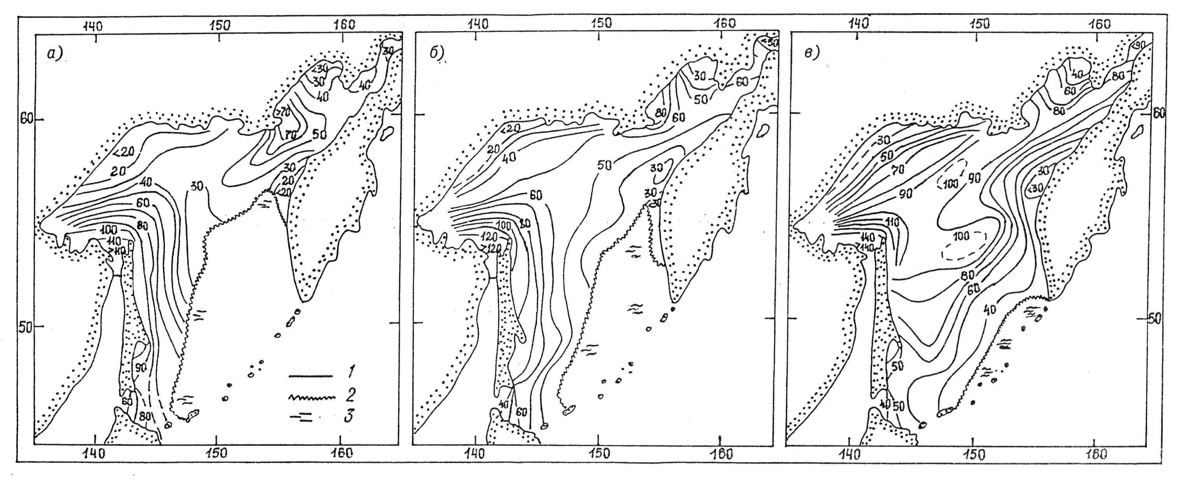
Fig. 2.11.4. Calculated ice thickness in the Sea of Okhotsk in period of its maximum development in mild (а), moderate (б) and severe winters (в) 1 – isolines of ice thickness, 2 – edge of drift ice, 3 – open water)

Ice transforms into thick first-year (more than 120 cm) in 12 10-day periods after beginning of ice formation, though in most severe winters it can occur 2 10-day periods earlier (Table 2.11.2).

Table 2.11.2 – Period between stable ice formation and reaching particular age with formation of ice cover under different conditions

Ice age | Number of 10-day periods between stable ice formation and reaching different age under ice formation
Ice age | In open water |  |  | Among open ice |  |  | Among compact ice
Ice age | average | Max. | Min. | average | Max. | Min. | average | Max. | Min.
Grey-white | 1 | 2 | 0 | 0 | 1,5 | 0 | 0 | 1 | 0
Thin first-year | 2,5 | 4,5 | 1,0 | 2,5 | 3 | 1 | 0 | 1,5 | 0

Dominant ice forms are changed with ice cover development in winter. Maximum prevalence of large ice forms occurs from January to March. In listed period broken ice is observed only near the drifting ice boundary as a narrow, 30-60 miles wide stripe. In north-western sea region vast ice floes with linear size up to 10 km are observed among dominant big
floes in February. In March big ice floes are also dominate along Sakhalin Island. In April intensive destruction of ice brecchia floes, which form vast ice floes, begins and amount of smaller ice floes (broken ice) increases.
Snow cover of the Sea of Okhotsk is propagated irregularly. In December snow cover is significantly developed in some sea regions. These are zones of Gulf of Sakhalin, Yamskaya and Penzhinskaya Bays. Snow cover in these zones reaches 2 marks.
In January snow cover increases in sea in general. In March total ice cover reaches its maximum. It is a natural process, connected with frequent occurrence of cyclones and with fall of large number of dry precipitations. Zone with snow cover of 3 marks is observed near Shantar Islands, Gulf of Sakhalin and propagates to the eastern coast of Sakhalin almost to Hokkaido Island. In April snow melting starts on ice surface and snow cover decreases everywhere.

2.11.4. Ice melting in summer and sea clearing

Beginning of ice melting is noticed in April. Ice starts melting in the southern sea regions on the boundary with the ocean. Beginning from April, ice edge moves northwards and total amount of ice decreases. More than half of sea area is ice-free to the middle of May (Table 2.11.1).
Eastern and western halves of the central Sea of Okhotsk are sharply distinguished by ice period duration and by type of ice conditions changes. Ice melting occurs during long period from April to June. In the north-western sea region ice remains till July. Southern coast of Kamchatka, central and northern Kuril Islands are distinguished by small ice cover and rather short terms of ice cover occurrence.
Melting processes intensively occur in May. Young ice and thin first-year ice melt first. In late May the most Sea of Okhotsk water area is normally ice-free.
Residual thick first-year ice can be observed in some sea regions for a long time. In June separate points of ice can be observed along north-eastern coast of Sakhalin Island, in zone of Shantar Islands, in Yamskaya and Penzhinskaya Bays (Fig. 2.11.5). It is parts of floes of thick first-year ice and broken fast ice, which is distinguished by large thickness and ridging. They melt slower due to their high capacity.
Sea absolutely clears from ice in July. But after severe and very severe winters stripes and points of drift ice can be observed in the second half of August south-westwards from Shantar Islands.
During entire period of observations the Sea of Okhotsk always got ice-free during summer. Ice, survived summer melting, which remains in sea till new stable ice formation, wasn’t observed.
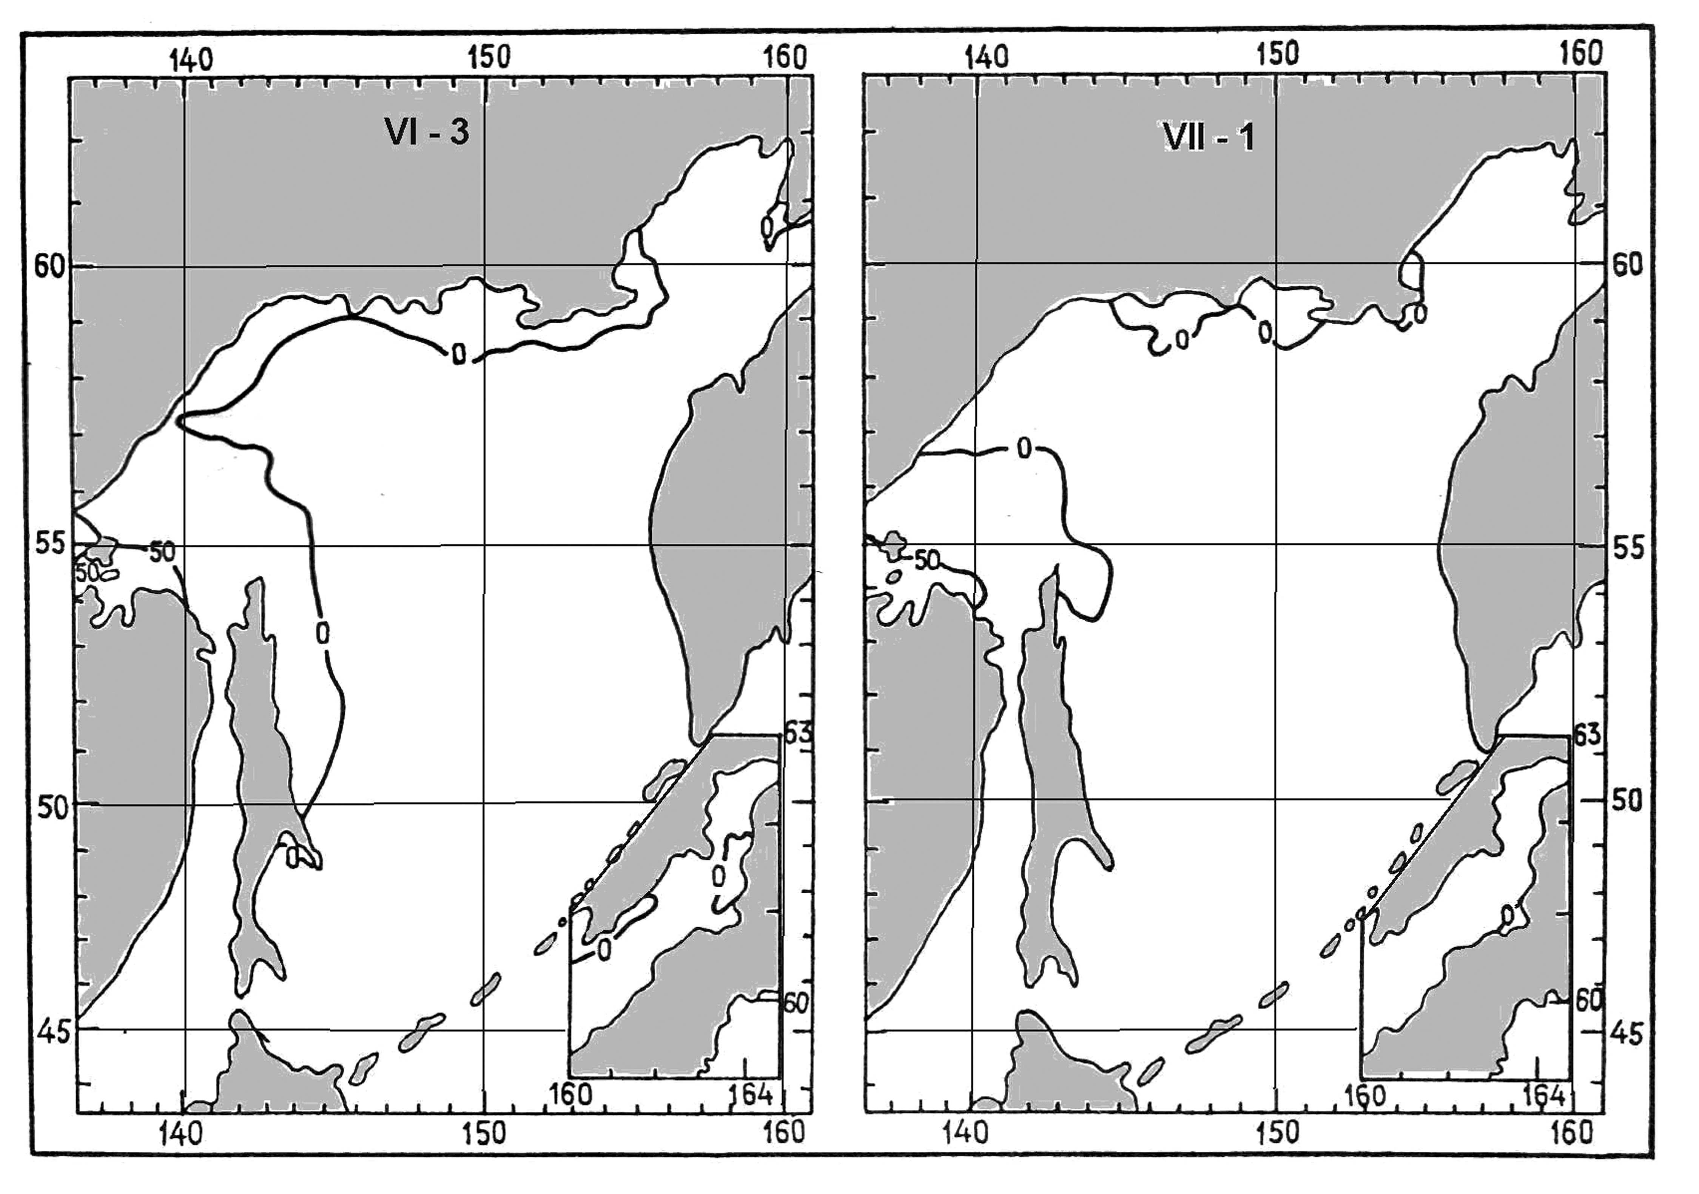
Fig. 2.11.5. Probability of ice observation (%) in the Sea of Okhotsk in period of clearing

