2.12. Characteristic of ice conditions in the Sea of Japan
2.12.1. General aspects

The Sea of Japan - is a sea in the north-western Pacific Ocean, separated by Japanese Islands and Island Sakhalin. The sea is considered to be a marginal oceanic sea by its physical-geographical location. It is fenced off from adjoining water basins by shallow barriers. In the north and north-east it is connected with the Sea of Okhotsk by Straights of Nevel and La Perouse (Soya), in the east – with the Pacific Ocean by Sangar Straight (Tsugaru), in the south – with the East-Chinese Sea by Korean Gulf (Tsusima) (Fig. 2.12.1). The most shallow straight among them is Nevel Straight with maximum depth 10 m, and the deepest is Sangar Straight – about 200 m. In the south branch of warm current Kurosio flows into the sea.
Sea area is 1,062 000 km². Average depth is 1535 m. The largest depth reaches 3742 m. Northern and western coastal regions of the sea freeze every winter.
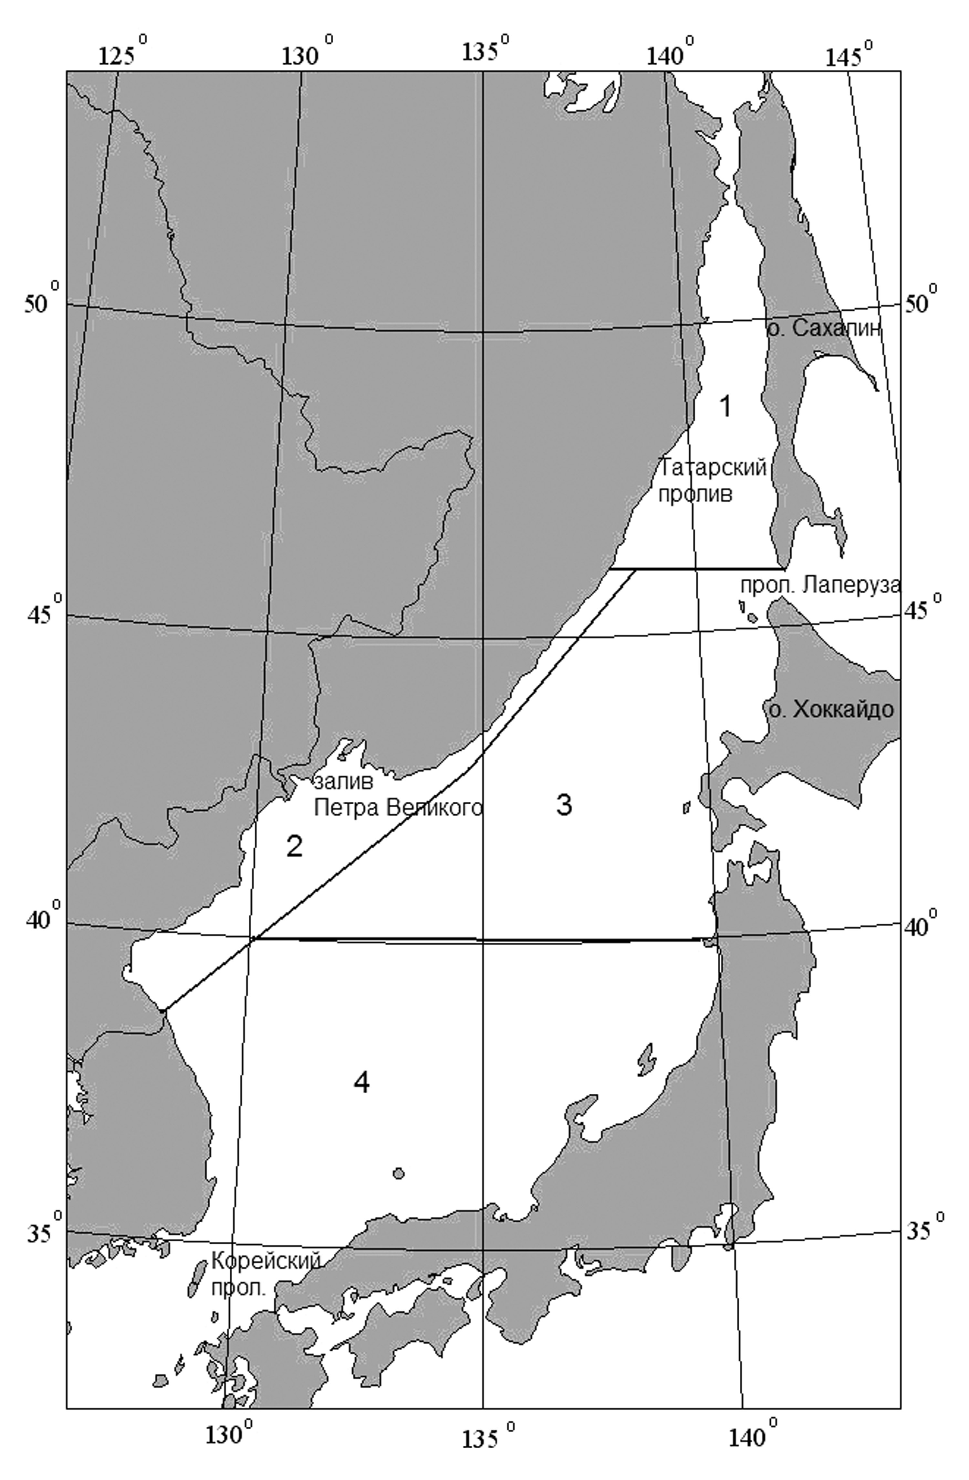
Fig. 2.12.1. Chart of the Sea of Japan with isobath

The Sea of Japan is located in two climatic zones: subtropical and moderate. Within these limits two sectors with different climatic and hydrologic conditions are separated: severe cold northern (partly covered with ice in winter) and mild warm adjoining to Japanese and Korean Coasts. Main factor, forming sea climate, is monsoon atmosphere circulation.
Ice conditions in the Sea of Japan are rather heterogeneous due to large sea extent in latitude direction and peculiar features of meteorological and hydrologic regimes. Three sea regions can be separated by ice conditions: Tatar Straight, western coastal region and Gulf of Peter the Great.
In winter ice is constantly observed only in Tatar Straight and in Gulf of Peter the Great. In other parts of water area ice, except closed gulfs and bays, hardly ever occurs. The coldest region in the Sea of Japan is Tatar Straight; where more than 90% of total ice is formed in winter.
Annual mean duration of ice period in Gulf of Peter the Great is about 120 days, and in Tatar Straight, due to its large meridian extent, from 40-80 days in the southern part of straight to 140-170 days in its northern part.

2.12.2. Ice formation

Stable ice formation is observed in early November in isolated, deeply run inland, bays in the northern part of Tatar Straight. During November young ice rapidly propagates to open water area of Tatar Straight.
In moderate winters stable ice formation in Tatar Straight, in Gulfs of Soviet Harbor, Chikhachev and in Nevel Straight normally starts in the first 10-day period of November. In Gulf of Peter the Great ice formation normally starts in the second 10-day period of November.
When ice formation is early, ice appears in Tatar Straight in the second half of October. In Gulf of Peter the Great (Gulf of Amur) early ice formation is observed in early November. Late terms of ice formation occur in late November.
In early December ice propagation along Sakhalin Island occurs more rapid, than along continental coast. To late December ice amount on the eastern and western periphery becomes equal, and direction of ice edge changes, after reaching parallel of Cape Surcum. Decreasing of ice edge motion (initial ice) and intensive motion of ice formation “wave” along continental coast are observed along Sakhalin coast. In late January ice occupies entire northern part of Tatar Straight.
Amplitude of terms of stable ice formation reaches 30 days.

2.12.3. Ice cover in autumn-winter period

During January and February stable ice propagation is observed in the sea freezing regions. Ice in the Sea of Japan has mostly local formation. Ice, coming from the Okhotsk Sea through Straight of La Perouse, is rarely observed.
In the Sea of Japan ice cover reaches its maximum propagation in the middle of February. On average, about 52% of Tatar Straight area and 56% of Gulf of Peter the Great area are covered with ice. In Tatar Straight absolute maximum of ice cover was registered (86,8% from area) in winter of 1950 – 51. In Gulf of Peter the Great this maximum approached in winter of 1969 – 70 (95% of area). Ice cover minimum in Tatar Straight was observed in 1991 (23,7% from area).
Ice edge takes its extreme southern location in February, when ice cover is maximum. In mild winters it is less than 2,7 %, in moderate - 5,4 %, and in severe winters increases up to 10,3 % from sea surface area (from total sea area, 1062000 km²). Seasonal propagation of ice cover is presented on Fig. 2.12.2.
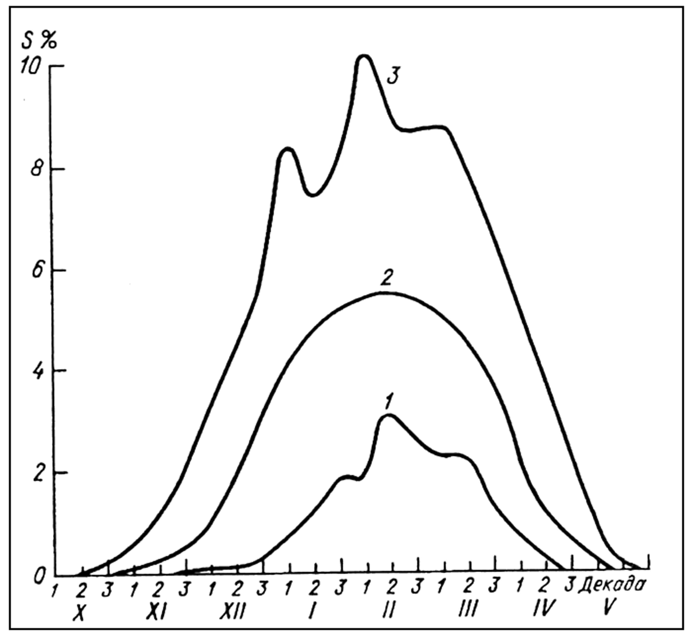
Fig. 2.12.2. Seasonal course of ice cover changes in the Sea of Japan (1 – favorable conditions,
2 – moderate conditions, 3 – unfavorable conditions)

Ice edge in period of its maximum propagation, which occurs in February, in the west moves down to 39° N, and in the east – to 43° N. Frequency of occurrence of different types of ice seasons is: 14% - minimum ice, 72% - close to norm and 14% - seasons of maximum ice.
In mild and moderate winters ice is observed only in Gulf of Peter the Great and Tatar Straight. On Fig. 2.12.3 different probabilities of ice observing in February are shown. Probabilities of 50% correspond with average boundary of ice location. Probabilities of 25% and 75% correspond with location of ice boundary under rather mild and severe conditions.
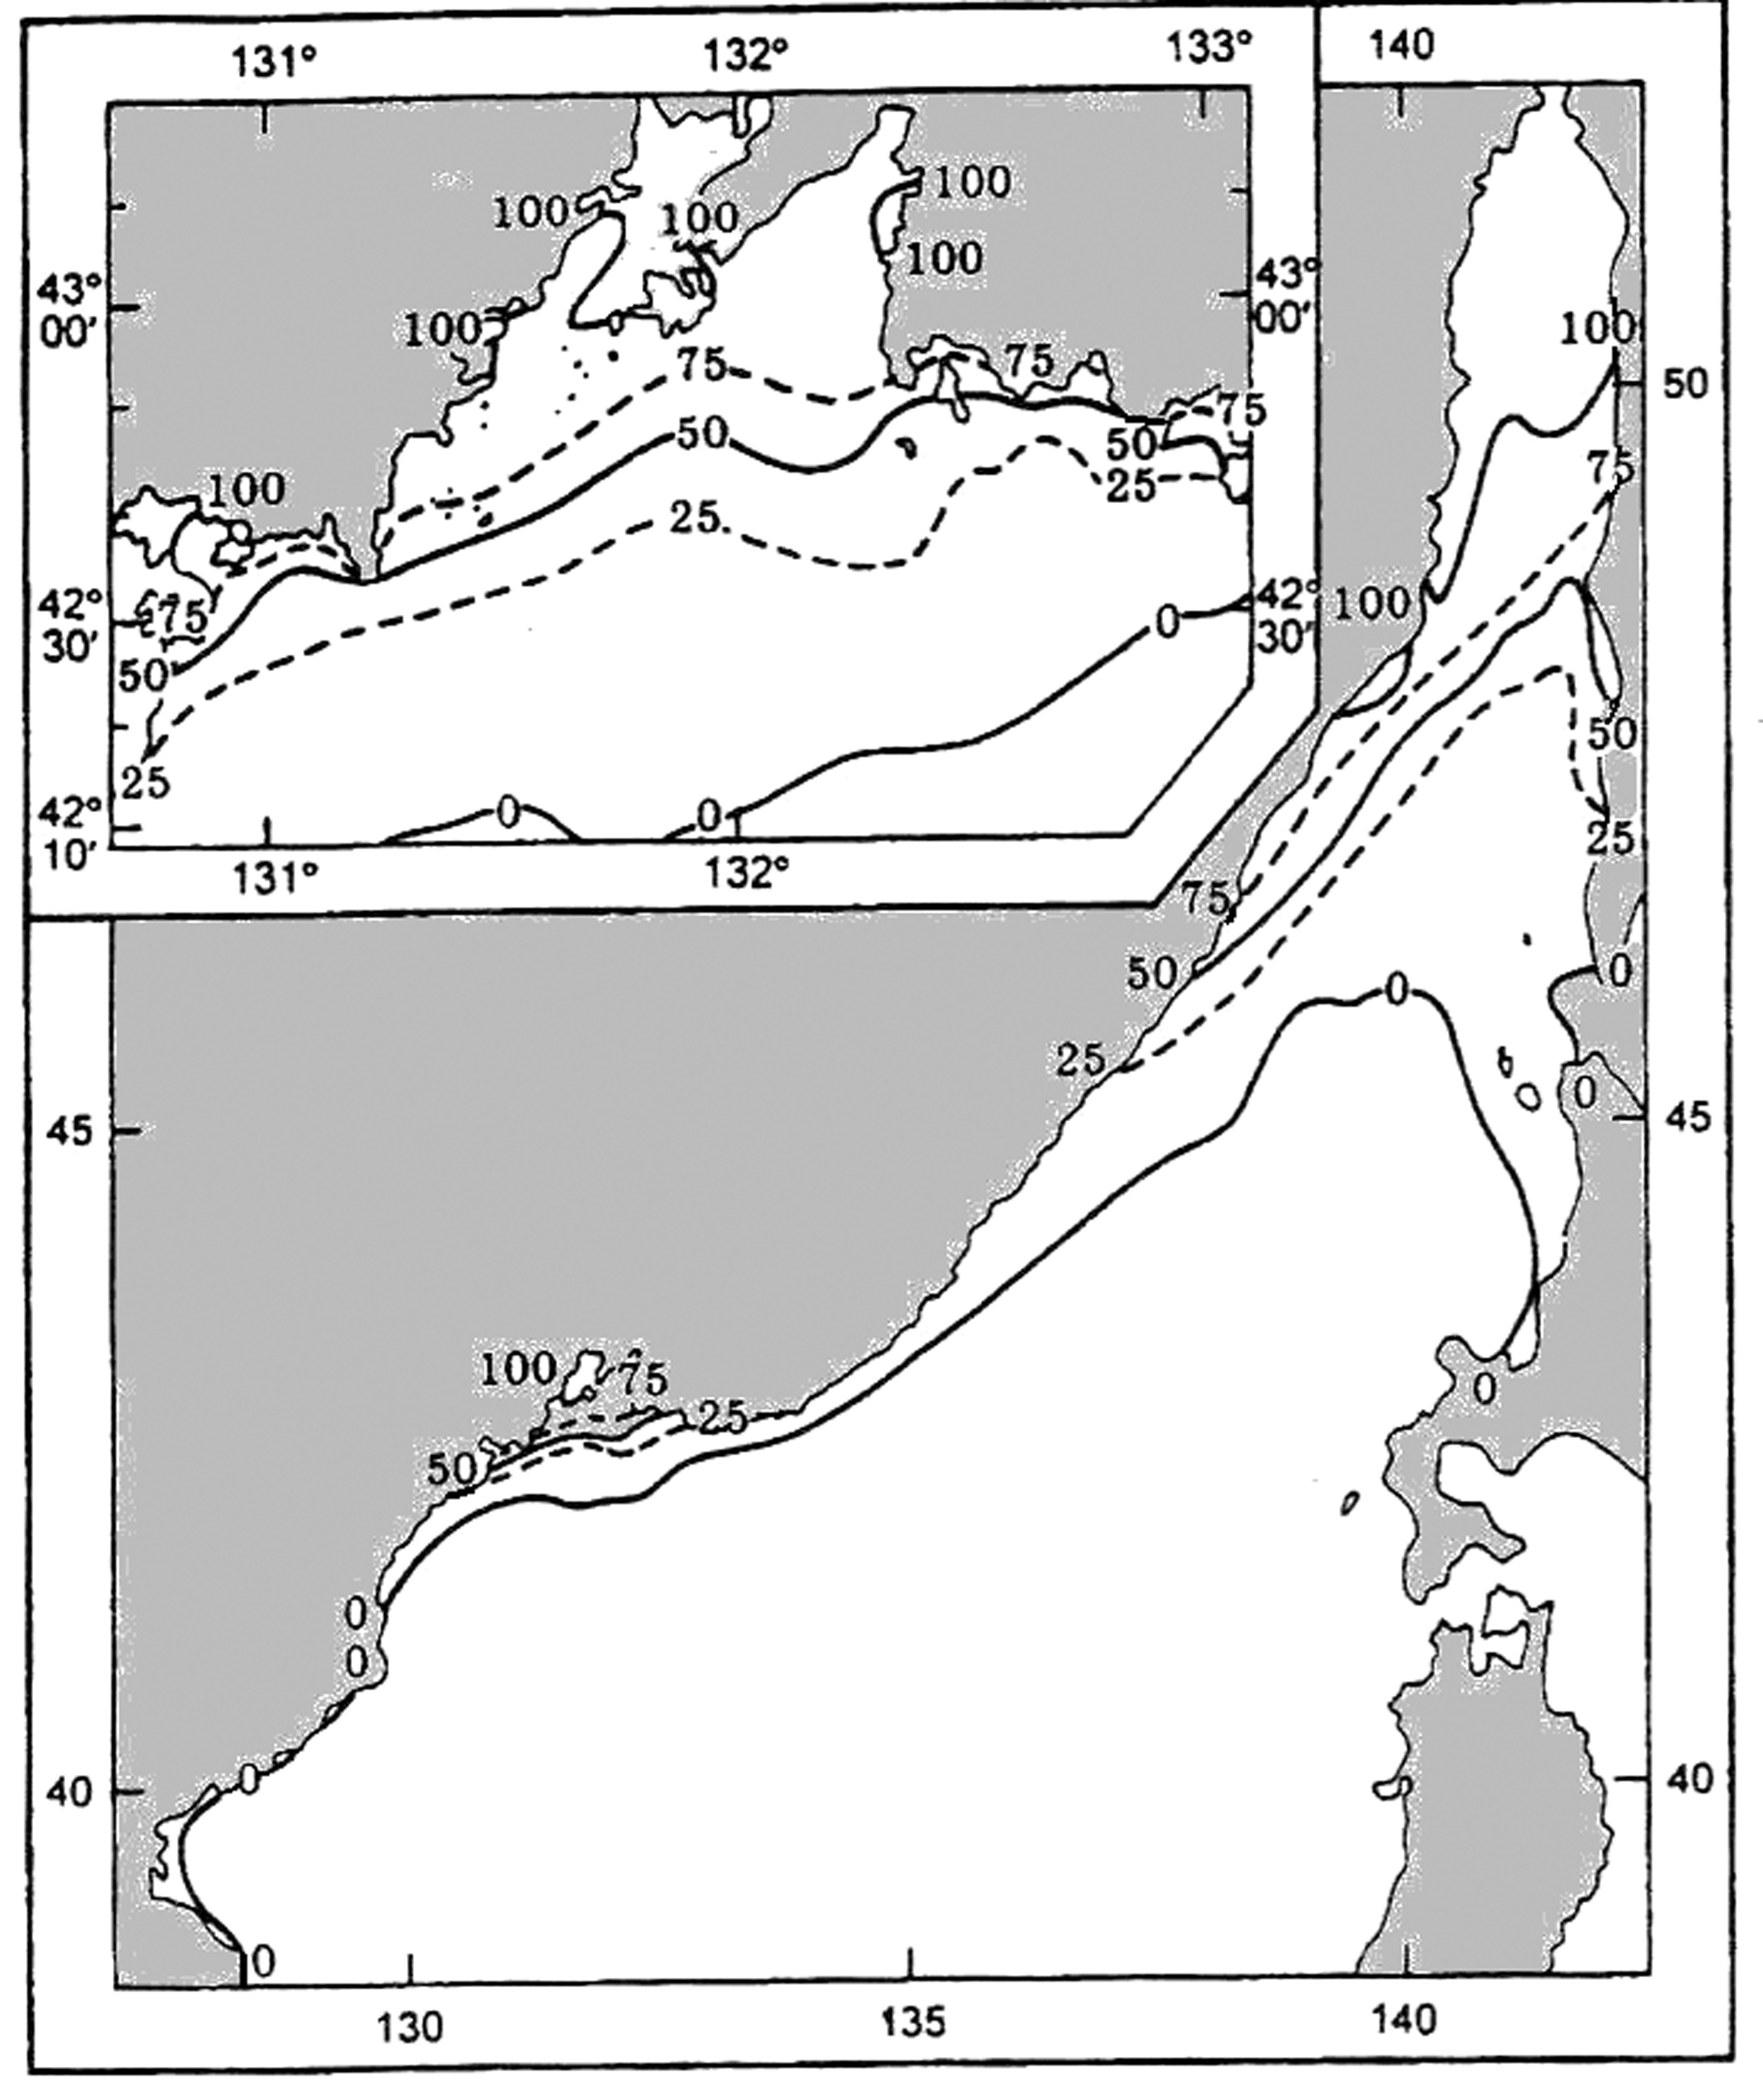
Fig. 2.12.3. Probability of ice observation in February

Ice of the Sea of Japan has different age composition during entire winter, depending on ice growth. Grey and grey-white ice is observed in the northern part of Tatar Straight in late November. Young ice reaches stage of thin first-year in late January – early February. Ice rafting, ridging and small ice cake are observed in coastal sea parts due to dynamic processes (offshore and onshore winds). Low temperatures facilitate its freeze up. That is why, ice with thickness up to 100 cm can be observed in separate coastal regions.
In spite of low air temperatures average thickness of drift ice in open parts of Tatar Straight is about 40 cm, but it can reach 60-80 cm in more severe years.
In the peak of Gulf of Amur grey ice is observed in late November, in the first 10-day period of December it transits to stage of grey-white ice. In January grey-white ice is observed in entire water area of Gulf of Peter the Great. Thin first-year ice is observed in the northern parts of gulf on the boundary with fast ice and in closed bays.
Annual mean ice boundary, which ice can approach with winds and currents from the north, approximately comes along Straight Posiet by the western sea coast to Cape Kamui at Hokkaido Island, deeply run to the north to 46 parallel. Northwards from this line ice is observed annually, southwards it hardly ever appears in the open sea. Only shuga, broken ice and slush ice are observed in small bays of western coast in very cold winters. Slush ice, shuga and broken ice are normally observed to 46° N. Northwards 46° N ice becomes more compact, its thickness increases up 30–60 cm; after 48° N its concentration increases a lot, especially along coast, where ice thickness on level floes reaches 50–80 cm. Ice cover of the Sea of Japan is extremely unstable. As a result of strong north-western winds, dominant in winter, ice uninterruptedly breaks and drifts south-westwards and southwards, especially in the central sea region, where strong ice motion and wide fracturing are observed during the most winter. Ice moves to Sakhalin coast by the same reason, forming here solid hummock ridges up to six meters height. During long-term south-eastern wind hummocks are formed along continental coast, but with less height, to 2 – 3 m.
It is necessary to mention, that ice cover in the eastern parts of Tatar Straight and Gulf of Peter the Great is less, than in western water areas. According to long-term data duration of ice period in Gulf of Peter the Great is about 120 days. In Tatar Straight (due to its large meridian extent) it is from 40 – 80 days in the southern part of straight to 140-170 days in the northern part.
In spite of relatively small area, occupied by ice in the Sea of Japan, concentration, age and ice forms significantly differ by spatial and time variability. E.g., ice is transported to the central and eastern parts of Tatar Straight under strong and long-term western and north-western winds. At the same time polynya is formed along western coast with width up to 5-10 miles, where intensive producing of initial ice occurs in its term. Under long-term storms with northern winds ice depression takes place, and under southern ones - ice compacting in the central part of straight, leading to ice edge retreat northwards.
In Tatar Straight dominant concentration of ice cover in period of ice formation and intensive ice growth (November-December) is - 7-9-th, under maximum possible values of concentration - 9-10-th; in period of maximum ice propagation (February) -9-10-th, under average possible values of concentration – 10-th. In March and in April average concentration starts to decrease.
Ice ridging in Tatar Straight propagates irregularly. Low ridging is observed in the central part of straight, compared to the western and eastern parts of straight, where ridging is higher. In November, when nilas and grey ice prevail, where ice rafting occurs instead of ridging, ice ridging is equal to zero. Starting from grey-white ice, motions and compacting of all age types lead to occurrence of hummocks. Average ridging in December – January (dominant grey-white ice) is 1-2, in February – April (dominant medium first-year ice) average ridging is 2. The highest ridging, reaching 3-4, is observed in the north-eastern part of straight (Fig. 2.12.4).
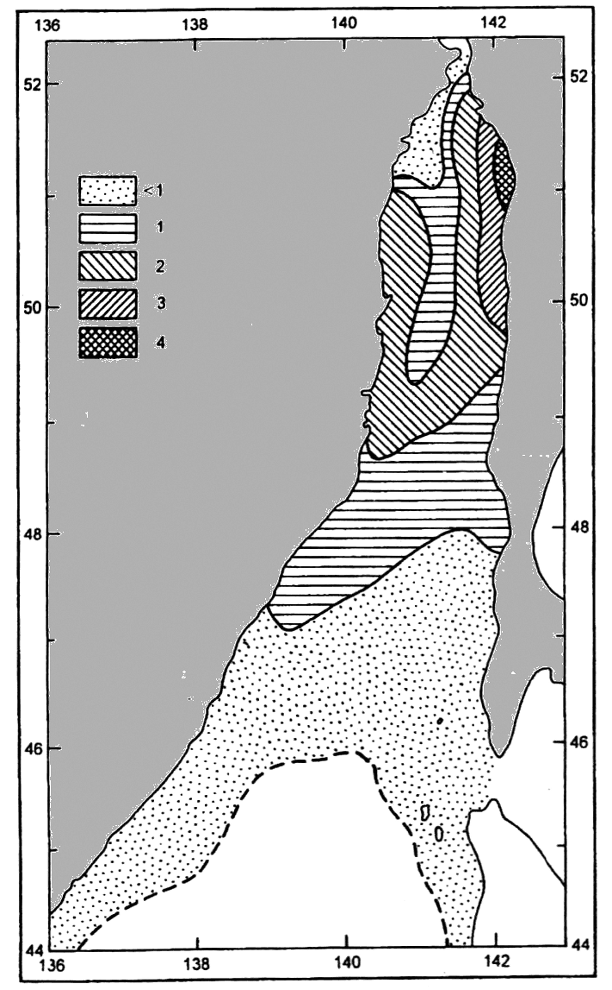
Fig. 2.12.4. Average ridging in Tatar Straight in period of maximum propagation of ice (marks)

Dominant size of ice floes changes during autumn-winter period. In November and December ice cake and small floes prevail. Decreasing of air temperature leads to rapid freezing of broken ice forms into large and medium floes. In January-March large and medium ice floes dominate in straight (Fig. 2.12.5). Large and giant floes can be observed in some rare cases. In April large ice forms start to melt. Dominant broken ice is observed in the straight.
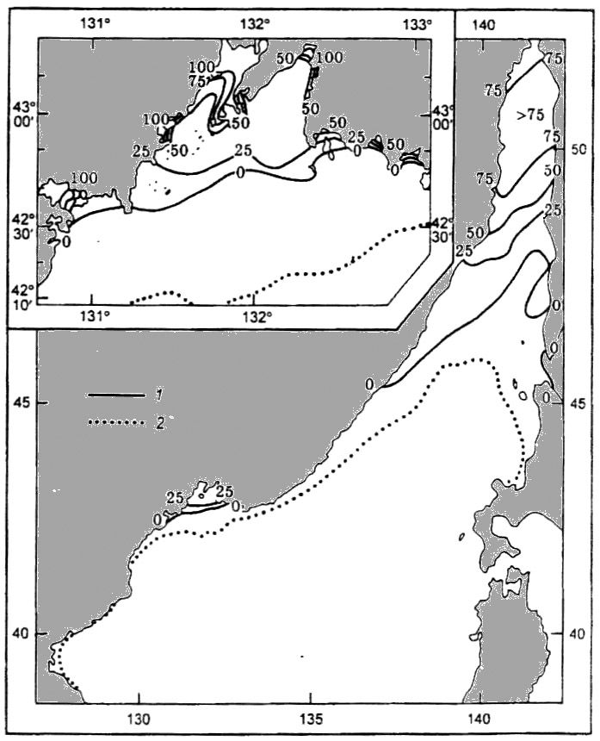
Fig. 2.12.5. Frequency of occurrence of large ice forms (large and medium floes) in period of maximum propagation of ice cover. (1 – frequency of occurrence isolines; 2 – boundary of the largest ice propagation)

Ice compacting in straight depends on velocity and direction of wind and tidal currents. When wind velocity is 15 m/s and more, role of wind component in compacting is dominating compared to tidal component. Ice compacting is normally observed under ice concentration 9 and 9-10-th. In zones, where large and giant floes prevail, ice compacting can start under concentration 7-8-th. As a rule, compacting occurs along coast, where ice suffers from off shore wind. Study of observations and climate estimations allows suggesting, that average intensity of compacting is 1. Maximum values of compacting can reach 2-3. Compacting is not observed in November, when young ice prevail and its concentration on average is less than 7-8-th, and in April, when average ice concentration decreases to 3-6-th.
In Gulf of Peter the Great and in the eastern and northern parts of Gulf of Amur and in Posiet Gulf ice areas with concentration 7-9-th dominate to mid-November. In bays and gulfs ice concentration is less than 6-th and only in Preobrazheniya Bay and harbor Tihkaya Pristan’ ice concentration can reach 9-10-th.
Propagation of ice age types has its own regularities. In the most northern part of straight grey ice zone with concentration 0 marks is observed as a rule. Southwards this zone there is a massif of compact grey-white and thin first-year ice. In zone near ice edge with width 10-15 miles broken grey-white ice dominates. In mild winters heavier ice accumulates along western and south-western coast, and in winters close to norm – concentrates along Sakhalin coast. Latitude propagation of age ice zones corresponds with severe winters: from Nevel Straight young ice sequentially transforms into old types, and only near ice edge frequency of occurrence of young ice increases again.
Amur and Ussuriysk Gulfs are mostly covered with grey and grey-white ice with concentration 7-9-th in January – February. Decreasing of temperature facilitates freezing of small ice forms into floes of frozen ice, which, beginning from January, are observed in the entire water area of Amur and Ussuriysk Gulfs. In spring ice concentration rapidly decreases due to intensive melting, all types of young ice disappear and percentage of older ice content increases. In the middle of March compact ice can be observed only in the northern half of Amur Gulf and in the eastern parts of Ussuriysk Gulf. During one or two 10-day periods ice concentration decreases to 1-3 to absolute clearing.

2.12.4. Ice cover in spring period

Spring processes, facilitating ice melting, start in late February, but especially sharp in March and April. Ice edge moves northwards and in mildest years ice absolutely disappears to late April. After very severe winters separate parts of ice can be observed near Nevel Straight even in late May. Early clearing from ice in the Sea of Japan occurs in second 10-day period of April, later – late May – early June (Fig. 2.12.2).
Sea absolutely clears from ice. Ice has never survived even after very severe winters.

