2.2. Characteristics of the White Sea ice conditions
2.2.1. General aspects
The White Sea, located in the north of European part of Russia, is connected with the Barents Sea and belongs to the Arctic Ocean water area, and in structural-geomorphologic relation it is marginal shelf sea.
Geographical location, morphometric features, river flow and advection influence of warm Barents water are characteristic features of hydrologic and ice regime of the White Sea. Some elements of its continental climate are defined by its inland location, which brings it closer to the Arctic Seas under hydrologic and ice regime. Negative water temperatures are kept in sea column even in summer, and compact ice cover is formed in winter.
Though rather small water area (about 90 000 km²), the White Sea was strongly dismembered and divided into several regions with their own names (Fig. 2.2.1).
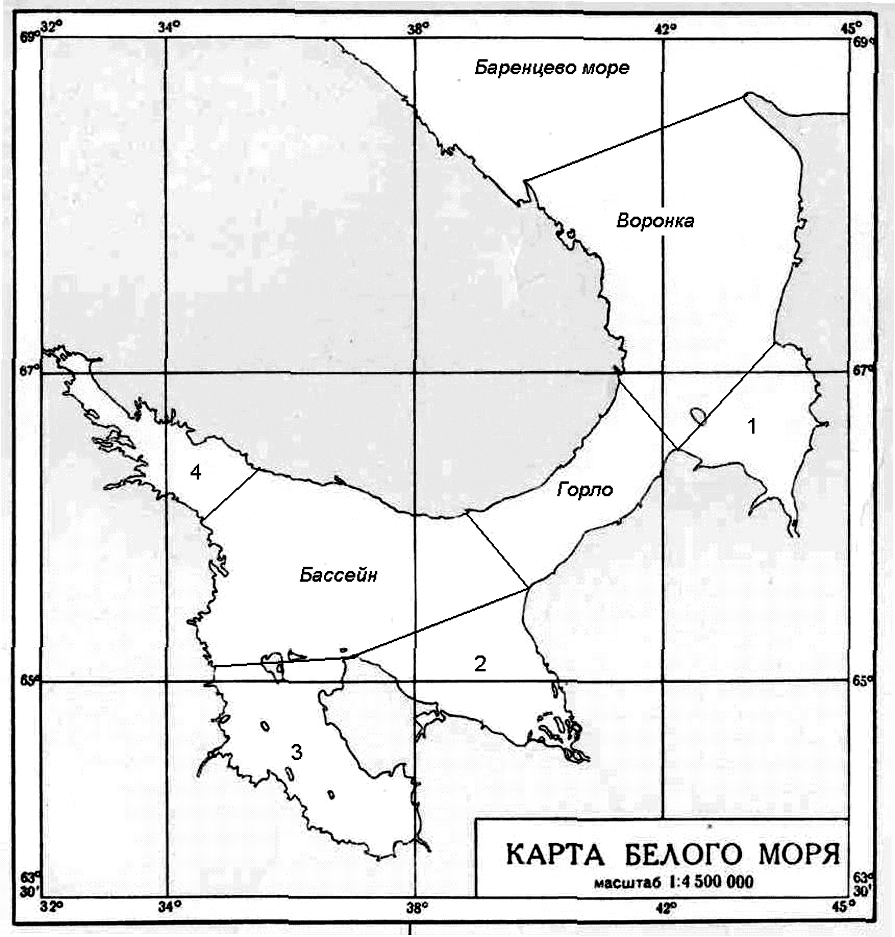
Fig. 2.2.1– The White Sea division into zones

Maximum depth of the White Sea is 343 m. On the large part of Voronka (funnel) and Gulf of Mezen depth doesn’t reach 50 m. The deepest part of the White Sea is its Basin. About 2/3 of its area is occupied by cavity with depth more than 100 m. This cavity with width 15-40 miles lasts from Gulf of Kandalaksha south-eastwards to entrance of Gulf of Dvine.
Gulf of Kandalaksha is the most deep-water among all sea gulfs. Its depth peak is 50 m. In Onega Bay depth of 10-25 m is dominant.

2.2.2. Ice formation
Sea ice formation starts in the first numbers of November in the gulf’s peaks. In December ice formation intensively propagate from gulfs to central sea regions. In the middle of December ice formation starts in Gorlo (throat), and in early January – in Basin (Fig. 2.2.2).
Fig. 2.2.2. Annual mean terms of stable ice formation in the White Sea

In January new and young ice are propagated to entire water basin, except north-western part of Voronka. In this region processes of ice formation are held back by warm flow of the Barents Sea water and by western winds, that move formed ice to eastern parts of Voronka.
Drift ice can cover the White Sea water basin ultimately and even come out of its boundary to the Barents Sea in severe winters.
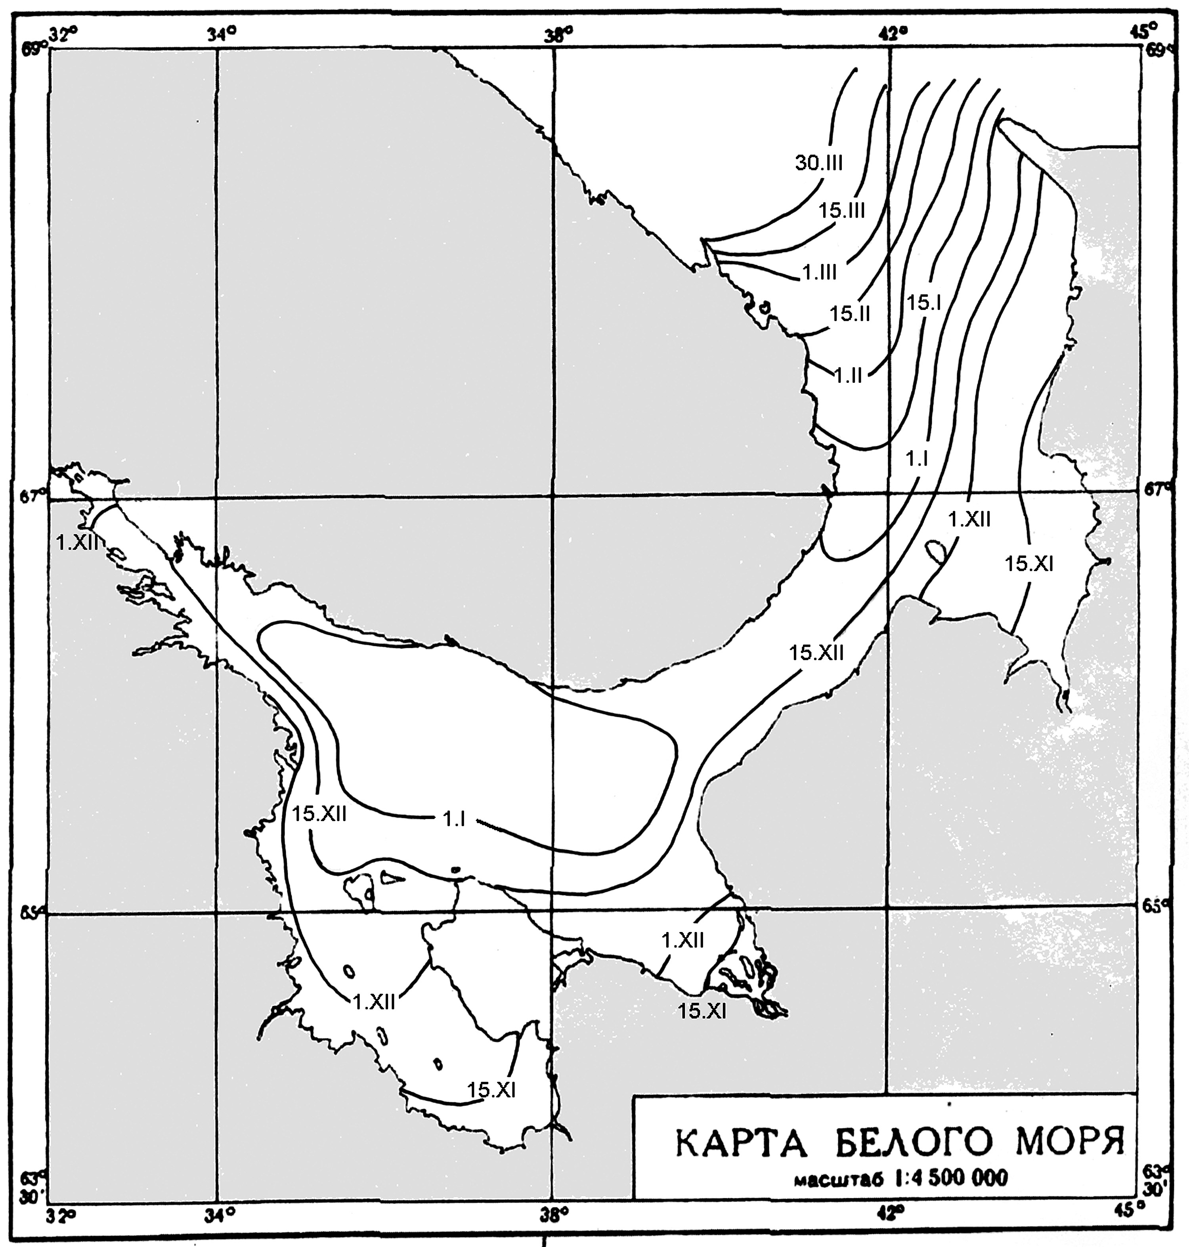
Fig. 2.2.2 – Ice growth and age composition of drifting ice

When stable ice formation is propagated, drifting ice edge in the White Sea moves to deep-water basin, then through Gorlo to Voronka and further to the Barents Sea boundary.
The White Sea ice has only local origin, that is why winter severity plays the most important role in formation of ice thickness and ice amount in the White Sea. Severity criterion of winter is air temperature and frost degree-days summary. Variability range of air temperature between mild and severe winters is more than 7○С in January-February (Fig. 2.2.3).

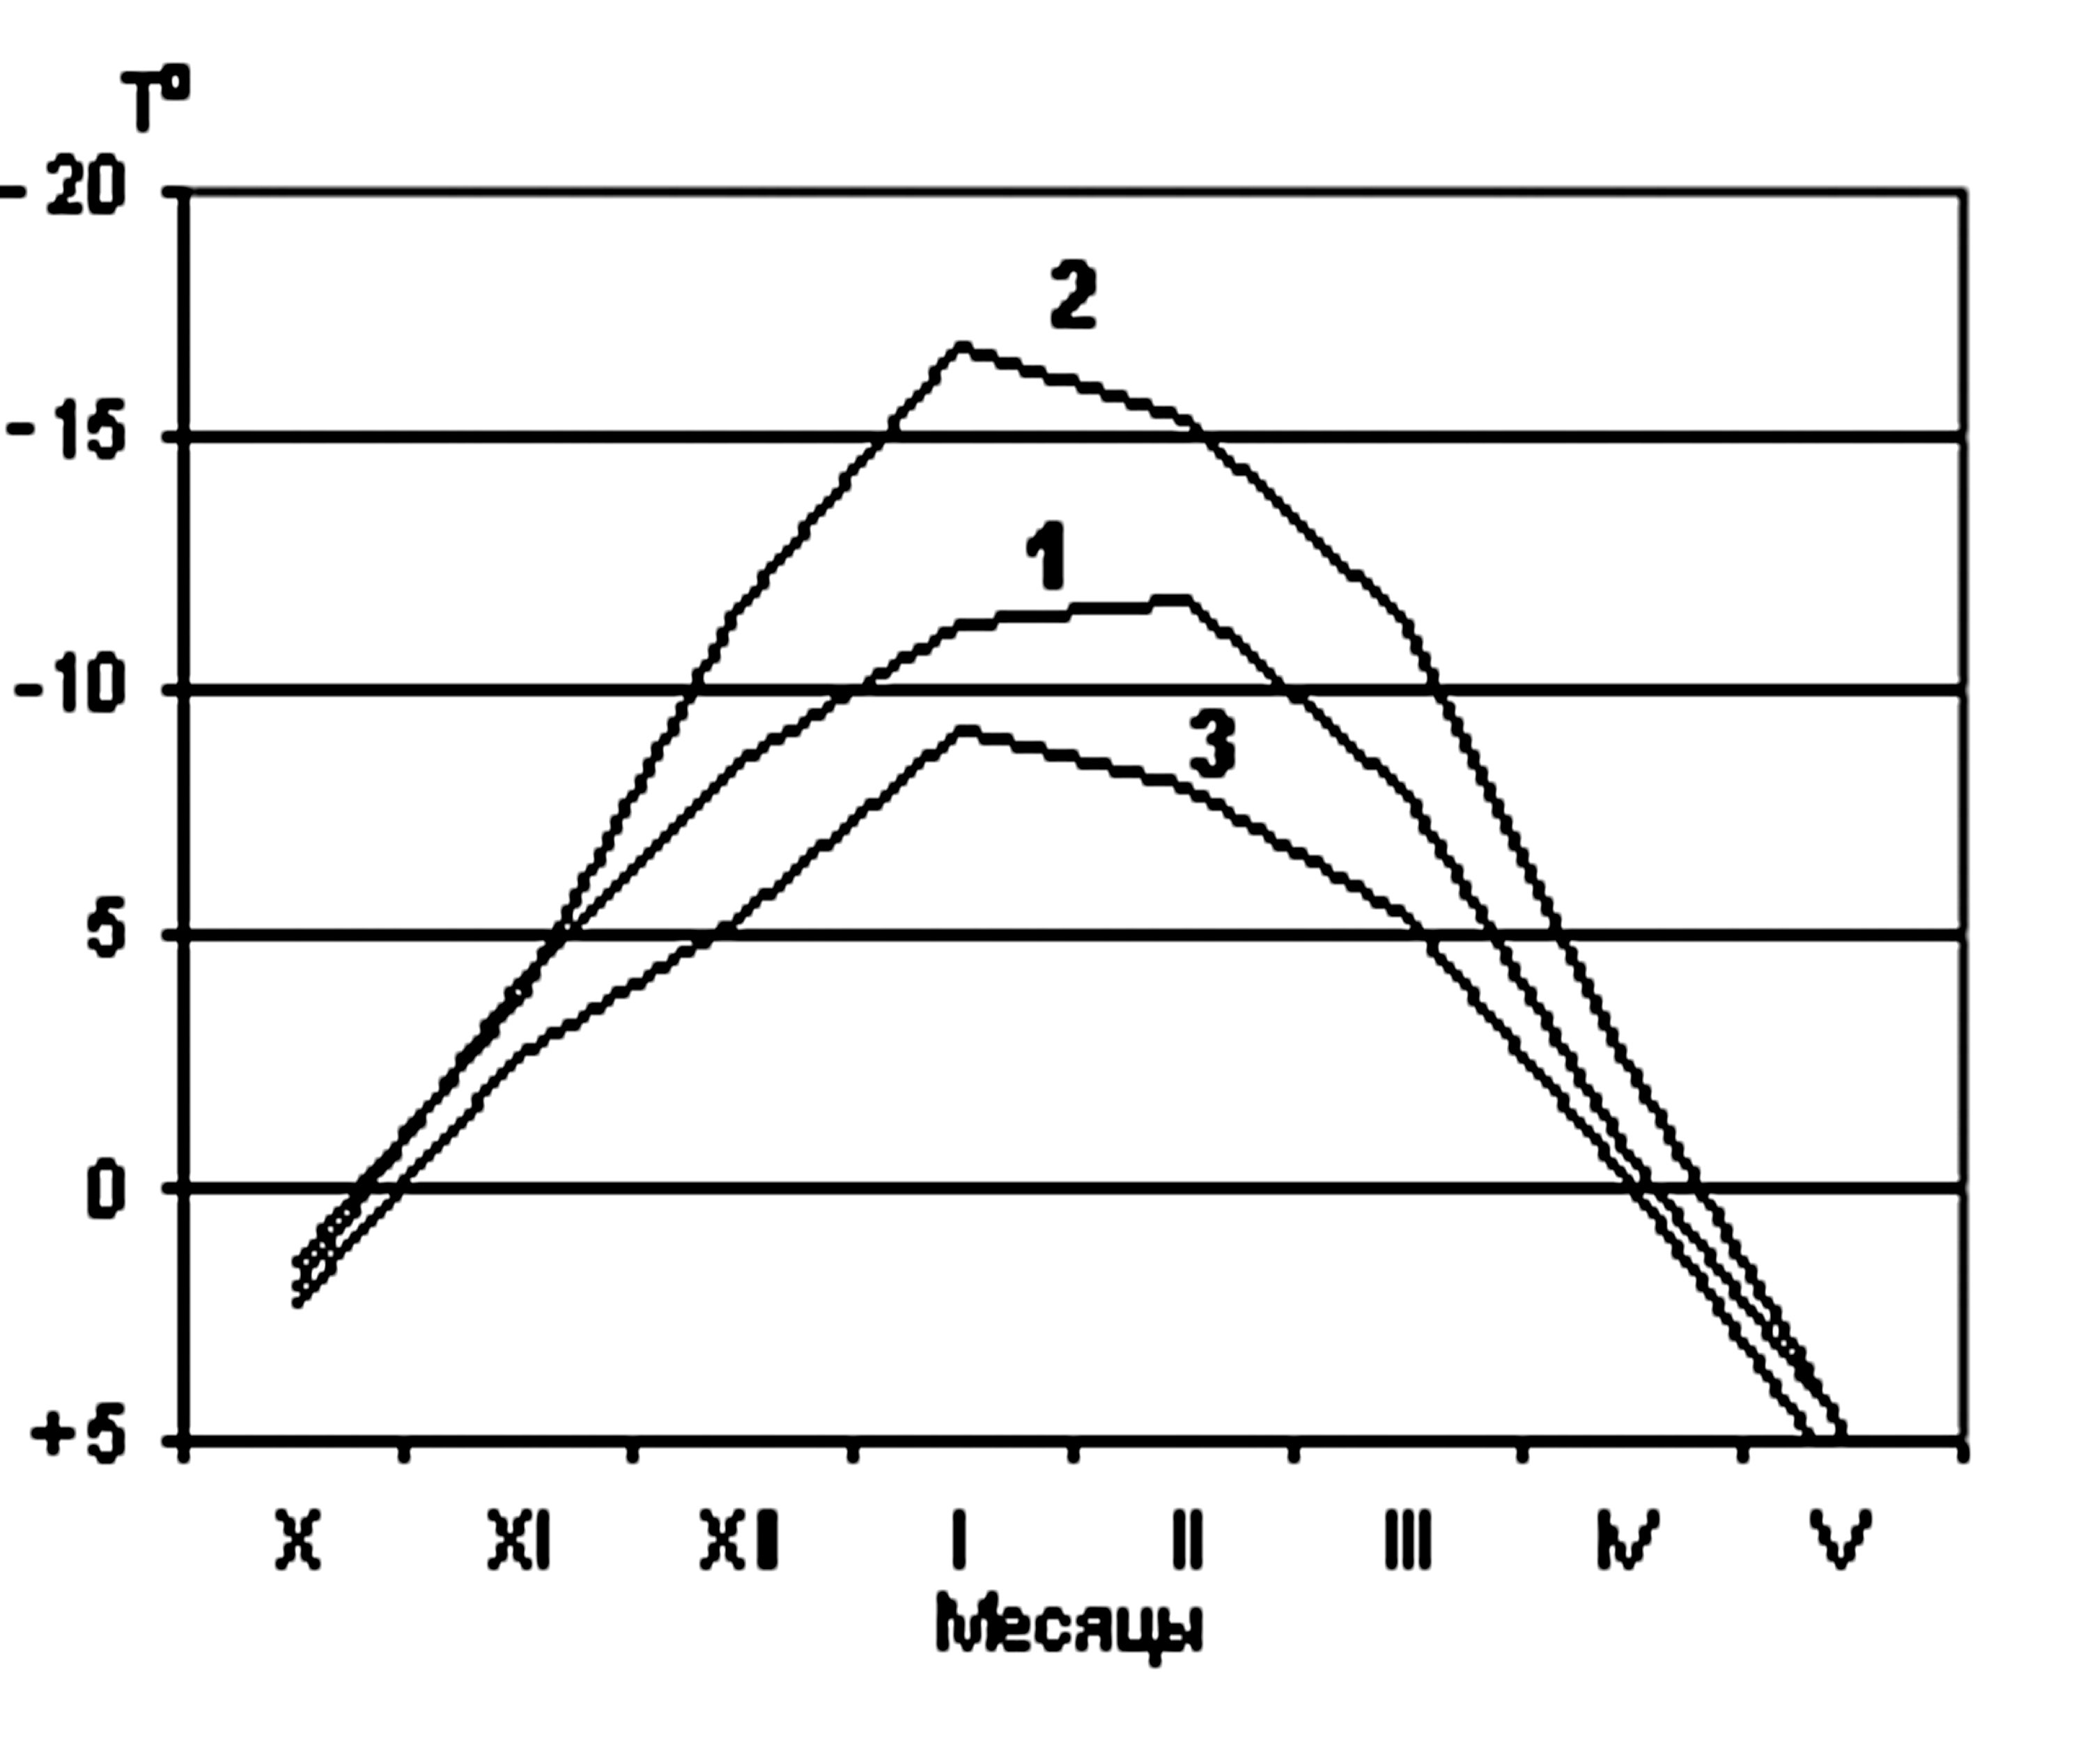
Fig. 2.2.3 – Average air temperatures in the White Sea in moderate (1), severe (2) and mild winters (3).

From data for 40 years observational period mild winters frequency of occurrence is - 20%, moderate - 63% and severe – 17%. Duration of ice period in the White Sea in heavier years is 8 months, 2 months more than in average years.
Ice edge location in freeze-up period is close to location of isochrones of terms of stable ice formation. Ice edge location significantly differs in sea, depending on winter severity. In moderate winters ice edge moves from gulf basins to open sea regions in December (Fig. 2.2.4), in severe – in November (Fig. 2.2.5), and in mild – only in January (Fig. 2.2.6).
Apart from the Arctic Seas, open ice and very open ice is completely absent in the White Sea (1-6).
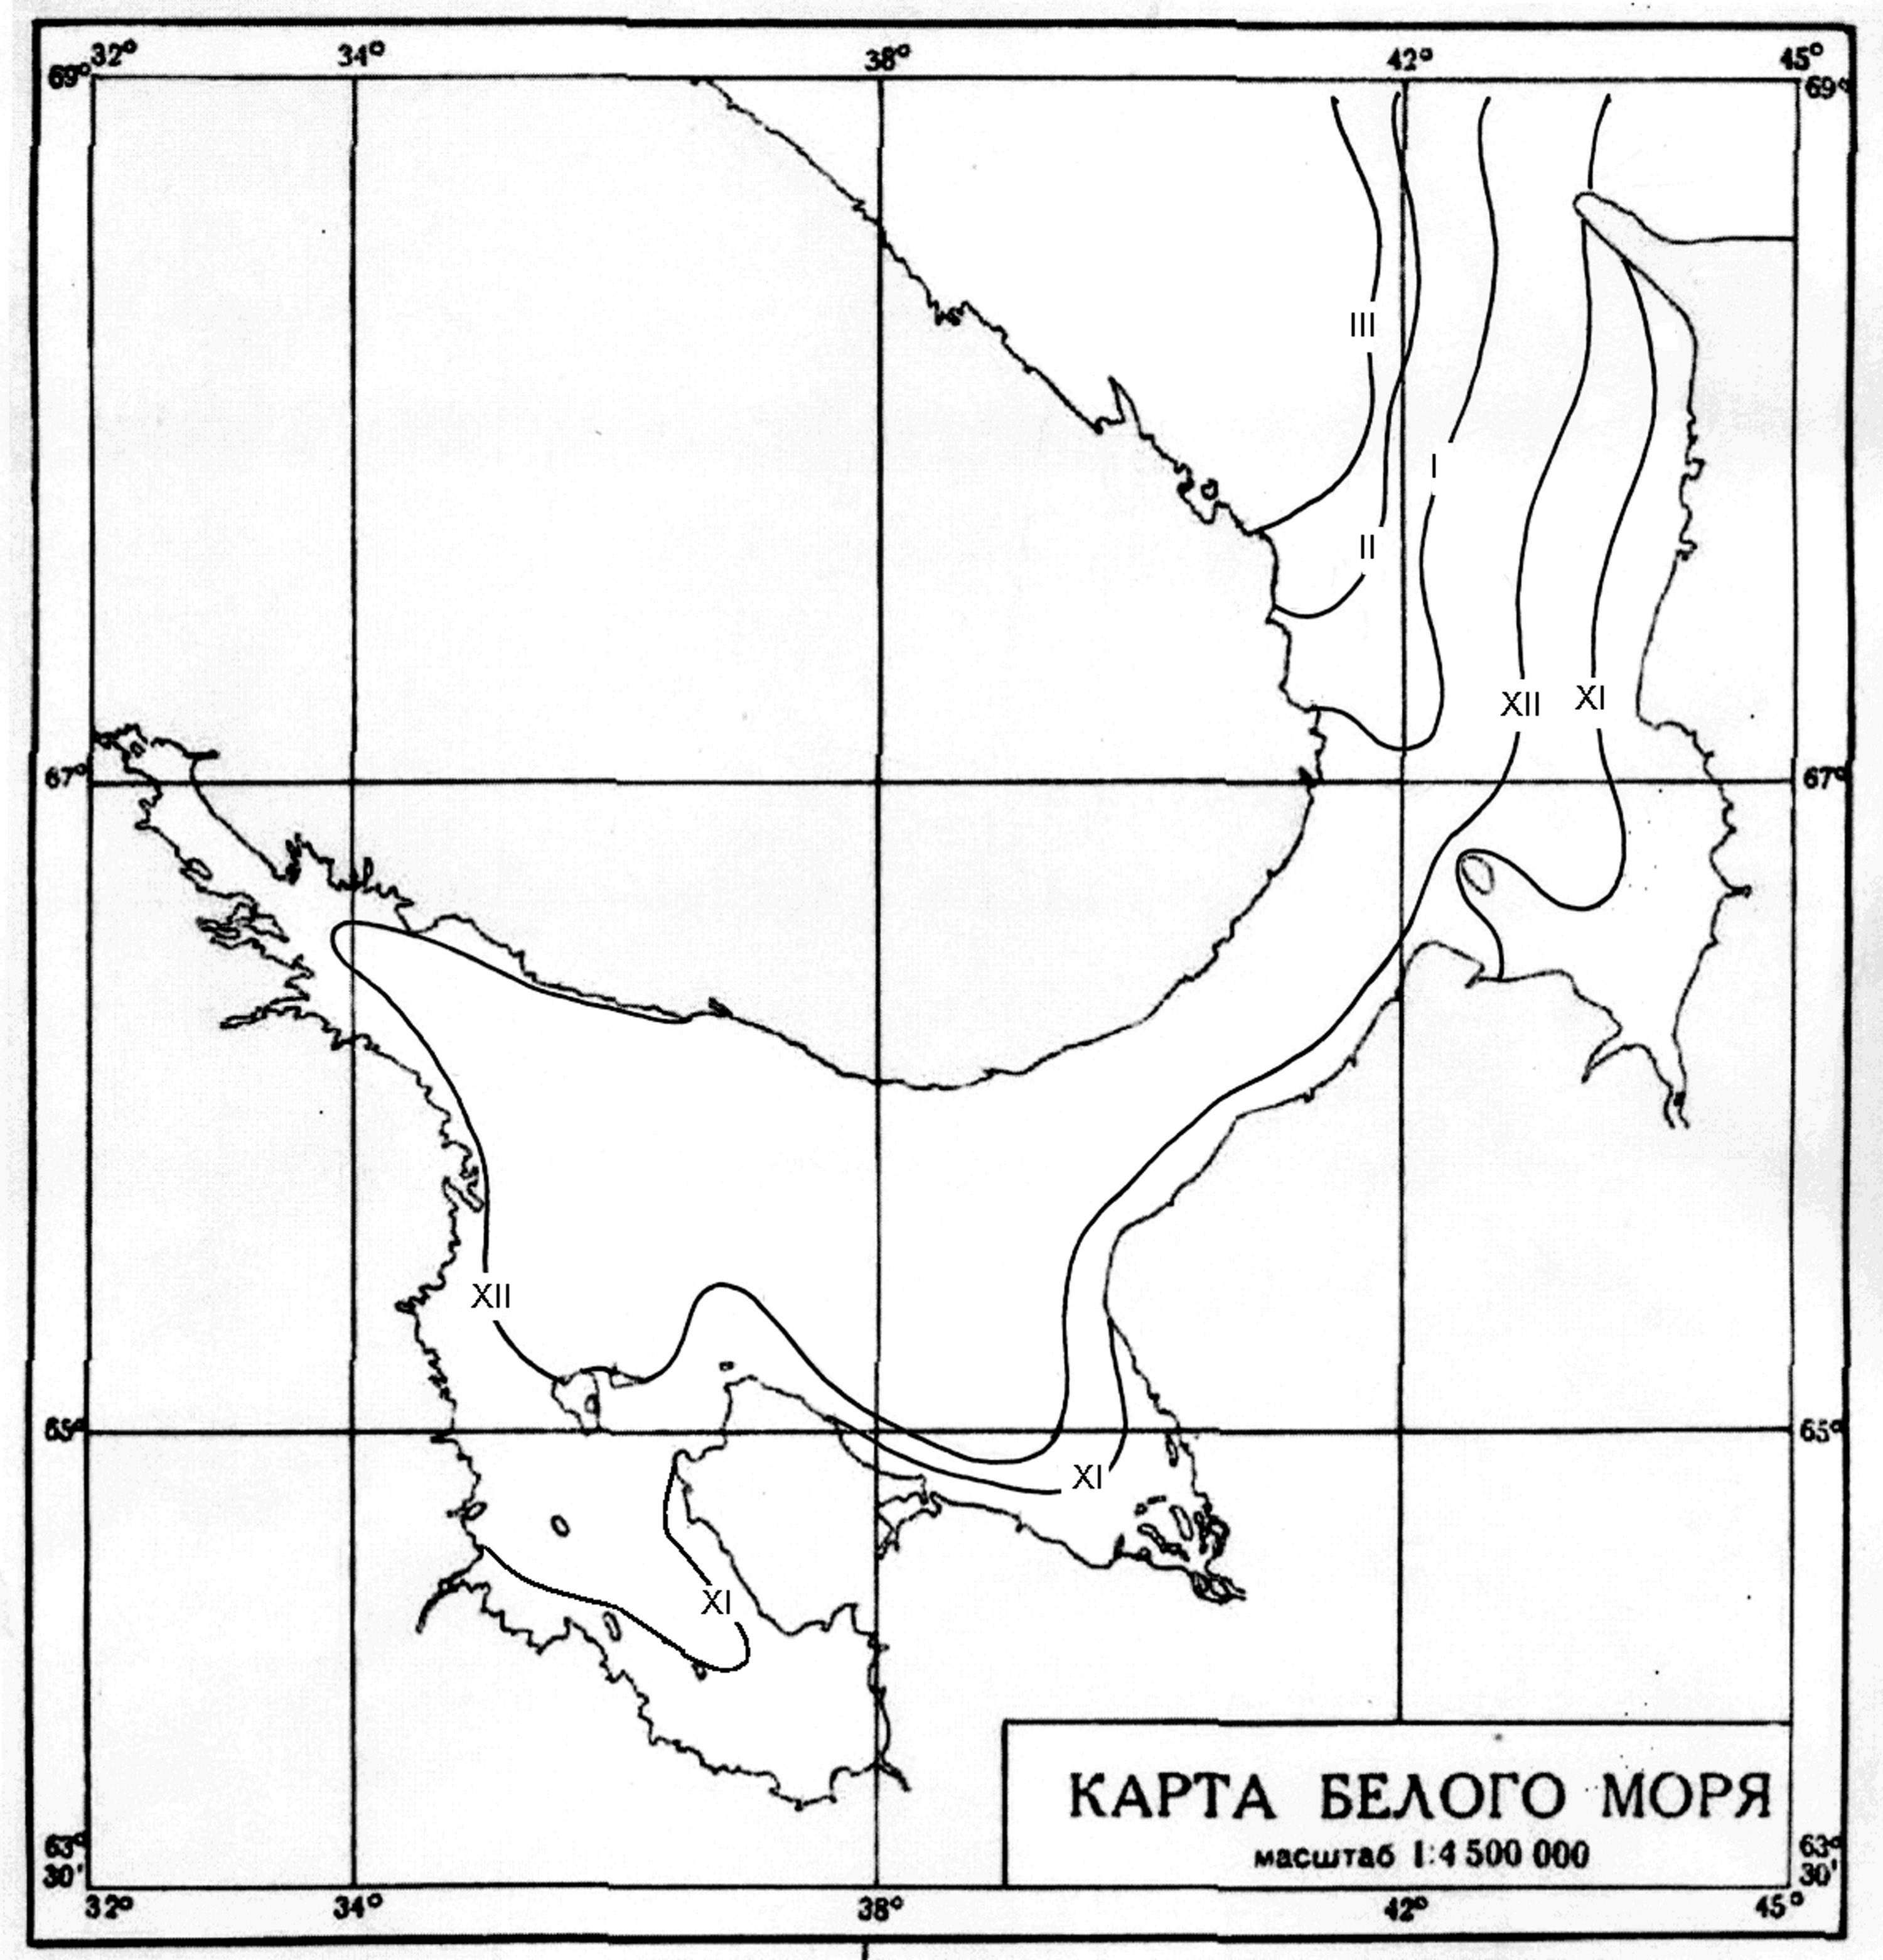
Fig. 2.2.4 – Ice edge location in the White Sea in moderate winter

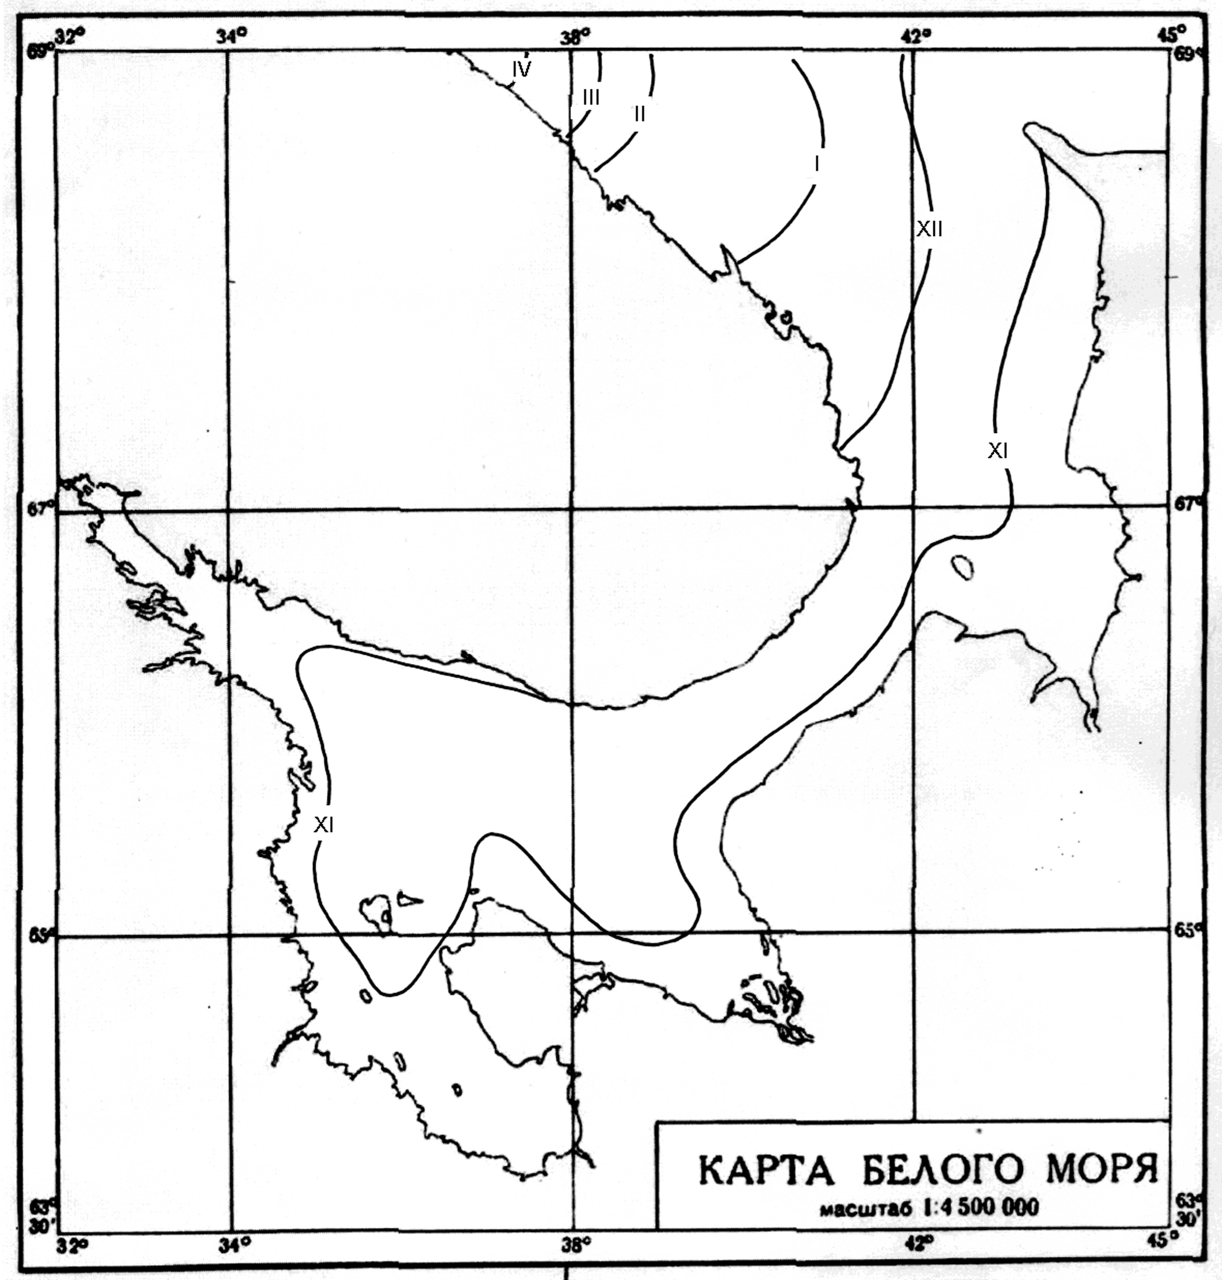
Fig. 2.2.5 – Ice edge location in the White Sea in severe winters

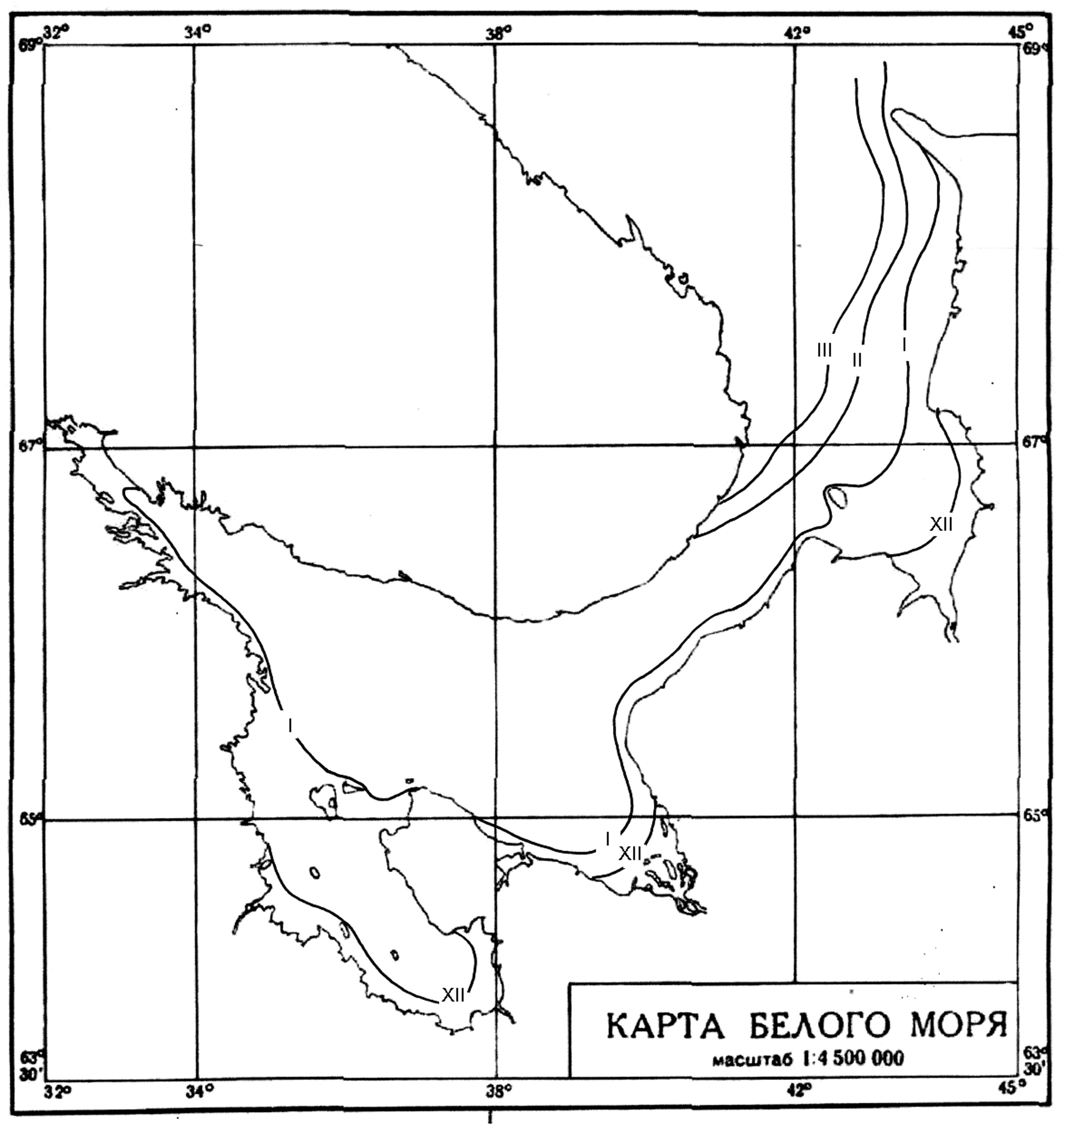
Fig. 2.2.6 – Ice edge location in the White Sea in mild winters

In severe winters ice edge comes out of sea limits in January, and ice cover formation continues till April (Fig. 2.2.5). In moderate and mild winters ice cover formation lasts till March (Fig. 2.2.4, 2.2.6). In mild winter about half of Voronka is free from ice, and in moderate – only edged north-western part.
In December first ice and nilas are seen in sea, grey ice starts to occur. Ice can be observed in Gulf of Onega, Gulf of Mezen and Gulf of Dvine.
From the middle of January all ice types are presented in sea, however, grey-white and thin first-year ice are dominant. Concentration of grey-white and first-year ice increases from 3 marks in Voronka, to 5 marks in Gorlo and to 7 marks in Basin. Grey ice and nilas have rest 3-7 marks.
Compact first-year ice and grey-white ice are observed in sea in February. The most amount of thin first-year ice (60 cm thickness) is located in sea Gorlo – up to 6 marks, 4 marks – in Voronka, and 2 marks – in Basin.
In March-early April compact first-year ice prevails in most water basin (Table 2.2.1), except western sea regions. Near western continental coast and western coast of Gulf (Karelia, Pomor, Letniy) polynyas are formed in summer under effect of prevailing south-western winds. Polynyas are filled in by young and less compact ice. In mild winters ice in polynyas is able not to form.
In February-March new ice and nilas can absolutely disappear as a result of long-term thaws.
Drifting sea ice doesn’t exceed age of thin first-year ice even in most severe winters (medium first-year ice is rarely formed in small amount). Sea ice is formed in December, two months earlier than in mild winters, in February-March its concentration reaches 9-10 marks. Age ice composition in period of maximum propagation is presented in Table 2.2.1.
Zones of ice, formed as a result of stratification, are observed practically in entire sea basin. Their thickness significantly exceed level ice thickness, formed only under effect of thermal factors, and can reach 1,5 m. Snow cover on sea routes doesn’t depend on winter severity, and in January on average it doesn’t reach 1-2 marks. It increases to 2-3 marks till March and in April decreases to 1-2 marks.

Table 2.2.1 –Ice age composition in the White Sea during period of its maximum propagation (March), from data for the period 1951-1985

Ice age | Ice thickness | Amount, %
Initial ice type | ≤5 cm | 1
Nilas | <10 cm | 7
Grey ice | 10-15 cm | 10
Grey-white ice | 15-30 cm | 18
Thin first-year ice | 30-70 cm | 43
Channels, polynyas | - | 21

2.2.4. Ice drift
Dynamics of water and ice in the White Sea are defined by morphometric sea features, river flow, wind regime and tidal phenomena. Scheme of general ice drift in the White Sea is defined by system of constant currents and prevailing from November to March south-western winds (Fig. 2.2.7).
Velocity of windy ice drift depends on wind velocity. If wind velocity is equal to 10-15 m/s, ice drift speed in Gorlo is 0,4-0,5 knots. Maximum velocity of total drift (wind and tidal both) in Gorlo can reach 2.5-4.2 knots.
In general exporting drift is typical for the Barents Sea. According to different estimations annual export is from 35 to 70% from the total ice volume of the White Sea.
Maximum velocity of ice drift in Gorlo was observed within limits of 20-25 miles/day, for other regions - 10-15 miles/day.

2.2.5. Fast ice and flaw polynyas
In the White Sea formation of fast ice starts on average in the second half of November from ice freeze-up in river mouth parts, flowing into seas. Fast ice establishment in gulf regions of sea occurs in late December – early January. Fast ice is formed in the second half of January along open coast. Maximum propagation of fast ice occurs in late February. By this time fast ice is edging almost entire sea coast, becoming wider in gulf peaks. In late winter total area of fast ice normally doesn’t reach 10% from sea area.
Fast ice reaches its most propagation in Gulf of Kandalaksha, Onega and Dvine (Fig. 2.2.7). In Gulf of Kandalaksha, depending on severity of winter conditions, maximum fast ice thickness varies in range of 45-65 miles.
In Gulf of Onega fast ice width changes in range of 9-13 miles, in Gulf of Dvine - 13-18 miles. In Gulf of Mezen fast ice develops sequentially, and its width on average doesn’t exceed 1-1,5 miles. Fast ice is located from several hundreds meters to a mile from open coast.
In Gulf of Onega fast ice width changes in range of 9-13 miles, in Gulf of Dvine - 13-18 miles. In Gulf of Mezen fast ice propagates sequentially, and its width on average doesn’t exceed 1-1,5 miles. Fast ice is located from several hundreds meters to a mile from open coast.
Every year fast ice is formed round Solovetskie Islands.
During winter the largest thickness of level fast ice near coast is on average 60-70 cm, and in severe winters is close to 100 cm (two times bigger than ice thickness in late mild winter).
Practically entire fast ice of Gulf of Onega, Mezen, southern part of Voronka is strongly hummocked and grounded hummocked. Ice ridging in some places can reach 4-5 marks.

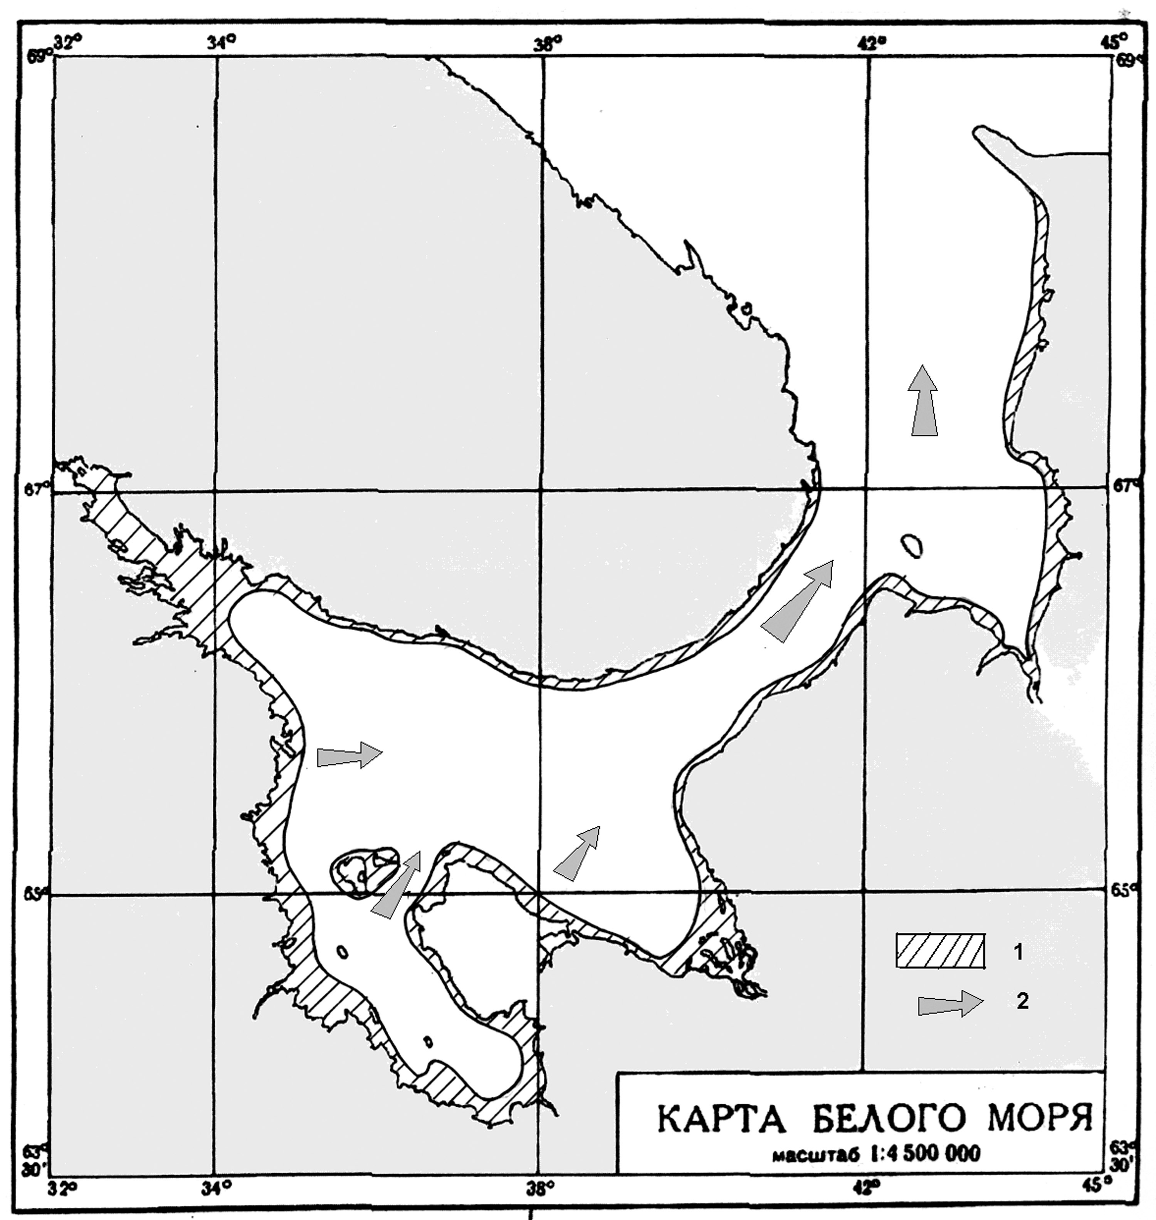
Fig. 2.2.7 – Maximum propagation of fast ice (1) and general ice drift direction (2) in the White Sea

The White Sea polynyas are rather dynamic. Their occurrence usually lasts several days and depends on wind force and duration, and also cooling intensity. Prevailing of western, south-western winds in winter leads to flaw polynyas occurrence and formation of depression zones, located mostly along Tersk (eastern) coast of Gorlo, and also along southern coasts of the White Sea Gulfs.

2.2.6. Compacting and ice ridging
Ice compacting is typical for entire sea basin, because ice constantly moves under tidal drift and wind effect. Tidal in the White Sea are semidiurnal. Tidal deviations of level from average position can reach in Voronka 3,5 m, in Gulf of Mezen – 10 m, in Gorlo – 3 m, in Gulf of Onega peak – 3,2 m. Tidal are significant for occurrence ice drift depression and zones of compacting in these regions (Fig. 2.2.8).
Ice cover in the White Sea is mostly ridged. Level floes of nilas and young ice partly can be seen in basin, Gulfs of Dvine and Kandalaksha and in Voronka, but they don’t exist long.
Grounded hummocking is typical for shallow regions of the White Sea. The largest amount is observed in Gulfs of Onega and Mezen. Thickness of hummock ridges in piles and barriers and grounded hummocks can exceed 10-15 m.
Ice ridging increases in course of general ice drift from Basin to Voronka in any winter month. At the same time seasonal increasing of ice ridging is observed on almost entire sea basin from January to April.
In January ice ridging in water basin is 0-1 marks, in throat – 1-2 marks, on the bigger part of Voronka (along Kaninsk coast) – 2-3 marks. In the north-easternest Gulf of Mezen ridging reaches 3-4 marks. Ice along Onega coast was ridged to 2-3 marks.
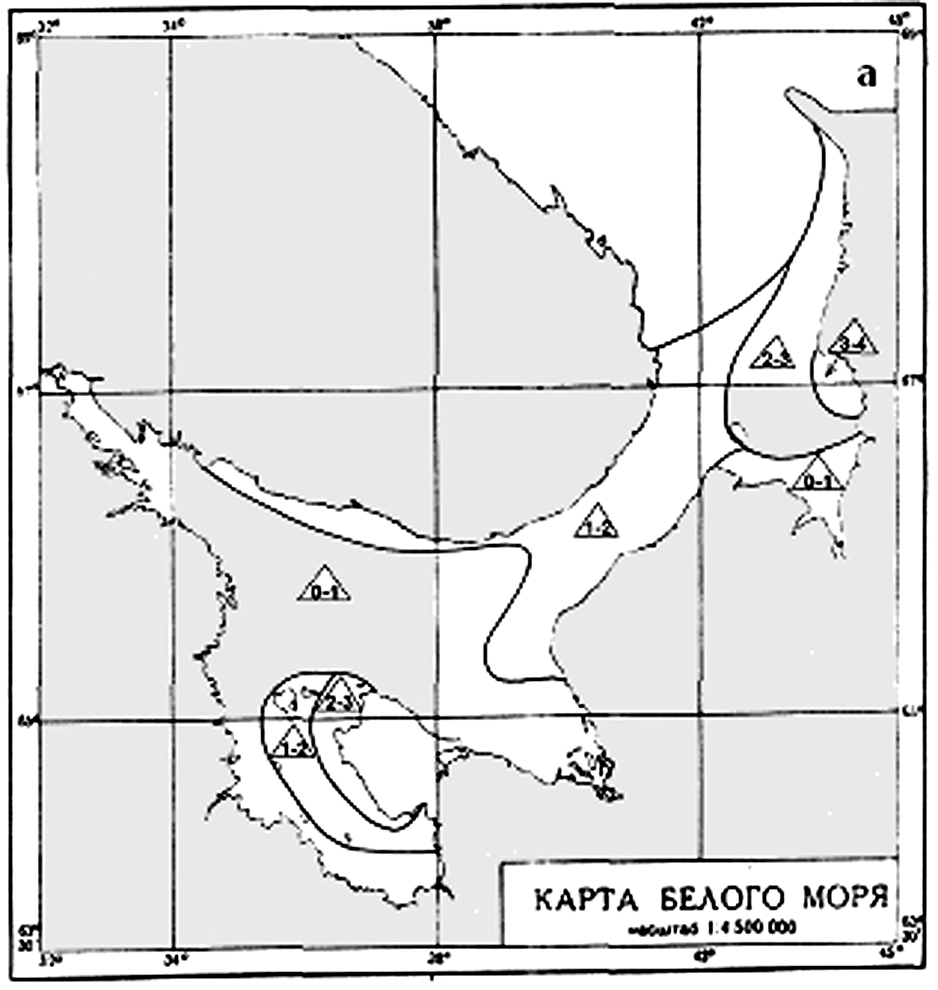 | 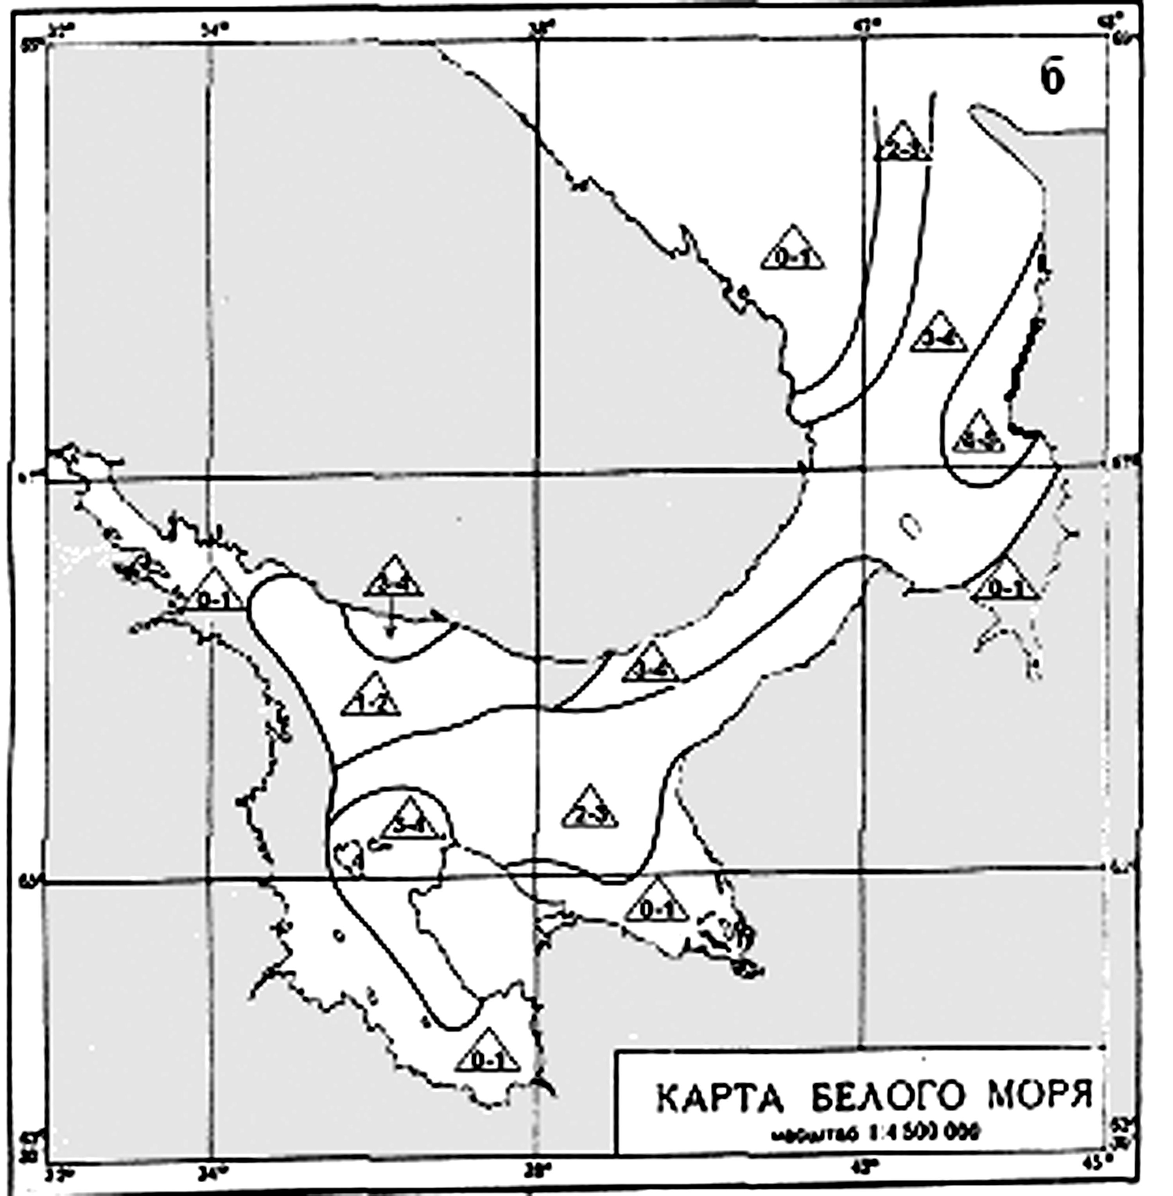

Fig. 2.2.8 – Ice ridging in the White Sea in January (a), and in April (b)

In April ice volume reaches its seasonal maximum on the most White Sea basin. Ridging of main mass, accumulated in Voronka and Gorlo, reaches 3-4 marks. Coastal region with ice 4-5-marks is widening along southern region of Kaninsk. Ice with ridging 2-3 marks occupies almost half of basin. Ice ridging increases to 3-4 marks along Onega coast. At the same time rather level ice mass is increasing (hummocks 0-1 marks) along Kandalaksha and Pomor coasts, including Gulf of Onega peak. It can be explained by small hummocking of young ice in polynyas, formed as a result of offshore wind and constant exporting ice drift for this sea region.
It is necessary to mention, that the most level ice (ridging not more than 1 mark) is kept near Karel and Pomor coasts during almost all winter, and in Gulf of Kandalaksha during all period. Similar ice ridging is observed on the biggest part of Gulf of Dvine basin (except March) and in Gulf of Mezen peak.

2.2.7. Drift ice
Ice floes are mostly typical for regions with weak tidal currents: in Basin, in Gulf of Kandalaksha and Gulf of Dvine. Broken ice with high ridging prevails in Gorlo and Voronka as a result of exporting ice drift, strong tidal currents. Co-called “kotli” – round-shape ice floes with contiguous high barriers of hummocks on edge, comparatively level in central parts, are often observed.
Ice cake and small broken floes are formed mostly due to ice floes decay and their parts. In April-March broken ice prevails.
To the end of winter small ice cake is often observed, which occurs at the same time with broken ice formation. Small ice cake under compacting can reach 3-4 m and more. Amount of small ice cake gradually increases in direction from Basin to Voronka.

2.2.8. Ice melting and ice-free sea
Melting intensity increases after stable air temperature transition through 0○C to positive values, that on average occurs in the second decade of April. Firstly, young ice, covering polynyas region, melts away, and depression ice zones appear. Thin first-year ice, dominant in sea, is exported from Gulfs of Kandalaksha, Onega, Dvine into basin and further through Gorlo to Voronka under western winds. At that, they are accumulated and ridged mostly in eastern parts of gulfs, Gorlo and Voronka.
More intensive process of clearing from ice occurs in May. In early May all drift ice is divided into three parts. One part of depression broken ice is usually located in the north-western Gulf of Onega, another – in Gulf of Kandalaksha and north-western part of basin. Third part of more compact ice is in region of Gorlo and Voronka near Tersk coast and north-western Gulf of Mezen. First two ice regions intensively melt away and are transported to centre of basin. Ice melting and decreasing of its concentration in third region occur slower, what is connected with its large power and volume, increased while ridging. By the same reason, this ice region is safe to late May – early July. It is also a result of wind changing into eastern, what prevents ice transportation from sea.
Final clearing of the White Sea from ice occurs as a rule in the first decade of June after final fast ice break up.

2.2.9. Fast ice break up and decay
First fast ice break up in the White Sea occurs in the end of second decade of April near Abram coast of Gulf of Mezen and Letniy coast of Gulf of Dvine, and also near Kandalaksha coast. Fast ice starts to break up along Kanin coast in the middle of third decade of April. Later than others, fast ice break up occurs in Gulf of Kandalaksha and along Tersk coast.
Final decay of fast ice normally occurs in May. In the first decade of May fast ice in Gulf of Onega and Gulf of Dvine finally breaks up, and in the second decade – in Gulf of Mezen and round Solovetskie Islands. Fast ice in Gulf of Kandalaksha is the latest; it breaks up in the third decade of May.
Broken fast ice partly melts away, where it was located, and partly is transported to open sea regions, where they ultimately disappear.

