2.3. Characteristic of the Barents Sea ice conditions
2.3.1. General aspects
Ice formation and decay conditions in the Barents Sea significantly differ from conditions of the Siberian Arctic shelf seas due to advection of Atlantic water, transported by the Gulfstream Current system. As a result of this effect the Barents Sea is not covered with ice completely even in severe winters, whereas all other Arctic Seas in winter period are covered by ice with concentration of 9-10/10-th.
The Barents Sea is subdivided by its ice-hydrologic features into three regions: western, north-eastern and south-eastern parts (Fig. 2.3.1.).Western region occupies about 53% of water area, north-eastern - 29% and south-eastern – about 18. The Pechora Sea - water area eastwards from Kolguev Island to the boundary with the Kara Sea is often separated within the limits of its south-eastern part.
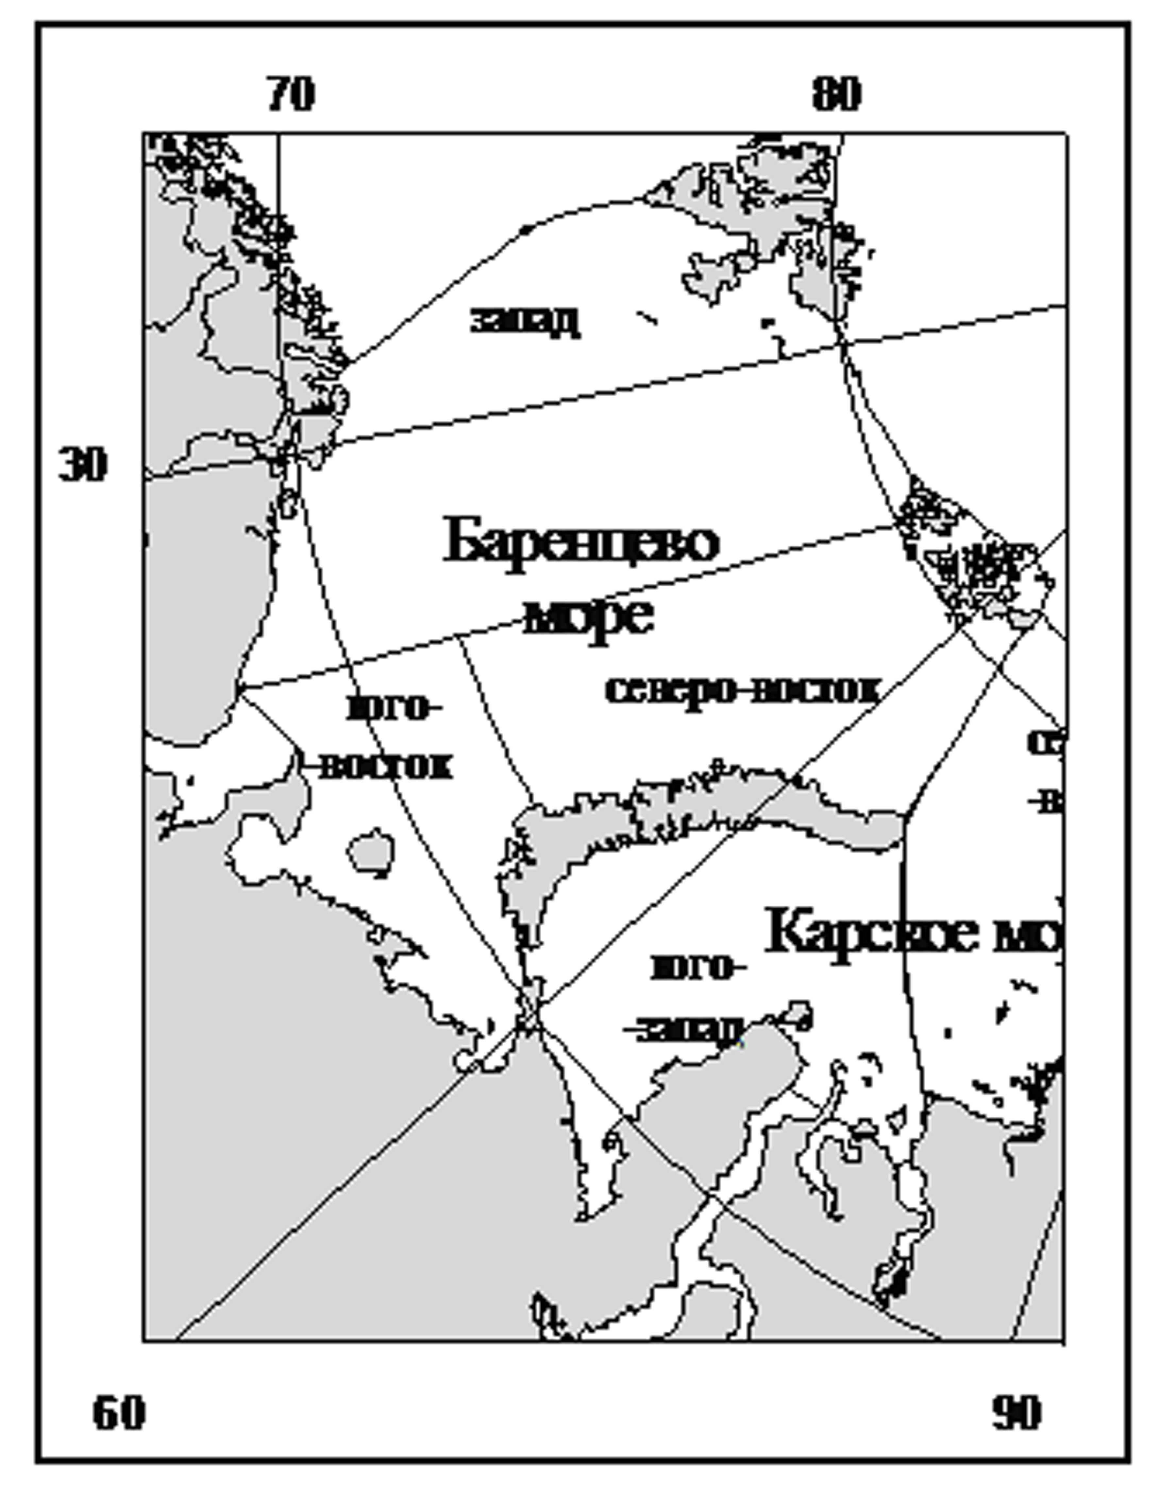
Fig. 2.3.1 – The Barents Sea division into zones

Ice formation in the Barents Sea starts from the second half of September and lasts for 7 months; melting period is 5 months. Maximum development of ice cover occurs in April. Minimum ice amount is observed in August-September.
In period of maximum development of ice cover (March-April), ice area in the Barents Sea usually comprises 55-60%, and the rest 40-45% of water area is ice-free. Under favorable conditions in winter period ice cover occupies only 30-35%, and under unfavorable conditions 85-90% of sea area.
In summer period ice cover (relative ice area) in the Barents Sea is only 5-10%. Under favorable summer conditions sea ice in the Barents Sea almost completely disappears, and under unfavorable conditions ice cover in the Barents Sea is 20-25% by the end of melting.
Existing of non-freezing sea parts means that in winter period zone of zero heat budget is located here. To the south and west from this zone continuous in-flow of warm water to surface water layers compensates for radiation cooling and cold advection by air transport, which prevents ice formation.
To the north and east from this area there aren’t such strong in-flow of warm water to surface layers, heat losses by means of infrared radiation cause active cooling of sea surface, and, as a result, ice formation.

2.3.2. Ice formation
Stable ice formation in the Barents Sea starts in late August on the boundary with the Arctic basin. First of all, Straights of France-Joseph Land and Svalbard archipelagoes freeze up. Gradually, at the same time with cooling of sea regions with large heat content, ice formation wave propagates to the south up to the latitude of the northern extremity of Novaya Zemlya. As it is seen from location of isochrones of stable ice formation terms, further the process of ice formation, propagating to the south in central sea parts, at the same time occupies water area to the west from Novaya Zemlya coast (Fig. 2.3.2).
According to annual mean data ice formation in the Barents Sea stops in the middle of April on the boundary of zone with water of high heat content. All water column to west and south from isochrones “April, 15” has rather high temperature that is why, heat in-flow from water depth in process of autumn-winter convection not only compensates its outflow to atmosphere, but keeps positive temperature on the sea surface. Further ice spreading in the sea is ceased. As a result of it, on average, 35% of the Barents Sea area is free from ice. 47% of this water area is located in the western sea part, 14% - in the north-eastern part and 30% in the south-eastern (Fig. 2.3.2).
In sea area, limited from south by isoline of 100% probability of ice occurrence, annual amplitude of stable ice formation terms on northern sea boundary is 40 days and it increases in direction of ice edge to 120 days (Fig. 2.3.3.). Such variability can be explained by both interannual variability of hydro meteorological factors in period, before ice formation, and conditions of heat exchange between sea and atmosphere in period of its cooling.

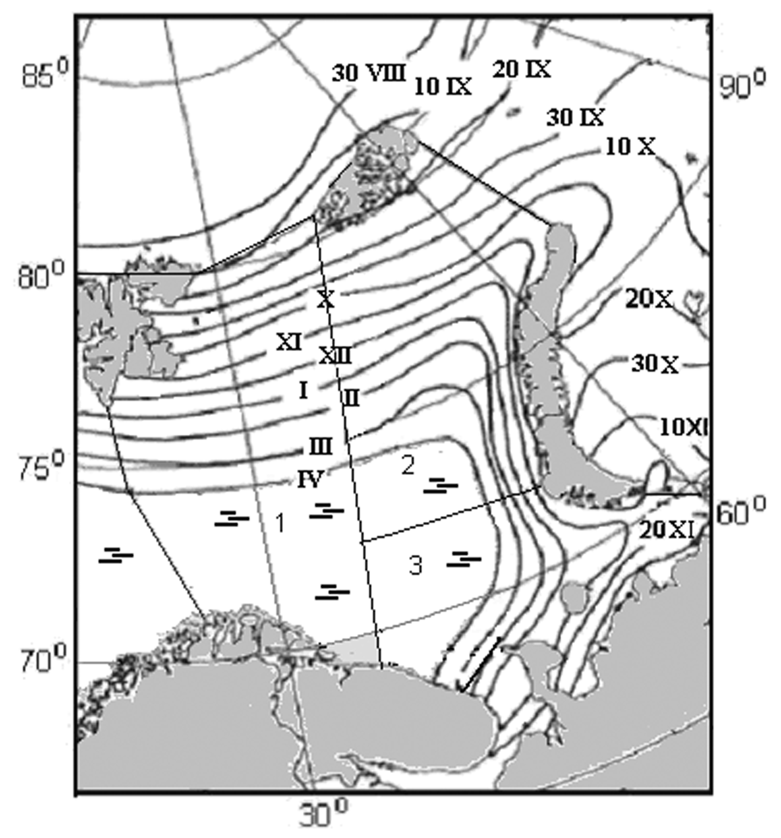
Fig. 2.3.2 – Average terms of stable ice formation in the Arctic seas
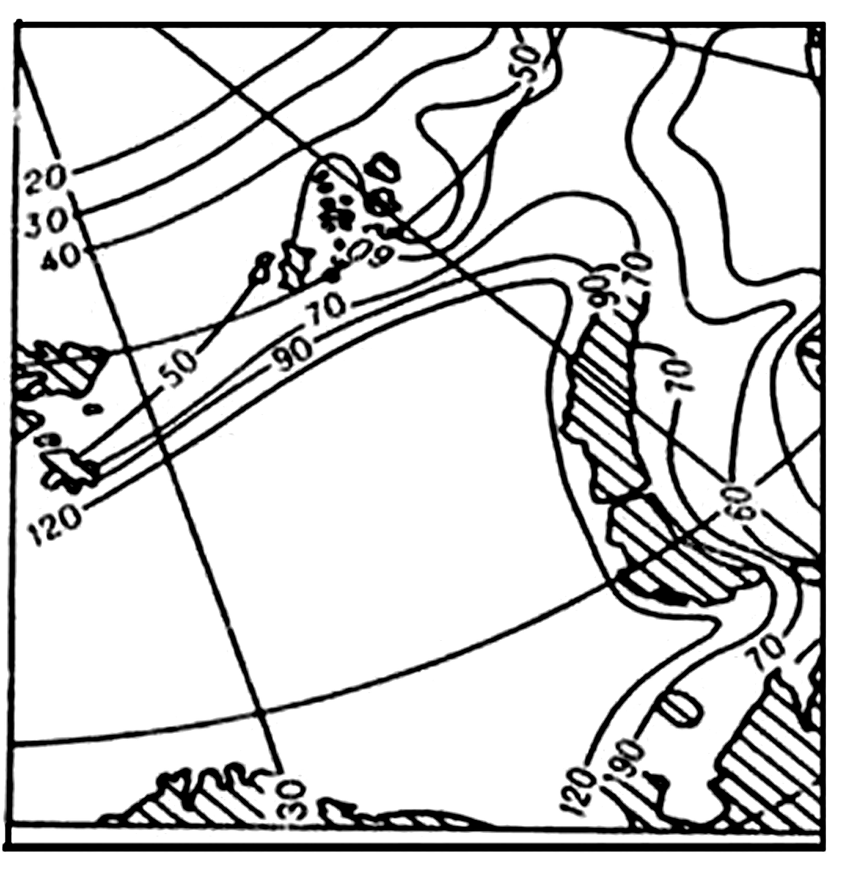
Fig. 2.3.3 – Amplitudes (days) of stable ice formation terms

2.3.3. Ice cover in winter period
Transition of new ice types to first-year ice occurs after stable ice formation, and ice edge gradually moves to open parts of the Barents Sea from north to south and from east to west.
This process lasts till April inclusive. At the moment of maximum development of ice cover in year with average ice conditions, ice edge is situated southwards from Svalbard near Medvezhiy Island, and gradually inclines to south-east, and reaches 45° E at 74° N. Then ice edge usually sharply turns to south-west and comes to continent coast in the area of Cape Svyatoi Nos (Fig. 2.3.2).
Fast ice. The Barents Sea fast ice isn’t distributed much, which distinguishes it from other Siberian Arctic shelf seas. It occupies only about 2% of the sea area. Stable fast ice is normally formed in peaks of bays and fjords in Svalbard, and in straights of Franz-Joseph Land, in bays of Novaya Zemlya, and near coast of Beliy, Victoria, Kolguev Islands, and also in several gulfs of the southern coast (Pechora Bay, Khaipudirskaya Bay and others). Along open coast of Novaya Zemlya and continent from Yugorskiy Shar Straight to Cape Kanin Nos fast ice width usually doesn’t exceed several hundred meters, at that it often breaks.
Drifting ice. The Barents Sea drifting ice is usually formed within the limits of the sea. But in some winters multiyear ice is transported from the Arctic Basin through straight between Svalbard and Franz-Joseph Land to its western part, and ice from the northern Kara Sea moves to the north-eastern part.
According to multiyear observational data (visual and instrumental aerial and satellite), supplemented with calculations, ice of different age in the Barents Sea has zonal distribution. Near ice edge there is a zone of young ice with thickness of 10-30 cm, and zones of thicker ice are located northward and eastward of. In November, Two months after ice formation beginning, thin first-year ice is formed in sea besides young ice.
When ice formation occupies new sea regions, ice transits to grade with higher thickness. This process lasts till maximum development of ice cover. At that areas of different ice types change (Table 2.3.1.).
In November thickness of drifting ice in all parts of the Barents Sea do not exceed 50-55 cm. At that in south-eastern sea part all formed ice is in stage of young ice with thickness up to 30 cm.
In February in western and north-western sea parts three age stages of ice are presented, from young to medium ice. Thin first-year ice prevails in south-eastern sea part, occupying 52% of its area. In April this ice medium first-year ice and its thickness reaches 70-80 cm. North-eastern sea part is occupied mostly by this ice (but with thickness of 90-120 cm), and areas of young and thin ice. In western sea part thin first-year ice and young ice is occupied in about quarter of its area and another quarter is occupied by medium ice (Table 2.3.1).

Table 2.3.1 – Ice age composition in the autumn-winter period in the Barents Sea regions under mean annual conditions, in % from the region area

Part | Months
Part | XI | II | IV | XI | II | IV | XI | II | IV | XI | II | IV | XI | II | IV
Part | No ice |  |  | Young ice |  |  | Thin first-year |  |  | Medium first-year |  |  | Thick first-year
West | 75 | 54 | 47 | 20 | 10 | 8 | 5 | 24 | 15 | - | 12 | 24 | - | - | 7
North-west | 59 | 25 | 14 | 14 | 4 | 2 | 27 | 16 | 6 | - | 55 | 70 | - | - | 8
South-west | 93 | 39 | 30 | 7 | 9 | 8 | - | 52 | 21 | - | - | 41 | - | - | -

Thick first-year ice with thickness of 130-150 cm is formed only in the north of western and north-western parts and occupies about 7-8% of their areas (Table 2.3.1).
Level drift ice thickness on all age stages is close to ice thickness on polar stations.
As a result of hummocking ice thickness of any age can increase on average to 20% in winter period.
Sea ice cover in the freeze-up period. Along with ice edge, ice cover is important characteristic of sea ice state– sea area or its zone covered by ice of any concentration. The highest speed of ice cover propagation is observed in November-December, on average 12% of the sea area is covered by ice. When ice edge shifts to zones with higher heat content of water, ice cover spreading in the sea slows down, and ice cover increase is 3-5% of its area from March to April (Table 2.3.2).
Ice drift in autumn-winter period. Main features of ice drift in the Barents Sea are determined by atmospheric circulation over sea and system of currents (Fig. 2.3.4). From October to April southern and south-eastern winds dominate in sea, and only on the boundary with Arctic basin from January to April eastern and north-eastern winds are observed. That is why, in winter period ice drift in the Barents Sea is directed to its northern parts, where strong pressures and ice hummockings take place under counter flow from the Arctic basin and the Kara Sea.

Table 2.3.2 –Variability of the ice cover in the Barents Sea and its parts in the freeze-up period under mean annual conditions, in, % of its water area
Part | Months
Part | X | XI | XII | I | II | III | IV
Entire sea | 15 | 27 | 39 | 49 | 57 | 62 | 65
Western | 15 | 25 | 34 | 41 | 46 | 49 | 53
North-eastern | 27 | 41 | 55 | 66 | 75 | 81 | 86
South-eastern | 0 | 7 | 26 | 45 | 61 | 67 | 70

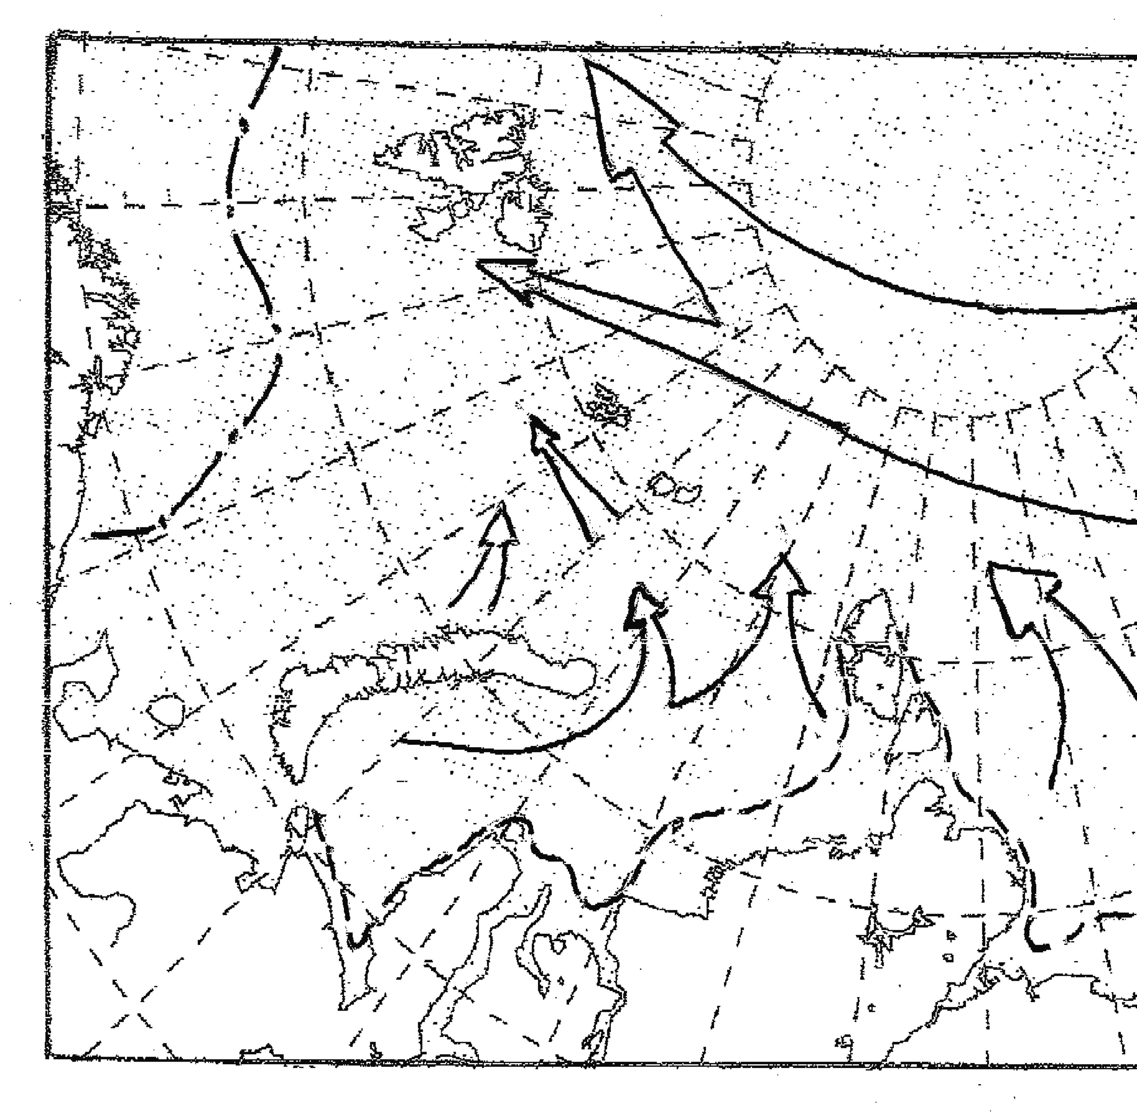
Fig. 2.3.4 – . Scheme of ice drift in winter period

Flaw polynyas. Formation and development of flaw polynyas depend on wind direction and its stability. Offshore wind is the cause of polynyas. Depending on their occurrence, polynyas are classified to as stationary, stable and episodic. Polynyas with a frequency of occurrence from 75% and more – are stationary, from 50% to 74% - stable, and less than 50% - episodic.
In the Barents Sea polynyas are formed near the southern and south-eastern coasts of Franz-Joseph Land, along the coast of Novaya Zemlya, near Kolguev and Vaigach Islands.
There are some characteristics of flaw polynyas of Franz-Joseph Land, obtained from ice reconnaissance data (Table 2.3.3.). According to table data, western and north-western polynyas of Franz-Joseph Land are stable. South-eastern polynya is episodic, if considering its frequency of occurrence.
Polynyas, formed along the entire southern coast of the Pechora Sea, are episodic. They exist from 1 to 22 days. On average duration of polynyas varies from 2 to 4 days in different parts of the coast.

Table 2.3.3 – Characteristics of polynyas of Franz-Joseph Land archipelago

Polynyas | Frequency of occurrence % | Average width, km
North-eastern | 60 | 24
South-eastern | 50 | 15
Western | 74 | 60

2.3.4. Ice cover melting and ice clearing in the sea
In May-June under effect of solar radiation and heat, transport by currents, processes of melting and destruction start. First features of melting are puddles, appearing on ice surface. According to data of polar stations ice melting starts in the south of the south-eastern Barents Sea and gradually propagates to the north. Average terms of melting beginning in Yugorsky Shar region, are in the end of third decade of May, and in straights of Franz-Joseph - on 20th of June. Process of ice disappearance finishes in September.
Melting intensity and ice disappearance. Intensity of melting in the Barents Sea regions significantly differs and increases from north to south because of its significant latitude extent. Thus, if to the end of June in Franz-Joseph Land area ice thickness decreases for 10 cm, ice thickness near the western coast of Novaya Zemlya – for 50 cm, and in Vaigach Island area - for 70 cm.
Under average melting conditions ice in open parts of the Barents Sea disappears faster, than in Seas of Siberian shelf, due to both thermal and dynamic current effect. Ice edge moves back to north and to coast of Novaya Zemlya. Western coast of Novaya Zemlya is free from ice in July; also ice disappears in the south-eastern sea part. In August ice edge reaches Svalbard and Franz-Joseph Land (Fig. 2.3.5.).
ice edge retreat to the north and to the east occurs mostly due to thinner ice melting. All young ice and partly thin first-year ice in the south of the north-eastern Barents Sea melts in May. In June thin ice zone almost disappears in all regions, and significant part of medium ice in south-eastern part and north-eastern sea parts is melted. In western sea part this ice still exist. South-eastern sea part and bigger part to the west from Novaya Zemlya are clear from ice in July. The rest of medium ice is located to the north from line Svalbard - Franz-Joseph Land in August. Melting process lasts till September and ends up among thick ice in straight between Svalbard - and Franz-Joseph Land.
Ice disappearance during period of melting occurs heterogeneously. Speed of ice edge retreat to the north in the central part (40°E) increases from April to July, and then slows down. Thus, in May it is equal to 60 miles a months, in June – 90 miles, in July – 110 miles, in August – 70 miles (Fig. 2.3.5).
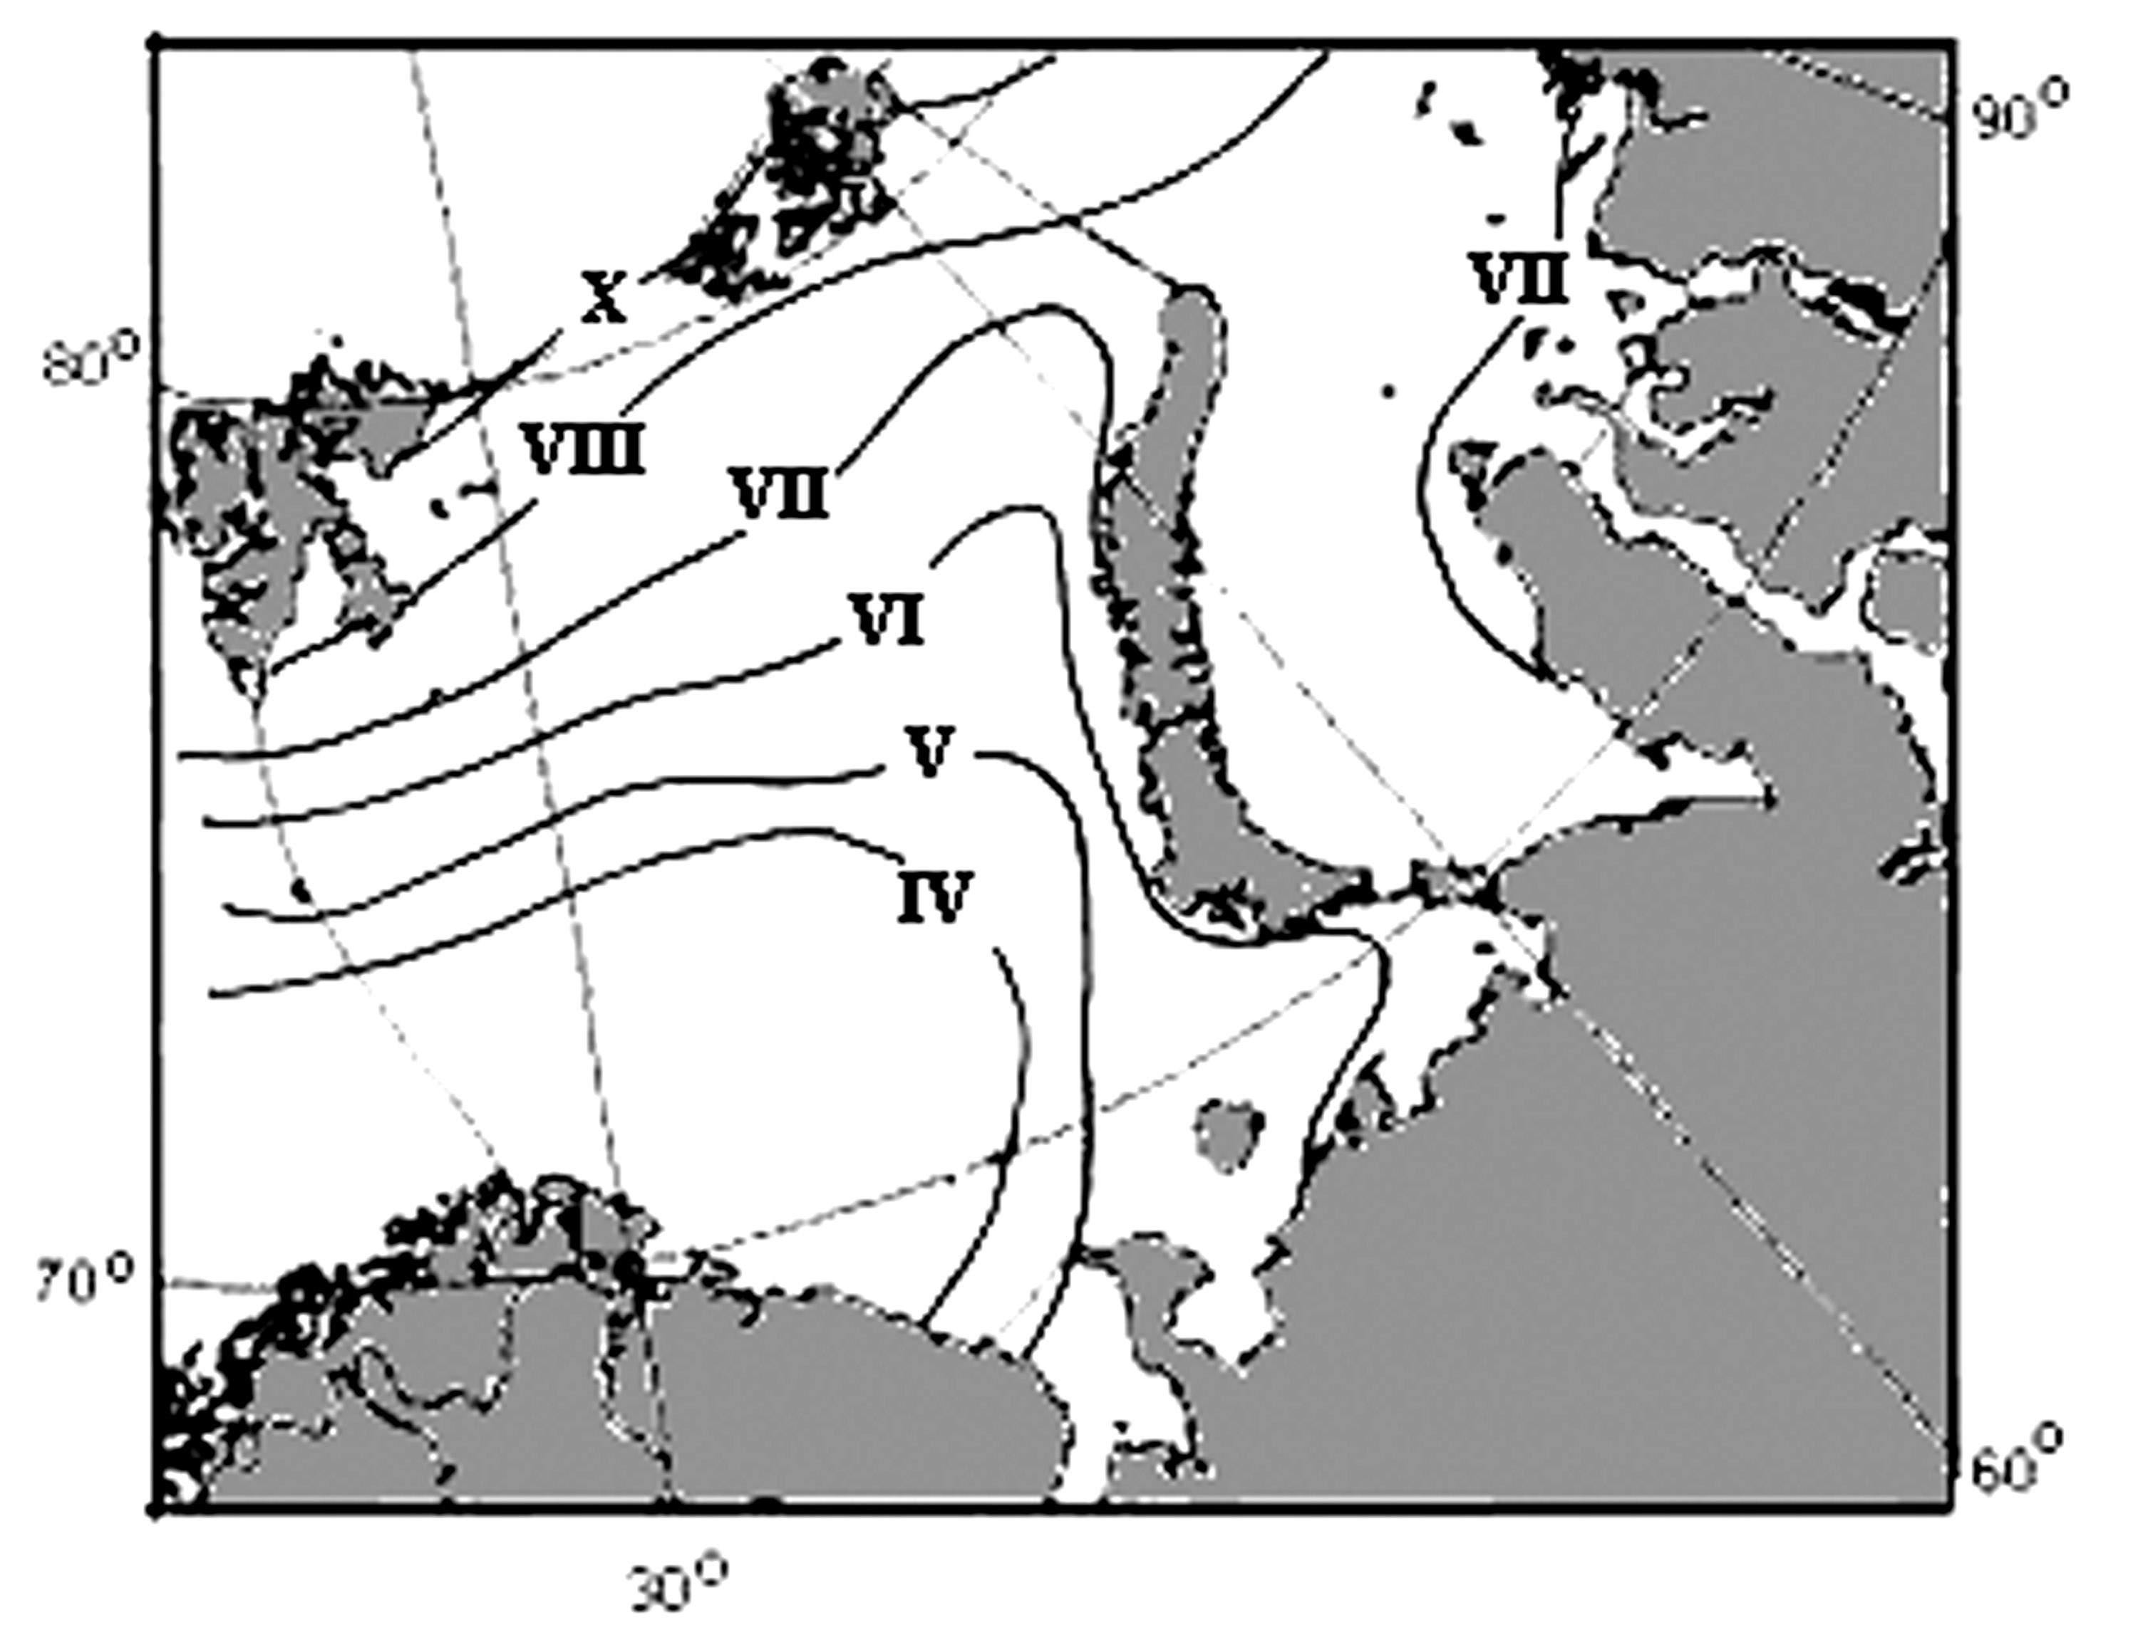
Fig. 2.3.5 – Location of drifting ice edge in summer period.

Sea ice cover in melting period. Changes of sea ice cover correspond with ice edge motion from month to month. In May (comparing to April) 7% of sea area clears from ice, and in June - 21%. Then velocity of clearing decreases, and in September amounts to 3% (Table 2.3.4). Similar pattern is observed in the western and north-western sea parts. Maximum clearing of the south-eastern part occurs in July, when 33% of the area is free from ice, and in August ice absolutely disappears. Ice, survived after melting, occupies 7-8% of the northern parts of western and north-eastern sea parts by the beginning of ice formation (Table 2.3.4).

Table 2.3.4 –Variability of the ice cover in the Barents Sea and its parts in the melting period, in, % of its water area
Part | Months
Part | IV | V | VI | VII | VIII | IX
Entire sea | 65 | 58 | 43 | 24 | 11 | 8
Western | 53 | 47 | 39 | 24 | 11 | 7
North-western | 86 | 79 | 62 | 36 | 20 | 15
South-western | 70 | 55 | 22 | 3 | 0 | 0

Ice drift in melting period. Process of the Barents Sea clearing from ice occurs under the influence of both thermal and dynamic processes as a result of ice drift. In May-August northern winds prevail in the Sea. These winds force ice drift to the south to warmed water, where they melt faster (Fig. 2.3.6).
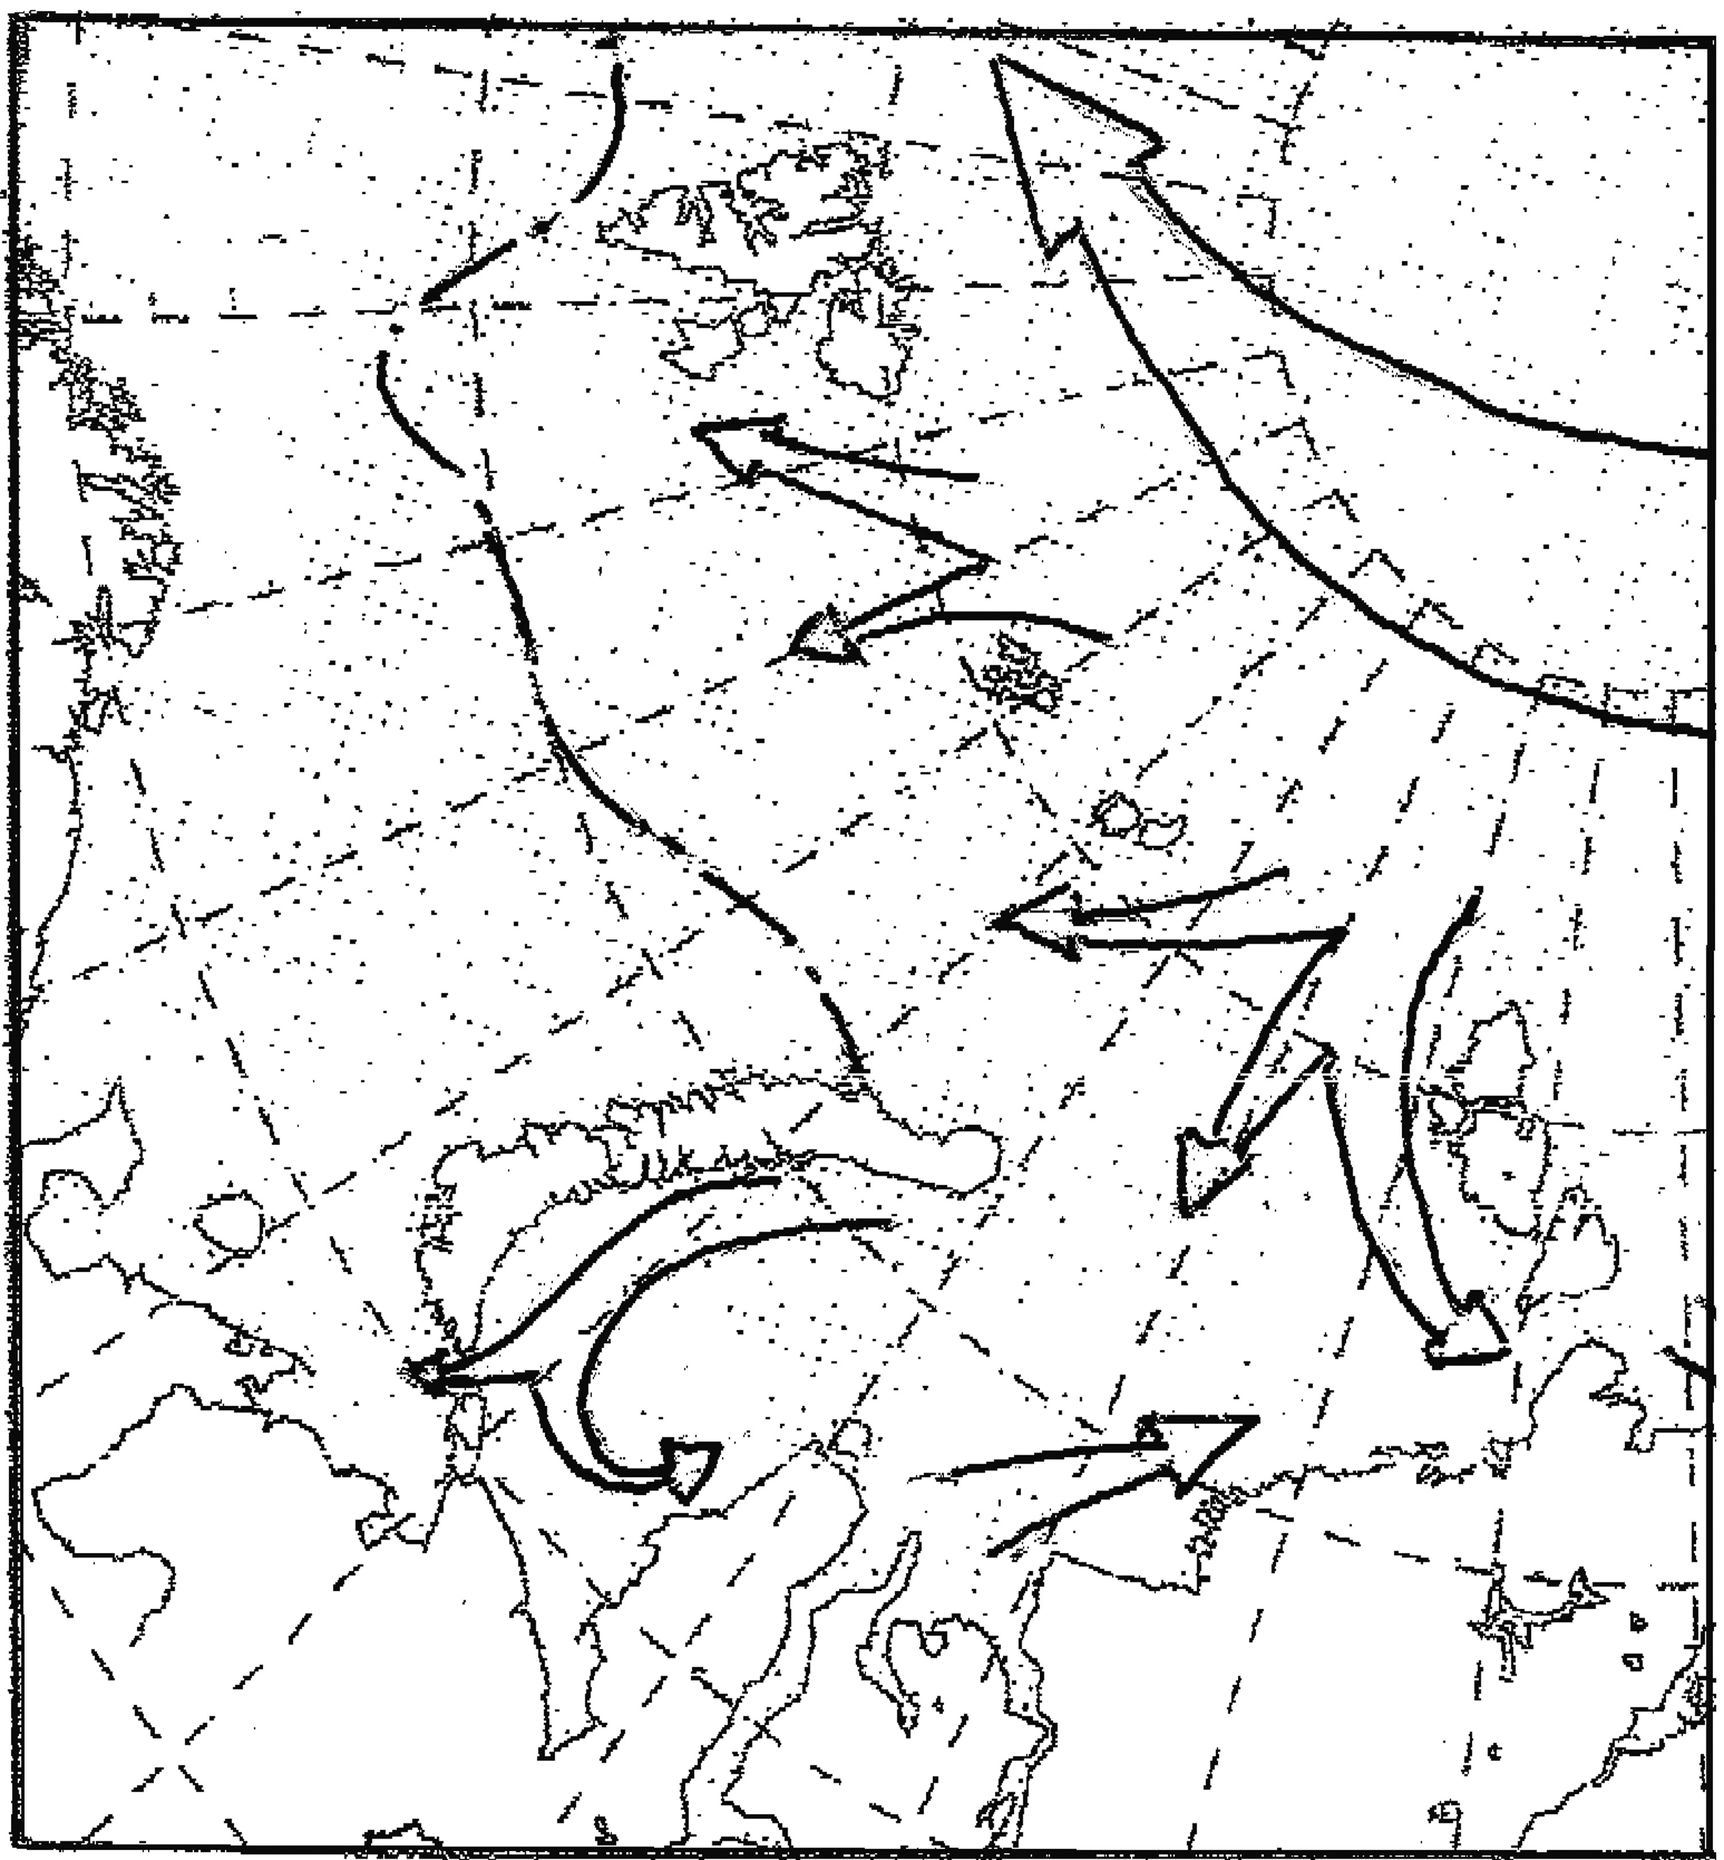
Fig. 2.3.6 – Scheme of ice drift in summer period

Icebergs. Icebergs observed in the Barents Sea calve from glaciers of Franz-Joseph Land, Svalbard and Novaya Zemlya in spring-summer period. Their largest amount can be observed in waters near Svalbard. The estimated volume of icebergs, produced by Svalbard glaciers, amounts to 5 km³ a year, by Novaya Zemlya glaciers – 2 km³ and Franz-Joseph Land glaciers – 1,5 km³. Size of these icebergs is not large, (average length, width and height of their above water part are, respectively, 64, 46 and 11 meters), that is why they mostly destructed in fjords, where they were formed, the rest part drift to central sea part under wind and currents effect. Separate icebergs and bergy bits were observed in the southern sea part in some years.
Analysis of interannual changes of ice cover of the Barents Sea was made on the basis of annual mean data. It is necessary to mention, that ice conditions in the Barents Sea are characterized by significant interannual variability, and ice area can change in limits 50-90% of its water area.

