3.1. Remote sensing observations of ice cover state

Remote sensing – is a process of observations, measurements and recording of energetic and polarization characteristics of self and/or reflected radiation of land, ocean and the Earth atmosphere elements in different spectral bands of electromagnetic waves.
Remote sensing of sea ice is also implemented taking into account physical processes of radiation, reflection and absorption of electromagnetic waves in visible, infrared and microwave wavelength bands. Every band has its own possibilities and limitations for determining sea ice parameters using different regimes of operation, connected with type of radiation – self- or reflected, under controlled conditions of electromagnetic radiation of sea ice.
The final product of remote sensing is quantitative or qualitative description of environment conditions. That is why it is necessary to consider natural component – atmosphere and underlying surface in composition of remote sensing system.
In general remote sensing is considered as a system of natural-technical components and their interactions. It is based on multistage process of information changes and transformation, described by regularity of interacted subsystems.
From the point of view of its composition, special feature of remote sensing system is spatial-temporal division of components (Fig. 3.1.1):
- natural processes in “atmosphere – underlying surface” system;
- sensitive element of remote sensor, located on spacecraft;
- reception and processing facilities and users, located all over the World.
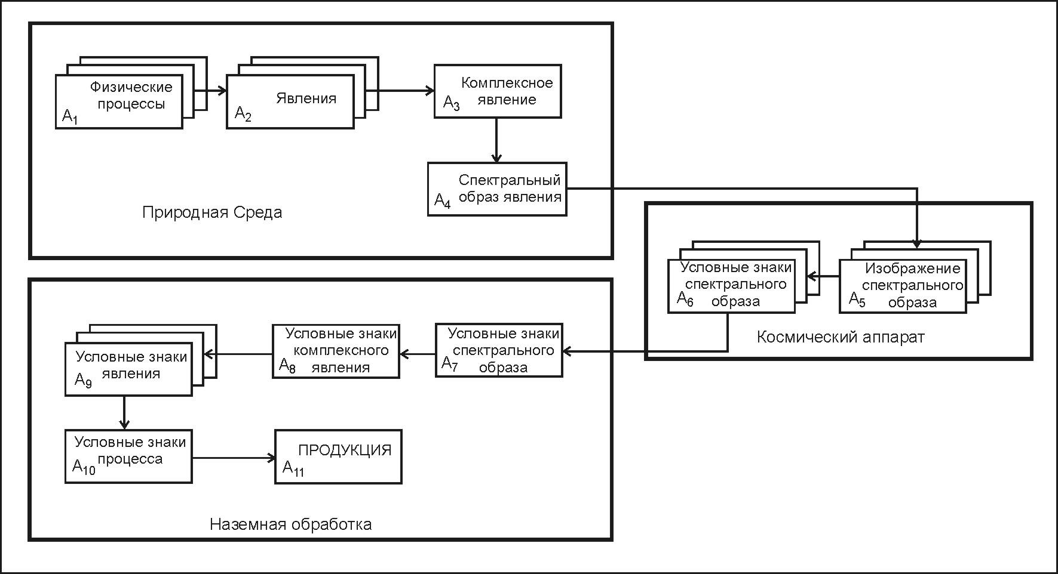
Fig. 3.1.1. Elements of remote sensing system.

Study and description of physical processes in the “atmosphere – underlying surface” system (A1), is an objective of remote sensing. Such processes in sea ice of the freezing seas are:
- process of ice cover formation, determining its type – first-year or multiyear,
- ice drift under influence of atmosphere motion, currents and sea bottom relief,
- ice deformation (breakup, rafting and ridging),
- process of sea ice destruction (melting).
The listed processes proceed according to physical laws, which present objectively existing stable connection between phenomena and properties of material world (objectively existing form of nature expression). Only some processes are observed by remote sensing from all their diversity (A1). Such selectivity is connected with the point, that every natural process influences formation of radiation (or influence some changes) of particular spectrum of electromagnetic radiation. Remote sensors also have selective sensitivity.
Physical processes themselves are not directly observed by remote sensing, they can be discovered only from phenomena observed in the “atmosphere – underlying surface” system, objectively existing characteristics of material world objects. They are indicators of processes (A2), which reflect properties of “atmosphere – underlying surface” system.
Complex phenomena are normally observed by remote sensing. That is why many of spatial-distributed phenomena compose observed complex phenomena (A3).
Complex phenomena in its term produce integrated radiation, which is recorded as a spectral pattern (A4). The listed fact is used in remote sensing in different spectral bands.
Processes and produced by them phenomena in the “atmosphere – underlying surface” system can be observed either by their self- radiation or by changes, that they insert in electromagnetic radiation artificially made under controlled conditions or underlying surface radiation. These changes are determined by heterogeneities (of different nature) of spatial distribution of objects, processes or phenomena. Spatial heterogeneities in their turn can be divided into two main categories:
- heterogeneities, that change radiation by their total volume
- heterogeneities, that change radiation on the interface.
Heterogeneities of the first type include many components (gas molecules, products of condensation, etc.). Size of such particles changes from a hundredth of micron to millimeters, and heterogeneities have large enough range of distribution.
Heterogeneities of the second type are characterized by surfaces with fractal geometrical structure.

Sea ice can be considered as a complex polycrystalline composite, consisting of pure ice with brine and air pockets. It is normally covered with snow. Its backscatter depends on many physical parameters, such as surface roughness, salinity, air inclusions, crystal structure, snow cover and others. This system forms two major mechanisms of scattering:
– surface scattering (scattering from the layer very near the ice or snow surface);
– volume scattering (scattering from the entire ice thickness).
Reflected radar signal significantly depends on surface roughness of different scales. An area consisting of many pieces of broken ice generally gives a higher backscatter than the same ice type with a level surface. Multiple reflections from two or more surfaces nearly perpendicular to each other can give the co-called corner reflection effect, which may enhance the return signal by up to an order of magnitude.
There are also regional differences of the sea ice backscatter values, depending on its location relative to the main ice pack.
Radar image brightness, which is determined by the sea ice and water backscatter, is the principal direct interpretation feature. Based on differences in backscatter, the major ice types can be detected.
Sea ice recently formed on the water surface includes frazil ice, grease ice, slush and shuga. Grease ice inhibits the formation of capillary waves and can be detected by its dark signature, often among bright areas of pancake ice or wind-roughened water surface.
Sensitive element of remote sensor, perceiving incoming radiation (which composition was defined by spectral pattern of phenomena), forms on its output a signal of this pattern (A5). On the output of remote sensor this signal undergoes informational transformation (coding) and is transmitted via radio channel as a multitude of conventional signs of the spectral pattern (A6). Selected system of codes (symbols) describes state of remote sensor signal, expressed in units of radiation field
Received radiosignal contains information about spectral pattern (A7), but distorted by noise of radiochannel. Chosen values of spectral pattern allow estimating values of complex phenomena parameters (conventional signs of phenomena – A8), by which, in its turn, several phenomena parameters can be estimated as well (conventional signs of phenomena A9). Estimation of physical processes, existing in the “atmosphere-underlying surface” system (A10), is made under known connections “process – phenomena”, description of which forms a product of remote sensing (A11).
Informational model of remote sensing system is presented in Fig. 3.1.2.
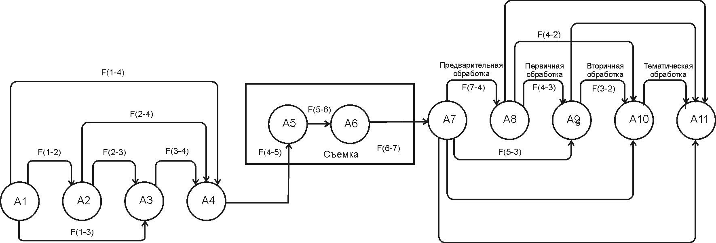
Fig. 3.1.2. Information model of remote sensing
First part of scheme (elements A1 - A4) describes transformations of information about existing processes.
Actions on the stage F (1-2) consist of studying representation mechanisms of manifestation of different processes, occurring in the “atmosphere – underlying surface” system in physical phenomena.
For example, process of vertical displacement of air mass in cyclone leads to water vapour condensation and cloudiness formation. Phenomenon of cloud formation will be an indicator of water condensation process in upwelling air flow. Process of above water surface temperature decreasing to negative values will be accompanied by ice formation phenomenon.
F (1-2) is a process of phenomena determination, as indicators of processes. Process indicator is formation of new objects in the “atmosphere – underlying surface” system and also changes of their state or characteristics.
Actions F (2-3) are directed on studying formation of complex phenomenon, because natural phenomenon is normally observed in complex. Thus, process of cloud formation is accompanied by appearance of new objects (clouds) and changes of water drops size.
Actions F (3-4) consist of studying formation of phenomena and objects spectral pattern, being observed in the “atmosphere – underlying surface” system.
Actions F (4-5), F (5-6), F (6-7) consist of studying transformations in a chain of instrumental changes of radiation, incoming to sensitive element of remote sensor. These changes include both spatial (scanning or survey law) and informational changes (transformation of continuous electric signal to digital coded signal).
Second part of scheme (elements A7- A11) shows actions, produced during ground-based processing and production preparing.
Remote sensing products (А11) are the following:
- results of thematic processing, which describe processes existing in the “atmosphere – underlying surface” system. It is necessary to perform the entire cycle of received information processing (А7) – preprocessing, primary and secondary processing - to obtain these results;
- results of secondary processing, which describe estimates or quantitative characteristics of phenomena, occurring at the moment of observation (conventional signs of phenomena)from the reconstructed values of complex phenomenon (conventional signs of complex phenomenon);
- results of primary processing, describing observed complex phenomenon from the reconstructed values of the spectral pattern (from image of spectral pattern).
- results of preprocessing, accounting for the influence of technical facility (communication channel, structural features of remote sensor, orbit parameters and etc.). Essentially, such phenomena are estimations of integrated radiation, incoming to the sensor from the every footprint (pixel). Preprocessing content F (7-4) consists from accounting regularities of information transformation in chains F (4-5), F (5-6), F (6-7);
- information, i.e. direct recording of signal, received at receiving station.
Identified peculiar features of functioning subsystem of data transformation on spatial distribution of phenomena in the “atmosphere – underlying surface” system shows that processes of spectral image formation and its conventional signs are really significant. First of them is connected with influence of sensitive radiation element on output signal. The second one is connected with peculiar features of signal formation on output of remote sensor.
Methods of observations and processing are used to provide remote sensing of environment.
Observational methods agree with a structure of ballistic group of space system, orbit parameters of spacecraft orbit and set of remote sensors. Ballistic group determines the Earth surface coverage and frequency of receiving and renewing of information.
Selection of satellite orbit is important for Earth survey. Circular orbits are preferable for studying and monitoring of the environment. Due to this, similar scale of images is reached along the entire orbit. Orbit inclination, i.e. angle value, formed by equatorial plane and orbit plane, is significant. Depending on inclination orbits can be equatorial (inclination 0°), polar (inclination 90°) and inclined. On to polar (or quasipolar) orbits satellite sensors can view the entire Earth surface. The near polar regions are not observed by the satellite sensors, when orbit inclination is less than 50-60°.
The inclination of satellite orbit is an important parameter, because it determines the range of surveyed latitudes. The satellite orbit can’t come out of this latitude range. Thus, swathwidth depends on inclination and height of orbit. There is the direct dependence: the bigger is inclination angle and height of orbit, the wider is swathwidth on the Earth surface. Besides circular orbits, used by meteorological satellites, manned space ships and orbital stations, the elliptical orbits with large height difference in apogee and perigee, are used for permanent observations of global processes on the Earth. Relative to the Sun or the Earth two types of orbits are separated - geosynchronous and geliosynchronous.
Geliosynchronous orbits are used for survey of Polar Regions, providing repetitive surveys of the same Earth surface areas under similar conditions of light in equal time intervals. Satellite orbits can be divided into three groups by height:
- low-orbit (200 - 400 km) are used in flights of manned space ships and orbital stations,
- medium-orbit (500 -1500 km) – meteorological and resource satellites;
- high-orbit (30000 - 90 000 km) – telecommunication satellites and research stations, intended to space study.
Satellites, located on low- and medium-orbits, are used for Polar Regions monitoring.
The method of signal processing at the receiving station will have to provide receiving of coded signal in user format. Processing in this case consists of signal value presentation in output of remote sensor in form suitable for user. This stage of processing is called preprocessing.
When product is information about distribution of radiation intensity, incoming to the remote sensor input (spectral pattern), then processing consists of accounting transformations, implemented in the onboard complex (e.g., scanning laws), radio signal transmission channel, i.e. on the stage of transformation of “sensor - coded signal in the receiving station output” information. The Listed procedures compose preprocessing stage. This procedure F (4-3) can be made, if transformation regularities are known F (3-4);
In case, when results of planned works consist of presentation of information about estimation or quantitative characteristics at the moment of phenomena observation, methods of processing, based only on transformation regularities on stages of preprocessing and primary processing, can be used. Such stage is called stage of secondary processing. It results in distribution of the spectral pattern of phenomenon. Secondary processing can be made only after finishing stages of preprocessing and primary processing.
Typical task of this stage is determining ice thickness from the infrared images.
The possibility to derive ice thickness from infrared images is mainly determined by the differences in temperature and emissivity of water and ice surfaces in thermal infrared band. The spectral channel of 10,5–12,5 micrometer is the most preferable for sea ice characteristics retrieval. In this channel one can neglect absorption in the atmosphere and assume that the sensor measures radiation emitted by the water, ice and clouds. The radiation power, recorded by the radiometer depends both on the temperature and emissivity of the specific surface.
Infrared emission from sea ice originates in the thin surface layer of ice or snow. Ice, snow and sea water have approximately equal emissivity (0,96–0,99), and therefore surface temperature determines the radiation power of these surfaces.
Determination of sea ice characteristics from infrared images is performed in the process of interpretation, using direct, indirect and logical indicators, the same as for visible images. During winter the thermodynamic temperature of the surface of compact sea ice in the Arctic depends on its thickness. This dependence is confirmed by numerous experimental measurements and calculations using thermodynamic models. However, attempts to find practically acceptable solution to the problem of determining sea ice thickness from satellite IR images were unsuccessful for a long tome. Mapping of sea ice thickness is possible only for cloud-free atmosphere in cold period.
If product of remote sensing is description of the processes in the “atmosphere – underlying surface” system, then methods of thematic processing include presentation of the processes on base of implementing the entire previous processing cycle (preprocessing, primary and secondary processing).
In general, fundamentals of practical use of remote sensing for study and monitoring of the environment, including the sea ice, are shown.

