3.2. Airborne observations. General information
3.2.1. Introduction
Nowadays there are two sources of information about ice distribution in the Arctic Ocean and in the Arctic and freezing seas – satellite information and visual airborne observations from airplanes and helicopters.
During last 15 years satellite information came on the first place by volume and possibilities of ice observations on large water areas, as a result of technical progress and development of instruments and equipment. From satellite images with resolution varying from 15 m to 5 km it is possible to derive information about ice distribution during 2-3 days and to accomplish tasks, which earlier could be solved only by means of visual or instrumental ice reconnaissance. At that, it is impossible or really complicated to determine some ice characteristics from satellite images. In winter, the following characteristics can be derived:
- boundaries between thin and medium first-year ice, and medium and thick ice;
- boundaries between old and grey ice;
- boundaries between old and first-year ice in summer.
From the other hand, visual and instrumental ice observations from airplanes and helicopters, covering smaller area, allow to specify satellite ice information. At the present airplanes and helicopters are equipped with the GPS satellite navigation system, which significantly improves accuracy of mapping and significantly changed tactics of ice observations.

3.2.2. Observations of sea ice from aircraft and helicopter
At present a great experience of producing ice observations from airplanes and helicopters is accumulated in Russia. It was presented in “Manual of producing airborne ice reconnaissance”. Aircraft ice reconnaissance is a special flight to produce visual or instrumental ice observations in water bodies (sea, river, lake, reservoir and etc.).
Airborne ice reconnaissance is divided into two types according to types of used aircrafts: airplane and helicopter.
Aircraft ice reconnaissance has significant advantages comparing to other systems of information collection, because it allows:
- To observe ice cover state shortly and estimate distribution of all principal characteristics on large area in the freezing seas, lakes, reservoirs, rivers and their estuaries;
- To produce both episodic and regular visual, aerial photo, ice thermal and radar surveys of ice cover, using suitable equipment and devices.
- To carry out all types of ice reconnaissance of pre-defined regions in needed time;
- To support ship steering through ice in operative mode;
- To choose optimal flight altitude for observations;
- To process observation data directly onboard of airplane and to transmit information to users operatively via different communication facilities.
Ice reconnaissance from helicopters is the component of a system of ice information collection. It helps to solve tactical tasks of navigation in ice, operation of hydrotechnical structures, supporting fishing and other trades, selection of ice floes for “North Pole” drifting stations.
The peculiar features of helicopter ice reconnaissance are the following:
- Relatively small flight range and small area of ice observation;
- A possibility to base helicopter on coastal sites, icebreakers, research vessels and platforms;
- Large variations of flight speed and altitude;
- A possibility of detailed ice cover mapping and better accuracy of estimating ice parameters;
Helicopter ice reconnaissance in combination with icebreaker or research vessel operation in the ice is a quite effective tool to study spatial structure of ice cover, interaction of ice floes, processes of ice compacting, ridging and melting. Last years selection of drifting ice floes and organizations of drifting stations in the high-latitude Arctic were carried out using helicopters.

3.2.3. Flight time.
Flight time of aircraft during ice reconnaissance is calculated from the moment of airplane’s take-off to the moment of its landing. Ice observer (expert) composes flight route and calculates flight time. Before the flight its route is passed to navigator, if observations are made from the airplane, and in case of helicopter observations - to helicopter commander, who records it in the onboard GPS. During preparing to flight for AN-26, АN-30 airplanes flight duration is 8 hours with speed 250-300 km/h, and АN-30-D airplane – 10 hours.
While making a route for airplane or helicopter, it is necessary to calculate flight time to approach region of planned observations. It is the time interval, when airplane flies without making observations. Airspeed of helicopter of MI-8 type is 160 km/h.
Flight duration is 2,5 hours without additional fuel tanks, 3,5 hours in case of one additional fuel tank, and 4,5 hours in case of two fuel tanks. During special helicopter ice reconnaissance flights the airspeed should be 100 km/h, allowing detailed mapping of ice cover characteristics.

Airborne ice reconnaissance is classified by purpose and technical tools of observations. Reconnaissance is divided into three types by its purpose: research (survey), science-industrial (operative) and special (Fig. 3.2.1), and by technical means into visual and instrumental. Last-named are carried out using side-looking airborne radar, radar ice thickness measurement device and thermal imager.
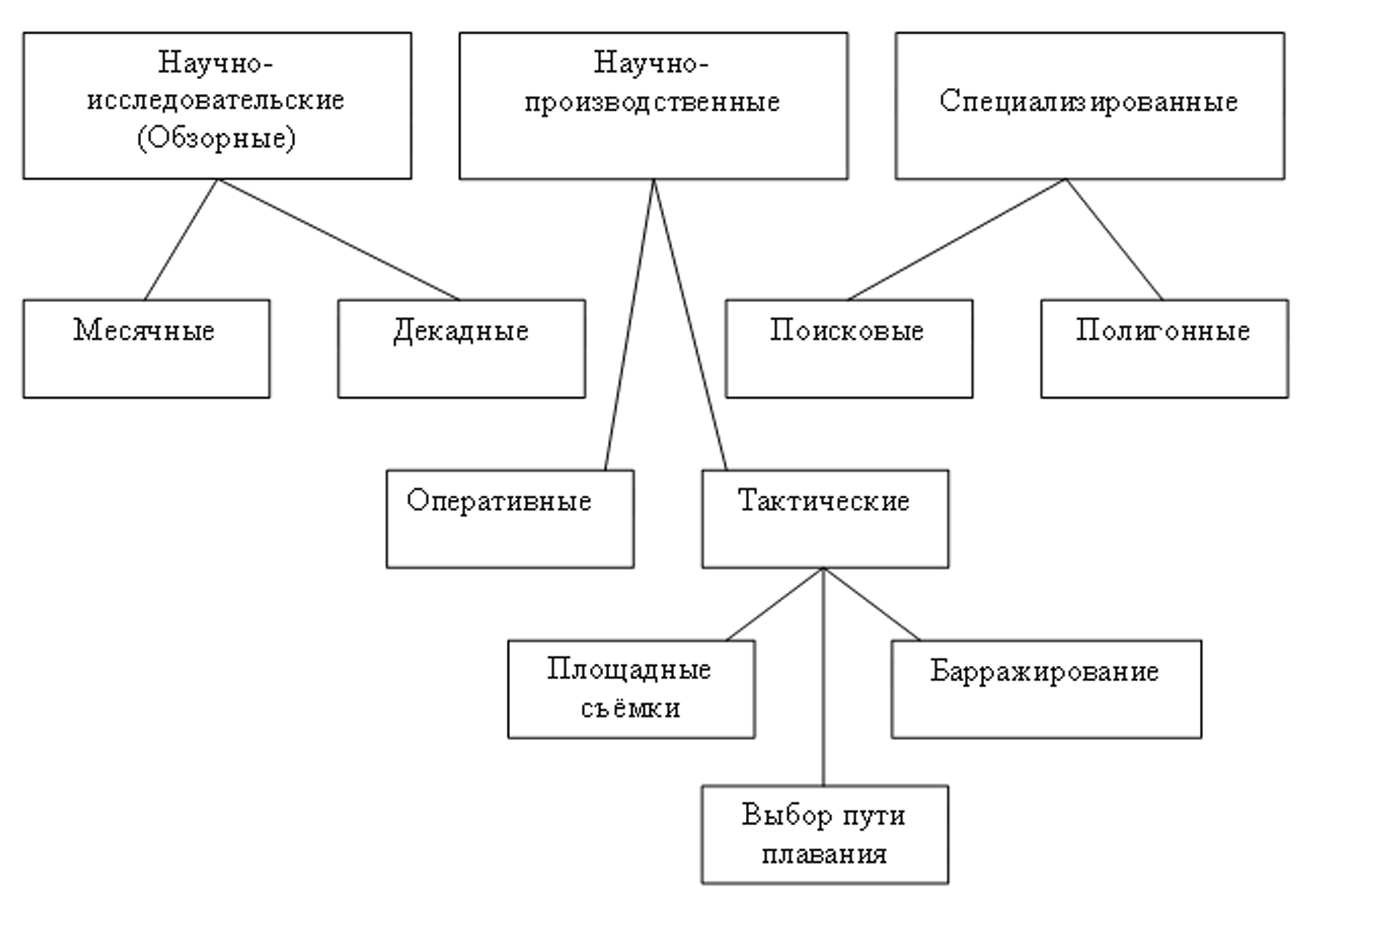
Fig.3.2.1. Classification of ice reconnaissance types

3.2.4. Classification of ice reconnaissance
3.2.4.1. Research reconnaissance
Research ice reconnaissance (survey) is carried out according to programs of scientific and science-industrial Roshydromet departments. Its purpose is studying spatial-temporal changes of ice cover and development of long-term and short-term ice forecasts. As a result of flights, periodically made along standard routes (Fig. 3.2.2 and 3.2.3), in the period 1950-1996 observational ice charts were composed, which allow to estimate general sea ice conditions in seas, lakes, reservoirs and rivers of Russia and to study its changes. Results of this reconnaissance flights were reported to national economic organizations for solving operative tasks of ship navigation, fishery and other practical needs.
Frequency of survey ice reconnaissance depends on intensity of ice cover temporal changes and is determined by organization, which plans reconnaissance, carry out researches and prepare forecasts. Survey ice reconnaissance is normally divided into monthly and ten-day. Survey ice reconnaissance are carried out more frequently on rivers, lakes, reservoirs and some sea areas in the period of ice floating and freezing-over.
Monthly survey ice reconnaissance in the Arctic Seas was carried out in December-May, August, when sea is mostly covered with ice.
Apart from collecting information about concentration, distribution, ridging, ice type and forms program of ice reconnaissance also includes observation of fractures (channels, leads and polynyas) to find out stage of its mechanical disintegration, and also snow cover, pollution, ice thickness and other parameters. Programs of survey ice reconnaissance often included conducting special experiments, testing new observational methods, devices and etc. Some flights in the Arctic included radar (December, May) and ice thickness measuring survey. Results of these surveys were used either for solving research tasks or for direct support of navigation.
Survey ten-day ice reconnaissance in the freezing non-Arctic seas were carried out in winter, and in the Arctic Seas – in summer.
In spring and autumn survey ice reconnaissance in rivers and their estuaries, reservoirs and lakes is reasonable to conduct in short time intervals (3 and 5 days), because ice processes develop very fast.
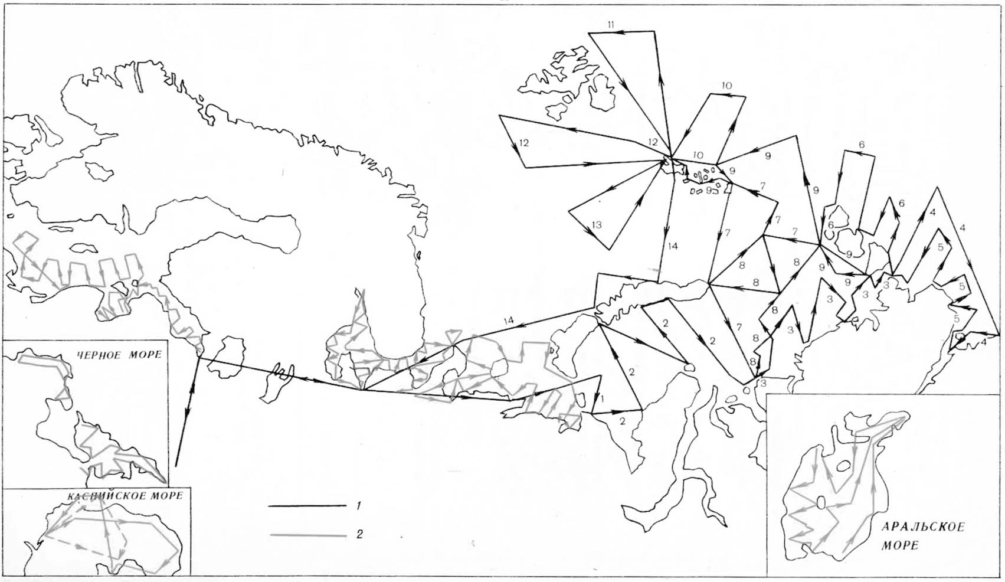
Fig.3.2.2. Standard scheme of monthly survey ice reconnaissance routes. Standard scheme of ice reconnaissance routes. 1— routes in third ten-day period of March; 2 — routes in January, February and March.

Fig.3.2.3. Routes of monthly survey ice reconnaissance in the Kara and Barents Seas in winter.

3.2.4.2. Science- industrial ice reconnaissance
Ice reconnaissance of this type is operational and it is the most important type of ice information collection in seas, rivers and reservoirs for direct support of navigation, fishery and other economical purposes. Ice reconnaissance is conducted according to agreements and programs of production organizations in areas, where and when it is necessary. Science-industrial ice reconnaissance is divided into operative and tactical by its purpose.
Operative airborne ice reconnaissance is conducted to determine location of ice massifs and ice edge, its concentration, type and other characteristics describing navigation conditions.
In the Arctic Seas and river estuaries operative ice reconnaissance were conducted in periods of preparation and implementation of marine operations (Fig. 3.2.4).
Tactical airborne ice reconnaissance is carried out in the parts of the route with heavy ice conditions to choose the optimal course of ship sailing (Fig. 3.2.5). As a rule, this reconnaissance is performed episodically, when there is a practical need. A task for ice reconnaissance and its planned route are elaborated before the flight and can be specified in its implementation.
Tactical ice reconnaissance is divided into the following types: areal survey (Fig. 3.2.4), selection of sailing route (Fig. 3.2.5) and barraging.

3.2.4.3. Areal survey.
This type of reconnaissance is performed for detailed observation of the route section, where ship steering or expedition works take place. Flight route in this case is several “U-shaped” traverses with a distance of 10-20 miles between them (Fig. 3.2.4).
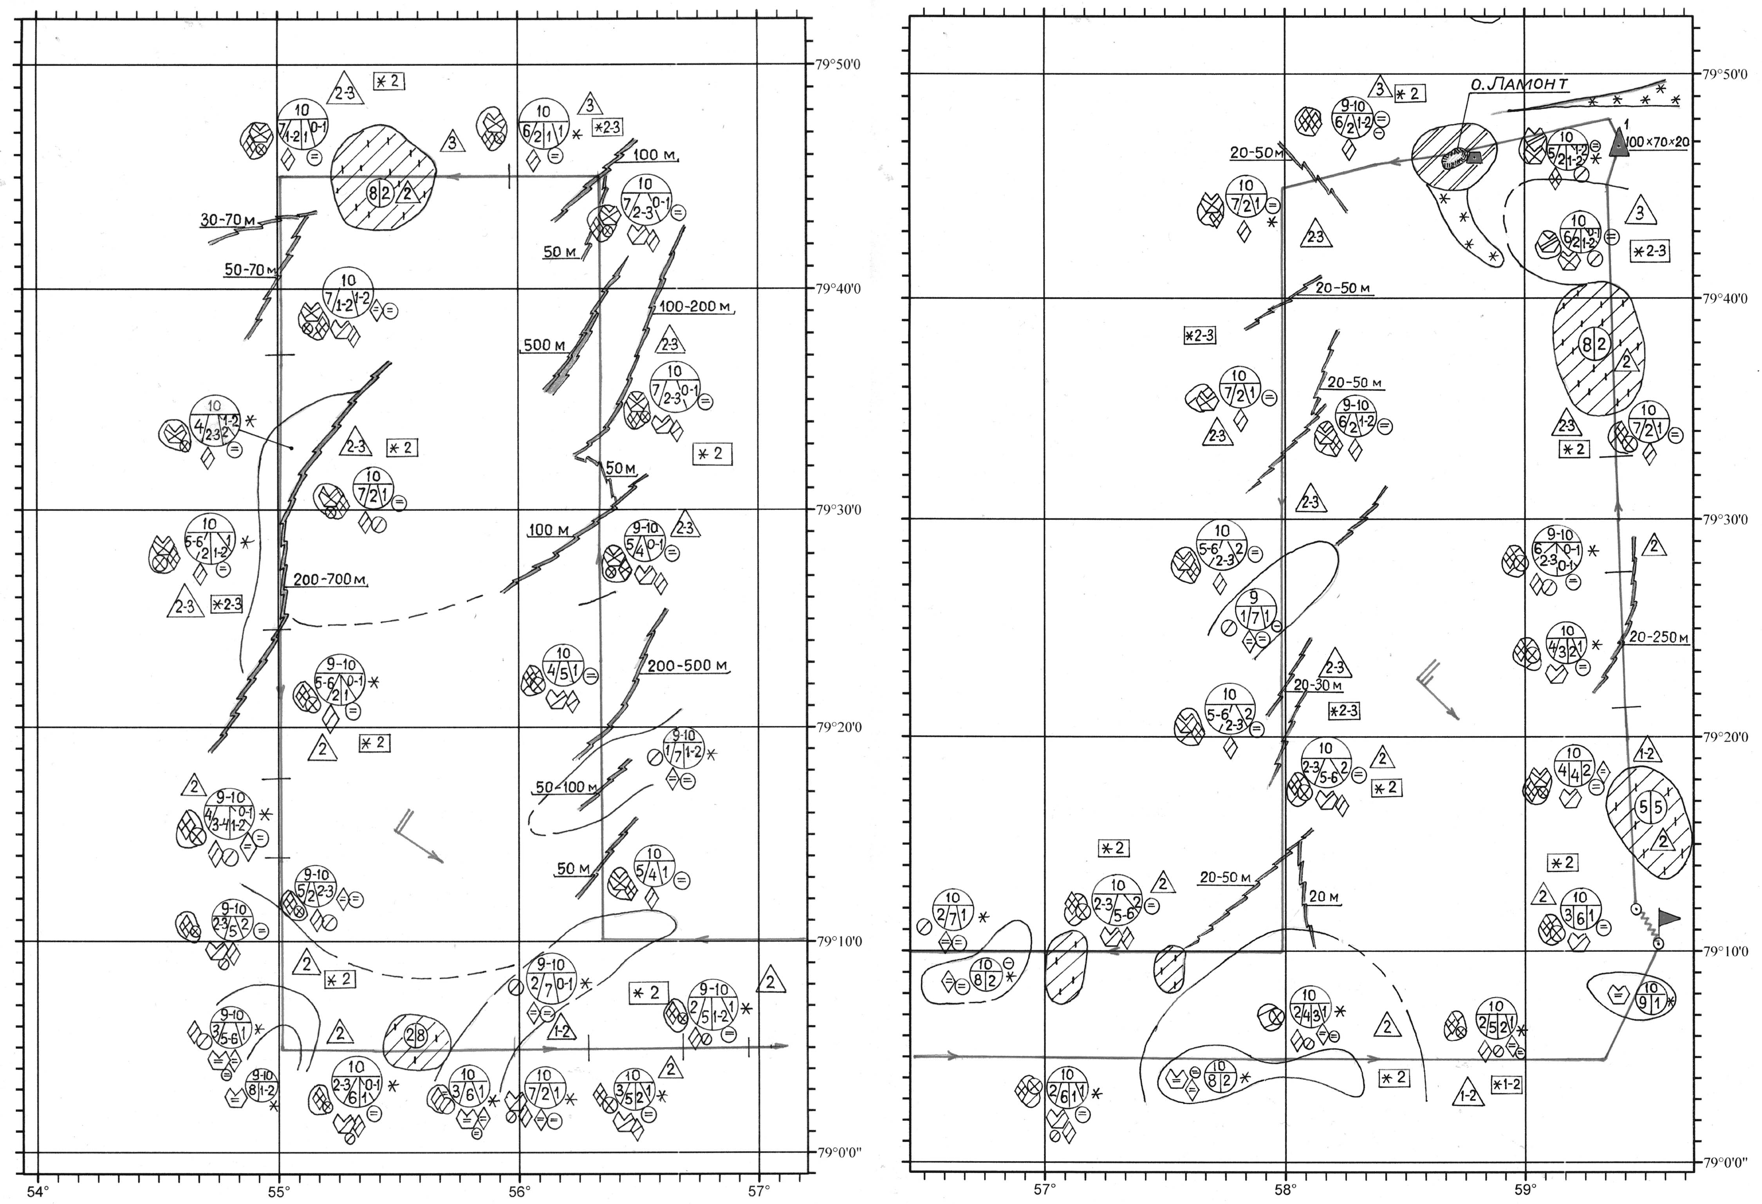
Fig.3.2.4. Area ice reconnaissance in the Barents Sea for 16th of April, 2007

The goals of ice reconnaissance, conducted on 16th of April, 2007 during the expedition onboard diesel icebreaker «M. Somov» in the Barents Sea (Fig. 4) consisted of the following: determination of the southern boundary of prevailing medium first-year ice (with partial concentration of 5-7/10-th), identification of large ice breccia floes of medium and thin first-year ice (for performing expedition work), detection of leads and fractures for sailing to the north-east, and also icebergs and bergy bits.

3.2.4.4. Selection of sailing route.

This type of ice reconnaissance using helicopters is the most essential for icebreakers and research vessels sailing in the Arctic and Antarctic. During planning of ice reconnaissance ship captain determines general route and, consequently, direction of ice reconnaissance. In case of availability of a satellite receiving station onboard vessel (icebreaker) and in cloud-free conditions leads and fractures can be identified from images and used for sailing. In this case route of helicopter flight is planned beforehand, and ice reconnaissance task is only to specify their location using helicopter GPS and to determine; limiting route parts, such as joints of large floes, and their bypassing ways. Ice expert onboard helicopter directly maps leads and fractures and operatively reports their turning points to icebreaker or ship by radio. The variant, when satellite information is absent and direction of channels and fractures don’t match with general sailing route is the most complicated. In this case it is impossible to plan flight route beforehand. After taking off ice expert chooses zig zag route above 10-100 m wide leads, which can deviate from general route on 20-90º and possibly transit into zones of broken ice between large floes. Thus, the main purpose is to select a sailing route to bypass large ice floes. It is necessary, because ship (icebreaker) speed decreases to 1-3 knots when she crosses ice floes, whereas in channels and fractures it equal to 6-8 knots, and in broken ice between floes – to 4-6 knots. A that it is necessary to account wind direction and the selected route must always be from leeward side of floes to avoid ship “wedge” in to joints of floes after leaving lead fracture, or broken ice zone. Ice reconnaissance, presented on Fig.3.2.5, shows the flight for selection of recommended sailing route with general course of 40º in channel, covered by nilas and grey ice.
3.2.4.5. Barraging
This ice reconnaissance is performed in very complicated conditions, when direct ship steering needs uninterrupted sea ice observations and giving recommendations to ship by radio-telephone or showing the optimal sailing route through ice isthmus by airplane (helicopter) evolutions. In case when airplane (helicopter) is within the field of view of ship navigator –barraging is performed by escorting method. When airplane (helicopter) controls ship motion on longer route and is not always in the field of view of ship navigator - barraging is performed by guidance method.

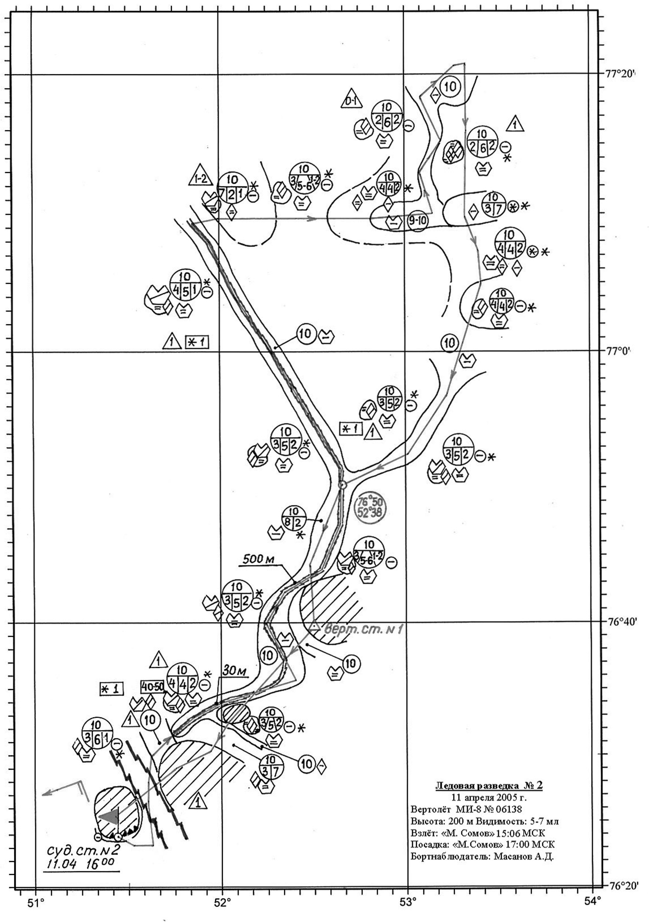
Fig.3.2.5. Tactical ice reconnaissance for selection sailing route for 11th of April, 2005 in the Barents Sea

3.2.5. Special ice reconnaissance

Special airborne ice reconnaissance is performed to solve search and experimental-research tasks, and also for support of other economical needs (road routing on ice, observations of ice condition in zone of hydro meteorological constructions and etc.).
Special ice reconnaissance is performed episodically by one-time demand, which depends on given purposes, and observes small ice areas. At that, high accuracy of observations and maximum detailing of some ice cover parameters, listed in the task, are necessary. Two types of special ice reconnaissance are identified at present: searching and polygon surveys (Fig. 3.2.6 and 3.2.7).

3.2.5.1. Searching ice reconnaissance

Searching ice reconnaissance is organized by either research institutes or national economical organizations for detection of:
- ice floes suitable for organization of runways and “North Pole” (NP) drifting stations;
- ice floes suitable for landing of airplanes for conducting scientific (oceanographic, ice research, geophysical and other) studies, and also for deployment of hydrometeorological automatic stations and other objects on drifting ice;
- ice floes with people and equipment, drifting to the open sea;
- places of winter ship anchorage;
- ice islands;
- routes for constructing winter ice roads.
In 2003 during conducting expedition work onboard diesel icebreaker «M. Somov» it was necessary to perform searching ice reconnaissance to select floes of thick first-year and second-year ice brecchia for further morphometric and ice research measurements. These floes were preliminary selected from satellite «NOAA-15» image (Fig. 3.2.6), and then searching ice reconnaissance was performed with landings and control drillings to determine ice thickness (Fig. 3.2.7).
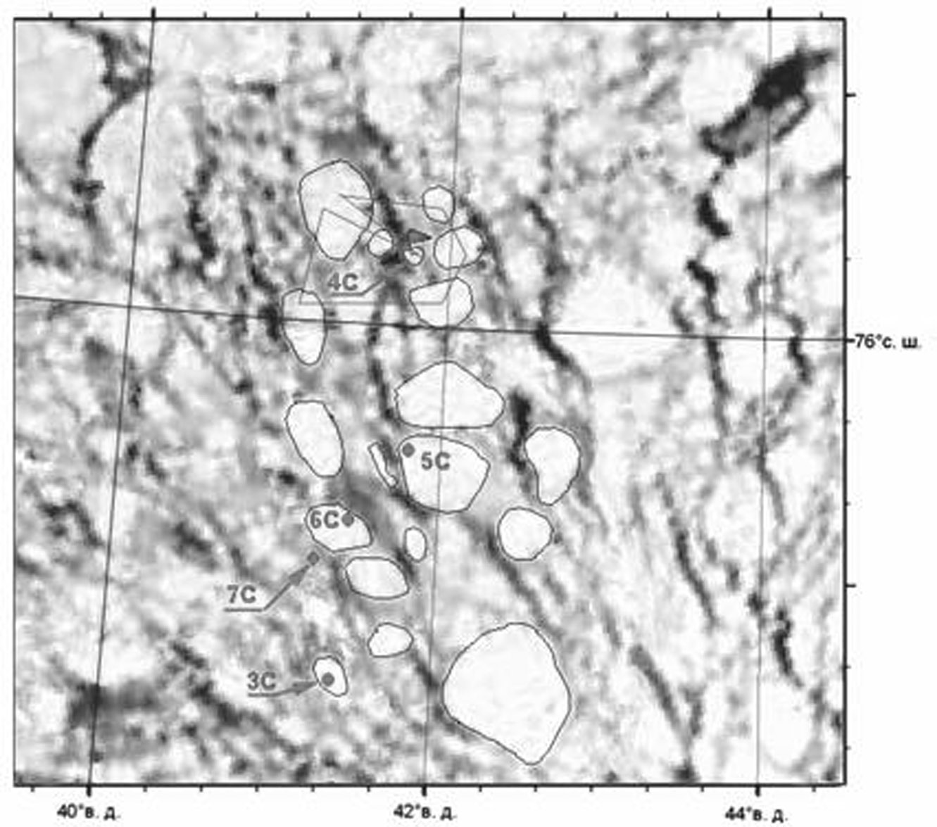
Fig.3.2.6. NOAA-15 Satellite image (6th of May, 2003). 3-7С – ship stations (conducting complex of morphometric and ice research observations);
Line – route of helicopter flight.

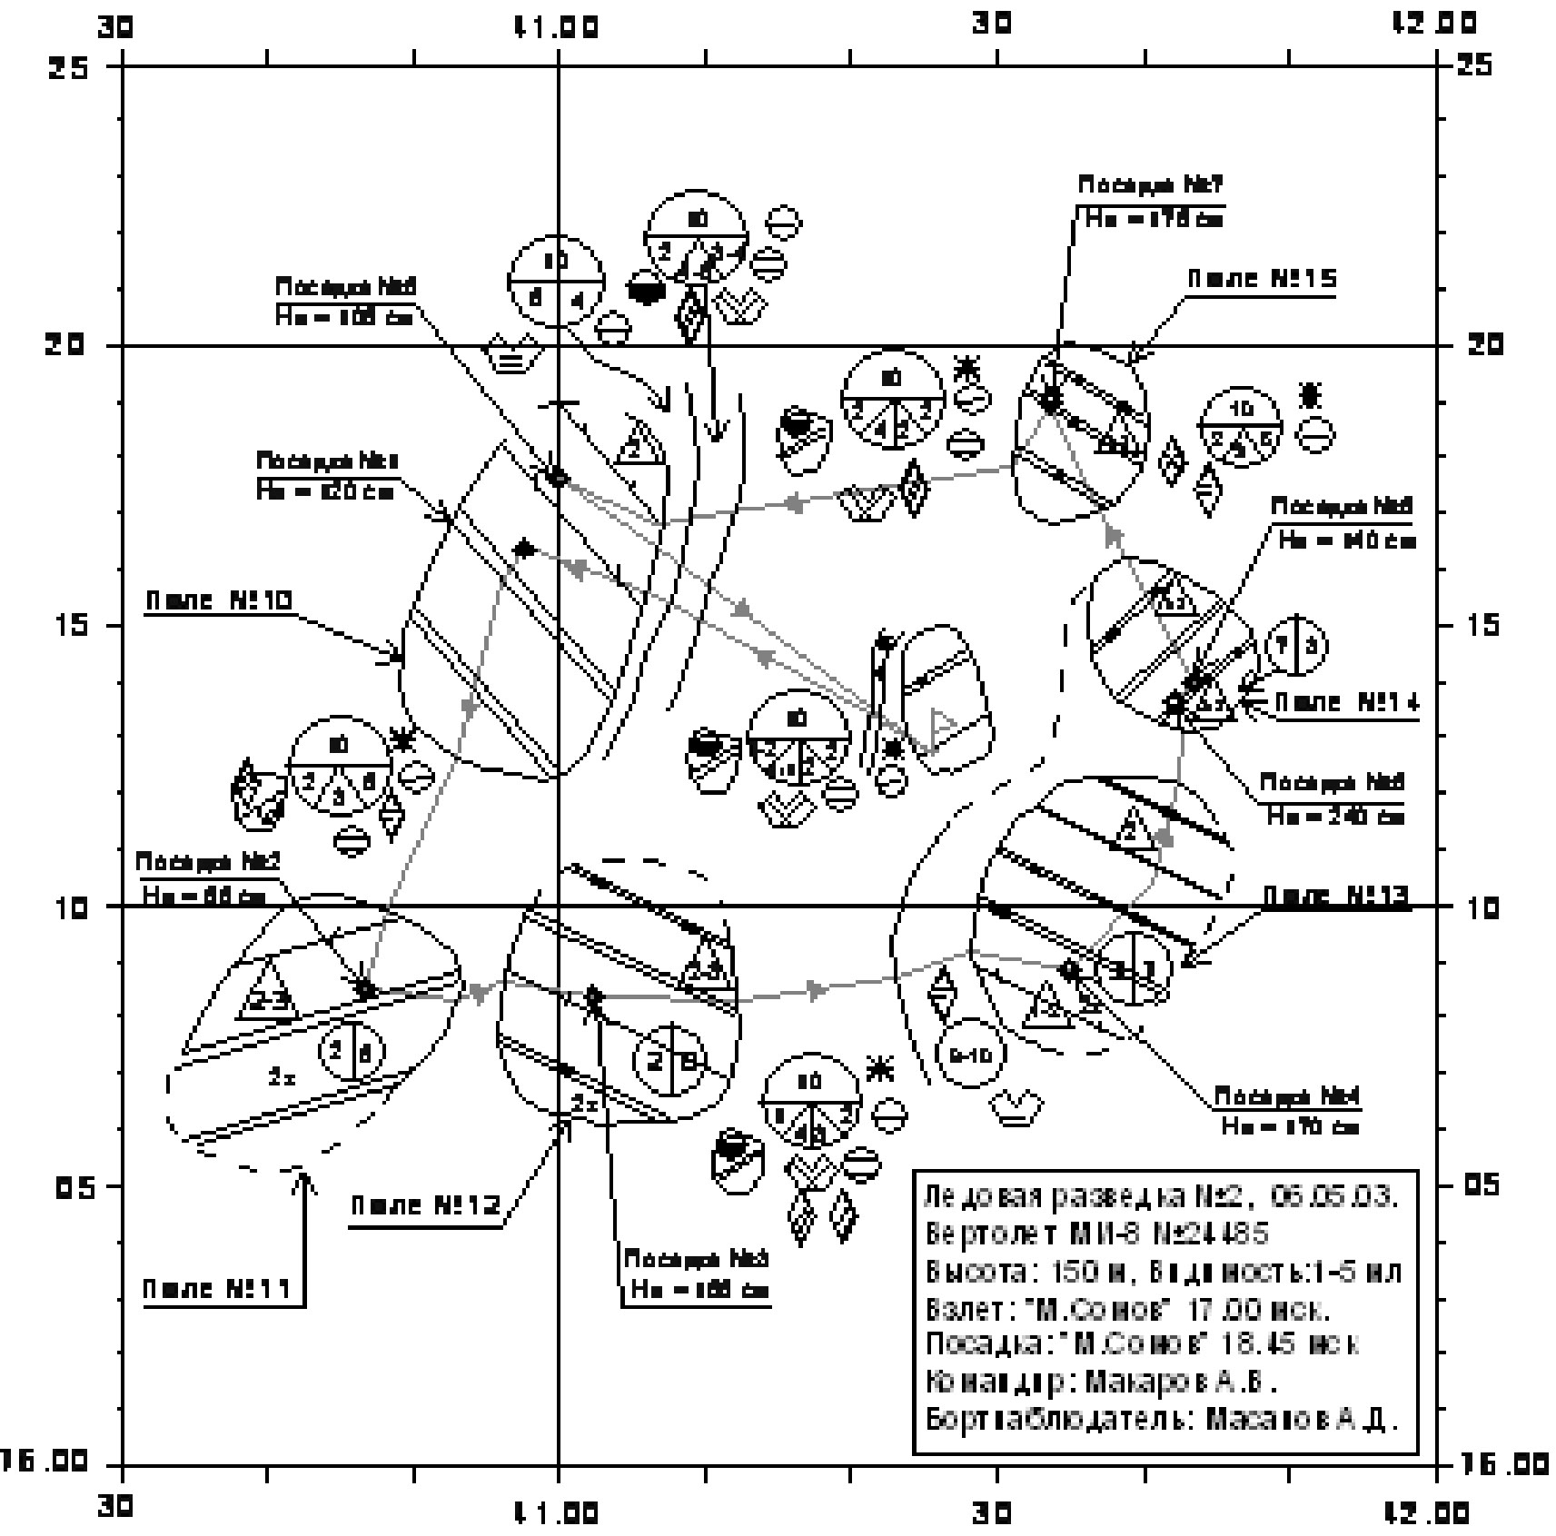
Fig. 3.2.7. Searching ice reconnaissance on 6th of May, 2003
3.2.5.2. Ground Polygon surveys

Polygon surveys are intended to study thermodynamic processes and ice drift. The tasks of the polygon surveys are the following: detailed mapping of some ice cover parameters (concentration, forms, disintegration orientation and size of leads, cracks etc.) to study destruction and formation of ice cover, motion drift etc.
In 2006 hydro meteorological support of drilling was provided in point ХХХХ ХХХХХ as a part of Swedish expedition «ACEX-2004» (Fig.3.2.8). The task of NIB «Soviet Union» consisted of breaking multiyear ice floes to pieces less than 100 m, and icebreaker «Oden» broke them to pieces less than 20-30 m. Icebreaker «Vidar Viking» made drilling and could move, comparative to point of its location, on distance less than 50 m, pushing off separate ice pieces. Areal ice mapping was performed in the 20х20 miles area to provide safe drilling and to determine time of their finishing in case of ice conditions deterioration (appearance of large floes, which can’t be destroyed in 1-2 hours). Flights with parallel traverses on a distance of 2,5 miles between them were performed for this purpose.

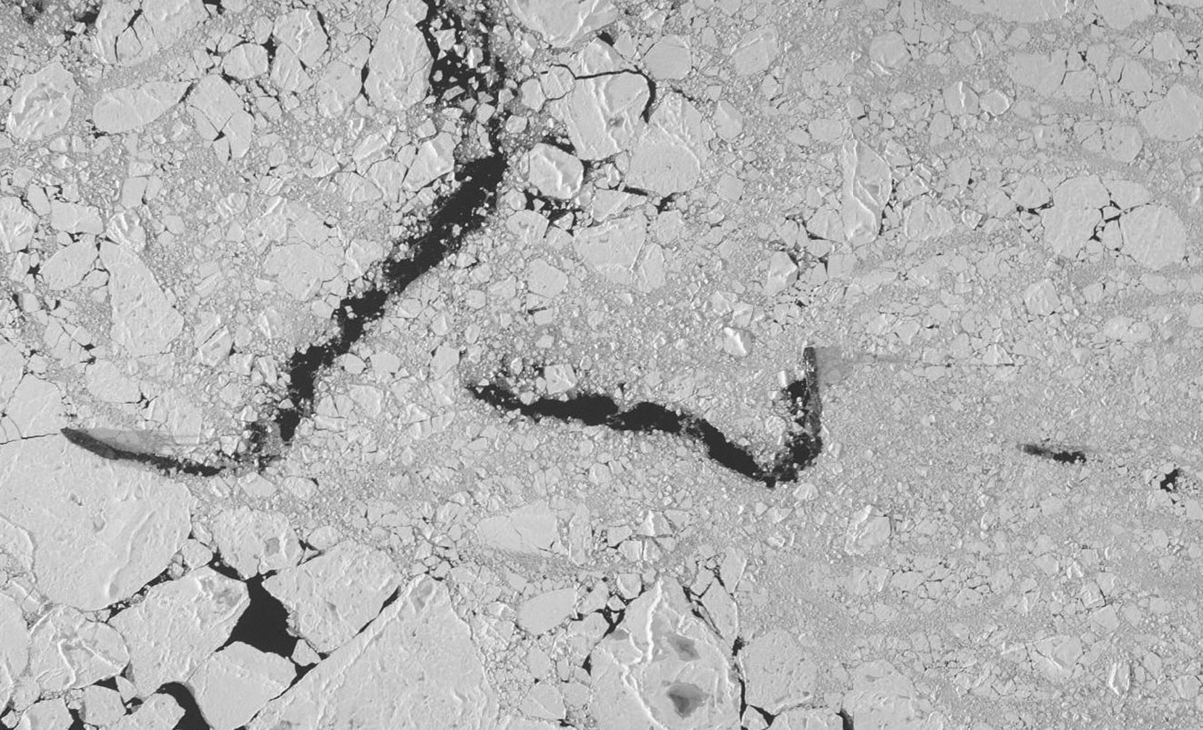

Fig. 3.2.8. Location of icebreakers during drilling works (leftmost –NIB “Soviet Union”, central – icebreaker “Oden”, rightmost – “Vidar Viking”).

Methodic of preparing and performing flights was elaborated after three flights. This methodic includes route composition on a distance of 2,5 miles by means of PC. Special computer program for calculation of turning points coordinates was compiled for this purpose. It simplified process of preparing to flight and its conducting. Before the flight forecasters determined ice drift direction for next 12 hours. Using PC the flight route was calculated in such a way, that all observational traverses had to be perpendicular to the forecasted drift direction (Fig. 3.2.9). Then, the route was given to a pilot (as a file) and further it was saved in memory of helicopter GPS. During flight pilot controlled helicopter location relatively to calculated route using GPS monitor. Accuracy of pilotage wasn’t worse than 50-100 m. Ice expert mapped all floes along route. If they were more than 2-3 miles, each floe was flied around, and then helicopter returned on its route.

In this section all types of airplane and helicopter ice reconnaissance are presented. In spite of large possibilities of satellite information visual ice reconnaissance hasn’t lost its actuality.

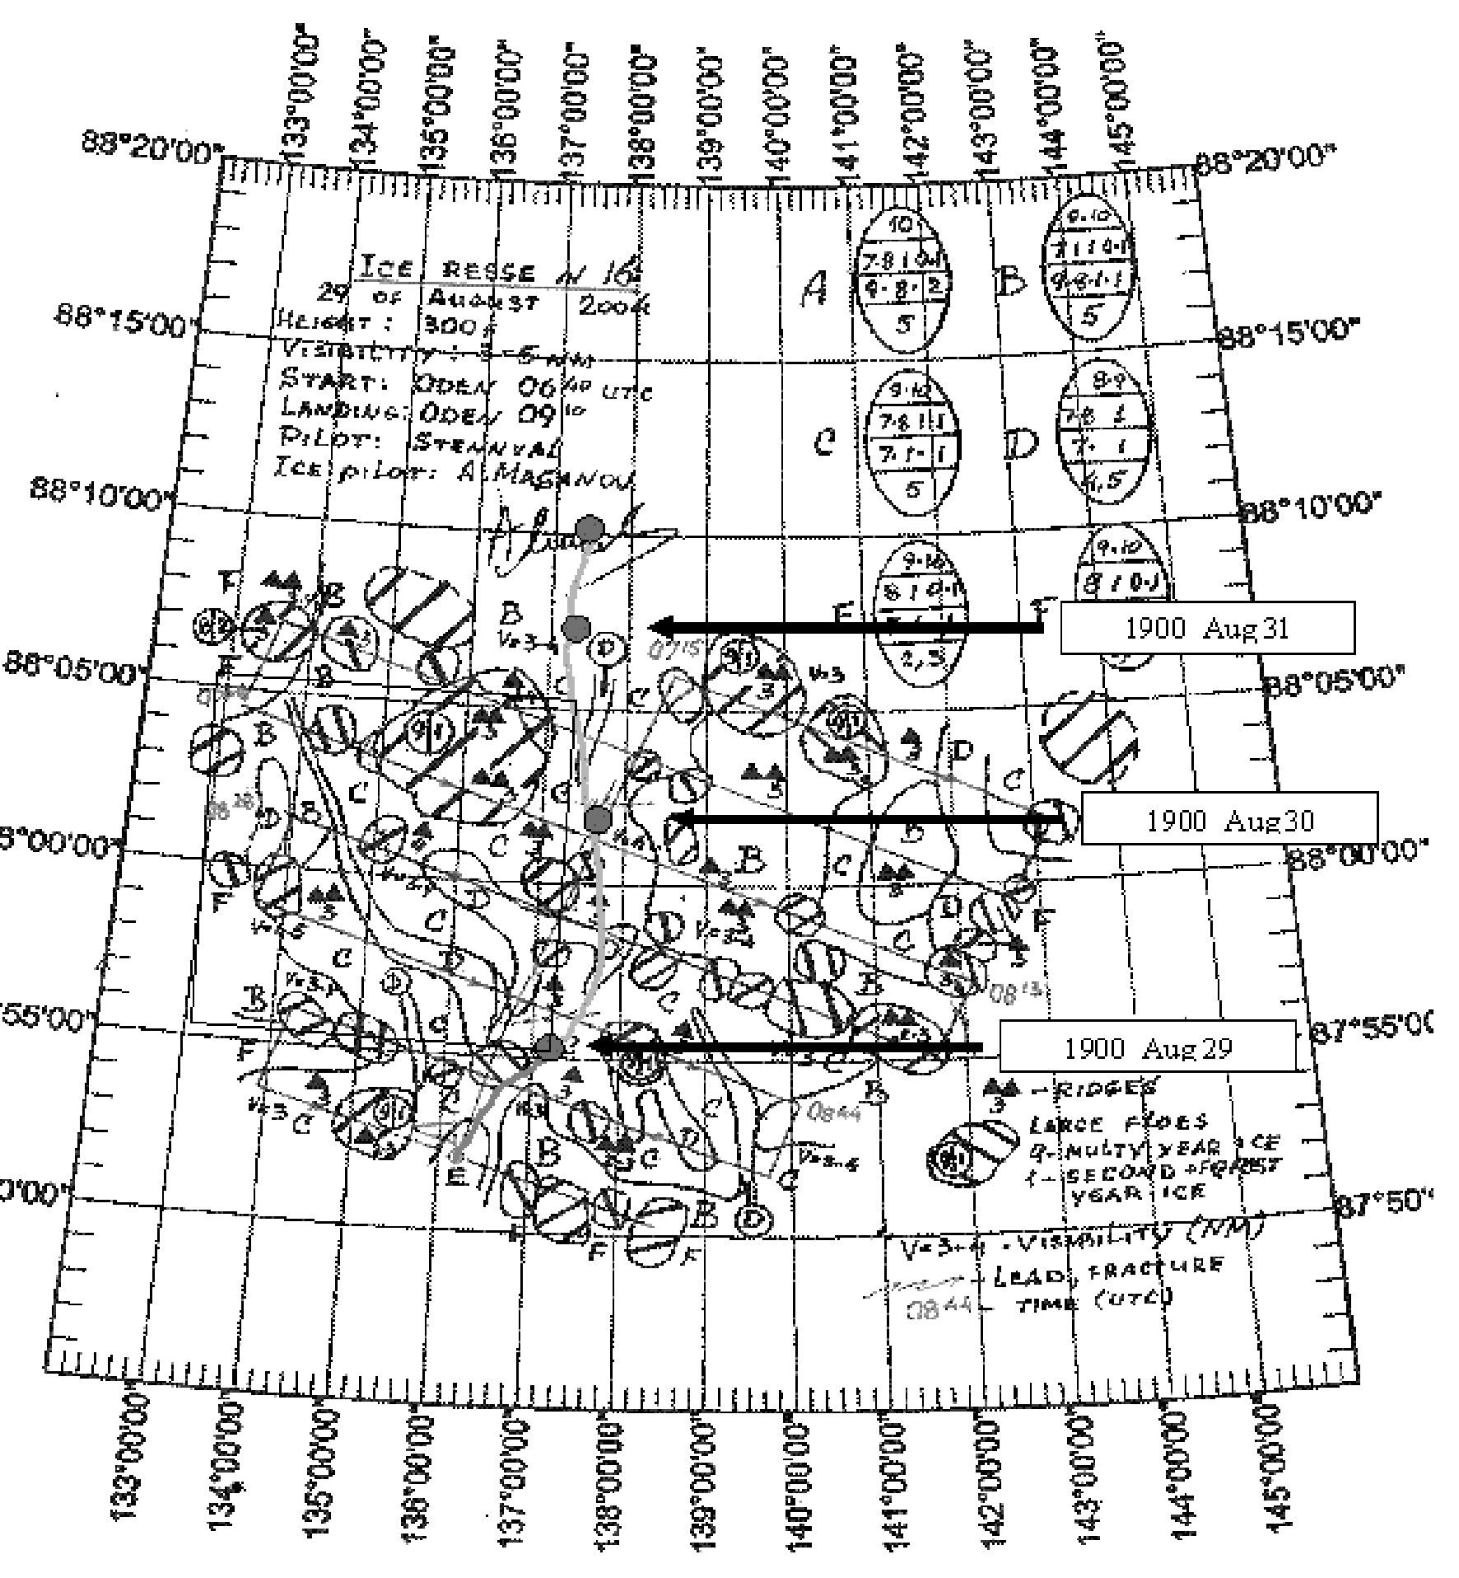
Fig.3.2.9. Polygon ice reconnaissance on 29th of August, 2004. Ovals and numbers – sea ice concentration according to international nomenclature; 4. 08-44 time of helicopter turn on route.

