3.4. Ship telemetering system for ice thickness recording

Ship telemetering system is related to systems of image perception and consists of television camera, images processing and representation devices to obtain ice floes parameters, e.g. their size.
Known device, used for exploratory survey of ice thickness during ship motion, is a measuring rod on line. The rod is a wooden desk with a length of 50 cm and a width of 7-10 cm, divided into decimeters. Rod sections with length of 1 dm are alternately colored in black and white, or in white and red. A hole for the line is made in the middle of rod, “knop” is tied on the reverse side. This device has the following usage: rod is thrown on the ice, where it serves as a scale for visual determination of ice floes thickness, which are turned near perpendicular at the shipboard. Low accuracy of ice thickness determination is the disadvantage of this method.
Ice meter by Tsurikov and Pervakov, determining ice thickness during ship motion, is also known. Ice meter (Fig. 3.4.1а) consists from a metal bar 1 (length 60 cm). Bracket 2 is fixed at the end of the bar with a short tube 3, parallel to the bar. Movable clip 4 is placed on the bar with a supporting screw 5. Metal frame 6 with transparent plate (14×22) is fixed to the clip. Straight-line grid with 2 cm scale division is put on the plate. One section of the grid is divided to smaller scale divisions - every 4 mm. 1 cm scale divisions are put on the bar.
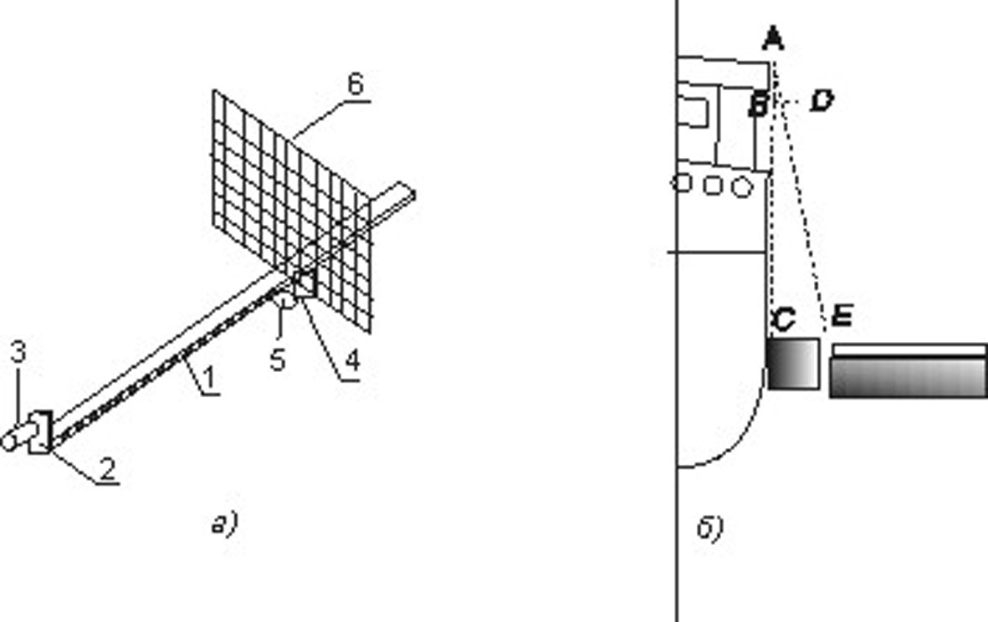
Fig. 3.4.1. An exploratory survey of ice thickness during ship motion

Zero of this scale coincides with the top end of the tube, which is put to observer’s eye. Rubber eye shade is worn on the tube to protect observer’s eye from contact with cold metal. Ice thickness measurements by ice meter are based on solving of similar triangles (Fig. 3.4.1б), big cathetus are distance from observer’s eye to measured object – near-perpendicular turned ice floe AC and the distance from observer’s eye to frame AB, and small cathetus are measured thickness CE and its projection onto grid BD.
Unknown ice thickness CE can be found from equation (1):
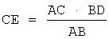 (1)
Height of observer eye above ice surface AC must be known for measurements. When ice floe is located abeam, a number of grid divisions BD, corresponding to ice floe thickness CE, is marked. The only disadvantage is a quick observer’s eyes tiredness during the work, which limits quantity of received information.
Measurement of ice floe thickness in ship telemetering system is carried out by means of calculating distance between two markers in the images of near-perpendicular turned floes. For this purpose television camera, digital to analog converter and manipulator (“mouse”, trackball and etc.) are included in the composition of known device, using which light markers, marking start and end of interval, are located in the image.
The essence of this device is illustrated by drawing, presented in Fig. 3.4.2. It explains connections between television camera, digital to analog converter, manipulator, processing and imaging devices.
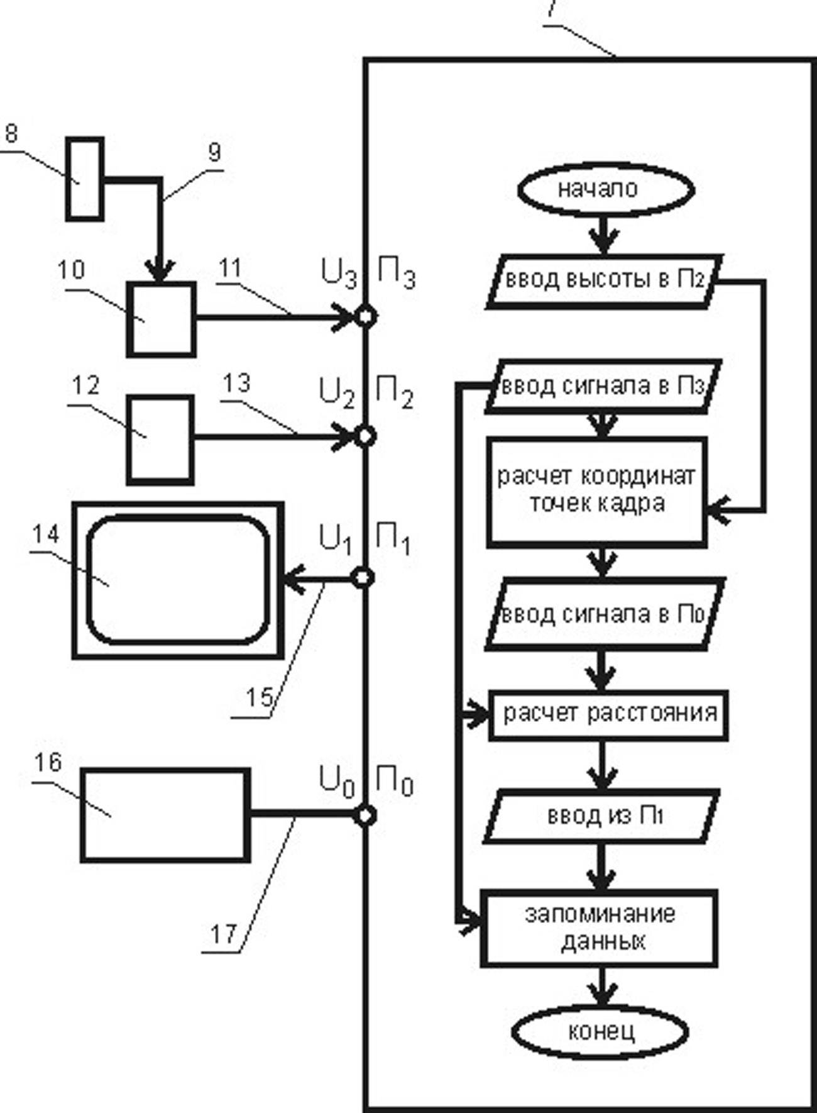
Fig. 3.4.2. System work scheme

П ₀-П₂ – input/output port of the processing device, U₀-U₂ – corresponding input (output) signals.
Television camera 8 is connected by cable 9 with the analogue-digital converter 10, which output signal U₃ by cable 11 comes to connector П₂ of the processing device 7. Data about camera height on the ship bridge as a signal U₂ are set into its input connector П₃ using input device 12. Processing device 7 is connected with a monitor 14 by cable 15 and with manipulator 16 by cable 17.
Working principal of this device is the following.
Television camera is located on the ship bridge in the position of sea surface sighting (point "А" on Fig. 3.4.1 б). Values of height above sea surface and inclination angle of optical axis of camera are recorded. Signal U₂ about corresponding data using data input devices 12, representing a keyboard, comes to input П₂ of the processing device 11 by cable 13. Digital signal of perspective image U3 as a matrix of digital brightness values on output of analogue-digital converter 10 by cable 11 comes to input П3 of the processing device 7, which calculates a distance between points, formed on monitor 14 as light markers, depending on camera height and position of matrix elements of digital signal U₃, which correspond to the location of markers. Image, combined with marker, comes to the monitor screen 14 as a signal U ₁ through output П₁. Digital matrix of image signal and values of distance between markers – ice floes size comes to data recording device under command from the data input device 12.
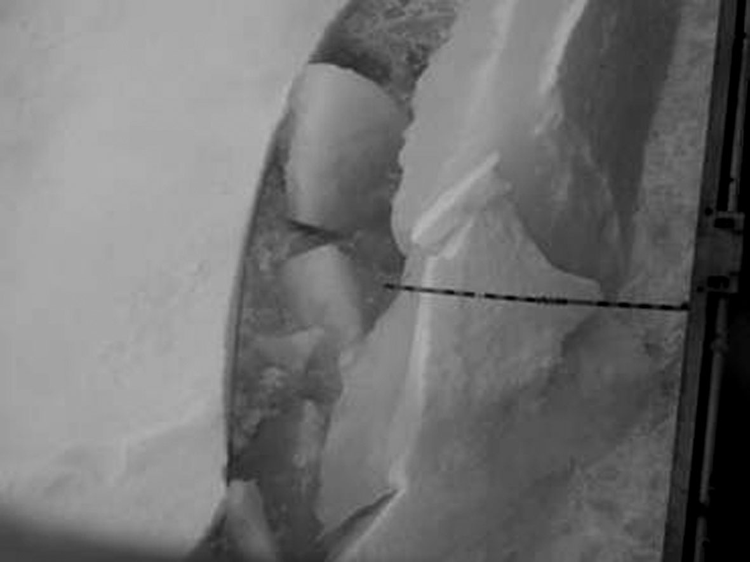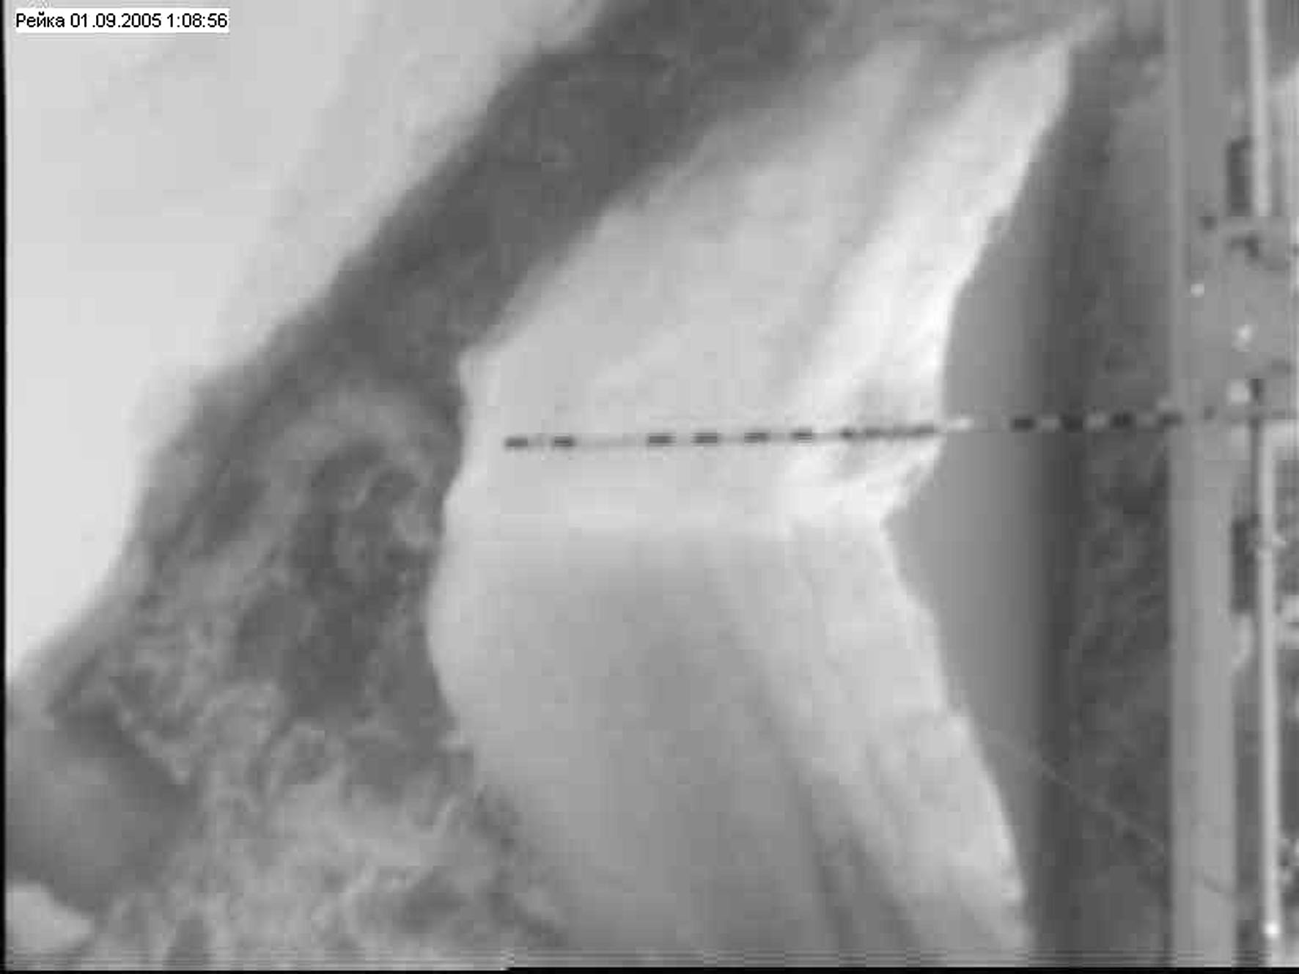
Fig. 3.4.3. Types of near-perpendicular turned ice floe а) and image on monitor б)

Long-term exploitation of the ship TS in 2004-2005 (21st and 23rd voyages of R/V «Academic Fedorov»), in 2006 onboard diesel icebreaker «Norilsk Nickel» (April), NIB «Yamal» (5 voyages, May-August), in 2007 onboard NIB «Rossiya» (2 voyages, May-June), R/V «Academic Fedorov» (26 voyages, July - September), in 2008 onboard tanker «Vasily Dinkov» (1 voyage, March), NIB «50 years of Victory» (2 voyages, July), NIB «Yamal» (2 voyages, August), R/V «Academic Fedorov» (28 voyages, August-September), showed both its efficiency and reliability during operation in extreme conditions (temperature changes, humidity, vibration) and high mobility and simplicity in operation, which allowed untrained staff to work with it. Photos of reversed ice and its image on the monitor are shown in Fig. 3.4.3
Necessary to mention, that in 2004-2005, when the first version of the telemetering system was in operation, amount of information was significantly less, than in 2006-2007. It can be explained, firstly, that in 2006 TS was renewed – black and white low-resolution camera was placed by a color high-resolution camera.
Material, received during this time, consists of more than 20000 measurements of ice thickness in 2006 (5 voyages of NIB «Yamal»), in 2007 - about 5000 (voyage of NIB «Rossiya»), more than 20000 in the 26th voyage of R/V «Academic Fedorov», in 2008 - 2000 images (voyage of tanker «Vasily Dinkov»), more than 20000 (voyages of NIB «50 years of Victory», «Yamal»), more than 10000 in the 28th voyage of R/V «Academic Fedorov».
This data bulk (more than 70 thousand images during 3 years of STS operation (2006-2008)) is of great scientific and practical interest. Receiving of such data massif by contact methods (ice drilling) is practically impossible, though its processing must be made by people with special interpretation skills and is quite time consuming.
Processing of the TS recordings consists of the following stages:
1. Archiving of program buffer «Tayfun» into files *.arv for every 4 recording hours, i.e. 6 archive files per day.
2. Selecting informative frames from archive files, their conversion and recording in *.jpeg format.
3. Writing a comment to the archive file for its further recording in “TS database”.
4. Registering and recording in file information about ship operation «with runs» (number of runs, single and total duration).
5. Registering and recording in file information about ship motion along fractures in close ice (time of beginning and end of fracture).
6. Recording and formation of database about biota accumulation under the ice.
7. Recording and formation of database about animal traces (bear, seal and etc.) on the ice.
8. Measurements of ice thickness and snow (firn) depth in images (*.jpeg files) with their automatic recording to the thickness database.
At that, clauses 2, 4-7 are made simultaneously with archive browsing.
It is necessary to mention, that clauses 2 and 8 are the most laborious, because with a recording discreteness of 1 frame/s, an operator must browse almost 14,4 thousand frames during processing of one archive file (4 hours). Even if speed of browsing is 2-3 frames per second, only browsing of daily recording will take from 8 to 12 hours, not accounting time necessary for identification of “invertion” and saving frame as *.jpeg file.
During processing average number of informative frames only by ice thickness (not accounting other parameters) amounted to almost 100 recordings per hour in some days. E.g., on 27.07.08 the total number of frames, selected for ice thickness estimates, amounted 1816, in some days of 2007 during motion in close ice – more than 2500 frames per day. Totally, this circumstance increases processing time minimum twice.
Speed of processing mostly depends on either operator’s qualification or experience of processing.
85% of STS recordings from four polar voyages of NIB “50 years of Victory” and “Yamal” were preprocessed (clauses 1-2 in processing description), and 20075 information frames were selected during 28th voyage of R/V «Academic Fedorov».
Total volume of recordings in expedition «Arctic-2008» for 19 days of motion in close ice is equal to 224 hours (0,8 million frames, Table 3.4.1).
Apart from that, materials about accumulation of carotinoids under the ice during the expedition «Arctic-2007», were prepared and passed to VNIRO specialists from the recordings of STS.
The reason for system modernizing was prepared in 2008 from analyzes of operation notices and suggestions about STS work in 2006-2007.
As a result, main component blocks and materials, necessary to construct a new system, were obtained by the early August, 2008, including:
- Television camera CNB AP800 with remote control function.
- Program «Tayfun», version V147.0 with electronic switch HASP (3 sets).
- Frame of image grabber «Tsunami -4» to connect with 4 cameras.
- Thermal case AWH32 with cleaner and washer.
- Support rotating device AiPT45.
- Telemetering signal receiver RTS-9.02М.
- Control console MG-K102 with a function of control of support rotating device inclination/turn, zoom/focus of television camera, switch on/off of cleaner/washer of thermal case.
- Deck plate of support rotating device.
- Power cable, signal cable, coaxial cables for switching devices.
After the principal scheme of commutation of the system devices was developed by specialists of research laboratory of ice navigation of the department of ice regime and forecasts, it was assembled and checked in the laboratory.
Table 3.4.1 – Composition of TS data archive in the expedition «Arctic-2008»
№ | Date | Time of file start | File | Work characteristic of TC | Preprocessing |  |  |  | Notices
 |  |  |  |  | Ice (number of images) | Runs (number) | fractures (total time) | GPS
  full recording
  partial recording
  thickness processing
 | Expedition "Arctic-2008", 28th voyage of R/V "Academic Fedorov", Arkhangelsk - Wrangel Island- NP-36 - Arkhangelsk
1 | 23.08.08 | 0:00 | 230808-00-04.arv
2 |  | 4:00 | 230808-04-08.arv
3 |  | 12:00 | 230808-12-16.arv
4 |  | 16:00 | 230808-16-21.arv
5 | 28.08.08 | 8:00 | 280808-08-12.arv |  |  |  |  |  | Survey of Wrangel Island 08-09
6 |  | 16:00 | 280808-16-21.arv |  |  |  |  |  | Adjustment SW 1625-1655
7 | 29.08.08 | 0:00 | 290808-08-12.arv
8 | 30.08.08 | 8:00 | 300808-08-12.arv
9 |  | 12:00 | 300808-12-16.arv
10 |  | 16:00 | 300808-16-21.arv
11 |  | 20:00 | 300808-20-24.arv
12 | 31.08.08 | 4:00 | 310808-04-08.arv
13 |  | 8:00 | 310808-08-12.arv | 10.19 clock was put 10 min forward. Before clock was always slow
14 |  | 12:00 | 310808-12-16.arv
15 |  | 16:00 | 310808-16-21.arv
16 |  | 20:00 | 310808-20-24.arv
17 | 01.09.08 | 0:00 | 010908-00-04.arv
18 |  | 4:00 | 010908-04-08.arv
19 |  | 8:00 | 010908-08-12.arv
20 |  | 12:00 | 010908-12-16.arv
21 | 02.09.08 | 4:00 | 020908-04-08.arv
22 | 05.09.08 | 8:00 | 050908-08-12.arv |  |  |  |  |  | СП-36, ice by shipboard
23 |  | 12:00 | 050908-12-16.arv |  |  |  |  |  | СП-36, ice by shipboard
24 | 06.09.08 | 8:00 | 060908-08-12.arv |  |  |  |  |  | Panorama
25 | 08.09.08 | 8:00 | 080908-08-12.arv
26 |  | 12:00 | 080908-12-16.arv
27 |  | 16:00 | 080908-16-21.arv
28 |  | 20:00 | 080908-20-24.arv
29 | 09.09.08 | 0:00 | 090908-00-04.arv
30 |  | 4:00 | 090908-04-08.arv
31 |  | 8:00 | 090908-08-12.arv
32 |  | 12:00 | 090908-12-16.arv
33 |  | 16:00 | 090908-16-21.arv
34 |  | 20:00 | 090908-20-24.arv
35 | 10.09.08 | 0:00 | 100908-00-04.arv
36 |  | 4:00 | 100908-04-08.arv
37 |  | 12:00 | 100908-12-16.arv
38 |  | 16:00 | 100908-16-21.arv
39 | 11.09.08 | 0:00 | 110908-00-04.arv
40 |  | 4:00 | 110908-04-08.arv
41 |  | 12:00 | 110908-12-16.arv
42 |  | 16:00 | 110908-16-21.arv
43 |  | 20:00 | 110908-20-24.arv
44 | 14.09.08 | 12:00 | 140908-12-16.arv
45 |  | 16:00 | 140908-16-21.arv
46 |  | 20:00 | 140908-20-24.arv
47 | 15.09.08 | 0:00 | 150908-00-04.arv | 00.44 – inconsistency for 9 min – corrected for 00.53
48 |  | 4:00 | 150908-04-08.arv
49 |  | 8:00 | 150908-08-12.arv
50 |  | 12:00 | 150908-12-16.arv
51 |  | 16:00 | 150908-16-21.arv
52 |  | 20:00 | 150908-20-24.arv
53 | 16.09.08 | 20:00 | 160908-20-24.arv
54 | 17.09.08 | 0:00 | 170908-00-04.arv
55 |  | 4:00 | 170908-04-08.arv
56 |  | 8:00 | 170908-08-12.arv
57 |  | 12:00 | 170908-12-16.arv
58 |  | 16:00 | 170908-16-21.arv
59 |  | 20:00 | 150908-20-24.arv
60 | 18.09.08 | 0:00 | 180908-00-04.arv
61 |  | 4:00 | 180908-04-08.arv
62 | 19.09.08 | 16:00 | 190908-16-21.arv |  |  |  |  |  | FJL region, test survey
 |  | Total 56 files arv (224 recording hours) for 19 days |  |  |  |  |  |  | 0,806 mln of frames
 |  |  | 1 file | Program calibration
 |  |  | 5 files | Panoramic survey

Further assembly and adjustment works of STC-M was conducted during the 28th voyage onboard R/V «Academic Fedorov».
Experience of STC-M operation during the expedition «Arctic-2008» showed, that this modification is efficient; and simplifies work of personnel (watch of crew SHEM on the bridge). Going out to the bridge to clean a box windscreen became unnecessary due to remote control of washer and cleaner. Camera positioning to zone, selected for survey, zoom adjustment and focusing can be made by one operator using the control console.
Apart from that, possibility to control local system using remote access allows to control work of system and partly control it by the net.
Implementation of support rotating device in the system made possible remote control for operational pointing and survey of any objects within 180° sector horizontally and from +20° to -80° vertically by ship starboard. Camera has optical zooming of 26× and automatic focusing, thus, quality of received image is quite high.
At present usage of remote control in corpore is impossible due to technical limitations of telemetering signal receiver. Only focus adjustment and optical zooming are available in the given band (2×10×). Function of camera control will be available in corpore after hookup of second receiver. Flowchart of STC-M and general view of main system components are presented in Fig. 3.4.4 – 3.4.6.

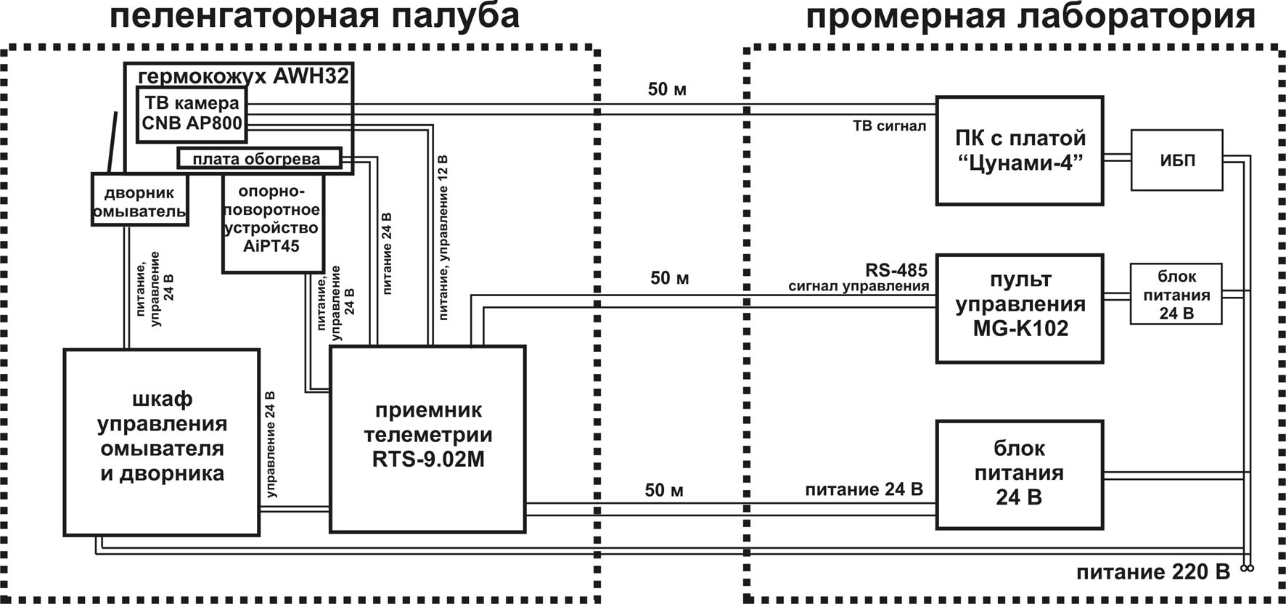

Fig. 3.4.4. Flowchart of ship telemetering system STS-M

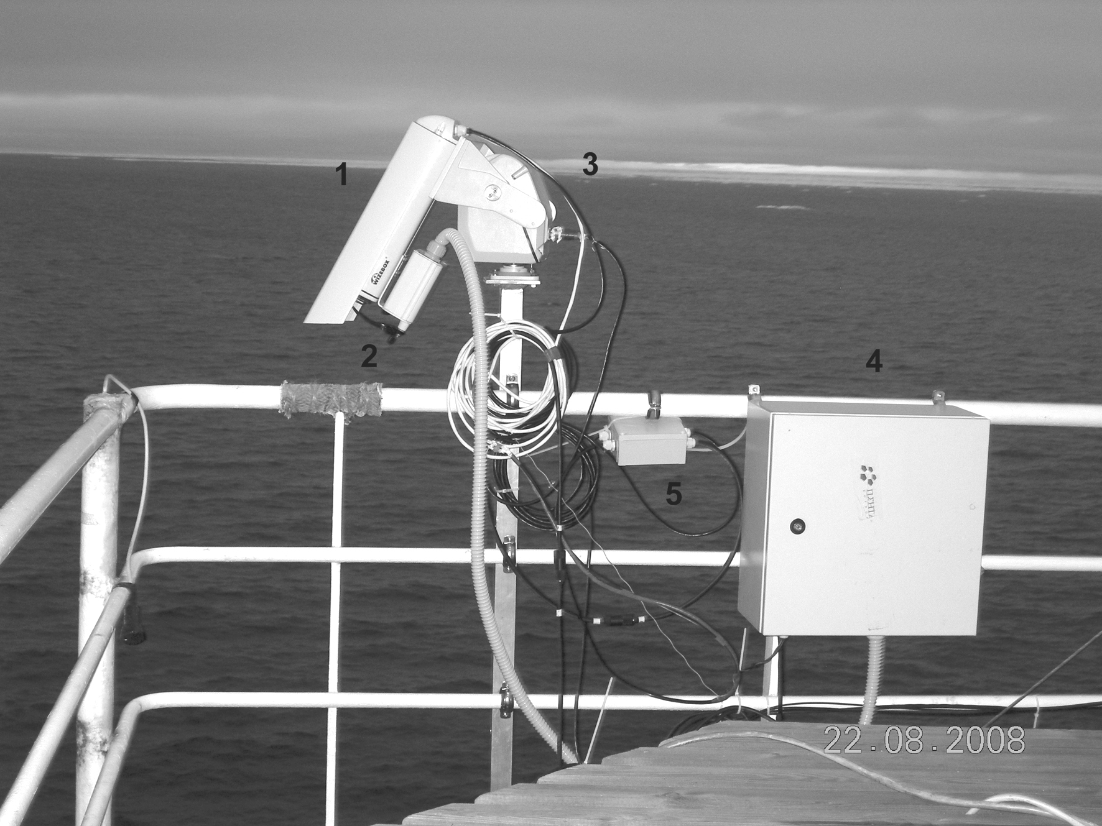
Fig. 3.4.5 General view of STS-M
1 – thermal case Wizebox AWH32; 2 – windscreen wipers and washer of thermal case; 3 – Support rotating device AiPT45 on special piece; 4 – case for control of washer and cleaner; 5 – telemetering signal receiver RTS-9.02М
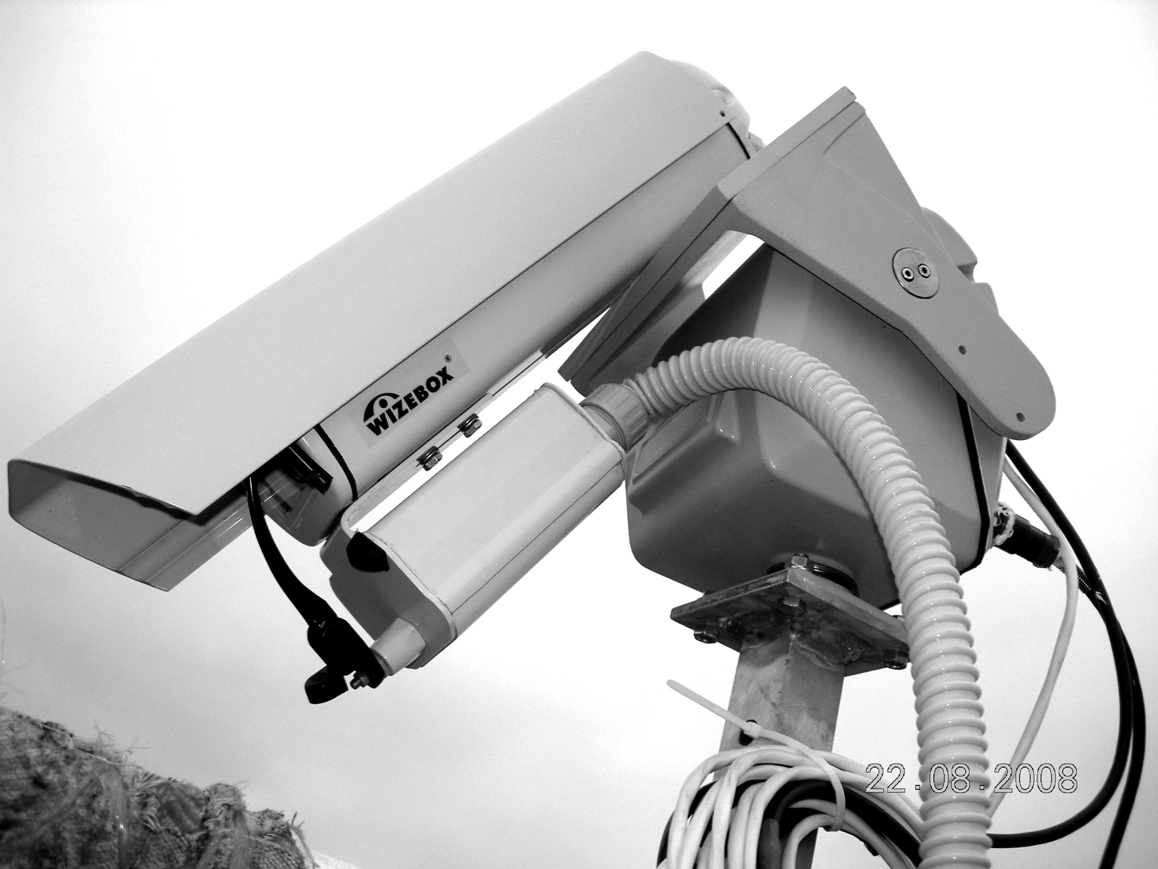
Fig. 3.4.6. Thermal case with cleaner and washer, fixed on the support rotating device

