3.5. Dangerous ice phenomena and ice formations

3.5.1. Types of dangerous and unfavorable ice phenomena
Dangerous ice phenomena (DP) – is hydrometeorological phenomenon or complex of hydrometeorological values, which can be dangerous for people due to their size, intensity or duration. It can also significantly damage economical objects and population.
Unfavorable hydrometeorological phenomenon (UHP) – is hydrometeorological phenomenon, which significantly complicates or impedes activities of individual enterprises and sectors of economics.
Presence of sea ice causes serious risk during conducting any type of work on drifting ice and fast ice. Safety and efficiency of navigation, marine work, functioning of hydrotechnical constructions depend on ice cover state.
Generally, value of sea ice impact on objects is defined by amount, concentration and thickness of ice, parameters of its motion, and ice strength.
Ice phenomena can’t be dangerous or safe, they pose a threat only within limits of their impact on particular objects and influence on certain types of work. Ice conditions and ice phenomena can passively influence or actively impact on industrial objects, threatening people’s safety, transport, hydrotechnical constructions and work realization.
There are two categories of potential threat to productive activity in connection with ice cover impact:
- Dangerous ice phenomena (DIP) of active impact of drifting sea ice, which are formed by dynamic factors, occur suddenly, operate in limited region and in limited time interval;
- Unfavourable hydrometeorological phenomenon (UHP) of passive effect of drifting ice and fast ice are determined by presence and state of the ice cover, which is mostly formed by thermal factors, occurs gradually and exists in large region during long time period.
Influence of unfavourable ice conditions and impact of dangerous ice phenomena directly determine level of safety and degree of economical efficiency of navigation, transportation on fast ice, work of offshore above-water platforms, pipelines and terminals for uninterrupted tanker fueling. Diverse influence of the sea ice on safety and efficiency of building hydrotechnical constructions is especially significant. Each object is specific, and due to this differently react to different ice impact.
Navigation. Efficiency of ice navigation mostly depends on thickness and concentration of drifting ice. The limiting parameters of ice are determined according to type and ice class of ships.
Ships can spend plenty of time traversing ridges. Thus, ridges in drifting ice decrease economical efficiency of cargo transportations approximately proportional to their concentration.
In straights and along coasts quite rarely occurs a strong local ice flow (“ice river”), which can complicate maneuverability of ship and cause emergency.
The most significant decrease of cargo transportation efficiency is caused by ice compacting. Average cruising speed of ship normally decreases under often and long ice compacting on the navigation route. Most emergencies, ship damage and even their wreck occur under very strong compacting.
In autumn and winter, when the air temperature is below - 10°С, ice adherence to a ship hull and icing of deck-erections can occur when ship sails near more or less large areas of young ice or open water. Partial decrease of ship speed and maneuverability or even their complete loss occurs when ice adheres to the ship hull.
Works on the fast ice. Efficiency and safety of works on the fast ice mostly depend on thickness and strength of ice, which corresponds to the melting stage of ice cover. Its limiting parameters are presented in the documents, providing safe works on the fast ice. These parameters are determined for particular type of works taking into account static pressure and dynamic impact of carriers.
Constructive strength of the near edge part of the fast ice is important during unloading on the fast ice. This part of the fast ice is less stable. Thus, presence of ridges and barriers of hummocks, which are partially grounded, reinforces constructive strength of the near edge part of fast ice.
Offshore above-water platforms and terminals, placed on the ground. These constructions are the most important during oil and gas exploration. Platforms and terminals can be effected by more or less significant pressure from drifting ice at the sea level. The value of pressure is proportional to the ice drift velocity, and total ice mass, interacted with construction. At that, the total ice mass, interacted with the construction, depends on thickness, concentration, and ridging of homogenously moving ice. Results of forces are mostly determined by strength and size of ice floes, and also by morphometric peculiar features of engineering objects location and peculiar features of dynamic effect of their interaction with ice cover.
Buried constructions for oil and gas exploration. This construction isn’t effected by force of drifting ice at the sea level. Underwater parts of moving icebergs, floebergs, large hummocks and dragging of large floes piles on the bottom, which are formed during pressing of large drifting ice masses, can be dangerous for them. Traces of contact of these ice formations and piles with the sea bottom are furrows of bottom exaration. Unfavorable effects of covering underwater metallic constructions with the ice, can’t be excluded.
Year-round uninterrupted fueling of tankers. Concrete constructions of terminals can resist ice drift pressure. However, it doesn’t mean that they can fuel tankers. Probably, large piles of broken ice can be formed around the terminal during ice pressure from different directions, which can be grounded like stamukhas, when sea depth is less than 20 m. It can be supposed, that this phenomenon can prevent tanker fueling for a long time. However, probability of terminal blockage by broken ice can widely change for different regions.
Navigation channels. If terminal is located in shallow fast ice zone (for protection from drifting ice pressure) with one or several navigation channels, connecting it with the sea area, there will be a danger of filling these channels with broken ice during rafting of drifting ice on the fast ice edge. Such phenomenon can probably prevent ship approaching to terminal or coast for a long time. However, its probability can change significantly in different regions.
Underwater pipelines laid in the ground. Underwater parts of moving icebergs, floebergs and large ridges, and also dragging of crushed ice against sea bottom over the pipeline during formation of grounded hummocks, as well as their subsequent effect are of great danger for the underwater engineering constructions. Furrows with different sizes (result of ice exaration) are observed during sonar observations of the sea bottom in many sea ice regions. Intensive erosion of the sea bottom around grounded hummocks and intrusion of their keels for 1-2 m into the bottom was found during their underwater observations.
Coastal constructions and constructions near the coast. In some regions of the Arctic coast piling of young ice on the shore is observed in autumn. During piling ice can cause exaration impact on the bottom of the coastal shoals and on the shore at a distance up to 100 m from the shore line. This ice piling on the shore can be dangerous for coastal buildings.
In autumn-spring period intensive storm can produce strong impact of ice floes in shallow coastal zone, if broken fast ice with thickness of about 1 m and hummock pieces are observed occur near the coast. This “ice storm” can be dangerous for coastal constructions.
Building of hydroengineering constructions. It is supposed, that building of hydroengineering constructions is carried out if the working area is totally free from fast ice and drifting ice. At that, the efficiency of construction work is influenced not only by dangerous ice phenomena, but mainly by unfavorable ice phenomena. Information about ice-free period duration, terms of water area clearing from ice, terms of ice formation beginning and young ice growth up to values of 10-15 cm and 25-30 cm are extremely significant for effective planning and implementation of construction works. Duration of ice-free period in the Arctic Seas is very short and annual terms of clearing and freeze-up change within wide limits. Orientation on average terms can be economically unprofitable.
Analysis of typical effect of ice cover in the freezing seas on navigation and ice impact on engineering constructions allows selecting dangerous ice phenomena (Table 3.5.1) and unfavorable ice conditions (Table 3.5.2). Danger of ice phenomena is taken into account in connection with their impact on particular engineering objects and influence on conducting particular type of work. Thus, when new specific hydroengineering constructions and type of work emerge, these lists can be specified and supplemented.

Table 3.5.1. List of dangerous ice phenomena

Ice phenomena | Hazard
Ice piling and pressure | Damage of above-water, buried and bottom constructions.
Moving ridge | Threat for buried and bottom constructions.
Strong ice compacting | Emergencies, damage of ships and above-water constructions
Intensive ice drift, including «Ice river» | Emergency situation for ships due to loss of maneuverability.
Ship hull covering with ice | Decreasing of ship velocity up to full stop. Emergency situations.
Ship icing, hydro technical construction icing | Loss of ship stability. Statistical tensions on elements of engineering constructions.
Ice floes and fast ice destruction under outer load | Collapsing of airplanes, helicopters and ground vehicle under the ice. People death.
Separation of fast ice in places of work | Emergency situation during unloading on the fast ice. Threat to people, ground vehicle and cargoes.
Ice piling | Shore line exaration. Threat to coastal buildings.
“Ice storm” | Shore line exaration. Threat to coastal buildings.

Table 3.5.2. List of unfavorable ice conditions.

Ice phenomena | Hazard
Drift ice condition (large thickness and etc.) | Direct influence on exploitation velocity of transport vessels.
Easy and heavy ice compacting | Decreasing of exploitation velocity of transport vessels.
Results of ice rafting, breaking and piling | Blockage of approaches to terminals and ship channels by broken ice
Late terms of ice remaining in water area | Late terms of navigation without icebreakers, constructing or repairing works. Small economic efficiency of work.
Early terms of ice remaining in water area | Early terms of navigation without icebreakers, constructing or repairing works. Small economic efficiency of work.

Organization of specialized system of monitoring and forecasting ice conditions is necessary to minimize ice impact on marine transportation system at the stage of operation. Ice cover monitoring provides regular acquisition, processing, analysis and distribution of the current sea ice information in the terminal area and along the sailing route to support navigation safety and conducting tie down operations, as well as for ecological safety of water area.
Ice formations (big floes of multiyear ice, ridges, grounded hummocks, icebergs and etc.) can have a dangerous and unfavorable impact on different types of productive activity. The list of dangerous and unfavorable ice formations is presented in Table 3.5.3.

Table 3.5.3. List of dangerous and unfavorable ice formations

Ice formation | Hazard
Giant and vast ice floes of deformed or multiyear ice | Damage of above-water, buried and bottom constructions. Complicated occurrence of tie-down operations.
Ridges and floebergs | Threat to buried and bottom constructions. Complicated occurrence of tie-down operations.
Stamukhas | Statistic load. Dynamic load under level fluctuations. Influence on under-water pipeline.
Icebergs and bergy bits | Emergency situation, when iceberg crashes vessels, above-water and under-water constructions.

Ice phenomena and ice formations become dangerous for productive activity during implementation of concrete productive activity, when they arrive to definite criterion. Thus, criterion must be précised, taking into account local ice conditions, and agreed with producing activity of served organizations.

3.5.2. “Ice river” phenomenon
Analysis of hydrometeorological conditions and phenomenological description of “Ice river” phenomenon
For a long time researchers of the Arctic Seas were interested in increased velocities of currents and especially ice drift. Ice, drifting in these local rapid flows, complicates navigation of ships and icebreakers in the freezing seas due to occurrence of huge, ice mass, “attached” to ship, which sometimes can cause emergencies and even catastrophes. At the same time ice floes, moving with a current, are excellent “tracers” for systematic airborne observations using aerial photosurvey. It is impossible to carry out these measurements using direct instrumental methods, because ice, drifting with high velocity, often presences a mixture of ice cake and small ice cake sometimes during compacting.
High velocities of ice drift were confirmed last decades as a result of instrumental observations. Extremely high velocity of ice drift often caused critical situations and emergencies during navigation in the Arctic. Ships of ice class and even of icebreaking type were powerless in conditions of extreme ice drift with compacting. Thus, at the present moment it is impossible to counteract against catastrophic phenomenon of “Ice river”. Danger degree of phenomenon should be dependant on current velocity in flow and mainly on ice concentration and compacting. Water flow with broken ice can overcome almost every ship. However, big ships, powerful icebreakers, and even nuclear icebreakers can’t sail in slow flow of ice cake and small ice cake with concentration of 9–10/10-th. At that they are playthings of nature for rather long time. Drift of nuclear icebreakers “Sibir’”, “Arktika” and icebreaker “Kiev” in the region of Yugor Shar Straight in March-April of 1980, and also drift of icebreaker “Captain Sorokin” in the Yenisey Gulf in November of 1977, can be given as example. “ICE RIVER” (ICE JET) – is a non-stationary jet flow of close floating ice cake and small ice cake, drifting with high velocity and sometimes with compacting, in straits, gulfs or in open areas of freezing seas near the fast ice boundary or slow-moving ice massif.
Analysis of known cases of this dangerous phenomenon allows its detailed examining. High velocity of current and ice occurrence in flow are the determining factors for identifying this phenomenon as a very dangerous. At that presence of drifting ice, especially along fast ice boundary, when this phenomenon is accompanied by compacting, complicates navigation even under very small velocity of “ice river” current (0,5–1 knots).
Under its compacting ice, moving with the current makes resistance for ship motion which is several times more, than that of water flow itself. It is necessary to take into account that horizontal turbulent vortexes sometimes occur in such flow. Their spatial and temporal scale is determined by bends of fast ice boundary, ice thickness near its edge, size of ice floes and horizontal gradient of velocity in the stream itself. Horizontal and vertical velocity gradients are peculiar features of dynamic instability of non-stationary current under non-linear interaction of different fluctuations in jet flow. “Ice river” phenomenon often occurs on the background of steady or periodic currents, as multiple acceleration of this flow in the surface layer.
Current acceleration in straights with presence of drifting ice (with high denivelation of the sea level on opposite sides of the straight) should be related to the listed phenomena. Though a mechanism of extreme velocities formation often differs from mechanism of “ice river” formation in the open Arctic Seas, they are connected by one significant circumstance. This is a complication of ship motion in flow of drifting ice, causing emergencies. Existence of the fast ice boundary in straight, which narrows a surface current, can cause conditions for the current acceleration. That is why, under appropriate winds ice edge “works” as a wall with local (near edge) denivelations of the sea level on the background of general level inclinations in the straight. Local denivelation of the sea level is always formed by surge wind near the coast and also wind near the ice boundary (fast ice or slow-moving ice massif) in the sea with mixed layers on liquid ground. Level gradients facilitate formation of extreme currents, which form phenomena like “ice river”, if drifting ice is present. Currents are accelerated especially significant in narrow straights, like Yugor Shar Straight, near Krestovskiye Islands in the Yenisey Gulf and others, even if ice edge is absent.
Formation of “Ice river” phenomenon occurs under definite conditions, which are defined by geographical, morphological, meteorological, ice and hydrophysical conditions.
Geographical factors. “Ice river” most often occurs in the Arctic straights independently on their location (regardless of some scientists opinion). These phenomena can be observed in narrow gulfs, where rivers flow, e.g. the Yenisey Gulf, Ob’skaya Bay and others, open parts of the Arctic Seas near coast with presence of fast ice boundary or close slow-moving floating ice massif.
Morphometric factors. The stated factors are narrowing of funnel-shaped coastline near straights, sea depth reduction, that is often summarized with effect of coast line narrowing, influence of configuration (sharp bends) of boundaries of fast ice or close slow-moving floating ice massif.
Meteorological factors. The meteorological factors, influencing formation, existence and weakening of “Ice river” phenomenon are the following:
- distribution of surface baric field gradients, i.e. surface wind, transmitting its kinetic energy to underlying ice surface due tangential stress as external exciting and supporting force;
- sustained effect of strong wind of the same direction;
- thermal processes as indirect factor of ice formation and melting;
- sharp and significant increase of air temperature in the cold season with strong frosts on the background, facilitating formation and outflow of brine from the ice, and as a result – significant salination of the water surface;
- hard frosts, facilitating rapid freeze-up of brine in young ice and desalination of the water surface .
Ice conditions. The ice conditions, facilitating formation, existence and weakening of “Ice river” phenomenon are the following:
- existence of drifting ice, often ice cake and small ice cake of different concentration, which joins this motion under the influence of current or wind, or under their combined unidirectional influence due to tangential stress at its lower and upper surfaces;
- existence of quite lengthy boundary of fast ice or close slow-moving floating ice massif, relatively to which ice cake with different concentration can join local motion due to effect of current and wind;
- formation of jammed brash barrier at the fast ice edge during compacting, which becomes multi meter deep wall for the surface water column often down density jump layer;
- reconstruction of local ice conditions under the influence of wind in narrow zone, when during compacting near the boundary of fast ice or massif, consisting of older thicker ice, strong ice breaking occurs. At the same time size regrouping of ice cake occurs due to different windage of ice floes;
- increase of roughness parameter with corresponding increase of wind drag coefficient of ice drift due to decrease of ice floe size, when its horizontal size becomes comparable to its vertical size during breaking;
- appearance of local sections, separating areas of different ice drift conditions, under opposing motion of drifting ice flows, which were caused by different reasons, occurred in different time, and some of them are indicators (“prints”) of past “Ice rivers”;
- formation of polynyas and leads in ice massifs.
Presence of drifting ice and increasing of roughness parameter are very important for jet flow formation, because small-sized floes join motion faster. Periodical compacting leads to ice floes regrouping, if ice is strongly broken and convergence is absent. As a result, narrow stripe of ice cake and small ice cake is formed along the boundaries of fast ice or ice massif, which plays role of “coast” for “Ice river”, when it was formed. The second - opposite coast is ice massif, composed from medium floes and small floes, which under favorable (for phenomenon formation) wind and current would be practically stable due to its rather large inertia relatively to ice cake and small ice cake due to their bigger windage. The more ice is broken near the edge, the more probable is formation of “Ice river” under appropriate wind and current.
If “ice river” flow is initiated by wind (“from above”), ice concentration in the flow must be maximum. If the flow was mainly initiated by hydrological reasons (“from below”), ice concentration of ice cake and small ice cake in the flow can be arbitrary. Though when concentration is small, the phenomenon is not “Ice river”, but just jet stream.
Hydrophysical factors. This is the most complicated and little-studied aspect of hydrometeorological conditions of the phenomenon under study formation.
The following factors can be related to these conditions:
а). Total or local denivelation of daturence surface дξ/дn, created by surging wind, when large gradients of the sea level facilitate formation of strong gradient currents and their acceleration, if vectors of external and internal forces coincide;
b). Presence of constant periodical – tidal and non-periodical currents, which accelerations under effect of other forces contributes to appearance of maximum velocities of jet flows;
c). Driving of flows to the boundaries of fast ice or ice massif under the impact of Coriolis force;
d). Occurrence of surface desalinated water layers with large static stability, divided by thin interlayer with high gradients of density ∂σ/∂z – effect of “Dead water” (during motion of upper layer relative to the lower layer);
e). Rapid ice heating under sharp and significant increase of air temperature, resulting in rapid abnormal desalination of the ice, salinity increase in the surface water layer, and formation of thin layer with high negative density gradients under it (– ∂σ/∂z) – instability of inversion type;
f). Increase of salinity in the surface water layer during ridging in the winter period (S‰ → max).
Considering first three aspects, it is necessary to mention, that motion in flow is supported by tangential stress of wind w and strongly developed baroclinicity due to large denivelation of level ∂ξ/∂n at opposite boundaries of straights, or may be polynyas or leads. Constant current and strong tidal current, forming jet flows, are often present a common background.
Last three aspects determine thickness of “Ice river” layer Δh, and, consequently, speed of its joining into motion and flow velocity. At that, listed processes, making effect of “Pure sliding”, create lubricant layer directly on ice bottom, and water isn’t practically join the motion.
Classification of all factors, determining conditions of “Ice river” formation, is presented in Fig. 3.5.1.
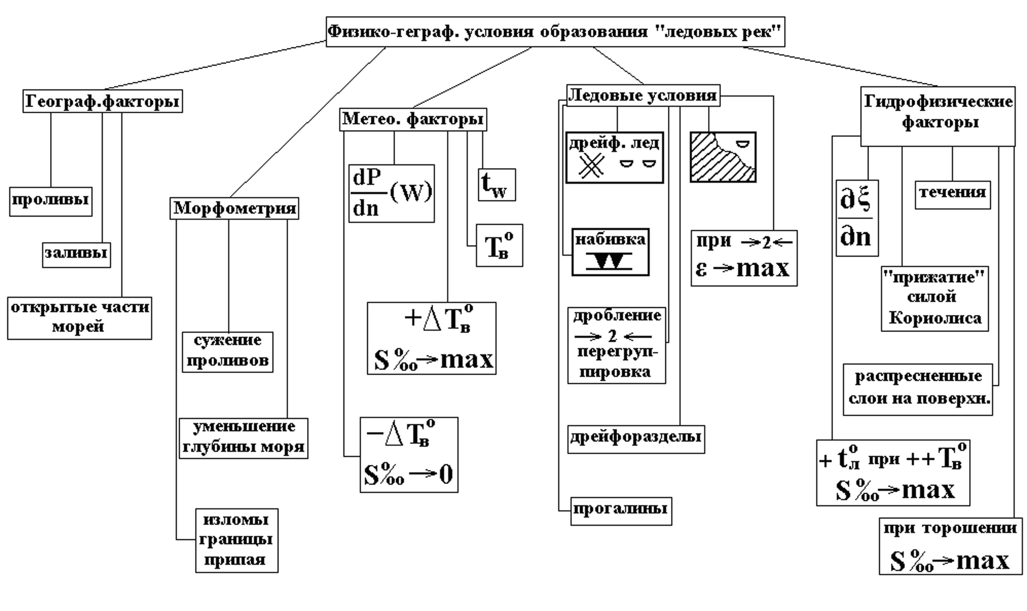
Fig. 3.5.1. Scheme of conditions, determining “ice rivers” formation.

Name of phenomenon (“Ice river”) is conventional, so using sea dynamics terminology it can be defined as extreme ice drift in boundary stream currents in a sea with strongly mixed layers, making an effect of “Pure sliding” in layer of density jump and surge effect with compacting along boundaries of close floating ice or fast ice in open regions of the freezing seas, gulfs and straights.
This complex of hydrometeorological conditions and their variability in the Arctic Seas exist quite often. Thus, total probability of “Ice river” formation is quite high, especially under at least partial combination of the listed hydrophysical factors.
Probably this phenomenon occurs quite often and visual information about it can be found on ice, as a “remained trace” of past “Ice rivers”. It means that sections, separating areas with different ice drift fields, which present frozen-up ridges of ice cake and small ice cake, located along coastal boundaries of fast ice or directly at the edges of large close ice formations, are often observed from airplane or ship, and visually look like boundaries of “Ice river”. Probably, this phenomenon occurred in other regions, but ice material was prepared for “Ice river” formation during quite long period. However, it is more probable, that this process occurred with beginning one of the hydrophysical factors (Fig. 3.5.1).
Anyway, sections, separating areas with different ice drift fields, are the indicators of high flow velocity in the past, because their typical feature is elongation (rectilinear) for several kilometers, and sometimes for tens of kilometers. Above all, large ice breaking degree after compacting and presence of (like “buffer” zone) near the ice edge point to phenomena like “Ice river”, which happened in the past.
Attendant hydrometeorological features in the entire history of the Arctic navigation are mentioned and recorded quite rarely. It can be explained by two psychological reasons.
Firstly, sailors were careless in recording attendant hydro meteorological conditions and especially in measuring their characteristics, after they had happily overcome a dangerous phenomenon.
Secondly, sailors unconsciously avoided regions, where “ice rivers” could occur.
Analyze of materials shows that normal duration of “Ice river” existence is directly proportional to its spatial scale, and is inversely to flow velocity. Scales of horizontal vortexes depend on heterogeneity size: internal waves on frictional boundary of density jump layer, sizes of sharp bend of ice massif or fast ice boundaries, ice floes distribution by size.
Scheme of flow velocity interactions in “Ice river” v with the listed meteorological and hydrophysical factors is presented on Fig. 3.5.2. Scheme of “Ice river” flow velocity dependence on meteorological and hydrophysical factors is presented in Fig. 3.5.2. Values of appropriate features, known from observation archive, are located in exponential stripe. The shown dependence is qualitative and gives correspondence of scale of listed factors changes, because they are mostly evaluative and non-instrumental. Apart from that, the other vertical axes do not directly depend on horizontal axes. They are only directly proportional to each other.

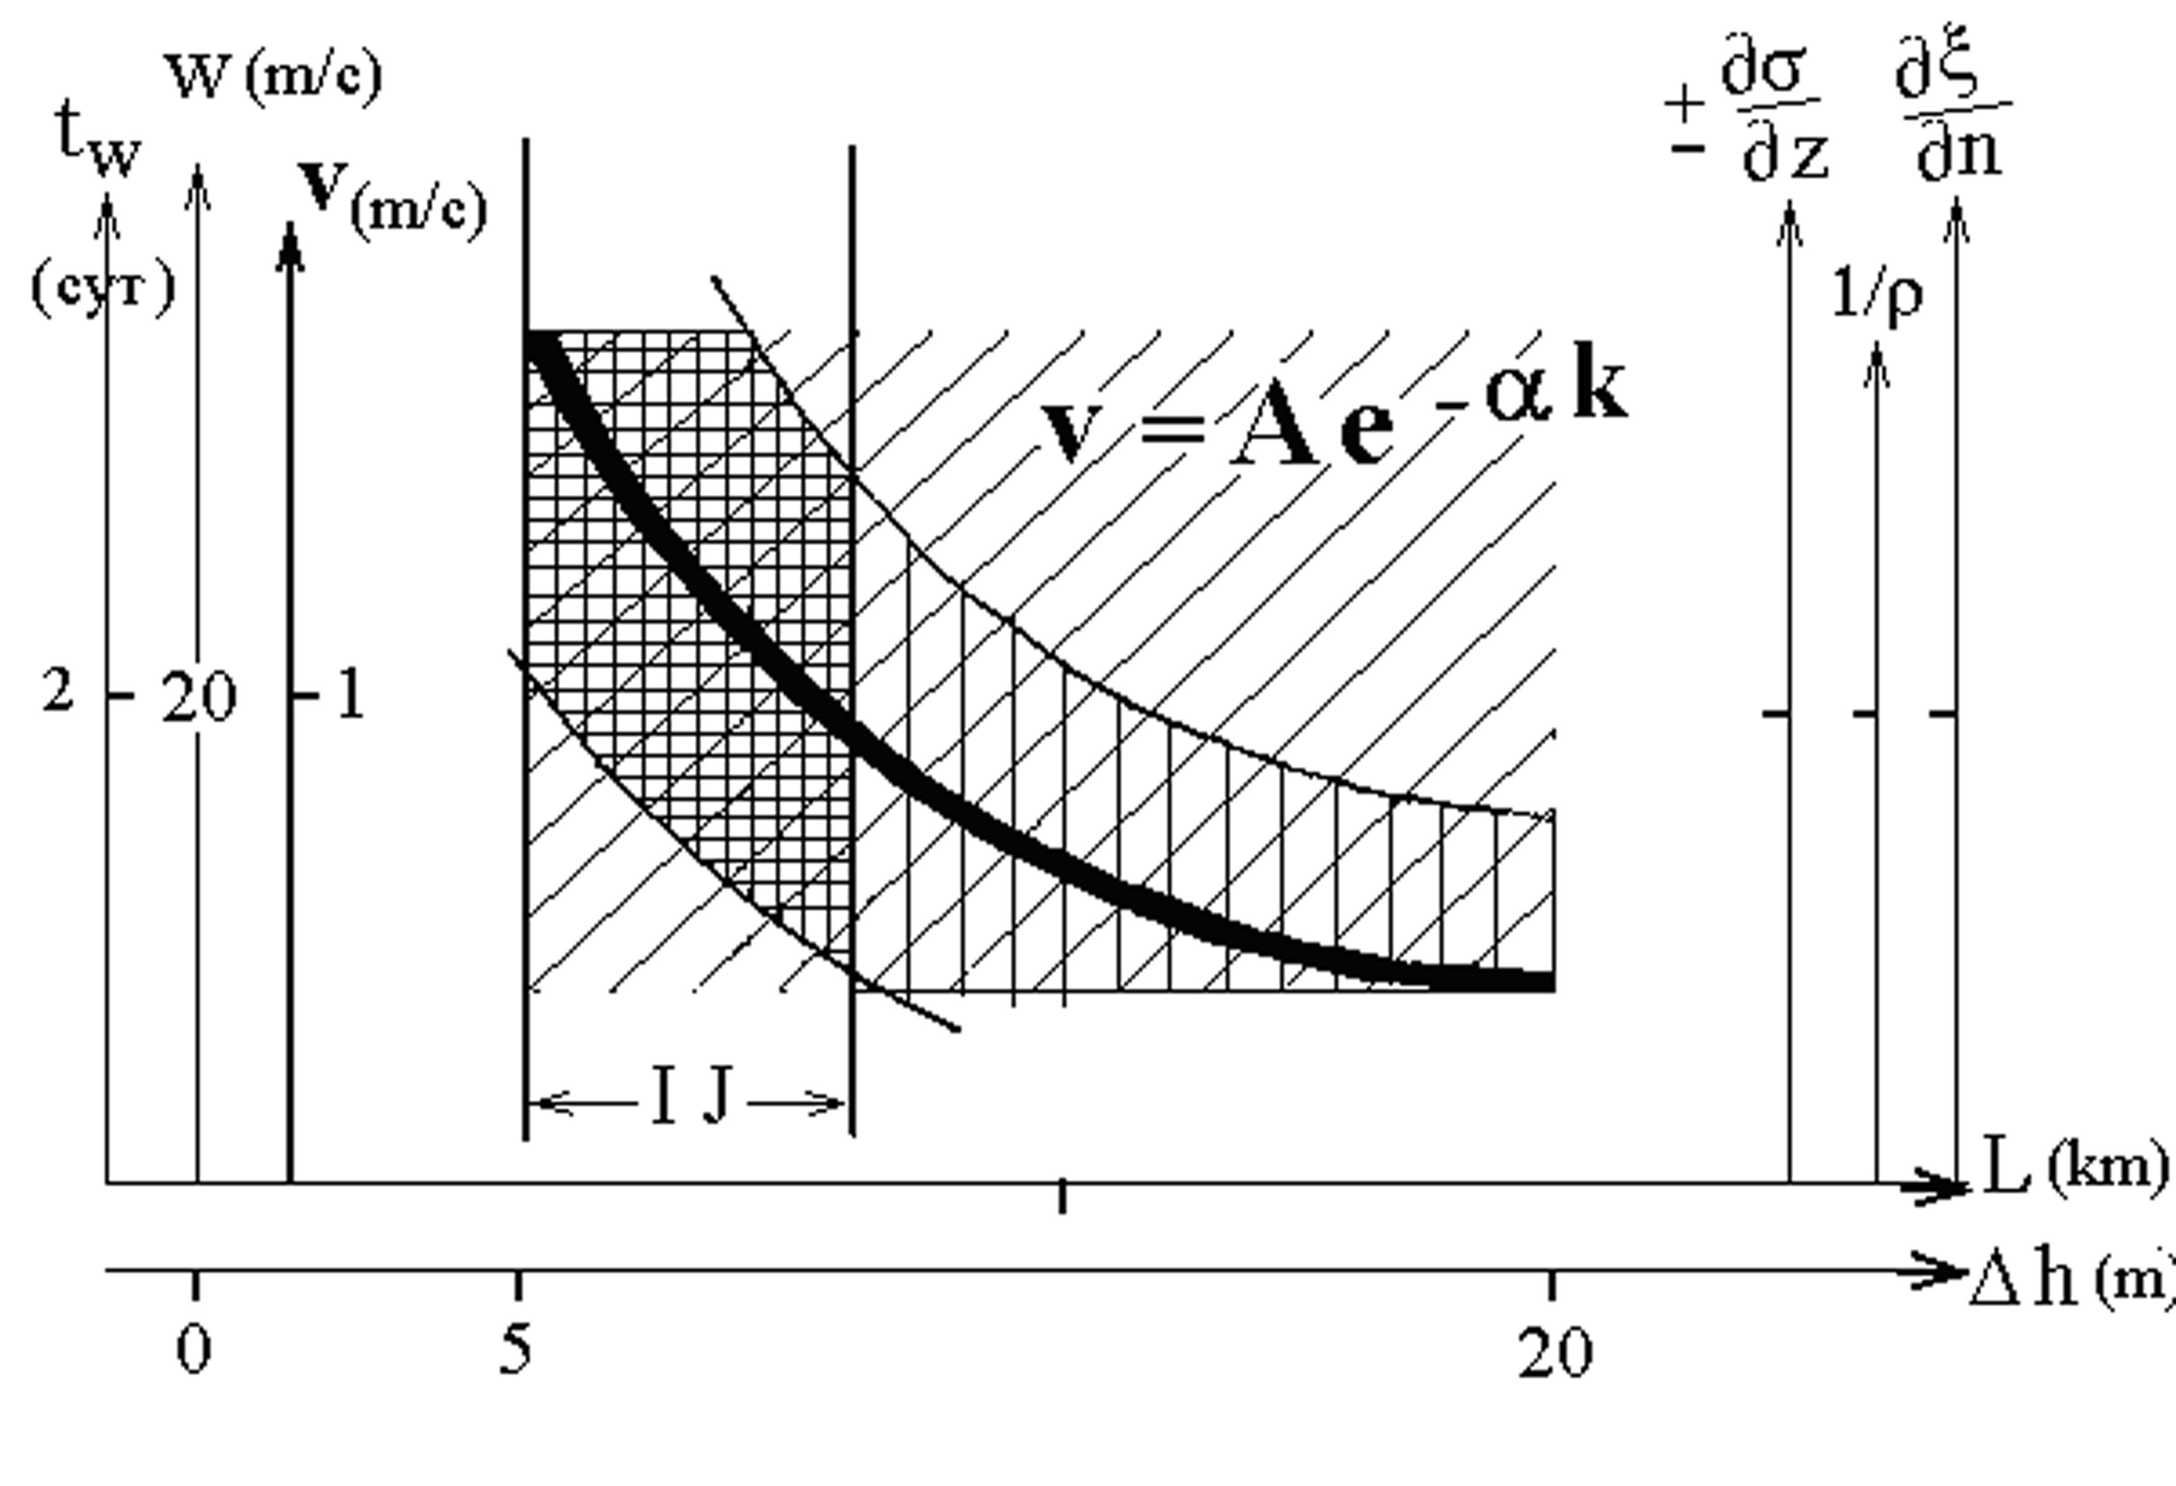
Fig. 3.5.2. Dependence scheme of flow velocity v in “ice river” (I J) from wind force w , duration of wind activity t_{w} , water density gradient σ , level denivelation ξ , ice floes breaking value ρ , flow scale L and flow depth Δh .

Parameters of the factors, given on Fig. 3.5.2 from incomplete data archive, in general corresponds to the listed scheme, though they should be specified theoretically and experimentally. It is obvious, that “Ice river” boundaries (IJ – Ice Jet) are diffused according to all listed in the Figure parameters, because they were specified heuristically. General scheme of ice and wind conditions, and flow itself (IJ) in the “Ice river” region is presented in Fig. 3.5.3. and Fig. 3.5.4. (1, 2) points (d, e,g).
Vertical structure of “Ice river” should be considered – its vertical profile along the motion axis under one force and wind direction W_{r} for two variants (1 and 2) of salinity and water density distribution and lubricant layer thickness of Δh.
Water density distribution σ in the left part of (1) in Fig. 3.5.4. according to hydrophysical factors corresponds to point (d) and this process occurs in summer-autumn period. Processes, connected with sharp changes of air temperature and winter ridging are shown in the right part of Fig. 3.5.4 (2) and correspond to hydrophysical conditions of salinity maximum and minimum in surface under-ice layer according to points (e) and (g). All this takes place in autumn-winter period. The largest amount of originating “Ice rivers” fall on this autumn-winter-spring period (points (d, e, g)). Other cases of “Ice river” origination (IJ) (points (a, b, c)) can take place in any season under appropriate hydrometeorological conditions.

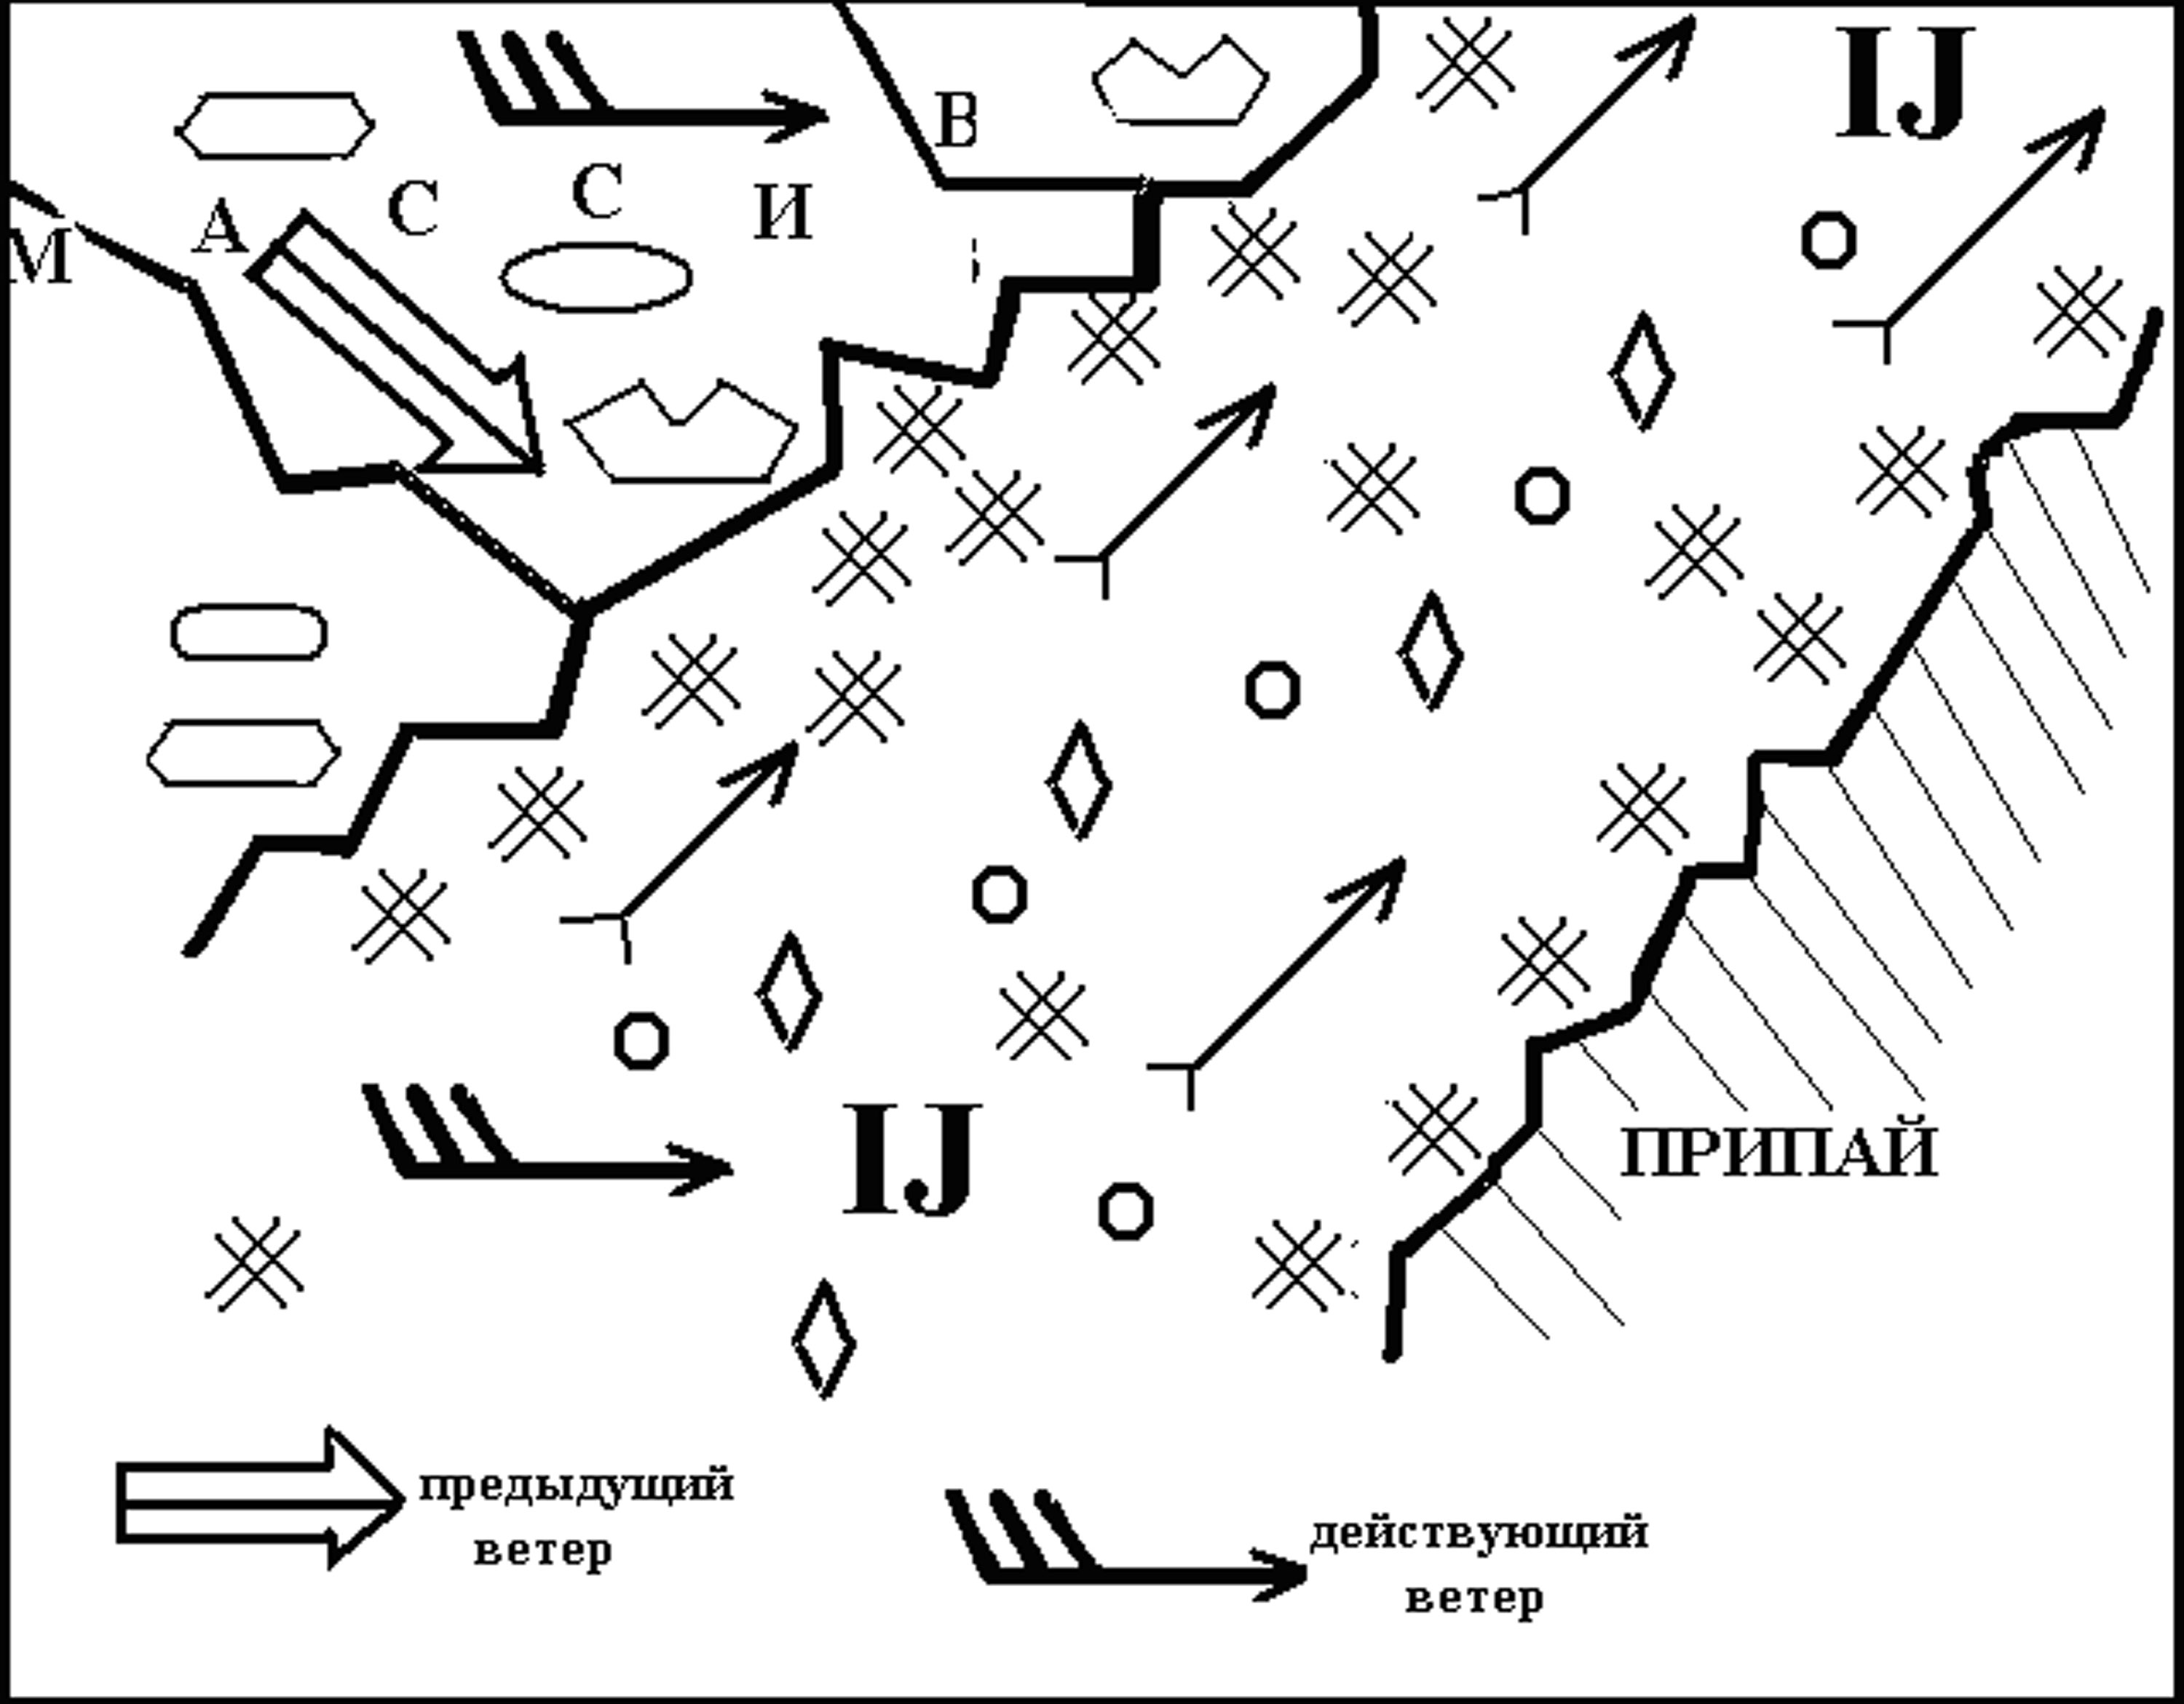
Fig. 3.5.3. General scheme of ice regime in the region of “ice jet” activity.

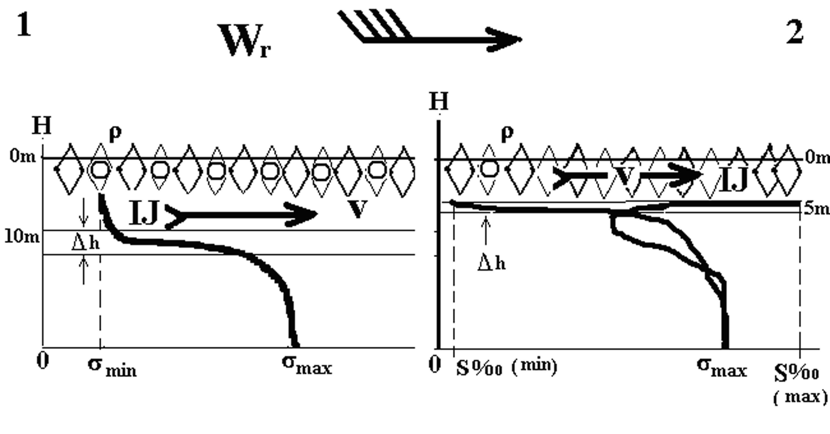
Fig. 3.5.4. Scheme of different variants (1) and (2) of “ice river” formation conditions (IJ) according to aspects (г, д, е) of hydro physical list in described before classification.

Water density distribution σ in the left part of (1) on Fig. 3.5.4 according to hydrophysical factors corresponds to point (d) and this process occurs in summer-autumn period. Processes, connected with sharp changes of air temperature and winter ridging are shown in the right part of Fig. 3.5.4 (2) and correspond to hydrophysical conditions of salinity maximum and minimum in the under-ice layer, according to points (d) and (g). All this take place in autumn-winter period. The largest amount of originating “Ice rivers” fall on this autumn-winter-spring period (points (d, e, g). Other cases of “Ice river” origination (points (a, b, c)) can take place in any time of the year under appropriate hydro meteorological conditions.
Above all, the thinner is lubricant layer Δh, the higher is “ice river” velocity (IJ) under other conditions being equal in any seasons, i.e. there is inverse proportional dependence v ~ 1/ Δh .
Scheme of “Ice river” flow velocity connections v with the listed meteorological and hydrophysical factors is presented (Fig. 3.5.4). Scheme of “Ice river” flow velocity dependence on meteorological and hydrophysical factors is presented in this figure. Values of corresponding characteristics, known from observation archive, are located in exponential stripe. This dependence is qualitative and gives correspondence of scales of changes of the listed factors, because they are mostly evaluative and non-instrumental. Apart from that, other vertical axes are not in direct dependence on horizontal axes. They are only proportional to each other.
Parameters of factors, which are given on Fig. from incomplete data archive, in general correspond to the listed scheme, though they should be specified theoretically and experimentally. It is obvious, that “Ice river” boundaries are diffused according to all parameters, presented in Figure, because they were specified heuristically. On Fig. 3.5.5 a chart of probable “Ice river” formation is presented under particular synoptic conditions as an example.
According to evidences of captains of diesel and nuclear icebreakers, participated in transport ships steering in the western sector of the Arctic during last years “Ice rivers” quite often significantly complicate navigation operations. Navigation is especially complicated in the regions of Yugor Shar Strait, Kara Gate and approaches to Dixon Island (mostly from the south), in the straights of Nordenskjold archipelago and others.

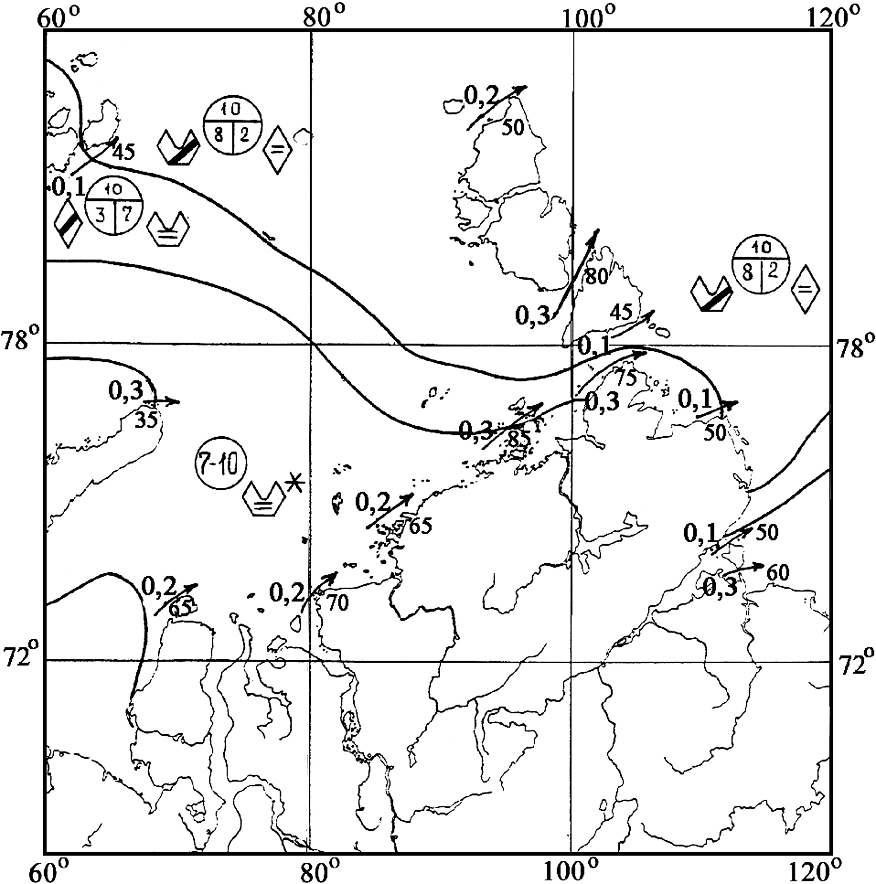
Fig. 3.5.5. Probability chart (0-1) of “ice river” formation in the Kara Sea under strong south-western wind in autumn. Two-digit numbers (35 – 80) - probabilities (per cent) of
(IJ) occurrence in local regions.

3.5.3. Snow-ice “pillow” adhesion with a ship hull

Snow and ice adhesion with a hull of icebreakers and transport ships during their sailings in autumn-winter period is a typical phenomenon. It is rarely observed in spring, only in cases of new ice (grease ice, nilas and grey ice) formation in polynyas and fractures.
During summer period of navigation this phenomenon usually is not observed. Process of snow-ice “pillow” adhesion to a ship hull consists of two stages:
1. Adhesion of crushed ice-snow conglomerate to a ship hull and rapid growth of its mass to length and width (contact of the surfaces ice – steel).
2. Freezing of ice pieces together in the entire monolith, composing body of snow-ice “pillow” (contact of the surfaces ice – ice).
Typical features of ice adhesion to a ship hull are suddenness of snow-ice “pillow” formation, and its avalanche-like increase and large force of ice adhesion to a ship hull.
The largest frequency of occurrence of adhesion is observed at the ship bow, where stress is stronger. Snow-ice “pillow”, formed near stem, propagates along shipboards to the midship. Cases, when ice adheres along the entire shipboard are observed very seldom. Frequencies of adhesion occurrence from the port side and from the starboard are approximately equal. Adhesion size on the port side and on the starboard can be different. Adhesion width can reach 15 m on one side, and less than 1-2 m on another at the same time.
Adhesion intensity is estimated by different features, which accounts spatial-temporal scale of phenomenon and force of ice adhesion to a ship hull.
- Weak adhesion – episodic adhesion, occurring once in 10-15 minutes on small areas of shipboard (1-2 m width and 3-5 m length). If snow-ice “pillow” hits channel edge during motion, it easily and completely separated from the ship falls off.
- Average adhesion. It is formed every 5-10 minutes and its size is 2-4 m width, and 5-20 m length. Ice is separated from the ship only after repeated reverses.
- Strong adhesion. It is formed continuously, along the entire shipboard, and its width is more than 4 m. After reverses it doesn’t completely separate from the ship.
Typical ice conditions, when adhesion is observed, are divided into three main types.
- Jammed brash barrier from grey and grey-white ice, occurred when compacting is up to 2 marks. Adhesion is intensive, and width of snow-ice “pillow” is in the range from 2 to 10 m.
- Ice brecchia of jammed brash barrier, ice cake, small ice cake, thin and medium first-year ice with snow depth more than 15-30 cm. Adhesion is intensive, and width of snow-ice “pillow” is more than 4-5 m.
- Thick first-year ice with snow depth more than 20-40 cm. Adhesion is of short duration and weak if compacting is absent. If compacting is up to 2 marks, average adhesion is possible.
The strong and average adhesion is observed for the following characteristics of ice conditions: ice concentration is 10/10-th, ice thickness is 30-70 cm, ice ridging is 2-3 marks, ice compacting is up to 2 marks, and snow cover depth on the ice is 30-40 cm and more.
Phenomenon of icebreakers and transport vessels adhesion essentially determines technical capabilities of their operation.
Adhesion with average intensity reduces velocity of “Moskva” type icebreakers up to 1-3 knots during their sailing in grey-white ice. When adhesion is absent, its velocity is about 10 knots in the same ice conditions.
Typical example of snow-ice “pillow” formation at the board of icebreaker “Kapitan Dranitsyn” during its sailing in the Laptev Sea is shown in Fig. 3.5.6.
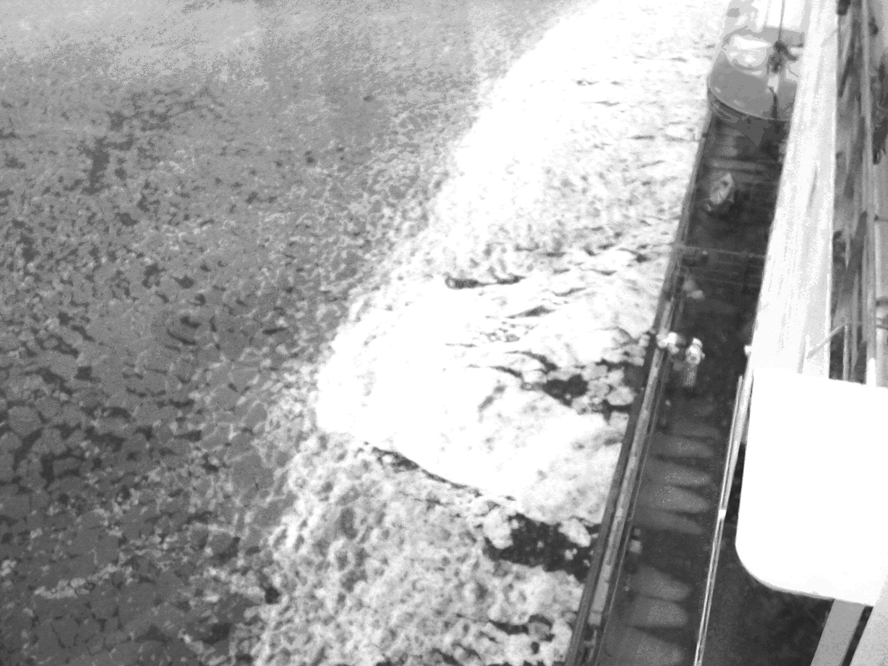
Fig. 3.5.6. Example of icebreaker hull “Kapitan Dranitsyn” covering with ice in the northern Laptev Sea (coordinates 79⁰ 15¹ N, 125⁰ 47¹ E) on the 2nd of September, 2003 with nilas. Top view, along the board. Intensive white part along left bow of icebreaker – snow-ice pillow.

Ice adhesion to the ship hull limits technical capabilities of icebreaking and transport fleet operation, as well as lead to emergencies. Sudden stop of icebreaker is a typical situation, when adhesion begins. It presents a real threat of collision with a steered ship, which can’t avoid piling. This danger is aggravated by ice compacting during adhesion, i.e. when steering distance is suddenly reduced (distance between hulls of ships). Number of emergency cases due to ice adhesion to ship hull amount to 10% of the total number of crashes, caused by ice conditions. Strong and average ice adhesion to ship hull is regarded as dangerous ice phenomena, due to its influence on navigation safety.
In order to remove a “pillow”, adhered to the ship hull, a navigator has to use reverses and engage a trimming system. Nevertheless, most “favorable” conditions for snow-ice “pillow” formation occur during “forward – back” motion in a channel with crushed small ice cake. Thus, ships less suffer from adhesion effect during sailing in undisturbed ice parallel to a channel, than in the channel filled with crushed small ice cake.
Intensity of snow-ice “pillow” formation, according to natural observations, depends on technology of making channel in compact ice. When icebreaker speeds up in compact ice, it “gets stuck” by waterline perimeter. It makes favorable conditions for snow-ice “pillow” formation. Thus, practical resume can be made: to reduce possibility of ice adhesion during making a channel, it is necessary to work as “chopper” or make a channel, as wide as possible, limiting icebreaker’s path by reducing its power.
State of hull surface (its deterioration) significantly influences adhesion process, i.e. roughness degree of connecting surfaces. If roughness increases, ice adhesion to hull increases.
Using probability maps of strong and average ice adhesion to ship (icebreaker) hull provide for estimation of typical ice conditions for its formation.
Natural studies of ice “pillow” formation conditions were carried out during voyages of icebreakers “Lenin”, “Sibir’” and “Arktika” in different regions of the Kara Sea. The results showed, that in spite of differences in morphological ice characteristics and thermohaline structure of surface water layers, a thick shuga layer or intrawater ice layer of several meters thick, consisting of small isometric crystals not more than 5 mm in diameter, always persist under ice during formation of this phenomenon. As a result of ice drilling it was found that the thickness of snow-ice “pillow” itself can reach 6-8 meters, and 80-90% of it consists of these crystals, which hold large ice pieces on its surface.
Based on the studies of this ice formation phase composition it was concluded that the mechanism of ice adhesion to a ship hull origin must be connected with dynamic conditions of ice formation, providing formation of shuga or intrawater ice layer under the ice cover. This conclusion is confirmed by fact, that in most cases this process is observed during lead formation due to dynamic motion of the ice and formation of open water areas. The Northern Sea Route passes through the marginal areas of drifting ice massif and areas of flaw polynyas, where the most intensive formation of intrawater ice and shuga is observed, and therefore the equal probability of the ice adhesion phenomena occurrence along the entire route looks reasonable, which is confirmed by long-term statistical data.
Results of the long-term laboratory experiments and natural studies allowed making several conclusions about conditions of ice adhesion to icebreakers and ships in the Arctic Seas:
1. Beginning of ice adhesion phenomenon can take place under different hydrometeorological and ice conditions.
2. Lack of changes in vertical distribution of temperature gradient along the ship hull and values of electric potentials difference under its interaction with the ice at the moment of ice “pillow” formation evidences that these two physical parameters can’t be the first cause of the phenomenon under study.
3. Thermohaline stratification of intrawater ice and shuga in the under ice layer can significantly facilitate occurrence of ice adhesion phenomenon.
4. Mechanism of contact occurrence of intrawater ice and shuga with a ship hull, causing ice “pillow” formation, must correspond well with observational results:
а) if icebreaker speed increases, ice contact with metal disappears;
b) absence of intrawater ice and shuga crystals freezing between itself, and with pieces of the ice and icebreaker hull in ice “pillow”;
c) asymmetry of ice “pillow” formation during work even in the same part of ice cover;
d) ice compacting facilitates ice “pillow” formation, and its fracturing and break up destroys it.
Map of the Kara Sea, where natural tests (measurements of snow-ice “pillow” parameters) in different sea regions in different years were carried out from the nuclear icebreakers “Lenin” and “Arctic” is presented in Fig. 3.5.7.

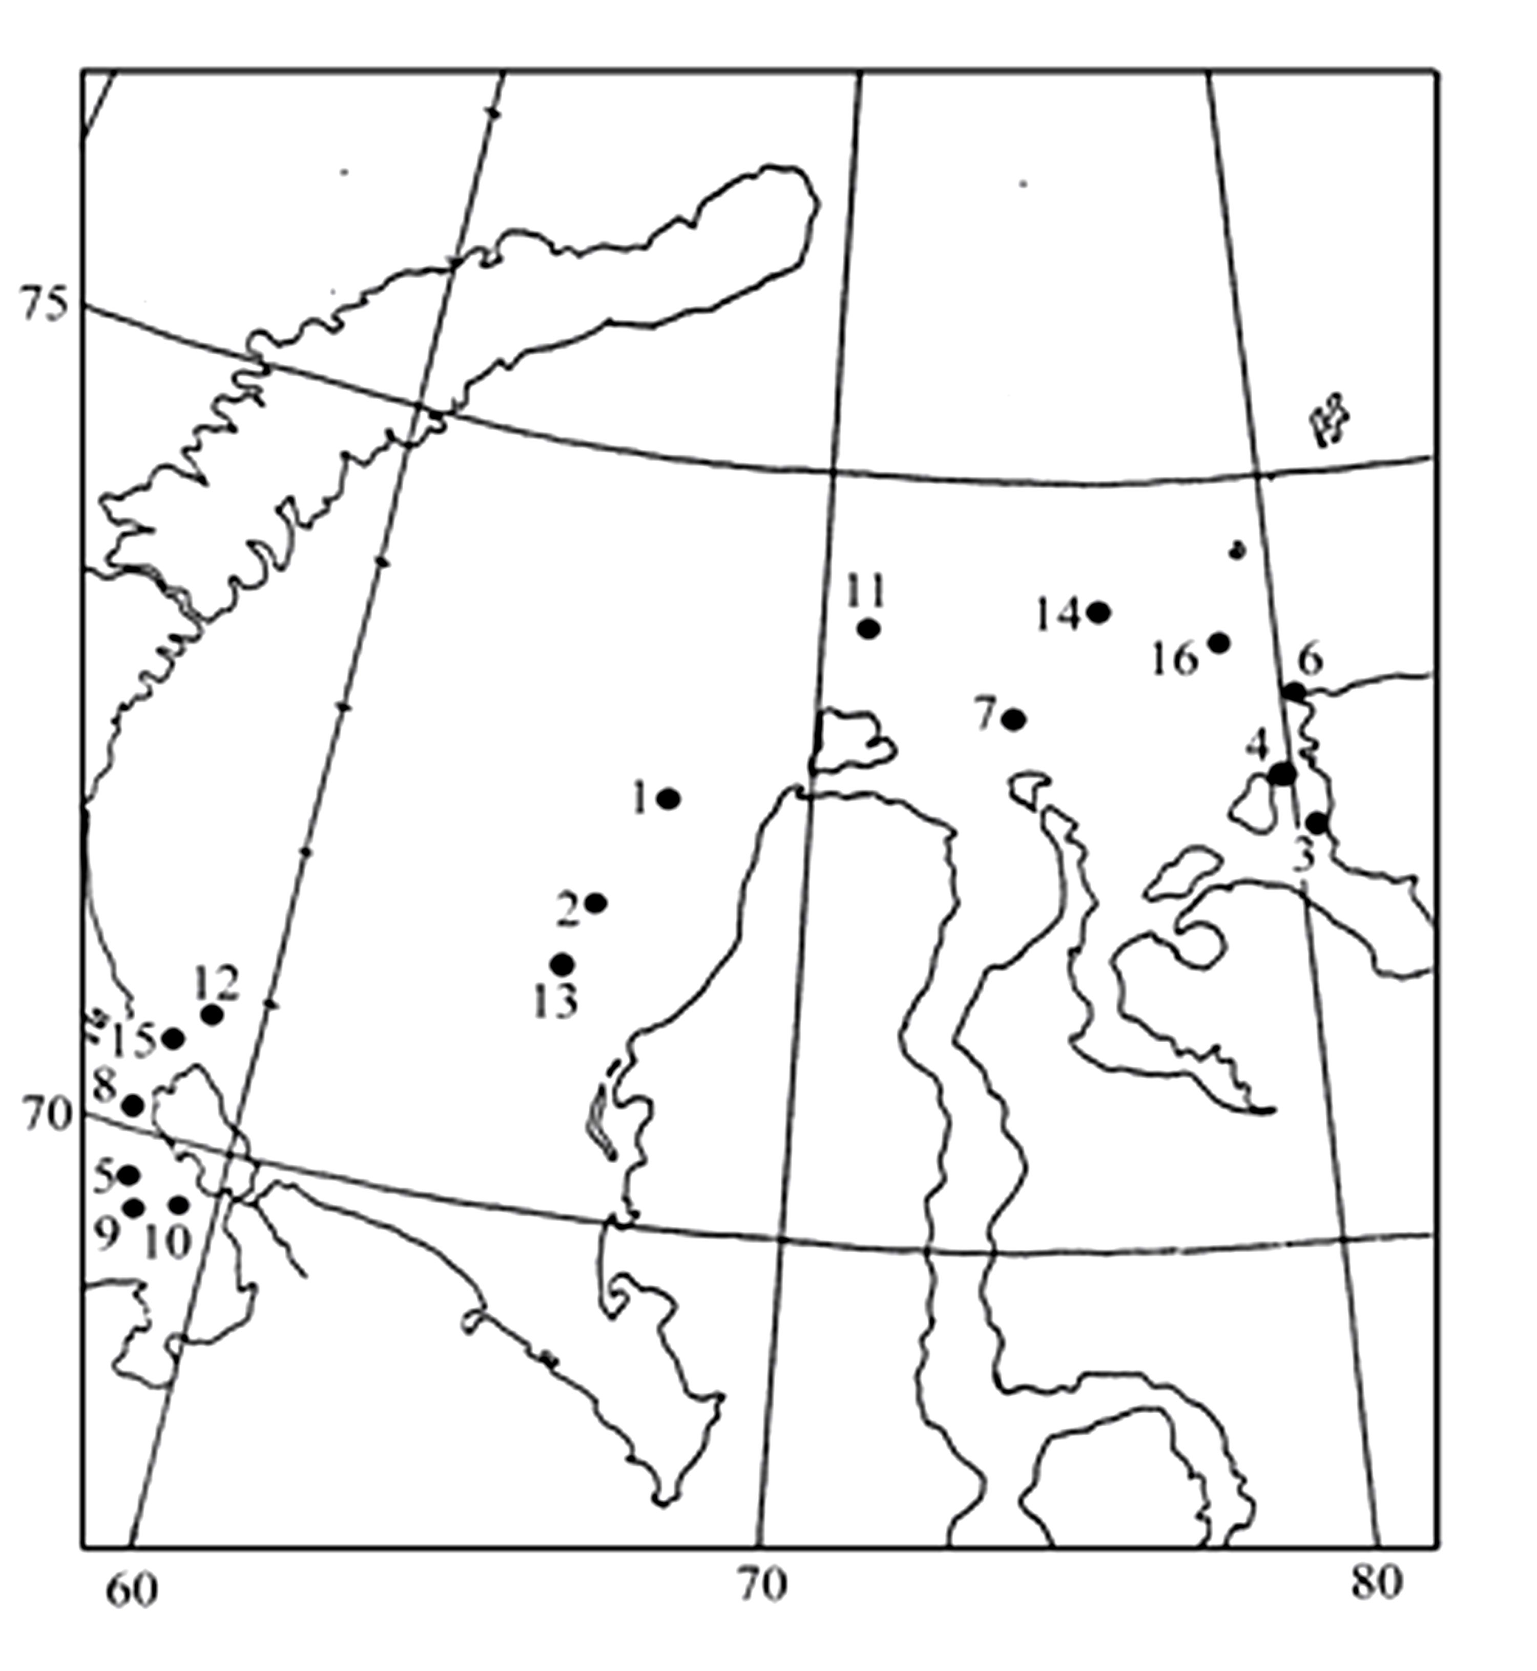
Fig. 3.5.7. Location of points, where field observation of NIB “Lenin” hull covering with ice occurred in December-January, 1987-88 (points 1-10), and NIB “Arctic” in December-January, 1988-89 (points 11-16).
Since in ice brecchia of thin and medium first-year ice with thickness of 50-100 cm, where ice “pillow” is formed most often, the icebreaker moves with speed not more than 5-6 knots, the value of dynamic flow pressure amounts to 0,004 МРа. It is almost half of the force of ice crystals film interaction with icebreaker hull, which for the listed conditions can amount to 0,008 МРа. However, in the period of field observation conducting, in two cases from 16 (points 7 and 12 in Fig. 3.5.7) works were carried out on ice brecchia of grey-white and thin ice with a thickness of 30-35 cm, under which even shuga layer with a thickness of 2,5-3,0 m was observed. During icebreaker motion in it with a speed of 12 knots ice adhesion was not observed. Only typical motion of ice pieces along hull on distance of 5-10m was observed. When the icebreaker reduced a speed to 5-6 knots, ice “pillow” was formed, and icebreaker lost speed completely. When it started motion using full power the similar picture was observed.
Thus, conducted field observations completely approved an influence of water flow specific pressure on formation of initial layer of ice “pillow”, which had to be formed with increasing value of this parameter up to 0,019 МРа.

