3.6. Ice effect on engineering constructions

3.6.1. Vessel classification.

Observations of creation and implementation of rules and recommendations of vessels projecting and operation are regulated by “Rules of projecting and classification of vessels”. Special classification organizations look after their compliance: English Lloyd, American Bureau of navigation, Norwegian VERITAS, German Lloyd and Russian Marine Navigation Register. At first these classification organizations (except of RMNR) were established as national insurance companies. Then, vessels classification on the basis of many features became necessary to fix insurance premium due to development of navigation and shipbuilding. It’s incorrect to fix the same rate of insurance payment for loss/damage of cargo or ship itself for vessels, which size differs a lot. The most essential feature for ships of transport fleet is their displacement, which approximately determines amount of transported cargo.
Another essential feature is a ship construction, which mostly determines ship hull strength, possibility of safety navigation in rough sea, cruising range, and finally terms of ship exploitation. This is particularly important for ships navigation in ice. Any ship, designed to navigate in the ice, must have appointed ice class of Register or other classification organization. This class establishes requirements to amount of ship hull strengthening due ice impact to correspond the necessary level of ship hull strength, which is additional to that for ships without ice class. There are other requirements to screw propeller strength, power capacity, etc., but the main one is to the ship hull strength.
Technical detail design of the ship is presented to the Register for technical examination and approval before ship constructing. The Register inspection employees observes constructing works, and ship can’t be delivered to customer for exploitation, and further it can’t put to sea without special examination and permission of Register, attesting appropriate technical condition of a ship, which guarantee its safe exploitation. RMNR is not only an insurance company (as other foreign classification organizations), but ship must obligatory receive the Register class to negotiate an insurance contract and obtain insurance payments for loss/damage of cargo or ship. Ship, which wasn’t registered in any classification organization, would be some kind of «Flying Dutchman», with a difference that this hypothetic ship physically did not exist, but threatened with its non-material phantom. Thus, our hypothetic ship can exist physically, but either sea administrations or cargo owners won’t “see” it without having a juridical person.
Ship classification and rules of their construction have a long history of more than 200 years. History of projecting, building and operation of engineering constructions for the sea shelf is much shorter. The first “Rules of classification, building and equipping of floating drilling constructions and marine stationary platforms” by RMNR were published in 2001.
The clause 3.10.1.2 in chapter 3.10 “Ship strengthening for navigation in the ice” of the Rules of Register (edition of 1990), states: «These rules regulate a minimum necessary strength level under effect of calculated ice load and ship construction depending on sign of the category mark of ice conditions in symbol of its class”. At that, it means that ship owner would operate a ship according to its passport, developed by competent organization, which specifies condition of safe ship operation in the ice, depending on sign of the category of ice strengthening, ice conditions and icebreaker support”. As it follows from the text, RMNR provides minimum margin of projecting/building safety for ships in these rules. Other competent organizations, firstly, AARI (presented by its main structural subdivision – department of ice states of ships) develop recommendations of safe navigation regimes in specific ice conditions.
Theoretical tasks to determine forces, occurring during ship push on the ice, solved at AARI in the 60s of XX century, allowed calculating ice loads for different types of contact at a good theoretical base. Levels of construction strength were set to efficiently resist loads. Ship hull strength to ice impact became a new field of studies. At the same time semiempirical method to calculate ice resistance to ship motion was developed, using possibilities of model experiment in the ice basin, and the independent field of hydromechanics – ship motion in the ice was established.
Peculiar features of operation and designing ships for navigation in the ice are exceptionally caused by ice cover existence in the Arctic Seas, at that, in several regions of the Arctic Ocean ice is observed all the year round.
Two directions of studies, described above – ship hull strengthening and ship motion in the ice are based on analysis of the processes of ship hull interaction with the ice. Classification of ice conditions as an environment for ship sailing was developed based on these results. It is different from the ice nomenclature, and depending on deformation type and ice melting, it can be subdivided into three categories: close ice, medium floes, small floes and ice cake.
Close ice is understood here as fast ice or floes of drifting ice, which are destructed during ship motion as a result of flexural strain. Depending on ship speed and ice thickness, minimum floe size was determined, which ship overcomes as “close ice”, i.e. when floe isn’t split by cracks.
Ice cake is an ice floes accumulation, and they cannot be destroyed by flexural strain due to their small size even with their relatively large thickness. Ice is just separated apart by ship hull and partly sunk. In this case main components of ice resistance to ship motion are components of ice floes separating and sinking.
Small floe – is ice, where ship motion is characterized by processes, typical for both close ice and ice cake.
Naturally, methods of ice resistance calculation to ship motion in listed conditions were developed, i.e. methods of ship velocity calculation in these conditions – ship motion in the ice. It is essential, that ice loads on ship hull and construction response – ice strength - were calculated for cases of ice motion in these conditions.
Important nomenclature characteristic of drifting ice, which should be taken into account in the calculations, is concentration – the ratio expressed in tenths describing the amount of the sea surface covered by ice as a fraction of the whole area being considered. Compact drifting ice has a concentration of 10/10-th and no water is observed. Close ice is a drifting ice with a concentration of 7-8/10-th, composed from ice floes, contacting with each other. Open floating ice is a drifting ice with a concentration within 4-6/10-th with large amount of fractures; ice floes don’t generally contact with each other. The next in the nomenclature is very open floating ice (1-3/10-th) and open water – less than 1/10-th.
Very important phenomenon is also ice compacting, which is related to dangerous ice phenomena and significantly complicates navigation in the ice. It obliges a designer to strengthen midship according to requirements of RMRN. Classifying, unfortunately, is qualitative and by external features and is estimated by three-point scale.

3.6.2. Typical regimes of ship operation in the ice.
3.6.2.1. Uninterrupted motion in compact ice.

This regime is typical for icebreakers and ships of active ice navigation, i.e. ships, which have relatively high ice class. In this regime (due to icebreaking form of bow line) ice is destroyed by flexure due to occurring vertical forces. Ice loads at that are not large and can’t be determining in the calculation of hull construction strength. However, this regime (regime of uninterrupted motion in the ice) most accurately characterizes ship passability through the ice – its ability to overpass the ice. Only during motion in level compact ice three main parameters can be rather accurately measured: ice thickness, power of energy installation and velocity of stable ship motion under these conditions. Curves of ship passability through the ice can be drawn based on these three parameters. Maximum ice thickness, which ship overpasses by uninterrupted course with stable velocity about 2 knots, is accepted to term as maximum ship passability through the ice.
The maximum ship passability through the ice is a passport characteristic of a ship, though in real conditions compact level ice is rarely observed.

3.6.2.2. Ice destruction by runs.

This regime is typical for icebreaker operation, when it can’t move continuously. At that, the largest ice loads occur, when icebreaker pushes the ice, but doesn’t destroy it, only crushing ice floe edge.

3.6.2.3. Motion in channel behind icebreaker.

It is one of the most important regimes of transport ships navigation under icebreaker steering. At that medium floes and ice edge in channel hit the hull of steered ship. In the last case ice loads can be high, what is approved by results of multiple natural tests of hull strength and analysis of ship damage, due to her piling on edge of ice floe. The variant of reflected blow in the channel edge, when ship is thrown from one safe edge of the channel to another, is the most dangerous.
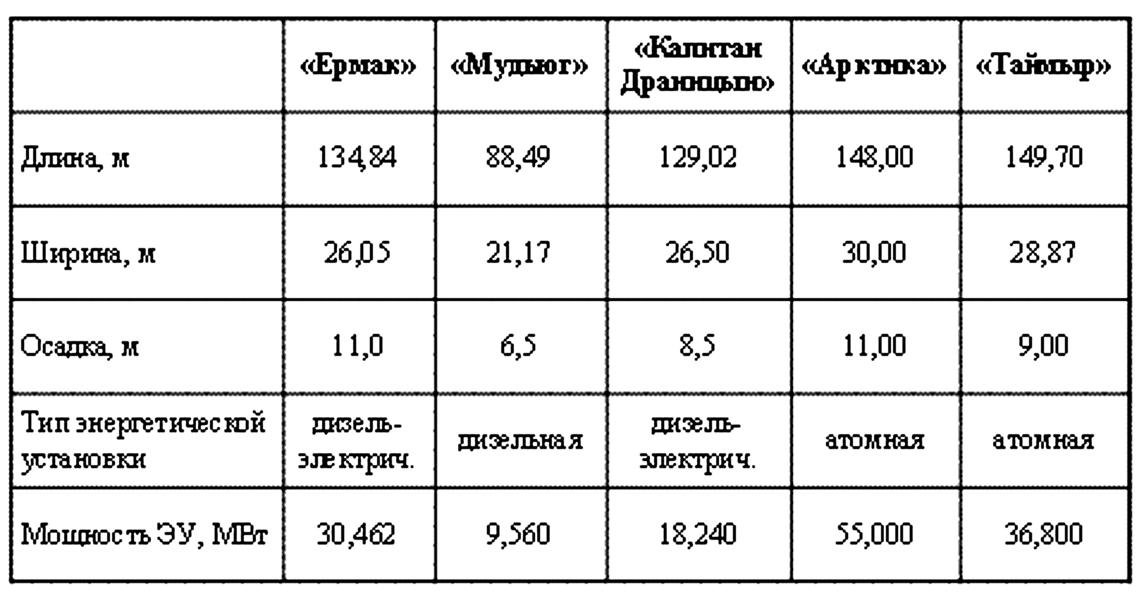
Fig. 3.6.1. Main types of the icebreakers

In this case, its value increases due to increase of cosine of resultant ice load direction. Ship steering by icebreaker is used in close drifting ice. In this case channel edge is formed by ice floes moved apart and broken by icebreaker. Taking into account, that they can be quite thick, and speed is quite high, blows in channel edge can also be dangerous.
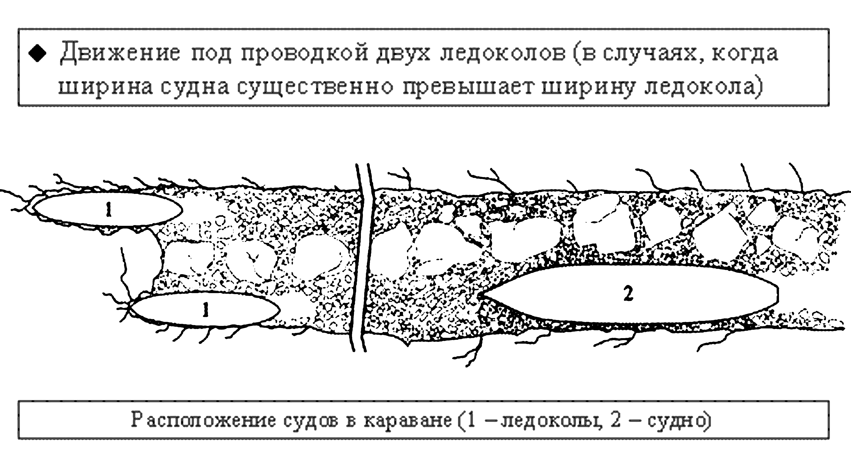
Fig. 3.6.2. Icebreaking convoy

3.6.2.4. Ship motion in drifting ice.

This regime is typical for both icebreakers and ships of all ice classes. Ship motion in floes of drifting ice can be quite similar to motion in the compact ice.
Navigation in drifting ice, depending on its concentration, has its own peculiar features, which should be carefully studied. Navigation in compact floating and close floating ice (when ice floes mostly contact with each other) is generally determined by ship passability through the ice and depends on engine power and hull shape. As a rule, considerable ice loads aren’t observed, because ship (in regime of autonomous motion) can’t develop high speed in thick ice, causing large ice loads. In thin drifting ice the situation is opposite. Under quite high speed, loads, destroying ice, are not large and aren’t dangerous for ship hull. Open floating ice is quite another matter. Ship can make quite high speed due to presence of fractures between ice floes. Sometimes navigator can’t reduce speed or turn aside from oncoming ice floe, which can be thick enough to have grave consequences.
Methods for determining maximum ship passability through ice should be presented separately. As mentioned, it is a passport characteristic of any ship. The only reliable method to determine it - natural testing of constructed ship in real operation conditions. It is necessary to mention, that in the 50s of XX century by special decision of Council of Ministers of USSR AARI was appointed a directing agency to be responsible for designing icebreakers and ice class vessels, designed and constructed for USSR on foreign and domestic shipyards. In the 60s USSR Ministry of Marine Fleet issued an order, stating that every lead ship of the ice class series must be tested in natural conditions, under the direction of AARI and according to program, prepared at AARI. Special time and ships (often distracted from main voyages) were fixed for these testing. At that one of the main tasks was determination of the maximum ship passability through the ice.
Level ice floes were chosen for testing (it is desirable in several thickness ranges). On every ice floe ship started to move using engine operative mode with step change of power. Each operative mode was changed, when ship passed not less than three lengths of its hull with constant speed using fixed power (in rudder position of “rudder straight”), i.e. motion regime was considered stable. Ice thickness, accompanying meteorological conditions and ship speed were recorded with the most possible accuracy. As a rule power and number of rudder revolutions were recorded from ship instruments. It was desirable to study several operative modes on each testing area, characterizing dependence of speed on power for given ice thickness. But it depended on thickness of level ice in the testing area: investigators received one or two points for ice thickness values, which are near the maximum for a given ship. The maximum ship passability through the ice, determined in this way, was both certificate ship characteristic and test of development work, which specified ice characteristics of the ship on stage of its designing.
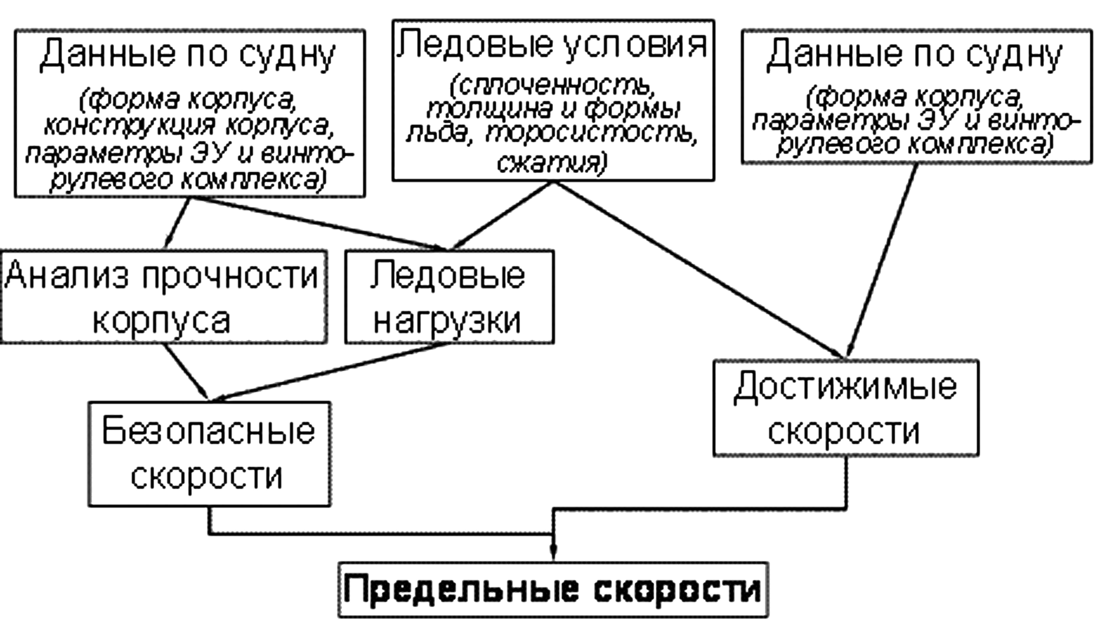
Fig. 3.6.3. Calculation of the ship velocity in ice conditions

The other method of ice characteristics of ships determination is the method of model testing in the specific ice tank. This method could be used after bringing into operation of the specific ice tank at AARI in 1955 – the first ice tank in the world. At the same time a methodic of ice modeling in this ice tank was developed. In compliance with the similarity theory, this methodic provided for compliance of geometric, kinematic and dynamic similarity criteria, which gave satisfying convergence of experiment results with nature.
The method is good in a way, that model testing is conducted on the projecting phase, and designer, accounting the experiment results, can correct the project and improve ice characteristics of the ship under construction. Accuracy of the of experiment results recalculations for nature depends on methodic of modelled ice formation, used in this ice tank. Shape of ship hull is optimized to reach maximum ship passability through the ice, based on the results of these tests. Minimum acceptable power of energy installation is established to provide specified ship passability through the ice; variants of rudder and screw propeller protection from ice are investigated. Shape of hull, ship passability through the ice, power and variants of screw propellers protection were worked out for both icebreakers and transport ships at the AARI ice tank. Model testing of transport ships (“Amguem” type) takes the special place in testing. Due to long series of model testing, ships of this type have better passability through ice, comparing with the more powerful (on 17%) prototype (diesel icebreaker “Lena”). Shape of “Amguem”type hull is admitted to be classic. More than 15 ships of these series were built. For many years they transported cargoes to the most distant settlements of the Russian Arctic in heavy ice conditions.
It is necessary to mention, that the first in the world ice tank of AARI became a prototype for designing and constructing many foreign experimental ice tanks. Similar tanks (in different variants of construction) were built in Finland, Germany, the USA, Canada and Japan. The International ice towing tank committee (ITTC) was established in 1970s. A series of comparative control testing of the same ship model were carried out in all ice tanks by ITTC initiative. The purpose was to inspect testing methodic in different ice tanks and methodic of model testing results recalculation to natural conditions. The results of testing in the AARI ice tank were admitted to be one of the best.
Possibility to check out the results of theoretical developments by model and natural testing data significantly advanced two main directions of providing ice characteristics of ship: ship passability through the ice and ice strength. In early 1970s an idea of ship “Ice certificate” was developed and realized in the department of ice characteristics of the ships. This idea was based on combined usage of ship passability through ice calculations, calculations of ice loads, analysis of hull reactions to these loads and calculations of safe speeds for ship motion in different ice conditions. Ice passport is a collection of recommendations to choose safe regimes of motion in different ice conditions for different ship types.
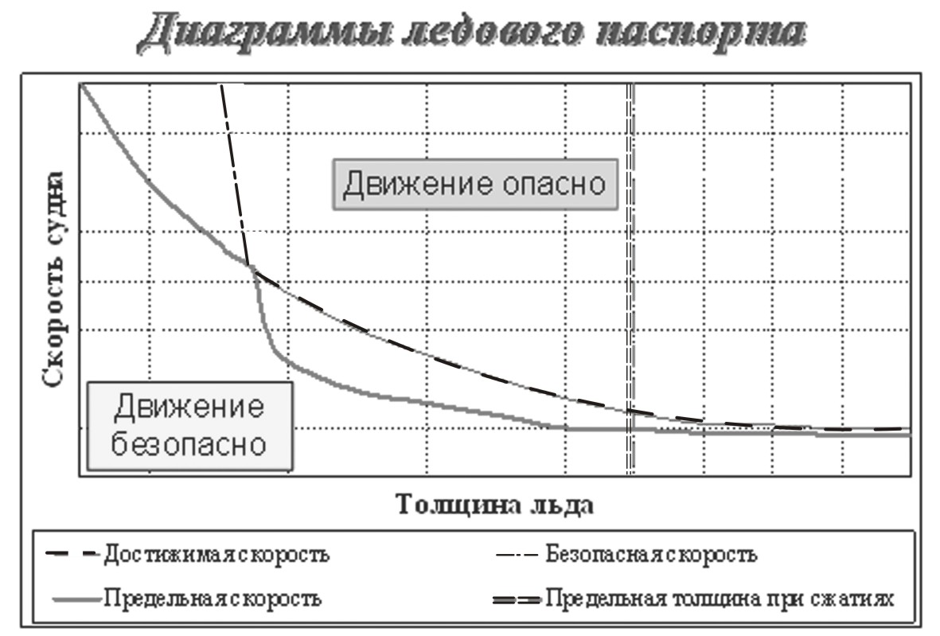
Fig. 3.6.4. Diagram of ice passport
First ice passport was developed by request of Murmansk Shipping Company for ships of “Pioneer Hero” series in 1974. There were already 10 ships of this series and significant part of cargo transportations in the NSR was provided by them. Natural testing was necessary for verification of calculation models of assessable and safe motion speeds. They were carried out in summer of 1973 onboard the motor ship “Shura Kober” during her Murmansk – Dixon – Tiksi – Igarka voyage. Tensometric testing of ship hull and ship passability through the ice were made during this voyage. In autumn testing was continued onboard “Tonya Bondarchuk”, which is of the similar ship type, in level young ice in the Yenisey Gulf and in the Kara Sea. Ice passport was developed and given to customer in 1974 on the base of testing. In fact, beginning from 1974 by requests of ship owners – Murmansk, Northern, Far Eastern and Primorsk Shipping Companies, one ice passport for particular type of ships was annually developed. Totally, ice passports were developed for more than 30 types of domestically produced and foreign ships.

