|  |  |  |
| --- | --- | --- |
| **WORLD METEOROLOGICAL ORGANIZATION**  **\_\_\_\_\_\_\_\_\_\_\_\_\_\_\_\_\_\_\_\_\_\_\_\_\_\_\_\_\_\_\_\_\_\_\_\_\_\_\_** | **INTERGOVERNMENTAL OCEANOGRAPHIC COMMISSION (OF UNESCO)**  **\_\_\_\_\_\_\_\_\_\_\_\_\_\_\_\_\_\_\_\_\_\_\_\_\_\_\_\_\_\_\_\_\_\_\_\_\_\_\_** | |
| EXPERT TEAM ON SEA ICE – FIFTH SESSION  STEERING GROUP FOR THE PROJECT  GLOBAL DIGITAL SEA ICE DATA BANK (GDSIDB) – THIRTEENTH SESSION  OTTAWA, CANADA, 25 TO 28 MARCH 2014 | | **ETSI-5/GDSIDB-13/Doc. 4.1.2**  Submitted by: Vasily Smolyanitsky  Date: 25.03.2014  Original Language: ENGLISH  Agenda Item: 4.1.2  4.3  Status: DRAFT 1 |

**REPORT FORM THE ARCTIC AND ANTARCTIC RESEARCH INSTITUTE**

|  |
| --- |
| Summary and Purpose of Document This document contains a report on sea ice activities related to the WMO Global Digital Sea Ice Data Bank project (GDSIDB) and JCOMM sea ice climatology during the current intersessional period, developed by the Arctic and Antarctic Research Institute of Roshydromet (St.Petersburg, Russia) |

**ACTION PROPOSED**

The Expert Team on Sea Ice is invited to:

* Note and comment on the information contained in this document, as appropriate;
* Provide guidance regarding future work of the WMO Global Digital Sea Ice Data Bank (GDSIDB) project and Expert Team on Sea Ice (ETSI) related to sea ice climatology;
* Prioritize the GDSIDB activities for the next intersessional period, together with the overall SFSPA Work Plan.

\_\_\_\_\_\_\_\_\_\_\_\_\_\_\_\_\_\_\_\_\_

**References:**

None

**Appendices:**

None

**DISCUSSION**

**Background**

1. During the past intersessional period the AARI World Data Center Sea Ice (WDC SI) department continued to provide informational support to the WMO “Global Digital Sea Ice Data Bank” project including national and international operational and climatological activities in terms of standards, collections and presentation of sea ice material.

2. The WDCSI provided general logistics support for sea ice climatological activities at AARI while the major umbrella for collection, informational exchange and publication of sea ice material remained the GDSIDB project, initiated in 1989 by the WMO CMM to support World Climate Research Program (WCRP), supervised before 2001 by the WMO Commission for Marine Meteorology (CMM) Sub-Group for Sea Ice (SGSI), and after 2001 – by Joint WMO-IOC Commission for Oceanography and Marine Meteorology (JCOMM) Expert Team on Sea Ice. Simultaneously, requirements from the Russian federal program ESIMO – Unified Information system on the World Ocean provided impetus and technical specifications for development of techniques of sea ice data processing and publication.

3. Accepted by the WDCSI paradigm for informational support, which differentiate WDCSI from the similar climatological center worldwide, is:

* Support for all historical ice charting collections and datasets in the WMO exchange formats, regardless of its version;
* Support for sea ice climatology based on ice charting;
* Provision of both ‘simple’ and ‘full’ interfaces to ice charting collections with unrestricted (at most of the cases) access;
* Implementation of user interfaces on a basis of OGC (Open Geospatial Consortium) open source software.

*Sea-ice standards*

4. Support for the general standards for sea ice informational exchange and presentation constituted the first part of the WDCSI work. By October 2013 all 3 volumes of the major WMO sea ice standard – the “WMO Sea Ice Nomenclature” (WMO/OMM/BMO - No.259) are available in electronic form (Vol. I – Terminology, Vol. II – Illustrated Glossary and Vol. III – International System of Sea-Ice Symbols) at <http://www.aari.ru/gdsidb/XML/wmo_259.php> in the four WMO languages (EN/FR/RU/ES) with additional up to 2014. Interface to publication is shown at figure 1 and provides the user to search and publish results in any of the 4 languages.

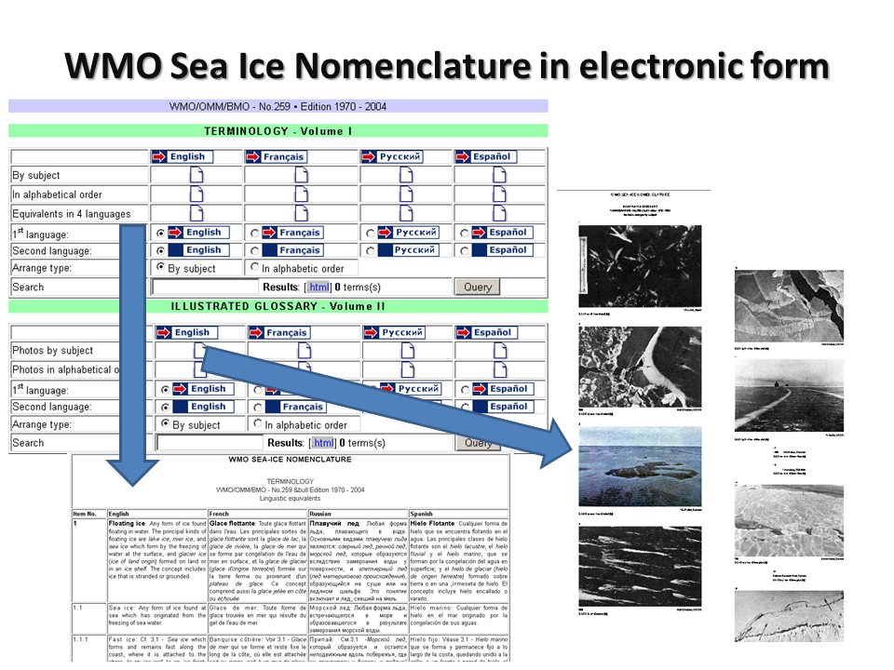

Figure 1 – Interface to the electronic version of the WMO Sea Ice Nomenclature at WDCSI (http://www.aari.ru/gdsidb/XML/wmo\_259.php)

*Historical sea ice collections and derived climatology*

5 The major sea ice collections at AARI GDSIDB/WDCSI by March 2014 include more than 26000 ice charts in WMO exchange raster and vector standards.

6. Raster SIGRID, SIGRID-2, Baltic Code and Ease-Grid format collections includes

* 10-30 days AARI Arctic Ocean ice charts for 1933-1992 & 1997-2008 – 2984 charts
* 10-30 days AARI Southern Ocean ice charts for 1971-1991 – 495 charts
* 1-4 days BSIM Baltic Sea ice charts – 2653 charts (Baltic Code & SIGRID)
* 7-days CIS Canadian Arctic ice charts for 1968-1998 – 3433 charts
* 5 days JMA Sea of Okhotsk ice charts for 1970-2013 – 2309 charts
* 7-days NIC Northern Hemisphere ice charts for 1972-1994 – 1200 charts
* 7-14 days Northern hemisphere ice charts for 1972-2007 – 2796 charts (Ease-Grid)
* 7-days NIC Southern Ocean ice charts for 1973-1994 – 1148 charts

7. The newer, constantly growing collections in the WMO vector SIGRID-3 format :

* 7 days AARI Arctic Ocean ice charts from 2008…. - > 300 charts
* 15 days AARI Southern Ocean ice charts from 2006…. > 252 chars
* 7-days AARI Eurasian Seas ice charts from 1998… - >5200 charts
* 7-days BSH Baltic Sea ice charts from 2012…. - > 40 charts
* 7-14-days CIS Canadian Arctic ice charts from 2006… - > 1600 charts
* 7-days HMC Moscow Azov, Caspian &White Seas from 2000… - >400 charts
* 14 days NIC Northern Hemisphere ice charts from 2003…. - > 300 charts
* 14 days NIC Southern Ocean ice charts from 2003…. - > 270 charts

8. Figure 2 illustrates the major checkpoints for sea ice collections at GDSIDB/WDCSI. Collections marked by ‘dark blue’ are available in the exchange formats to the user community. Collections marked by ‘grey colour’ are either 1-dimensional (ice index) or still awaiting digitization. Collections marked by ‘green colour’ do exist in digital form but are awaiting submission to WDCSI.

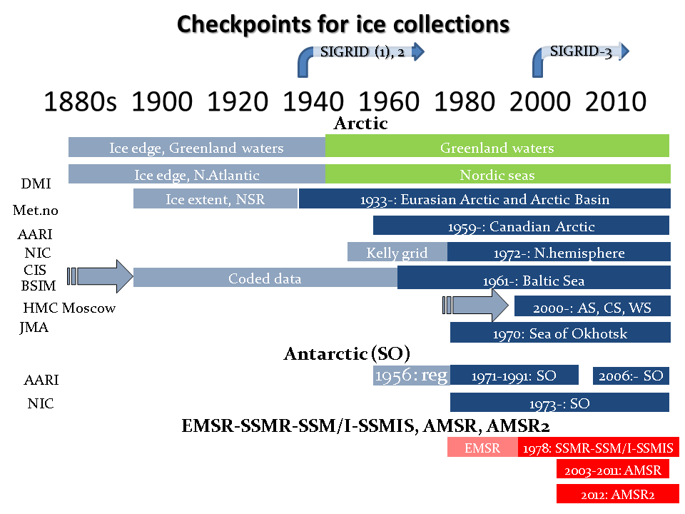

Figure 2 – Checkpoints for ice collections at AARI WDC Sea Ice. Abbreviations for agencies: DMI – Danish Meteorological Institute, Met.no – Norwegian Meteorological Institute, AARI – Arctic and Antarctic Research Institute( St.Petersburg, Russia), NIC – USA National Ice Center, CIS – Canadian Ice Service, BSIM – Baltic Sea Ice Meeting, HMC Moscow – Hydrometeorological Center, Moscow, JMA – Japan Meteoorological Agency; Regions: N. – Northern, SO – Southern Ocean, AS – Azov Sea, CS – Caspian Sea, WS – White Sea

9. The longest digital collection for the Northern Polar Region remains the Eurasian Arctic ice charts from the AARI since 1933 which is complemented from 1960 by BSIM for the Baltic Sea, from 1968 by the CIS for the Canadian Arctic, from 1970 by JMA for the Sea of Okhotsk, from 1972 by NIC with hemispheric scale and from 2000s by HMS Moscow for the mid-latitude Eurasian Seas.

10. The Southern Ocean collections span period from 1971 (AARI) with the NIC hemispherical scale charts from 1973.

11. It should be noted that historical collections in older times (mainly prior to advance of the satellite means in 1960s) do have a number of gaps both in time and in space and vary in periodicity from 4 days till 1 month.

12. Climatology derived from the ice charting collections and available from the WDCSI, include statistics for the basic sea ice parameters: total concentration (CT), occurrence of CT intervals (ice free/very open/open/close/very close/fast ice), partial concentrations of the sea ice major stage of development (new/young/first-year/old ice). Statistics are derived both for the whole period of instrumental observations (presently from 1933) or sub-periods corresponding to observed ‘warm’ (1940s-1960s, 2000s-) and ‘cold’ (1970-1990) sub-periods.

*Access and presentation of sea ice collections*

13. WDCSI provides both a ‘simple’ and a ‘full’ interfaces to ice charting collections with unrestricted (at most of the cases) access. Sample view of the interfaces is shown on figure 3.

14. A simplified access to data collection is implemented via the ‘http’ protocol at <http://wdc.aari.ru/datasets>. Ice charts collections and climatological material are arranged by formats, agencies, regions in separate indexed directories (e.g. d0001 – SIGRID-1, 2 and Baltic Code). Further steps will include generation of static replicas for all charts in graphic formats (using WMO/Td-No.1215), implementation of OpeNDAP or similar as well as extensive documentation of all data collections.

15. A ‘full’ interface is based on provision of Web Map Services (WMS) for ice material. The server part is implemented on a basis of Geoserver open-source software and SLD-styling for egg-code symbology on ice charts and colour coding in accordance with the WMO/Td-No.1215. Beside collection of data, implementation of the ‘full’ interface includes post-processing of ice charts (normalization to WMO exchange standard SIGRID-3, calculation of value-add data tags etc) and registration (publication) at geoserver. User-interface is implemented on a basis of open-source openlayers software, presently available as a “Prototype AARI Ice Portal” at <http://gisa.aari.ru> and supports:

* Access to ice chart collections in vector SIGRID-3
* Search by agencies/time
* 6 fixed projections (Northern and Southern Polar)

|  |  |
| --- | --- |
|  | C:\Users\vms\Pictures\Новый рисунок (11).png |

Figure 3 – ‘Simplified’ and ‘full’ interfaces to WDC SI ice charting collections

*Development of sea ice historical data processing*

*Blending ice charting data in gridded format*

16. The GDSIDB holds a 5 to 30 day period mapped ice data for the Arctic starting from 1933 and for Antarctic from 1971 to present for both regions. There are a number of gaps in factual data: temporal (mostly in wintertime) and spatial (mostly outside navigable areas like Eastern passage/Northern Sea Route or Western passage). From the 1970s, the GDSIDB ice charts may serve as a ground-truth to SSM/I products (as it is based on comprehensive usage of all available sources of ice information and expert knowledge), or be the unique source of ice conditions and climate for the period earlier than 1978. Ice charts from the separate ice services have different temporal attributes (i.e., starting moment, validity period) and in a number of cases overlap each other, so blending of individual data sets enhances usage of factual data.

17. During the periods of 2002 to 2007, the blending technique for Northern Hemisphere GDSIDB charts in SIGRID(1,2) formats was developed and implemented at the AARI. The principal blending scheme for constructing the monthly 15’x15’ total concentration dataset for the periods of 1950 to1998, included merging of five GDSIDB (AARI, BSIM, CIS, JMA, NIC) to monthly spacing by means of averaging to middle of month. Output dataset (as consequent revised versions) was provided in 2003-2005 for the testing and intercomparison purposes to the United Kingdom Met Office (Hadley Center) and presented at MARKDAT-II seminar (October 2005). This scheme was repeated in October 2007 using the same material and for the period 1933-2004.

18. Advances within the OGC project as well as in computer capability and following requests from the numerical climate modelling and seasonal forecasting communities allowed to revisit blending techniques in 2012 – 2013. A new technique was successfully developed within the joint grant project with IARC (UAF 12-0063 - «International collaboration within ACE to improve predictive capabilities for Arctic Sea Ice» for the whole collection of sea ice charting material in raster SIGRID, SIGRID-2 and vector SIGRID-3 format spanning now period up to 2013.

19. Resulting blended datasets contain gridded CT values and supplementary information on a hemispheric (90°N…45°N 0°….360°) geographical 0.25°by 0.25° grid or 1440 columns x 180 rows with the northernmost westernmost 90N,0 value in left upper corner, with monthly interval. Presently the dataset spans interval from Jan 1901 to Jan 2013. Spatial extent of the resulting dataset and orientation of the grid is shown on figure 4.

**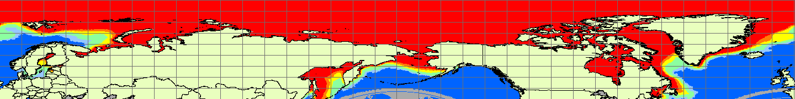**

Figure 4 – Extent of resulting blended dataset

20. Blended dataset contains the following 5 parameters stored as separate files:

1. mean,
2. minimum,
3. maximum,
4. number of cases and
5. originating source (national ice service).

21. Proportions of material from individual services and origins and by decades are shown on Figures 5 and 6.

22. Maximum, minimum and trimean monthly sea ice total concentration statistics based on blended ice charting for 1901-2012 are shown on figure 7.

|  |  |
| --- | --- |
| Новый рисунок | Новый рисунок (1) |
| Figure 5 – Summary number of charts (left) and summary number of points by originating centers for the period January, 1901 – January, 2013 | |

|  |  |
| --- | --- |
| Новый рисунок (3) | Новый рисунок (4) |

Figure 6 – Summary absolute and % number of points by decades by originating centers for the period January, 1901 – January, 2013

|  |  |  |  |
| --- | --- | --- | --- |
| 01 | 01 | 01 | ct_leg |
| January | | |  |
| 02 | 02 | 02 | ct_leg |
| February | | |  |
| 03 | 03 | 03 | ct_leg |
| March | | |  |
| 04 | 04 | 04 | ct_leg |
| April | | |  |
| 05 | 05 | 05 | ct_leg |
| May | | |  |
| 06 | 06 | 06 | ct_leg |
| June | | |  |
| 07 | 07 | 07 | ct_leg |
| July | | |  |
| 08 | 08 | 08 | ct_leg |
| August | | |  |
| 09 | 09 | 09 | ct_leg |
| September | | |  |
| 10 | 10 | 10 | ct_leg |
| October | | |  |
| 11 | 11 | 11 | ct_leg |
| November | | |  |
| 12 | 12 | 12 | ct_leg |
| December | | |  |

Figure 7 – Maximum of maximums (left), minimum of minimums (center) and trimean (right) monthly sea ice total concentration statistics based on blended ice charting for 1901-2012

\_\_\_\_\_\_\_\_\_\_\_\_