## RUSSIAN FEDERATION

18 March 2014 Revision

#### 1. Organization

Sea-ice services in the Russian Federation are provided by the Arctic and Antarctic Research Institute in St Petersburg (AARI), the Hydrometeorological Centre (Hydrometcentre) and the Scientific Research Center of Space Hydrometeorology "Planeta" (SRC “PLaneta”) and local hydrometeorological offices in the Arctic, Far-Eastern Russia, Baltic, Black and Caspian seas; all belonging to the Russian Federal Service for Hydrometeorology and Environmental Monitoring (Roshydromet).

AARI provides centralized general and customer-oriented services for shipping and coastal and harbour activities within the Northern Sea Route (NSR), for the Central Arctic Basin and Arctic seas – Greenland, Kara, Laptev, Eastern-Siberian, Chukchi as well as for the seas with the seasonal ice cover – Baltic, White, Bering, Okhotsk, Caspian and also Antarctic seas. AARI is responsible for coordination of the Marine Safety Information (MSI) provision for the GMDSS system for METAREAs XX and XXI. Most of the sea-ice charting services are provided by the AARI Centre for Ice Hydrometeorological Information while forecasting services are provided by the AARI research departments.

Hydrometcentre Moscow is providing sea-charting services for the seas with seasonal ice cover – Azov, Caspian and White and customized support for the seas within the NSR. The SRC “PLaneta” provides similar ice charting services and is responsible for provision of customized sea-ice products (Arctic, Antarctic) based on remotely-sensed data from various satellite systems (METEOR, NOAA, EOS etc.)

#### 2. Data acquisition

Coastal weather stations of Roshydromet in the Arctic and Antarctic and on the coasts of the seas with seasonal ice cover make daily visual and instrumental ice observations on sea-ice concentration and stages of ice development, ice thickness, forms of ice, ice drift and other phenomena. Most of the icebreakers and vessels conducting ice navigation routinely report similar ice parameters plus parameters describing ice navigation. Observed data are relayed to analyzing centers via the national meteorological network, WMO GTS and are generally available on-line, e.g. via Cliware system - <http://cliware.meteo.ru>.

Before 1992 aircraft ice reconnaissance flights were conducted in the Arctic on a regular 10-30 days basis from January to December and were the prime source of information for the ice charting. Since 1993 aircraft ice reconnaissance is conducted quite occasionally, commonly during tailored hydrometeorological support of applied and scientific activities and is used only for tactical support. The scope of ice information collected during air-ice reconnaissance included visual observations both on main ice parameters (mentioned above excluding thickness and ice drift) as well as discontinuities in sea-ice cover (leads, cracks, etc.) and various surface parameters (hummocks, ridges, snow, contamination, stages of melting, etc.). Huge collection of these historical log-books and ice charts (since 1930s till 1990s) is archived at the AARI and Hydrometcentre and is available on-line in the WMO SIGRID or SIGRID-3 formats within the GDSIDB project.

The AARI satellite reception station in St.Petersburg and the new one in Barentsburg, Svalbard, opened in October 2013, provide visible and infrared satellite images for the whole Arctic from a series of satellites (NOAA, METOP, TERRA, AQUA, FY3). Customized access to the operational and archived data is provided online (<http://portal.esimo.aari.ru/portal/portal/esimo-user/services/SatView/>). Information for other regions (e.g. Antarctic) or from other satellites (METEOR, OKEAN, EROS, Radarsat etc.) is provided to AARI via Internet from other Roshydromet reception stations (Moscow, Khabarovsk etc) or from commercial satellite data providers (MDA, Scanex etc.). All data are further processed within an ice information system, including ArcGis versions 8 - 10 software and utilized for regional and pan-Arctic, sub-Arctic and pan-Antarctic sea-ice analysis by AARI. The SRC “Planeta” is responsible for Roshydromet satellite core ground segment and specializes on processing satellite imagery from the Russian METEOR-M, Elektro and Kanopus satellites, list of products is available online (<http://planet.iitp.ru/english/products_eng.htm>)

AARI, Hydrometcentre Moscow, SRC Planeta and the local meteorological offices of the Roshydromet exchange sea ice information and disseminate derived products to customers by applicable means and techniques (internet, radiofax, ground and satellite mobile operators, VSAT).

For the Baltic, Barents and White seas regions observers of the Northwestern, Murmansk and Northern departments of Roshydromet at the coastal hydrometeorological stations are providing visual and instrumental daily observations on ice conditions by internet, phone or telegraph. From 1960s till 1991 daily aircraft ice reconnaissance flights for the Gulf of Finland, the Gulf of Riga or Barents and White seas regions were carried out. Quite frequent flights over the White Sea region to monitor living conditions of seals populations continue up to present moment. From 1992 NOAA and EOS TERRA and EQUA satellite imagery is used in operative work. Sets of information are produced daily and include: SEA telegram, icebreakers report and review of ice conditions. The Baltic Group maintains a vast archive of daily ice chards (since 1927) and the stages of ice development (since 1920).

#### 3. Output products

*(a) Chart output*

(i) General sea-ice conditions charts of the Arctic Ocean are prepared by AARI on weekly scale (every Tuesday) and available via the AARI web page for public use (<http://www.aari.ru/projects/ecimo/ModuleLoad.php?mod=d0015&in=1> and <http://wdc.aari.ru/datasets/d0015/arctic/>). Charts depict drifting and fast ice boundaries and five classes of sea-ice concentration in the summer period or stages of development in the winter period and are available in graphic GIF format and in digital WMO SIGRID-3 format. A sample sea-ice conditions chart for the Arctic is presented in Figure X-1, Annex X.

(ii) Detailed sea-ice conditions charts for the 3 Antarctic sectors (Atlantic-Weddell Sea, Indian - Cosmonavtov-Sodruzhestva Seas and Pacific -Ross Sea) are prepared by AARI twice a month (every 10-15 and 25-31 days of month) to provide tailored support for operational activities of the Russian Antarctic Expedition (RAE – <http://www.aari.aq>) and general ice monitoring in the South Ocean. These products are available on-line as SIGRID-3 at <http://wdc.aari.ru/datasets/d0015/antarc/>. Sample charts are given in Figure X-2, Annex X.

(iii) Detailed regional sea-ice conditions charts and annotated imagery for the seas Greenland, Barents, Kara, Laptev, East-Siberian, Chukchi, Beaufort, Bering, Okhotsk, Baltic and Caspian Seas are prepared by AARI on weekly (every Wednesday) or shorter scales and on request and are disseminated via various telecommunication means to captains, shipping companies, local authorities, news media and other users requesting tailored support. Informational products are relayed to the users accordingly in graphic georeferenced GIF / JPEG formats, in WMO SIGRID-3 and S-57 formats. Detailed regional sea-ice charts in national coding are available via the AARI web site in GIF and SIGRID-3 formats (<http://www.aari.ru/projects/ecimo/ModuleLoad.php?mod=d0004&in=1> and <http://wdc.aari.ru/datasets/d0004/>). Sample detailed ice charts and annotated imagery for the Kara, Okhotsk and Caspian Seas are presented in Annex X, figures X-3, X-4 and X-5.

*(b) Plain language information*

(i) Coastal and open sea sea-ice and weather GMDSS and other plain language reports are prepared routinely on weekly, daily or shorter scales and on request by AARI and the local meteorological offices of Rosgydromet for METAREAs XX, XXI and XIII and are disseminated via various telecommunication means to the customers.

(ii) Synoptic bulletin on weather conditions in the Eurasian Arctic is prepared routinely on daily scale by AARI and is disseminated via various telecommunication means to the customers and published on AARI web-site. (http://www.aari.ru/projects/ecimo/ModuleLoad.php?mod=d0011&in=1).

*(c) Support for navigation within the Northern Sea Route areas*

1. Since 2013 AARI and other Roshydromet departments are routinely providing weather and sea-ice diagnostic and prognostic information and products to the Northern Sea Route Administration (NSRA). That includes weekly detailed regional and/or review ice charts, prognostic charts of sea ice parameters and type of ice conditions, daily weather bulletins. During the navigational period products and information are used by the NSRA administration for consideration of applications for navigation within the NSR or by the navigators. Information is available on-line at <http://nsra.ru/en/icecharts/>

(*d) Gulf of Finland sea-ice products*

Regular daily and longer term analysis and prognostic products for the Gulf of Finland are provided by the NW Hydromet Baltic Ice Group and include:

(i) Daily report for coastal points “SEA” / MORE” in KN-2 code.

(ii) Daily ice report for fairway containing review of Gulf of Finland ice conditions, the Baltic sea ice code telegram, information about icebreakers, navigation restrictions, point of convoy formation for the ships steering. Ice report for fairway is produced in English and Russian by 8:00 GMT.

(iii) review ice chart produced by 10:00 GMT twice a week (Mon, Thu) in international black-and-white and color coding.

(iv) Ice bulletin produced twice a weak (Monday and Thursday). The bulletin consist s of ice chart, detailed review of ice condition of the Gulf of Finland and short ice review of Baltic sea, short-term forecast (next 3-4 days) of ice condition’s development for the Gulf of Finland.

(v) Long-term forecasts of the ice appearance, total freezing, fracturing of fast ice, total disappearance of ice at the points of Gulf of Finland in advance of 20- 45 days.

(vi) Preliminary forecast of maximum ice conditions for the Gulf of Finland for the coming ice season on July 31st with amendment on November 30th.

#### 4. Forecasts and forecasts methods

(i) Daily diagnosis and forecast charts of mean daily and instantaneous ice drift, surface currents and level elevation in the Arctic Ocean for period 0d…+6d on the basis of dynamic AARI sea-ice model;

(ii) Weekly or shorter period diagnosis and forecast charts of the evolution of ice cover in Barents and Kara Seas including sea ice total concentration, thickness (stages of ice development), hummocks concentration and level of compacting for period 0d…+6d on the basis of the dynamic thermo-dynamic AARI model;

1. Daily diagnosis and forecast charts for winds, wave significant height and direction and ice accretion for open water areas in the Western and Eastern Eurasian Arctic Seas for period 00…+72h with 6-h interval on the basis of the AARI wave model;
2. Numerical forecast for water level at selected coastal points of Eurasian Arctic for period 0d…+6d;

(v) Seasonal forecasts of ice conditions in the Eurasian Arctic seas and big Siberian rivers estuaries based on AARI empirical-statistical techniques (textual bulletins);

(vi) Weekly-monthly forecasts of ice phenomena in the big Siberian rivers estuaries based on AARI empirical-statistical techniques (textual bulletins).

Sample numerical forecast charts are presented in figure X-6, Annex X.

#### 5. Publications

The following publications are issued by AARI at different periods:

*(a)* The quarterly and yearly bulletin *Review of the hydrometeorological processes in the Arctic Ocean* (in Russian);

*(b)* The quarterly bulletin *State of the Antarctic Environment* (in Russian and English);

(*c*) Bulletin “Long-term forecast of the ice conditions in the Arctic seas”: 3 bulletins are published per year in the end March, June and August (in Russian);

*(d)* *Trudi AANII* (AARI Transactions): irregular two to three volumes are published per year (in Russian);

(*e*) *Problemi Arktiki i Antarktiki* (Problems of the Arctic and Antarctic): two volumes are published per year (in Russian);

*(f)* Irregular express information, informational bulletins of the Russian Antarctic expedition, monographs etc.

#### 6. Mailing and Internet addresses

*Mailing addresses*

Arctic and Antarctic Research Institute (AARI)

Bering Str., 38

199397, St Petersburg Russian Federation

Telephone: +7 (812) 337-3123 Telefax: +7 (812) 337-3241

E-mail: [service@aari.nw.ru](mailto:service@aari.nw.ru), [aaricoop@aari.nw.ru](mailto:aaricoop@aari.nw.ru)

Hydrometeorological Centre of Russia (Hydrometcentre Moscow)

B. Predtechensky per., 11–13

123242, Moscow Russian Federation

Telephone: + 7 (499) 252-3448 Telefax: +7 (499) 255-1582

E-mail: [vilfand@rhmc.mecom.ru](mailto:vilfand@rhmc.mecom.ru)

State Research Center "Planeta"

Bolshoy Predtechensky st. 7

123242, Moscow, Russian Federation

Telephone: +7 (499) 252-3717 (secretary) Telefax: +7 (499) 252-6610

E-mail: [asmus@planet.iitp.ru](mailto:asmus@planet.iitp.ru)

[St Petersburg Center](http://ideashistory.org.ru/) for Hydrometeorology and Environmental Monitoring. (NW Hydromet)

Hydrometeorological Center of St.-Petersburg

Baltic Russian Ice Service

199106, Vasilevsky Ostrov, 23 liniya, 2-a

St.-Petersburg, Russian Federation

Tel/Fax: +7(812)321-3018

E-mail: [sea@meteo.nw.ru](mailto:sea@meteo.nw.ru)

Primorsky Directorate of Hydrometeorological Service (Primpogoda)

Mordovtseva Str., 3

690950, Vladivostok Russian Federation

Telephone: +7 (4232) 204974 Telefax: +7 (4232) 221750

E-mail: [pkmeteo@primpogoda.ru](mailto:pkmeteo@primpogoda.ru)

Far Eastern Regional Hydrometeorological Research Institute (FERHRI)

Fontannaya Str., 24

690600, Vladivostok Russian Federation

Telephone: +7 (4232) 26-97-88 Telefax: +7 (4232) 22-77-54

E-mail: [hydromet@online.ru](mailto:hydromet@online.ru)

*Internet addresses*

AARI:

<http://www.aari.ru> (main page)

<http://www.aari.ru/projects/ecimo/modul.php?mod=d0015&in=1> (weekly ice charts)

<http://www.aari.ru/projects/ecimo/ModuleLoad.php?mod=d0004&in=1> (weekly detailed ice charts)

<http://portal.esimo.aari.ru/portal/portal/esimo-user/services/SatView/> - satellite imagery

<http://www.aari.ru/projects/ecimo/index.php?im=101> (prognostic products)

<http://www.aari.ru/projects/ecimo/ModuleLoad.php?mod=d0011&in=1> (synoptic bulletin)

Planeta:

<http://planet.iitp.ru/english/products_eng.htm> (Satellite data products)

<http://planet.iitp.ru/Oper_pr/Oper_pr.html> (Operational products)

See also direct links:

<http://planeta.infospace.ru/prod-cgi/last.pl?product=67> (Ice charts – Black and Azov Seas)

<http://planeta.infospace.ru/prod-cgi/last.pl?product=107> (Antarctic mosaic)

Hydrometcentre of Russia: http://wmc.meteoinfo.ru/

NW Hydromet: <http://www.meteo.nw.ru>

Primpogoda: <http://www.primpogoda.ru>

FERHRI: <http://www.hydromet.com>

# ANNEX X – Russian Federation

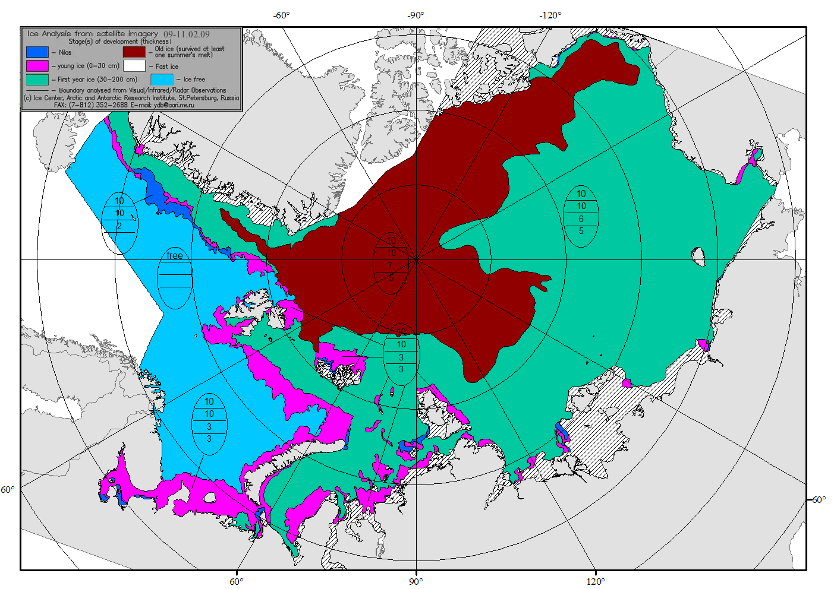

Figure X-1 – Common usage ice chart for the Arctic Ocean on 9 February 2009.

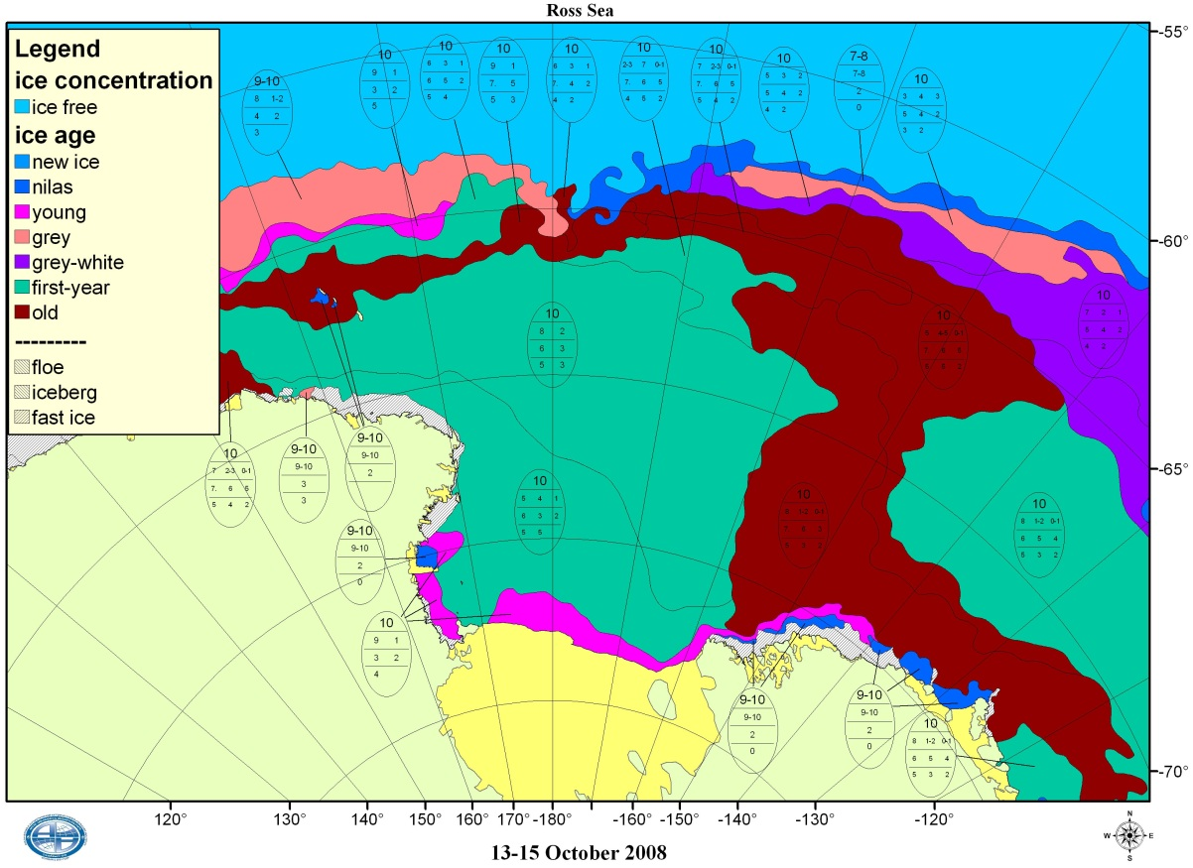

Figure X-2 – Antarctic sea ice analysis: Pacific sector (Ross Sea) for 13-15 October 2008.

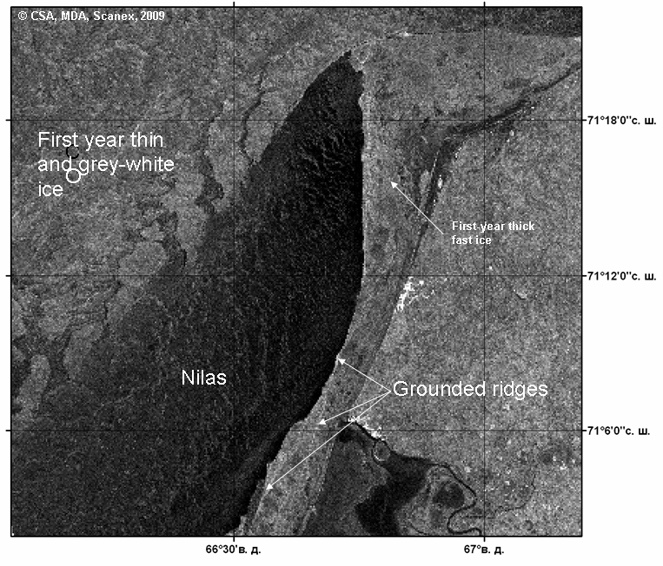

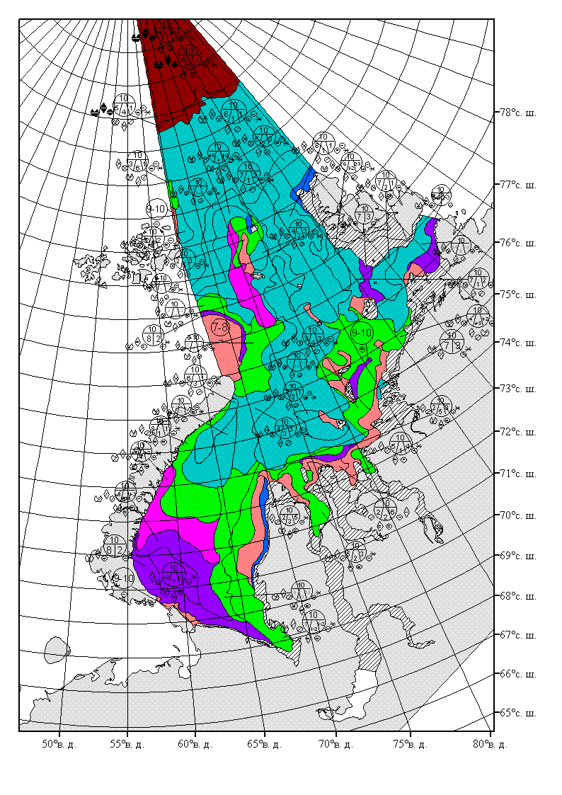

Figure X-3 – Background Radarsat-1 fine beam imagery for 5 February 2009 12:54 for the area near Yamal peninsula and detailed ice chart in Russian national symbology for the Kara Sea, 2-4 February 2009.

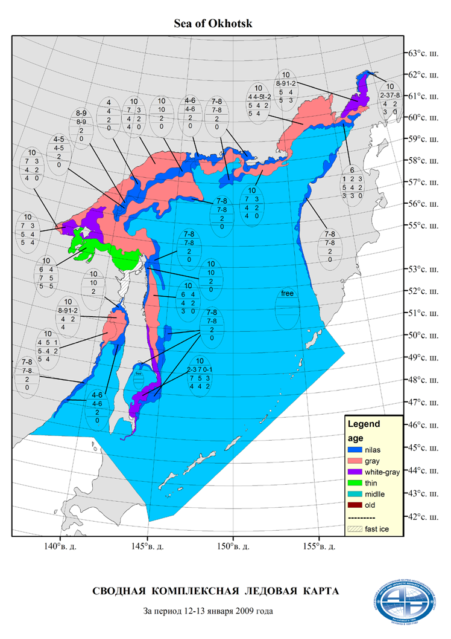

Figure X-4 –Detailed ice chart for the Sea of Okhotsk and Tatar Strait for 12-13 January 2009.

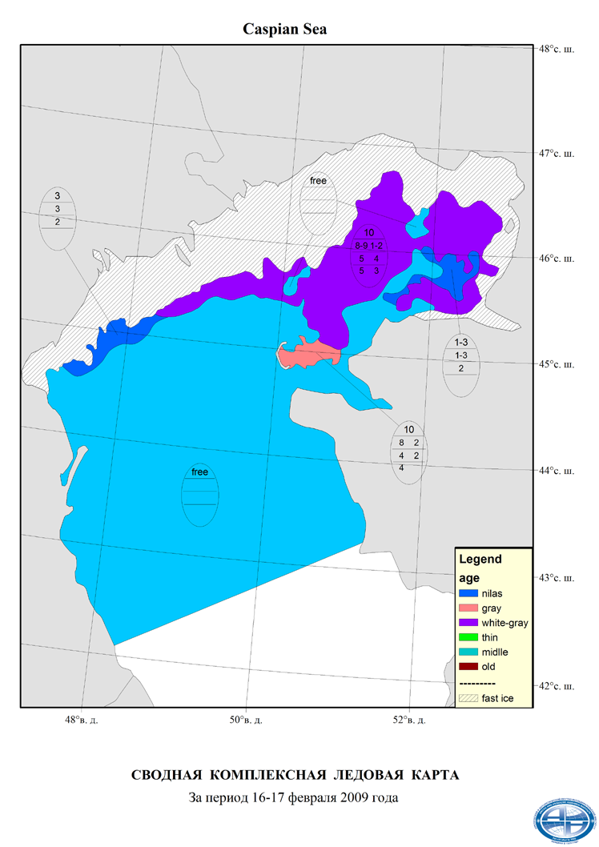

Figure X-5 –Detailed ice chart for the Caspian Sea for 16-17 February 2009.

|  |  |
| --- | --- |
|  |  |
| (a) | (b) |
|  |  |
| (c) | (d) |
| image1 | img1sibEGRRpr |
| (e) | (f) |
| Figure X-6 – Short-term prognostic charts: 2010-02-05 +024h for the Barents-Kara Seas: hummocks concentration (a) and level of ice compacting (b); 2010-02-05 +024h for the Arctic Ocean: surface currents and level elevation (c) and mean daily ice drift (d); 2009-10-03 +024h significant (3%) waves height, level of ice accretion and surface widn vectors for the Western Eurasian (e) and Eastern Eurasian (f) Arctic seas. | |