**United States National Ice Center**

**March 2014**

**1. Organization**

The U.S. National Ice Center (USNIC) is a tri-agency organization comprised of the National Oceanic and Atmospheric Administration (NOAA), the U.S. Navy (USN) and the U.S. Coast Guard (USCG). The primary mission of the USNIC is to provide global ice and snow coverage (including the Great Lakes and the Chesapeake and Delaware Bay Systems) analysis and forecasting services for the maximum benefit of United States government interests. The USNIC analysis areas also includes the southern hemisphere, and select subarctic seas.

The U.S. National Ice Center is also a partner in the North American Ice Service (NAIS), a Collaboration of the USNIC, Canadian Ice Service (CIS) and the U.S. Coast Guard’s International Ice Patrol (IIP).

**2. Data acquisition**

Satellite imagery accounts for over 95% of the data used for ice analysis. This real/near real time data is a critical requirement to ensure the mission of the USNIC is met every day. Currently, sea ice information is analyzed using synthetic aperture radar, visible and infrared images, passive microwave and scatterometer data.

Additional sources of information includes; ship/station reports, webcams, drifting buoys, meteorological guidance products, ice model predictions and government partners including foreign ice services.

Ship reports are limited and account for little information in the analysis process. However, some meteorological data is available from buoys maintained by the International Arctic Buoy Program (IABP). This data is freely available and is located at <http://iabp.apl.washington.edu>.

Numerical weather and ice prediction used at USNIC include the U.S. Navy’s Global Environmental Model (NAVGEMS) and the U.S. Naval Research Laboratories (NRL)’s Arctic Cap Nowcast/Forecast System (ACNFS).These products and the U.S.

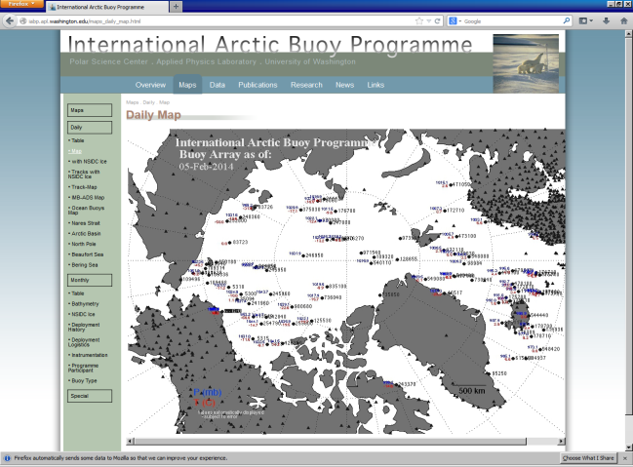

*Fig.1. IABP Buoy Array*

National Weather Service (NWS) Medium Range Forecast (MRF) are ingested into the USNIC sea ice analysis system. Analysts also routinely accesses numerical guidance produced by Environment Canada, European Center for Medium Range Weather Forecasting (ECMWF), and the Australian Government Bureau of Meteorology in the southern hemisphere. Sea Ice analysis from the NWS

Anchorage, Alaska Ice Desk and ice services around the world are also consulted during the analysis process. Iceberg information for waters near the Grand Banks of Newfoundland/NE Atlantic are available from the NAIS, a product jointly produced by the IIP and CIS. A daily iceberg analysis is produced in both a graphic and text format. This product can be accessed on USCG and CIS’s website at CIS’s website <http://iceweb1.cis.ec.gc.ca> and the IIP’s website posted at <http://www.navcen.uscg.gov/?pageName=iipProducts> .

|  |  |
| --- | --- |
|  |  |
| *Fig. 2. ACNFS Fields* | *Fig. 3. NAIS Iceberg Chart* |

1. Ice Analysis. The USNIC provides a diverse suite of digital and graphic ice products in support of the needs of the U.S. Government to include Arctic Maritime Domain Awareness, Safety of Navigation, tactical/operational sea ice routing, seasonal outlooks in the Beaufort and Ross Seas, legacy data outlooks, snow coverage of the northern hemisphere, Synthetic Aperture Radar (SAR) wind fields in the Arctic, and annotated imagery. The USNIC also produces sea ice and iceberg analysis in Antarctic waters and collaborates with the CIS (through NAIS) to produce a common Great Lakes ice analysis, as well as Great Lakes analyses unique to the USNIC. Analysis for the Chesapeake and Delaware Bays and Potomac River are produced as necessary. Metadata for all ice analysis is available via the USNIC website (<http://www.natice.noaa.gov>).
2. Daily Ice Edge. USNIC produces a daily near real time product depicting both the Arctic
3. and Antarctic ice edge, marginal ice zone, pack ice and a 48 hour ice edge forecast. Daily ice edges for the Great Lakes and U.S. Alaska waters are available in GRIB format. ASCII output is produced for U.S. Navy customers.

These products are available in a graphic and digital format via the USNIC website.

1. Arctic Maritime Domain Awareness. USNIC produces routine environmental awareness
2. products for U.S. Government agencies upon request. These products are geared toward operational readiness and mission planning for the USN and USCG. These products are disseminated using different methods and formats based on the customer’s requirements. USNIC does not currently provide tailored support for commercial interests.
3. Annotated Imagery. Special support products are disseminated to support scientific
4. research efforts sponsored by the U.S. Government. These products are disseminated directly to the customer via ftp or email, and are not normally available to the general public. Annotated imagery is also produced to support emergency response missions and operational planning.
5. USNIC Daily Snow Coverage. Analyst using the Interactive Multisensor Snow and Ice
6. Mapping System (IMS) monitors northern hemispheric snow cover. A description of the product, history of the program and daily IMS product is available on the USNIC IMS webpage at (<http://www.natice.noaa.gov/ims>).
7. SAR Wind Fields. .PNG,.KMZ, and .TIF files are available on the public website depicting wind
8. Speed inferred from the radar cross section of the ocean surface measured from synthetic aperture radar data. The wind speed data is valid only over open water.
9. Antarctic Icebergs. The size and location of icebergs in Antarctic waters are available on
10. the USNIC website.
11. Digital products. Various formats of USNIC products are available to the public via the
12. USNIC website.
13. Legacy products. Sea ice information is available from 1972 to present day. Legacy
14. products are available from the National Snow and Ice Data Center. Great Lakes analysis data is available from the Great Lakes Environmental Research Laboratory (GLERL) and the Canadian Ice Service.

The most recent five years of analysis are available on the USNIC website.

1. Routing Information/Ship Rider Support. U.S. Government vessels may request
2. Ship routing information through the ice pack via text message or annotated imagery. Ice analysts are occasionally available to join ship’s party during operational missions to provide ice analysis, forecasts and routing guidance.
3. Ice Forecasts. 48 hour ice edge forecast are produced daily. Short term sea ice forecasts
4. are available to U.S. Government customers upon request.
5. Seasonal Outlooks. Yearly outlooks for Western Arctic are prepared jointly by USNIC
6. and CIS. This outlook is published in May. In the southern hemisphere, a Ross Sea Outlook is prepared each December.

**3. International Collaboration**

The US National Ice Center is an active member of the following international organizations:

* North American Ice Service (NAIS)
* International Ice Charting Working Group )IICWG)
* JCOMM Expert Team on Sea Ice (ETSI)
* International Arctic Buoy Program (IABP)

Through participation in these international collaborations, significant efforts continue to be made to format data standards, provide input to WMO publications, and strengthen the scientific and operational missions of each national ice service.

**4. Contact Information**

Mailing Address: 4251 Suitland Road e-mail: nic.liaison@noaa.gov

NSOF

Washington, DC 20395

Physical Address: 4231 Suitland Road

NSOF

Suitland, MD 20746

Commercial Phone: (301)-817-3911

Operations Floor: (301)-817-3975

Command Duty Officer: (301)-943-6977 e-mail: [nic.cdo@noaa.gov](mailto:nic.cdo@noaa.gov)

Website: http://www.natice.noaa.gov

_____________