**Appendix 1 – Sample of U.S. National Ice Center Products**

**NAIS Iceberg Bulletin**

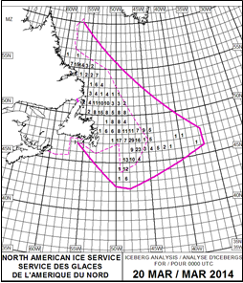NAVAREA IV

NORTH AMERICAN ICE SERVICE (NAIS) ICEBERG BULLETIN.

1. 200001Z MAR ICEBERG LIMIT ALONG TRACKLINE JOINING

46-55N 055-55W, 42-30N 050-00W, 42-15N 048-00W

46-55N 055-55W, 42-30N 050-00W, 42-15N 048-00W,

46-00N 036-30W, 47-45N 036-40W, 60-00N 057-00W.

2. WESTERN ICEBERG LIMIT ALONG TRACKLINE BETWEEN

51-35N 056-45W AND 51-20N 056-35W.

3. SEA ICE LIMIT ALONG TRACKLINES JOINING:

A. 46-55N 055-25W, 45-55N 053-05W, 47-00N 049-35W,

44-00N 049-20W, 44-50N 047-00W, 47-20N 045-00W,

46-00N 036-30W, 47-45N 036-40W, 60-00N 057-00W.

2. WESTERN ICEBERG LIMIT ALONG TRACKLINE BETWEEN

51-35N 056-45W AND 51-20N 056-35W.

3. SEA ICE LIMIT ALONG TRACKLINES JOINING:

A. 46-55N 055-25W, 45-55N 053-05W, 47-00N 049-35W,

44-00N 049-20W, 44-50N 047-00W, 47-20N 045-00W,

*Fig. 4. NAIS Iceberg Product*

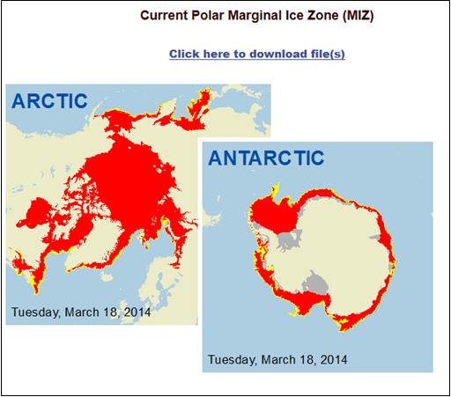

*Fig. 5. Daily Ice Edge Products*

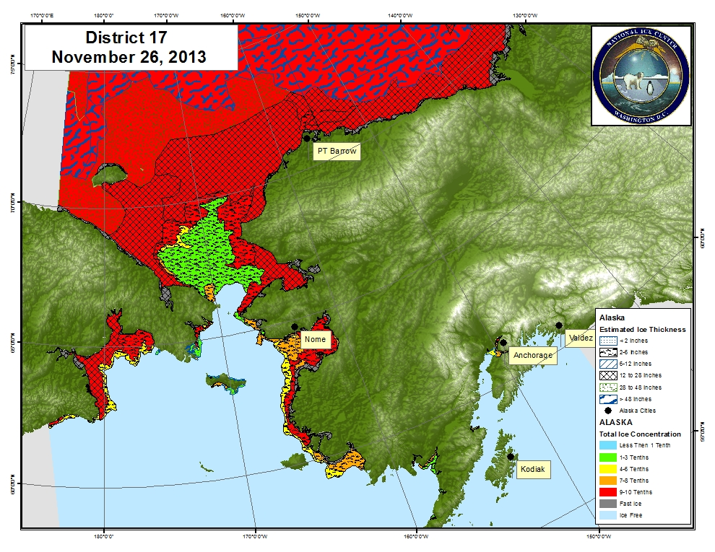

*Fig. 6. Sample Arctic Maritime Awareness Briefing Aid*

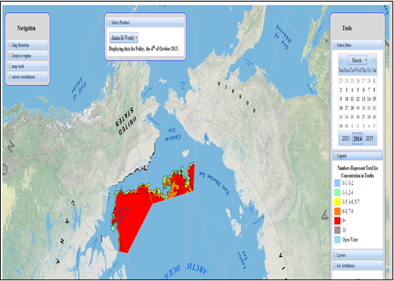

*Fig. 7. Product on Demand on USNIC website. User selects area and individual polygons to retrieve sea ice attributes.*

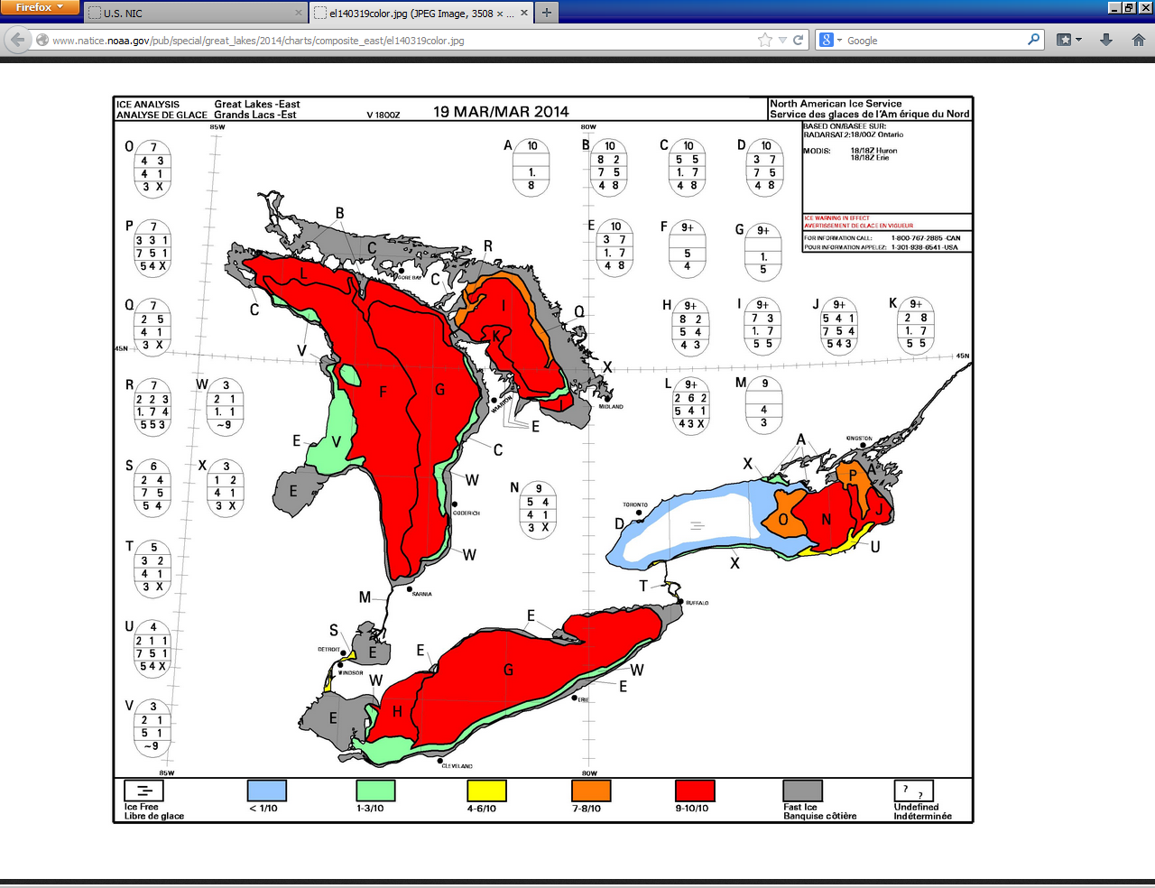

*Fig. 9. NAIS Great Lakes Ice Products*

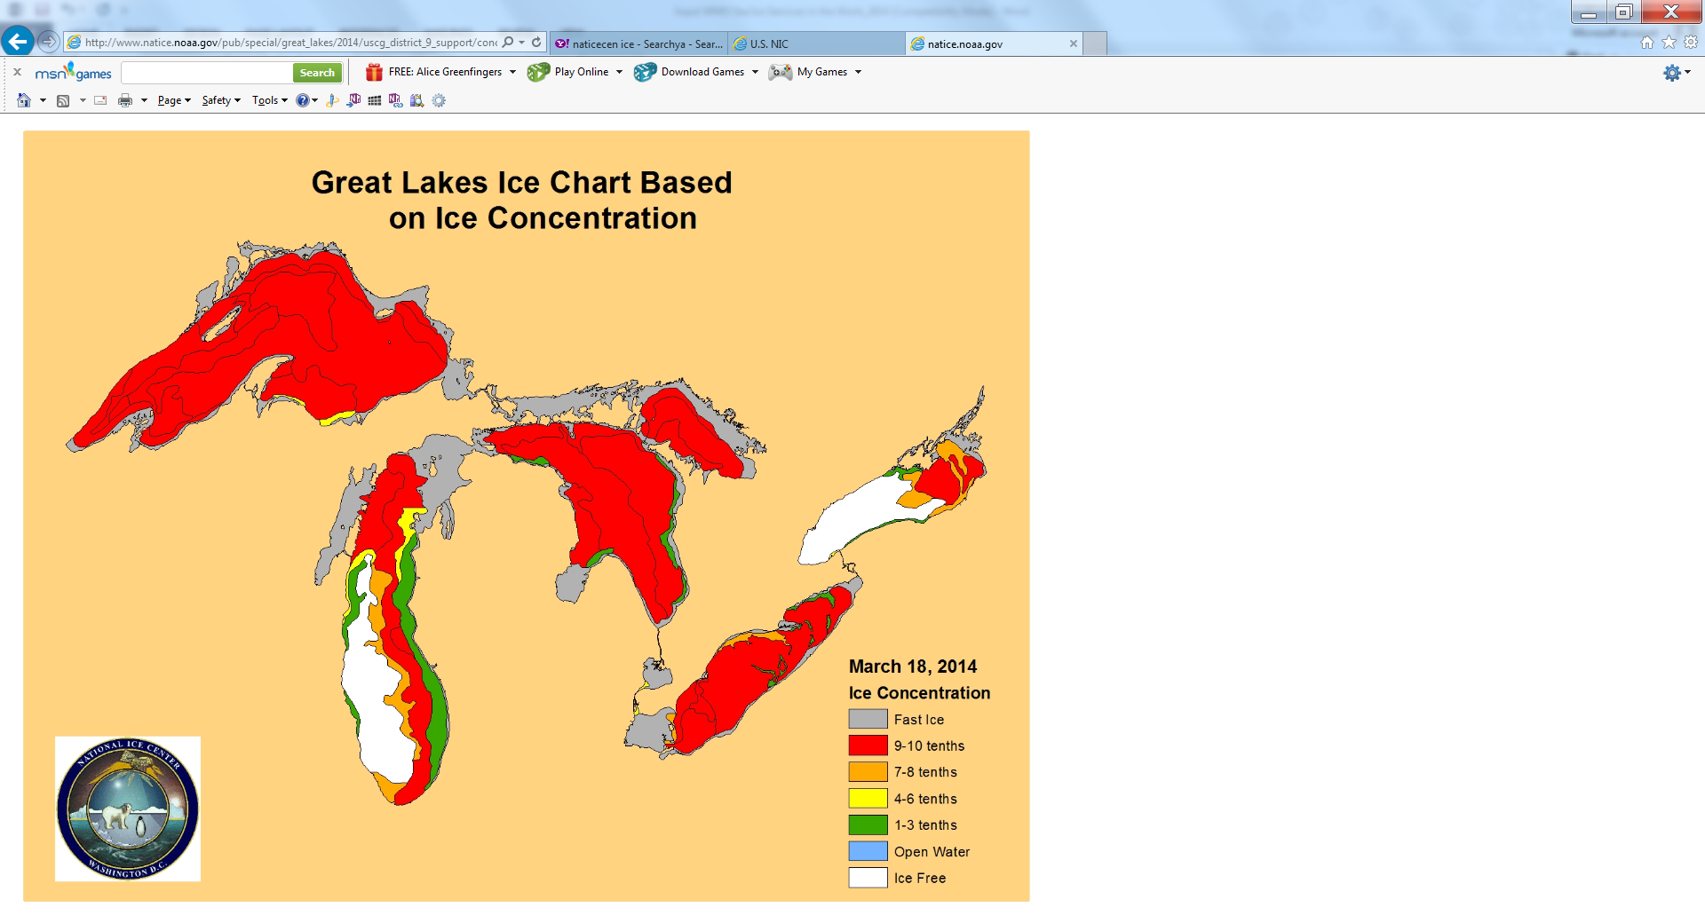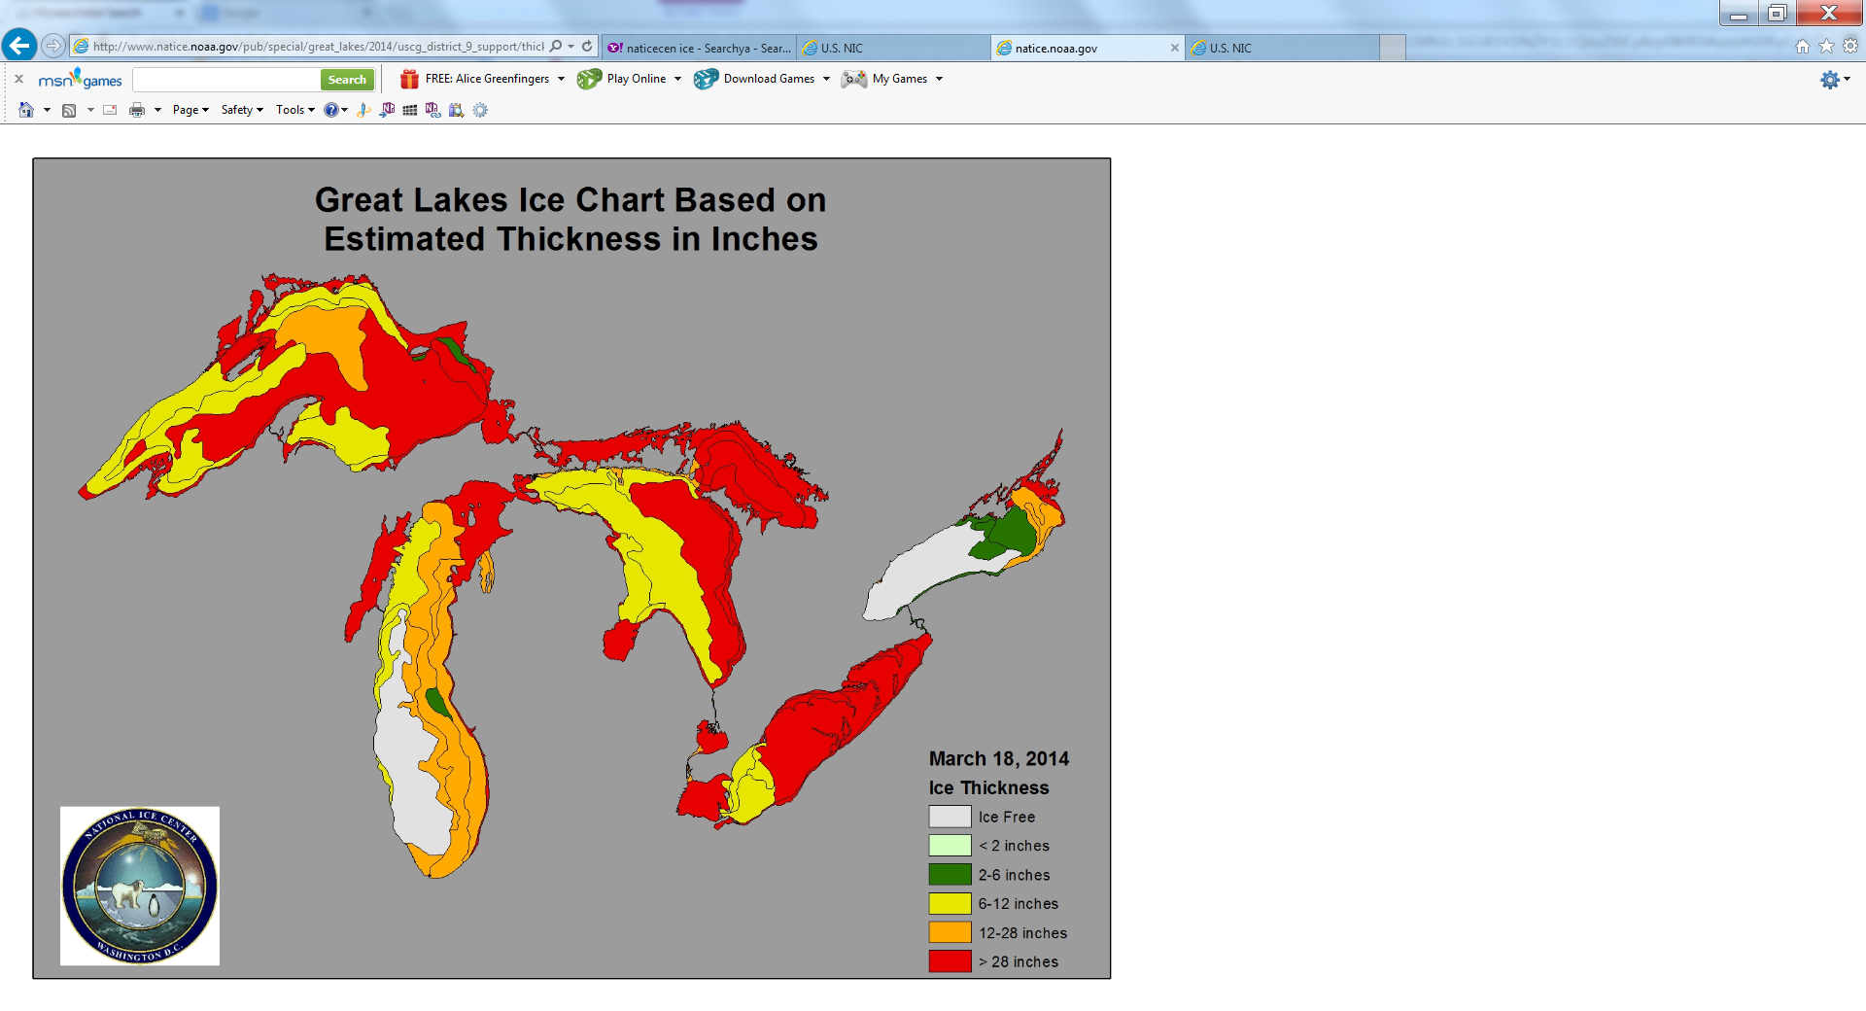

*Fig. 10. USNIC Great Lakes Ice Products*

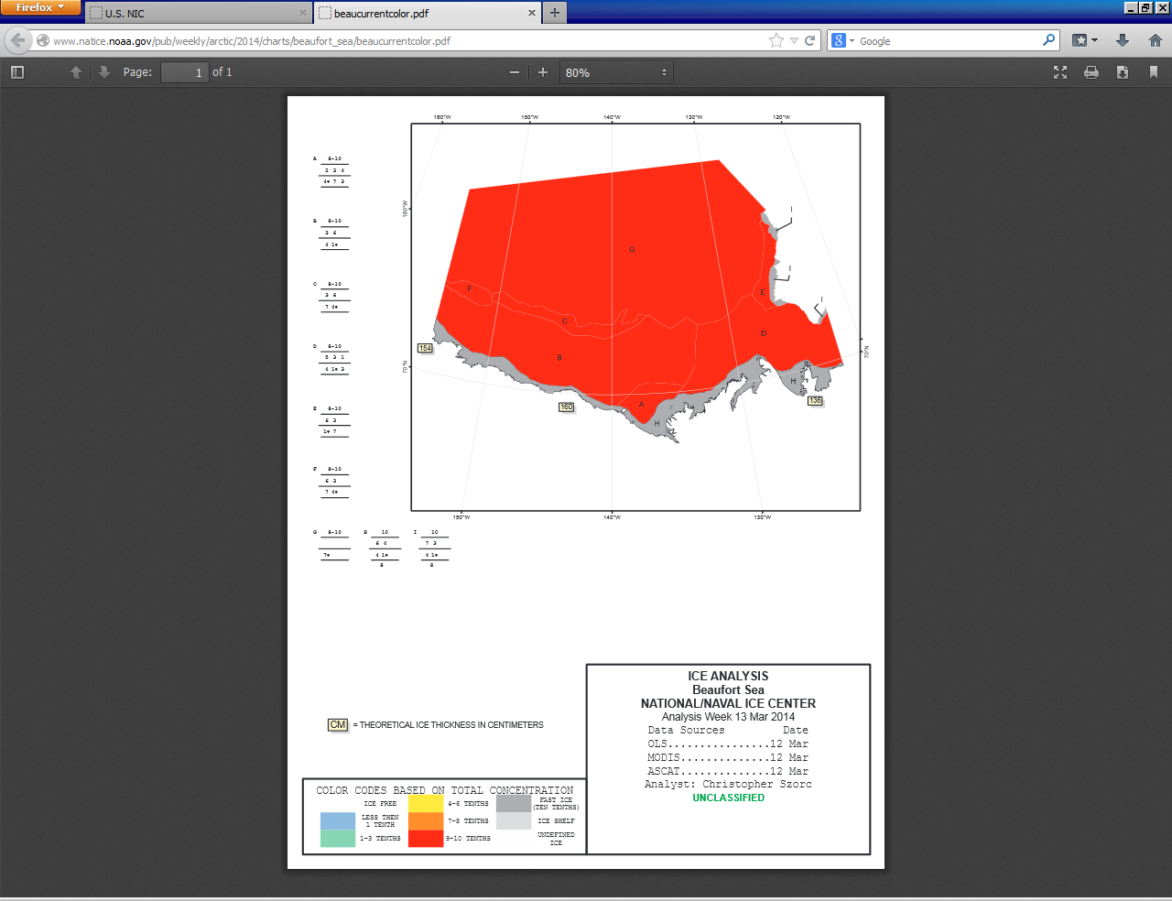

*Fig.11. Beaufort Sea Ice Analysis*

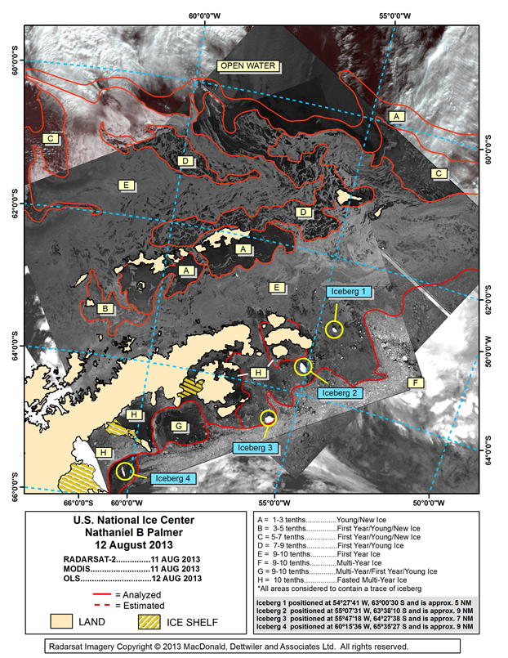

*Fig. 12. Sample Annotated Imagery*