Sea-Ice Information Services
in the World

Edition 2010
(last revision 2015-12-04)

WMO-No. 574

SOUTHERN HEMISPHERE

ARGENTINA
04 February 2017

1. Organization
Sea ice information and related services in Argentina are provided by the Argentine Navy Meteorological Service (SMARA) of the Naval Hydrographic Service (SHN), through the Glaciological Division at city of Buenos Aires. This information is regularly provided for ships sailing or operating in Antarctic waters, with focus in Antarctic Peninsula and Weddell and Eastern Bellingshausen Seas.
As responsible for NAVAREA VI, a complete set of ice charts, iceberg location and complement information is periodically provided to secure maritime activities, considering the main objective of secure life at sea and contribute to safety of navigation.
In accordance with these purposes, sea ice and iceberg information is delivered by SafetyNET and NAVTEX throughout all NAVAREA VI (in Spanish and English) and simultaneously uploaded in the SHN web page (www.hidro.gob.ar/Smara/glacio/sglaciologica.asp, only in Spanish). Besides, specific information can be requested by email (hielo.marino@hidro.gov.ar, in Spanish or English).
Users of these products include the Argentine Navy Ships during the Antarctic Campaigns, and fishing or tourist vessels of all nationalities mostly sailing and operating in Antarctic Peninsula and Bellingshausen Sea.
The Argentine Naval Hydrographic Service assumes the Argentina international representation in the International Ice Charting Working Group (IICWG) and in the Expert Team on Sea Ice (ETSI) of the Joint World Meteorological Organization-Intergovernmental Oceanographic Commission Technical Commission for Oceanography and Marine Meteorology (JCOMM).

2. Data acquisition
The principle data source are based on satellite images such as those derived from SENTINEL, RADARSAT, COSMO SKYMED, AQUA and TERRA-MODIS, among others.
Satellite information is complemented with ice observations from land and ship stations through the coding with SIGLAC software. These observations are made twice a week from land stations and every six hours from ships. Argentina counts with six permanent stations in Antarctica and other seven during the summer, which allows having a very good representation of ice conditions near the cost and inside bays and coves. Around five Argentine Navy Ships deploy to Antarctica every summer, increasing the observational information and helping with validation of satellite imagery.
Another source of information is provided by glaciological flights, on board helicopters or airplanes, that allows the ice analysts to confirm and validate information obtained by satellite images and establishes the general conditions of concentration and state of development of sea ice.
All ice observations are made by experienced personnel who have a specific training course focused in the different techniques of observations based on the Argentine Ice Observers Manual and in the codification of the information with SIGLAC software.

3. Output products
Sea ice and icebergs information is provided for public service by different media, depending in the type of product: ice charts, icebergs charts, sea ice edge chart, ice observations report and sea ice concentration forecast
The following information is available for Antarctic Peninsula, Weddell and Bellingshausen Sea and South Atlantic Ocean:
- Sea ice edge chart: position and concentrations are provided, with updates twice a week. The information is displayed in the SHN web page: http://www.hidro.gob.ar/Smara/glacio/sglaciologica.asp#, then click on 'Borde de Hielo Marino' (Sea Ice Edge).
- Ice charts: concentration and stage of development are provided, with twice a week updates. These charts are made considering 9 different zones (see Annex XIV) for better details. The information is displayed in the SHN web page: http://www.hidro.gob.ar/Smara/glacio/sglaciologica.asp#, then click on 'Cartas de Hielo' (Ice Charts).
- Iceberg charts: the information provided in these charts includes actual position and track of icebergs greater than 10 NM according with names assigned by U.S. NIC, position and track of icebergs lesser than 10 NM but significantly identifiable by satellite imagery and polygons of icebergs, bergy bits and growlers. Direction and intensity of local currents are shown to determine the possible drift of icebergs. This product is updated twice a week. The information is displayed in the SHN web page http://www.hidro.gob.ar/Smara/glacio/sglaciologica.asp#, then click on 'Carta de Témpanos' (Icebergs Chart).
- Sea ice and iceberg information in NAVAREA VI message is transmitted by SafetyNET and NAVTEX system with daily updates. In the link http://www.hidro.gob.ar/nautica/cnv.asp can be found the entire NAVAREA VI message which includes the ice information. In red letters there is a link to an English version.
- Ice Observations Report: a glaciological report is displayed with ice observations of land based stations, during the entire year by the Argentine permanent stations. Updates are twice a week. The information is displayed in the SHN web page http://www.hidro.gob.ar/Smara/glacio/sglaciologica.asp#, then click on 'Observaciones Glaciológicas' (Glaciological Observations). At the bottom of the page there is a link to the English version.
- Sea Ice Concentration Model: climatological model of sea ice concentration and anomalies of concentration with monthly update. See section 4. Forecasts for details about the Model. The information is displayed in the SHN web page http://www.hidro.gob.ar/smara/sb/sb.asp.

4. Forecasts
Since 2001, the Argentine Navy Meteorological Service of the Naval Hydrographic Service has implemented of a forecasting model for Variables Sea Ice Concentration and Anomalies of Sea Ice Concentration. Based on this information, monthly climatological estimations are made for the anomalies fields of air temperature, surface pressure and precipitation.
To obtain these results it is used monthly data of sea ice concentration, derived from the information generated by NASA algorithms and provided by the National Snow and Ice Data Center (NSICC). The data base that is used is composed with full information since November 1978.
This forecasting model is based on Principal Component Analysis applied to the monthly anomalies series of Sea Ice (S-Mode) and monthly anomalies fields of Sea Ice (T-Mode)., from which are obtained 6 temporal patterns, valid in some regions of Antarctica, assuming the importance on determining the sea regions around Antarctica that will have Sea Ice anomalies.
To improve the results of the forecasting model it has been added multi neural networks Perceptron with supervised learning and backward propagation algorithms This artificial neuronal network is dedicated to the images recognition and it is been implemented through the anomalies fields of temperature and pressure associated to the anomalies spatial patterns of Sea Ice concentration.

5. Publications
Two Sea Ice Atlases have been published for Antarctic Seas between 0ºW and 90ºW; one covering the period 1972-1990 and the other for 1973-1982. Statistics on sea ice boundaries for nonstandard periods can be compiled, with archived data since 1972 to date.
Ice Observers Manual, with a full description of ice formation processes, stages of development, classifications and different techniques of observations from land, ships and airborne.
Photographic Atlas of Floating Ice: Identification and Coding. Available in printed version and through the SHN web page: http://www.hidro.gob.ar/Smara/glacio/generalidades.asp#, then click on ‘Mural’.
Annual Technical Reports on Antarctic Sea Ice Conditions and Climatological Forecasts, since 2005 to date.

6. Mailing and internet address
Argentine Navy Meteorological Service (SMARA)
Naval Hydrographic Service (SHN).
Edificio Libertad
Av. Comodoro Py 2055 – Piso 15.
BUENOS AIRES - ARGENTINA.
P.O. Box: C1104BEA
Telefax: +54 11 4317 2309
E-mail: hielo.marino@hidro.gov.ar
Web page: www.hidro.gob.ar

ANNEXES - SAMPLE CHARTS AND OUTPUT PRODUCTS OF NATIONAL SERVICES

ANNEX XIV – Argentina

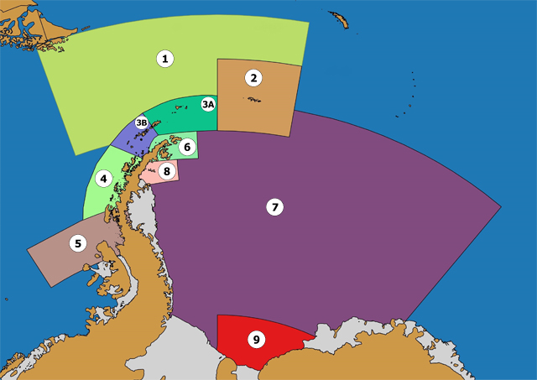
Figure XIV-1 – Antarctic Zones for Argentina Ice Chart production.

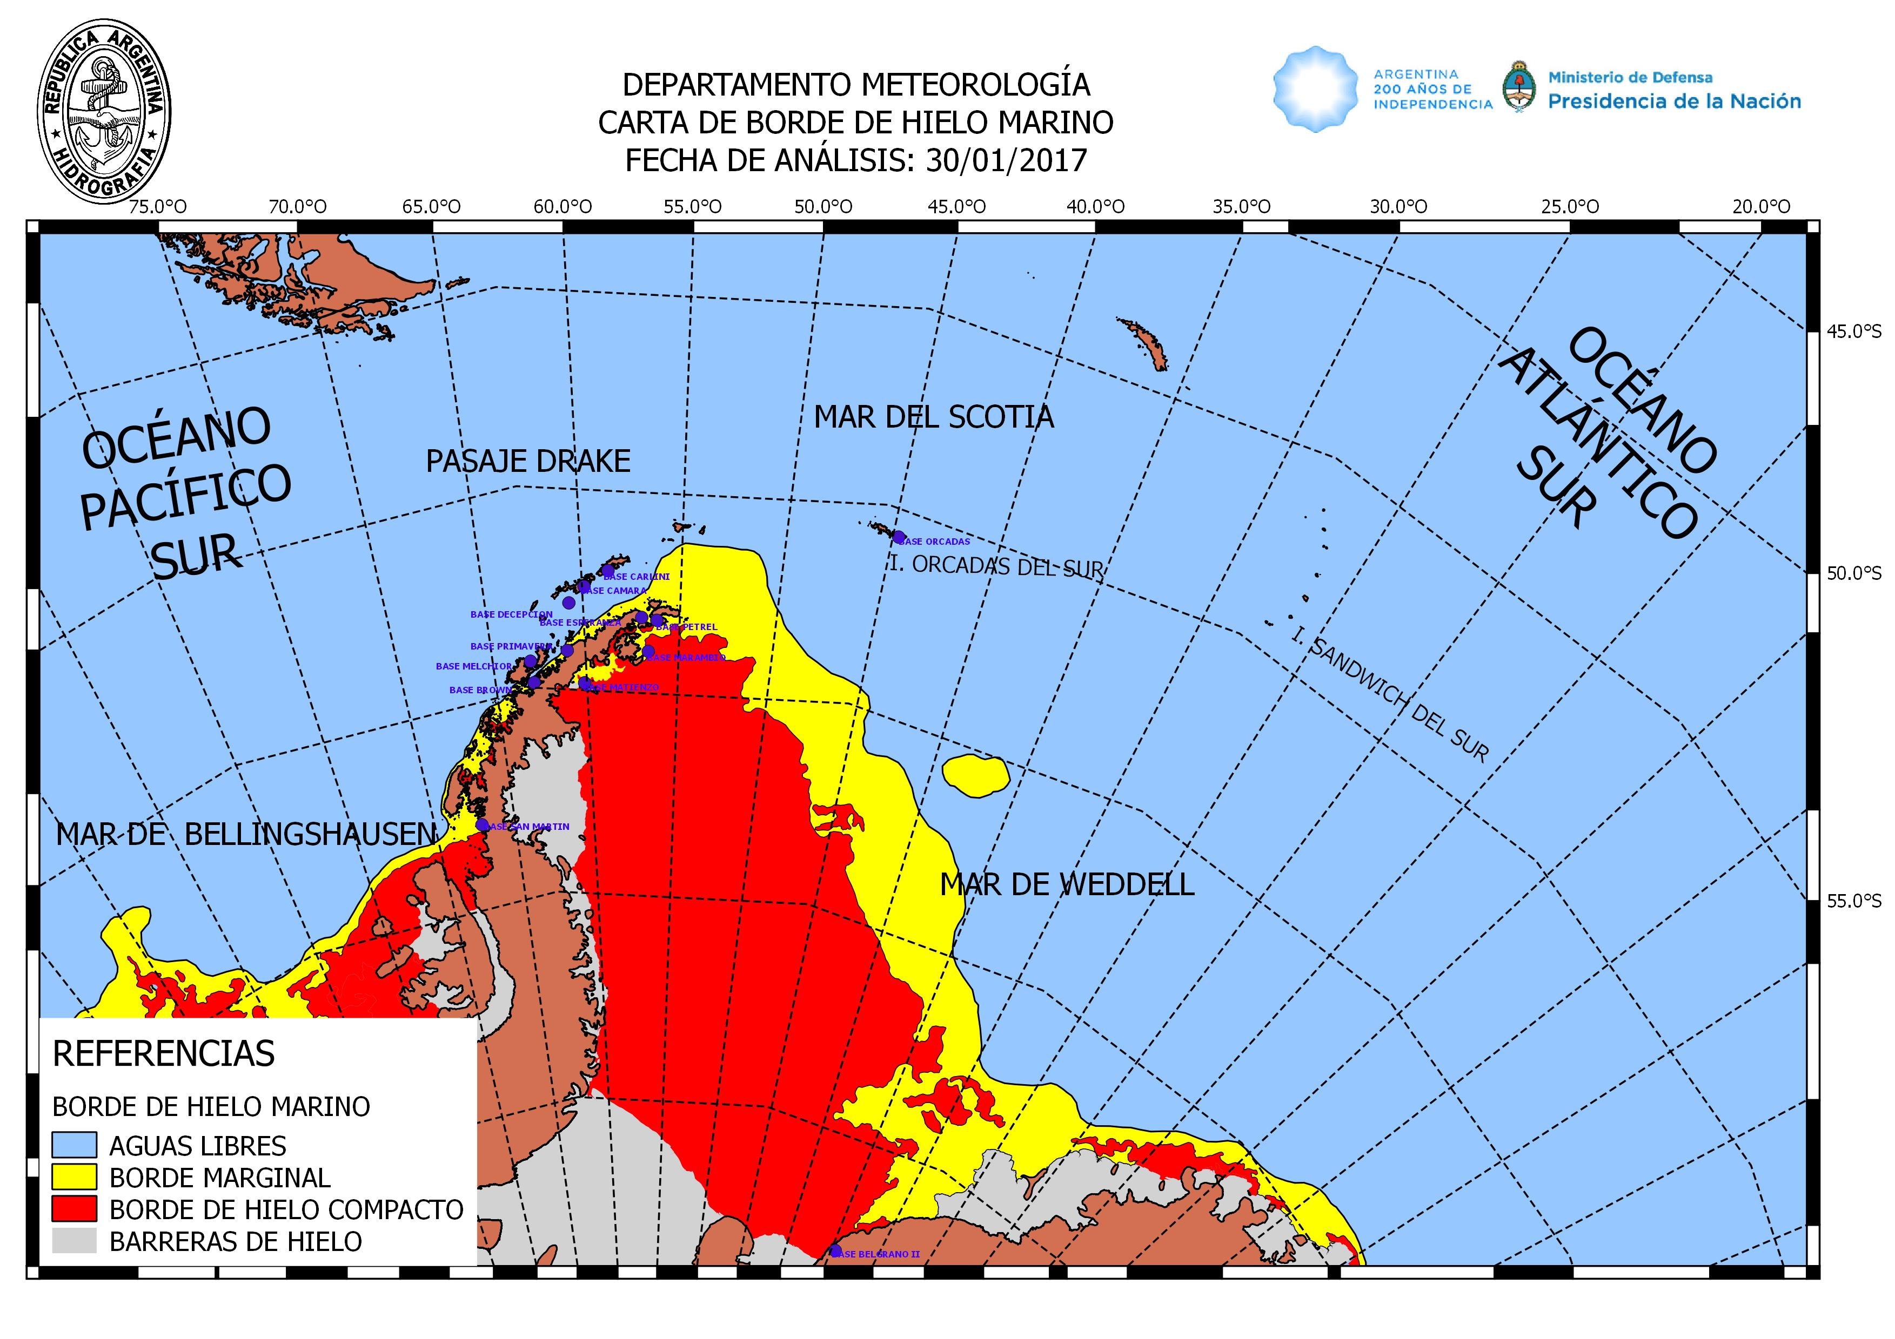
Figure XIV-2 – Sea Ice Edge Chart for January 30th 2017.

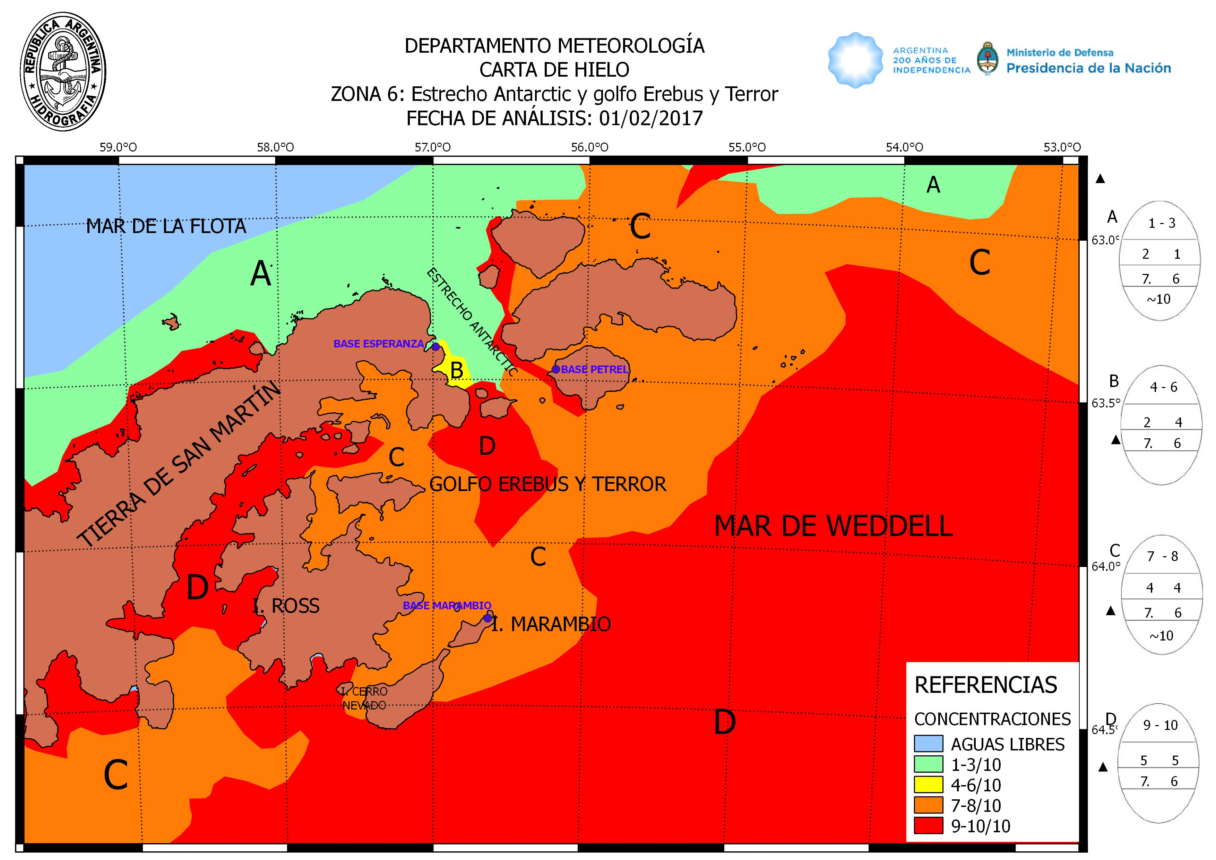
Figure XIV-3 – Ice Chart of Zone 6 for February 1st 2017.

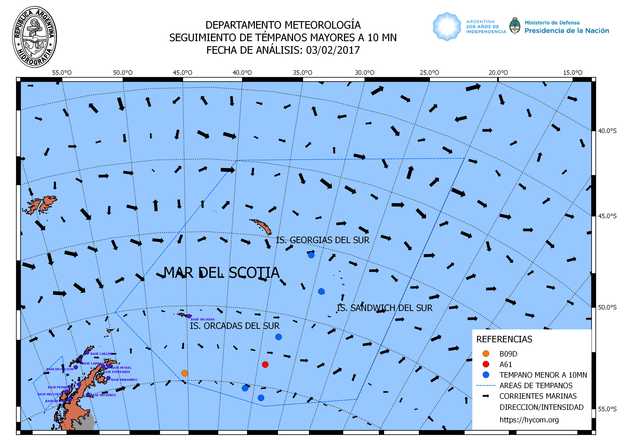
Figure XIV-4 – Icebergs Chart for February 3rd 2017.

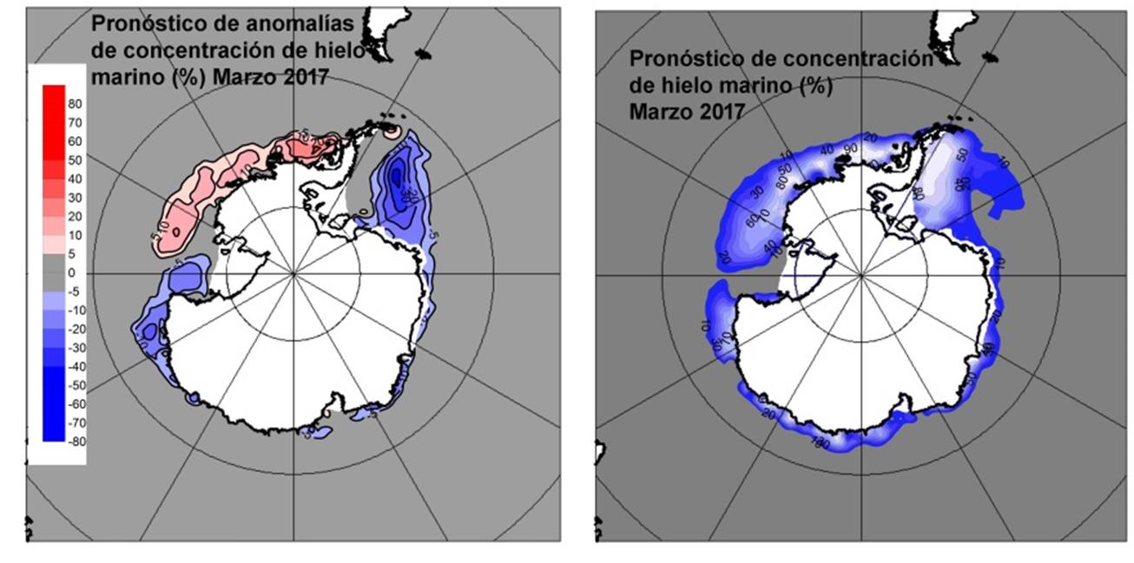
Figure XIV-5 – Sea Ice Concentration Forecast valid for March 2017. Left image: Sea Ice Concentration Anomalies Forecast. Right Image: Percentage of Sea Ice Concentration Forecast.

