**CANADA**

09 February 2017 Revision

1. **Organization**

The Canadian Ice Service (CIS), a division of the Meteorological Service of Canada at the Department of the Environment is a centre of expertise providing reliable and timely marine ice and iceberg information for Canada and its surrounding waters. The Ice Service works closely with the Canadian Coast Guard which operates a fleet of icebreakers to assist marine transportation in Canadian waters.

Ice information products and services are provided for Canada’s waters in areas of known marine activity. Arctic areas are typically active from June to November while southern areas, including the Gulf of St. Lawrence and the Great Lakes are usually active from December to May. In addition to Canadian waters, the CIS also provides ice information for METAREA XVII and METAREA XVIII.

Major users of Ice Service products and services are marine interests and researchers.

The Canadian Ice Service has expertise in ice reconnaissance, analysis and forecasting, modelling, remote sensing and Canadian ice climatology. The CIS maintains an archive of Canadian ice information products.

It has a staff of approximately 90 people working in Ottawa and in field offices. The office in Ottawa is staffed 7 days a week.

1. **Data acquisition**

Radar and visual imagery from satellites are the principle data sources, augmented by visual observations transmitted by ice observers onboard fixed-wing aircraft and helicopters. RADARSAT-2 and SENTINEL synthetic aperture radar (SAR) data provides extensive and detailed (typically 100 m resolution) coverage of ice conditions. The Ice Service uses approximately 11,000 SAR images annually. Data are received in near real-time by Canadian satellite receiving stations and are processed and delivered to the Canadian Ice Service typically within an hour.

Visual and infrared imagery from U.S. polar orbiting satellites is also used in the ice analysis program. Passive microwave imagery is received daily to provide background information on the general ice distribution at low resolution.

1. **Output products**

Ice information products are available on the Canadian Ice Service web site, the marine weather section on Environment Canada’s weather.gc.ca, the Canadian Coast Guard website, and through Canadian Coast Guard marine radio broadcasts. All products are available in English and French.

Specialized products and services to meet the short-term tactical and longer-range planning needs of clients are also available. These products and services include detailed ice charts, satellite imagery, special forecasts covering days to months and onsite briefings. Products are distributed via e-mail, fax, and internet.

*(a) Ice charts*

Ice charts illustrate ice or iceberg conditions at a particular time, presenting full and partial concentrations using the complete egg code. Each chart is produced using both WMO colour codes as well as black and white and custom colour palettes. Sea ice and lake ice charts are available in .gif and .pdf formats. Sea ice and iceberg data are available electronically in Sigrid3 and .e00 formats. The following charts are available:

1. Regional (weekly) Ice Chart (Figure I-1, Annex I);

Regional ice charts show the analysis of ice conditions for a given region valid on Mondays. They are based on an analysis of satellite imagery collected over a few days and integrate weather and oceanographic data.

1. Daily Ice Charts (Figure I-3, Annex I);

Daily Ice charts represent the best estimate of ice conditions at the valid time of the chart. A variety of satellite imagery is used as well as model output to forecast the location and condition of the ice. These charts are provided daily in areas of marine activity in Canadian waters.

1. Satellite Image Analysis Charts (Figure I-4, Annex I);

Image analysis charts provide a visual interpretation of the ice conditions extracted from synthetic aperture radar imagery frames. The charts are valid at the image acquisition time. The areal extent of an image analysis chart varies depending on the satellite’s orbit as well as on operational requirements to support shipping. These charts are available in areas where the satellite pass covers areas with marine activity.

1. Ice Reconnaissance Charts (Figure I-5, Annex I);

Reconnaissance charts present very detailed information on ice conditions at the time of the aircraft survey. They are provided for active marine areas where ice conditions are challenging.

1. Daily Iceberg Forecast Charts (Figure I-2, Annex I);

This chart presents an estimate of iceberg conditions in East Coast waters south of 60° N based on visual observations of icebergs from aircraft, ships, and occasionally from satellite imagery. Positions are forecast to 00:00 UTC along with an iceberg limit line. For areas north of 53ºN, the iceberg limit is estimated when there is a lack of aircraft observations. The chart includes an estimate of the number of icebergs per degree square of latitude and longitude.

*(b) Bulletins*

Text bulletins provide information on present iceberg conditions. The following bulletins are available:

1. Daily Iceberg Bulletins
2. METAREA bulletins

*(c) Imagery Mosaics and Composite*

Imagery mosaics and composites are automatically generated from multiple scenes and/or swaths of satellite imagery and provide an overview of ice conditions for the area of interest for the time period of the data collection. The following imagery mosaics are available:

1. 3-day RADARSAT Mosaics – Western Arctic; Eastern Arctic; Hudson Bay (Figure I-6, Annex I)
2. 7-day MODIS Composites - Arctic (Figure I-7, Annex I)
3. **Forecasts and Outlooks**

Forecasts provide information on present and forecast ice conditions in text format.

The following forecasts are available:

1. Daily Ice Forecasts (Figure I-8, Annex I);

Daily forecasts describe the ice edge location, and for each marine area the total ice concentration, the predominant stage of development and the concentration of the oldest ice type. The forecasts are valid from the time of issue until the end of the following day. Warnings are issued for strong ice pressure, rapid closing of coastal leads, and unusual ice conditions that may pose a threat to navigation.

1. 30 Day Ice Outlooks

The long-range outlook describes the general advance or retreat of ice in a region over a 30-day period. It estimates the stage of ice development and identifies any anticipated departure from normal conditions. Forecasts are issued around the third business day following the 1st and 15th of each month.

1. Seasonal Ice Outlook (graphical and text format)

The seasonal outlook describes the expected timing of the ice breakup in the Arctic or freeze-up in the Great Lakes or the East Coast. This product is not updated or amended and is replaced by the 30-day forecast.

1. **Publications**

The following publications are available in print and on-line as indicated:

1. Seasonal Summary for the Canadian Arctic since 2004 (available on request)
2. Seasonal Summary for the Great Lakes and Eastern Canadian Waters since 2004(available on request)
3. MANICE - Manual of Standard Procedures for Observing and Reporting Ice Conditions.
4. Sea Ice Climatic Atlas - Northern Canadian Waters 1981-2010
5. Sea Ice Climatic Atlas - East Coast of Canada 1981-2010
6. Lake Ice Climatic Atlas - Great Lakes 1973-2002
7. Annual Arctic Ice Atlas 1990 – present (available on request)
8. **Mailing and internet addresses**

Canadian Ice Service – Environment and Climate Change Canada

373 Sussex Drive, Block E – 4th floor

Ottawa, Ontario

Canada K1A 0H3

Telephone: +1 (877) 789-7733 | Fax: +1 (613) 947-9160

E-mail: ec.ecweather-meteo.ec@canada.ca

Internet: <http://ice-glaces.ec.gc.ca>

Figure I-1 – Regional Ice chart for the Eastern Arctic for 05 December 2016.

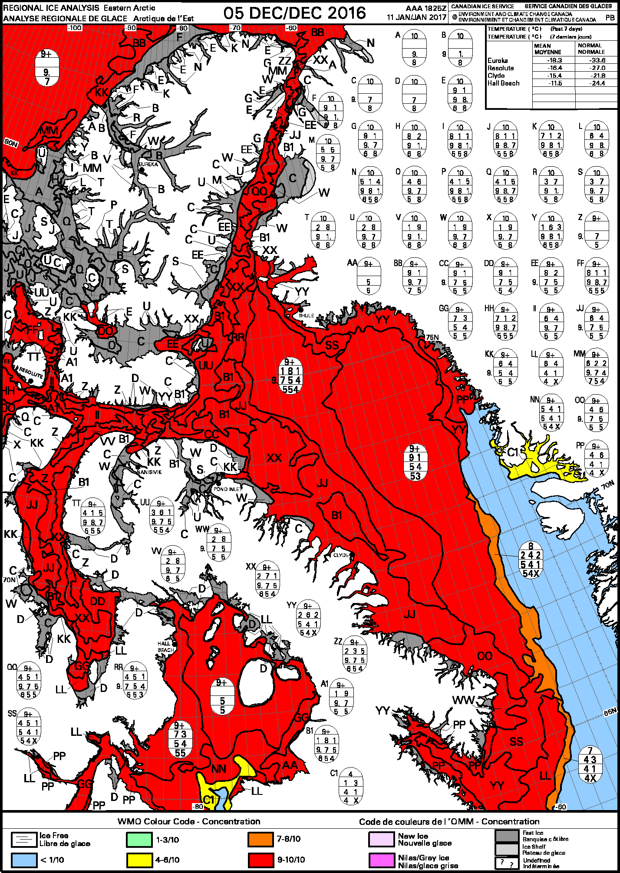

Figure I-2 – Daily Iceberg Analysis chart for the Canadian East Coast for 8 February 2017

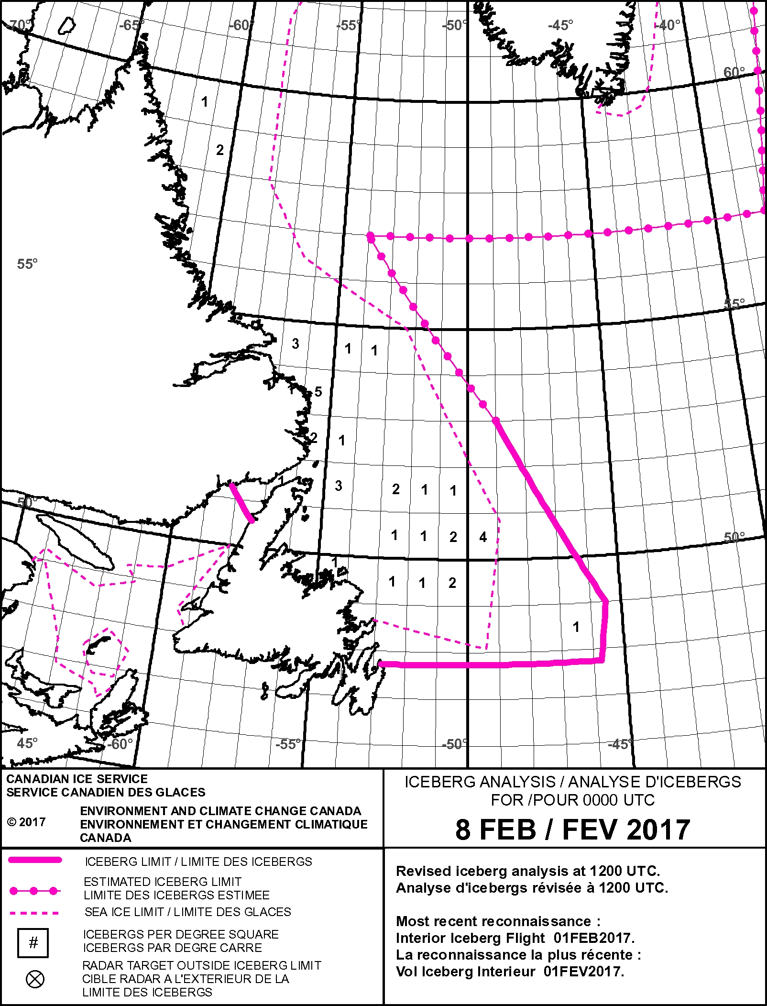

Figure I-3 – Daily ice chart for the Canadian East Coast for 15 February 2016.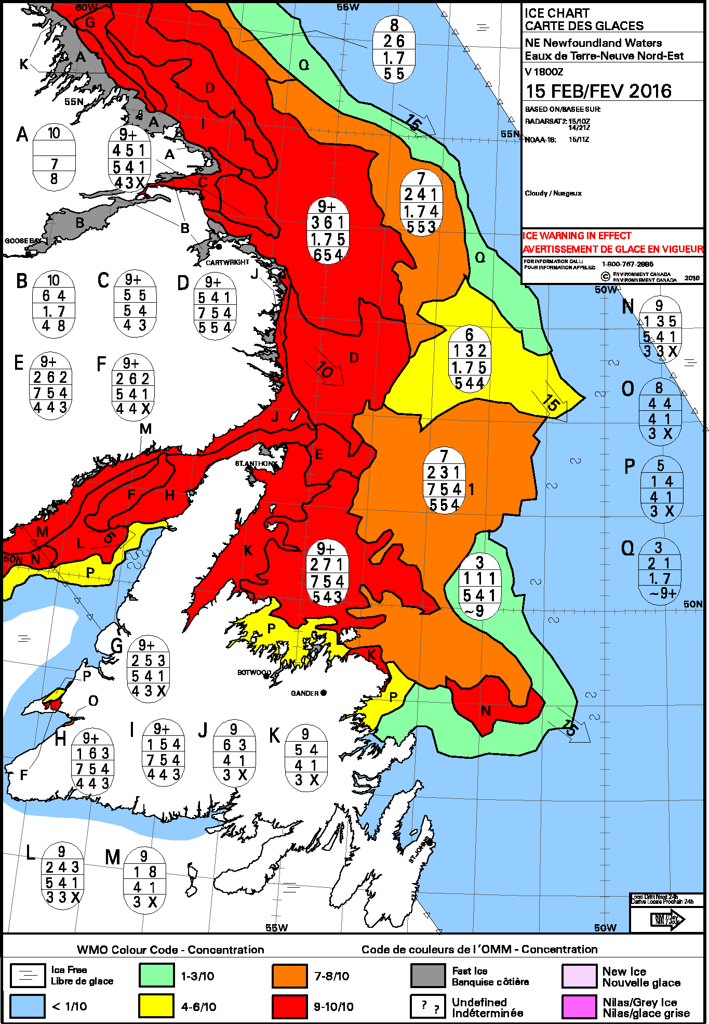

Figure I-4 – Image analysis chart for East Newfoundland Waters on 06 February 2017.

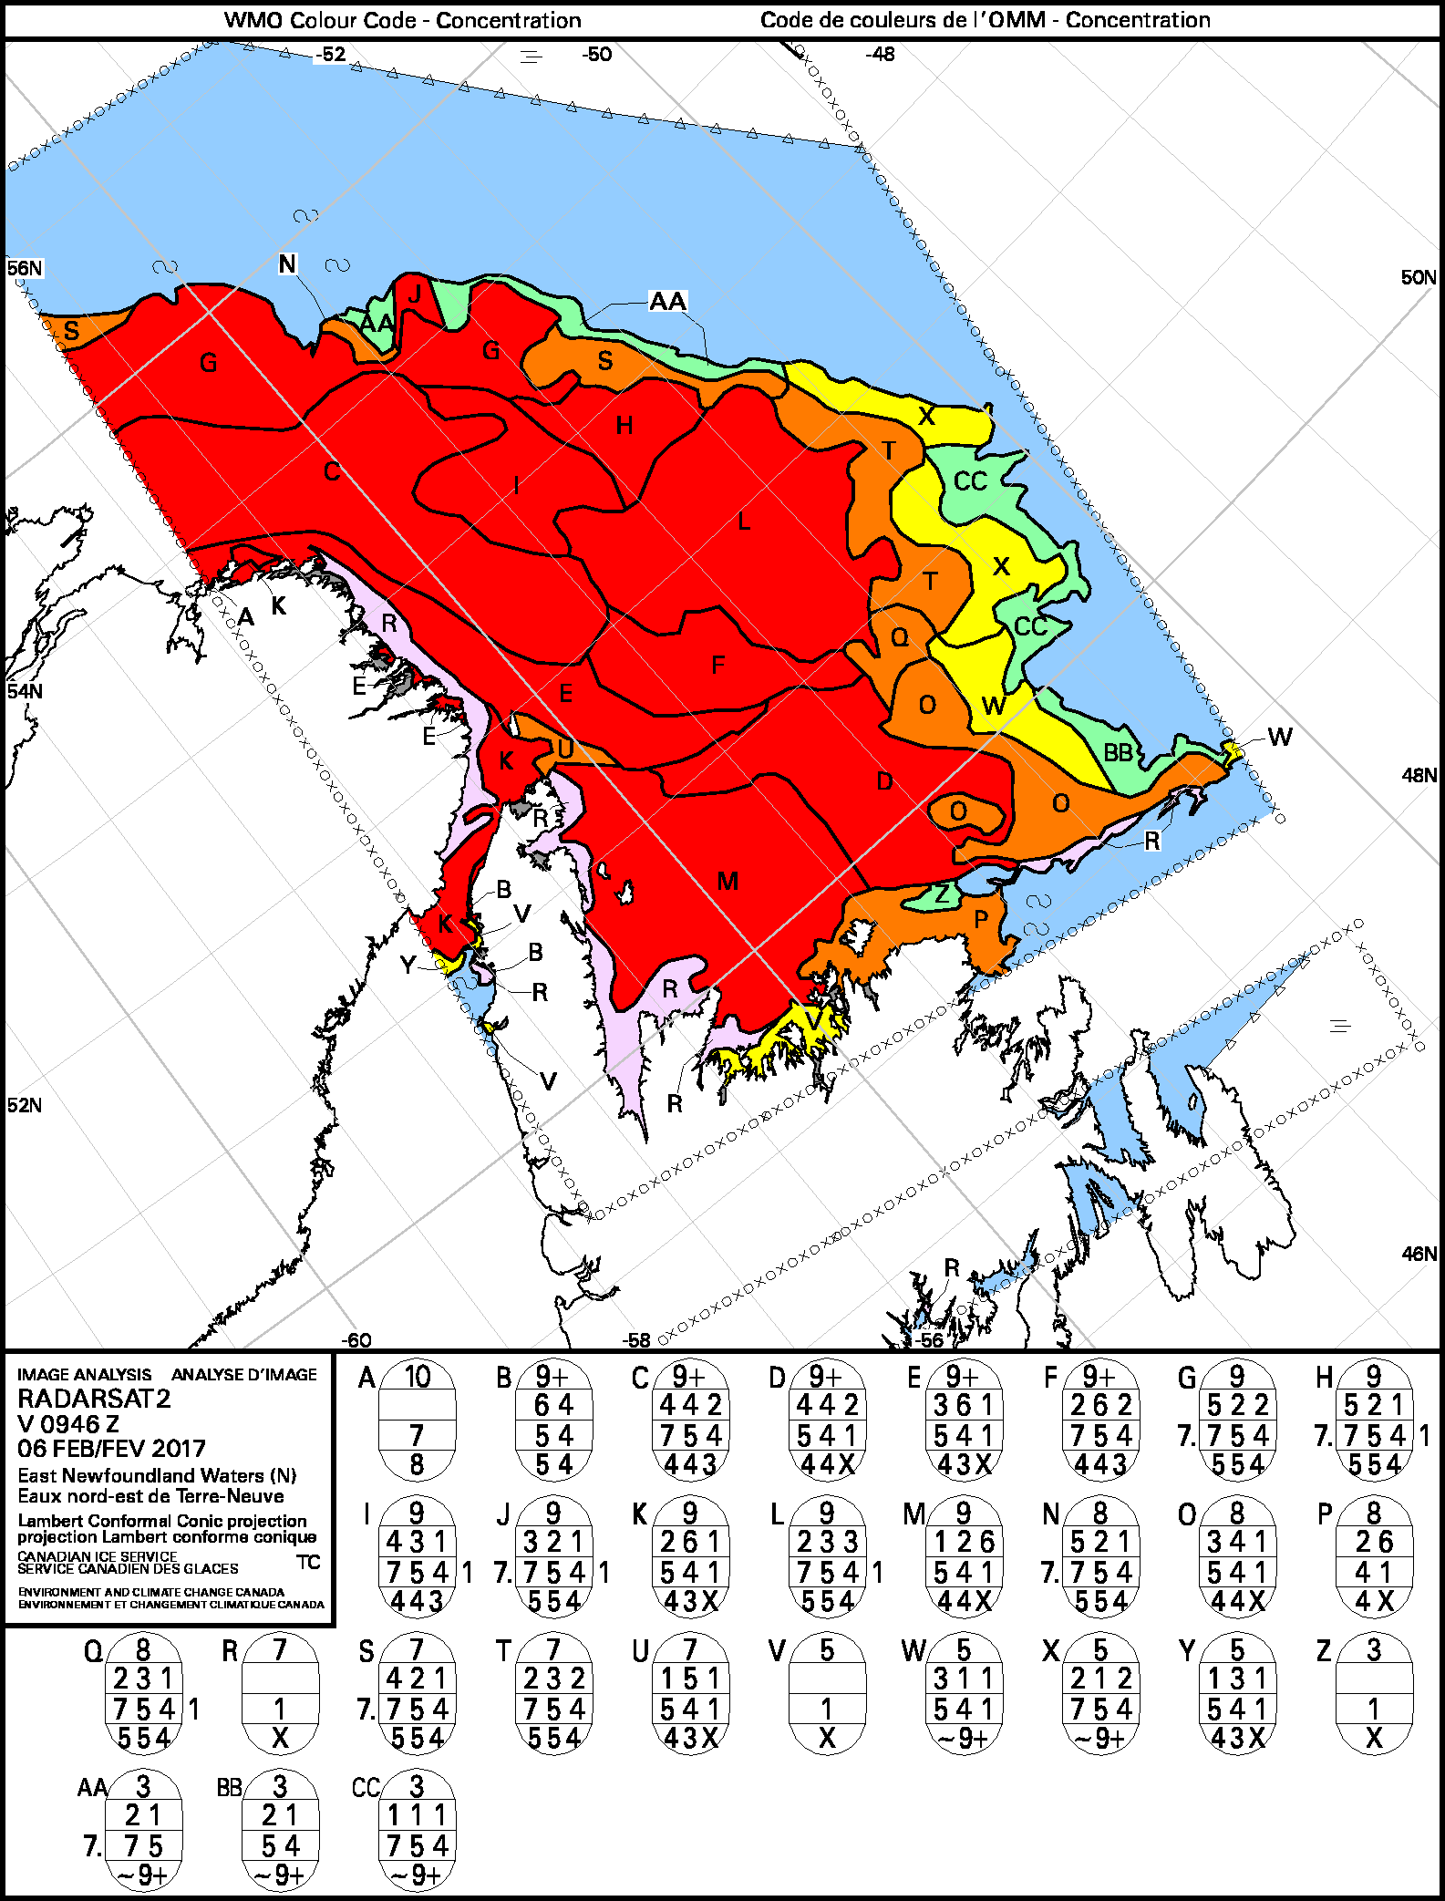

Figure I-5 – Ice Reconnaissance chart for the Port of Montreal on 06 February 2017.

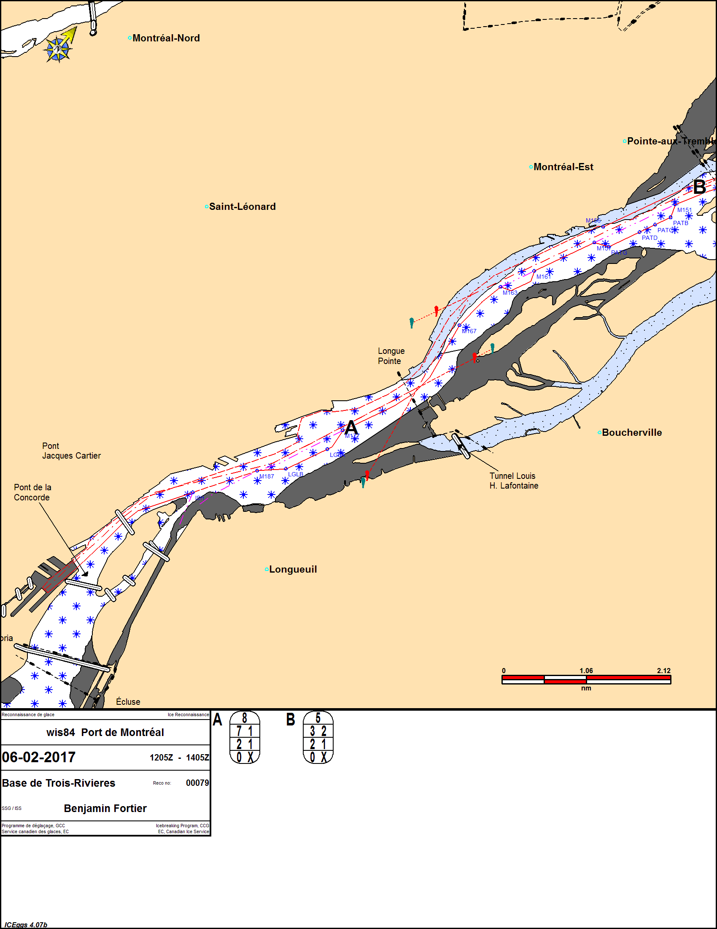

Figure I-6 – RADARSAT Mosaic (27 to 30 January, 2017)

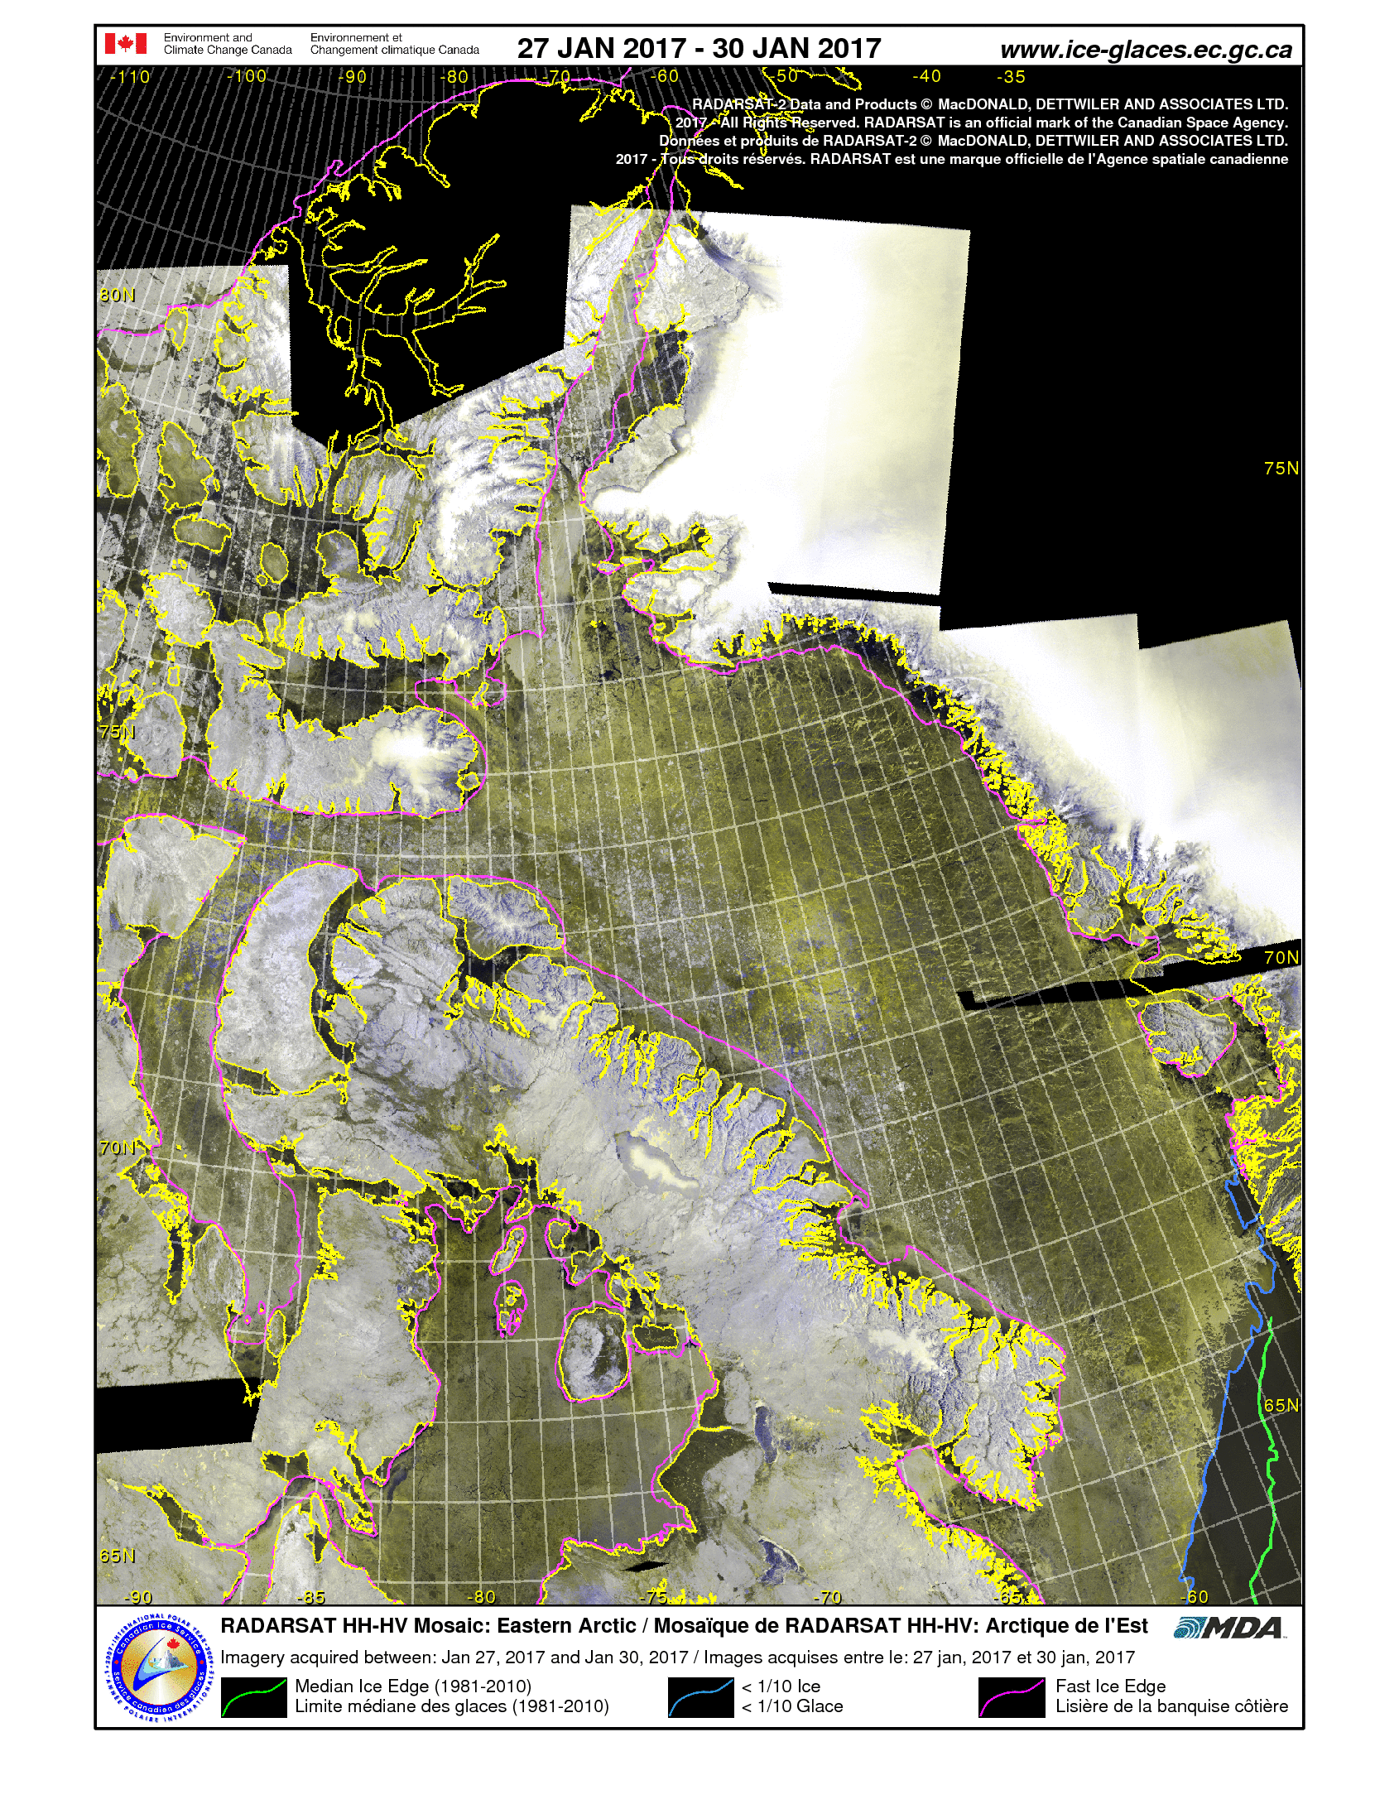

Figure I-7 – MODIS Composite (02 to 08 August, 2017)

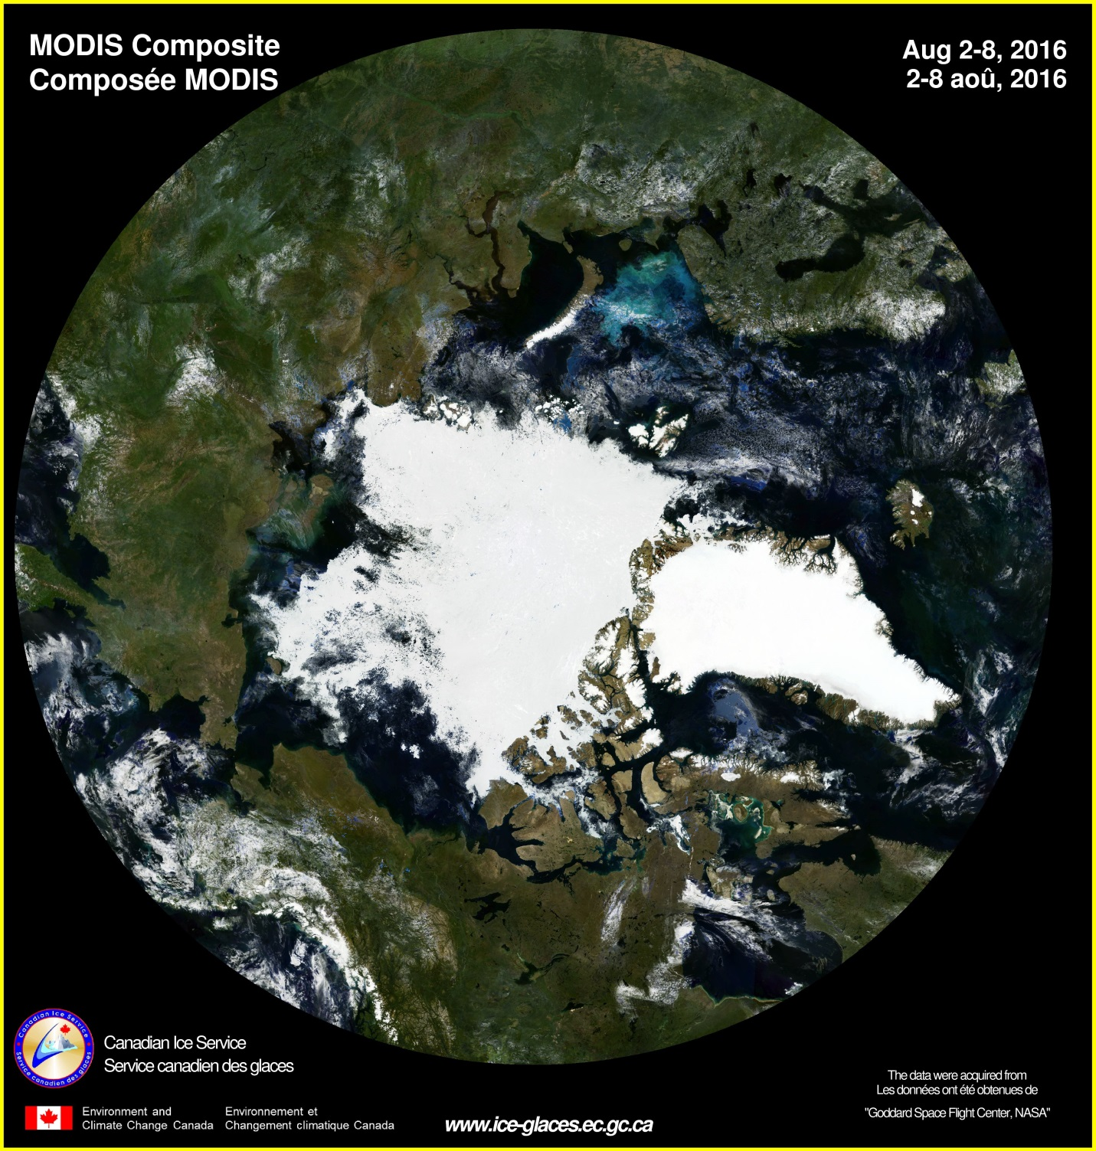

Figure I-8 – Daily Ice Forecast for East Coast Newfoundland for 07 February 2017

FICN18 CWIS 071446

Ice forecasts for the eastern waters of Newfoundland and Labrador issued by Environment Canada at 10:00 a.m. EST Tuesday 7 February 2017 for today tonight and Wednesday. The next scheduled forecasts will be issued at 10:00 a.m. Wednesday.  
  
Ice edge estimated from Newfoundland near 4840N 5305W to 4805N 4925W to 5050N 4855W to 5500N 5220W to 5625N 5630W to 5800N 5815W then northward. Sea ice west of the ice edge.  
  
Strait of Belle Isle - eastern half.  
9 tenths of new ice including 2 tenths of grey ice except 9 plus tenths of grey ice including 3 tenths of grey-white ice in the eastern and southern sections.  
  
Strait of Belle Isle - western half.  
Ice pressure warning in effect.  
9 tenths of grey ice including 3 tenths of grey-white ice except 9 plus tenths of grey-white ice including 1 tenth of first-year ice along the Newfoundland coast. Strong ice pressure along the Newfoundland coast easing this evening.  
  
Belle Isle Bank - northwestern half.  
Bergy water except 6 tenths of first-year ice including a trace of old ice in the western section.  
  
Belle Isle Bank - southeastern half.  
Bergy water except 6 tenths of grey-white ice including a trace of old ice.  
  
South Labrador Coast.  
9 tenths of grey ice including 3 tenths of first-year ice except 9 plus tenths of first-year ice including a trace of old ice in the northeastern section.  
  
Lake Melville.  
Consolidated first-year ice.  
  
Mid Labrador Coast.  
9 plus tenths of first-year ice except 9 plus tenths of first-year ice including a trace of old ice in eastern sections.

(…)  
  
Contact ECAREG Canada via marine radio for routing advice. East coast ice analysis charts can be copied on CFH Halifax at 2222 UTC and 0001 UTC and on VCO Sydney at 1142 UTC and 2331 UTC.  
  
End