Sea-Ice Information Services
in the World

Edition 2010
(last revision 2015-12-04)

WMO-No. 574

PART II - REGIONAL AND NATIONAL PRACTICES

GERMANY
15 February 2017 Revision

1. Organization
The ice service provided by the Federal Maritime and Hydrographic Agency (BSH) covers the whole Baltic during the winter, with special emphasis on the German Bight and the Baltic Sea west of Bornholm. The agency is separate from the Meteorological Service but both are part of the Federal Ministry of Transport and Digital Infrastructure. The products of the ice service are provided for fisheries, national and international shipping in the Baltic Sea and for harbor activities, maritime agencies and off-shore activities. On request world-wide ice information is provided.
A joint web page for the Baltic Sea Ice Services (BSIS) has been developed and established as an independent domain at BSH (http://www.bsis-ice.de), which also includes the JCOMM Ice Logistics Portal.

2. Data acquisition
Daily ice information is reported in Baltic Sea Ice Code from 134 areas or fairway sections along the coast of the southwestern Baltic Sea and the German Bight. A selection of these form 54 main areas or fairways grouped in 11 districts. Details are given in WMO No.9, Volume D – Information for Shipping. In addition to the coded information, observers at many stations also perform ice thickness measurements. The other main data sources are satellite observations, mostly from freely available sources (NOAA, MODIS, Sentinel and VIIRS in the optical, passive microwave from AMSR and active microwave (SAR) from Sentinel). Reports, data and charts are also exchanged with foreign ice services via e-mail and GTS. Internet access to ice information products of foreign services is greatly used. Information over sea surface temperature is taken from coastal stations, satellite data and from the operational model.

3. Output products
All regular products are freely available on the Internet at www.bsh.de. The ice charts are also available at the JCOMM Ice Logistics Portal and part of them (in black and white) are also broadcasted as radio facsimile over long wave using the station at Pinneberg (search on Website of the DWD at www.dwd.de). The radio facsimile transmission also include the iceberg charts for the North-West Atlantic provided by IIP (International Ice Patrol) and CIS (Canadian Ice Service), the Swedish ice chart of the Baltic and the Norwegian ice chart of the European Arctic.
(a) Ice charts
(i) A reference ice chart of the ice conditions in the Baltic Sea using the international system of sea-ice symbols is produced once a week.
(ii) An ice chart showing ice conditions in the western Baltic and German Bight using the international system of sea-ice symbols is made as necessary (up to daily) when ice is present in considerable amounts at sea in the Skagerrak or Kattegat.
(iii) An ice chart showing ice conditions at the German coast using the international system of sea-ice symbols is made as necessary (up to daily) when ice is present in considerable amounts.
Note: all charts are constructed with the ArcMap program using Mercator projection. The standard format for the regular user is PDF, but the data is also made available on the internet as shapefiles and in S411. Larger scale (approximately 1:850,000) sub-regional charts are prepared as needed in PDF format.
Sample ice charts are given in Annex VI.
(b) Coded and plain language information
(i) A bulletin describing ice conditions and traffic restrictions in the whole Baltic Sea and North Sea using plain English and German and the Baltic Sea Ice Code is made Monday to Friday. An ice outlook for three to six days is included.
(ii) Similar bulletins covering the western Baltic and the German Bights are prepared daily in English and German for GTS and national NAVTEX.
(iii) Detailed descriptions of the ice at the German coast are made in plain German, there are separated in a Baltic report and a North Sea report.

4. Forecasts
An operational, 3-dimensional numerical ocean model including sea ice is run twice a day with a forecast length of 72 hours. The model covers the whole Baltic and North Sea. As the model does not assimilate sea ice data, the direct use of the model output for operational sea ice products is very restricted. But the model output is used at times by the sea ice analyst for additional information regarding formation of new and young ice, sea ice thickness and the decay of ice.

5. Publications
Each year a description of the last ice season is done in summer and made available at the BSH website. Other publications are prepared at irregular intervals, like summaries of several winters as special BSH reports, and sea ice chapters for nautical publications. There are two actual ice atlases (published 2012 and 2015), one for the western and southern Baltic and the other for the German Bight and Limfjord.

6. Mailing and Internet addresses
BSH – Eisdienst
Neptunallee 5
18057 Rostock Germany
Telephone: +49 (0) 381 4563 782 (and 787)
Telefax: +49 (0) 381 4563 949
E-mail: ice@bsh.de
Internet:
http://www.bsh.de/de/Meeresdaten/Beobachtungen/Eis/index.jsp (in German/English)
http://www.bsis-ice.de (a joint web page for the Baltic Sea Ice Services), with a mirrored backup at http://www.eisdienst.de .

ANNEXES - SAMPLE CHARTS AND OUTPUT PRODUCTS OF NATIONAL SERVICES

ANNEX VI – Germany
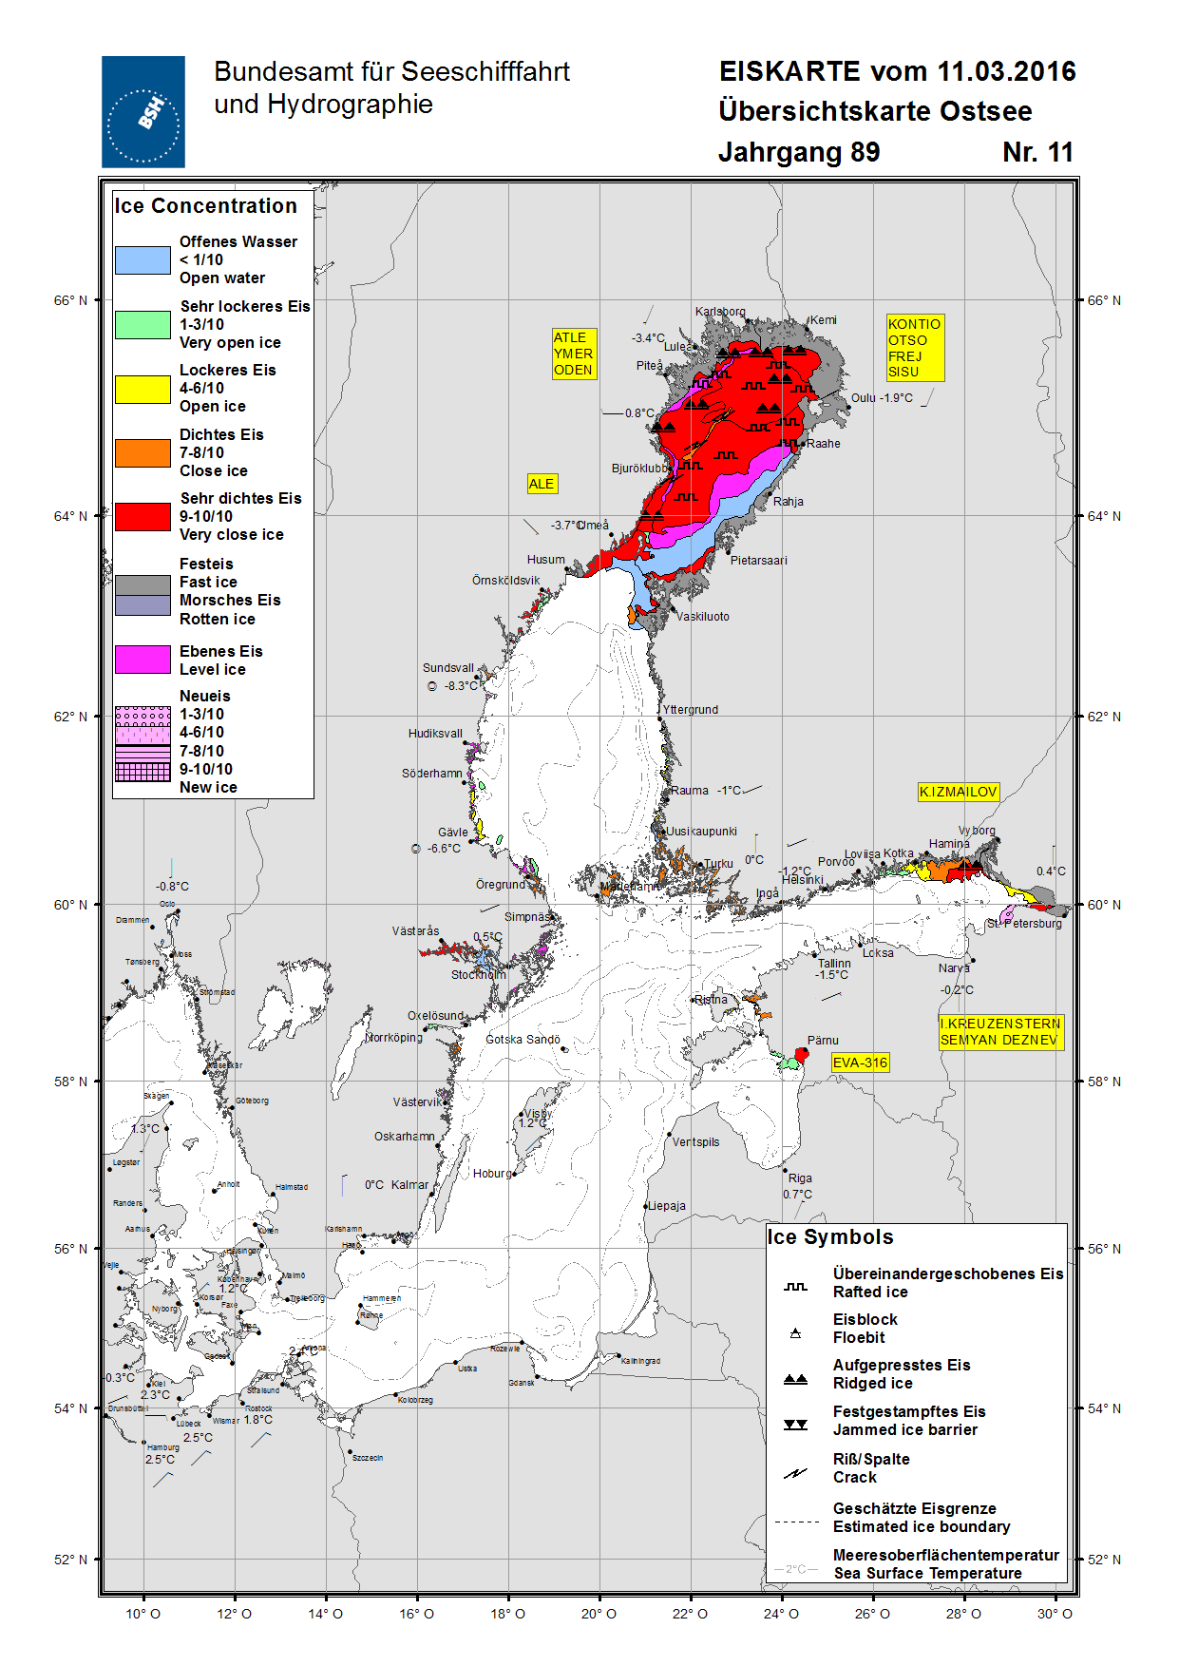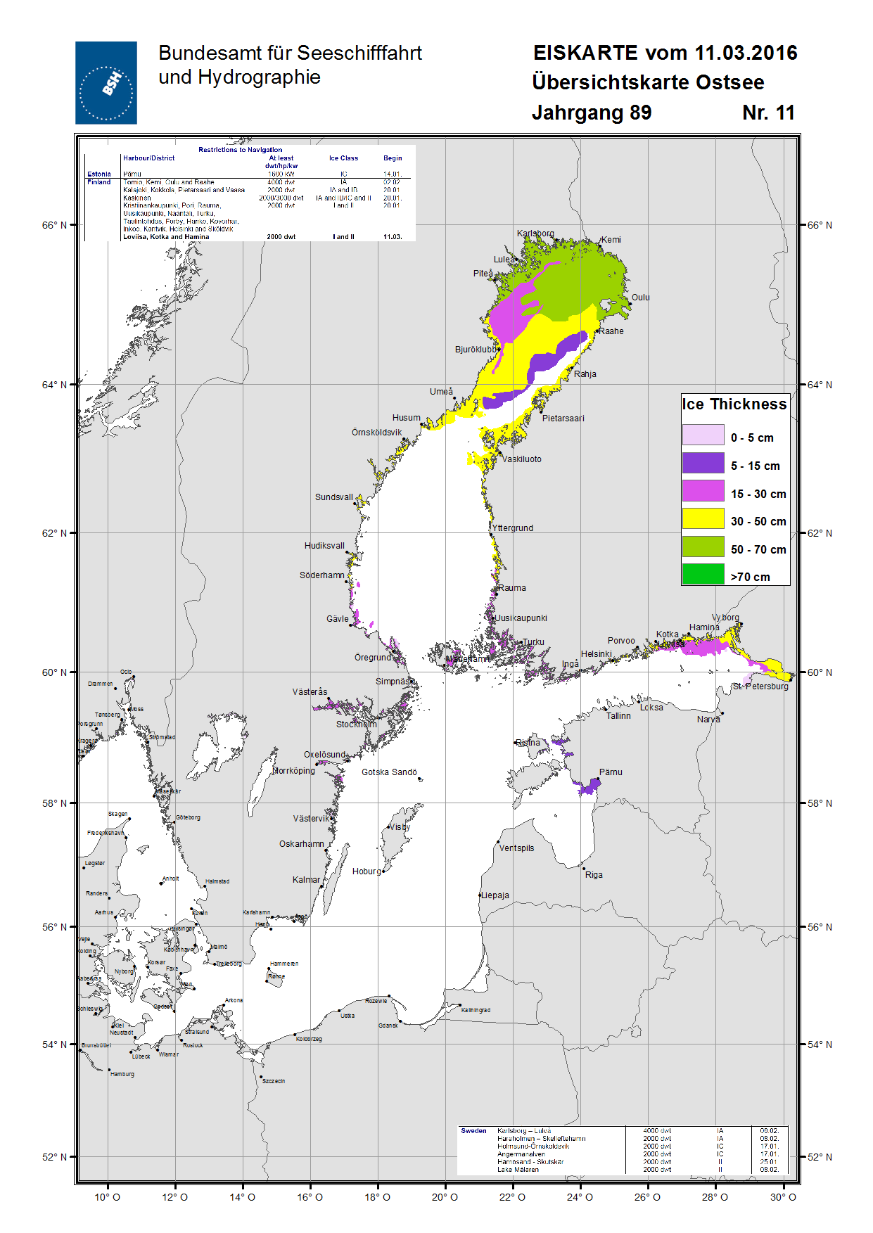
Figure VI-1 – Ice chart for the whole Baltic, March 13, 2016.
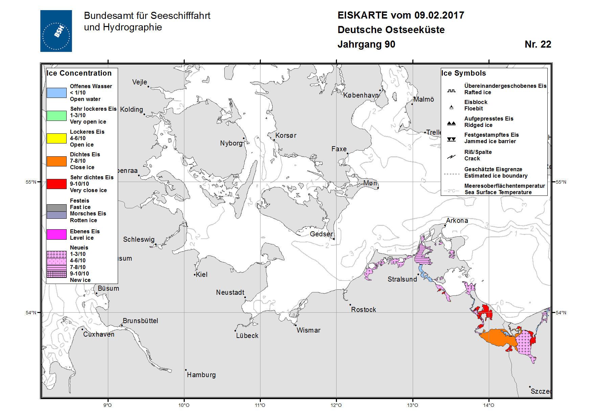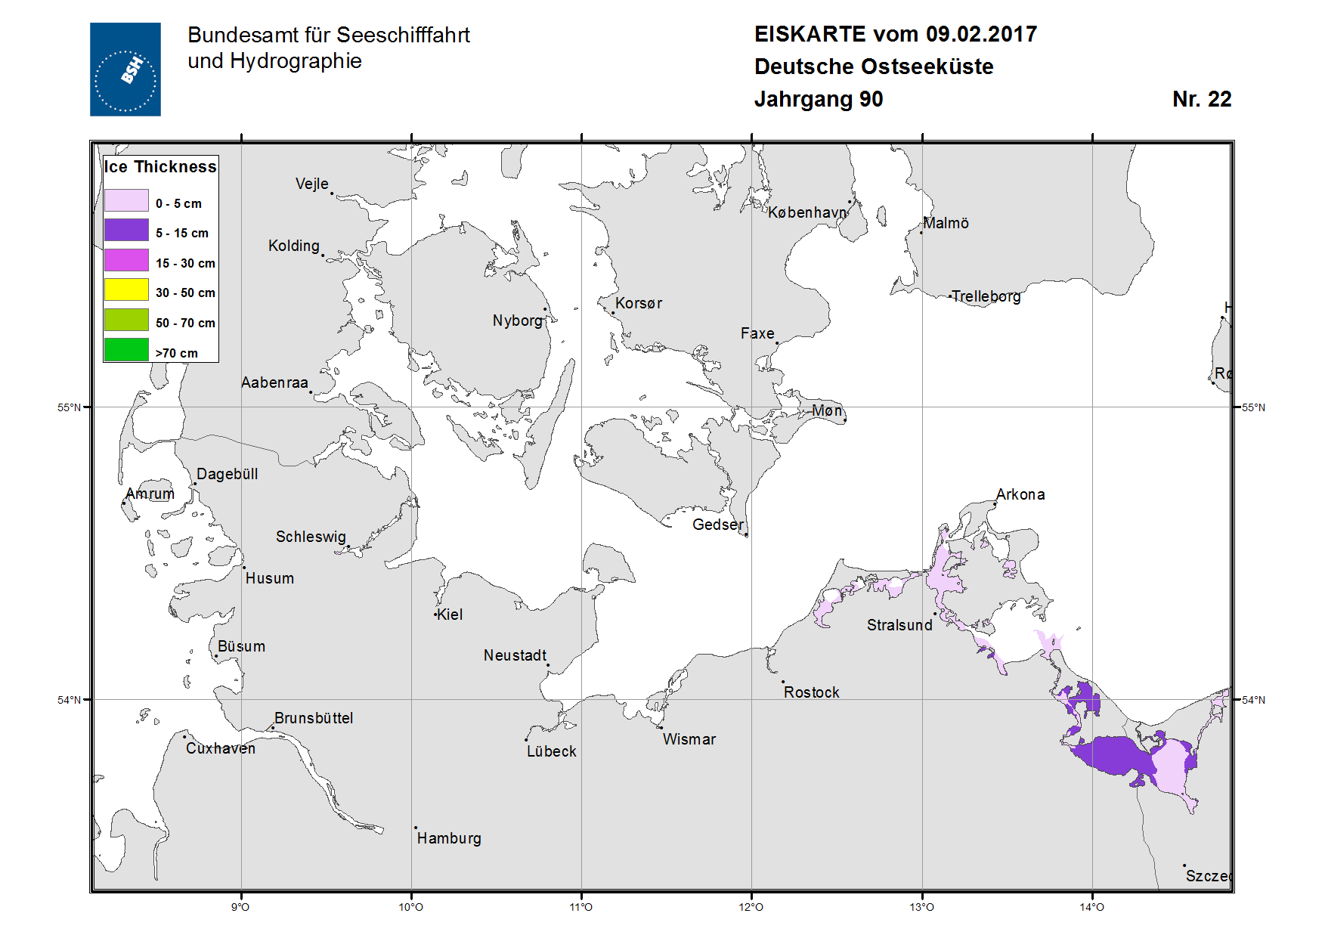
Figure VI-2 – German coast chart, February 9, 2017.
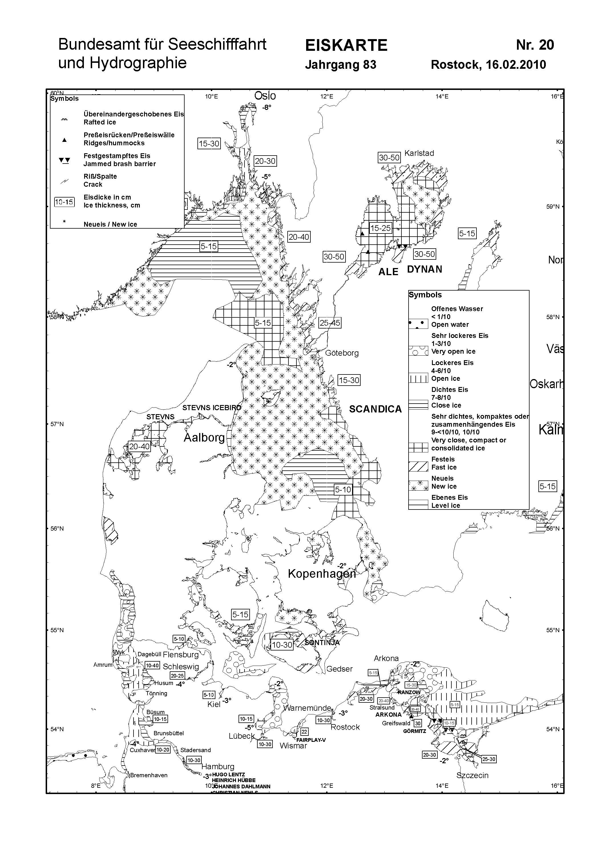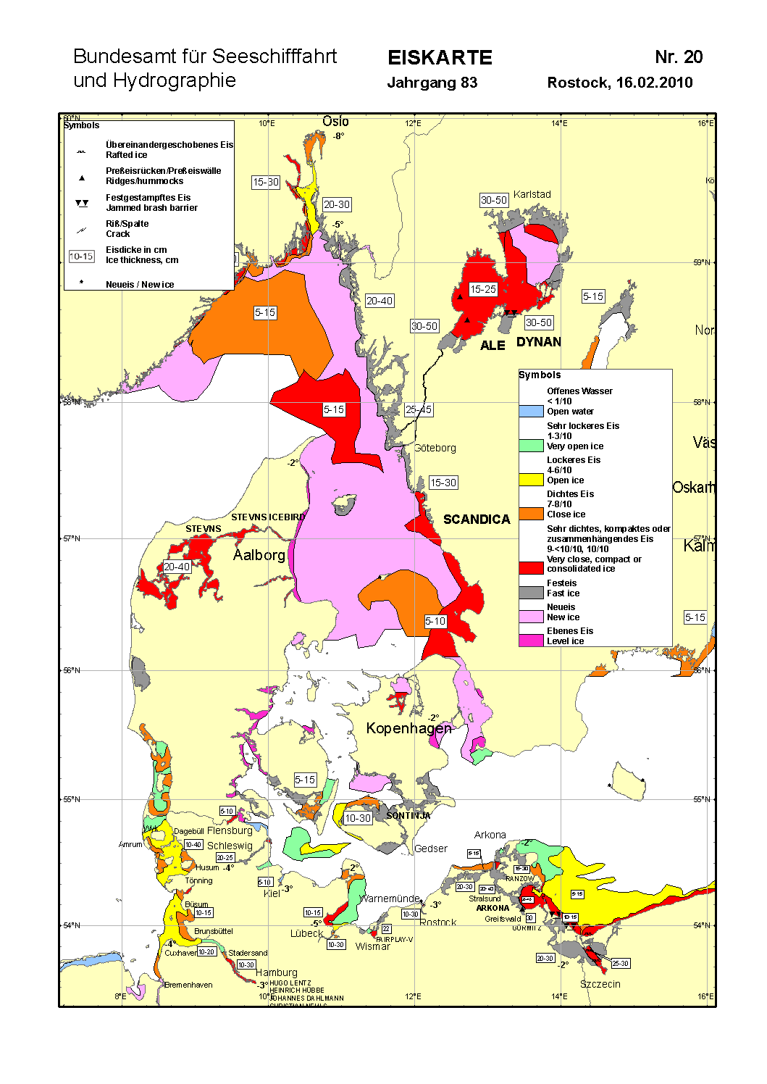
Figure VI-3 – Western Baltic Sea area and North Sea coast ice chart for 16 February 2010. The black and white version is for radio facsimile broadcast. Newer maps in color will look more similar to the actual ice charts of the whole Baltic and the German coast.

Sea-ice products by areas of the World Ocean available via the Ice Logistics Portal
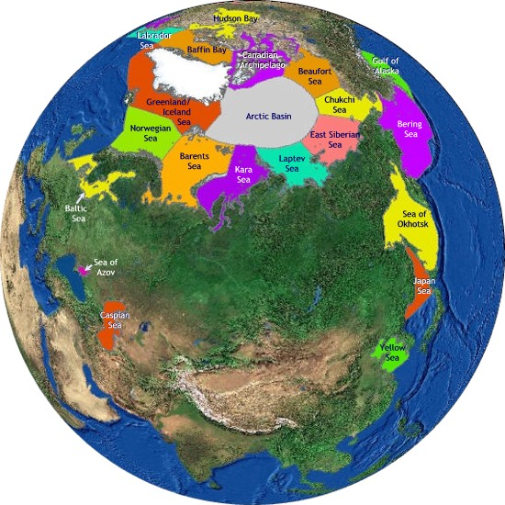
High connection speed: http://www.bsis-ice.de/IcePortal/displayNorthernMap90E.html
Low connection speed: http://www.bsis-ice.de/IcePortal/North_low.html
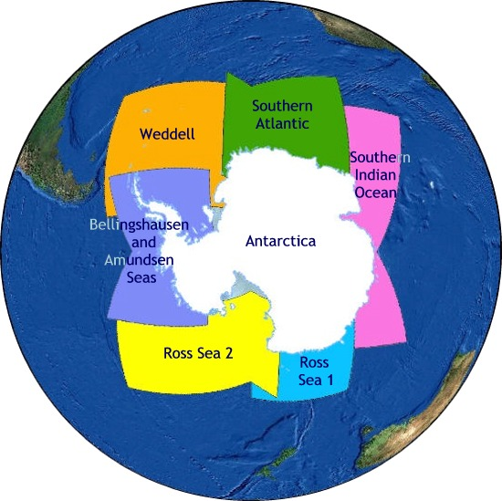
High connection speed: http://www.bsis-ice.de/IcePortal/displaySouthernMap.html
Low connection speed: http://www.bsis-ice.de/IcePortal/South_low.html

All available actual S411 charts: http://www.bsis-ice.de/IcePortal/ILP_S411.shtml

