Sea-Ice Information Services
in the World

Edition 2010
(last revision 2015-12-04)

WMO-No. 574

© 2015, World Meteorological Organization, Geneva

ISBN 92-63-13574-6
NOTE
The designations employed and the presentation of material in this publication do not imply the expression of any opinion whatsoever on the part of the Secretariat of the World Meteorological Organization concerning the legal status of any country, territory, city, or area, or of its authorities, or concerning the delimitation of its frontiers or boundaries.

TABLE FOR NOTING SUPPLEMENTS RECEIVED
Supplement  No. | Dated | Inserted in the publication by
1  2  3  4  5  6  7  8  9  10  11  12  13  14  15  16  17  18  19  20  21  22  23  24  25 | 2008-09-01  2008-10-31  2008-12-16  2008-12-22  2008-12-29  2008-12-31  2009-01-13  2009-01-20  2009-03-23  2009-04-15  2009-04-15  2009-05-07  2010-02-28  2010-03-08  2010-03-19  2014-03-10  2014-03-17  2014-03-21  2015-12-04 | Norway – Nick Hughes  Poland – Marzenna Sztobryn  Finland – Ari Seina  Argentina – Beatriz Lorenzo  Sweden – Lisa Lind  USA – Caryn Panowicz  Canada, NAIS – Marie-France Gauthier  Denmark – Martin Nissen  Russia – Vasily Smolyanitsky  Netherlands  Germany – Juergen Holfort  Latvia – Andris Viksna  Sweden – Amund Lindberg  Finland – Ari Seina  Canada, NAIS - Marie-France Gauthier  Denmark, DMI – Keld Qvistgaard  Finland, FMI – Antti Kangas  USA, NIC – Caryn Panowicz  Japan, JMA - Keiji Hamada

CONTENTS
INTRODUCTION 1
PART I 2
GENERAL 2
1. The nature of sea ice 2
2. Ice observing methods 4
3. Integrated o bservational systems 5
4. Ice information services 6
5. International cooperation 6
PART II - REGIONAL AND NATIONAL PRACTICES 8
Northern Hemisphere 8
North and North-east Asia and North Europe 8
CHINA 8
JAPAN 10
RUSSIAN FEDERATION 12
North-East Atlantic and Baltic Sea areas 16
DENMARK 16
ESTONIA 19
FINLAND 21
GERMANY 23
ICELAND 25
LATVIA 26
LITHUANIA 28
NETHERLANDS 30
NORWAY 31
POLAND 33
SWEDEN 34
UNITED KINGDOM 37
North America 38
CANADA 38
NORTH AMERICAN ICE SERVICE 41
UNITED STATES 42
SOUTHERN HEMISPHERE 45
ARGENTINA 45
AUSTRALIA 46
NEW ZEALAND 46
ANNEXES - SAMPLE CHARTS AND OUTPUT PRODUCTS OF NATIONAL SERVICES 47
ANNEX I - Canada 48
ANNEX II – China 54
ANNEX III – Denmark 57
ANNEX IV - Estonia 59
ANNEX V - Finland 60
ANNEX VI – Germany 63
ANNEX VII – Japan 65
ANNEX VIII – Norway 66
ANNEX IX - Poland 67
ANNEX X – Russian Federation 68
ANNEX XI – Sweden 73
ANNEX XII - United States 74
ANNEX XIII – North American Ice Service 80
List of acronyms and other abbreviations 81
Sea-ice products by areas of the World Ocean available via the Ice Logistics Portal 84

JAPAN
09 February 2017 revision
1. Organization
Sea-ice information services in Japan are provided by two governmental agencies (the Japan Meteorological Agency (JMA) and the Japan Coast Guard (JCG)) for fishing, shipping, coastal/harbor and other activities.
At JMA’s Tokyo Headquarters, analysis is performed in relation to sea ice from November to July for the Sea of Okhotsk, the northern part of the Sea of Japan, the northern part of the Yellow Sea, the Bohai Sea and the areas of Hokkaido, the Kuril Islands and the Kamchatka Peninsula.
JMA’s Sapporo Regional Headquarters monitors sea ice around Japan’s northern island of Hokkaido from December to June.
2. Data acquisition
Three JMA Local Meteorological Offices and six JCG Coast Guard Office and station facilities in Hokkaido conduct daily visual observation of sea-ice amounts and conditions. JCG patrol vessels also routinely report on sea-ice conditions including type, concentration, thickness and difficulty of navigation. JMA and JCG exchange sea-ice data by e-mail/telefax and disseminate derived products to users.
Around 15 aerial observations are carried out per year jointly by the Ministry of Defense and JMA, and JCG also carries out around the same number. Both sets of data are used for sea-ice analysis by JMA and JCG.
Satellite remote sensing data provided by Himawari/AHI, NOAA/AVHRR, Metop/AVHRR, Terra/MODIS, Aqua/MODIS, Suomi-NPP/VIIRS and GCOM-W1/AMSR2 are also used for sea-ice analysis.
3. Forecast
JMA operates a numerical sea-ice model system to provide seven-day forecasts of sea-ice distribution in the southern part of the Sea of Okhotsk and neighboring waters. The model incorporates physical processes of sea-ice formation/melting and wind-and-current-driven sea-ice drift.
4. Output products
- Daily sea-ice condition charts are issued by JMA and made available via the Internet both in color (http://ds.data.jma.go.jp/gmd/goos/data/rrtdb/jma-pro/man_ice_okh_D.html (Figure VII-1, Annex VII)) and in monochrome (http://www.data.jma.go.jp/gmd/kaiyou/db/seaice/analysis/okhotsk_all.html (in Japanese)) every day from December to May.
- Sea-ice condition charts (Figure VII-2, Annex VII) issued by JMA are broadcast by meteorological radio facsimile on short wave (call sign: JMH) and posted on the JMH website (http://www.jma.go.jp/jmh/sml_00_stpn.html) on Tuesdays and Fridays from December to May. The charts detail sea-ice conditions and provide one-week forecasts in Japanese and English.
- Local sea-ice information (Figure VII-3, Annex VII) issued by the Sapporo Regional Headquarters is made available via the Internet (http://www.data.jma.go.jp/gmd/kaiyou/shindan/c_1/okhotsk_anal/hokkaido_iceinfo.html (in Japanese)) on Tuesdays and Fridays and as necessary from December to May. The information includes details of sea-ice conditions and one-week forecasts in Japanese for the area around Hokkaido.
- Numerical sea-ice condition forecast charts showing the distribution and concentration of sea ice for two and seven days ahead (Figure VII-4, Annex VII) are also broadcast by JMH and posted on the JMH website (http://www.jma.go.jp/jmh/sml_00_fioh0416.html) on Wednesdays and Saturdays when the southern edge of the sea-ice extent in the Sea of Okhotsk is located south of 48°N.
- The Ice Information Center of JCG’s 1st Regional Coast Guard Headquarters also disseminates daily sea-ice condition charts for the area around Hokkaido via the Internet (http://www1.kaiho.mlit.go.jp/KAN1/drift_ice/eng.html) in Japanese, English and Russian.
5. Publications

Kaiyou Gaihou – Kaihyou Hen: a yearly publication provided by JCG’s 1st Regional Coast Guard Headquarters containing an annual summary of observations made by six Coast Guard Office and station facilities, patrol vessels and aircraft; published on paper (in Japanese).
6. Mailing and Internet addresses
Mailing address
Office of Marine Prediction
Global Environment and Marine Department
Japan Meteorological Agency (JMA)
1-3-4 Otemachi, Chiyoda-ku
Tokyo 100-8122, Japan
Telephone: +81-3-3212-8341 (ext. 5129) Fax: +81-3-3211-3047
E-mail: seaice@climar.kishou.go.jp

Ice Information Center
1st Regional Coast Guard Headquarters
Japan Coast Guard (JCG)
5-2 Minato-machi, Otaru-shi
Hokkaido 047-8560, Japan
Telephone: +81-134-27-0118 Fax: +81-134-27-6190
Fax: +81 134-32-9301 (polling mode, Otaru)
E-mail: kanri01@jodc.go.jp

Internet addresses
JMA:
http://www.data.jma.go.jp/gmd/kaiyou/shindan/index_seaice.html (in Japanese)
http://www.jma.go.jp/en/seawarn/1010.html (marine warnings for the Sea of Okhotsk)

JMA’s Sapporo Regional Headquarters:
http://www.jma-net.go.jp/sapporo/kaiyou/seaice/seaice.html (in Japanese)

JCG’s Ice Information Center:
http://www1.kaiho.mlit.go.jp/KAN1/drift_ice/eng.html (Japanese, English and Russian)

JMH:
http://www.jma.go.jp/jmh/jmhmenu.html (in Japanese)

North-East Asian Regional GOOS (NEAR-GOOS):
http://ds.data.jma.go.jp/gmd/goos/data/database.html

ANNEX VII – Japan
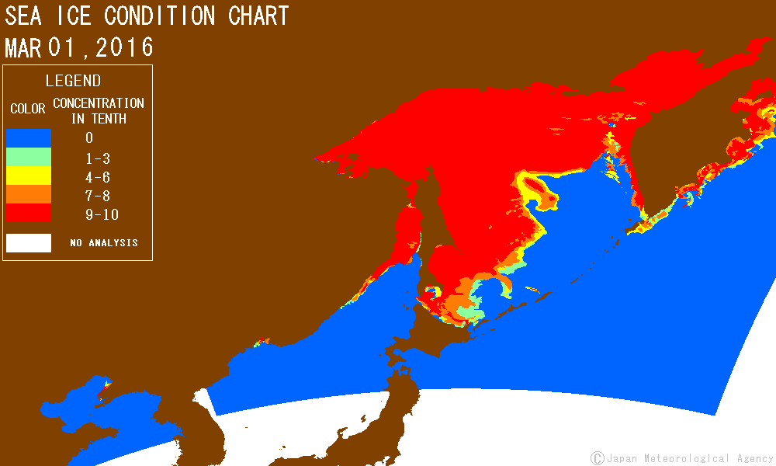
Figure VII-1 ― Daily sea-ice condition chart for the Sea of Japan and the Sea of Okhotsk for 1 March 2016
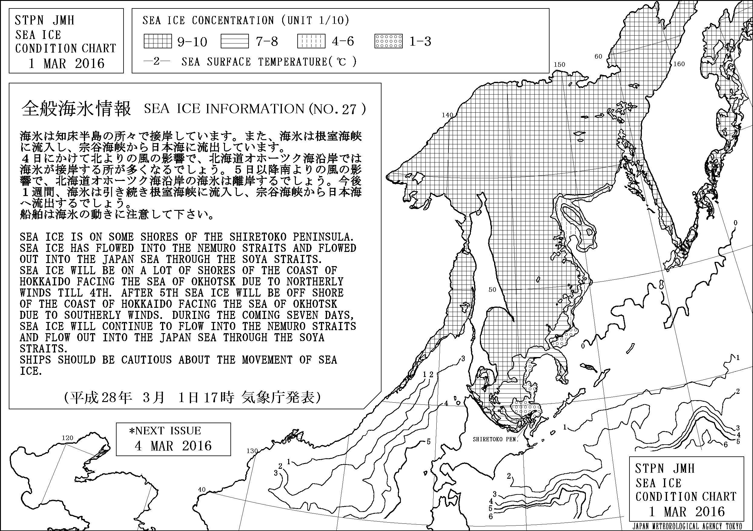
Figure VII-2 ― Sea-ice condition chart for the Sea of Japan and the Sea of Okhotsk for 1 March 2016

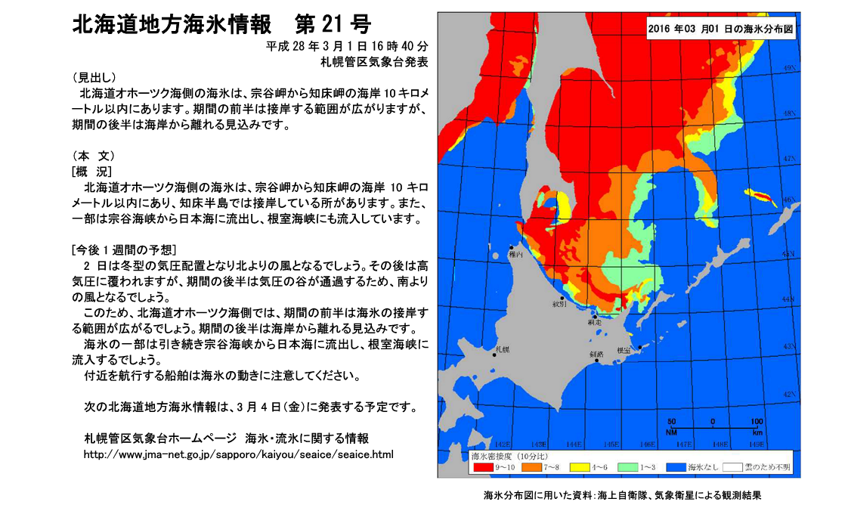
Figure VII-3 ― Local sea-ice information for the area around Hokkaido for 1 March 2016
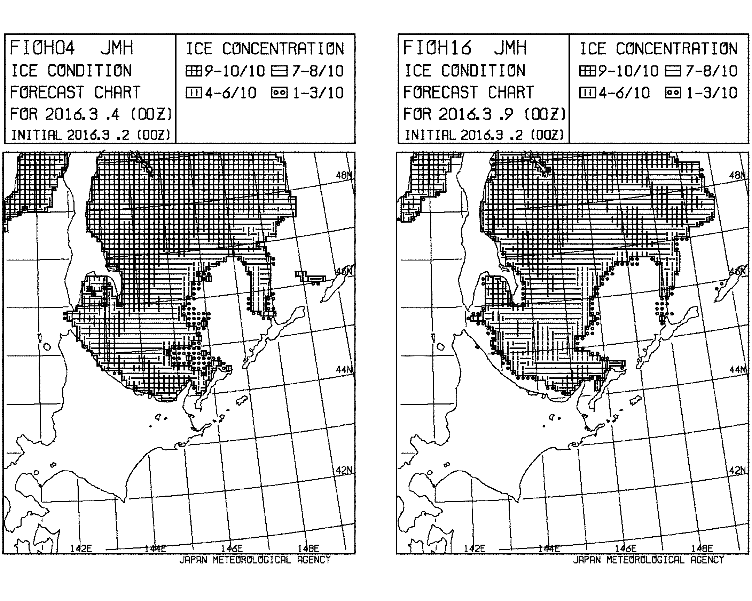
Figure VII-4 ― Ice condition forecast charts for 4 and 9 March 2016 for the southern part of the Sea of Okhotsk (initial conditions for 2 March 2016)

List of acronyms and other abbreviations

AARI Arctic and Antarctic Research Institute
ACSYS Arctic Climate System Study
AHI Advanced Himawari Imager
AIRSS Arctic Sea Ice Regime Shipping System
AMSR Advanced Microwave Scanning Radiometer
APT Automatic Picture Transmission
ATF Antarctic Task Force (Argentina)
AVHRR Advanced Very High Resolution Radiometer
BIM Baltic Icebreaking Management
BSH Bundesamt für Seeschiffahrt und Hydrographie (Germany)
BSIM Baltic Sea Ice Meeting
BSIS Baltic Sea Ice Services
CAA Chinese Antarctic and Arctic Administration
CEADO Argentine Centre of Oceanographic Data
CCG Canadian Coast Guard
CDA Command Data Acquisition (satellite communications)
CDC Climate Data Centre
CIS Canadian Ice Service
CliC Climate and Cryosphere project
CLIVAR Climate Variability and Predictability (WCRP)
CMM former WMO Commission for Marine Meteorology
COADS Comprehensive Ocean Atmosphere Data Set
COTS Commercial Off-the-Shelf
COOBC China Offshore Oil Bohai Corporation
DCRS Danish Center for Remote Sensing
DMSP Defense Meteorological Satellite Program (USA)
DMI Danish Meteorological Institute
DNMI Norwegian Meteorological Institute
EC Executive Council
ECDIS Electronic Chart Display Information System
ECMWF European Centre for Medium-Range Weather Forecasting
EIS European Ice Service
EMHI Estonian Meteorological and Hydrological Institute
ENVISAT Environmental Satellite
ERS European Remote-Sensing Satellite
ESA European Space Agency
ESDIM Environmental Services, Data, and Information Management Programme
ETSI JCOMM Expert Team on Sea Ice
EUMETSAT European Organization for the Exploitation of Meteorological Satellites
FIMR former Finnish Institute of Marine Research (now part of FMI)
FMI Finnish Meteorological Institute
GCC-EWG Gore-Chernomyrdin Commission Environmental Working Group
GCOS Global Climate Observing System
GDSIDB Global Digital Sea Ice Data Bank
GIS Geographic Information System
GLERL Great Lakes Environmental Research Laboratory (USA)
GMDSS Global Maritime Distress and Safety System
GMES Global Monitoring of Environment and Security Programme
GTS WMO WWW Global Telecommunications System
HRPT Higher Resolution Picture Transmission
IABP International Arctic Buoy Programme
IHO International Hydrographic Organization
IICWG International Ice Charting Working Group
IIP International Ice Patrol
IMGW Institute of Meteorology and Water Management (Poland)
IMO Icelandic Meteorological Office
IMO International Maritime Organization
IOC Intergovernmental Oceanographic Commission (of UNESCO)
IPAB International Programme for Antarctic Buoys
IST Information Society Technology
IWICOS Weather, Sea ice and Ocean Service System
IUGG International Union of Geodesy and Geophysics
JCOMM Joint WMO/IOC Technical Commission for Oceanography and Marine Meteorology
JCG Japan Coast Guard
JDA Japan Defense Agency
JIWG Joint USA/Canada Ice Working Group
JMA Japan Meteorological Agency
HELMI forecast dynamic-thermodynamic numeric model for sea ice used at FIMR
LAC Local Area Coverage
LEGMA Latvian Environment, Geology and Meteorology Agency
LHMS Lithuanian Hydrometeorological Service
MANICE Manual of Standard Procedures for Observing and Reporting Ice Conditions (CIS)
MetOffice UK Meteorological Office
MODIS Moderate Resolution Imaging Spectrometer
NAIS North American Ice Service
NASA National Aeronautics and Space Administration (USA)
NAVOCEANO Naval Oceanographic Office (USA)
NAVTEX International system for reception of marine safety information
NCEP National Center for Environmental Prediction (USA)
NESDIS NOAA National Environmental Satellite Data Information Service
NGDC NOAA National Geophysical Data Center
NIC National Ice Center (USA)
NMEFC National Marine Environment Forecast Centre (China)
NOAA National Oceanographic and Atmospheric Administration (USA)
NPOESS National Polar Orbiting Environmental Satellite (USA)
NSIDC National Snow and Ice Center (USA)
OLS Operational Linescale System
ONR Office of Naval Research (USA)
OTSR Optimum Track Ship Routing
PIPS Polar Ice Prediction System (USA)
PRIC Polar Research Institute of China
PSC University of Washington Polar Science Center
QC Quality Control
QMFO Qingdao Marine Forecasting Observatory
RADARSAT Satellite from Canada
RIZA Institute for Inland Water Management and Waste Water Treatment (the Netherlands)
SAR Synthetic Aperture Radar
SCC CLiC Science and Coordination Committee
SCG JCOMM Services Programme Area Coordination Group
SG Steering Group
SGSI former CMM Subgroup on Sea Ice
SIGRID Format for the archival and exchange of sea-ice data in digital form
SHN Naval Hydrographic Service (Argentina)
SIMS Sea Ice Mapping System
SMARA Argentine Navy Meteorological Service
SMHI Swedish Meteorological and Hydrological Institute
SMN Argentine National Meteorological Service
SOA State Ocean Administration (China)
SPA JCOMM Services Programme Area
SSM/I Special Sensor microwave Imager
SST Sea Surface Temperature
SYKE former Finnish Environmental Institute (now part of FMI)
TD Technical Document
UN United Nations
UNESCO United Nations Educational, Scientific and Cultural Organization
USN U.S. Navy
USCG U.S. Coast Guard
VIIRS Visible Infrared Imaging Radiometer Suite
WCP World Climate Programme
WCRP World Climate Research Programme
WDC World Data Centre
WMO World Meteorological Organization
WWW World Weather Watch of WMO
XML Extensible Markup Language

