## NORWAY

24 January 2017 Revision

Two government institutions in Norway issue sea-ice information:

*(a)* The Ice Service of the Norwegian Meteorological Institute is responsible for ice monitoring within the Atlantic part of the Arctic with the emphasis on Svalbard.

*(b)* The Ice Service belonging to the Norwegian Coastal Administration is responsible for informing vessels about the ice situation in Norwegian waters in Skagerrak Strait from the Swedish border to Kristiansand.

### I. Norwegian Meteorological Institute

#### 1. Organization

The Norwegian Ice Service is located in Tromsø¸ and shares offices with the Forecasting Division for Northern Norway, which is in turn part of the Norwegian Meteorological Institute (MET Norway). The Ice Service provides daily (working day, Monday-Friday) ice charts for the Atlantic part of the Arctic, covering the east coast of Greenland to the western coasts of Siberia, with the emphasis on Svalbard. In addition it provides a weekly (on Mondays) ice chart for the Weddell and Bellingshausen Seas of the Antarctic during the austral summer (October to April), covering the area between Peter I and Bouvet Islands with an emphasis on the Antarctic Peninsula.

The main users of the Ice Service are fishing vessels, sailing close to the ice edge in northern and south-eastern parts of Spitsbergen throughout the year. The majority of these ships consist of non-ice class shrimp trawlers that are dependent on good ice information to be able to work and plan their activities in a safe and cost-efficient manner. Cruise ships and private yachts are very active during summertime and reliable charting of the highly dynamic nature of sea ice within the fjords, narrow straits and sounds of the Svalbard archipelago is critical for their operations. Detailed and accurate ice information on the ice conditions is therefore important, and in high demand by the users.

The Ice Service analysts study the current conditions primarily via remotely sensed data and provide ice charts, ice-edge information and an overview of the sea surface temperatures.

The ice charts are high-resolution and based on SAR, and contain sea ice concentration as well as delineating areas of fast ice. Sea surface temperatures are included as contours from thermal imaging satellite data..

#### 2. Data acquisition

Data received from satellites are the main source for analysts, augmented by visual observations and meteorological weather forecasts. The following informational products are used (in order of preference):

(a) Synthetic Aperture Radar (SAR) from the European Union (EU) Copernicus programme Sentinel-1A and -1B satellites in Extended Wide (EW) and Interferometric Wide (IW) modes at 50 and 10 metres resolution respectively. Typically these are dual (HH+HV) polarisation.

(b) RADARSAT-2 ScanSAR wide scenes covering the Svalbard area at 100 metres resolution. Typically these are dual (HH+HV) polarisation.

(c) COSMO SkyMed X-band single polarisation (HH) SAR images in ScanSAR (Huge Region) and Spotlight (Himage) modes at 100 and 5 metres resolution respectively.

(d) High resolution optical images from the EU Copernicus programme Sentinel-2A satellite.

(e) NOAA VIIRS optical images.

(f) NASA MODIS Terra and Aqua optical images.

(g) NOAA/EUMETSAT AVHRR optical images.

(h) Sea ice concentrations processed from JAXA AMSR-2 passive microwave data at 3.125 km resolution provide background global coverage and are used when no SAR or cloud-free optical images are available.

(i) Sea ice concentration and type images from the EUMETSAT OSI SAF (Ocean and Sea Ice Satellite Application Facility) at 10 km resolution.

#### 3. Output products

*(a)* Ice charts are issued daily (working day, Monday-Friday) throughout the year and are typically e-mailed users and distributed by the web page. The position of the ice edge for GMDSS METAREA-XIX is also relayed to users by telex. The overview ice chart, covers the European Arctic. A sample chart is given in Figure VIII-1, Annex VIII.

*(b)* Formatted sea ice data are prepared regularly for use in the AROME weather prediction and ROMS ocean prediction models. These gridded products are also distributed via the EU Copernicus Marine Environment Monitoring Service (CMEMS)

*(c)* High-resolution ice charts are issued for the Svalbard area. A sample chart is given in Figure VIII-2, Annex VIII.

(d) A weekly (Mondays) Antarctic chart has been produced in austral summers (October-April) since the 2010-11 season. From 2014, this was produced in collaboration with the U.S. National Ice Center and Russian Arctic and Antarctic Research Institute. A sample chart is given in Figure VIII-3, Annex VIII. In addition, a high-resolution chart is issued for the Bransfield Strait and Adelaide Island areas of the Antarctic Peninsula.

#### 4. Forecasts and forecast methods

Several forecast models are under development and are being tested on a pre-operational basis. These include:

(a) Arctic-20km and Nordic-4km Regional Ocean Modelling System (ROMS), and

(b) The “(Towards) an Operational Prediction system for the North Atlantic European coastal Zones” (TOPAZ) model, run by MET Norway for the EU Copernicus CMEMS.

#### 5. Publications

Publications are issued both on a regular and irregular basis.

#### 6. Mailing and Internet addresses

Istjenesten  
Vervarslinga for Nord-Norge  
Postboks 6314 Langnes  
NO-9293 Tromsø  
Norway

Telephone: +47 77 62 14 62  
Telefax: +47 77 62 13 01  
E-mail: [istjenesten@met.no](mailto:istjenesten@met.no) or [iceservice@met.no](mailto:iceservice@met.no)   
Internet: [http://www.met.no](http://www.met.no/)   
[http://polarview.met.no/](http://retro.met.no/kyst_og_hav/iskart.html) (regular ice charts)

<http://marine.copernicus.eu/> Coperncius Marine Environment Monitoring Service (gridded products)  
Twitter: @istjenesten (climatological reporting, text alerts)

### II. Norwegian Coastal Administration

#### 1. Organization

The main task of the Norwegian Coastal Administration Ice Service is to inform vessels about the ice situation in Norwegian waters from the Swedish border to Kristiansand including the Oslofjord.

The Norwegian Ice Service does not include assistance by icebreaker to and from ports. The larger ports have icebreaker service in the harbour and for assistance during approach and departure from the port. Please contact local port authorities for information.

#### 2. Data acquisition

The coast is divided into observation areas that are identified by a code of letters and numbers according to “The Baltic Sea Ice Code”.

#### 3. Output production

Plain language ice reports and coded ice observations according to “The Baltic Sea Ice Code” are available and regularly updated: 1 December to 31 March, see http://www.kystverket.no/Maritime-tjenester/Meldings--og-informasjonstjenester/Istjenesten-i-Norge.

#### 4. Mailing and Internet addresses

Kystverket Southeast, Ice Service

Serviceboks 625

N-4809 ARENDAL, NORGE

Telephone: +47-3701 9700/ -3701 9718 / -3701 9759

Cell phone: +47-4815 4142 / -9593 0261

Fax: +47-3701 9701/ -3702 7619

E-mail: [ismelding@kystverket.no](mailto:ismelding@kystverket.no)

Internet: [http://www.kystverket.no](http://www.kystverket.no/)

# ANNEX VIII – Norway

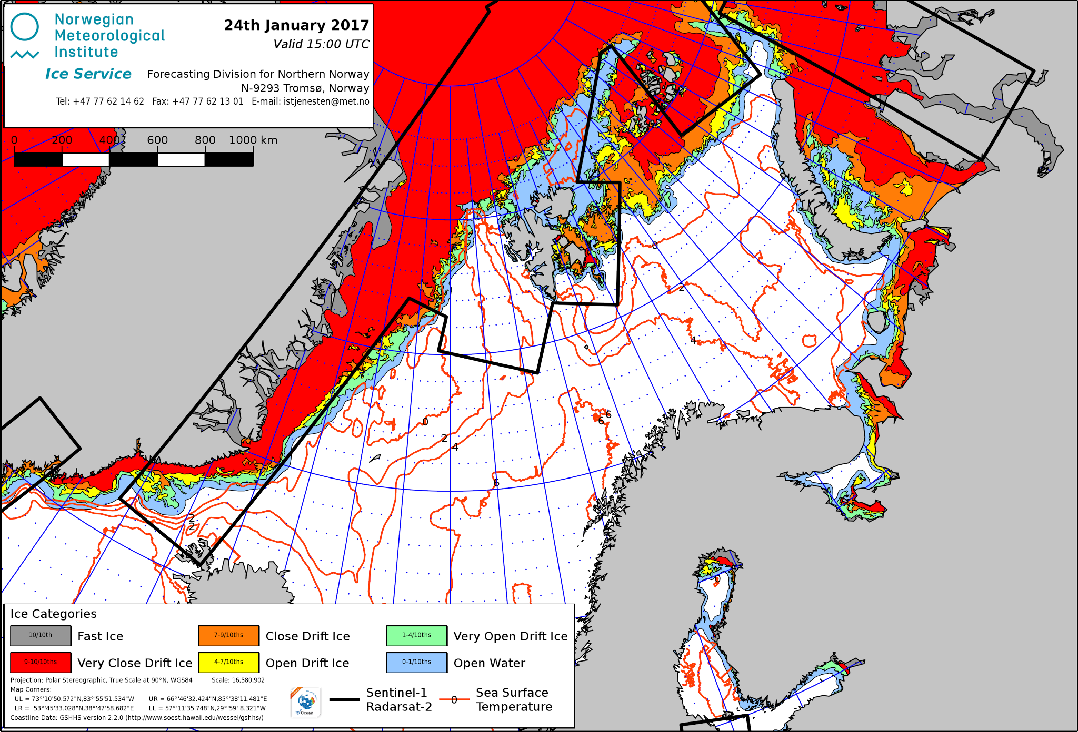

Figure VIII-1 – Daily ice chart for the Atlantic sector of the Arctic for 24 January 2017.

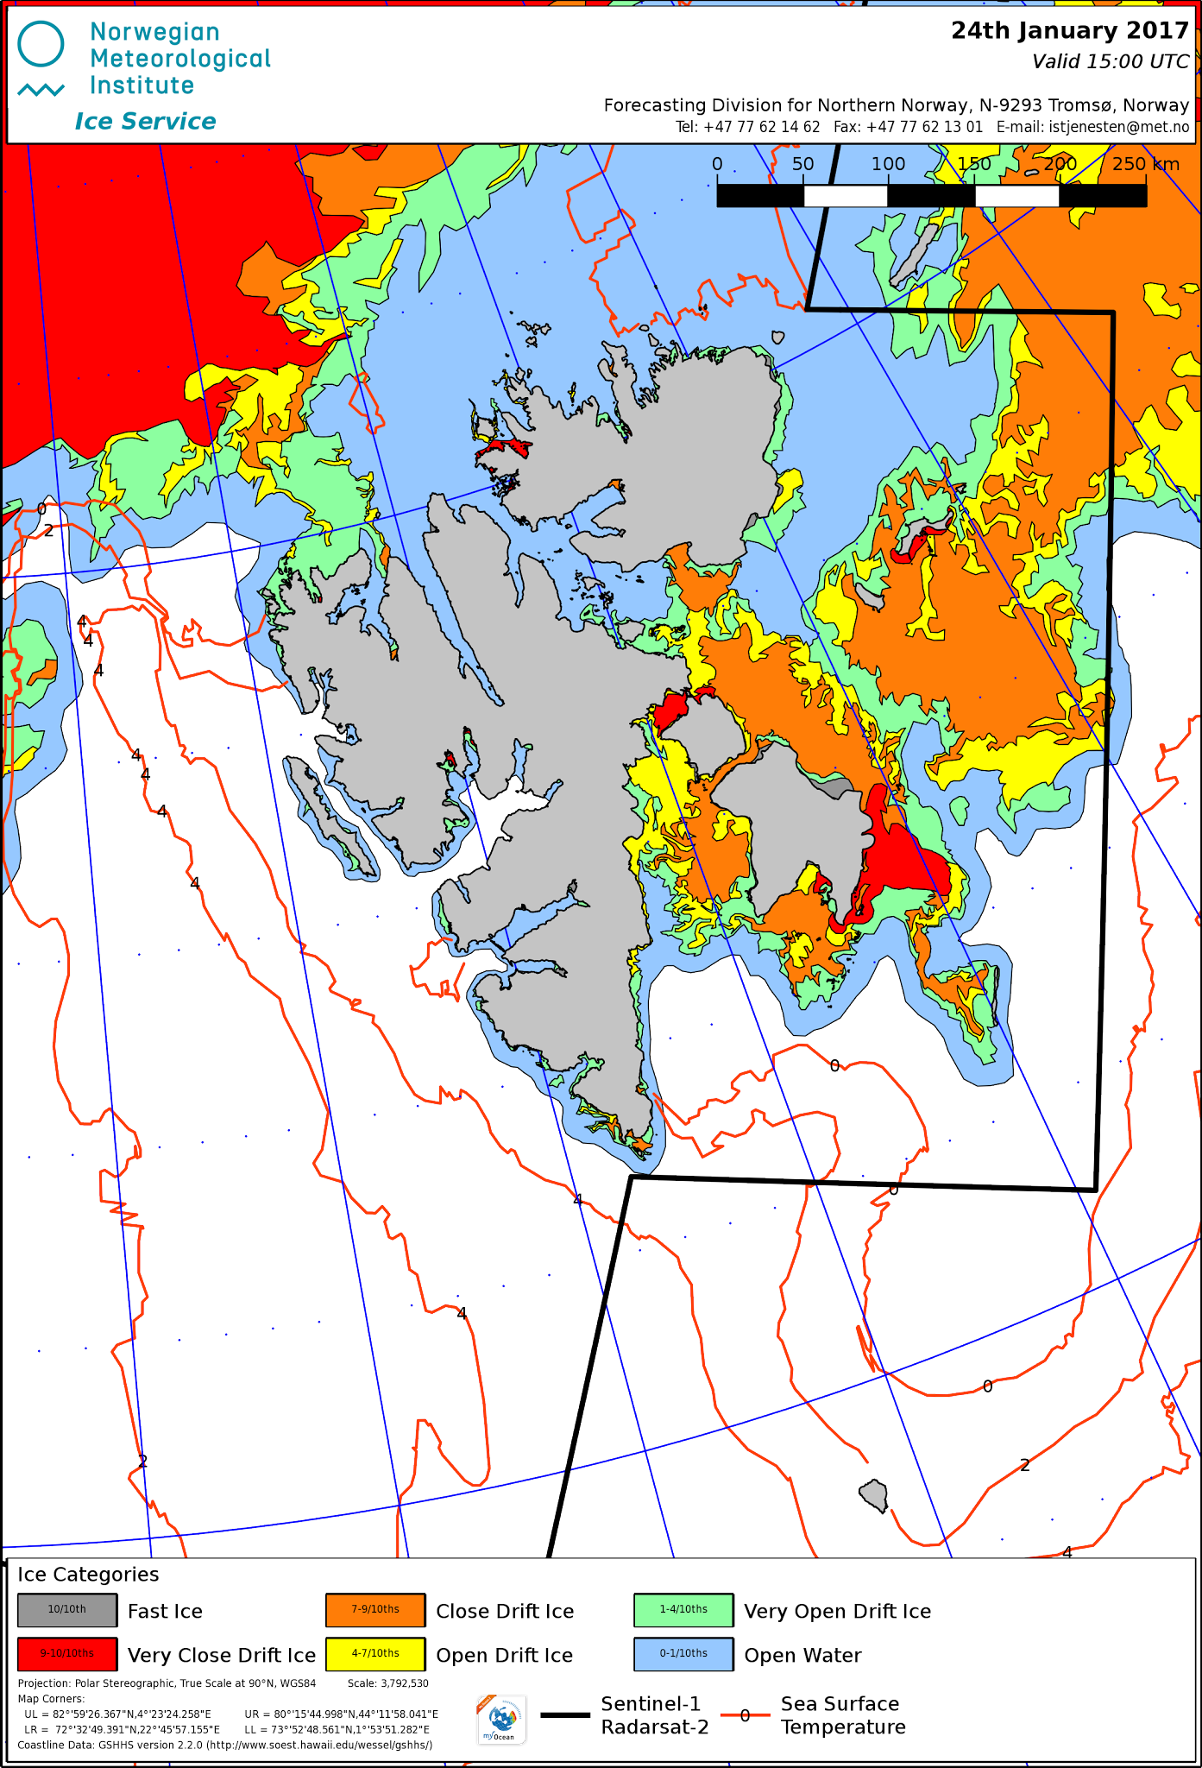

Figure VIII-2 – High-resolution ice chart for the Svalbard area for 24 January 2017.

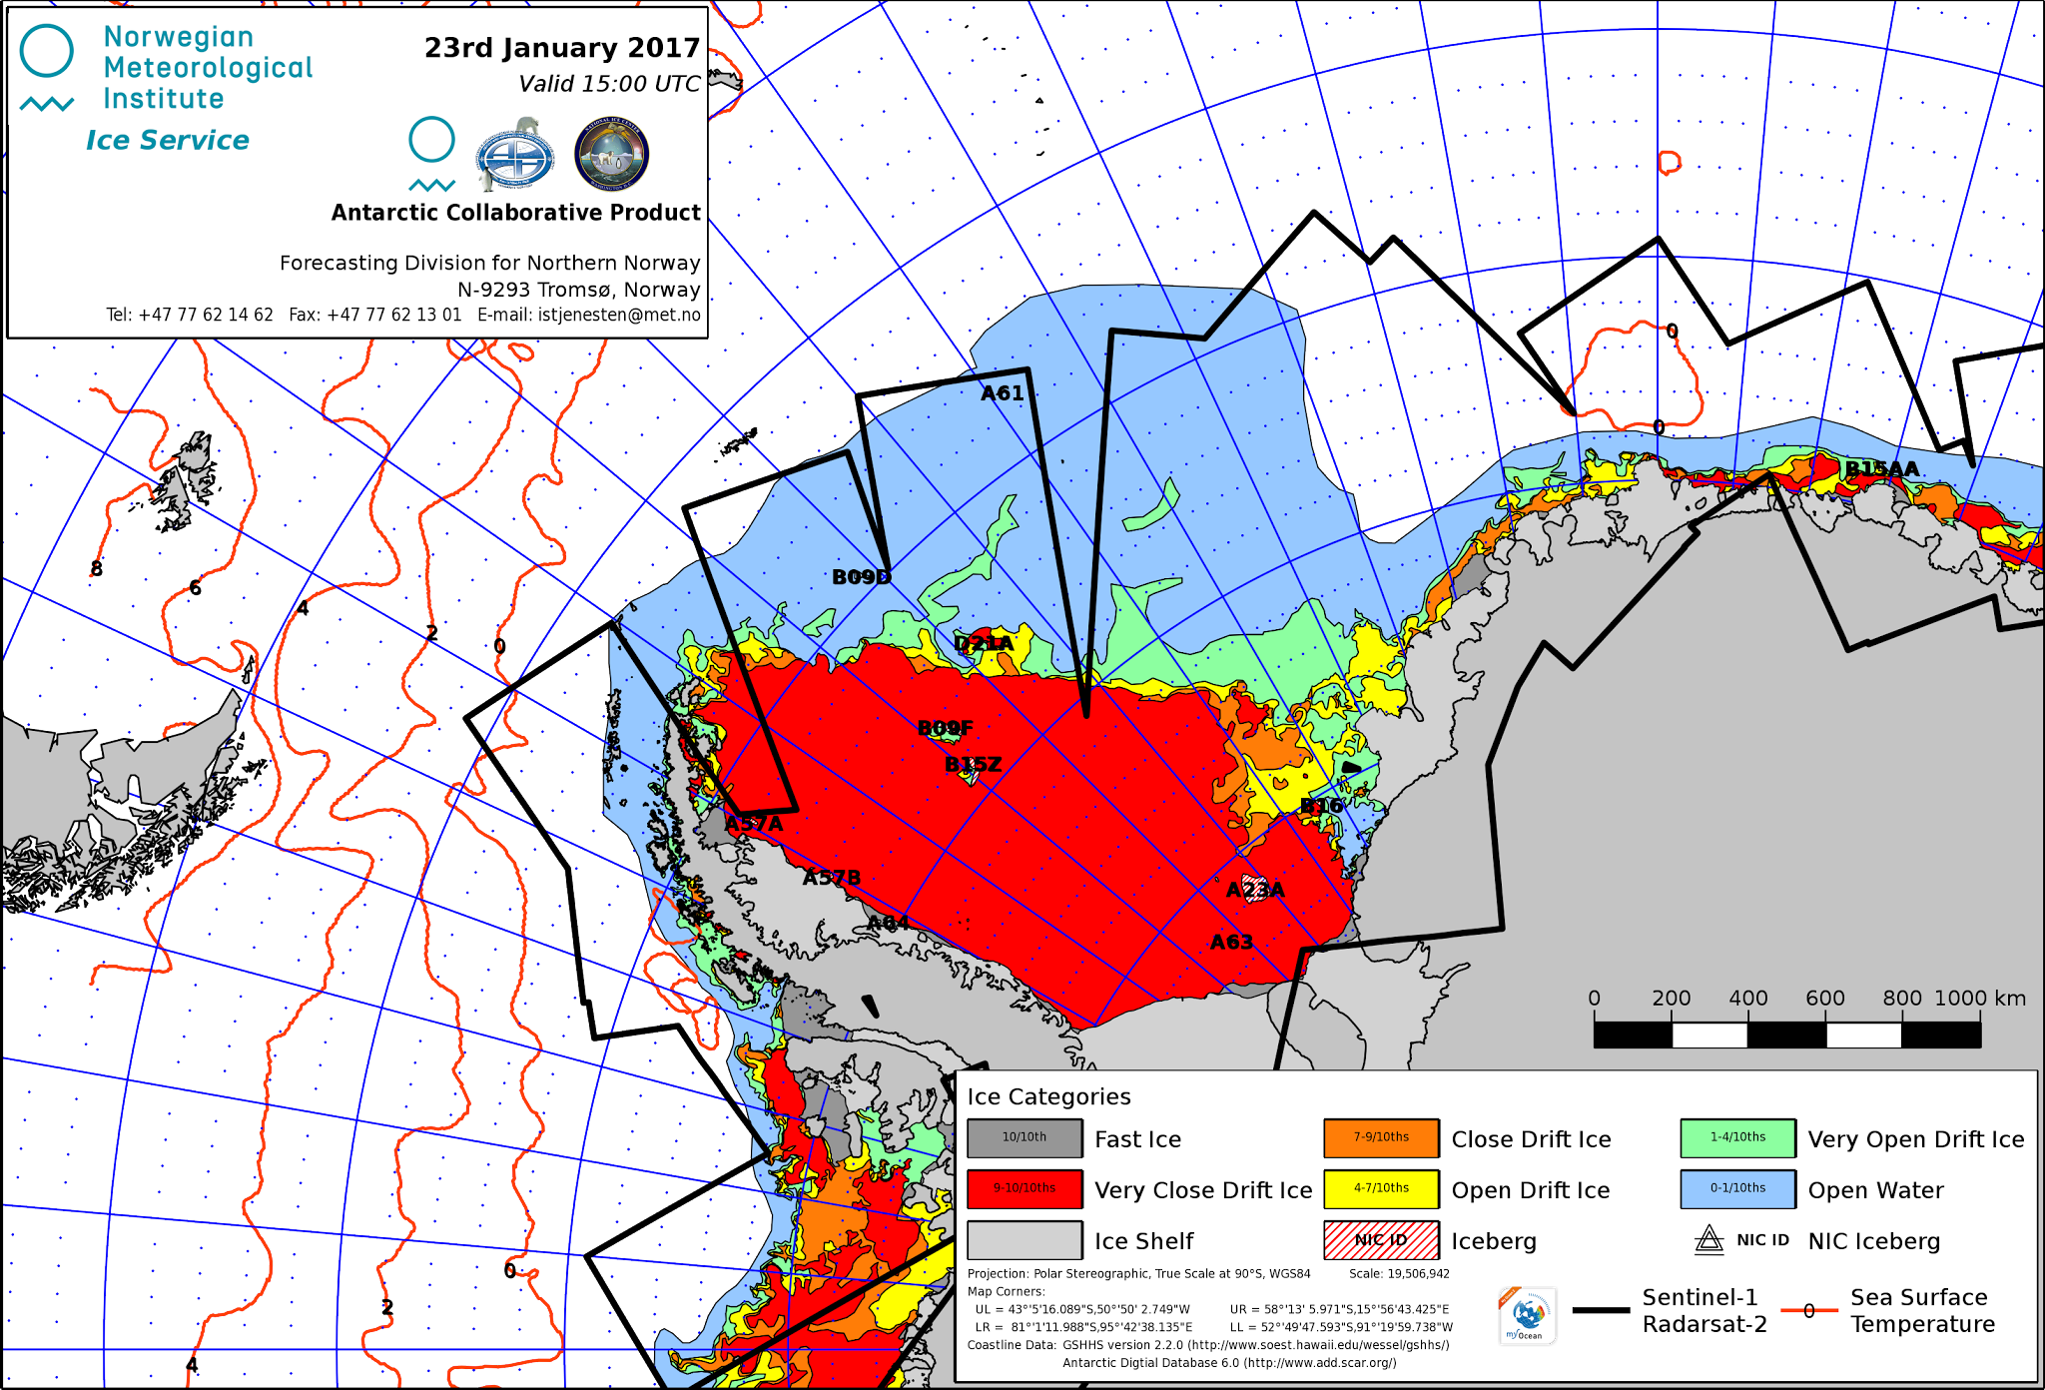

Figure VIII-3 – Weekly collaborative ice chart for the Weddell and Bellingshausen Seas sector of the Antarctic for 23 January 2017.