## POLAND

10 February 2017 Revision

#### 1. Organization

The ice service is provided by the Hydrological Forecasting Office, Institute of Meteorology and Water Management, Maritime Branch in Gdynia (IMGW-PIB Instytut Meteorologii Gospodarki Wodnej-PIB, Oddzial Morski w Gdyni, Biuro Prognoz Hydrologicznych). It covers Polish waters, Southern Baltic and South-Eastern Baltic during an ice winter. Radio transmission of ice reports and bulletins, ice charts are provided for national and international shipping in the Baltic Sea and for harbour activities, fisheries, maritime agencies and off-shore activities.

#### 2. Data acquisition

Visual daily ice information in Baltic Ice Code are available from coastal stations along Polish Coast. Additional sources of information includes: ship reports and Harbour Masters reports in plain language, webcams, meteorological guidance products, satellite visual/infrared imagery from MODIS and from Sentinel. Aerial reconnaissance made only under very severe ice conditions.

Details on coastal stations are listed in publication WMO-No. 9, Volume D – Information for Shipping.

Reports, bulletins, data and charts are also exchanged within foreign ice services via e-mail, ftp, joint web page for the BSIS and GTS - transmission in plain language reports and coded data.

#### 3. Output products

*(a)* *Ice observations /Ice reports*

A coded ice report is broadcast daily by Witowo Radio on ice conditions in Polish waters. A plain language report is provided in Polish and English. A coded ice report is also exchanged via GTS transmission.

*(b)* *Ice charts*

*(i)* An ice chart (colour) of ice conditions in the Southern and South-Easten Baltic (Polish Baltic coast) is produced from one to three times a week when ice is present using the international system of sea-ice symbols. It is distributed via e-mail and presented on the Internet. Type of chart: Mercator projection, Baltic Sea between 53°20’N and 55°30’N, 13°40’E and 20°30’E.

*(ii)* A printed ice chart (colour) of ice conditions in whole Baltic Sea is produced once a week using the international system of sea-ice symbols. It is e-mailed and presented on the Internet. Type of chart: Mercator projection, Baltic Sea between 53°30'N and 66’N, 12’E and 30°30’E.

Note: charts (i)-(ii) are constructed with the digital ArcMap program.

Sample ice charts are given in Annex IX.

*(c)* *Ice bulletins*

A bulletin of ice conditions in the Baltic Sea is prepared using plain Polish during ice season twice a week (Tuesday, Friday). In case of very severe winter, the ice bulletin is prepared daily from Monday to Friday. Bulletin includes coded reports for the open Baltic Sea and coastal waters for all the Baltic countries. Short term subjective forecast of ice conditions for Polish Coast is included during severe winter. It is distributed by e-mail and presented on the Internet.

#### 4. Forecasts and forecast methods

A short term ice forecast for Polish waters is included in the ice bulletins. It uses subjective dynamical methods and a forecast of meteorological conditions. The freezing of sea ice is forecasted by empirical model.

#### 5. Publications

A descriptive summaries of the ice season is prepared annually and published on the Internet. Other publications are prepared irregularly.

#### 6. Mailing and Internet addresses

Instytut Meteorologii i Gospodarki Wodnej – PIB (IMGW-PIB)

Oddzial Morski – Biuro Prognoz Hydrologicznych - Gdynia

ul. Waszyngtona 42

PL 81-342 Gdynia

Poland

Telephone: +48 58 6288 146/+48 781 774 173

Telefax: +48 58 620 1641

E-mail: [hydrologia.gdynia@imgw.pl](mailto:hydrologia.gdynia@imgw.pl)

Internet:

<http://www.imgw.pl>

<http://www.baltyk.pogodynka.pl//index.php?page=2&subpage=64>

[http://www.bsis-ice.de](http://www.bsis-ice.de/) (a joint web page for the Baltic Sea Ice Services)

**ANNEX IX - Poland**

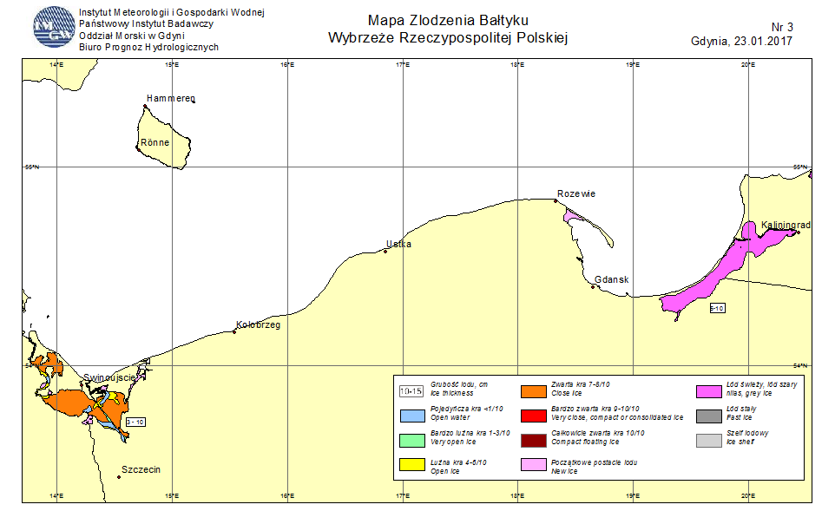

Figure IX-1 – Ice chart for the Polish Baltic coast on 23 January 2017

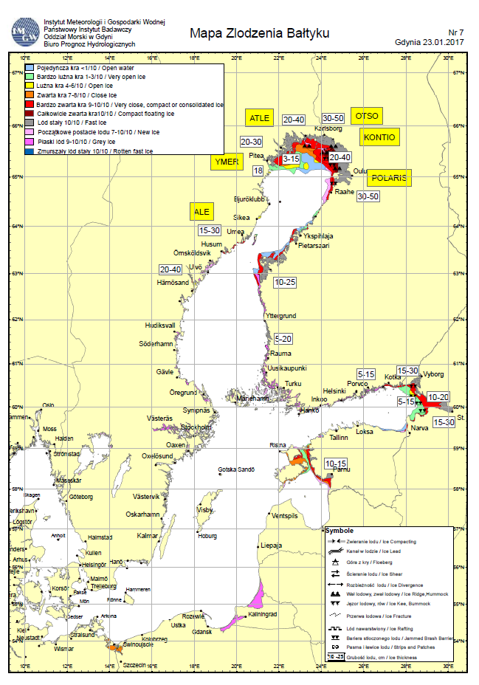

Figure IX-2 – Ice chart for the Baltic Sea on 23 January 2017