RUSSIAN FEDERATION
15 February 2017 Revision

1. Organization
Sea-ice information services in the Russian Federation are provided by the Arctic and Antarctic Research Institute in St Petersburg (AARI), the Scientific Research Center of Space Hydrometeorology "Planet" in Moscow, the Moscow Hydrometeorological Centre (HMC Moscow) and the regional hydrometeorological offices in the Arctic, Far-Eastern Russia, Baltic, Black and Caspian seas; all belonging to the Russian Federal Hydrometeorological Service (Roshydromet).
AARI provides centralized services for shipping, coastal and harbor activities within the Northern Sea Route (NSR), for the Central Arctic Basin, Eurasian Arctic seas (Greenland, Kara, Laptev, Eastern-Siberian, and Chukchi Seas), the weather forecast areas within METAREAs XX and XXI and the Southern Ocean. Planet and HMC Moscow provide similar centralized services for the Bering, Okhotsk, Japan, Caspian, Black, Azov and White Seas. In addition to the ice services the AARI is responsible for the SafetyNet ice and weather information for METAREAs XX and XXI (Arctic), while the regional Roshydromet offices are responsible for provision of NAVTEX weather messages within the coastal areas of METAREAs XX, XXI, XIII (NW Pacific), Black, Azov and Caspian Seas.

2. Data acquisition
Coastal weather polar stations of Roshydromet make daily visual and instrumental ice observations on sea ice concentration and stages of ice development, ice thickness, forms of ice, ice drift and other phenomena. Icebreakers and icebreaking vessels on the NSR routes routinely (commonly once a day) report the main ice parameters describing ice navigation. Before 1994 aircraft ice reconnaissance flights were conducted in the Arctic usually on a monthly basis from November to April and on a 10-day internal during the summer navigation period. Since 1995 aircraft (mostly helicopter) ice reconnaissance flights are conducted only occasionally during tailored hydrometeorological support of applied and scientific activities in the Eurasian Arctic. The scope of ice information collected during air ice reconnaissance includes visual observations on a full scope of sea ice parameters essential for navigation and marine safety (egg-code, icebergs, openings, dynamics, surface features). Though being nowadays not the prime sources, the stated information (coastal, aircraft) is continuously used for validation of the sea ice analysis and prognostic products at the ice centers.
The AARI and Planet satellite reception stations provide operational optical imagery for the Arctic Ocean and North Pacific from a series of satellites (NOAA, EOS TERRA, Aqua, Suomi NPP, FY3, Meteor, Ocean). Information for other regions (e.g. Antarctic), from other satellites and ranges (Sentinel-1,2,3, Radarsat-2, TerraSar-X, etc.) is received via Internet from corresponding data portals directly or from commercial satellite data providers. All data are further processed within ice information systems and utilized for regional, pan-Arctic or pan-Antarctic sea-ice analysis. Sample satellite products are available via the AARI and Planet web pages.
AARI, Planet, HMC Moscow, and the regional Roshydromet offices exchange the described sea ice data and disseminate derived products to users using applicable transmission means (Internet, satellite connections, GMDSS Inmarsat and HF, facsimile etc).

3. Output products
(a) Chart output
(i) General sea-ice conditions charts of the Arctic Ocean are prepared by AARI on weekly scale (every Tuesday) and available via the AARI web page for public use. Charts depict drifting and fast ice boundaries and major classes of sea-ice concentration in the summer period or stages of development in the winter period and are available in graphic GIF format and in digital WMO SIGRID-3 format. A sample sea-ice conditions chart for the Arctic is presented in Figure X-1, Annex X.
(ii) Detailed hemispheric Southern Ocean sea-ice conditions charts are prepared by AARI every two weeks to provide tailored support for national activities and general ice monitoring in the region. Sample charts are given in Figure X-2, Annex X.
(iii) Detailed regional sea-ice conditions charts and annotated imagery for the seas Greenland, Barents, Kara, Laptev, East-Siberian, Chukchi, Bering, Okhotsk and Baltic are prepared by AARI on weekly (every Tuesday) or shorter scales and on request and are disseminated via various telecommunication means to captains, shipping companies, local authorities and other users requesting tailored support. Informational products are relayed to the users accordingly in graphic georeferenced formats (GIF, PNG, JPEG), in WMO SIGRID-3, S-57 formats. Detailed regional sea-ice charts in national coding are available via the AARI web site in GIF and SIGRID-3 formats. Sample detailed ice charts for the Barents, Kara and Chukchi Seas are presented in Annex X, figures X-3, X-4 and X-5.
(iv) Detailed regional sea-ice conditions charts and annotated imagery for the Bering, Okhotsk, Japan, Caspian, Azov and White Seas are prepared by Planet and HMC Moscow on weekly (every Tuesday) scale. Informational products are relayed to the users accordingly in graphic georeferenced formats (GIF, PNG, JPEG) and in WMO SIGRID-3 formats. Detailed regional sea-ice charts in national coding are available via the Planet and HMC Moscow web sites in GIF and SIGRID-3 formats. Sample detailed ice charts and annotated imagery for the Azov, Caspian and Okhotsk Seas are presented in Annex X, figures X-6, X-7 and X-8.
(b) Plain language information
(i) Coastal and high sea sea-ice and weather GMDSS and other plain language reports are prepared routinely on twice a day, daily, weekly or other scales and on request by AARI and the local meteorological offices of Roshydromet for METAREAs XX, XXI, XIII, sub-areas of Black, Azov, Caspian Seas, and are disseminated via GMDSS and other telecommunication means to the customers.
(ii) Synoptic bulletin on weather conditions in the Eurasian Arctic is prepared routinely on daily scale by AARI and is disseminated via various telecommunication means to the customers and published on AARI web-site.

4. Forecasts and forecasts methods
(i) Daily diagnosis and forecast charts of mean daily and instantaneous ice drift, surface currents and level elevation in the Arctic Ocean for period 0d…+6d on the basis of dynamic AARI sea-ice model;
(ii) Weekly or shorter period diagnosis and forecast charts of the evolution of ice cover in the Eurasian Arctic Seas including sea ice total concentration, thickness (stages of ice development), hummocks concentration and level of compacting for period 0d…+6d on the basis of the dynamic thermo-dynamic AARI model;
- Weekly or shorter period prognostic charts of the type of ice conditions in accordance with the Northern Sea Route Administration ‘Rules of navigation in the water area of the Northern Sea Route’ on the basis of the output from the dynamic thermo-dynamic AARI model;
- Daily diagnosis and forecast charts for winds, wave significant height and direction and ice accretion for open water areas in the Western and Eastern Eurasian Arctic Seas for period 00…+72h with 6-h interval on the basis of the AARI wave model;
- Numerical forecast for water level at selected coastal points of Eurasian Arctic for period 0d…+6d;
(v) Seasonal forecasts of ice conditions in the Eurasian Arctic seas and big Siberian rivers estuaries based on AARI empirical-statistical techniques (textual bulletins);
(vi) Weekly-monthly forecasts of ice phenomena in the big Siberian rivers estuaries based on AARI empirical-statistical techniques (textual bulletins).
Sample numerical forecast charts are presented in figure X-9, Annex X.

5. Publications
The following publications are issued by AARI at different periods:
(a) The quarterly and yearly bulletin Review of the hydrometeorological processes in the Arctic Ocean (in Russian);
(b) The quarterly bulletin State of the Antarctic Environment (in Russian and English);
(c) Bulletin “Long-term forecast of the ice conditions in the Arctic seas”: 3 bulletins are published per year in the end March, June and August (in Russian);
(d) Trudi AANII (AARI Transactions): irregular two to three volumes are published per year (in Russian);
(e) Problemi Arktiki i Antarktiki (Problems of the Arctic and Antarctic): two volumes are published per year (in Russian);
(f) Irregular express information, informational bulletins of the Russian Antarctic expedition, monographs etc.

6. Mailing and Internet addresses
Mailing addresses
Arctic and Antarctic Research Institute (AARI)
Bering Str., 38
199397, St Petersburg Russian Federation
Telephone: +7 (812) 337-3123 Telefax: +7 (812) 337-3241
E-mail: aaricoop@aari.ru sever@aari.ru

State Research Center "Planeta"
Bolshoy Predtechensky st. 7
123242, Moscow, Russian Federation
Telephone: +7 (499) 252-3717 Telefax: +7 (499) 252-6610
E-mail: asmus@planet.iitp.ru

Hydrometeorological Research Centre of the Russian Federation (Hydrometcentre)
B. Predtechensky per., 11–13
123242, Moscow Russian Federation
Telephone: + 7 (499) 252-3448 Telefax: +7 (499) 255-1582
E-mail: vilfand@rhmc.mecom.ru

St Petersburg Center for Hydrometeorology and Environmental Monitoring. (NW Hydromet)
Hydrometeorological Center of St.-Petersburg
Baltic Russian Ice Service
199106, Vasilevsky Ostrov, 23 liniya, 2-a
St.-Petersburg, Russian Federation
Tel: +7(812)234-1274 Fax: +7(812)234-5604
E-mail: sea@meteo.nw.ru

Primorsky Directorate of Hydrometeorological Service (Primpogoda)
Mordovtseva Str., 3
690950, Vladivostok Russian Federation
Telephone: +7 (4232) 204974 Telefax: +7 (4232) 221750
E-mail: pkmeteo@primpogoda.ru

Far Eastern Regional Hydrometeorological Research Institute (FERHRI)
Fontannaya Str., 24
690600, Vladivostok Russian Federation
Telephone: +7 (4232) 26-97-88 Telefax: +7 (4232) 22-77-54
E-mail: hydromet@online.ru

Internet addresses
AARI:
http://www.aari.ru (main page)
http://www.aari.ru/projects/ecimo/modul.php?mod=d0015&in=1 (Arctic weekly ice charts)
http://www.aari.ru/projects/ecimo/ModuleLoad.php?mod=d0004&in=1 (Eurasian Arctic seas weekly detailed ice charts)
http://ice.aari.aq (Southern Ocean)
http://www.aari.ru/projects/ecimo/index.php?im=101 (prognostic products)
http://www.aari.ru/projects/ecimo/ModuleLoad.php?mod=d0011&in=1 (synoptic bulletin)
http://wdc.aari.ru/datasets/ (WDC Sea Ice / WMO GDSIDB – SIGRID-3 files)
Planeta:
http://planet.iitp.ru/english/products_eng.htm (Satellite data products)
http://planet.iitp.ru/Oper_pr/Oper_pr.html (Operational products)
See also direct links:
http://planeta.infospace.ru/prod-cgi/last.pl?product=67 (Ice charts – Black and Azov Seas)
http://planeta.infospace.ru/prod-cgi/last.pl?product=107 (Antarctic mosaic)

Hydrometcentre of Russia: http://wmc.meteoinfo.ru

NW Hydromet: http://www.meteo.nw.ru
Primpogoda: http://www.primpogoda.ru
FERHRI: http://www.hydromet.com

ANNEX X – Russian Federation
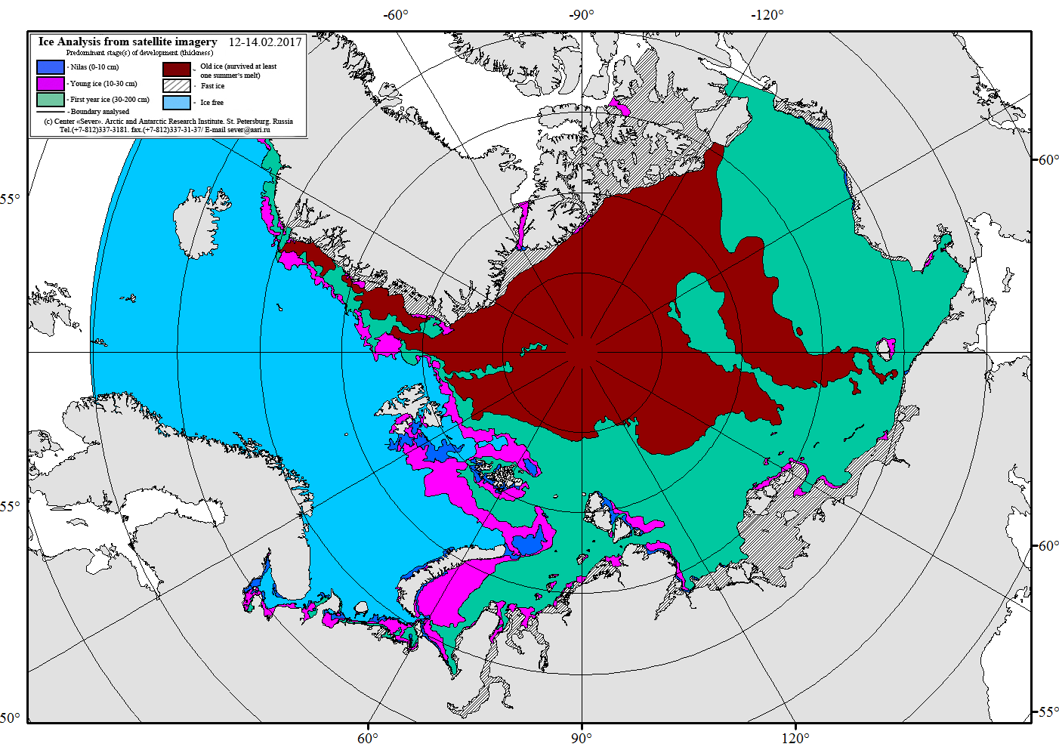
Figure X-1 – Common usage AARI ice chart for the Arctic Ocean on 12-14 February 2017.
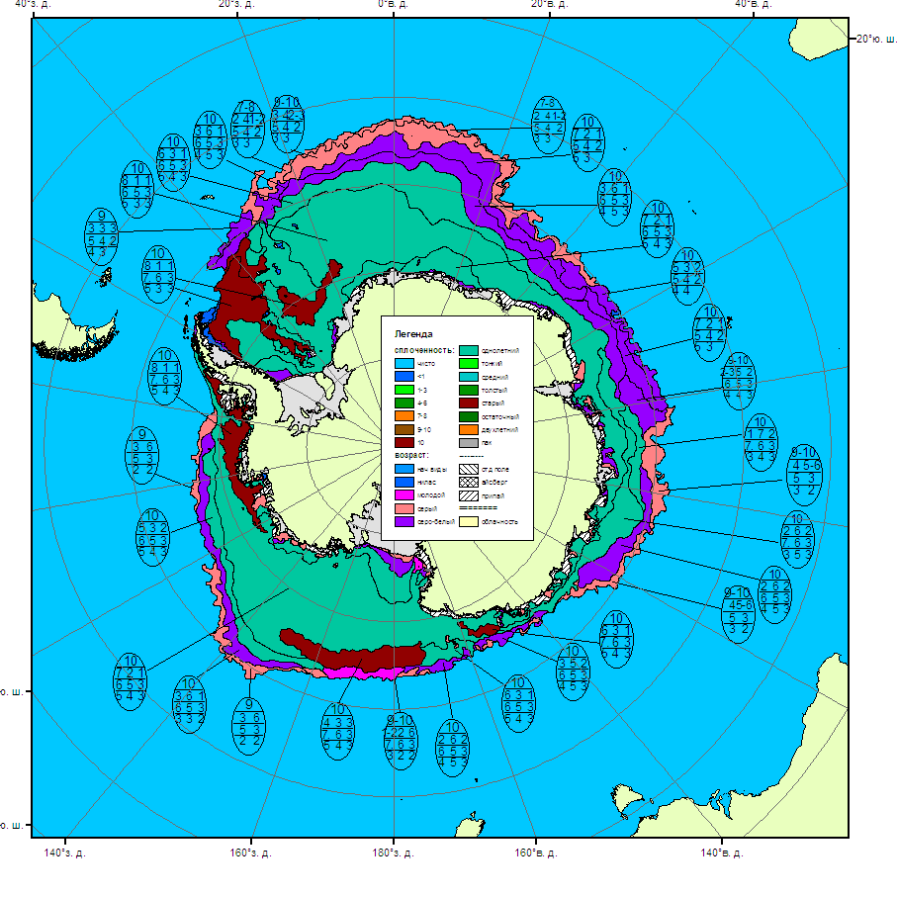
Figure X-2 – AARI Antarctic sea ice analysis for 25-29 September 2016.

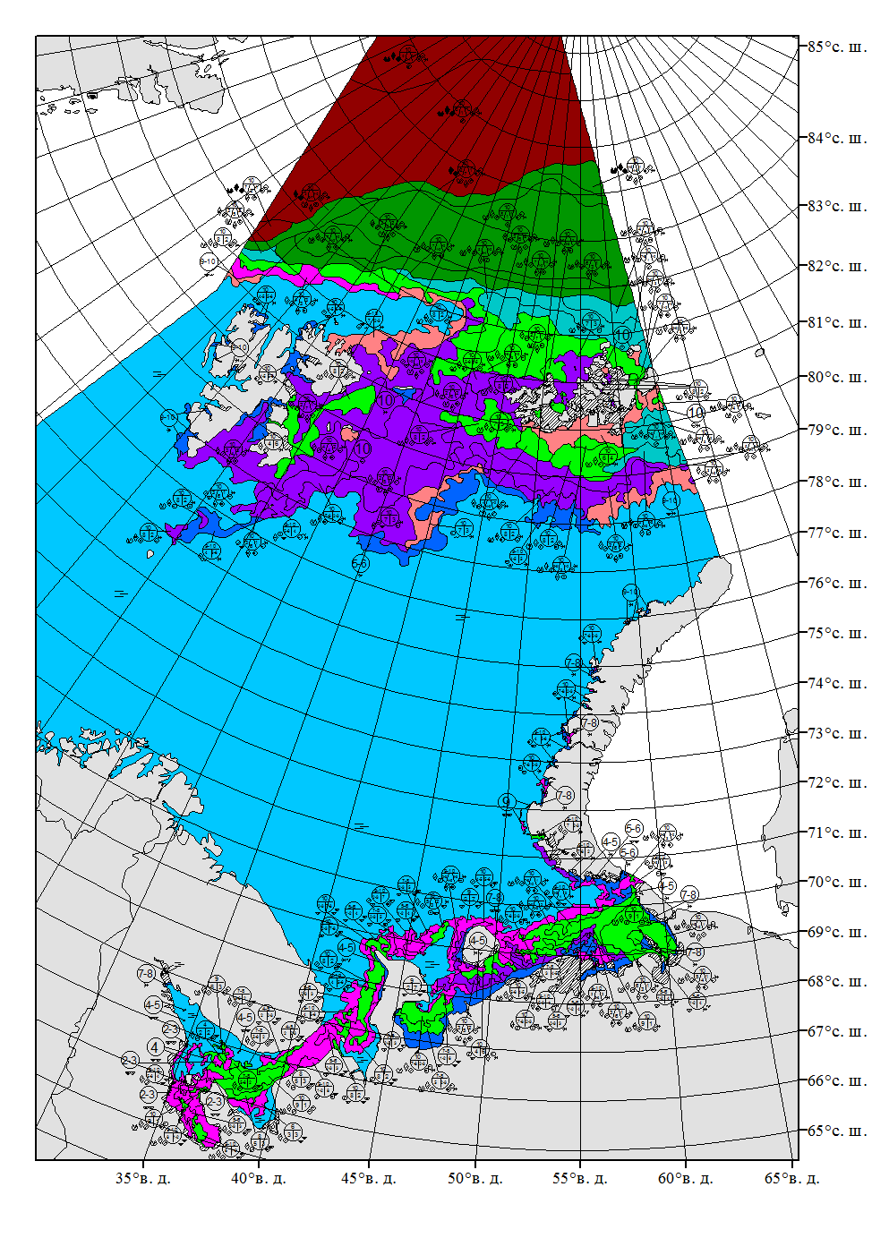
Figure X-3 – AARI ice chart in Russian national symbology for the Barents Sea, 4-5 April 2016.
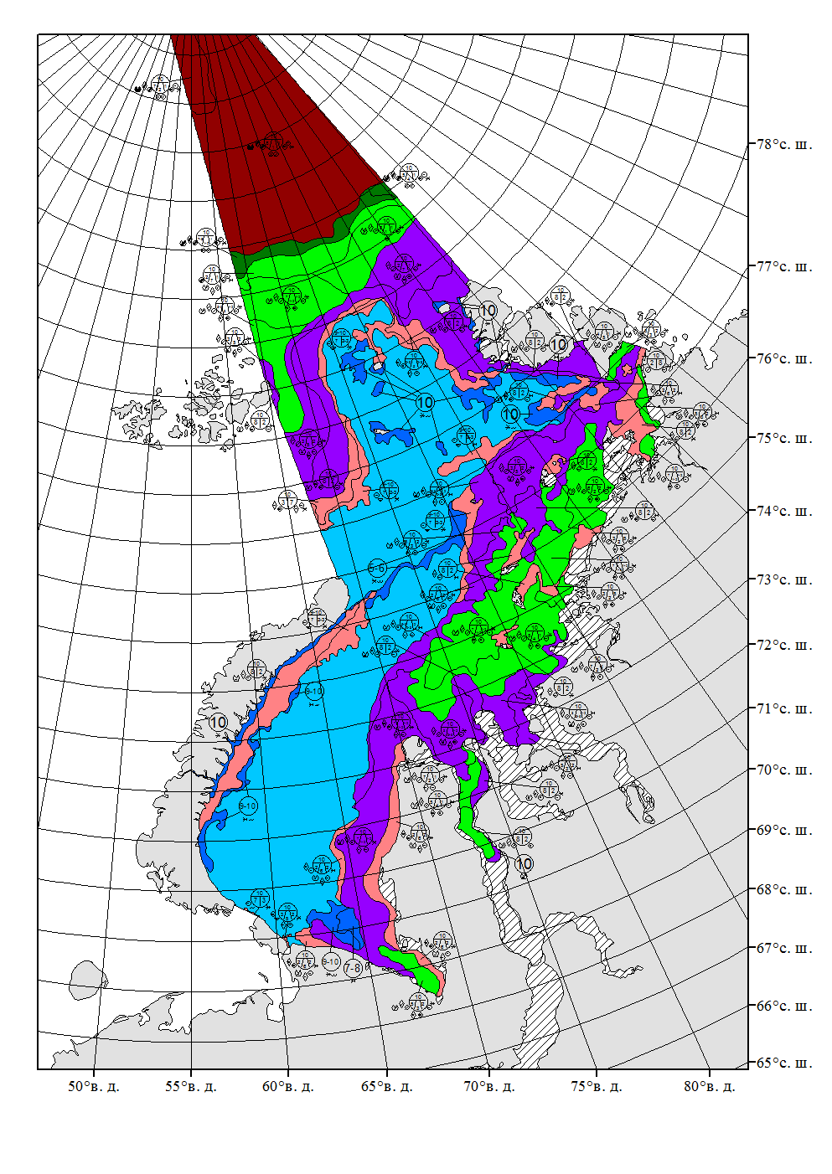
Figure X-4 – AARI ice chart in Russian national symbology for the Kara Sea, 5-6 December 2016.
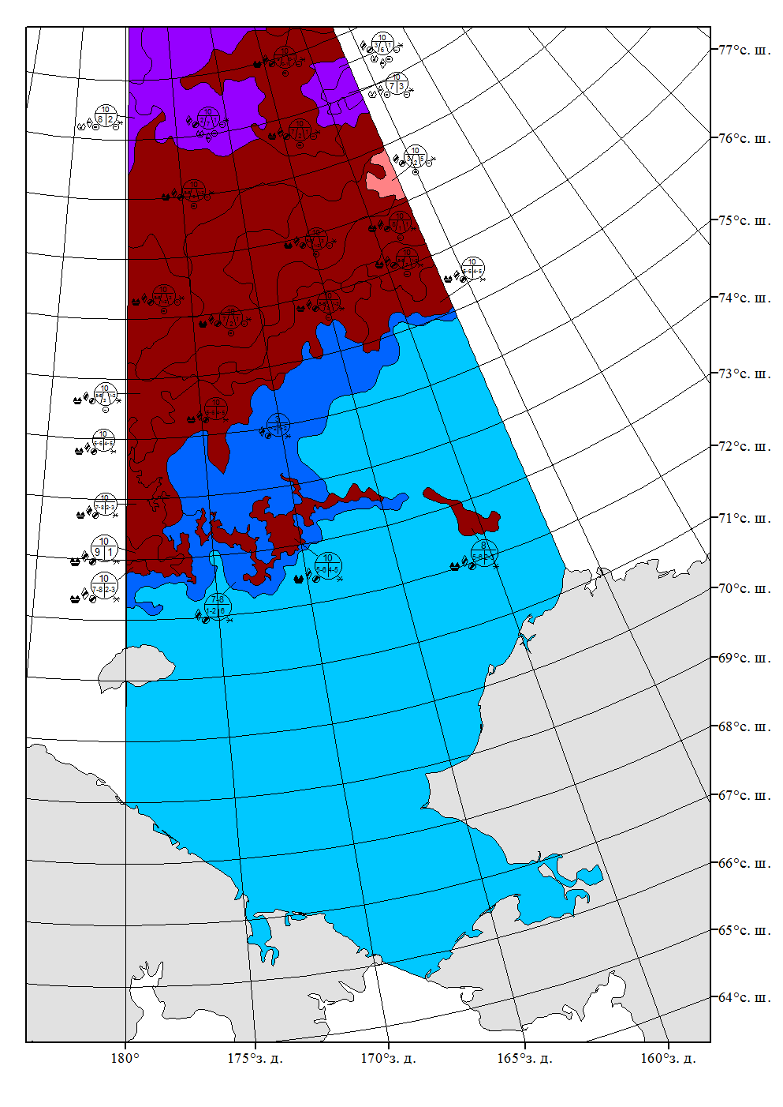
Figure X-5 – AARI ice chart in Russian national symbology for the Chukchi Sea for 3-4 October 2016
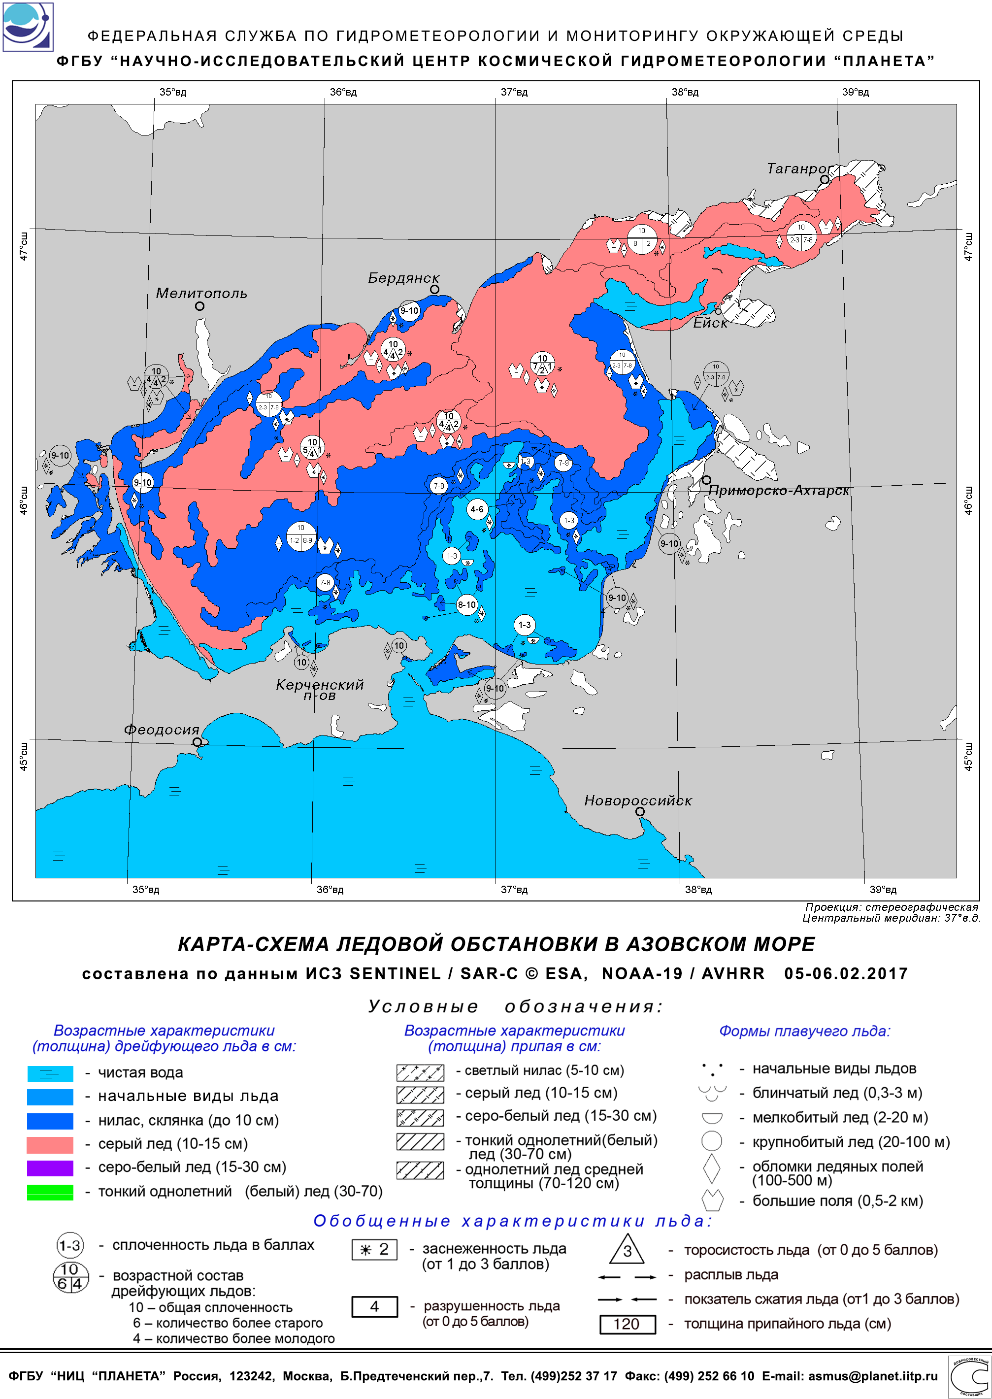
Figure X-6 – Planet ice chart in Russian national symbology for the Azov Sea for 5-6 February 2017.
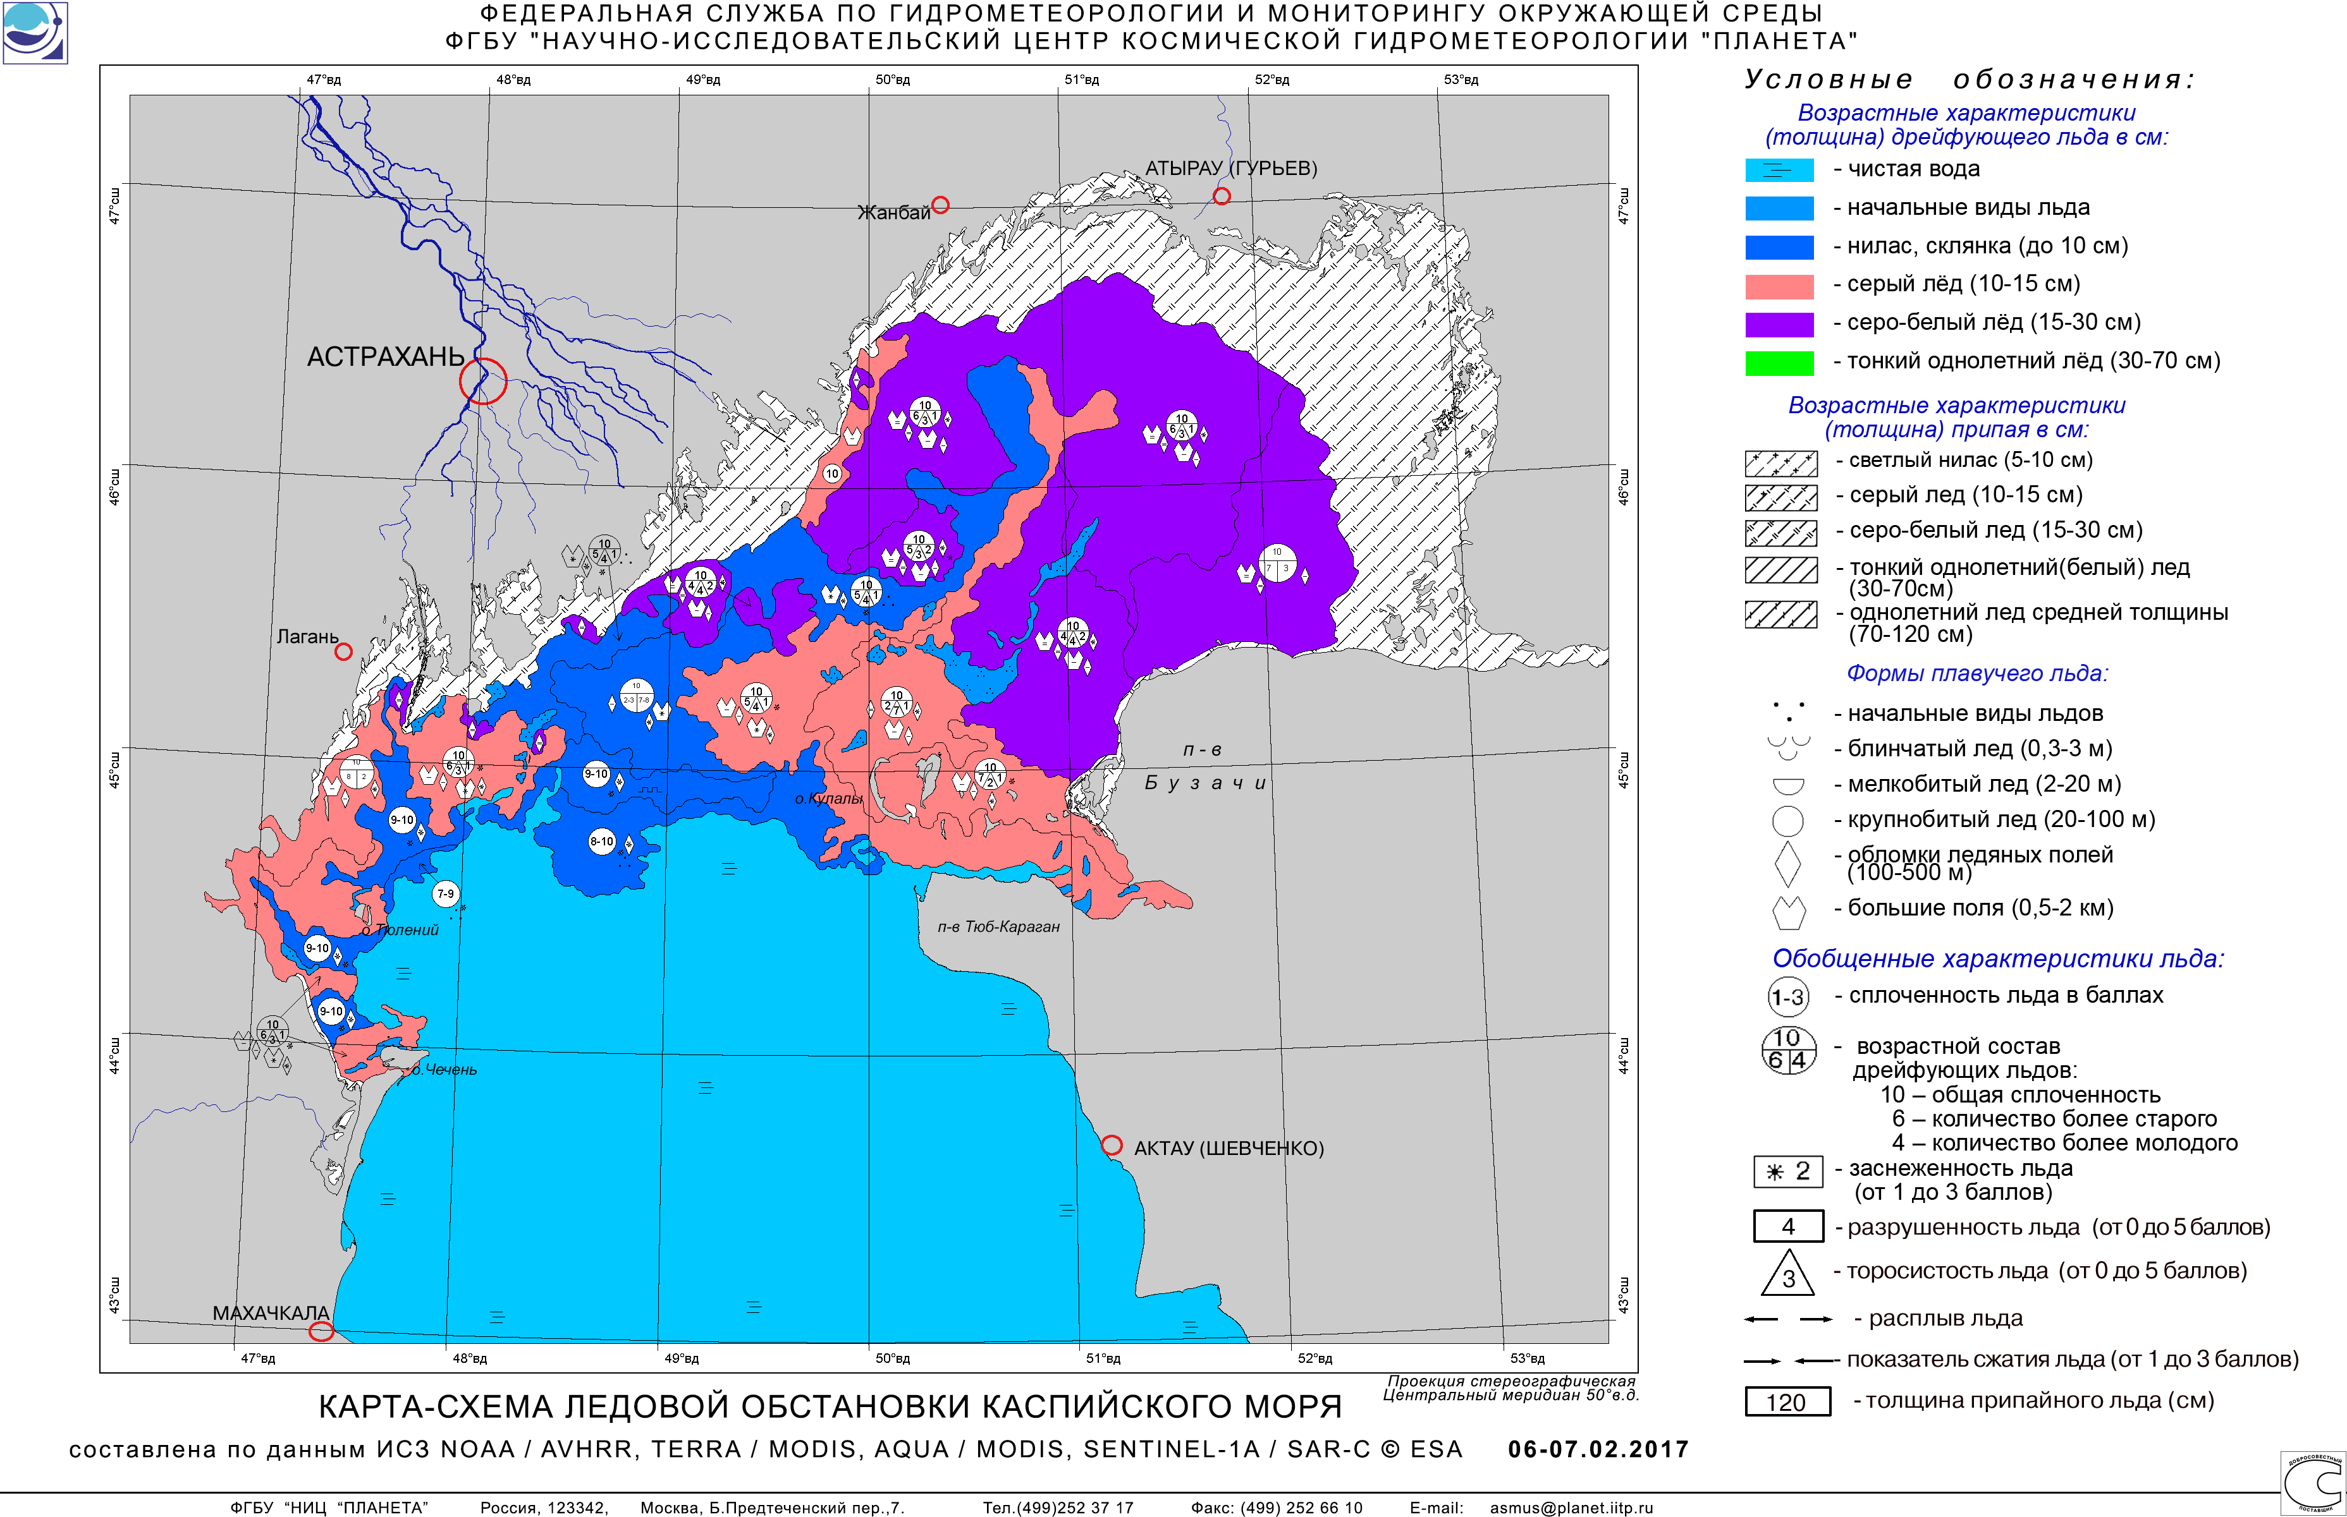
Figure X-7 – Planet ice chart in Russian national symbology for the Caspian Sea for 6-7 February 2017.
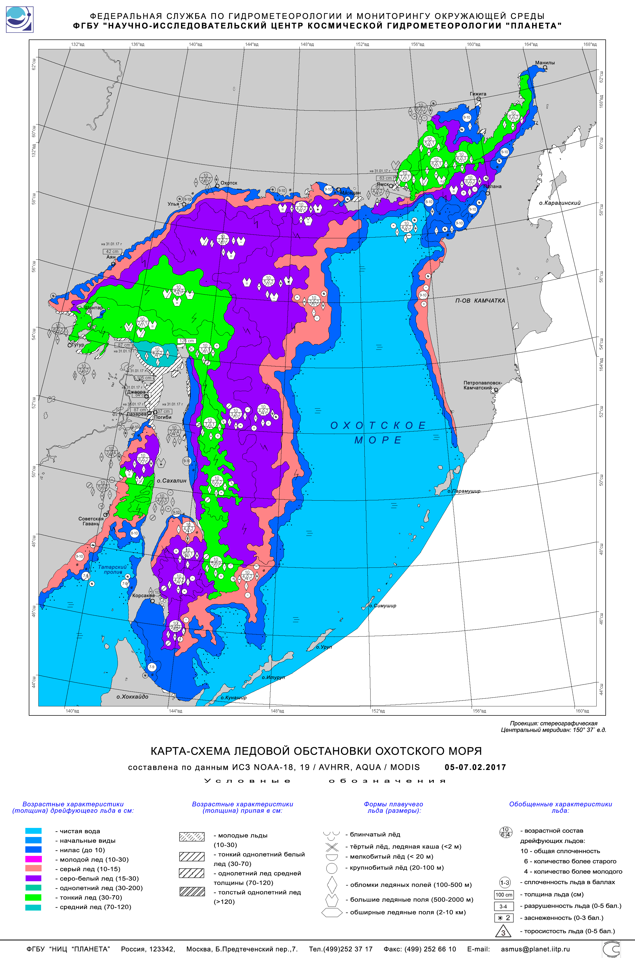
Figure X-8 – Planet ice chart in Russian national symbology for the Okhotsk Sea for 6-7 February 2017.

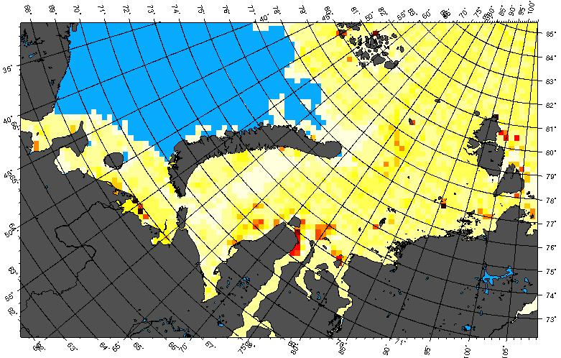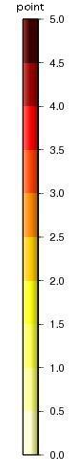 | 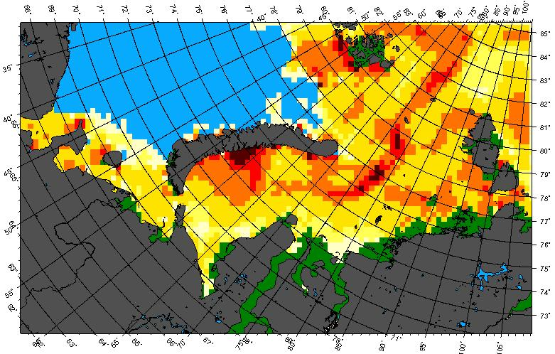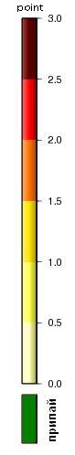
(a) | (b)
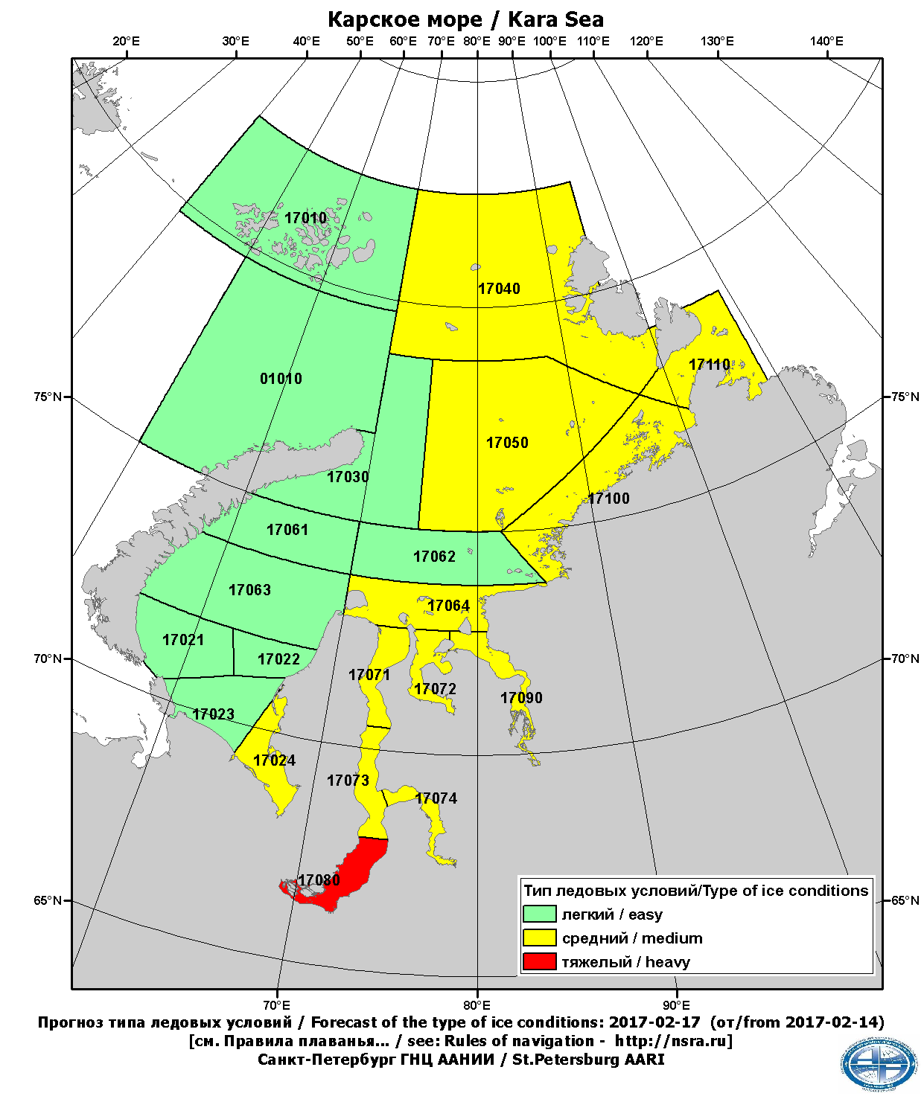
(c)
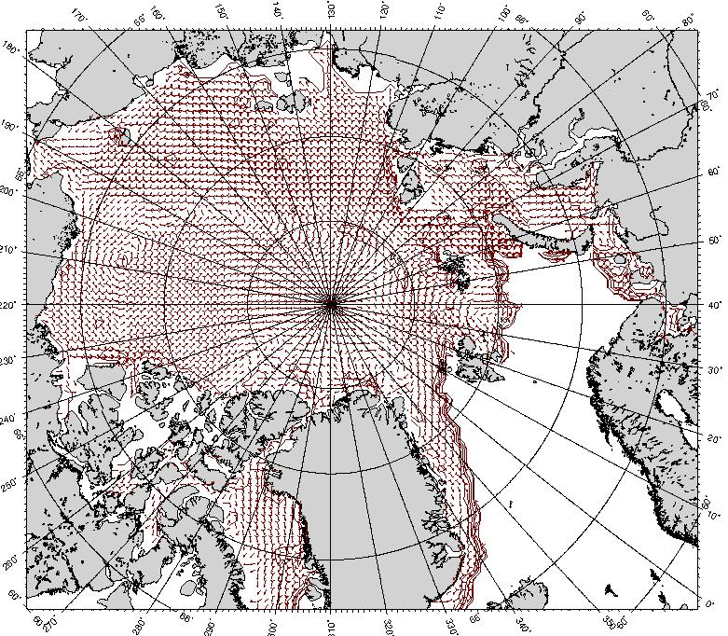 | 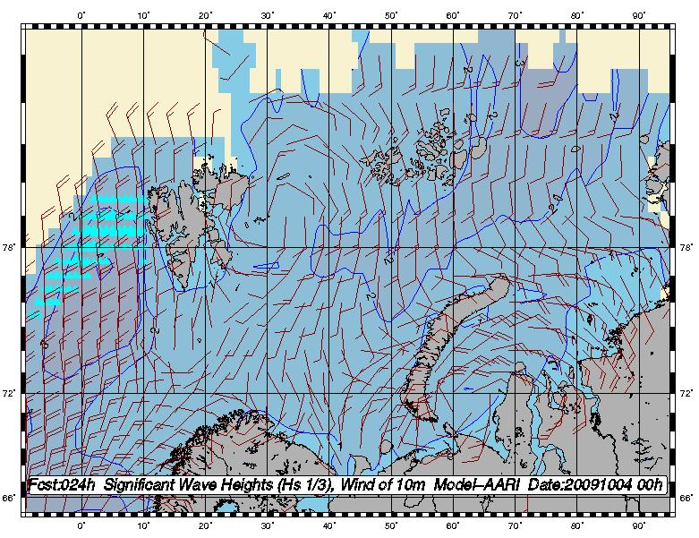
(d) | (e)
Figure X-9 – Short-term prognostic charts: 2010-02-05 +024h for the Barents-Kara Seas: hummocks concentration (a) and level of ice compacting (b); 2017-02-14 +72h: type of ice conditions (c); 2010-02-05 +024h for the Arctic Ocean: mean daily ice drift (d); 2009-10-03 +024h significant (3%) waves height, level of ice accretion and surface wind vectors for the Western Eurasian Arctic seas (e).

