Sea-Ice Information Services
in the World

Edition 2010
(last revision 2015-12-04)

WMO-No. 574

© 2015, World Meteorological Organization, Geneva

ISBN 92-63-13574-6
NOTE
The designations employed and the presentation of material in this publication do not imply the expression of any opinion whatsoever on the part of the Secretariat of the World Meteorological Organization concerning the legal status of any country, territory, city, or area, or of its authorities, or concerning the delimitation of its frontiers or boundaries.

SWEDEN
1 February 2017 Revision

1. Organization
The Swedish Meteorological and Hydrological Institute (SMHI) is responsible for the sea ice information service in Sweden since 1930. SMHI provides ice information for the Swedish icebreakers and international shipping through the National Maritime Administration, the Royal Swedish Navy and the general public and media.
Further, the Swedish Ice Service is, as the national expert authority on sea ice, often involved in marine accident investigations as well as other external inquiries. The Swedish Ice Service is operational seven days a week during the ice season, and produce daily ice charts and ice reports as well as client specific products such as ice formation forecasts. The ice season in the Baltic Sea normally begins in late November when ice starts to form in the northernmost archipelagos of the Bay of Bothnia, and lasts until end of May. The Swedish Ice Service is represented in IICWG and the JCOMM Expert Team on Sea Ice as well as in other international collaborative forums.

2. Data acquisition
(a) Ice observations – plain language
When at sea, icebreakers report on current ice conditions 3-4 times per day. Ice information is also provided in plain language by merchant vessels, either on their own initiative or upon request, and by a few coastal observation stations.
Ice observations - Baltic Sea Ice Code
Ice observations in Baltic Sea Ice Code are reported by a few observers along the coast. National ice reports in Baltic Sea Ice Code from Sweden, Denmark, Estonia, Finland, Germany, Latvia, Lithuania, Netherland, Poland and Russia are available via the WMO GTS network.
(b) Satellites
100 m resolution SAR images from RADARSAT-2 and Sentinel-1 are used during ice season. A variety of optical images are used from the NOAA (AVHRR), Suomi-NPP (VIIRS) and Metop A and B satellites, received daily all year. OSISAF images are received daily and used in SST analysis.
(c) Sea surface temperature observations
Hourly or daily SST observation data is collected from buoys and automatic stations (both Swedish and international via ftp), coastal stations and some merchant and passenger vessels (mainly by Ferrybox).
(d) Meteorology forecasts
For meteorological forecasts the weather service at SMHI use a number of international meteorological models including SMHI’s HIRLAM (High Resolution Limited Area Model) and the operational atmospheric model at European Centre for Medium-Range Weather Forecasts (ECMWF).

3. Output products
(a) Ice charts
Ice charts in Mercator projection are produced daily and cover the Baltic Sea including the Gulf of Finland and Gulf of Riga, Kattegat and Skagerrak, and the major Swedish lakes (Vänern and Mälaren). The scale at 60° N is 1:4 000 000. Charts display ice concentration, thickness and type using WMO international sea-ice symbols and colour code standard. Ice charts also include navigational restrictions for ports in Sweden and Finland and information on position of the operating icebreaker vessels. For ports in other countries in the Baltic area, info is available at www.baltice.org. Twice weekly, the ice chart is complemented by a sea surface temperature (SST) chart for the same area.
All charts are uploaded on the SMHI webpage for public access. On request, vessels can receive the ice chart by email or fax. The Swedish ice charts are also transmitted on radio facsimile by the German stations Hamburg/Pinneberg.
(b) Ice bulletins /Ice reports
Daily bulletins, in English, on current ice situations at sea, navigational restrictions and icebreaker information are distributed by NAVTEX, the GTS network and are available for public access on the SMHI web page both in Swedish and English. The ice reports are also uploaded on the Baltic Icebreaker Management website. An abridged ice report is broadcasted daily on Swedish Public Radio.
(c) Baltic Sea Ice Code
Ice information for selected fairway sections is distributed in Baltic Sea Ice Code via WMO GTS network and is available on the SMHI web page. All Swedish and international Baltic Sea Ice Code data is stored in SMHI’s Ice Database.
(d) Ice forecasts
SMHI produce ice forecasts for up to 15 days. The forecasting service is both a commercial service available to shipping companies, but also a service to other authorities including the Swedish Maritime Administration, Swedish Navy and Coastal Guard. For more information on ice forecast methods see section 4.
(e) Other output products
Ice charts are converted to grid files which are used in data assimilation for SMHI’s ocean circulation model NEMO (see section 4). SMHI send daily wind, atmospheric pressure and water level forecast data to an external database for access and visualization onboard Swedish and Finnish icebreakers.

4. Forecasts and forecast methods
Sea ice forecasts are prepared using SMHI’s operational ocean circulation model NEMO-Nordic. NEMO is an abbreviation for Nucleus for European Modelling of the Ocean. NEMO-Nordic is a three dimensional baroclinic model, with a coupled ice model. NEMO-Nordic currently runs with horizontal resolutions of 1 and 2 nautical miles. The ice model is based on LIM3.
The forecast parameters are; ice concentration, thickness, and ice drift. The ice model can produce forecasts up to 10 days and is from winter 2017, forced with a combination of ECMWF and AROME model or the operational ECMWF meteorological model. Using the combined AROME and ECMWF forcing, ice forecasts of up to 60 hours are produced with 1 nm resolution. For longer forecasts (up to 10 days) the ECMWF model is used to force NEMO-Nordic at 2 nm resolution.
Initial conditions are determined by assimilation of data from observations, gridded SST charts and satellite data through the method of 2D or 3D ensemble variational data assimilation. The above described ice modelled forecasts, together with other meteorological models and ensemble models such as the ECMWF, are used as a basis, by experienced marine forecasters, to produce ice formation forecasts up to 15 days to our clients.

5. Publications
SMHI publish a monthly summary of meteorological, hydrological and oceanographical conditions in which ice conditions are presented during ice season.
Every year SMHI and the National Maritime Administration publish a joint report summarizing the past ice season. This report includes month by month description of ice development, statistical information on selected fairways, weather and SST summaries and a summary of icebreaking activities.

6. Mailing and Internet addresses
Swedish Meteorological and Hydrological Institute (SMHI)
Swedish Ice Service
601 76 Norrköping
Sweden
Telephone: +46 (0) 11 495 8533
Telefax: +46 (0) 11 495 8053
E-mail: ice@smhi.se
Internet:
http://www.smhi.se
http://www.smhi.se/iceservice (Ice products)
http://www.smhi.se/oceanweb/forecasts (visual ice forecast)
http://www.baltice.org (icebreaker activities, ice reports)

ANNEX XI – Sweden
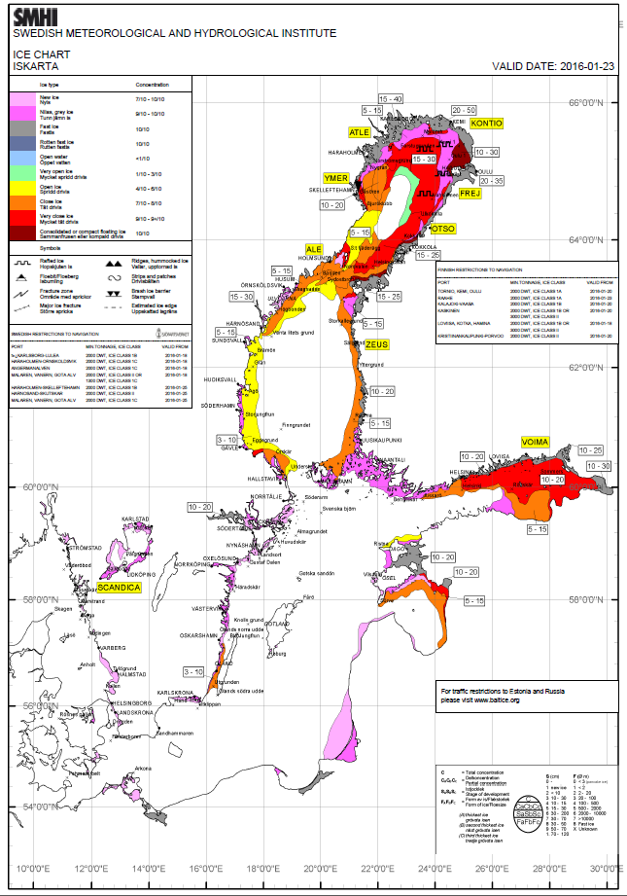
Figure XI -1 – Daily ice chart for the Baltic Sea, 23 January 2016

