Sea-Ice Information Services in the World

Edition 2010
(last revision 2010-03-19)

WMO-No. 574



GERMANY
15 April 2009 Revision

Organization
The ice service provided by the Federal Maritime and Hydrographic Agency (BSH) covers the German Bight and the Baltic Sea west of Bornholm during the winter. The agency is separate from the Meteorological Service but both are part of the Federal Ministry of Transport, Building and Urban Affairs. Radio transmission of ice reports and a daily facsimile broadcast of ice charts are provided for fisheries, national and international shipping in the Baltic Sea and for harbour activities, maritime agencies and off-shore activities. An overall ice report for the whole Baltic Sea and the southeastern North Sea with relevant ice charts is offered to subscribers via mail, telefax, e-mail and the Internet. On request world-wide ice information is provided.

Data acquisition
Daily ice information is reported in Baltic Sea Ice Code from 134 areas or fairway sections along the coast of the southwestern Baltic Sea and the German Bight. A selection of these form 54 main areas or fairways grouped in 11 districts. Details are given in WMO No.9, Volume D – Information for Shipping. In addition to the coded information, a great many stations perform ice thickness measurements. The other data sources are observations from regular aerial reconnaissance, icebreakers and merchant ships, reported in plain language, from NOAA and MODIS satellite visual/infrared imagery and from AMSR microwave imagery. Reports, data and charts are also exchanged with foreign ice services via telefax and e-mail and via telex (GTS) transmission of plain language reports and coded data. Internet access to ice information products of foreign services is greatly used.
A joint web page for the Baltic Sea Ice Services (BSIS) has been developed and established as an independent domain at BSH (http://www.bsis-ice.de).

Output products
- Ice charts
  - A printed ice chart (black/white and colour) of the ice conditions in the Baltic Sea using the international system of sea-ice symbols is mailed, telefaxed and e-mailed twice a week and presented on the Internet. Type of chart: Mercator projection, Baltic Sea north of 56°N and east of 16°E. If sea ice occurs farther south, charts cover the whole Baltic Sea area.
  - A printed ice chart (black/white and colour), showing ice conditions in the western Baltic and German Bight using the international system of sea-ice symbols is mailed, telefaxed and e- mailed three times a week when ice is present and shown on the Internet. Type of chart: Mercator projection, Baltic Sea between 52°30’N and 60°N, 7°E and 15°40’E.
  - A facsimile broadcast of the data in (ii) is made daily when ice is present; Mercator projection, Baltic Sea between 52°N and 60°N, 7°E and 16°E.
  - A daily facsimile broadcast is (re-)transmitting the North American Ice Service (NAIS) iceberg charts for the North Atlantic provided by IIP (International Ice Patrol) and CIS (Canadian Ice Service), (Figure XII-1, Annex XII).
  - A daily facsimile broadcast is done for the Swedish ice chart of the Baltic and the Norwegian ice chart of the European Arctic.
Note: charts (i)–(iii) are constructed with the digital ArcMap program. Larger scale (approximately 1:850,000) sub-regional charts are prepared as needed.
Sample ice charts are given in Annex VI.
- Coded and plain language information
  - A bulletin describing ice conditions in the Baltic Sea using plain English and German and the Baltic Sea Ice Code is mailed, telefaxed, e-mailed and presented on the Internet Monday to Friday. An ice outlook for four to six days is included.
  - Similar bulletins covering the western Baltic and the German Bights are prepared daily in English and German for telex (GTS) and radio relays as well as for distribution via mail, telefax and e-mail and for presentation on the Internet.

Forecasts
Forecasts of the date of formation of new and young ice are provided for the western Baltic using thermodymanic methods. The analogue method is used for the decay of ice. An ice model simulates the formation, melting and drift of sea ice for the German Bight and western Baltic as well as for the other North Sea and Baltic Sea areas. The forecasts for the seas, computed by the operational ice model, cover 48 hours.

Publications
A publication on the ice season is presented regularly on the Internet and in special reports of the BSH. Other publications are prepared only at irregular intervals.

Mailing and Internet addresses
BSH – Eisdienst Neptunallee 5
18057 Rostock Germany
Telephone: +49 (0) 381 4563 782 (and 787)
Telefax: +49 (0) 381 4563 949
E-mail: ice@bsh.de Internet:
http://www.bsh.de/de/Meeresdaten/Beobachtungen/Eis/index.jsp (in German/English) http://www.bsis-ice.de (a joint web page for the Baltic Sea Ice Services)

North America

NORTH AMERICAN ICE SERVICE
11 November 2016 Revision

Organization
The mission of the North American Ice Service (NAIS) is to leverage the strengths of the Canadian Ice Service (CIS), US National Ice Center (NIC), and the International Ice Patrol (IIP) to monitor and provide the highest quality, timely and accurate ice analysis, in order to meet the needs of the maritime interests of the United States and Canadian governments in support of:
- Safe and efficient maritime operations;
- Weather and environmental modeling;
- National and environmental security;
- Research and climate understanding; and
- International treaty and other obligations

Since December 2004, CIS, NIC, and IIP have jointly produced ice charts, ice forecasts, 30-day forecasts, iceberg warning products, and seasonal outlooks for the Great Lakes, North American waters, and the North Atlantic under the banner of the North American Ice Service. The North American economy is dependent on the reliable and efficient movement of goods and materials through ice-encumbered coastal waters. The ice services of Canada and the United States enable this by providing timely and accurate strategic and tactical ice information to the maritime community. In doing so, these agencies reduce the risk of loss of life, property, and environmental damage from ice-related accidents and disasters. Government operations in the polar regions (land and sea patrols) depend on regular ice information to enhance their domain awareness and to plan their operations under, through and on the surface of sea ice. The mandate of the NAIS is to create harmonized products and services for ice information for North American waters to serve the needs of users for safety of navigation and informed decision-making. The integrated service combines the strengths of the existing centers and results in seamless products of high quality and consistency. The NAIS offers a single point-of-entry for ice information and will provide a suite of common North American ice products that may be produced at any of the three centers equally, effectively, and indistinguishably to the user. Each center is recognized as a contributing partner to the NAIS, and products may be issued jointly without specific attribution to the center of production. Ultimately, the product suite of the NAIS may evolve into a set of constantly updated databases of past, current, and forecast ice conditions from which users will retrieve the information they desire, rendered and delivered in a format of their own specification.

Output products
- Iceberg chart for the North Atlantic. A sample chart is given in Figure XII-1.
- Ice charts issued weekly for the Great Lakes. A sample chart is given in Figure XIII-1, Annex XIII.
- Ice hazard bulletins for the Great Lakes in plain language.

Forecasts and forecast methods
30-days forecasts and seasonal outlooks for the Great Lakes.
30-days forecasts and seasonal outlooks for waters surrounding North America in the Arctic.
30-days forecasts for icebergs in North Atlantic waters.

Internet address

http://www.navcen.uscg.gov/?pageName=NAIceService

CANADA
19 March 2010 Revision

Organization
The Canadian Ice Service, a division of the Meteorological Service of Canada in the Department of Environment, is a centre of expertise for ice related information for all of Canada and its surrounding waters. The Ice Service co-operates closely with the Canadian Coast Guard which operates Canada’s fleet of icebreakers to assist marine transportation in Canadian waters.
The Canadian Ice Service promotes safe and efficient maritime operations and protects Canada's environment by providing reliable and timely information about ice conditions in Canadian waters. For example, the Ice Service provides timely warnings of icebergs and ice conditions that pose immediate threats to ships, ports and other marine operations; advises on ice conditions in shipping routes for navigators; provides information to help shipping, fishing and offshore operators plan their seasonal operations in a safe and efficient manner.
To meet its mission, the Canadian Ice Service collects and analyses data on ice conditions in all regions of the country affected by the annual cycle of pack ice growth and disintegration. In summer, the focus is on conditions in the Arctic and the Hudson Bay region. In winter and spring, attention shifts to the Labrador Coast and East Newfoundland waters, the Gulf of St. Lawrence, the Great Lakes and St. Lawrence Seaway.
Major users of Ice Service products and services are:
- the Canadian Coast Guard uses weather and ice information for marine safety, icebreaking operations and efficient marine transportation
- port authorities obtain site-specific information on current and long-term ice conditions in ports and shipping routes
- the commercial shipping industry uses ice information for strategic and tactical vessel passage planning
- fishing fleets obtain enroute and on-site ice conditions for ice-encumbered areas
- the offshore oil and gas companies use iceberg and sea ice information for exploration and production, both on-site and in transit
- the marine construction industry uses site-specific current and historical data for offshore and onshore projects, such as bridges and port facilities
- the tourism industry gets technical and general information for the operation of cruise ships and the enjoyment of passengers
- the marine insurance industry uses ice information for risk assessment for offshore operations affected by ice
- environmental consultants use ice data, analyses and expert advice for environmental impact assessments
- research scientists use ice information relating to research on transportation, construction, climate change, meteorology, oceanography, biology and socio-economic impacts.
The Canadian Ice Service operates a comprehensive ice information service, encompassing reconnaissance, analysis and forecasting, ice climatology, data archiving, informatics support and research and development. It has a staff of approximately 90 people working at the Ice Centre in Ottawa, aboard Coast Guard icebreakers and in field offices.

Data acquisition
Radar imagery from satellites is the principle data source, augmented by visual observations from fixed-wing aircraft and helicopters. RADARSAT and ENVISAT synthetic aperture radar (SAR) data provides extensive and detailed (up to 30 metres resolution) coverage of ice conditions. The Ice Service uses approximately 7,000 SAR images covering over a billion square kilometres annually. Data are received in real-time by two Canadian satellite receiving stations, processed and delivered to the Canadian Ice Service and disseminated to marine users within hours.
Visual and infrared imagery from U.S. polar orbiting satellites is also used extensively in the ice analysis program. Passive microwave imagery is received daily to provide background information on the general ice distribution at low resolution.
Experienced ice observers are stationed on the major Coast Guard icebreakers and in regional ice offices. They conduct local visual reconnaissance by helicopter and transmit the observations to the Ice Centre immediately after the flight. These observed ice charts are posted on the Ice Service web site marine users immediately upon receipt.
The Canadian Ice Service is integrated with the national meteorological network and has access to the necessary meteorological and oceanographic inputs. Co-operation with research institutes, universities and other federal departments also provide other valuable data.

Output products and forecasts
The Canadian Ice Service provides its clients and the Canadian public with a variety of accurate and timely analyses and forecasts of ice conditions ranging from daily ice forecasts to seasonal outlooks. Information on ice conditions posing immediate threats, such as rapid closing of coastal leads, ice pressure or unusual ice conditions, are directly available from the Canadian Ice Service web site, the weather office web site of Environment Canada, and through weather and marine radio broadcasts.
Specialized products and services to meet the short-term tactical and longer-range planning needs of clients are also available. These products include detailed ice analysis charts, radar and satellite imagery, image analysis charts, and special forecasts covering days to months. These products are distributed in a variety of formats, including mail, e-mail, fax, and Internet.
The Ice Service provides a variety of field services, normally through the Coast Guard, for clients who need specialized ice information. Ice Service Specialists provide field support to clients on shore and aboard ships, including briefings on ice conditions, direct analysis of satellite images and special visual observations.
The Canadian Ice Service has expertise in ice modelling, remote sensing and climatological ice conditions in and around Canada. It supports research and development by scientists working in government, universities and the private sector. Drawing on the Canadian Ice Service national ice data archive, ice analysts work directly with clients to identify and analyze appropriate climatological ice information and provide advice on historical ice and iceberg conditions.
Ice information products and services are provided in those areas of Canada’s waters where there is marine activity in the vicinity of sea ice. Arctic areas are active from June to November while southern areas, including the Gulf of St. Lawrence and the Great Lakes are active from December to May.
- Ice charts
Ice charts graphically illustrate ice or iceberg conditions at a particular time, presenting data by means of a standard international code. Charts may be used for strategic and tactical planning. Charts available from the Canadian Ice Service include:
  - Regional Ice Chart (Figure I-1, Annex I);
  - Daily Iceberg Analysis Charts (Figure I-2, Annex I);
  - Daily Ice Analysis Charts (Figure I-3, Annex I);
  - Ice Reconnaissance Charts (Figure I-4, Annex I);
  - Image Analysis Charts (Figure I-5, Annex I);
- Bulletins
Bulletins provide advice on present ice or iceberg conditions in simple text format. The following bulletins are available from the Canadian Ice Service:
  - Daily Iceberg Bulletins
  - Daily St. Lawrence River Ice Bulletins
  - Seasonal Ice Summary
  - Forecasts
- Forecasts
Forecasts provide advice on present and forecast ice conditions in text format. The seasonal ice outlook provides a forecast of the ice season in graphical and chart format. The following bulletins are available from the Canadian Ice Service:

 | (i) | Daily Ice Forecasts (Figure I-6, Annex I);
 | (ii) | 30 Day Ice Forecasts
 | (iii) | Seasonal Ice Outlook.
(d) | Images
In preparing the charts and bulletins, the Canadian Ice Service uses an extensive array of satellite data. Raw images are available to users depending on their ability to receive image data:
  - Visual / Infrared Satellite Imagery
  - SAR images from Radarsat and Envisat
- Weather maps
The Canadian Ice Service makes available the following weather maps produced by Environment Canada:
  - Surface Analysis Weather Map
  - 500 HPA Height Analysis Map
  - Surface Prognostic Weather Map out to 120 hours
  - 500 HPA Prognostic Weather Map out to 120 hours
  - Public and Marine Weather Forecast Bulletins
  - Significant weather depiction charts
  - Ocean wave analysis
  - 12-24-36 hour ocean wave prognosis
(.f) Special services
The Canadian Ice Service responds to enquiries from users and provides a range of specialized forecasting, consultation and advisory services on a best-effort, cost-recovered basis. If needs are substantial, the user is referred to the private sector when possible.

Publications
The Canadian Ice Service has a collection of reference material related to sea ice and icebergs. The following representative publications are available in printed format and on-line as indicated:
- Seasonal Summary for the Canadian Arctic since 2004 (available on-line).
- Seasonal Summary for the Great Lakes and Eastern Canadian Waters since 2004 (available on-line).
(c) MANICE - Manual of Standard Procedures for Observing and Reporting Ice Conditions. (available on- line).
- Ice Thickness Climatology (1961-1990)
- Melting and Freezing Degree Days (1961-1990)
- Sea Ice Climatic Atlas - Northern Canadian Waters 1971-2000 (also in CD) (available on-line).
- Sea Ice Climatic Atlas - East Coast of Canada 1971-2000 (available on-line).
- Lake Ice Climatic Atlas - Great Lakes 1973-2002 (available on-line).
- Annual Arctic Ice Atlas 1990 – present (available in paper format until 2003, then on CD or on-line)

Mailing and internet addresses
Canadian Ice Service – Environment Canada 373 Sussex Drive, Block E - 3rd floor Ottawa, Ontario
Canada K1A 0H3
Telephone: +1 (877) 789-7733 Telefax: +1 (613) 947-9160
E-mail: cis-scg.client@ec.gc.ca Internet: http://ice-glaces.ec.gc.ca

UNITED STATES
24 January 2017 Revision

Organizations
- U.S. Naval/National Ice Center (NIC)
Sea ice products and services in the United States are provided by the National Ice Center located just outside of Washington, D.C., in Suitland, Maryland. Through the collective efforts of three Federal Government agencies: the National Oceanic and Atmospheric Administration (NOAA), the United States Navy (USN), and the United States Coast Guard (USCG), manpower and fiscal resources are contributed and used in the collaborative operation of the NIC.
The mission of the NIC is to provide the highest quality, timely, accurate, and relevant snow and ice products and services to meet the strategic, operational, and tactical requirements of the United State’s interests across a global area of responsibility.
The NIC’s global area of responsibility includes:
- Arctic – All routinely ice covered Arctic Ocean waters, to include the Sea of Japan, Sea of Okhotsk, and the Yellow Sea.
- Antarctic – All routinely ice covered Antarctic waters.
- United States – Alaskan waters, Great Lakes, Chesapeake Bay, and the Delaware Bay.
- In addition to the global sea ice analyses and forecasts, the NIC produces a daily Northern Hemisphere Snow and Ice Cover Analysis Chart, and maintains an Antarctic Iceberg Database.
Internationally, the National Ice Center actively participates in the International Arctic Buoy Program (IAPB), International Ice Charting Working Group (IICWG), North American Ice Service (NAIS), and the World Meteorological Organization-Intergovernmental Oceanographic Commission’s (WMO-IOC) Expert Team on Sea Ice.
Sea ice analyses for Alaskan areas are also prepared by the NOAA National Weather Service (NWS) in Anchorage, Alaska.
- USCG International Ice Patrol (IIP)
Iceberg warning products and services in the United States are provided by the International Ice Patrol located in New London, Connecticut.
The mission of the IIP is to monitor the iceberg danger in the North Atlantic Ocean and to provide relevant iceberg warning products to the maritime community.
Along with CIS and NIC, IIP is one of the three members of NAIS as well as an integral part of the IICWG.

Data acquisition
NIC ice products are produced primarily using radar, visible, and infrared imagery from a variety of sources. Satellite imagery constitutes over 95 per cent of the information received and integrated into NIC analysis products. Microwave and scatterometer data is also used in product production. In addition to imagery, drifting buoy data, ice model predictions, limited ship reports, and meteorological and oceanographic input is available to the analyst, as well as ice information provided by other international centers. The NIC has an extremely productive and active working relationship with the Canadian Ice Service (CIS) and receives some shared imagery from their center – and vice versa.

IIP directs aerial reconnaissance from U.S. Coast Guard HC-130J aircraft to detect and identify icebergs in the North Atlantic Ocean. Satellite imagery from RADARSAT-2 and Sentinel-1a is downloaded and analyzed at IIP using iceberg detection software. Iceberg reports are also received from commercial aerial reconnaissance based in St. John’s Newfoundland and from vessels transiting the area. All of this iceberg data is then analyzed using IIP’s iceberg drift and deterioration model. Watchstanders produce an Iceberg Limit based on the model’s forecast that is displayed graphically on the NAIS Iceberg Chart (ANNEX XII, Figure XII-1) and textually on the NAIS Iceberg Bulletin each day, valid at 00Z. These iceberg products warn shipping traffic of the areas to avoid. Ships are encouraged to immediately report sightings of icebergs or stationary radar targets that may likely be icebergs to the nearest Canadian Coast Guard MCTS Center or through INMARSAT using Service Code 42, as there is no charge when using this code.

Output products and forecasts
NIC produces a variety of ice analyses and forecasts in support of operations and climate data covering both the northern and southern polar region. Routine NIC ice products include a daily ice edge analysis of the northern and southern hemispheres, marginal ice zone analysis in the northern hemisphere, a daily snow cover product, weekly or bi-weekly regional scale graphical ice analysis, alphanumeric text messages, and WMO Sea Ice in GRIDed (SIGRID) format. Geographical Information System (GIS) formats such as shape files, .e00 files, and coverage information is created either daily or weekly. Additionally, electronic charts in .pdf format, annotated imagery, and short term forecasts are available. All sea ice analysis, text messages and GIS products are available via the NIC website at http://www.natice.noaa.gov. Outlooks for the Ross Sea, Western Arctic, and Great Lakes are produced regularly and posted to the NIC website.
Special requests such as route recommendations, pre-sail ship briefs, ship rider support, legacy ice information (1972 to present), long term ice forecasts, location and orientation of exploitable openings or thin ice features in the ice pack, multi-year ice locations, estimated ice thickness based on ice stage of development, and tactical annotated imagery are available with some restrictions based on the requesting customer, (i.e., Department of Defense, research, academia, etc.).

Except for the Great Lakes analyses, which are produced in Lambert Conformal, all NIC ice products use polar stereographic projections, and WGS84 datum.
During the Great Lakes ice season, bi-weekly ice analyses, seasonal outlooks, 15 and 30 day forecasts, .e00 files, ASCII files, and an ice concentration product are provided as a service of the NAIS. The NIC and CIS alternate the twice weekly chart, providing a seamless, identical product available to customers. These products can currently be located on the NIC and CIS (http://ice-glaces.ec.gc.ca) website.

The USCG’s International Ice Patrol resumes creation of the NAIS Iceberg Warning Products from the Canadian Ice Service in late January when icebergs typically begin to threaten the transatlantic shipping lanes. IIP continues production of the NAIS Iceberg Products until September when icebergs typically only threaten Canadian coastal waters. According to the International Convention for the Safety of Life At Sea (SOLAS), the Ice Season formally begins in mid-February and continues into July. IIP deployments to St. John’s, Newfoundland to conduct aerial reconnaissance run from February through August to ensure that the iceberg danger is being monitored regularly. IIP creates two products for the maritime community each day, the NAIS65 Iceberg Chart (graphical representation) and the NAIS10 Iceberg Bulletin (text representation). They are normally released at 1830Z and are valid for 0000Z the following day. The iceberg chart is broadcast over radiofacsimile (RADIOFAX) and the Internet. The iceberg bulletin is broadcast over SafetyNET, Navigational Telex, Simplex Teletype Over Radio (SITOR), and the Internet. On the Internet, they are available on the IIP website, on the CIS website, on the National Weather Service (NWS) website. SOLAS requires that ships transiting the IIP area of the North Atlantic Ocean utilize the IIP iceberg warnings.
The NAIS Iceberg Chart (ANNEX XII, Figure XII-1) includes the following information:
- The Iceberg Limit is denoted by a solid line and represents the extent of the iceberg population based on recent reconnaissance and computer simulated iceberg drift and deterioration. Drifted iceberg positions have an area of uncertainty that is fully encompassed by the Iceberg Limit.
- The Estimated Iceberg Limit is represented by a dotted line. This line represents a rough estimate of the current extent of the iceberg population in this region. It is based on climatological data provided by the Danish Meteorological Institute.
- The Sea Ice Limit is denoted by the dashed line and represents the estimated extent of at least 1/10 sea ice coverage. The Sea Ice Limit is valid for 1600Z on the day prior to the date on the chart. The Sea Ice Limit is provided by the Canadian Ice Service and the Danish Meteorological Institute.
- Numbers on the chart represent the total number of icebergs including growlers, bergy bits, and radar targets, whose estimated positions are within the respective area bounded by one degree of latitude and one degree of longitude.
- Stationary Radar Targets will not be used to establish the Iceberg Limit but still represent a potential hazard to the Mariner. When a stationary radar target’s estimated position is outside the Iceberg Limit, the radar target symbol will be used in the estimated position to represent the potential hazard.
- The Most Recent Reconnaissance is at the end of the NOTE block. It indicates what area was most recently surveyed (SW, S, SE, E, or W limit), whether the work was a dedicated iceberg flight, a general flight, or a satellite pass, and when the work was done. Northern Survey indicates reconnaissance focused on counting icebergs north of 50N instead of delineating the iceberg extent. If a dedicated iceberg flight has flown in the last seven days, it will be considered the most recent reconnaissance.
- The NOTE block will be used to indicate if a special situation applies to the chart. Examples include a chart revision (when new information is received that affects the accuracy of the chart) and a significant expansion or reduction of the Iceberg Limit (defined as at least one degree of change in latitude or longitude from the previous Iceberg Limit).

The NAIS Iceberg Bulletin will be updated each day by 00Z and when changing ice conditions require a revision. The Bulletin contains the same information displayed on the chart with the exception of the numbers of icebergs per square degree of latitude and longitude. Estimated positions of stationary radar targets will be included.

If an iceberg is detected and reported outside the published NAIS Iceberg Limit, a Notice to Shipping (NOTSHIP) will immediately be sent by the Canadian Coast Guard Marine Communications and Traffic Service (MCTS) and an urgent NAVAREA IV message will be distributed over GMDSS by the National Geospatial-Intelligence Agency (the NAVAREA IV Coordinator). These warnings will remain in effect for 24 hours. Iceberg products will be revised shortly after notification between 1200 UTC and 0000 UTC or by 1400 UTC the following day if reported between 0000Z and 1200Z. No updates to the Iceberg Chart will be made between 0000Z and 1200Z.

A full list of IIP products and broadcast times, in addition to reporting requirements, can be found at http://www.navcen.uscg.gov/?pageName=iipProducts.
The Ice Desk of the NWS Anchorage, Alaska office produces sea ice advisories, sea ice analyses of Alaskan waters, including Cook Inlet, sea surface temperature analysis, and five day forecasts. These products can be accessed at http://pafc.arh.noaa.gov/ice .

Publications
- EWG Arctic Sea Ice Atlas - an Arctic compendium of sea-ice information. Information included on this CD-ROM is derived from unclassified and classified ice data (1972-1990). Statistics include: probability of occurrence of all ice, ice extent extremes (maximum, mean, minimum) and median ice concentration charts.
- The NIC Polar Science team regularly publishes papers and reports. The majority of these reports are available via the NIC website.
- Great Lakes climatology is available from the National Snow and Ice Data Center (NSIDC), Canadian Ice Service, and NOAA’s Great Lakes Environmental Research Laboratory (GLERL).
- North Atlantic Iceberg Summary – As required by SOLAS, the USCG’s International Ice Patrol publishes an annual report summarizing its operations and the ice, meteorological, and oceanographic conditions experienced during the North Atlantic Ice Season. All historical reports can be located on the International Ice Patrol’s website at http://www.navcen.uscg.gov/?pageName=IIPAnnualReports.

Contact Information
National Ice Center
  - Mailing address:
Director, National Ice Center 4251 Suitland Road
NSOF Washington, D.C., 20395
  - Physical address: 4231 Suitland road
NSOF Suitland, MD 20746 USA
  - Telephone:
Administration: (301)-394-3200
Operations Floor: (301)-394-3099
Operations Department Head: (301)-394-3020
Operations Technical Advisor: (301)-394-3028
Information Technology Department Head: (301)-394-3007
Science Department Head: (301)-394-3120
Chief Scientist: (301)-394-3105
  - E-mail: liaison@natice.noaa.gov

International Ice Patrol
  - Mailing address:
Commander, USCG International Ice Patrol
1 Chelsea Street
New London, CT 06320
USA
  - Physical address:
1 Chelsea Street
New London, CT 06320
USA
  - Telephone:
IIP Operations Center: (860) 271-2626
IIP Duty Watch Officer Cell: (860) 235-8171
IIP Ice Operations Officer: (860) 271-2633
IIP Ice Information Officer: (860) 271-2643
IIP Information Technology Specialist: (860) 271-2783
IIP Chief Scientist: (860) 271-2757
  - E-mail: iipcomms@uscg.mil

NWS Anchorage Alaska – Ice Desk
- Mailing address: NWSFO Anchorage 222 West 7th Avenue
Building #23, Room 517 Anchorage, AK 99513-5113 USA
- Telephone: Ice Desk: (907)-226-5138
- E-mail: nws.ar.ice@noaa.gov

ANNEX I - Canada

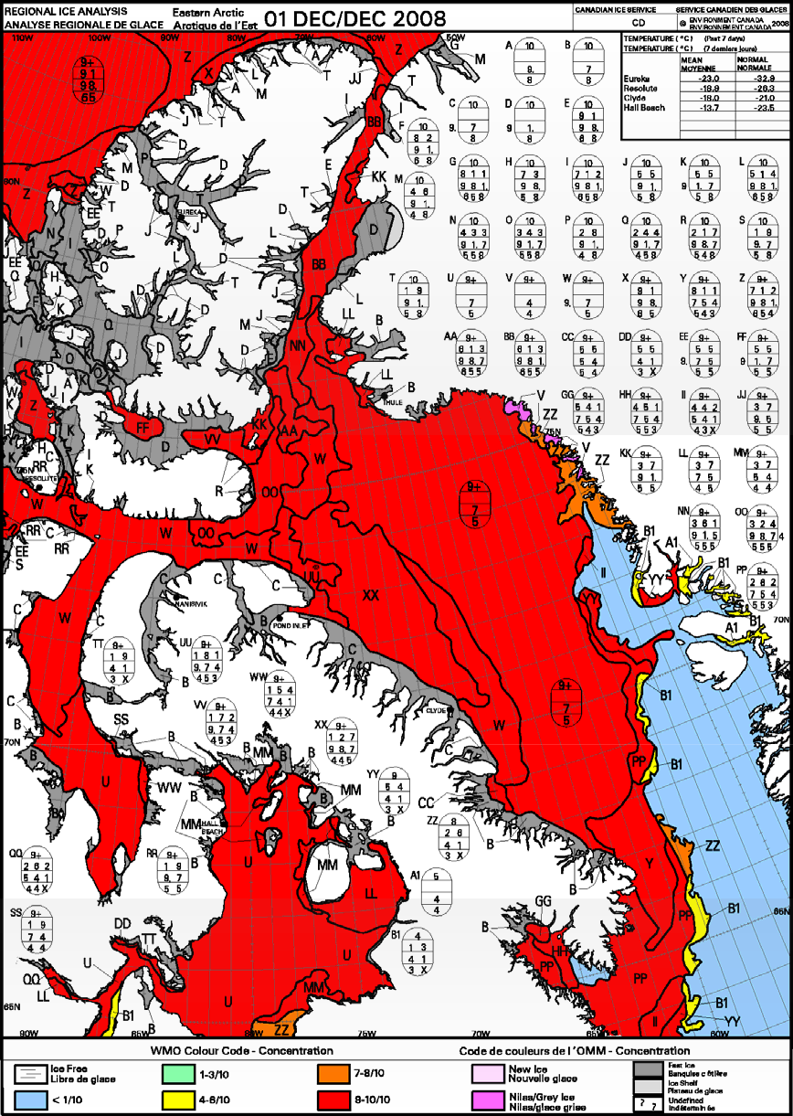

Figure I-1 – Regional Ice chart for the Eastern Arctic for 1 December 2008.

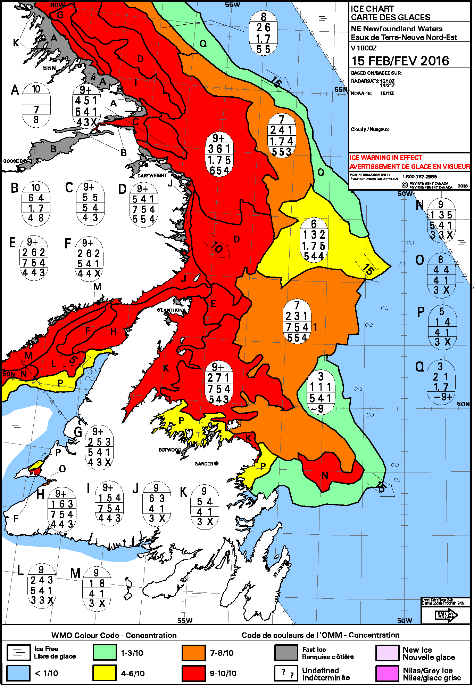
Figure I-2 – Daily Ice analysis chart for the Canadian East Coast for 15 February 2016.

ANNEX XII - United States

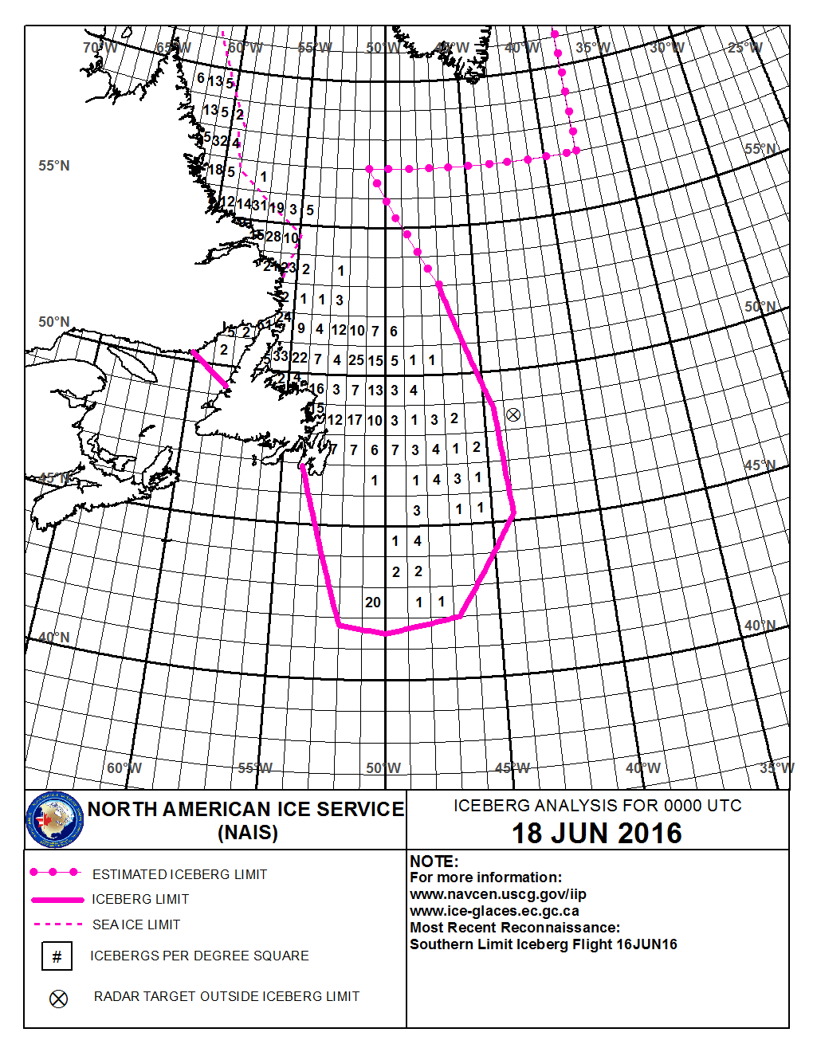
Figure XII-1 – NAIS Iceberg chart for 18 June 2016.

List of acronyms and other abbreviations

AARI Arctic and Antarctic Research Institute ACSYS Arctic Climate System Study
AIRSS Arctic Sea Ice Regime Shipping System AMSR Advanced Microwave Scanning Radiometer APT Automatic Picture Transmission
ATF Antarctic Task Force (Argentina)
AVHRR Advanced Very High Resolution Radiometer BIM Baltic Icebreaking Management
BSH Bundesamt für Seeschiffahrt und Hydrographie (Germany) BSIM Baltic Sea Ice Meeting
BSIS Baltic Sea Ice Services
CAA Chinese Antarctic and Arctic Administration CEADO Argentine Centre of Oceanographic Data CCG Canadian Coast Guard
CDA Command Data Acquisition (satellite communications) CDC Climate Data Centre
CIS Canadian Ice Service
CliC Climate and Cryosphere project
CLIVAR Climate Variability and Predictability (WCRP) CMM former WMO Commission for Marine Meteorology COADS Comprehensive Ocean Atmosphere Data Set COTS Commercial Off-the-Shelf
COOBC China Offshore Oil Bohai Corporation DCRS Danish Center for Remote Sensing
DMSP Defense Meteorological Satellite Program (USA) DMI Danish Meteorological Institute
DNMI Norwegian Meteorological Institute EC Executive Council
ECDIS Electronic Chart Display Information System
ECMWF European Centre for Medium-Range Weather Forecasting EIS European Ice Service
EMHI Estonian Meteorological and Hydrological Institute ENVISAT Environmental Satellite
ERS European Remote-Sensing Satellite
ESA European Space Agency
ESDIM Environmental Services, Data, and Information Management Programme ETSI JCOMM Expert Team on Sea Ice
EUMETSAT European Organization for the Exploitation of Meteorological Satellites FIMR former Finnish Institute of Marine Research (now part of FMI)
FMI Finnish Meteorological Institute
GCC-EWG Gore-Chernomyrdin Commission Environmental Working Group GCOS Global Climate Observing System
GDSIDB Global Digital Sea Ice Data Bank GIS Geographic Information System
GLERL Great Lakes Environmental Research Laboratory (USA) GMDSS Global Maritime Distress and Safety System
GMES Global Monitoring of Environment and Security Programme GTS WMO WWW Global Telecommunications System
HRPT Higher Resolution Picture Transmission IABP International Arctic Buoy Programme
IHO International Hydrographic Organization IICWG International Ice Charting Working Group IIP International Ice Patrol
IMGW Institute of Meteorology and Water Management (Poland) IMO Icelandic Meteorological Office
IMO International Maritime Organization
IOC Intergovernmental Oceanographic Commission (of UNESCO) IPAB International Programme for Antarctic Buoys
IST Information Society Technology IWICOS Weather, Sea ice and Ocean Service System
IUGG International Union of Geodesy and Geophysics
JCOMM Joint WMO/IOC Technical Commission for Oceanography and Marine Meteorology JCG Japan Coast Guard
JDA Japan Defense Agency
JIWG Joint USA/Canada Ice Working Group JMA Japan Meteorological Agency
HELMIforecast dynamic-thermodynamic numeric model for sea ice used at FIMR LAC Local Area Coverage
LEGMA Latvian Environment, Geology and Meteorology Agency LHMS Lithuanian Hydrometeorological Service
MANICE Manual of Standard Procedures for Observing and Reporting Ice Conditions (CIS) MetOffice UK Meteorological Office
MODISModerate Resolution Imaging Spectrometer NAIS North American Ice Service
NASA National Aeronautics and Space Administration (USA) NAVOCEANO Naval Oceanographic Office (USA)
NAVTEX International system for reception of marine safety information NCEP National Center for Environmental Prediction (USA)
NESDIS NOAA National Environmental Satellite Data Information Service NGDC NOAA National Geophysical Data Center
NIC National Ice Center (USA)
NMEFC National Marine Environment Forecast Centre (China)
NOAA National Oceanographic and Atmospheric Administration (USA) NPOESS National Polar Orbiting Environmental Satellite (USA)
NSIDC National Snow and Ice Data Center (USA) OLS Operational Linescale System
ONR Office of Naval Research (USA)
OTSR Optimum Track Ship Routing
PIPS Polar Ice Prediction System (USA)
PRIC Polar Research Institute of China
PSC University of Washington Polar Science Center QC Quality Control
QMFO Qingdao Marine Forecasting Observatory RADARSAT Satellite from Canada
RIZA Institute for Inland Water Management and Waste Water Treatment (the Netherlands) SAR Synthetic Aperture Radar
SCC CLiC Science and Coordination Committee
SCG JCOMM Services Programme Area Coordination Group SG Steering Group
SGSI former CMM Subgroup on Sea Ice
SIGRID Format for the archival and exchange of sea-ice data in digital form SHN Naval Hydrographic Service (Argentina)
SIMS Sea Ice Mapping System
SMARA Argentine Navy Meteorological Service
SMHI Swedish Meteorological and Hydrological Institute SMN Argentine National Meteorological Service
SOA State Ocean Administration (China)
SOLAS International Convention for the Safety of Life at Sea
SPA JCOMM Services Programme Area SSM/I Special Sensor microwave Imager SST Sea Surface Temperature
SYKE former Finnish Environmental Institute (now part of FMI) TD Technical Document
UN United Nations
UNESCO United Nations Educational, Scientific and Cultural Organization USN U.S. Navy
USCG U.S. Coast Guard
WCP World Climate Programme
WCRP World Climate Research Programme WDC World Data Centre
WMO World Meteorological Organization WWW World Weather Watch of WMO XML Extensible Markup Language

