|  |  |
| --- | --- |
| **World Meteorological Organization**  **JOINT WMO/IOC TECHNICAL COMMISSION FOR OCEANOGRAPHY AND MARINE METEOROLOGY (JCOMM)**  **EXPERT TEAM ON SEA ICE (ETSI)**  **Sixth Session**  **STEERING GROUP FOR THE PROJECT GLOBAL DIGITAL SEA ICE DATA BANK (GDSIDB)**  **Fourteenth Session** Helsinki, 28 February to 3 March 2017 | **Intergovernmental Oceanographic Commission (of UNESCO)**  **ETSI-6/GDSIDB-14/Doc. 3.1.5**  Submitted by:  ETSI  24.I.2017 |

**REview ofWMO Sea ice nomenclature volume i**

***(Submitted by ETSI Chair)***

|  |
| --- |
| Summary and Purpose of Document This document provides information on the current status for the publication *WMO Sea Ice Nomenclature* (WMO No. 259, volume 1 – Terminology and Codes, Volume II – Illustrated Glossary and III – International System of Sea-Ice Symbols) and suggestions for mechanisms for its further regular revisions.  . |

**ACTION PROPOSED**

The Team is invited to:

1. Note and comment on the information provided as appropriate;
2. Consider suggestions to changes to the standard from the Team members as appropriate;
3. Elaborate mechanisms for updating the WMO No. 259, volume 1 – 3 during the next intersessional period including its harmonization with SIGRID-3, Ice Objects Catalogue and the GCW requirements
4. Take other actions on the issue raised in the report, as appropriate;

______________________

**References:**

WMO Sea Ice Nomenclature electronic version - http://www.aari.ru/gdsidb/xml/wmo_259.php

METEOTERM - WMO terminology database http://www.wmo.int/pages/prog/lsp/meteoterm_wmo_en.html

**Appendices**:

(1) WMO Sea-Ice Nomenclature, Terminology – Volume I (EN/FR/RU/ES linguistic equivalents)

(2) WMO Sea-Ice Nomenclature, Illustrated Glossary – Volume II (English version)

(3) WMO Sea-Ice Nomenclature, International System of Sea Ice Symbols – Volume III (English version)

**DISCUSSION**

# Background

# 1. The WMO publication No. 259 “Sea Ice Nomenclature” is a top level WMO sea-ice standard. The first complete version was initially published in 1970 with several later revision through 2014 (ETSI-V session) and includes 3 volumes:

* Volume 1 – Terminology
* Volume II – Illustrated Glossary
* Volume III – International System of Sea-Ice Symbols

**Volume I - Terminology and codes**

2. The latest amendments to terminology and codes were introduced by ETSI-V (Ottawa, 2014, JCOMM Meeting report No.114) in relation to advances in icebergs monitoring and coding practices and include 6 new terms, 1 term amended:

New terms

**4.4.8.3.1** Limit of All Known Ice: The demarcation at any given time between ice-free waters and waters in which sea ice or glacial is confirmed present.

**4.4.8.3.2** Limit of All Significant Ice: The demarcation at any given time between waters which are either defined as ice free, open water, bergy water, and, waters which are defined as few or many icebergs or concentrations of sea ice or glacial ice.

**4.4.8.3.3** Limit of All Ice (estimate): The demarcation at any given time between ice-free waters and waters in which sea ice or glacial is confirmed or expected present (the limit may be identical to the limit of all known ice but a safety/practical approach due the satellite resolution cut-off could be the “Limit of All Known Ice + 30 nm”)

**4.2.7.1** Iceberg risk: An area containing 1/10 or more of sea ice as well as infrequent glacial ice known or expected to be present.

**4.2.7.2** Few Icebergs: An area containing glacial ice (in amounts or numbers) that require occasional manoeuvring. The area could contain any amount of sea ice.

**4.2.7.3** Many icebergs: An area containing glacial ice in numbers that require constant manoeuvring. The area could contain any amount of sea ice.

Amended

**4.2.7** Bergy water: An area containing less than 1/10 of sea ice as well as infrequent glacial ice known or expected to be present (Note: “downgraded in March 2014 ” to include less glacial ice).

3. By February 2017 Volume I contains 226 terms and definition in 13 sections (Appendix 1).

4. That includes 33 terms related to *icebergs* (form, size, concentration, limits), 8 terms related to *lake ice* and 5 terms related to *river ice*.

5. The team is invited to consider any appropriate changes to existing sets of terms including:

* tuning of definition of *bergy water* to distance it from *iceberg risk*
* consider adding specific values of icebergs concentration (distance between icebergs) to the terms 4.2.7.1 – 4.2.7.3, e.g. ‘Expected distance between icebergs is > 45 n.m.’ for 4.2.7.1, ’10-45 n.m.’ for 4.2.7.2 and ‘less than 10 n.m.’ for 4.2.7.3
* sub items for particular categories of the *very large iceberg* (I, II, III, IV, V, VI)

**Volume II – Illustrated Glossary**

6. No harmonized changes to Volume II were undertaken during 2014-2017. The present glossary contains close to 180 photos (Appendix 2) which are mostly a) black and white with low quality and b) based on experience from aircraft reconnaissance.

7. In February AARI proposed sample color photos from the new year 2017 edition of the national “Glossary of ice terms” (reproduced in Appendix 2). The Team is invited to consider that initiative and agree on the similar contributions from the national services following simplified template:

* One or more terms from Volume I which are described in the photo
* Photographer, Country, affiliation
* Height of scenery
* Metadata/ Comments / description of objects presents in English

**Volume III – International System of Sea-Ice Symbols**

8. Volume III – International System of Sea-Ice Symbols is a 14-pages document with lastest revisions introduced in 1989 In 2013 the ETSI chair completed creation of Volume III in EN/FR/RU/ES as MS Word document (Appendix 3). As the new ice charting and ice coding standards (“SIGRID-3”, “Colour Standard for Ice Charts”, “Ice Objects Catalogue” and S-411 specifications) are now on hand, the document needs through revision in many parts – e.g. sections 4 – 15 with symbols as well as coding tables.

9. As a start, the Team is proposed to consider a way of harmonization of portrayal of icebergs currently in action in the WMO “Sea Ice Nomenclature” and the S-411, summarized in table 1. Further, the Team is proposed to consider new portrayals depicting number of icebergs (table 2) and icebergs concentration or distance between icebergs (table 3). Last addition is for the boundaries for icebergs zones. It is proposed to use a dashed or solid red line ( ). All the above proposals are based on existing national practices – at the AARI, DMI and were proposed for consideration during the ETSI 6th session at the 5th Ice Analysts Workshop in My 2016.

|  |  |
| --- | --- |
|  |  |
| Volume III as of March 2014 | S-411 as of June 2014 |

Table 1 – Portrayal of icebergs currently in action in the WMO “Sea Ice Nomenclature” and the S-411

|  |  |
| --- | --- |
|  |  |
| Option 1 | Option 2 |

Table 2– Proposed portrayal for the number of icebergs

|  |  |
| --- | --- |
| IA_OBN (Number of icebergs within the area | IA_BCN (icebergs concentration within the area) |

Table 3 – Proposed portrayal for a number (IA_OBN) and concentration/distance (IA_BCN) between icebergs

**Management of the WMO “Sea Ice Nomenclature”**

9. Following ETSI-II recommendations, all three Volumes of the publication are now formally managed as electronic database with both content and interface available in EN/FR/RU/ES <http://www.aari.ru/gdsidb/XML/wmo_259.php>. Technically, Volumes I and II are stored in MySQL database in UTF-8 coding with backup as a master CSV-format files:

* <http://www.aari.ru/gdsidb/xml/dump/terms_2017.csv>
* <http://www.aari.ru/gdsidb/xml/dump/glossary_2017.csv>

10. PHP-interface provides possibility of a) captions in English, French, Russian and Spanish, b) sorting by subject and alphabet and c) search for output as .html. MySQL database is presently hosted by the AARI GDSIDB center and supervised by the ETSI chair. Changes to terminology database are provided by means of local editing of the master .CSV file with subsequent import to MySQL database. It is proposed to follow such approach during the next intersessional period with agreed amendments submitted to ETSI chair / AARI for update of the master file and update to database.

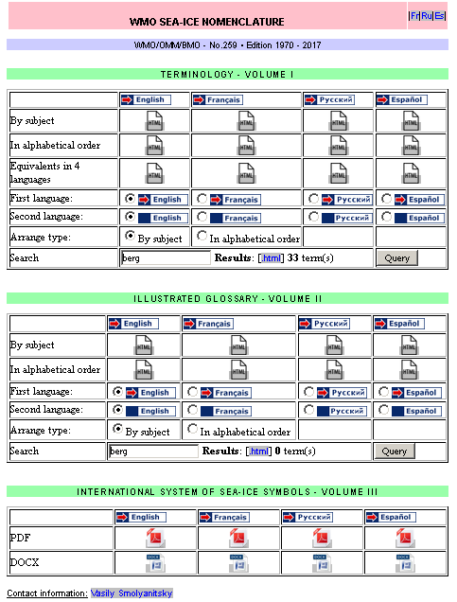

Interface to WMO-No.259 in electronic form

11. In 2009 the WMO Sea-ice Nomenclature was formally provided to the WMO Secretariat linguistic department and is now available as a part of the WMO terminology database METEOTERM - <http://www.wmo.int/pages/prog/lsp/meteoterm_wmo_en.htm> There are now a number of changes to Nomenclature so that an **Action** is necessary for the WMO Secretariat to ensure consistence between the master copy of the nomenclature and METEOTERM.

11. In 2015 the WMO Sea-ice Nomenclature was formally provided to the Global Cryosphere Watch Portal Team and is now available as a part of the GCW Glossary - <http://globalcryospherewatch.org/reference/glossary.php>. There are now a number of changes to Nomenclature as well as there is question whether the floating ice terms from the WMO-No.259 in the GCW Glossary should be articulated as the prime WMO standard. There is an **Action** for the Team as well as to the GCW project office to manage these issues.

_____________

Appendices: 3