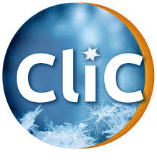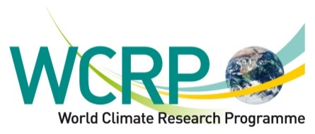 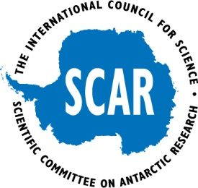

# GCW, WCRP, CliC, SCAR Teleconference

Date: Nov 17, 2016

**Participants:**

* Jenny Baeseman – SCAR
* Jeff Key – GCW
* Lawrence Hislop – CliC
* Gerhard Krinner - CliC
* Mike Sparrow – WCRP
* Etienne Charpentier – WMO Secretariat, Chief, OBS
* Rodica Nitu – WMO Secretariat, GCW- PM

**Context: previously established/drafted agreements:**

* Collaboration between WCRP-CliC and GCW, signed in May 2016 ,
* Partnership between WMO (including WCRP) and SCAR agreement, prepared for the XXXIV SCAR Delegates Meeting, Kuala Lumpur, Malaysia, 2016.

**Objectives:**

* examine areas of collaboration, with focus on sea ice observations and science activities;
* identifying concrete short term and longer term activities that would demonstrate in practice the intent of the two mentioned documents.
* Prepare for the GCW Steering Group meeting, Jan 16-19, 2017.

**Topics discussed:**

* Sea Ice Team of the GCW (Integrated Products WG) has been formed, but has had no activity
* SCAR, CliC (WCRP) have several projects and expert teams related to sea ice observations and research;
* It was recognized that SCAR/CliC are focused on research, while GCW focuses more on operational aspects.
* Potential areas of collaboration:
  + Integration/consolidation of existing best practices for sea ice observations, from various communities, as part of the GCW Best Practices;
  + Contribution of experts to developing GCW Best Practices Guide and Manual.
  + Working towards achieving a consistency of terminology used throughout the community, e.g. via the GCW Glossary.
* Documents on practices developed over time within SCAR and CliC, but nothing has been published recently. The engagement with GCW could serve as a platform to consolidate the existing documents (draft, etc) and work towards publication as part of the WMO Technical Regulations
* Explore the potential for combining efforts of (merging?) the sea ice groups; potentially under GCW;
* SCAR is looking for assistance from GCW on using the WMO framework, engagements with the International Maritime Organization (IMO) to mandate countries that are currently building icebreakers to equip them with dedicated equipment and collect sea ice data (identify standardized equipment and data required). (NOTE: a meeting WMO/IMO planned for Dec 2016)
  + Need to link with science communities and representative of the countries building icebreakers

**Actions:**

* Map who is involved in various sea ice groups and their strengths, weaknesses , relevance (include the various WMO maritime observing teams, e.g. JCOMM, Ship Observing Team, VOS, etc that are also interested on the future of observing systems): potentially as a shared responsibility.
* RN to provide to Jenny and Lawrence a short paragraph on the needs to support the development fo the GCW Best Practices Guide regarding sea ice observations.
* Identify additional actions that could benefit all programs and present at the GCW Steering Group (note: each organization represented will be asked to identify concrete areas of collaboration for 2017 and beyond and proposed approaches).

Notes:

* The JCOMM Groups with polar/near polar activities:
  + International Arctic Buoy Program (IABP)
  + WCRP-SCAR International Programme for Antarctic Buoys (IPAB)
  + North Pacific Data Buoy Advisory Panel (NPDBAP)
  + International south Atlantic Buoy Programme (ISABP)
  + Expert Team on Sea Ice (ETSI)

**Development of the GCW Best Practices Manual and Guide**

**Solicitation of contributions for the development of guidance material on the measurement and observation of essential cryosperic variables.**

The GCW Best Practices Team of the Observations Working Group is leading the development of GCW Best Practices Manual and Guide by integrating existing, widely accepted, recommended standards and practices that are critical for enhancing the quality of cryospheric observational data. When fully developed, the GCW Best Practices will be a reliable, consolidated, and comprehensive reference for anyone seeking to make available good quality observations.

The GCW Best Practices will address all aspects of the measurement (parameters, resolution, accuracy, units, representativeness, coverage), terminology, observing techniques and equipment, data codes, and data exchange, documenting when different applications would require observations being taken using different methodologies.

The GCW Best Practices will be developed by cryosphere components, covering (i) snow and solid precipitation, (ii) sea ice; lake and river ice, (iii) glaciers, ice caps, ice sheets and ice shelves, (iv) permafrost and seasonally frozen ground.

GCW is seeking support from SCAR and CliC to reach out to experts with experience in observations of the above noted components of the cryosphere, who can contribute to the development of the best practices, as noted above.

The nature of contribution could be:

* Leading/Contributing to the development of individual sections;
* Sharing of already available documentation (manuals, guidelines, techniques) that documents current practices for measuring one or more cryosphere variables;
* Review of sections and chapters of the GCW Guide developed by other experts.

GCW CryoNet Tean has identified for each cryosphere component, variables that are recommended and desired to be measured. These are documented in Annex 6 of the CryoNet team meeting report <http://globalcryospherewatch.org/meetings/graz2016/>.