INTERNATIONAL HYDROGRAPHIC ORGANIZATION

JCOMM



Ice Information Product Specification

Edition 1.1.0, June 2014

IHO S-411 / JCOMM Technical Report No. 81

Published by the
International Hydrographic Bureau
4, Quai Antoine 1er
B.P. 445 - MC 98011 MONACO Cedex
Principauté de Monaco
Telefax: (377) 93 10 81 40
E-mail: info@ihb.mc
Web: www.iho.int

Version Number | Date | Author | Purpose
1.0.0 | 28.02.2014 | Alexander Benke
1.1.0 | 15.06.2014 | Jürgen Holfort | Clarifications in the based on ETSI Meeting 2014 and new color for 10/10.

Contents
1 Overview 1
1.1 Introduction 1
1.2 References 1
1.3 Terms, definitions and abbreviations 1
1.3.1 Use of Language 1
1.3.2 Terms and Definitions 1
1.3.3 Abbreviation 1
1.4 General Data Product Description 1
1.5 Data product specification metadata 2
1.5.1 Product Specification Maintenance 2
2 Specification Scopes 3
2.1 General Scope 3
3 Data Product Identification 3
4 Data Content and Structure 4
4.1 Introduction 4
4.2 Application Schema 4
4.3 Feature Catalogue 5
4.3.1 Introduction 5
4.3.2 Application Schema Elements, Named Types 5
4.3.3 Feature Types Summary 19
4.4 Dataset Types 21
4.4.1 Introduction 21
4.5 Geometry 21
5 Coordinate Reference Systems (CRS) 22
6 Data Quality 22
7 Data Capture and Classification 22
8 Data Product format (encoding) 23
8.1 Introduction 23
8.2 Encoding Rules 23
8.2.1 Longitude / Latitude 23
8.2.2 Elements and attributes 23
8.3 Encoding Examples 23
8.3.1 Polygon Feature 23
8.3.2 LineString Feature 23
8.3.3 Point Feature 24
9 Data Product Delivery 25
9.1 Introduction 25
9.2 Exchange Set 25
9.2.1 Exchange Set Naming 26
9.3 Dataset 26
9.3.1 Dataset Naming 26
9.4 Support Files 26
9.4.1 Support File Naming 26
9.5 Exchange Catalogue 26
9.5.1 Exchange Catalogue Naming 26
10 Metadata 27
10.1 Introduction 27
10.1.1 ISO 19139 Metadata 27
10.2 Language 31
11 Maintenance 32
11.1 Maintenance and Update Frequency 32
12 Portrayal 33
12.1 Rules 33
12.2 Symbols 34
12.2.1 Polygon Features 34
12.2.2 Line Features 37
12.2.3 Point Features 38
12.2.4 Draw order 39
13 Additional Information 40
Annex A – Data Classification and Encoding Guide 41
Annex B – Data Product format (encoding) 41
Annex D – Feature Catalogue 41
Annex F – Portrayal Catalogue (SE, XSLT + SVG) 41
Annex G – Encoding Example for all ice features 41
Annex I – Exchange Catalogue Example 41

Page intentionally left blank

Overview
This document has been produced by the BSH as part of JCOMM/ETSI in response to a requirement to produce an ice data product that can be used within Electronic Chart Display and Information Systems.

Introduction
The Ice Information product specification is based on the IHO S-100 framework specification, Geography Markup Language (GML) Encoding Standard and the ISO 19100 series of standards. It is a vector product specification that is primarily intended for encoding the extent and nature of Sea Ice for navigational purpose.

References
S-100 IHO Universal Hydrographic Data Model
GML OpenGIS® Geography Markup Language (GML) Encoding Standard (Version 3.2.1)

Terms, definitions and abbreviations

Use of Language
- “Must” indicates a mandatory requirement.
- “Should” indicates an optional requirement, that is the recommended process to be followed, but is not mandatory.
- “May” means “allowed to” or “could possibly”, and is not mandatory.

Terms and Definitions

Abbreviation

CRS Coordinate Reference System
ECDIS Electronic Chart Display Information System
EPSG European Petroleum Survey Group
ENC Electronic Navigational Chart
IHO International Hydrographic Organization
IMO International Maritime Organization
ISO International Organization for Standardization
GML Geography Markup Language
ETSI Expert Team on Sea Ice

General Data Product Description
Title: Ice Information
Abstract: Ice information for ship navigation
Content: Ice features as vector data
Spatial Extent:
Description:
East Bounding Longitude: -180
West Bounding Longitude: 180
North Bounding Latitude: 90
South Bounding Latitude: -90
Purpose: Navigation in ice covered regions

Data product specification metadata
Title: Ice Information Product Specification
S-100 Version: 1.0.0
S-411 Version: 1.0.0
Date: 28.02.2013
Language: English
Contact: Jürgen Holfort (ice@bsh.de)
Identifier: JCOMM S-411
Maintenance: Changes to this product specification are coordinated by ETSI.

Product Specification Maintenance

Introduction
Changes to JCOMM S-411 will be released by the IHO as a new edition, revision, or clarification.

New Edition
New Editions of S-10n introduce significant changes. New Editions enable new concepts, such as the ability to support new functions or applications, or the introduction of new constructs or data types. New Editions are likely to have a significant impact on either existing users or future users of S-10n.

Revisions
Revisions are defined as substantive semantic changes to S-10n. Typically, revisions will change S-10n to correct factual errors; introduce necessary changes that have become evident as a result of practical experience or changing circumstances. A revision must not be classified as a clarification. Revisions could have an impact on either existing users or future users of S-10n. All cumulative clarifications must be included with the release of approved corrections revisions. Changes in a revision are minor and ensure backward compatibility with the previous versions within the same Edition. Newer revisions, for example, introduce new features and attributes. Within the same Edition, a dataset of one version could always be processed with a later version of the feature and portrayal catalogues. In most cases a new feature or portrayal catalogue will result in a revision of S-10n.

Clarification
Clarifications are non-substantive changes to S-10n. Typically, clarifications: remove ambiguity; correct grammatical and spelling errors; amend or update cross references; insert improved graphics in spelling, punctuation and grammar. A clarification must not cause any substantive semantic change to S-10n. Changes in a clarification are minor and ensure backward compatibility with the previous versions within the same Edition. Within the same Edition, a dataset of one clarification version could always be processed with a later version of the feature and portrayal catalogues, and a portrayal catalogue can always rely on earlier versions of the feature catalogues. Changes in a clarification are minor and ensure backward compatibility with the previous versions

Version Numbers
The associated version control numbering to identify changes (n) to S-10n must be as follows:
New Editions denoted as n.0.0
Revisions denoted as n.n.0
Clarifications denoted as n.n.n

Specification Scopes

General Scope
Scope Identification: JCOMM S-411 dataset

Hierarchical Lelvel: MD_ScopeCode -005

Hierarchical Level Name: dataset

Extent: EX_GeographicExtent -Global coverage of maritime areas.
EX_TemporalExtent -Not defined for this product specification.
EX_VerticalExtent-Not defined for this product specification.

Data Product Identification

Title: Ice Information

Abstract: Ice Information for navigation in ice covered regions

Topic Category: transportation, climatologyMeteorologyAtmosphere

Geographic Description: Ice covered regions

Spatial Resolution: ---

Purpose: Navigation in ice covered regions

Language: English (optional additional)

Classification: Unclassified

Spatial Representation Type: vector

Point of Contact: Producing Agency

Use Limitation: ---

Data Content and Structure

Introduction
The application schema of ice information product contains 28 feature types with their attributes, enumerations etc. It is based on the ice objects catalogue (Version 5.1) and can also be found in the ICE domain of the IHO Registry. Because of this it is not possible to describe full schema in suitable form in this specification. The full schema can be found as XML Schema File in Annex B – Data Product format (encoding).

Application Schema
Picture below shows very simplified structure of ice data structure

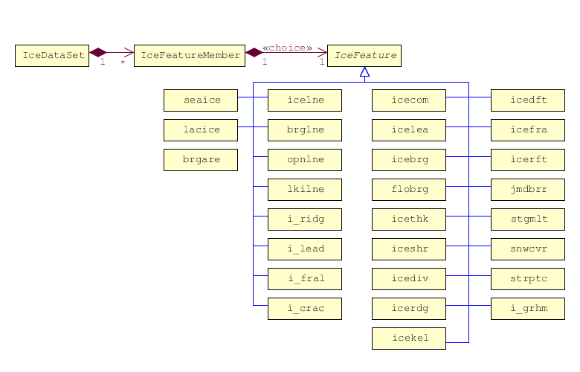
Figure 1: Ice Data Product – Structure
General GML (XML) representation:

<?xml version="1.0" encoding="UTF-8"?>
<ice:IceDataSet xmlns:ice="http://www.iho.int/ice"
xmlns:gml=http://www.opengis.net/gml/3.2>
<ice:IceFeatureMember>
<ice:seaice>
<ice:iceact> … </ice:iceact>
.
.
<gml:Polygon srsName="..">… </gml:Polygon>
</ice:seaice>
</ice:IceMember>
<ice:IceMember>
<ice:i_ridg>
<ice:icerdv> … </ice:icerdv>
.
.
<gml:LineString srsName="..">… </gml:LineString>
</ice:i_ridg>
</ice:IceMember>
<ice:IceMember>
<ice:icebrg>
<ice:icebsz> … </ice:icebsz>
.
.
<gml:Point srsName="..">… </gml:Point>
</ice:icebrg>
</ice:IceFeatureMember>

Feature Catalogue

Introduction
The feature Catalogue for Ice Information contains only geographic features. The ice features which can be used in ECDIS are fully presented in the ICE domain of the IHO Registry.

Application Schema Elements, Named Types

Ice Application Schema Types Overview

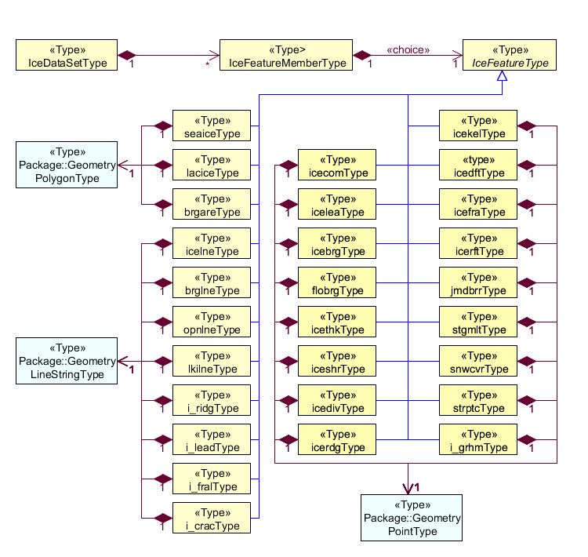
Figure 2: Ice App Schema Types

Role Name | Name | Description | Mult. | Data Type
Class | IceDataSet | Set of ice data | - | IceDataSetType
Association | IceFeatureMember | Contains ice feature members | 1..* | IceFeatureMemberType

Role Name | Name | Description | Mult. | Data Type
Class | IceFeatureMember | A member of Ice Features in a Dataset | - | IceFeatureMember Type
Association | IceFeature | Abstract ice feature | 1..1 (choice) | IceFeatureType
Association | IceDataSet | Set of ice data | *..1 | IceDataSetType

Role Name | Name | Description | Mult. | Data Type
Class | IceFeature | Abstract ice feature class | - | IceFeatureType
Association | IceFeatureMember | Contains one of ice feature | 1..1  (choice) | IceFeatureMemberType
Association | seaice | One of choice options: Sea Ice | 1..1 | seaiceType
Association | lacice | One of choice options: Lake Ice | 1..1 | laciceType
Association | brgare | One of choice options: Iceberg Area | 1..1 | brgareType
Association | icelne | One of choice options: Ice Edge | 1..1 | icelneType
Association | brglne | One of choice options: Iceberg Limit | 1..1 | brglneType
Association | opnlne | One of choice options: Limit of Open Water | 1..1 | opnlneType
Association | lkilne | One of choice options: Limit of All Known Ice | 1..1 | lkilneType
Association | i_ridg | One of choice options: Line of Ice Ridge | 1..1 | i_ridgType
Association | i_lead | One of choice options: Line of Ice Lead | 1..1 | i_leadType
Association | i_fral | One of choice options: Line of Ice Fracture | 1..1 | i_fralType
Association | i_crac | One of choice options: Line of Ice Crack | 1..1 | i_cracType
Association | icecom | One of choice options: Ice Compacting | 1..1 | icecomType
Association | icelea | One of choice options: Ice Lead | 1..1 | iceleaType
Association | icebrg | One of choice options: Iceberg | 1..1 | icebrgType
Association | flobrg | One of choice options: Floeberg | 1..1 | flobrgType
Association | icethk | One of choice options: Ice Thickness | 1..1 | icethkType
Association | iceshr | One of choice options: Ice Shear | 1..1 | iceshrType
Association | icediv | One of choice options: Ice Divergence | 1..1 | icedivType
Association | icerdg | One of choice options: Ice Ridge | 1..1 | icerdgType
Association | icekel | One of choice options: Ice Keel | 1..1 | icekelType
Association | icedft | One of choice options: Ice Drift | 1..1 | icedftType
Association | icefra | One of choice options: Ice Fracture | 1..1 | icefraType
Association | icerft | One of choice options: Ice Rafting | 1..1 | icerftType
Association | jmdbrr | One of choice options: Jammed Brash Barrier | 1..1 | jmdbrrType
Association | stgmlt | One of choice options: Stage of Melt | 1..1 | stgmltType
Association | snwcvr | One of choice options: Snow cover | 1..1 | snwcvrType
Association | strptc | One of choice options: Strips and Patches | 1..1 | strptcType
Association | i_grhm | One of choice options: Grounded Hummock | 1..1 | i_grhmType

Role Name | Name | Description | Mult. | Data Type
Class | seaice | Sea Ice, one of IceFeatureMember | - | seaiceType
Association | IceFeatureMember | contains ice feature | 1..1 | IceFeatureMemberType

Role Name | Name | Description | Mult. | Data Type
Class | lacice | Lake Ice, one of IceFeatureMember | - | laciceType
Association | IceFeatureMember | contains ice feature | 1..1 | IceFeatureMemberType

Role Name | Name | Description | Mult. | Data Type
Class | brgare | Iceberg Area, one of IceFeatureMember | - | brgareType
Association | IceFeatureMember | contains ice feature | 1..1 | IceFeatureMemberType

Role Name | Name | Description | Mult. | Data Type
Class | icelne | Ice Edge, one of IceFeatureMember | - | icelneType
Association | IceFeatureMember | contains ice feature | 1..1 | IceFeatureMemberType

Role Name | Name | Description | Mult. | Data Type
Class | brglne | Iceberg Limit, one of IceFeatureMember | - | brglneType
Association | IceFeatureMember | contains ice feature | 1..1 | IceFeatureMemberType

Role Name | Name | Description | Mult. | Data Type
Class | opnlne | Limint of Open Water, one of IceFeatureMember | - | opnlneType
Association | IceFeatureMember | contains ice feature | 1..1 | IceFeatureMemberType

Role Name | Name | Description | Mult. | Data Type
Class | lkilne | Limint of All Known Ice, one of IceFeatureMember | - | lkilneType
Association | IceFeatureMember | contains ice feature | 1..1 | IceFeatureMemberType

Role Name | Name | Description | Mult. | Data Type
Class | i_ridg | Line of Ice Ridge, one of IceFeatureMember | - | i_ridgType
Association | IceFeatureMember | contains ice feature | 1..1 | IceFeatureMemberType

Role Name | Name | Description | Mult. | Data Type
Class | i_lead | Line of Ice Lead, one of IceFeatureMember | - | i_leadType
Association | IceFeatureMember | contains ice feature | 1..1 | IceFeatureMemberType

Role Name | Name | Description | Mult. | Data Type
Class | i_fral | Line of Ice Fracture, one of IceFeatureMember | - | i_fralType
Association | IceFeatureMember | contains ice feature | 1..1 | IceFeatureMemberType

Role Name | Name | Description | Mult. | Data Type
Class | i_crac | Line of Ice Crack, one of IceFeatureMember | - | i_cracType
Association | IceFeatureMember | contains ice feature | 1..1 | IceFeatureMemberType

Role Name | Name | Description | Mult. | Data Type
Class | icecom | Ice Compacting, one of IceFeatureMember | - | icecomType
Association | IceFeatureMember | contains ice feature | 1..1 | IceFeatureMemberType

Role Name | Name | Description | Mult. | Data Type
Class | icelea | Ice Lead, one of IceFeatureMember | - | iceleaType
Association | IceFeatureMember | contains ice feature | 1..1 | IceFeatureMemberType

Role Name | Name | Description | Mult. | Data Type
Class | icebrg | Iceberg, one of IceFeatureMember | - | seaiceType
Association | IceFeatureMember | contains ice feature | 1..1 | IceFeatureMemberType

Role Name | Name | Description | Mult. | Data Type
Class | flobrg | Floeberg, one of IceFeatureMember | - | seaiceType
Association | IceFeatureMember | contains ice feature | 1..1 | IceFeatureMemberType

Role Name | Name | Description | Mult. | Data Type
Class | icethk | Ice Thickness, one of IceFeatureMember | - | icethkType
Association | IceFeatureMember | contains ice feature | 1..1 | IceFeatureMemberType

Role Name | Name | Description | Mult. | Data Type
Class | iceshr | Ice Shear, one of IceFeatureMember | - | iceshrType
Association | IceFeatureMember | contains ice feature | 1..1 | IceFeatureMemberType

Role Name | Name | Description | Mult. | Data Type
Class | icediv | Ice Divergence, one of IceFeatureMember | - | icedivType
Association | IceFeatureMember | contains ice feature | 1..1 | IceFeatureMemberType

Role Name | Name | Description | Mult. | Data Type
Class | icerdg | Ice Ridge / Hummock, one of IceFeatureMember | - | icerdgType
Association | IceFeatureMember | contains ice feature | 1..1 | IceFeatureMemberType

Role Name | Name | Description | Mult. | Data Type
Class | icekel | Ice Keel / Bummock, one of IceFeatureMember | - | icekelType
Association | IceFeatureMember | contains ice feature | 1..1 | IceFeatureMemberType

Role Name | Name | Description | Mult. | Data Type
Class | icedft | Ice Drift, one of IceFeatureMember | - | icedftType
Association | IceFeatureMember | contains ice feature | 1..1 | IceFeatureMemberType

Role Name | Name | Description | Mult. | Data Type
Class | icefra | Ice Fracture, one of IceFeatureMember | - | icefraType
Association | IceFeatureMember | contains ice feature | 1..1 | IceFeatureMemberType

Role Name | Name | Description | Mult. | Data Type
Class | icerft | Ice Rafting, one of IceFeatureMember | - | icerftType
Association | IceFeatureMember | contains ice feature | 1..1 | IceFeatureMemberType

Role Name | Name | Description | Mult. | Data Type
Class | jmdbrr | Jammed Brash Barrier, one of IceFeatureMember | - | jmdbrrType
Association | IceFeatureMember | contains ice feature | 1..1 | IceFeatureMemberType

Role Name | Name | Description | Mult. | Data Type
Class | stgmlt | Stage of melt, one of IceFeatureMember | - | stgmltType
Association | IceFeatureMember | contains ice feature | 1..1 | IceFeatureMemberType

Role Name | Name | Description | Mult. | Data Type
Class | snwcvr | Snow cover, one of IceFeatureMember | - | snwcvrType
Association | IceFeatureMember | contains ice feature | 1..1 | IceFeatureMemberType

Role Name | Name | Description | Mult. | Data Type
Class | strptc | Strips and Patches, one of IceFeatureMember | - | strptcType
Association | IceFeatureMember | contains ice feature | 1..1 | IceFeatureMemberType

Role Name | Name | Description | Mult. | Data Type
Class | i_grhm | Grounded Hummock, one of IceFeatureMember | - | i_grhmType
Association | IceFeatureMember | contains ice feature | 1..1 | IceFeatureMemberType

IceDataSet / Types

IceDataSetType

IceDataSetType is a type of root Element of an ice information data set.

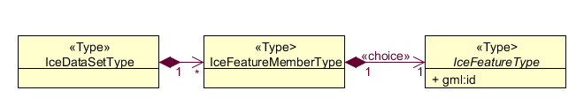

Ice Data Set contains an unlimited number of Ice Feature Members, each Ice Feature Member contains one Ice Feature (seaice, lacice, iceberg, etc.).

seaiceType (Sea Ice)
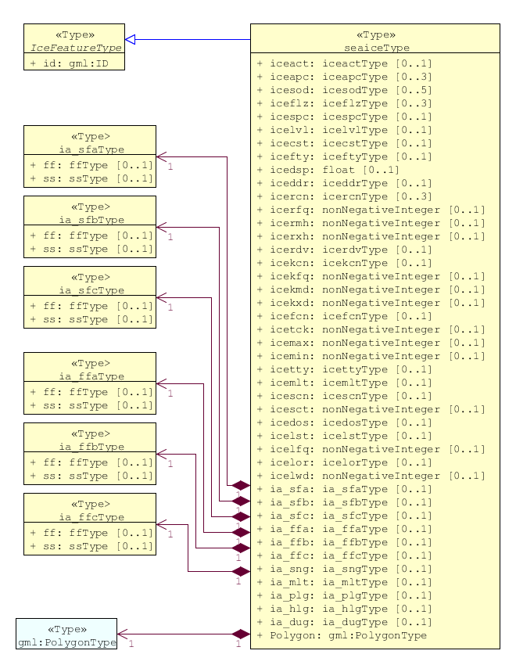

laciceType - Lake Ice
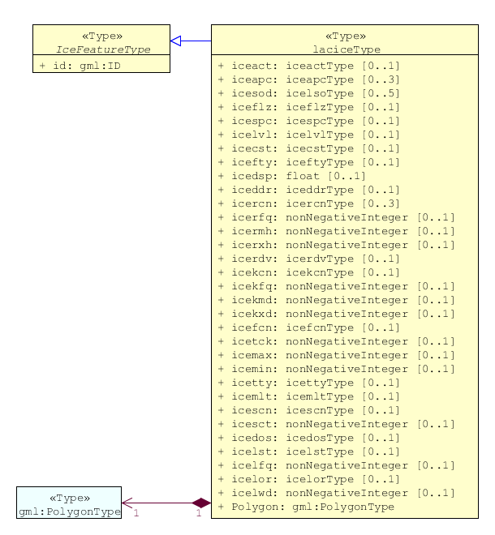

brgareType - Iceberg Area
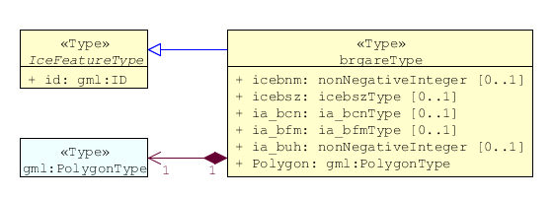

icelneType - Ice Edge
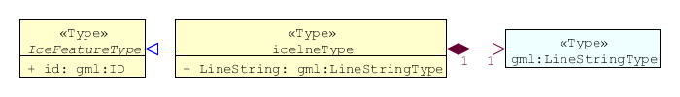

brglneType - Iceberg Limit
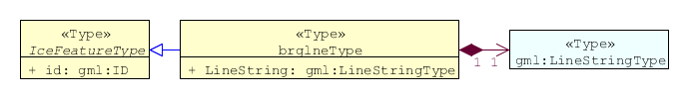

opnlneType - Limit of Open Water
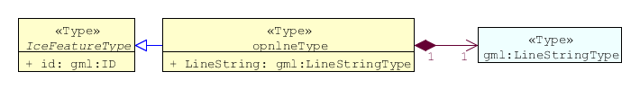

lkilneType - Limit of All Known Ice
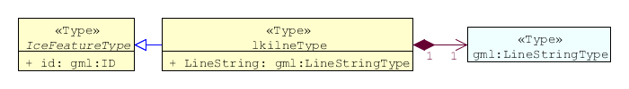

i_ridgType - Line of Ice Ridge
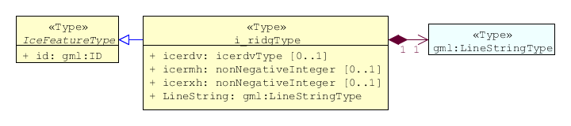

i_leadType - Line of Ice Lead
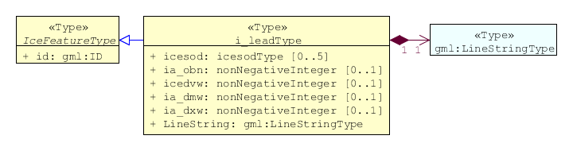

i_fralType - Line of Ice Fracture
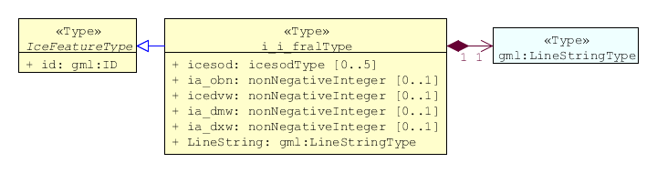

i_cracType - Line of Ice Crack
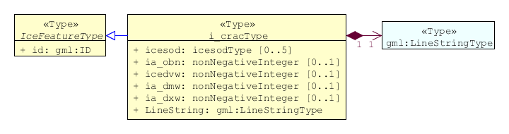

icecomType – Ice Compacting
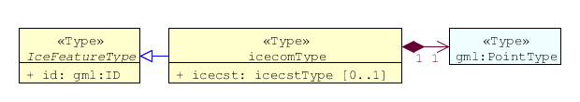

iceleaType – Ice Lead
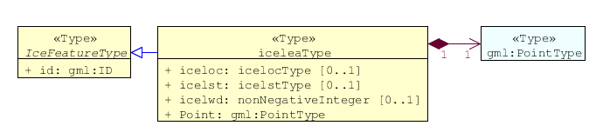

icebrgType – Iceberg
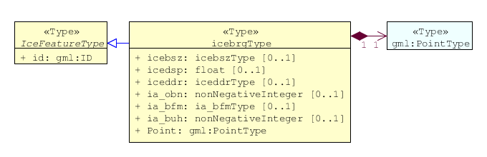

flobrgType – Floeberg
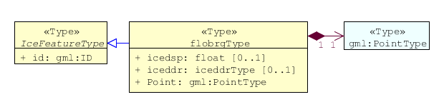

icethkType – Ice Thickness
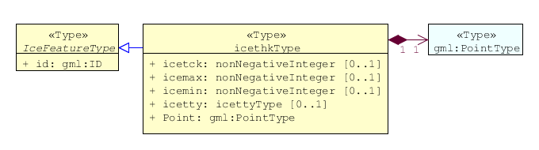

iceshrType – Ice Shear
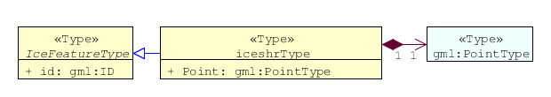

icedivType – Ice Divergence
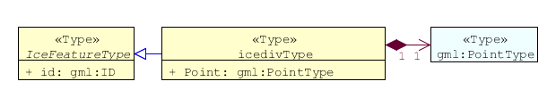

icerdgType – Ice Ridge/Hummock
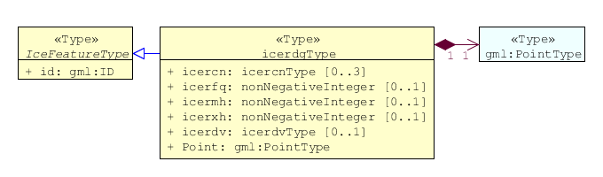

icekelType – Ice Keel/Bummock
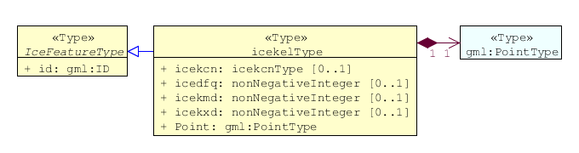

icedftType – Ice Drift
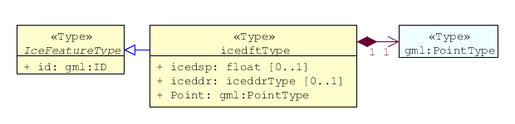

icefraType – Ice Fracture
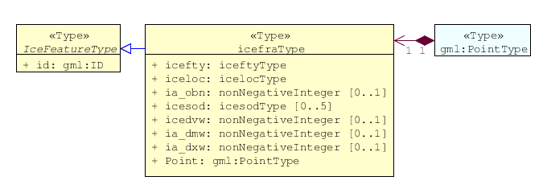

icerftType – Ice Rafting
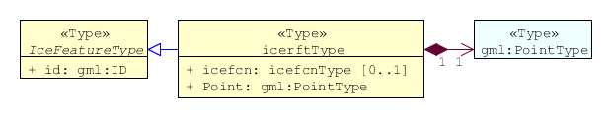

jmdbrrType – Jammed Brash Barrier
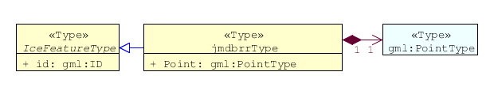

stgmltType – Stage of Melt
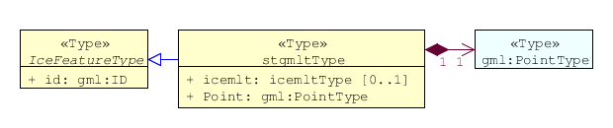

snwcvrType – Snow Cover
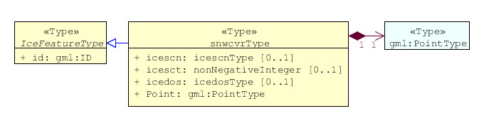

strptcType – Strips and Patches
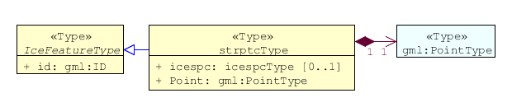

i_grhmType – Grounded Hummock
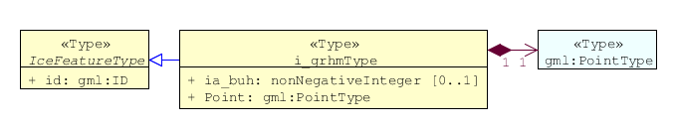

Feature Types Summary

Table 1: Summary of Types
Register  Dictionary | Index | Alpha code | Name
IceFCD | Feature | SEAICE | Sea Ice
IceFCD | Feature | LACICE | Lake Ice
IceFCD | Feature | BRGARE | Iceberg Area
IceFCD | Feature | ICELNE | Ice Edge
IceFCD | Feature | BRGLNE | Iceberg Limit
IceFCD | Feature | OPNLNE | Limit of Open Water
IceFCD | Feature | LKILNE | Limit of All Known Ice
IceFCD | Feature | I_RIDG | Line of Ice Ridge
IceFCD | Feature | I_LEAD | Line of Ice Lead
IceFCD | Feature | I_FRAL | Line of Ice Fracture
IceFCD | Feature | I_CRAC | Line of Ice Crack
IceFCD | Feature | ICECOM | Ice Compacting
IceFCD | Feature | ICELEA | Ice Lead
IceFCD | Feature | ICEBRG | Iceberg
IceFCD | Feature | FLOBRG | Floeberg
IceFCD | Feature | ICETHK | Ice Thickness
IceFCD | Feature | ICESHR | Ice Shear
IceFCD | Feature | ICEDIV | Ice Divergence
IceFCD | Feature | ICERDG | Ice Ridge/Hummock
IceFCD | Feature | ICEKEL | Ice Keel/Bummock
IceFCD | Feature | ICEDFT | Ice Drift
IceFCD | Feature | ICEFRA | Ice Fracture
IceFCD | Feature | ICERFT | Ice Rafting
IceFCD | Feature | JMDBRR | Jammed Brash Barrier
IceFCD | Feature | STGMLT | Stage of Melt
IceFCD | Feature | SNWCVR | Snow Cover
IceFCD | Feature | STRPTC | Strips and Patches
IceFCD | Feature | I_GRHM | Grounded Hummock
IceFCD | Attribute | ICEACT | Total Concentration
IceFCD | Attribute | ICEAPC | Partial Concentration
IceFCD | Attribute | ICESOD | Ice Stage of Development
IceFCD | Attribute | ICELSO | Lake Ice Stage of Development
IceFCD | Attribute | ICEFLZ | Floe Sizes
IceFCD | Attribute | ICEMLT | Melt Stage
IceFCD | Attribute | ICESPC | Concentration of Strips and Patches
IceFCD | Attribute | ICEBNM | Number of Icebergs in Area
IceFCD | Attribute | ICELVL | Level Ice
IceFCD | Attribute | ICECST | Compacting Strength
IceFCD | Attribute | ICEFTY | Ice Fracture Type
IceFCD | Attribute | ICELST | Ice Lead Status
IceFCD | Attribute | ICELFQ | Frequency of Leads or Fractures
IceFCD | Attribute | ICELOR | Orientation of Leads or Fractures
IceFCD | Attribute | ICELWD | Ice Lead (or Fracture or Crack) Width
IceFCD | Attribute | ICELOC | Ice Location Information
IceFCD | Attribute | ICEBSZ | Iceberg Size
IceFCD | Attribute | ICEDDR | Ice Drift Direction
IceFCD | Attribute | ICEDSP | Ice Drift Speed
IceFCD | Attribute | ICETCK | Ice Average Thickness
IceFCD | Attribute | ICEMAX | Maximum Ice Thickness
IceFCD | Attribute | ICEMIN | Minimum Ice Thickness
IceFCD | Attribute | ICETTY | Ice Thickness Type
IceFCD | Attribute | ICESCT | Snow Depth
IceFCD | Attribute | ICESCN | Snow Cover Concentration
IceFCD | Attribute | ICEDOS | Direction Of Sastrugi
IceFCD | Attribute | ICERCN | Ice Ridge Concentration
IceFCD | Attribute | ICERDV | Ice Ridge Classification
IceFCD | Attribute | ICERMH | Ice Ridge Mean Height
IceFCD | Attribute | ICERFQ | Ice Ridge Frequency
IceFCD | Attribute | ICERXH | Ice Ridge Maximum Height
IceFCD | Attribute | ICEKCN | Ice Keel Concentration
IceFCD | Attribute | ICEKFQ | Ice Keel Frequency
IceFCD | Attribute | ICEKMD | Ice Keel Mean Depth
IceFCD | Attribute | ICEKXD | Ice Keel Maximum Depth
IceFCD | Attribute | ICEFCN | Ice Rafting Concentration
IceFCD | Attribute | IA_SFA | Ice Stage of Development and Floe Size for the 1st p.c.
IceFCD | Attribute | IA_SFB | Ice Stage of Development and Floe Size for the 2nd p.c.
IceFCD | Attribute | IA_SFC | Ice Stage of Development and Floe Size for the 3rd p.c.
IceFCD | Attribute | IA_FFA | Ice Breccia for the 1st partial concentration
IceFCD | Attribute | IA_FFB | Ice Breccia for the 2nd partial concentration
IceFCD | Attribute | IA_FFC | Ice Breccia for the 3rd partial concentration
IceFCD | Attribute | IA_SNG | Snow concentration
IceFCD | Attribute | IA_MLT | Stage of melting
IceFCD | Attribute | IA_PLG | Contamination
IceFCD | Attribute | IA_HLG | Hills concentration
IceFCD | Attribute | IA_DUG | Fractures concentration
IceFCD | Attribute | IA_BCN | Icebergs concentration
IceFCD | Attribute | IA_BFM | Prevailing iceberg form
IceFCD | Attribute | IA_BUH | Max. height of the above-water part (iceberg / grounded hummock)
IceFCD | Attribute | IA_OBN | Number of ice objects
IceFCD | Attribute | IA_DXW | Max. width of ice lead (or fracture or crack)
IceFCD | Attribute | IA_DMW | Min. width of ice lead (or fracture or crack)
IceFCD | Attribute | ICEBRS | Brash Ice

Dataset Types

Introduction
At the moment is only one type of dataset supported. This is GML(XML) encoded ice feature collections.

Geometry
Ice Information datasets use S-100 Level 3a geometry which supports 0-, 1-, and 2-dimensional objects (points, line strings, and polygons).

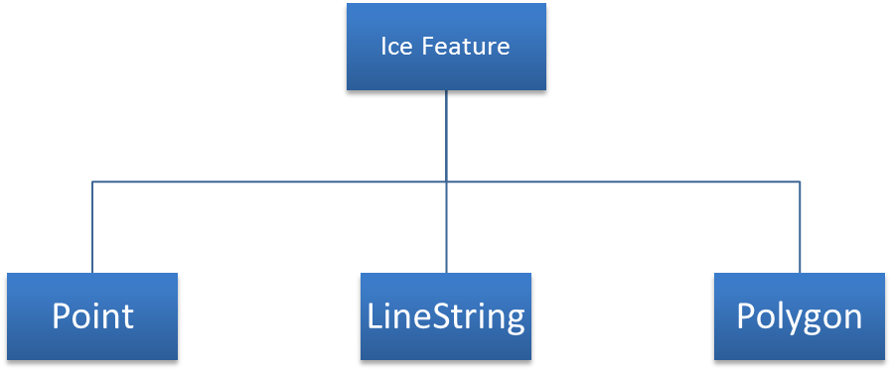

Figure 3: Geometric Primitives in Ice Information Product

There are three types of geometry: Point, Line String and Polygon. Multi-geometries will be not supported. The standard geometries of GML where redefined for S-411. The reason for this is to reduce file sizes. It is only possible to use “posList” with blanks separated coordinate values, like

<gml:posList>-73.991 40.736 -73.991 40.736</gml:posList>

For standard GML it would be also possible to use following (DO NOT USE THIS):
<gml:posList>
<pos>-73.991 40.736</pos>
<pos>-73.991 40.736</pos>
</gml:posList>

Which means much more chars in the file and growing of file size.

All multi-geometries must be splitted into single geometries. Encoding for geometry is GML:

Point encoding example:
<gml:Point
<gml:pos>147.291 -42.851</gml:pos>
</gml:Point>

Line String encoding example:
<gml:LineString>
<gml:posList>-73.991 40.736 -73.991 40.736</gml:posList>
</gml:LineString>

Polygon encoding example:
<gml:Polygon>
<gml:exterior>
<gml:LinearRing>
<gml:posList>
22.546 62.391 25.033 62.404 24.995 60.182 22.483 60.169 22.546 62.391
</gml:posList>
</gml:LinearRing>
</gml:exterior>
<gml:interior>
<gml:LinearRing>
<gml:posList>
23.227 61.811 23.467 61.306 24.023 61.621 24.035 61.621 23.227 61.811
</gml:posList>
</gml:LinearRing>
</gml:interior>
</gml:Polygon>

Coordinate Reference Systems (CRS)
For exchange of ice data WGS84 (EPSG: 4326) must be used.

Data Quality
As ice charts are done for different purposes (from weekly overview to tactical charts and further to model forecasts) data quality can differ. Differences can also be found between ice charts of the same region and same nominal date resulting from different issuing agencies or also from different forecasts models. Further information can be found in the WMO publication 574.

Data Capture and Classification
The data will be captured normally from satellite data. The extraction and classification will be done by ice analysts. In some areas of the world (e.g. the Baltic Sea) in addition also some direct shore and ship based observations and textual ice reports from ice authorities will be used. Further information can be found in the WMO publication 574 in Appendix A.

Data Product format (encoding)

Introduction
This clause describes encoding rules for S-100 base ice datasets. For the encoding of ice datasets GML 3.2.1 was used.

Encoding Rules

Longitude / Latitude
- Longitude and latitude must be encoded in decimal degrees, e.g. : 12.567 56.765
- Number of decimals is not limited, but it should be as less as possible for minimizing of file size, normally 3 or even 2 digits are enough

Elements and attributes
- Names of elements representing ice features or attributes (from IceFDC dictionary see Table 1: Summary of Types) must be encoded with lower case letters
- Names of elements representing features or attributes from other dictionaries must be encoded with upper case letters
- Character Set is UTF-8
- Elements or attributes may be empty, but it should be eliminated for minimizing of file size

Encoding Examples
Below there are three examples of the encoding of various ice features using different geometric primitives, the encoding of other ice objects can be done in a similar way.

Polygon Feature

<ice:IceFeatureMember>
<ice:brgare gml:id="brgare.1">
<ice:icebnm/>
<ice:icebsz/>
<ice:ia_bcn/>
<ice:ia_bfm/>
<ice:ia_buh/>
<gml:Polygon srsName="http://www.opengis.net/gml/srs/epsg.xml#4326">
<gml:exterior>
<gml:LinearRing>
<gml:posList>
22.546 62.391 25.033 62.404 24.995 60.182 22.483 60.169 22.546 62.391
</gml:posList>
</gml:LinearRing>
</gml:exterior>
<gml:interior>
<gml:LinearRing>
<gml:posList>
23.227 61.811 23.467 61.306 24.023 61.621 24.035 61.621 23.227 61.811
</gml:posList>
</gml:LinearRing>
</gml:interior>
</gml:Polygon>
</ice:brgare>
</ice:IceFeatureMember>

LineString Feature
<ice:IceFeatureMember>
<ice:i_fral gml:id="i_fral.1">
<ice:icesod>83</ice:icesod>
<ice:ia_obn>50</ice:ia_obn>
<ice:icedvw>30</ice:icedvw>
<ice:ia_dmw>25</ice:ia_dmw>
<ice:ia_dxw>35</ice:ia_dxw>
<gml:LineString srsName="http://www.opengis.net/gml/srs/epsg.xml#4326">
<gml:posList>-73.991 40.736 -73.991 40.736</gml:posList>
</gml:LineString>
</ice:i_fral>
</ice:IceFeatureMember>

Point Feature
<ice:IceFeatureMember>
<ice:icecom gml:id="icecom.1">
<ice:icecst/>
<gml:Point srsDimension="2" srsName="http://www.opengis.net/gml/srs/epsg.xml#4326">
<gml:pos>147.291 -42.851</gml:pos>
</gml:Point>
</ice:icecom>
</ice:IceFeatureMember>

Data Product Delivery

Introduction
Ice Information Product will be delivered as Exchange Set, containing dataset itself, metadata, etc. It is also possible that several charts are available for an area. The decision, which one to use, is within the responsibility of the navigator on the vessel.

Exchange Set
The exchange set for the Ice Information Product has following structure:

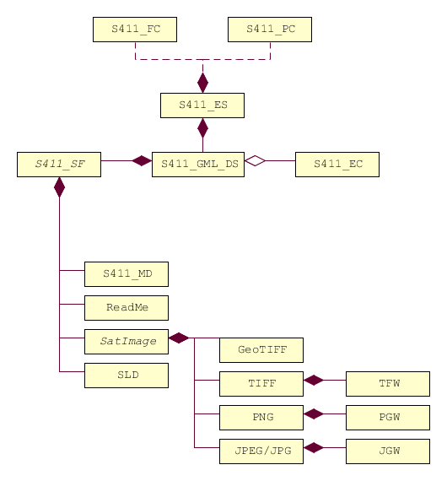

Figure 4: Exchange Set Structure

Exchange Set Naming
Name of Exchange Set has following structure:

S411_ProducerCode_DatasetNameWithoutEnding

Example: S411_BSH_ek1-20130305-17

An exchange Set can be a simple data folder, but it is recommended to zip this folder for minimizing file size. In this case name of Exchange Set looks like:

S411_ProducerCode_DatasetNameWithoundEnding.zip

Example: S411_BSH_ek1-20130305-17.zip

or if .tar.gz compressing algorithm is in use:

S411_ProducerCode_DatasetNameWithoutEnding.tar.gz

Example: S411_BSH_ek1-20130305-17.tar.gz

Dataset

Dataset Naming
The data producer are free to choose file name for data set. The ending or postfix must be “*.gml”.

Example: ek1-20130305-17.gml

Support Files

Support File Naming
There are no restrictions for support file naming. But it is important to describe the files in the exchange catalogue file.

ISO Metadata File
The metadata for Dataset based on ISO 19139/19115, is also official S-100 Metadata with mandatory file identifier. ( See Chapter 10)

Portrayal, Symbology
The portrayal (display instructions) should be a part of system, installed on board. But as option display instructions could be a part of exchange set, that means the display instruction xml file and svg symbols can be delivered within the exchange set as support files.

SVG Graphics

Readme

Exchange Catalogue

Exchange Catalogue Naming
Name of Exchange Catalogue is

CATALOG.ICE

Metadata

Introduction
There are two kinds of metadata to prepare:
- ISO 19139 Metadata
This kind of metadata implementation can be read by broad range of software.
- S100 Metadata
The S100 metadata are for describing the structure of Exchange Catalogue

ISO 19139 Metadata
For the description of ice data following metadata are necessary:
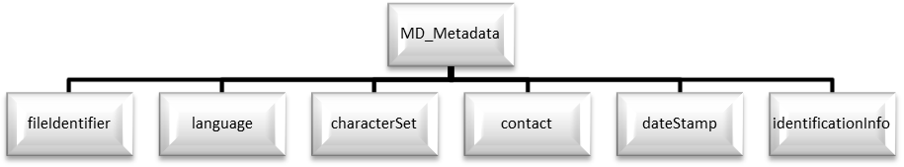
Element Name | Description | Namespace
MD_Metadata | root element | gmd
fileIdentifier | Id for dataset | gmd
language | Product language | gmd
characterSet | Used characterset | gmd
contact | Contact data | gmd
dateStamp | date of publishing | gmd
identificationInfo | Specific info about product | gmd

<?xml version="1.0" encoding="UTF-8"?>
<gmd:MD_Metadata xmlns:gmd="http://www.isotc211.org/2005/gmd"
xmlns:gco="http://www.isotc211.org/2005/gco"
xmlns:gml="http://www.opengis.net/gml/3.2"> <gmd:fileIdentifier> ... </gmd:fileIdentifier>
<gmd:language> ... </gmd:language>
<gmd:characterSet> ... </gmd:characterSet>
<gmd:contact> ... </gmd:contact>
<gmd:dateStamp> ... </gmd:dateStamp>
<gmd:identificationInfo> ... </gmd:identificationInfo>
</gmd:MD_Metadata>

fileIdentifier
Element Name | Description | Namespace
fileIdentifier | Id for dataset | gmd
CharacterString | String contained id value | gco

<gmd:fileIdentifier>
<gco:CharacterString>bsh_ek1-20130114-08</gco:CharacterString>
</gmd:fileIdentifier>

language
Element Name | Description | Namespace
language | Language of dataset | gmd
LanguageCode | Code for language | gmd

LanguageCode element contains two attributes:
- codeList: Link to the list containing the codes for languages
- codeListValue value from the list defining the used language

<gmd:language>
<gmd:LanguageCode codeList="http://www.isotc211.org/2005/resources/Codelist/ML_gmxCodelists.xml#LanguageCode" codeListValue="eng">English</gmd:LanguageCode>
</gmd:language>

characterSet
Element Name | Description | Namespace
characterSet | characterSet of dataset | gmd
MD_CharacterSetCode | Code for characterSet | gmd

MD_CharacterSetCode element contains two attributes:
- codeList: Link to the list containing the codes for character set
- codeListValue value from the list defining the used character set

<gmd:characterSet>
<gmd:MD_CharacterSetCode codeList="http://www.isotc211.org/2005/resources/Codelist/ML_gmxCodelists.xml#MD_CharacterSetCode" codeListValue="utf8">UTF 8</gmd:MD_CharacterSetCode>
</gmd:characterSet>

contact
Element Name | Description | Namespace
contact | Contact for questions to dataset | gmd
CI_ResponsibleParty | ISO Element for contact data | gmd
individualName | Name of responsible person | gmd
CharacterString | individualName value (text) | gco
organisationName | Name of responsible organisation | gmd
CharacterString | organisationName value (text) | gco
contactInfo | Contact information | gmd
CI_Contact | ISO Element for contact information | gmd
phone | phone | gmd
CI_Telephone |  | gmd
voice |  | gmd
CharacterString | Voice telephone value (text) | gco
facsimile |  | gmd
CharacterString | Fax number value (text) | gco
address |  | gmd
CI_Address |  | gmd
deliveryPoint |  | gmd
CharacterString | Postal Address (street, house number) | gco
city |  | gmd
CharacterString | City name value (text) | gco
administrativeArea |  | gmd
CharacterString | Administrative Area name value (text) | gco
postalCode |  | gmd
CharacterString |  | gco
electronicMailAddress |  | gmd
CharacterString | Email value (text) | gco
role |  | gmd
CI_RoleCode |  | gmd

CI_RoleCode element contains two attributes
- codeList: Link to the list containing the codes for roles
- codeListValue value from the list defining the used roles

<gmd:contact>
<gmd:CI_ResponsibleParty>
<gmd:individualName>
<gco:CharacterString>Jürgen Holfort</gco:CharacterString>
</gmd:individualName>
<gmd:organisationName>
<gco:CharacterString>FMHA Germany (BSH)</gco:CharacterString>
</gmd:organisationName>
<gmd:contactInfo>
<gmd:CI_Contact>
<gmd:phone>
<gmd:CI_Telephone>
<gmd:voice>
<gco:CharacterString>+49 (0) 381 4563-782</gco:CharacterString>
</gmd:voice>
<gmd:facsimile>
<gco:CharacterString>+49 (0) 381 4563-949</gco:CharacterString>
</gmd:facsimile>
</gmd:CI_Telephone>
</gmd:phone>
<gmd:address>
<gmd:CI_Address>
<gmd:deliveryPoint>
<gco:CharacterString>Neptunallee 5</gco:CharacterString>
</gmd:deliveryPoint>
<gmd:administrativeArea>
<gco:CharacterString>Rostock</gco:CharacterString>
</gmd:administrativeArea>
<gmd:postalCode>
<gco:CharacterString>18057</gco:CharacterString>
</gmd:postalCode>
<gmd:electronicMailAddress>
<gco:CharacterString>ice@bsh.de</gco:CharacterString>
</gmd:electronicMailAddress>
</gmd:CI_Address>
</gmd:address>
</gmd:CI_Contact>
</gmd:contactInfo>
<gmd:role>
<gmd:CI_RoleCode codeList="http://www.isotc211.org/2005/resources/Codelist/gmxCodelists.xml#CI_RoleCode" codeListValue="originator">originator</gmd:CI_RoleCode>
</gmd:role>
</gmd:CI_ResponsibleParty>
</gmd:contact>

dateStamp
Element Name | Description | Namespace
dataStamp | Date Stamp | gmd
Date | Formatted String (yyyy-MM-dd) | gco

The dateStamp should be used for the publication date (just day using gco:date or including the time using gco:datetime). The date and time where the ice chart is considered valid should be given in identificationinfo (see 10.1.1.6). Classic operational ice charts should have a time stamp within the temporal extent given in identificationinfo, a dateStamp preceding the temporal extent denotes a prognosis chart, a dateStamp that is more recent then the temporal extent denotes an historic reanalysis or a climatological chart.

<gmd:dateStamp>
<gco:Date>2013-02-25</gco:Date>
</gmd:dateStamp>

identificationInfo

Element Name | Description |  | Namespace
identificationInfo |  |  | gmd
MD_DataIdentification
citation
CI_Citation
title
CharacterString |  |  | gco
date
CI_Date
date
Date |  |  | gco
dateType
CI_DateTypeCode
abstract
CharacterString |  |  | gco
language
LanguageCode
characterSet
MD_CharacterSetCode
topicCategory
MD_TopicCategoryCode
extent
EX_Extent
geographicElement
EX_GeographicBoundingBox
westBoundLongitude
Decimal |  |  | gco
eastBoundLongitude
Decimal |  |  | gco
southBoundLatitude
Decimal |  |  | gco
northBoundLatitude |  |  | gmd
Decimal |  |  | gco
temporalElement |  |  | gmd
EX_TemporalExtent |  |  | gmd
extent |  |  | gmd
TimePeriod |  |  | gml
beginPosition |  |  | gml
endPosition |  |  | gml

<gmd:identificationInfo>
<gmd:MD_DataIdentification>
<gmd:citation>
<gmd:CI_Citation>
<gmd:title>
<gco:CharacterString>IceArea25022013.shp</gco:CharacterString>
</gmd:title>
<gmd:date>
<gmd:CI_Date>
<gmd:date>
<gco:Date>2013-02-25</gco:Date>
</gmd:date>
<gmd:dateType>
<gmd:CI_DateTypeCode codeList="http://www.isotc211.org/2005/resources/Codelist/ML_gmxCodelists.xml#CI_DateTypeCode" codeListValue="creation">creation</gmd:CI_DateTypeCode>
</gmd:dateType>
</gmd:CI_Date>
</gmd:date>
</gmd:CI_Citation>
</gmd:citation>
<gmd:abstract>
<gco:CharacterString>Ice Chart for Baltic sea</gco:CharacterString>
</gmd:abstract>
<gmd:language>
<gmd:LanguageCode codeList="http://www.isotc211.org/2005/resources/Codelist/ML_gmxCodelists.xml#LanguageCode" codeListValue="eng">English</gmd:LanguageCode>
</gmd:language>
<gmd:characterSet>
<gmd:MD_CharacterSetCode codeList="http://www.isotc211.org/2005/resources/Codelist/ML_gmxCodelists.xml#MD_CharacterSetCode" codeListValue="utf8">UTF 8</gmd:MD_CharacterSetCode>
</gmd:characterSet>
<gmd:topicCategory>
<gmd:MD_TopicCategoryCode>geoscientificInformation</gmd:MD_TopicCategoryCode>
</gmd:topicCategory>
<gmd:extent>
<gmd:EX_Extent>
<gmd:geographicElement>
<gmd:EX_GeographicBoundingBox>
<gmd:westBoundLongitude>
<gco:Decimal>8.963</gco:Decimal>
</gmd:westBoundLongitude>
<gmd:eastBoundLongitude>
<gco:Decimal>30.353</gco:Decimal>
</gmd:eastBoundLongitude>
<gmd:southBoundLatitude>
<gco:Decimal>53.613</gco:Decimal>
</gmd:southBoundLatitude>
<gmd:northBoundLatitude>
<gco:Decimal>65.0</gco:Decimal>
</gmd:northBoundLatitude>
</gmd:EX_GeographicBoundingBox>
</gmd:geographicElement>
<gmd:temporalElement>
<gmd:EX_TemporalExtent>
<gmd:extent>
<gml:TimePeriod gml:id="ek1-20130225-16">
<gml:beginPosition>2013-02-25</gml:beginPosition>
<gml:endPosition>2013-02-27</gml:endPosition>
</gml:TimePeriod>
</gmd:extent>
</gmd:EX_TemporalExtent>
</gmd:temporalElement>
</gmd:EX_Extent>
</gmd:extent>
</gmd:MD_DataIdentification>
</gmd:identificationInfo>

Language
The language used in metadata must be English. Other languages are optional and only as addition to the English version.

Maintenance

Maintenance and Update Frequency
Ice information datasets should be maintained if a new dataset of region and provider is available. There is no updating mechanism necessary, because the datasets itself will not updated. The old one have to be replaced with new one.

Portrayal

Rules

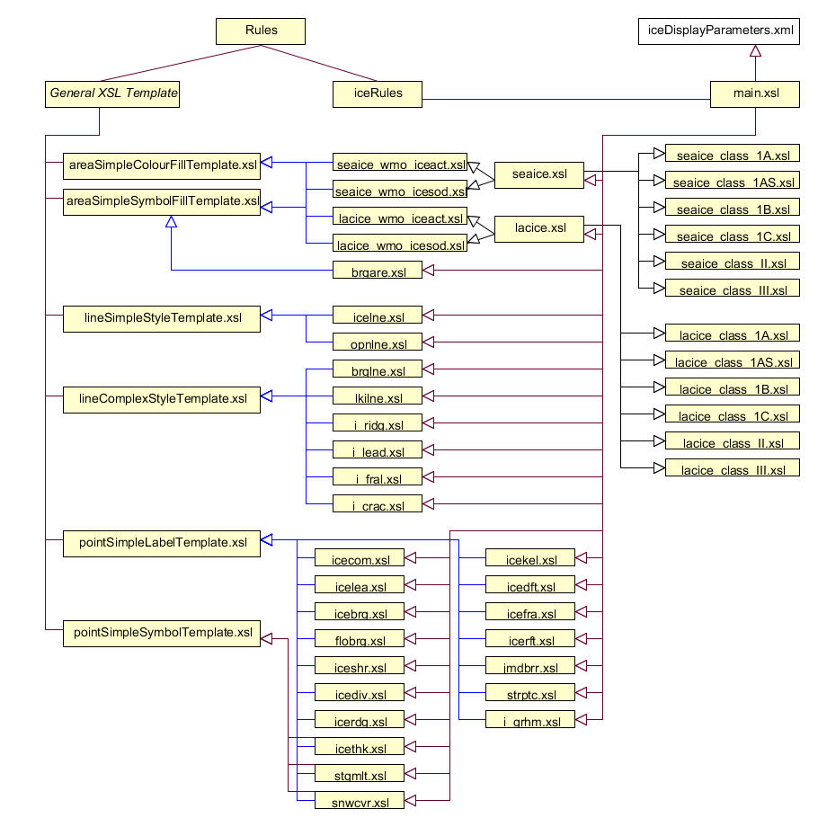
main.xsl includes all the rules for single feature types. It manages the selection of the right rule, depending on current feature type in dataset and parameters in iceDisplayParameters.xml.

iceDisplayParameters.xml contains parameters important for display of ice features:
- String iceclass
- Boolean encoverlay
- String Display Mode

Depending on the iceclass parameter the right seaice or lacice rule can be selected. The default is *_class_III.xsl

The encoverlay parameter helps to calculate the priority for display of single ice feature types. If encoverlay is true, the priority will be calculated, depending on priority of land area feature in ENC. The area objects of ice features should be displayed under the land area polygons, because they are usually drawn over the land.

Symbols

Polygon Features

IceNavigationalDisplayMode (Traffic Light Principle, depends on Ice Class)

IceScientificIceactDisplayMode
iceact | description | rgb | color
1 | Ice Free | 000 100 255
2 | Open Water (< 1/10 ice) | 150 200 255
3 | Bergy Water | 150 200 255 | 
10 | 1/10 ice | 140 255 160
12 | 1/10 to 2/10 ice | 140 255 160
13 | 1/10 to 3/10 ice | 140 255 160
20 | 2/10 ice | 140 255 160
23 | 2/10 to 3/10 ice | 140 255 160
24 | 2/10 to 4/10 ice | 140 255 160
30 | 3/10 ice | 140 255 160
34 | 3/10 to 4/10 ice | 140 255 160
35 | 3/10 to 5/10 ice | 255 255 000
40 | 4/10 ice | 255 255 000
45 | 4/10 to 5/10 ice | 255 255 000
46 | 4/10 to 6/10 ice | 255 255 000
50 | 5/10 ice | 255 255 000
56 | 5/10 to 6/10 ice | 255 255 000
57 | 5/10 to 7/10 ice | 255 255 000
60 | 6/10 ice | 255 255 000
67 | 6/10 to 7/10 ice | 255 255 000
68 | 6/10 to 8/10 ice | 255 125 007
70 | 7/10 ice | 255 125 007
78 | 7/10 to 8/10 ice | 255 125 007
79 | 7/10 to 9/10 ice | 255 125 007
80 | 8/10 ice | 255 125 007
81 | 8/10 to 10/10 ice | 255 000 000
89 | 8/10 to 9/10 ice | 255 125 007
90 | 9/10 ice | 255 000 000
91 | 9/10 to 10/10 or 9+/10 ice | 255 000 000
92 | 10/10 ice | 145 000 000
99 | Undetermined/Unknown | SymbolFill | 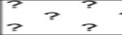

IceScientificIcesodDisplayMode
icesod | desc | rgb | color
1 | Ice Free | 150 200 255
70 | Brash Ice | 150 200 255
80 | No stage of development | 150 200 255
81 | New Ice (<10 cm) | 240 210 250
82 | Nilas Ice Rind (<10 cm) | 255 100 255
83 | Young Ice (10 to <30 cm) | 170 040 240
84 | Grey Ice (10 to <15 cm) | 135 060 215
85 | Grey – White Ice (15 to <30 cm) | 220 080 235
86 | First Year Ice (30 to 200 cm) | 255 255 000
87 | Thin First Year Ice (30 to <70 cm) | 155 210 000
88 | Thin First Year Ice Stage 1 (30 to <50 cm) | 215 250 130
89 | Thin First Year Ice Stage 2 (50 to <70 cm) | 175 250 000
91 | Medium First Year Ice (70 to 120 cm) | 000 200 020
93 | Thick First Year Ice (>120 cm) | 000 120 000
94 | Residual Ice | 000 120 000
95 | Old Ice | 180 100 050
96 | Second Year Ice | 255 120 010
97 | Multi-Year Ice | 200 000 000
98 | Glacier Ice (Icebergs) | SymbolFill
99 | Undetermined/Unknown | SymbolFill | 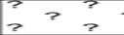

Line Features

Point Features
Feature Class | Acronym | Symbol
Ice Compacting | icecom
Ice Lead | icelea
Floeberg | flobrg
Ice Shear | iceshr
Ice Divergence | icediv
Ice Ridge / Hummock | icerdg
Ice Keel / Bummock | icekel
Ice Fracture | icefra
Ice Rafting | icerft
Jammed Brash Barrier | jmdbrr
Stage of Melt | stgmlt
Snow Cover | snwcvr
Strips and Patches | strptc
Grounded Hummock | i_grhm
Iceberg | icebrg
 | icebrg 01 (Growler)
 | icebrg 02 (Bergy Bit)
 | icebrg 03 (Small Iceberg)
 | icebrg 04 (Medium Iceberg)
 | icebrg 05 (Large Iceberg)
 | icebrg 06 (Very large Iceberg)
 | icebrg 07 (Ice Island Fragment)
 | icebrg 08 (Ice Island)
 | icebrg 09 (Radar Target)
 | icebrg 99 (Unknown)
Ice Drift | icedft
 | icedft 01 (No Ice Motion)
 | icedft 02 (NE)
 | icedft 03 (E)
 | icedft 04 (SE)
 | icedft 05 (S)
 | icedft 06 (SW)
 | icedft 07 (W)
 | icedft 08 (NW)
 | icedft 09 (N)
 | icedft 10 (Variable)
 | icedft 99 (Unkonwn)

Draw order
The highest number will be drawn on the top.

No. | Name | Acronym
1 | Sea Ice | seacie
1 | Lake Ice | lacice
2 | Iceberg Area | icebrg
3 | Ice Edge | icelne
4 | Iceberg Limit | brglne
5 | Limit of Open Water | opnlne
6 | Limit of All Known Ice | lkilne
7 | Line of Ice Ridge | i_ridg
8 | Line of Ice Lead | i_lead
9 | Line of Ice Fracture | i_fral
10 | Line of Ice Crack | i_crac
11 | Ice Compacting | icecom
12 | Ice Lead | icelea
13 | Iceberg | icebrg
14 | Floeberg | flobrg
15 | Ice Thickness | icethk
16 | Ice Shear | iceshr
17 | Ice Divergence | icediv
18 | Ice Ridge / Hummock | icerdg
19 | Ice Keel / Bummock | icekel
20 | Ice Drift | icedft
21 | Ice Fracture | icefra
22 | Ice Rafting | icerft
23 | Jammed Brash Barrier | jmdbrr
24 | Stage of Melt | stgmlt
25 | Snow Cover | snwcvr
26 | Strips and Patches | strptc
27 | Grounded Hummock | i_grhm

Additional Information

Annex A – Data Classification and Encoding Guide
The data classification is generally done by ice services, see the WMO publication “Sea-Ice Information Services in the World” (WMO-No.574). As a guide for encoding some python scripts are given in directory “software” to convert shapefiles (e.g. SIGRID-3) into S-411.

Annex B – Data Product format (encoding)
In directory “Schemas”

Annex D – Feature Catalogue
File S411FC.xml

Annex F – Portrayal Catalogue (SE, XSLT + SVG)
In directory “Portrayal”

Annex G – Encoding Example for all ice features
In directory “Test”

Annex I – Exchange Catalogue Example
In directory “Example”; templates for Metadata and Exchange set are also found in directory “software”.

