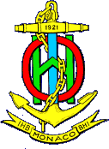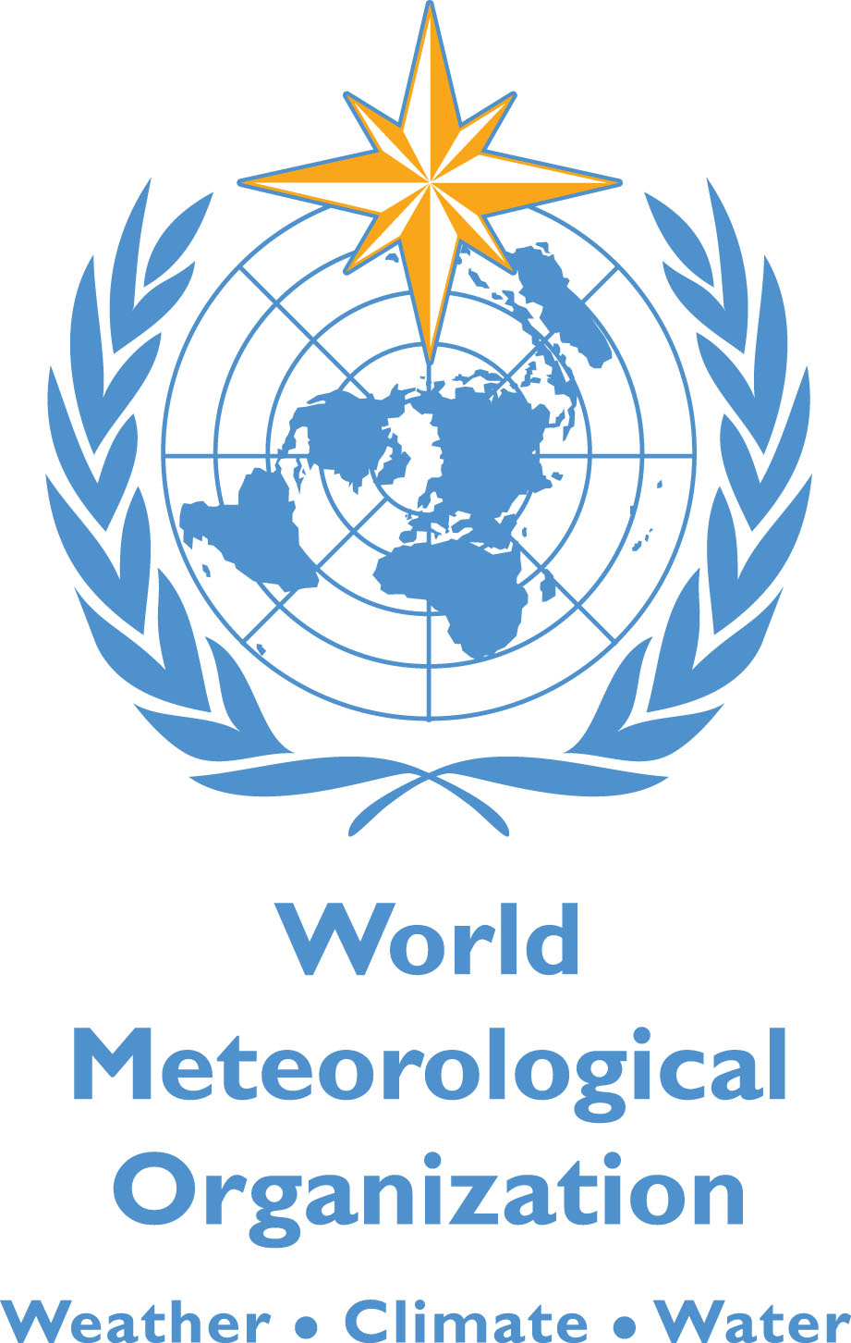

**MEMORANDUM OF UNDERSTANDING**

**BETWEEN**

**THE WORLD METEOROLOGICAL ORGANIZATION (WMO)**

**AND**

**THE INTERNATIONAL HYDROGRAPHIC ORGANIZATION (IHO)**

The World Meteorological Organization, hereinafter referred to as ‘WMO’ is an intergovernmental Organization having its seat at Geneva, Switzerland. WMO is a specialized agency of the United Nations and is the UN system’s authoritative voice on the state and behaviour of the Earth’s atmosphere, its interaction with the oceans as well as the climate it produces. The responsibilities of WMOinclude the coordination of Marine Weather Information provided by National Meteorological Services (NMS) to the Global Maritime Distress and Safety System (GMDSS) in response to the International Convention for the Safety of Life at Sea (SOLAS), as well as development of services beyond the GMDSS to support safety and efficiency of marine and offshore operations (e.g. support for Polar Code) Included within SOLAS is the provision that “the Contracting Governments undertake to encourage the collection of meteorological data by the ships at sea, and to arrange for their examination, dissemination and exchange in the manner most suitable for the purpose of aiding navigation”.

The International Hydrographic Organization, hereinafter referred to as ‘IHO’, is an intergovernmental consultative and technical organization having its seat at xxxxxxxxxxxx that was established in 1921 to support safety of navigation and the protection of the marine environment. The official representative of each Member Government within the IHO is normally the national Hydrographer, or Director of Hydrography, who, together with their technical staff, meet at 5-yearly intervals in Monaco for an International Hydrographic Conference, the highest governing body of the organization that reviews the progress achieved by the Organization and adopts the programmes to be pursued during the ensuing 5-year period. The objects of the IHO are to bring about: (i) the coordination of the activities of national hydrographic offices; (ii) the greatest possible uniformity in nautical charts and documents; (iii) the adoption of reliable and efficient methods of carrying out and exploiting hydrographic surveys; and, (iv) the development of the sciences in the field of hydrography and the techniques employed in descriptive oceanography. The IHO enjoys observer status at the United Nations and the International Maritime Organization (IMO); where it is recognized as the competent international authority for matters concerning hydrography and nautical charting.

WMO and IHO agree to establish and maintain cooperation relative to matters of common interest to both Organizations, in particular the coordination of the activities relating to the provision of Maritime Safety Information (MSI) through the GMDSS, in the framework of SOLAS, Polar Code and for the Electronic Navigational Charts / Electronic Chart Display & Information System (ENC/ECDIS) The following arrangement will be put in place under this Memorandum of Understanding (MoU):

1. WMO and IHO agree to exchange information and documentation and to keep each other fully informed of their activities and programmes of work relating to the promulgation of MSI, subject always to such arrangements as may be necessary for safeguarding or withholding of information of a confidential nature. Exchange of information is subject to the provisions of the Convention of each Organization as well as any of their respective rules and procedures.
2. With a view to facilitating attainment of their respective objectives as set forth in their constituent instruments, WMO and IHO agree to establish and maintain regular consultation in regard to matters of common interest in the field of maritime communications for maritime safety and efficiency of navigation. Accordingly, when either Organization proposes to initiate a programme or activity on a subject in which the other Organization has or may have substantial interest, it will consult the latter Organization taking into account the respective objectives of both Organizations.
3. Each Organization may propose matters for consideration by the organs of the other Organization, submitted to the Secretary-General of WMO or the President of IHO for appropriate action.
4. Participation in meetings:

(a) WMO may be invited to be represented in meetings of IHO organs or their subsidiary bodies or conferences convened by IHO. Such participation shall be in accordance with WMO General Regulations and the applicable Rules of Procedure.

(b) IHO may be invited to be represented as an observer in meetings of WMO organs or their subsidiary bodies or conferences convened by WMO. Such participation shall be in accordance with IHO General Regulations the applicable Rules of Procedure.

(c)Each party shall be responsible for its own costs and/or funding its respective responsibilities under this MoU.

5. Each Party shall appoint a Representative that shall coordinate relations with the other Party, including between technical experts of the Parties, and that

shall keep the Head of his or her Organization informed. Any change of Representative shall be communicated in writing to the other Party.

|  |  |
| --- | --- |
| Name and signature of  WMO Representative | Name and signature of  IHO Representative |
| Representative of WMO | Representative of IHO |

6. Any use by either Party of the other Party’s name, emblem or logo, shall only be made with the prior written approval of that other Party.

7. The Parties shall settle between them any question of interpretation or difference concerning this MoU.

8. Nothing contained in this MoU shall constitute or be deemed a waiver, express or implied, of any of the privileges and immunities enjoyed by WMO or by IFRC.

9This MoU may be revised by written agreement between WMO and IHO.

10 IHO or WMO may at any time terminate this MoU by giving six months’ prior written notice to the other Party.

11This MoU shall enter into force on the date of its signature by the Parties, it being understood that where it is subject to approval or ratification, it shall enter into force on the date on which the Party concerned has given written notification to the other party that the approval or ratification has taken place.

12This MoU shall remain in force for an initial period of 5 years and shall thereinafter be renewed automatically, each time for a new period of five years, unless a written notice of termination is given by one of the Parties to the other at least six months prior to the renewal date, or the Parties have agreed on its termination or on its renewal by another period.

Done in duplicate in the English language.

|  |  |
| --- | --- |
| **For the World Meteorological Organization (WMO):**  **Mr Michel Jarraud**  **Secretary-General**  **Geneva, Date:** | **For the International Hydrographic Organization (IHO):**  **Mr Robert Ward**  **President**  **Monaco, Date:** |