### Sea ice monitoring and forecasting situation in China

###### 1．Sea ice situation near China coast

There are different degrees of icing in winter in Bohai Sea and the north of Yellow Sea each year, they are the lowest latitude sea ice areas in the northern hemisphere, so the sea ice in these areas is one-year ice, and the differences of ice conditions between light and heavy ice years are very obvious.

Sea ice disaster frequently happens in Bohai Sea and the north of Yellow Sea. According to the statistics, heavy sea ice disaster occurs almost every 5 years. For example, the sea ice disaster happened in Bohai sea was very serious in 2009-2010, while in recent several years, the temperature in Northern China goes up in winter, it is 6℃ higher than normal in January 2017 along the Bohai Sea, which directly lead to the lighter result than usual in the Liaoning coastal area.

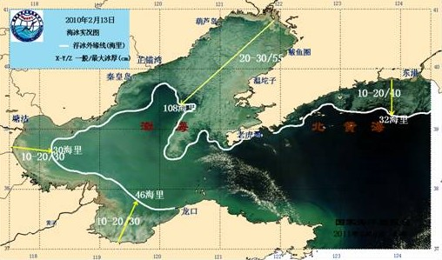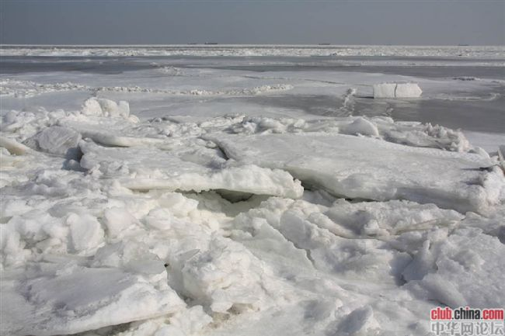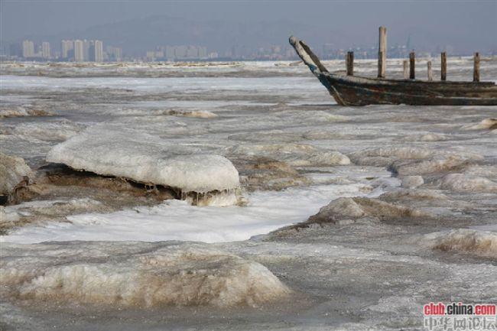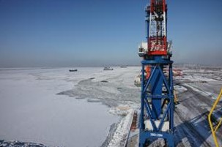

Sea ice in Bohai Sea and north Yellow Sea

###### 2. Organizations

North China Sea branch of State Oceanic Administration, National Satellite Ocean Application Service and National Marine Environment monitoring Center are responsible for the daily observation and emergency observation of sea ice, observation methods include satellite remote sensing, aerial remote sensing, radar, and in-situ observation.

National Marine Environmental Forecasting Center, North China Sea Environmental Forecasting Center, National Marine Environment monitoring Center, which are the subordinate units of the State Oceanic Administration, and the marine forecasting agencies of Tianjin, Liaoning, Hebei, Shandong provinces are responsible for the daily and emergency forecasting of sea ice, and forecast products producing and distributing.

###### 3. Data acquisition

China has been monitoring the sea ice from the 1960s, and the shore-based radar monitoring station was established in the 1980s. Until now, multi-platform and stereo sea ice observation system has already been established to facilitate the sea ice monitoring and warning, which includes platform radar and shore-based radar, satellite remote sensing, aerial remote sensing, observation stations, field observation, UAV observation and so on.

（1）Platform radar, installed on the oil platform in Bohai Sea, could be able to monitor the sea ice distribution, development and movement with high frequency in 360 degrees with weatherproof. The shore-based radar can monitor the coastal sea ice conditions.

（2）Satellite remote sensing data, including visible / infrared sea ice imagery, is mainly provided by NOAA, MODIS, HY-1 satellite(HY-1 is the China ocean color satellite). Airborne remote sensing of sea ice is carried out by airborne microwave radiometer, radar scatterometer and synthetic aperture radar (SAR).

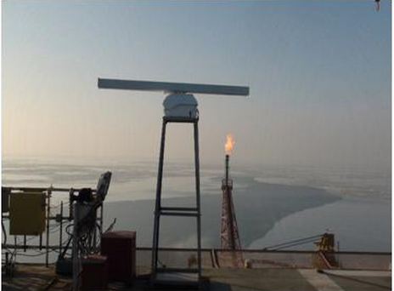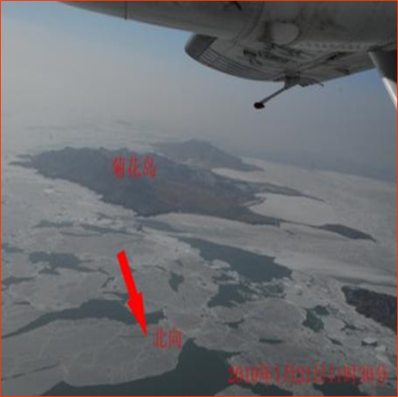

Platform Radar Aerial surveillance

（3）Station observation is used for fixed observation of sea ice conditions.

（4）Field observation is used to monitor and measure the ice on-site, including ice thickness, density, temperature, salinity, sea condition, visibility and weather conditions etc. Unmanned aerial vehicles (UAV) are additionally used to assist surveyors to carry out sea ice monitoring, which greatly reduce the workload and the risks of activities on ice.

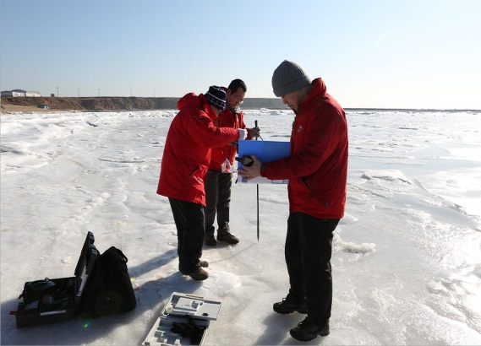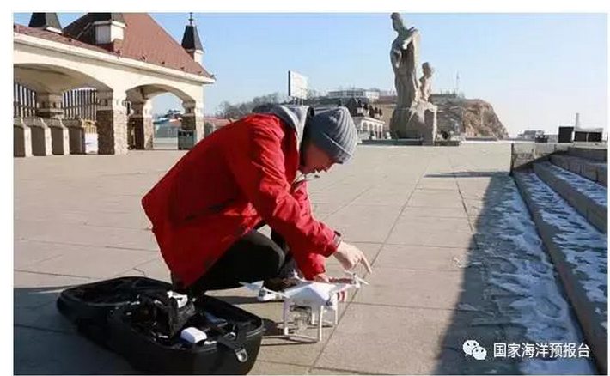

In-situ observation UAV

###### 4. Outputs and distribution

(1)Forecasting products

* Annually forecast products. The sea ice conditions from this winter to the coming spring are forecasted every November based on the weather forecast in winter. The main forecasting information is the new ice stage, heavy ice stage and final stage, and the distribution of drifting ice, ice thickness and maximum ice thickness etc..
* Monthly, ten-day, weekly forecast products. The shorter period forecasts of ice conditions are produced based on in-situ observation and satellite remote sensing monitoring. The main forecasts contain the distribution of drifting ice, ice thickness and maximum ice thickness.
* Ice warning information is broadcasted, which is caused by the sudden catastrophic weather.
* Operational forecasting. Numerical models based on operational forecast are utilized to predict the different thickness of sea ice cover and distribution for 7- day every 6 hours.
* High resolution and refined numerical forecasting. High resolution and refined numerical models to predict sea ice distributions are used in the key areas and ports. The models contain different thickness of sea ice cover and wind- and current-driven sea ice drifting.

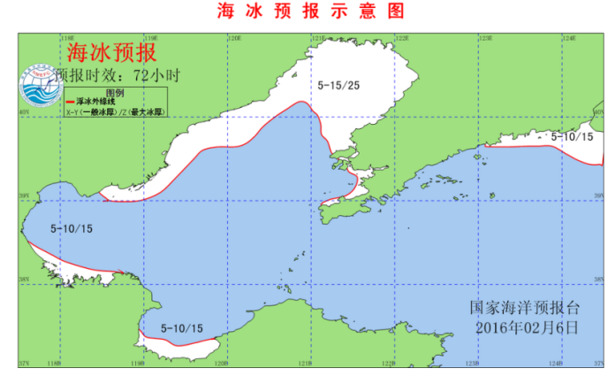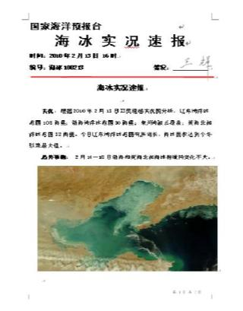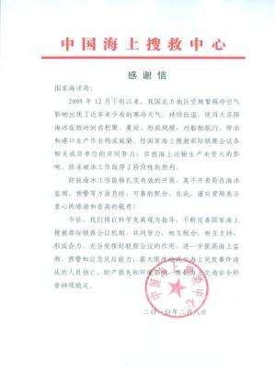

Sea ice thematic map bulletins

(2) Sea ice conditions imagery products

Satellite remote sensing imagery products are provided by NOAA、MODIS、HY-1, radar sea ice imagery products are from platform radar and shore-based radar.

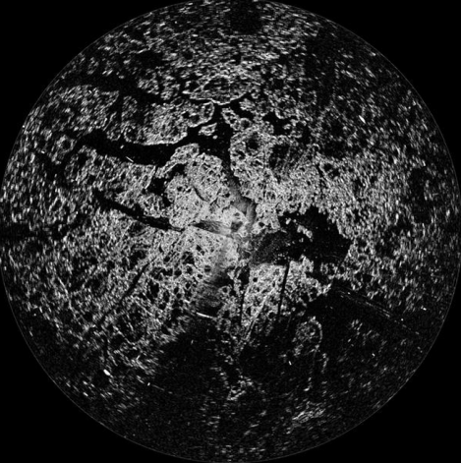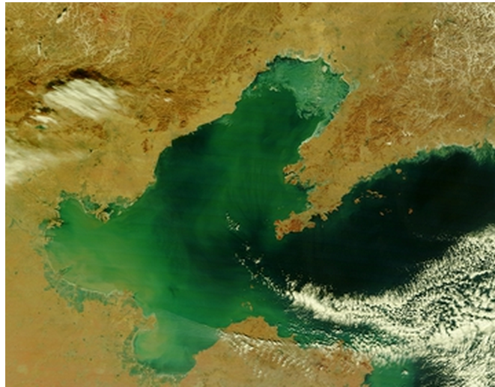

Platform Radar imagery Satellite imagery

(3) Sea ice bulletins

Annually, Monthly, ten-day and weekly ice condition bulletins in Bohai Sea and the north of Yellow sea are produced in forms of textual and graphic bulletins, including thematic maps, in-situ photos.

(4)Products release

All the products are posted on the official websites, broadcasted on radio and TV, and mobile platforms to the public. And to the governments and enterprises via mail or telefax.

###### 5. Others

We have studied on the physical processes and numerical model of sea ice formation in the Arctic and Antarctic, providing information and services to ensure the safe navigation and investigation of scientific research.