**Wave and ocean models needed**

|  |
| --- |
| Join the network of RSMC’s supporting marine services  Help support global marine service improvement |

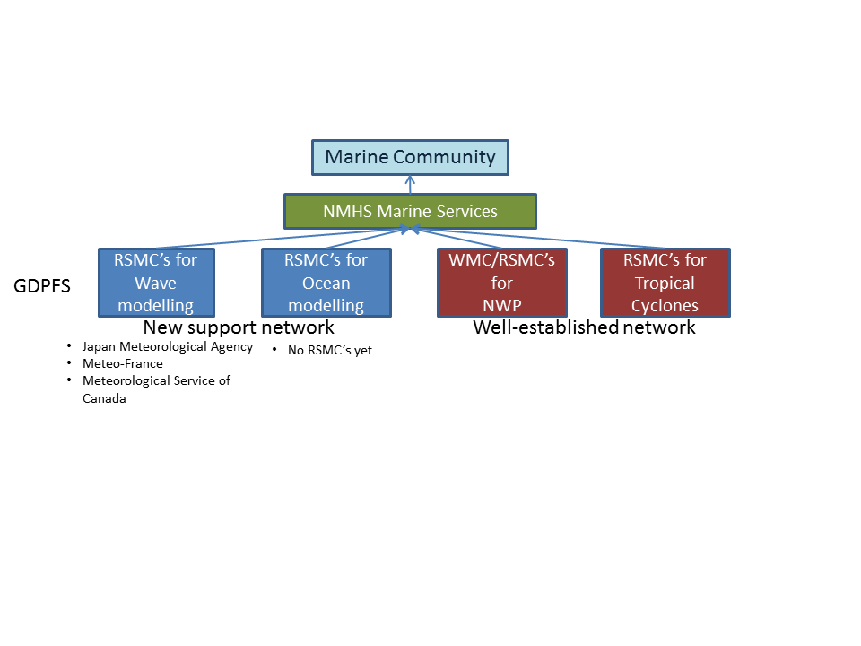

**How you can help in 3 easy steps?**

1 - Produce the standard product suite

* Wave models – 0.5 degrees; Hsig, Period, Direction
* Ocean models – 0.5 degrees; Temp, currents – multi-layers

2 – Make the products available on the WIS

3 – Provide verification results

**Steps to join the global support system**

1. Check the requirements of an Regional Specialized Meteorological Center (RSMC) in the GDPFS Manual (WMO No.485).
2. Contact [mmo@wmo.int](mailto:mmo@wmo.int) for an application form.
3. Submit the completed application form back to [mmo@wmo.int](mailto:mmo@wmo.int).

**Want to know more?**

Ask the WMO Marine Meteorology and Ocean Affairs Division

Email: [mmo@wmo.int](mailto:mmo@wmo.int)