# Case study article on TC warnings and improved decision making by vessels

## Planning section

2 article styles

* MeteoWorld - aimed at WMO Members and general readers (about 500 words, limited opportunity for graphics)
* Longer article for submission to shipping and partner communication channels (should include graphics)

### Key messages that we want to convey in the article

1. Tropical Cyclones are dangerous, and pose hazard to vessel integrity and personnel
2. Tropical Cyclone warnings include the area of gale force winds or stronger, which could extend beyond 150nm from the centre.
3. The WWMIWS can provide 200nm or 24 hour lead-time to assist safe decision making
4. Monitor WWMIWS warnings on SafetyNET
5. Make an early decision and stay clear of the warning area and TC path
6. TCs’ long-range forecasts and information about the errors (or forecast uncertainty) especially for the recurving TCs can benefit the decision
7. The importance of observations from vessels in modifying the real-time warning of TCs

### How we could structure the article

* Use the case study examples and pictures to emphasise correct decision making behaviour, and the size of the TC warning area.
* Provide a short background on WWMIWS and RSMC’s/TCWC’s.
* Provide a short background on the forecast capability of different TC RSMCs including China.
* Provide the case study examples of vessel observations in improving the TC forecasts and warnings ,especially for making the gale warning forecast.

## Content for MeteoWorld article (due August 31, 2018)

Each year, over 100,000 forecasts and warnings are transmitted to ships at sea through the IMO/WMO Worldwide Met-Ocean Information and Warning Service (WWMIWS). The service provides the vital weather, wave and ice warnings that have been specified in the United Nations Convention for Safety of Life at Sea (SOLAS) to improve ship safety and protect the welfare of seafarers.

A near-miss involving a merchant vessel that transited directly through the eye of a tropical cyclone has underlined the importance of voyage planning and making early decisions using warnings issued as part of the WWMIWS. The incident has prompted the World Meteorological Organization (WMO) to emphasise the hazards to shipping resulting from a tropical cyclone, and to outline the importance of warnings and forecasts in supporting voyage planning decisions.

Tropical cyclones can produce a range of hazards to shipping including: hazardous winds and gusts, huge swells, heavy rain reducing visibility, and lightning. The impacts of these hazards on a vessel include increased risks to vessel integrity, safety of personnel and passengers, and carriage of cargo. There may be costly consequences to shipping companies and marine insurers if vessels are unable to avoid the hazard areas associated with a tropical cyclone that can range 300 nautical miles in diameter.

Ships are made aware of tropical cyclones through the WWMIWS. The service, coordinated by 19 National Meteorological and Hydrological Services, transmits wind warnings to the vessel using satellite and radio communication systems, covering the majority of the world’s oceans. The warnings describe the current area of gale-force winds and above, the area of maximum wind intensity, and also provides the position of the tropical cyclone and movement over the next 24 hours.

A web portal provides a one-stop shop for viewing all warnings issued for the WWMIWS. The web portal is a useful tool for ship fleet managers, and also for vessels to monitor weather systems on their route. The web portal is hosted by Meteo-France, and receives 8000 views per month.

<http://weather.gmdss.org/index.html>

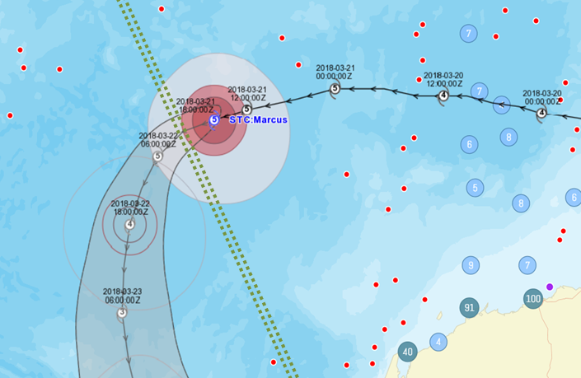

Example of a tropical cyclone warning path intersecting with a major shipping lane from Western Australia to the Persian Gulf (dotted green lines). Note that the ships (red dots) have kept a large distance from the path of the tropical cyclone.

**Content that might be a bit too much detail**

A group of 21 dedicated meteorological centres monitor the ocean environment and issue forecasts and warnings for hazardous weather systems and ocean conditions in their defined METAREA. As a vessel move across an ocean route, the satellite system will recognise the METAREA that the vessel is located within and transmit these forecasts and warnings to the ship’s bridge.

Consider inserting a case that shows desired response to the TC warnings. I believe you showed one during the IUMI presentation of ship avoidance along a forecast TC path. Showing desired behaviour along with behaviour that need reconsidering might be more impactful.