Content for MeteoWorld article

Each year, over 100,000 forecasts and warnings are transmitted to ships at sea through the IMO/WMO Worldwide Met-Ocean Information and Warning Service (WWMIWS).  The service provides the vital weather, wave and ice warnings that have been specified in the United Nations Convention for Safety of Life at Sea (SOLAS) to improve ship safety and protect the welfare of seafarers.

A near-miss involving a merchant vessel that transited directly through the eye of a tropical cyclone has underlined the importance of voyage planning and making early decisions using warnings issued as part of the WWMIWS.  The incident was discussed at the 1st meeting of the WWMIWS Committee, held at the International Hydrographic Organization (IHO), Monaco, 27-31 August 2018.

The Committee meeting decided to focus on developing educational material to outline to ships that tropical cyclones can produce a range of hazards to shipping including: hazardous winds and gusts, huge swells, heavy rain reducing visibility, and lightning.  The impacts of these hazards on a vessel include increased risks to vessel integrity, safety of personnel and passengers, and carriage of cargo. There may be costly consequences to shipping companies and marine insurers if vessels are unable to avoid the hazard areas associated with a tropical cyclone that can range 300 nautical miles in diameter.

Ships are made aware of tropical cyclones through the WWMIWS. The service, coordinated by 19 National Meteorological and Hydrological Services, transmits wind warnings to the vessel using satellite and radio communication systems, covering the majority of the world’s oceans.  The warnings describe the current area of gale-force winds and above, the area of maximum wind intensity, and also provides the position of the tropical cyclone and movement over the next 24 hours.

A web portal provides a one-stop shop for viewing all warnings issued for the WWMIWS.  The web portal is a useful tool for ship fleet managers, and also for vessels to monitor weather systems on their route.  The web portal is hosted by Meteo-France, and receives 8000 views per month.

<http://weather.gmdss.org/index.html>

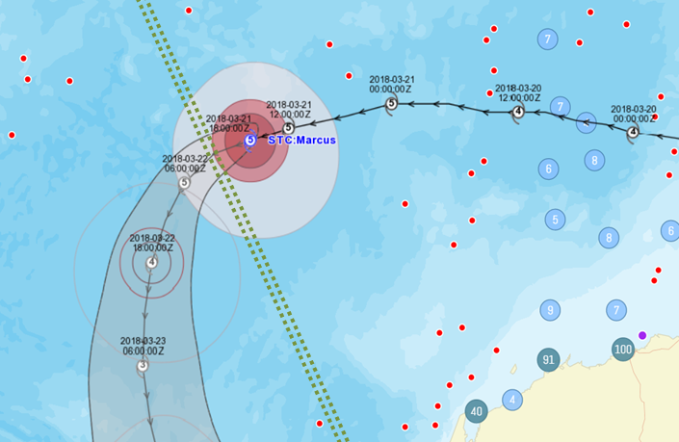

*Example of a tropical cyclone warning path intersecting with a major shipping lane from Western Australia to the Persian Gulf (dotted green lines).  Note that the ships (red dots) have kept a large distance from the path of the tropical cyclone.*