# Severe Tropical Cyclone Marcus

Screenshot taken at 2030UTC on 20/3/2018

MV Lara intersected with Tropical Cyclone path on southward journey from China to Kwinana, and deviated path northward to avoid eye of Tropical Cyclone.

The MV Lara reported the following conditions before changing course northwards away from the Tropical Cyclone.

**On about 50 nm radius from forecast position, sustain wind about 65 knots, gusting 75-80 knots  SSW’ly direction. Wave:  height about 5-6 meters SSW’ly , Swell: about 3-4 meters.**

There is a fishing vessel (Japan Flag), No 1 Fukuseki Maru, that is currently located in the path of the Tropical Cyclone. No track information is available for this vessel, so uncertain which way it is moving.

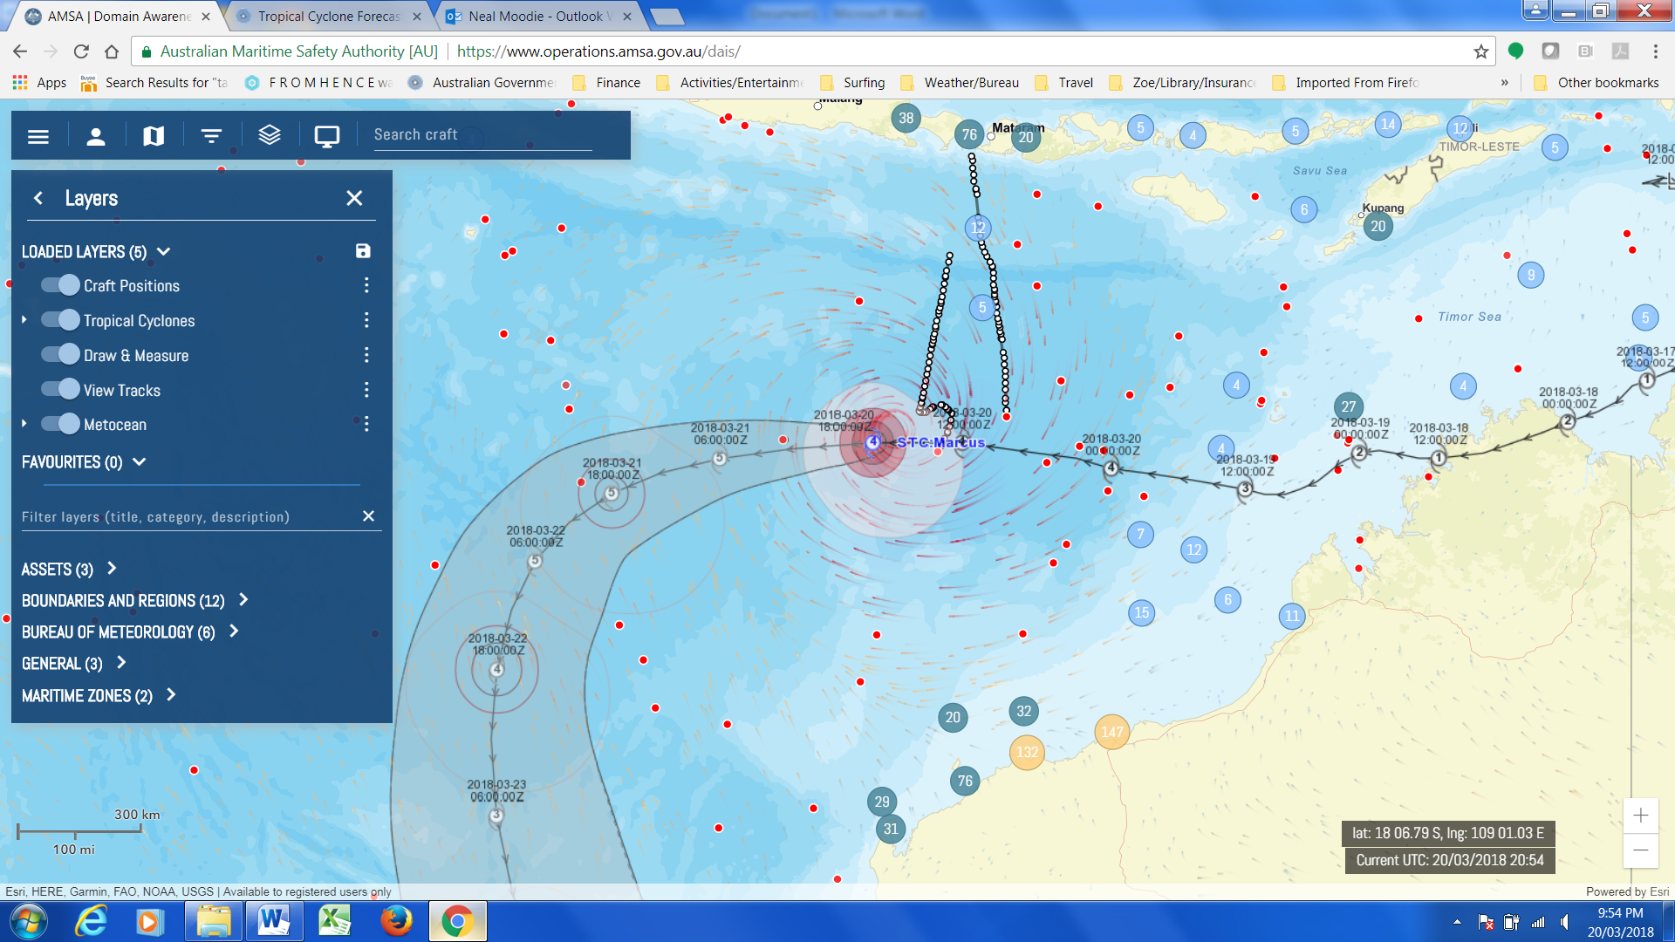

Main Shipping Channel towards Singapore is the next shipping lane to be affected. Uncertain if ships are preparing to change their path to avoid Category 5 Tropical Cyclone in 24 hours.

At 1900UTC, 21/3/2018, All ships had headed the warning and deviated their routes. All ships were well away from the path of the Tropical Cyclone.

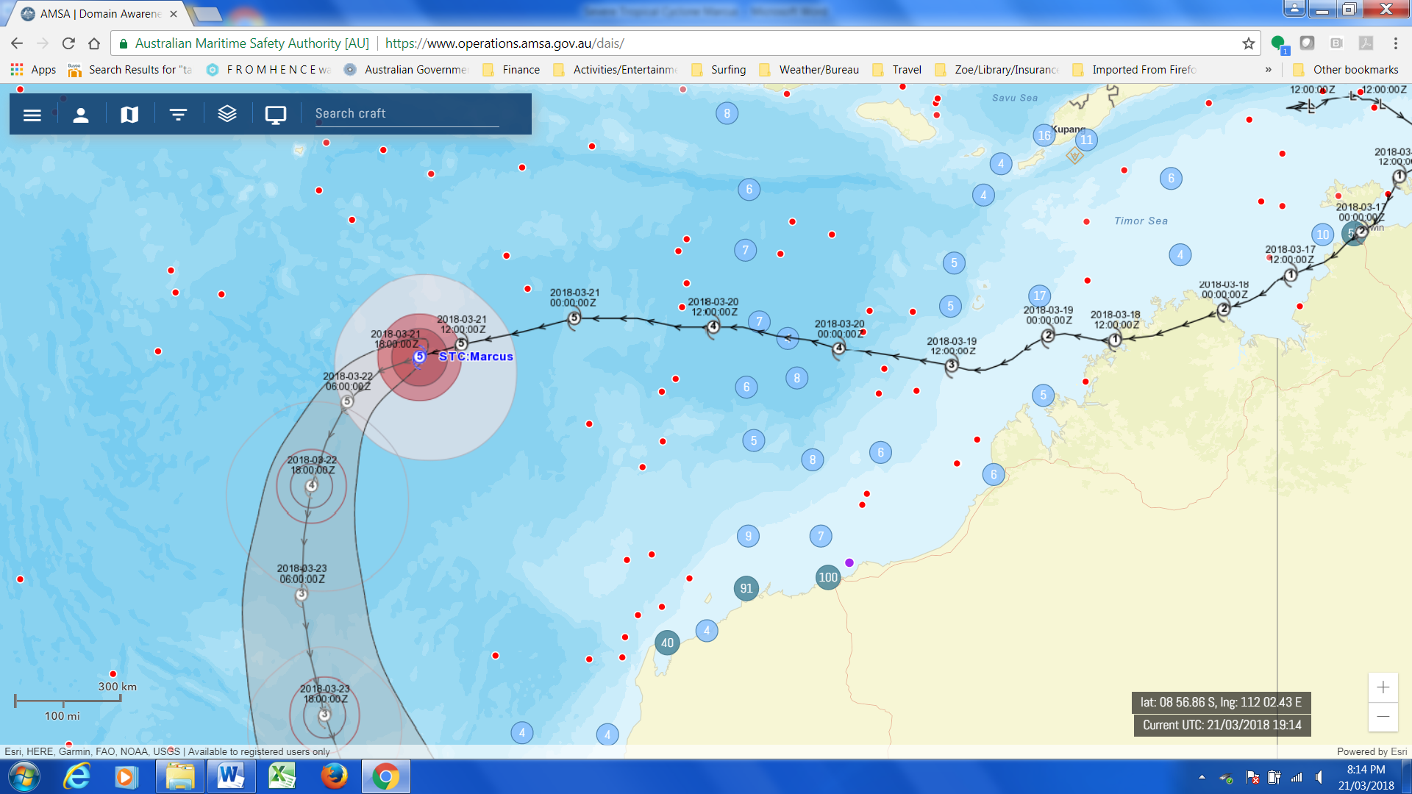

However, the No 1 Fukuseki Maru had a rough time of it, with the track suggesting that the vessel encountered the eye of the Tropical Cyclone.

