# WWMIWS-1 Meeting objectives

*This document provides additional guidance about the objectives of each agenda item presented at the WWMIWS-1 meeting in Monaco, August 2018. The following descriptions add complementary details to the WWMIWS Committee work plan.*

## 2.1 - Outcomes from the METAREA Coordinator presentations.

METAREA Coordinators have been requested to prepare a presentation on activities within their METAREA.

The presentation will focus on new service initiatives, any planned service changes, any challenges in provision or coordination of the MSI service, stakeholder interactions, and education efforts.

There will be a number of initiatives or issues highlighted by individual METAREA coordinators. Some items may concern all METAREA’s or need further discussions.

Discussion: The Committee will summarise any key priority areas or opportunities for improvement. The Committee will then consider which items should be added to the WWMIWS Committee workplan.

## 2.2 – S-412 (including seamless GDPFS, 3.1)

Joe Phillips will provide an update on the S-412 specification and next steps.

**Problem**

The S-412 service will involve a global data layer – providing a single authoritative source for shipping. However, the current structure of the WWMIWS is based on 21 METAREA’s. It is obvious that this will be difficult to achieve a seamless layer of all parameters across the globe.

Discussion: The Committee should consider the challenges in providing seamless services to shipping (e-navigation graphical services and text). Develop pros and cons on a two-centre model that would be responsible for providing this seamless global data layer. This would help guide further thinking and activity following the WWMIWS-1 meeting.

Consider whether NMHS could contribute or not? Consider how the METAREA text MSI service would align with this?

**Problem:**

Recent development requires discussion on whether it's appropriate for S-412 to be divided into 3 separate product specifications.  The proposed product specifications are: (1) S-412 Weather Hazards; (2) S-4xx Weather Conditions; and (3) S-4xx Weather Observations.  S-412 Weather Hazards data will be vector based; S-4xx Weather Conditions would be gridded data sets; and S-4xx Weather Observations would be vector based.  Reasons for dividing S-412 are technical, administrative and governance related.  Technical reasons include improving data modeling, grouping concepts by their data format, data file size and improving the future maintenance of S-412.  Administrative considerations include improving communication of the project's technical concepts and the foreseeable issues of maintaining an all-inclusive product specification. Governance considerations include the future delivery of products, regulatory actions needed to implement new services, and collaborative efforts to ensure seamless services across METAREAS.

Discussion: The Committee should consider the authoritative content currently required to be broadcast via GMDSS and other services that exceed this requirement. Specific attention should be given to authoritative warning services (hazard polygons and weather systems data) and gridded data.

Discussion: The Committee should discuss how they envision S-412 products to be disseminated in the future, specifically with scheduled broadcasts, at-will broadcasts, and near or real-time data streaming.  Particular consideration should be given to the large data size of gridded data and the small data size of vector data.

**Problem:**

Various agencies will be moving to operationalize S-100 based product specifications in the near-future.  One major piece that has not been realized is how a mariner will access these data files.

Discussion: The Committee should consider how they envision S-412 products to be disseminated in the future, specifically through GMDSS, national cloud services, and radio broadcast networks.

## 2.3 – WWMIWS web portal upgrade

**Challenge**

Refer to the WWMIWS work plan, and also the google drive folder for the latest specification information.

Discussion: Review the work outputs of the working group. The Committee should form a consensus view on the specifications for the display of SafetyNET and NAVTEX bulletins on the web portal. This will allow the IT developers at Meteo-France to continue the development of the portal over the following months.

## 2.4 - Inmarsat EGC discussion

**Problem - Default radius used in SafetyNET EGC code for TC/circular warnings**

The general practice in WWMIWS Issuing Services and TC RSMC Preparation Services when issuing a circular EGC code warning is to use a default radius (999nm from centre). This is too conservative.

In the example below, most vessels stayed 200nm away from TC centre, and the MV Alam Seri (which travelled through the centre of the TC, see black track) took 48 hours to travel 400nm, so even reducing the radius to 500nm would provide over two days to plan decisions on best route.

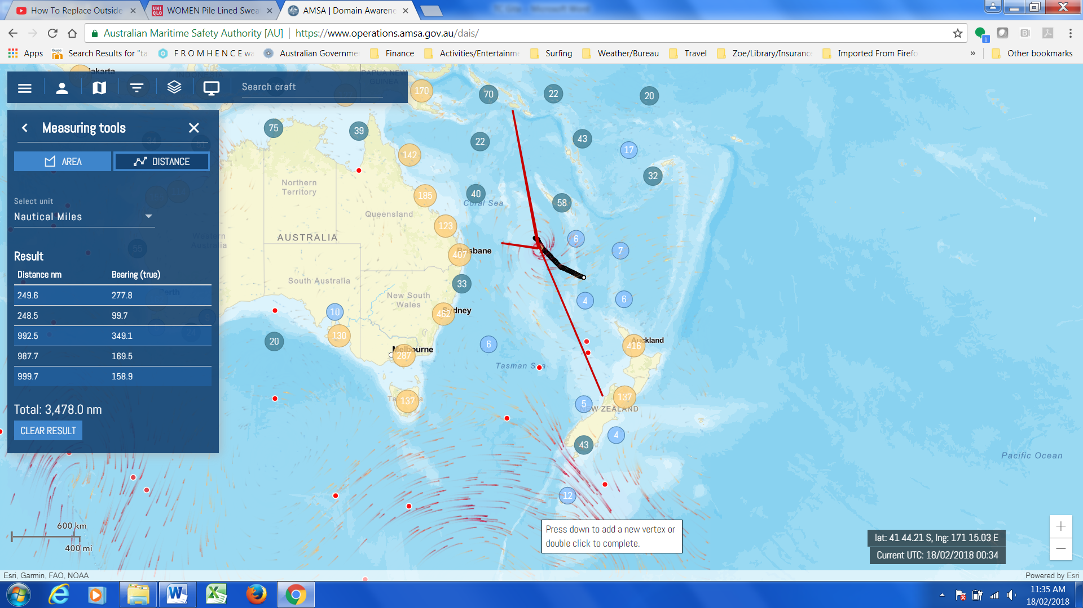

Discussion

Recommendation would be to reduce to a standard 400nm radius across all TC basins under the WWMIWS.

## 3.1 – Seamless GDPFS and S-412

Refer to description for 2.2.

## 3.2 - Marine verification

Discussion: Review the initial outputs generated by the working group on marine verification, part of the WWMIWS Committee work plan.

## 3.3 - Marine forecasters competency implementation

**Problem:**

The WMO Executive Council at their 70th meeting decided to encourage WWMIWS Issuing Services to ensure that all their marine forecasters were competent by 2023. A Task Team is being formed in JCOMM to develop specific outputs that will assist countries to implement the competency framework.

Discussion: Review the Executive Council decision, and analyse the implementation status results from the METAREA Coordinator self-assessments. Review the TOR’s for the Task Team on marine forecaster competency implementation – and develop a plan to contribute to the Task Team’s work outputs.

## 4.1 - Documentation review – IMO Resolution A.1051(27)

**Problem**:

IMO A.1051 needs to be updated at NCSR-6 in March 2019, with documentation deadline in Nov 2018. A working group has been formed to develop an initial draft of changes for the WWMIWS Committee to consider.

Plan to review and finalise updated content at Aug 2018 WWMIWS Committee meeting.

Update needs to include new service-related content from WMO 558, and inputs from DRWG regarding satellite providers.

Discussion: To review the working groups initial draft of changes, and to recommend additional amendments as necessary.

## 4.2 - Documentation review - WMO 558 and WMO 471

**Problem**:

The re-structure and revision of WMO No.558 Manual, and WMO No. 471 Guide have been completed and published in 2018. This has set us up to manage the content and service definitions easier. The aim of WMO No. 558 is to provide universal guidance on service standards and best practice for NMHS and private meteorological services – and there remains gaps that limit this goal.

There is limited guidance provided in WMO No. 558 for services involving map products, or tabular/graph products. Some of these principles could help guide the development of the S-412 specification.

Discussion: Develop plans to introduce a new chapter in WMO No. 558 dedicated to map and tabular/graph products.

Identify any sections in 558 and 471 that need to be updated for the 2019 version.

## 4.3 - GDPFS Manual – marine related centres

**Problem 1**:

The network of RSMC’s for Marine Safety Services has been established at JCOMM-5, consisting of all members of the WWMIWS Committee. The activities of these RSMC’s was defined for the GDPFS Manual (WMO No. 485), however, there remains sections about mandatory products and verification scores to complete.

Discussion: Compile the list of mandatory products, and consider any appropriate verification scores to include in the GDPFS Manual.

**Problem 2**:

The verification scores for wave models were defined a long time ago. There is an opportunity to add some further contemporary verification scores to assist with NMHS utilizing and understanding the wave model outputs available from the RSMC network of wave models.

Discussion: Review the current list of verification scores outlined in section 2.2.37 of the GDPFS Manual, and propose amendments as necessary.

**Problem 3**:

Some centres outside of the WWMIWS provide marine service products for regional areas (Fiji for South Pacific, Caribbean Institute of Meteorology is considering setting up a forecasting centre to produce products for the Caribbean).

Discussion: Consider defining RSMC criteria for marine centres providing regional marine service products.

**Problem 4**:

There are a number of known initiatives that provide high-resolution wave model guidance for specific regional areas. We should consider recognizing these centres as a RSMC network to improve visibility for NMHS, and set standards. Example: Senegal run a regional wave model for Western Africa. Caribbean Institute of Meteorology run a 4km wave model for the next 7 days for the Caribbean region.

Discussion: Consider defining RSMC criteria for wave model centres providing regional wave model guidance.

**Problem 5**:

Under section 2.2.2.6 on Tropical Cyclone Warning RSMC’s, the description of the marine service requirements is out of date and not adequate. The TC RSMC/TCWC network provide products to Issuing Services for dissemination on SafetyNET and these products should comply with the requirements listed in WMO No.558 and IMO documentation.

Discussion: To control the requirements of a Preparation Service (generally for TC warnings), the WWMIWS Committee should ensure that the marine service description provides adequate guidance and reference to WMO No.558. We may also need to consider a new category in the GDPFS Manual for Preparation Services, or make it clearer in the TC warnings chapter.

## 4.4 – Review of Operations Handbook for METAREA Coordinators

Discussion: Review the latest draft. The Committee should agree on the draft content for a version 1. This version 1 will then be provided to WMO publications unit to convert into a WMO formal publication.

## 4.5 - TR for marine services.

Details yet to be defined.

## 4.6 - Review of PAME Polar Code Best Practices portal

**Background**

The Arctic Council is a collective of Governments with interests in the Arctic environment and to develop consistent practices and policies. The Arctic Council has established a number of Working Groups, and a few of these working groups cover meteorological interests, and WMO has a role to play. The working group called PAME – Protection of the Arctic Marine Environment, has a majority focus on safe shipping in Arctic waters. A project of the PAME WG was to establish a best practices web portal on applying the Polar Code regulations. The Polar Code is a goal based regulation which leaves room for interpretation on how to apply these functional goals and requirements.

Link to Best Practices web portal,

<https://pame.is/index.php/chapter-11>

**Problem**

The initial text proposed by WMO was not user focused, in-line with the intent of the best practices web portal. The current text reads like an advertorial for all of WMO’s programmes, but does not outline how they relate to the Polar Code in practice, if at all.

Discussion:

The Committee should review the text submitted by WMO for the relevant components of the Polar Code, as per Annex 1. The Committee should agree to revised text submissions that are user focused and relevant to application of the Polar Code.