|  |  |
| --- | --- |
| WWMIWS Committee Meeting 1 | WWMIWS-1 |
| Monaco, 26-30 August 2018 | Agenda 2.4 |

## Inmarsat EGC discussion

**Problem - Default radius used in SafetyNET EGC code for TC/circular warnings**

The general practice in WWMIWS Issuing Services and TC RSMC Preparation Services when issuing a circular EGC code warning is to use a default radius (999nm from centre). This is too conservative.

In the example below, most vessels stayed 200nm away from TC centre, and the MV Alam Seri (which travelled through the centre of the TC, see black track) took 48 hours to travel 400nm, so even reducing the radius to 500nm would provide over two days to plan decisions on best route.

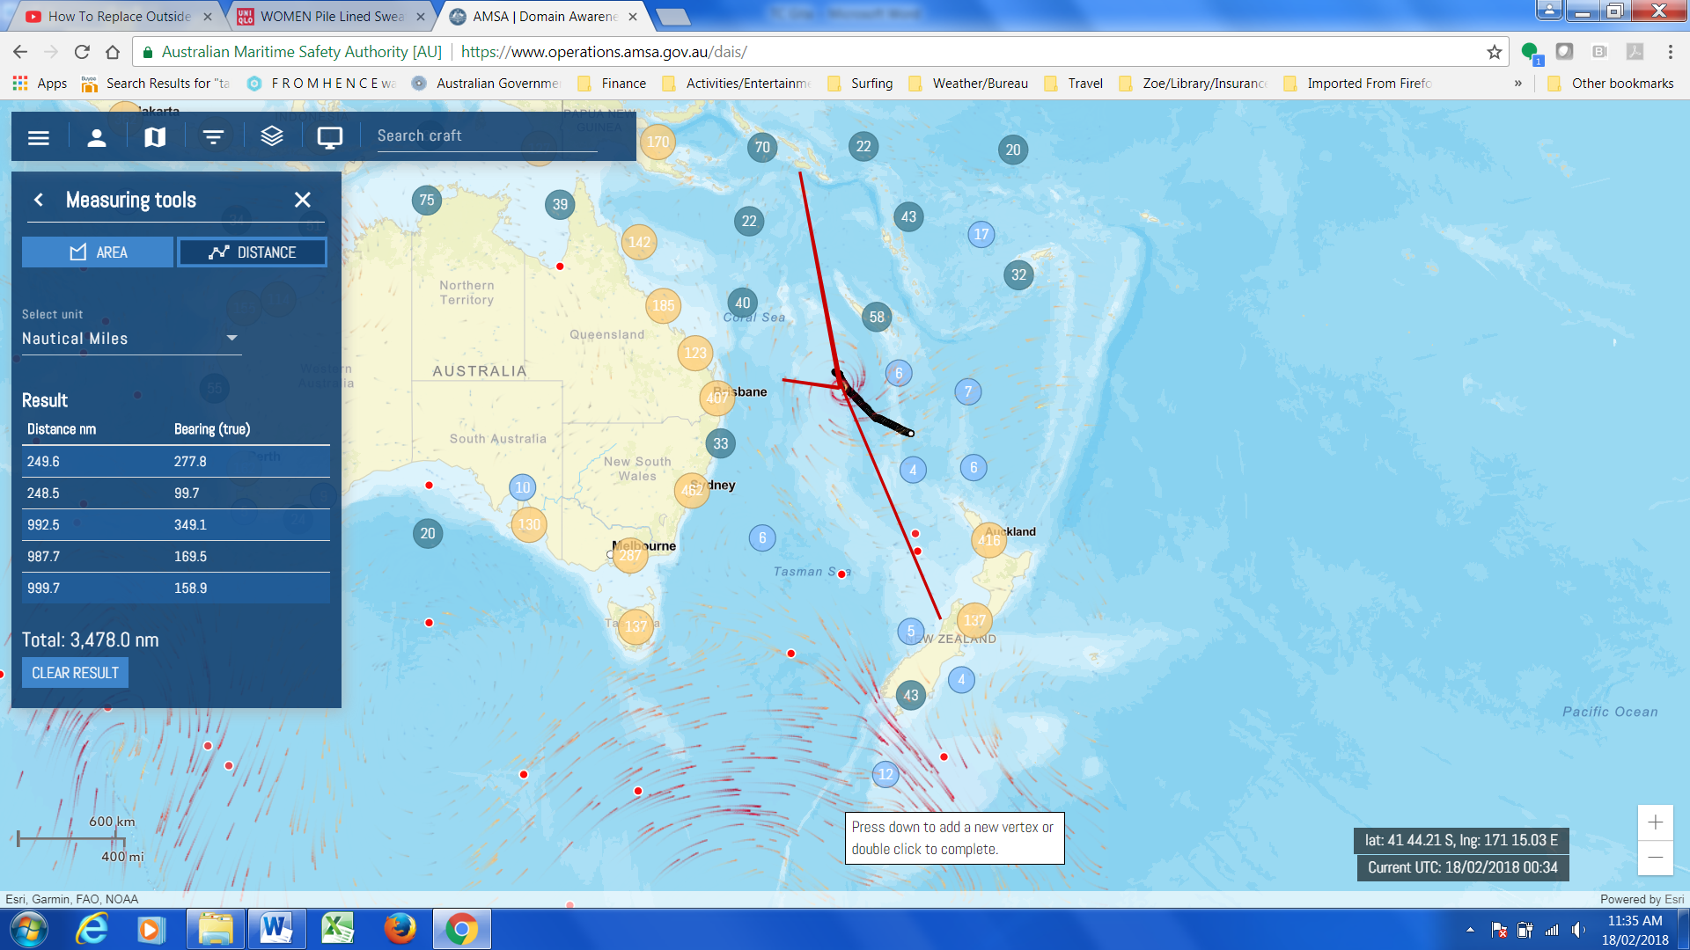

Discussion

Recommendation would be to reduce to a standard 400nm radius across all TC basins under the WWMIWS.

Discussion

The Committee will discuss the specifications for machine to machine message transfer on SafetyNET 2, presented by Inmarsat.