**Proposal for inclusion of new terminology to the WMO Sea-Ice Nomenclature (WMO-259)**

For discussion on the 7th session of the WMO/IOC JCOMM Expert Team on Sea Ice (13-15 May 2019)

Submitted to Dr. Vasily Smolyanitsky and Juergen Holfort on 08 May 2019

by M. Hoppmann, I. Smith, P. Langhorne, S. Jendersie, G. Dieckmann and M. Richter

**Subject:** Here we propose the inclusion of the terms „platelet ice“, “sub-ice platelet layer”, “incorporated platelet ice” and “platelet crystal” in the official WMO sea-ice nomenclature.

Basal melt of ice shelves is not only part of Antarctica’s ice sheet mass budget, but it is also the origin of one of the most peculiar types of sea ice found in the polar oceans: platelet ice. In many regions around coastal Antarctica, tiny ice crystals form and grow in supercooled plumes of Ice Shelf Water, releasing heat into the surrounding water. They usually rise towards the surface, and are sometimes trapped under an ice shelf as marine ice. In some locations, masses of those crystals are advected out of the ice-shelf cavity, and accumulate below a solid sea-ice cover to form a semi-consolidated layer. When the overlying sea ice grows into this so-called **sub-ice platelet layer**, the loose crystals are subsequently consolidated to form **incorporated platelet ice**, adding additional thickness to a sea-ice cover. These phenomena are generally referred to as **platelet ice**, although there is substantial confusion about the terminology in the literature. In addition to its impact on sea ice thickness and other physical properties, the presence of platelet ice, especially in its semi-consolidated form, has a variety of implications for the polar marine biosphere: it provides a stable, sheltered, nutrient- and food-rich habitat for a highly productive and uniquely adapted ecosystem. It has also been hypothesized that platelet ice may be an indicator of the health of an ice shelf, as ISW only forms under cold cavity ice shelves with a low contribution of net submarine melt to overall mass loss. However, comprehensive time series are limited to the Ross Sea, and many process knowledge gaps still exist.

The authors of this proposal have published numerous papers about this research topic during the last 3 decades, and are considered leading experts in this field. This proposal is part of the authors’ efforts to clarify and define the terminology in order to facilitate the interdisciplinary research needed to better understand this unique system. For example, the different terms proposed here have been used interchangeably; some older literature refer to this ice as “underwater ice”, “frazil ice”, “anchor ice”, “marine ice”, or don’t give a distinct name at all. At this point, it is close to impossible to discover all the relevant literature in this field. Although this has been addressed in past publications by the authors, from our peer-reviewing experience, the terminology is still a big issue.

As a basis for your team’s discussion of our request during the next meeting, we are proposing the following (preliminary) definitions for the terms highlighted above, which shall serve as a starting point and may of course be modified:

**Platelet ice:** “A type of sea ice that is formed in or modified by supercooled Ice Shelf Water (ISW) that originates from cold-cavity ice shelves around Antarctica. It can be further separated into a semi-consolidated form termed "sub-ice platelet layer", and a consolidated form termed "incorporated platelet ice". The term "platelet ice" is usually used to refer to both types, when a further distinction is not necessary.”

**Sub-ice platelet layer:** “A semi-consolidated, up to several meter thick layer of randomly oriented, individual ice crystals, which reside at the underside of a solid sea-ice cover.”

**Incorporated platelet ice:** “Solid sea ice that results from a subsequent consolidation/freezing of the sub-ice platelet layer. It has similar properties to regular sea ice, but its texture is characterized by randomly oriented crystals and it results in a much larger thickness of the local sea-ice cover.”

**Platelet crystals:** “The individual ice crystals within platelet ice.”

Although we are currently working on a review paper that aims to clarify the terminology, we feel that the inclusion of the proposed terms, along with a proper definition, in an officially recognized document such as the Sea-Ice Nomenclature, would enable much more efficient and aligned research. It would facilitate the exchange of knowledge between researchers of different disciplines by resolving ambiguous uses of terminology, accelerating the search for and use of relevant literature from different fields, and hopefully sparking much needed interdisciplinary research on this fascinating type of ice.

With kind regards, the “platelet ice team”.

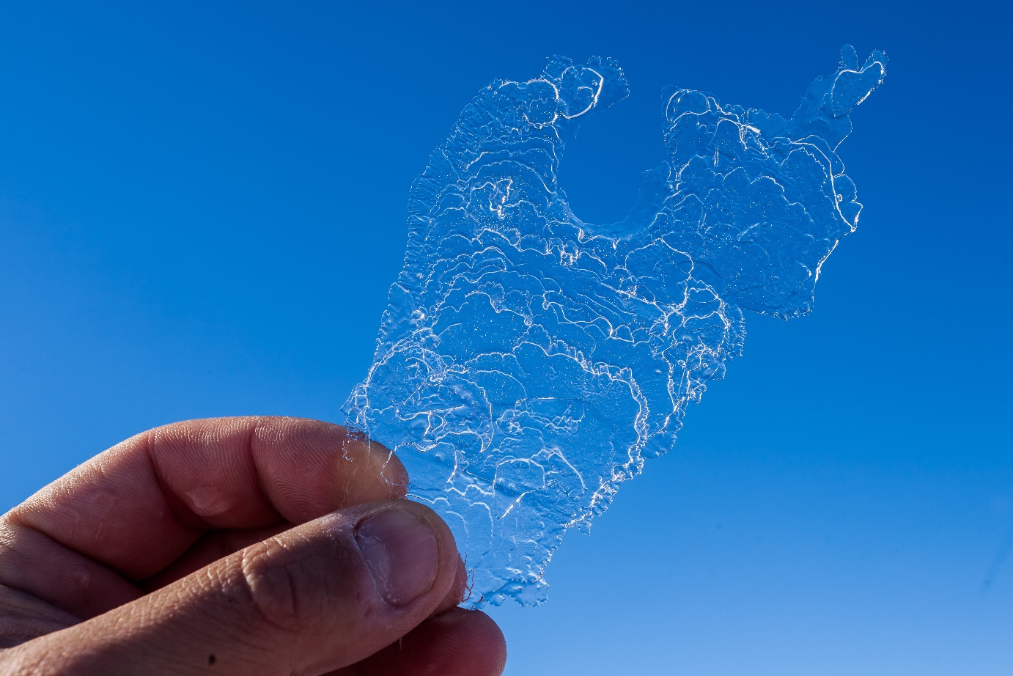

Figure 1: Photo of individual platelet crystal

|  |  |
| --- | --- |
| D:\Eigene Publikationen\2017_Platelet_Review\images\SIPL.jpg  Figure 2: Screenshot of sub-ice platelet layer video recording | D:\Eigene Publikationen\2017_Platelet_Review\images\ATKA11_20121219_vertical_062-072_c-7.jpg  Figure 3: Thin section of incorporated platelet ice |

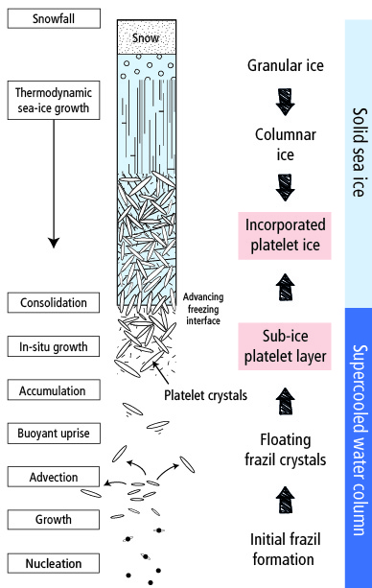

Figure 4: Scheme of proposed ice types (from our paper in preparation)