## Third Session of the Pan-Arctic Regional Climate Outlook Forum (PARCOF-3), Rovaniemi, Finland, May 2019

### Consensus Statement for the Arctic Summer 2019 Season Outlook

To meet climate adaptation and decision-making needs in the Arctic, substantial progress has been made towards the establishment of an Arctic Regional Climate Centre Network (ArcRCC-Network). The ArcRCC-Network is based on the World Meteorological Organization (WMO) RCC concept with active contributions from all the Arctic Council member countries. The Pan-Arctic Regional Climate Outlook Forum (PARCOF) is a flagship activity of the ArcRCC-Network to create a forum to meet directly with Arctic users of climate information, and follows the well-known Regional Climate Outlook Forum (RCOF) concept supported by WMO and its partners around the world. The ArcRCC is now in the second year of its demonstration phase.

Freezing and thawing periods on the fringes of the warm and cold seasons are among the most important considerations for many sectors of the Arctic. Therefore, PARCOFs are held twice per year: a face-to-face meeting in May preceding the summer ice break-up, and a virtual meeting in October before the ice returns in the Arctic winter season.

The third PARCOF meeting was held May 8-9, 2019 in Rovaniemi, Finland, with Permanent Participants of the Arctic Council representatives of Arctic Indigenous Peoples, scientists from all of the Arctic Council Member States, and stakeholders. This consensus statement is a collaborative effort by the network which reviews the trends in the historical monitoring data, recent observations, forecasts from models, and uses regional expertise to fill gaps in the data.

This consensus statement includes a seasonal summary and forecast verification of the previous 2018-2019 winter season, and an outlook for the upcoming 2019 summer season. The statement was adopted by the participants at the end of the PARCOF-3 meeting.

|  |
| --- |
| Current state of the Arctic Observed and projected annual average warming in the Arctic continues to be more than twice the global mean, with higher increases in winter. Arctic annual surface air temperatures in 2014-2018 exceeded those of any year since 1900. Arctic winter sea ice maxima in 2015-2018 were at record low levels, and the volume of Arctic sea ice present in the month of September has declined by 75 percent since 1979.[1] The state of the Arctic climate varies seasonally and geographically. This document presents a summary of surface air temperature, precipitation, and sea ice conditions in the different regions of the Arctic during the previous cold season, and for the upcoming summer. Summary for the present period A meridional atmospheric circulation (north-south) in the Arctic between November 2018 and January 2019, followed by an increase in storminess in parts of the Arctic between February and April 2019 were the main drivers of this past season’s temperature, precipitation and sea ice anomalies. Above normal temperatures forecast for all Arctic regions between June and August 2019 will continue to have implications for precipitation and sea ice over that time period.  **Temperature:** The winter 2019 (NDJ: November 2018, December 2018, January 2019) average surface air temperature was above normal for most of the Arctic domain, with eastern Siberia experiencing its second warmest NDJ on record. During February, March and April (FMA) 2019, the temperatures were above normal, with the exception of the eastern Canadian Arctic where temperatures were below normal. Above normal temperatures are expected to continue across the majority of the Arctic regions between June and August 2019.  **Precipitation:** Siberia saw their driest NDJ in the 70-year record. The southern portion of the Canadian Arctic saw their driest FMA in the 70-year record, while northeastern Siberia and a portion of the Arctic Ocean saw their wettest FMA on record. Between June and August 2019, the multi model forecasting system is issuing a non-decisive forecast over the greatest part of the Arctic region.  **Sea ice:** The Northern Hemisphere March 2019 maximum sea ice extent was the 7th lowest on record. There were large regional differences observed in sea ice conditions between the Canadian and Eurasian Arctic during winter 2019. The thermal and wind patterns during winter 2018-2019 led to extreme low ice extent in the Bering Sea, while the predominance of northerly winds in the Barents Sea region since January 2019 led to close to normal ice extent in the northern part of this area. Predicted above normal temperatures for the Arctic region will contribute to below to near normal sea ice conditions for the majority of the Arctic, with the exception of Greenland and the Canadian Arctic. |

### Temperature

***Summary of November 2018 to April 2019 conditions:*** The November 2018, December 2018, and January 2019 (NDJ) average surface air temperature in the Arctic domain north of 65°N was, in most regions, above normal (red areas in Figure 1, left). Using data from NCEP/NCAR reanalysis to rank the average surface air temperature, the NDJ period ranged from the top 10 warmest over parts of Alaska, Greenland, and the European Arctic, to the 3rd coldest (a portion of the southern Canadian Arctic) winter in 70 years, since the start of the record in 1949. Over the February, March, and April (FMA) 2019 period, average surface air temperature in the Arctic domain north of 65°N was, in the majority, above normal (red areas in Figure 1, right). Particularly, Alaska, northwestern Canada, central Siberia, and the Beaufort, Chukchi and Bering Seas saw their warmest FMA since the start of the record in 1949. On the other hand, average surface air temperature over eastern Canadian Arctic for that same time period was only the 30th – 45th warmest, that is near the median for the same period.

|  |  |
| --- | --- |
|  |  |

**Figure 1:** Left:November, December, and January 2018-2019, and Right: February, March, and April 2019 temperature anomaly based on the 1981-2010 reference period from Hydrometcenter Moscow/NCEP/NCAR Reanalysis.

|  |  |
| --- | --- |
|  |  |

***Verification of the previous seasonal forecast February, March, April 2019:*** To verify the seasonal forecast for temperature (Figure 2, left), statistical techniques are used to fill gaps when meteorological observation data was not available. The interpolated result is adapted by a meteorological model in order to produce a re-analysis (Figure 2, right). The verification is done by subjective comparison between the forecast and re-analysis region by region. A subjective percentage score is adapted where 100% is the best possible forecast for the region, and below 33% is a miss due to the three forecast categories (above, below, and near normal) .

Surface air temperature over North America and the Atlantic regions was, for the most part, accurately forecast for the FMA 2019 season. In particular, surface air temperature over the Alaskan Arctic, the western part of the Canadian Arctic, and most of the Atlantic region was accurately forecast. On the other, the Atlantic region over eastern Greenland and northern Scandinavia only saw a 50% accuracy in surface air temperature forecast during that same time period.

The accuracy of the FMA 2019 surface air temperature over the European and western Siberian regions varied spatially between an accurate, indecisive (below 33% accuracy) and incorrect forecast. Surface air temperature forecast over the ocean for both regions was accurately forecast. The above normal surface air temperature forecast for western Siberia was also accurate. Forecast over remainder of the European and western Siberian continental regions were mostly indecisive. For instance, surface air temperature forecast over the Chukchi region was mostly above normal, while observed values ranged from near normal to below normal in the western part of the region. The only region with an incorrect surface air temperature forecast was a localized area over eastern Siberia, with a near normal and below normal forecasts.

As a general conclusion, in the regions where the multi-model seasonal forecast was decisive, approximately 75% of the Arctic territory had a correct forecast. Based on our verification methodology, the FMA 2019 forecast was thus deemed very good for the Arctic Territory.

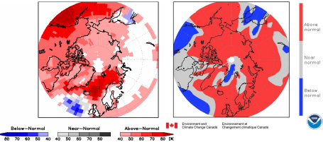

**Figure 2:** Left) Surface Air Temperature Outlook for February, March and April 2019. Multimodel ensemble (MME) probability forecast of three categories (below normal, near normal and above normal) (www.wmolc.org). Right) NCAR (National Center for Atmospheric Research) Climate forecast System Reanalysis (CFSR) for air Temperature, February, March and April 2019.

***Outlook for Summer 2019:*** Surface air temperatures during the June, July, and August (JJA) 2019 period are forecast to be above normal across the majority of the Arctic regions (red areas in Figure 3). The probability of such forecast is highest over the eastern Alaskan region (60-70%) and over the Atlantic region (>70%). Southern Scandinavia, the northern islands of the Canadian Archipelago, and the western portion of the continental Canadian Arctic, on the other hand, have a probability of at least 40% of an above-normal summer temperatures. The forecast is non-decisive over the other parts of Canadian Arctic and over northern Scandinavia (white areas in Figure 3).

|  |  |
| --- | --- |
| Similarly, the probability of above-average summer air temperature ranges between 40% over the western part of the continental European Arctic, to 40-50% for eastern Siberia and the eastern portion of the Chukchi region, increasing to 60% for the westernmost part of the Chukchi region. The forecast is non-decisive over the eastern part of European Arctic and over the western edge of western Siberia (white areas in Figure 3), while temperatures should remain near normal over the eastern portion of western Siberia (grey areas in Figure 3). | **Figure 3:** Multi model ensemble probability forecast for surface temperature for JJA 2019. |

### Precipitation

***Summary of November 2018 to April 2019 conditions:***

Siberia saw their driest NDJ in the 70-year record (Figure 4, left). The southern portion of the Canadian Arctic saw their driest FMA in the 70-year record, while northeastern Siberia and a portion of the Arctic Ocean saw their wettest FMA on record (Figure 4, right).

|  |  |
| --- | --- |
|  |  |

**Figure 4:** Left: November, December and January 2018-2019, and Right: February, March and April precipitation anomaly based on the 1981-2010 reference period from Hydrometcenter Moscow/NCEP/NCAR Reanalysis

***Verification of the previous seasonal forecast FMA 2019:*** To verify the seasonal forecast for precipitation (Figure 5, left), statistical techniques are used to fill gaps when meteorological observation data was not available. The interpolated result is adapted by a meteorological model in order to produce a re-analysis (Figure 5, right). Similar to surface air temperature, verification of precipitation forecast for each region is done through subjective comparison between the forecast and re-analysis. A subjective percentage score is adapted where 100% is the best possible forecast for the region, and below 33% is a miss due to the three forecast categories (above, below, and near normal).

The accuracy of the FMA 2019 precipitation forecast over the Arctic regions varied spatially between an accurate, indecisive (50% accuracy) and incorrect forecast. Over the Alaskan Arctic, the seasonal forecast had correct results for an above normal precipitation, with the exception of localized regions over central and western Alaska where results were not decisive. On the contrary, the forecast was incorrect over the Canadian Arctic zones where decisive results were available. The only exception to this result is a correct forecast for below normal precipitation for isolated pockets over northern Canada and Victoria Island. Over the Atlantic region, correct forecast was observed over one third of the region, namely eastern Greenland and southern Norway. Seasonal forecast for all other Atlantic regions was not correctly simulated by the multi model ensemble mean. Over the European region and eastern and western Siberian regions, the seasonal forecast was not decisive and therefore no verification was performed. Finally, above normal seasonal forecast for the Chukchi region was correctly forecasted and were observed over the western parts of the region. Other areas of the Chukchi region had non-decisive forecast, which were not verified.

As a general conclusion, in the regions where the multi model seasonal forecast was decisive, approximately 40-50% of the Arctic territory had a correct forecast. Based on our verification methodology, this result is considered better than a pure chance forecast of 33% accuracy.



**Figure 5:** Left: MME probability forecast for precipitation for FMA 2019. Right: NCAR Climate Forecasting System Reanalysis (CFSR) for precipitation, FMA 2019.

|  |  |
| --- | --- |
| ***Outlook for Summer 2019:*** Precipitation forecast during JJA 2019 over the majority of the Arctic is non-decisive (white areas, Figure 6). This result means that the seasonal forecasting models used to calculate probabilistic forecast could not agree on the expected amount of precipitation in summer. The few exceptions to this result are a probability of at least 40% for above normal precipitation for scattered areas over southern Alaska, the western European region and the Western Siberian region (green areas, Figure 6). | **Figure 6:** Multi model ensemble probability forecast for precipitation for JJA 2019. |

### Sea Ice

***Summary for Winter 2018-2019:***

|  |  |
| --- | --- |
|  |  |

**Figure 7:**  Blended AARI/CIS/NIC ice chart for 19-22 March 2019. Left: total concentration, right: predominant stage of development. Ice edge reference period: 1999-2018.

The winter maximum sea ice extent (14.89 mln km2), reached on March 11, 2019, was the 7th minimum in row since 1979 (2018 – 2nd), with the maximum winter sea ice extent observed in 1979 (16.77 mln km2). Estimates of the sea ice volume, based on numerical reanalysis (HYCOM-CICE, PIOMAS), show slightly higher or similar to 2018 values, and significantly higher than in 2016-2017. Observed at coastal stations, maximum winter ice thicknesses was slightly less than normal for most of the Arctic seas with some positive anomalies observed in Kara sea and significant negative anomalies in Chukchi Sea region. At several stations (Baker Lake, Tiksi, Kotelny, North Pole) recorded vales (201 to 215 cm) were close to physical maximum for the first year ice. Conditions for mid March 2019 are shown in Figure 7.

High variability of ice conditions was recorded during the observed period for some of the regional seas. The thermal and wind patterns during winter 2018-2019 led to extreme low ice extent in Bering Sea with close to normal ice extent in the adjacent Sea of Okhotsk. Predominance of northerly winds in the Barents Sea region since January 2019 led to close to normal ice extent in the northern part of this area ; this is opposite both to 2018 as well as last decade situation.

***Forecast verification for Winter 2019:*** The winter sea ice outlook verified reasonably well. The forecast for March sea ice extent was based on the CanSIPS models (ECCC). Below to near normal ice extent was correctly predicted for the Barents Sea and below normal ice extent was correctly predicted for the Bering Sea. Above normal ice extent in the Sea of Okhotsk was not predicted correctly, where the model prediction for this region was below to near normal. The model confidence in these regions was moderate; the confidence in all other regions was low and is not discussed. Overall the March 2019 ice extent was the 7th lowest on record and the most notable reduction in ice cover occurred in the Bering Sea, which was at a 40-year record low at the end of March. Although the model correctly predicted below normal in the Bering Sea, it did not capture the extreme.

***Outlook for Spring break-up 2019:*** The outlook for spring break-up is an experimental forecast from CanSIPS (ECCC). The qualitative 3-category (high, moderate, low) confidence in the forecast is based on the historical model skill, only regions where the model has skill are included in the outlook. A summary of the forecast for the 2019 spring break up (Figure 8) for the different Arctic regions is shown in Table 1.

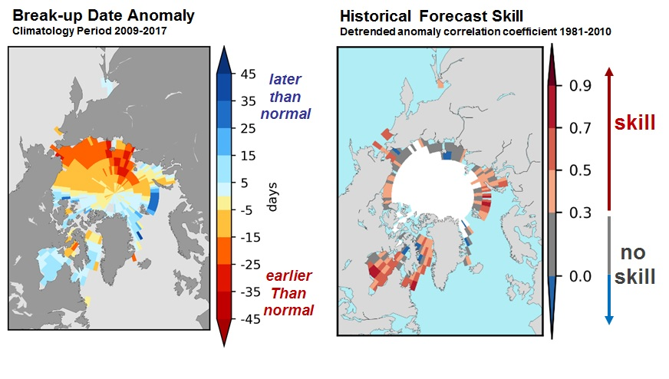

**Figure 8:** Forecast for the 2019 spring break-up where break-up is defined as the date when the ice concentration drops below 50%. Left: anomaly (difference from normal) based on the 2009-2017 period and right: the historical skill defined as the detrended anomaly correlation coefficient based on the 1981-2010 period.

|  |  |  |
| --- | --- | --- |
| **REGION** | **SPRING BREAK-UP** | **CONFIDENCE** |
| **Hudson Bay** | **late clearing** | **[moderate to high confidence]** |
| **Baffin Bay** | **late clearing** | **[moderate to high confidence]** |
| **Barents Sea** | **late clearing** | **[moderate to high confidence]** |
| **Southern Beaufort Sea** | **early clearing** | **[moderate confidence]** |

**Table 1:** 2019 outlook for spring break-up

***September 2019 Sea Ice Extent***

|  |  |
| --- | --- |
| **Figure 9**. September 2019 probability of sea ice at concentrations greater than 15% from CanSIPS (ECCC). Ensemble mean ice extent from CanSIPS (black) and observed mean ice extent 2009-2017 (green). | The outlook is based on 4 WMO Global Producing Centre of Long-Range Forecasts (GPC-LRFs): ECMWF, NOAA/CPC, ECCC/CCCMA and the UKMetOffice. The outlook is expressed as below normal, near normal and above normal ice extent based on the last 10 years. Confidence in the forecasts is qualitative and based on the level of agreement between the model forecasts: ‘high agreement’ where there is good agreement between model forecasts; ‘medium’ agreement where there is some agreement between the models; and ‘low agreement’ where there is little agreement between models. Figure 9 is the probabilistic forecast for September 2019 from the Environment and Climate Change Canada (ECCC) CanSIPS system that is a multi-model ensemble of two climate models. Forecast for the different Arctic regions is summarized in Table 2. |

|  |  |  |
| --- | --- | --- |
| **REGION** | **SEA ICE EXTENT** | **CONFIDENCE** |
| **Chukchi Sea** | **below to near normal** | **[moderate agreement]** |
| **East Siberian Sea** | **below to near normal** | **[low agreement]** |
| **Laptev Sea** | **below to near normal** | **[low agreement]** |
| **Kara Sea** | **below to near normal** | **[moderate agreement]** |
| **Barents Sea** | **below normal** | **[moderate agreement]** |
| **Greenland Sea** | **near to above normal** | **[low agreement]** |
| **Canadian Arctic Archipelago** | **near normal** | **[low agreement]** |
| **Beaufort Sea** | **below to near normal** | **[good agreement]** |

**Table 2:** Outlook for the September 2019 sea-ice extent

***Key shipping regions***

Beaufort Sea: Although there is less multi-year ice in the Beaufort Sea than normal this winter, it is expected that some multi-year ice will persist near the Alaska coast into late summer which could impact shipping. In the Eastern Beaufort there is a possibility (low risk) that multi-year ice could drift south of Banks Island as in September 2018, restricting ship traffic through Amundsen Gulf.

Northwest Passage (NWP): A return to normal concentrations of multi-year ice along the southern route of the NWP could delay melt and the start of the shipping season compared to the last 10 years. The presence of multi-year ice is expected to be a hazard throughout the shipping season. Along the northern route of the NWP, concentrations of multi-year ice are the 7th highest since 1980 and are expected to keep the route closed this season.

Svalbard: The ice extent around Svalbard is expected to be below normal throughout the summer season. Sea ice in the northern Barents Sea is expected to clear later than last 10-years and may restrict shipping activities in this region in the beginning of summer 2019.

Northern Sea Route (NSR):

Easy ice conditions for navigation are expected for the western part of the NSR (Kara and western Laptev Seas) through the summer 2019 season. Below and near normal ice extent expected in the eastern Laptev and western Eastern Siberian Seas (ESS) may lead to increased icebreaker support or higher ice class ships required for safe navigation in this region, particularly along the northern navigation routes. There is also a risk of old ice along the northern routes; similar to 2018 a strip of sea ice in the central ESS could persist through late summer 2019. Very easy ice conditions for navigation will dominate the Chukchi Sea area.

### 

### 

### Regions of the Arctic

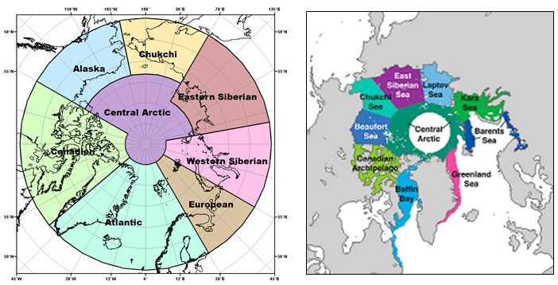**Figure 10:** Left: Regions used for the seasonal summary and outlook of temperature and precipitation, and Right: Regions used in the sea ice summer outlook for spring break-up.

This document presents the seasonal summaries and outlooks for temperature, precipitation, and sea ice over the entire Arctic. In order to capture the geographical variability of these seasonal summaries and outlooks, the Arctic domain is further divided into smaller domains based on the regional factors influencing the different variables. Figure 10 (left) shows the different regions used for the seasonal summary and outlook of temperature and precipitation, while Figure 10 (right) shows the regions used for sea ice. Due to established marine shipping routes, and because the atmospheric and environmental factors influencing temperature/precipitation and sea ice are different, different regions are used for temperature/precipitation and sea ice.

### Background and Contributors

This Arctic seasonal climate outlook was prepared for PARCOF-3. Contents and graphics were prepared in partnership with the Russian, United States, Canadian, Norwegian, Danish, Finnish, Swedish, and Icelandic meteorological agencies and contributions of the Expert Team on Sea Ice, an expert team of the Joint WMO/IOC Technical Commission on Oceanography and Marine Meteorology, the Global Cryosphere Watch, the International Ice Charting Working Group, and with input from the Arctic Monitoring and Assessment Programme (AMAP).

The temperature and precipitation forecasts are based on a multi-model ensemble (MME) approach using computer-generated climate predictions from a number of WMO designated GPC-LRFs. The multi-model ensemble approach is a methodology reputed as providing the most reliable objective forecasts. The sea ice consensus statement is based on experimental model forecasts from 4 WMO Global Producing Centers of Long-Range Forecasts (GPC-LRFs) and statistical/heuristic forecasts from the Canadian, Norwegian, Russian and US national ice services. A multi-model ensemble for sea ice from the GPC-LRFs centres that will form the basis for future ArcRCC Consensus Statements is under development. Outlooks for key shipping areas that describe the summer sea ice conditions were provided by national ice services and were based on forecaster experience and statistical methods.

The ArcRCC is in demonstration phase to seek designation as a WMO RCC-Network, and products are in development and are experimental. For more information, please visit www.arctic-rcc.org.

***Acronyms:***

AARI: Arctic and Antarctic Research Institute

ArcRCC: Arctic Regional Climate Centre

CAA: Canadian Arctic Archipelago

CanSIPS: Canadian Seasonal to Interannual Prediction System

CIS: Canadian Ice Service

ECCC: Environment and Climate Change Canada

ESS: Eastern Siberian Seas

GCW: Global Cryosphere Watch

GPC-LRF: Global Producing Centres Long-Range Forecasts

IICWG: International Ice Charting Working Group

IOC: Intergovernmental Oceanographic Commission

NIC: National Ice Center (United States)

NCEP/NCAR: National Centers for Environmental Prediction/National Center for Atmospheric Research

MME: Multi-model ensemble

NSR: Northern Sea Route

NWP: Northwest Passage

PARCOF: Pan-Arctic Regional Climate Outlook Forum

RCC: Regional Climate Centre

RCOF: Regional Climate Outlook Forum

WMO: World Meteorological Organization

1. “Arctic Climate Change update 2019”, Arctic Monitoring and Assessment Programme (AMAP)